FLORAL DESIGN CONTEST GUIDELINES
The Floral Design Contest will consist of a verbal identification of cut flowers, foliages and potted plants (pictures are included in the contest) and a demonstration of how to make a Round Mug Arrangement. Time will be a factor if there is a tie. Supplies will be provided including knife or pruners. Students can provide their own equipment.
Judges will select 15 from the following lists of cut flowers, foliages and potted plants for the contestant to identify.

CUT FLOWERS | CUT FLOWERS | FOLIAGES | POTTED PLANTS
Carnation | Spray Rose | Leatherleaf | African Violet
Liatris | Gladiolus | Italian Ruscus | Dumb Cane
Stephanotis | Statice | Lemon Leaf | Prayer Plant
Miniature Carnation | Rubrum Lily | Lily Grass | Schefflera
Cattelya Orchid | Hybrid Tea Rose | Ming Fern | Peace Lily
Gypsophila | Hybrid Lily | Pittosporum | Croton
Alstromeria | Snapdragon | Baby Blue Eucalyptus | Philodendron
Chrysanthemum | Iris | Plumose | Snake Plant
Bells of Ireland | Protea | Seeded Eucalyptus | Arrowhead Vine
Daisy | Calla |  | Bromeliad
Hydrangea |  |  | Fern
 |  |  | Poinsettia

Twenty will be chosen for the test. The contestant will be required to properly pronounce the name of each plant to the judges.
Each contestant must work independently and without assistance from anyone. Such assistance may disqualify the contestant. Contestants will be kept in a holding area until the competition begins.

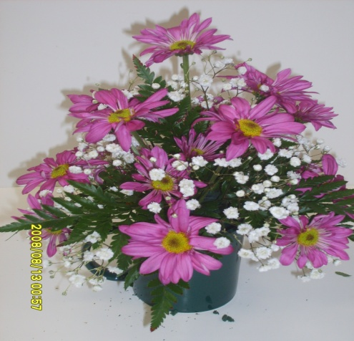

FLORAL DESIGN INFORMATION SHEET
STEPS FOR MAKING A ROUND ARRANGEMENT IN A MUG
Materials and equipment will be provided.
- 1 mug
- 15-18 daisy pompons
- 2 stems of leather leaf
- 1 stem of baby’s breath
- Floral foam
- Flower shears, cutters, or knife
- Anchor tape

PROCEDURE:
Select materials
STEP 1 Prepare the container. Cut saturated foam to fill the mug. The foam will be 1 inch above the cup. Secure foam with a crisscross of anchor tape over the top.
STEP 2 Cut leather leatherleaf in smaller pieces
STEP 3 Add 4 pieces of leatherleaf to the base of the foam.
STEP 4 Add remaining leather leaf to fill in the foam
STEP 5 Add first flower to the center of the cup approximately 2 times the height of the cup.
STEP 6 Add additional flowers
STEP 8 Add remaining flowers (15-18) to the design without each flower touching another.
STEP 9 Add Gypsophila to fill in arrangement. Gypsophila should not extend beyond the flowers.
STEP 10 Clean area. When the contestant has completed the arrangement and is satisfied with the project and workmanship, the contestant should signal the judge and stop work. This will determine the time and speed. Contestants will be rated on the basis of total scores, including such accuracy, speed, acceptable procedures, workmanship and safety.
- Deaf/Hard-of-Hearing students will be allowed to have an interpreter.

Visual Steps for Round Design

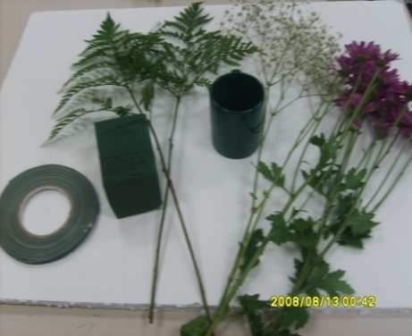
Materials to use for Design
Anchor tape, cup, leather leaf (2 stems), Gypsophila (1 stem), Pompom daisy (15-18 flowers), foam
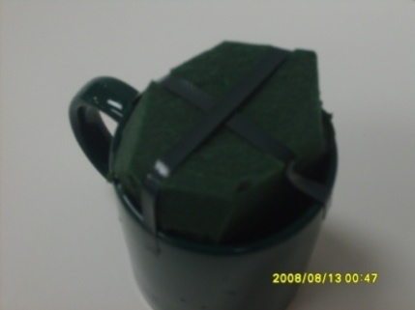
Step 1 Prepare the container.
The foam is one inch above the cup.
Add anchor tape to the top.

Step 2 Cut leather leaf in smaller pieces
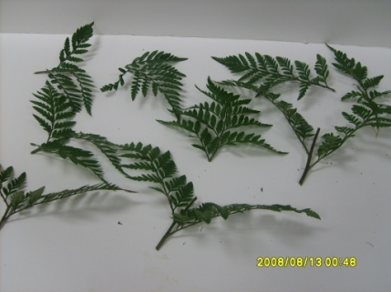
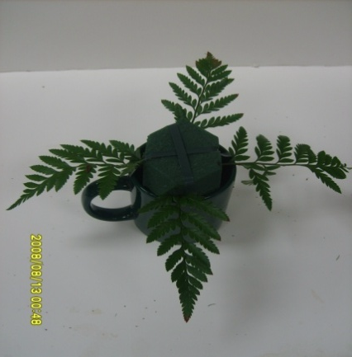
Step 3 Add 4 pieces leather leaf to foam

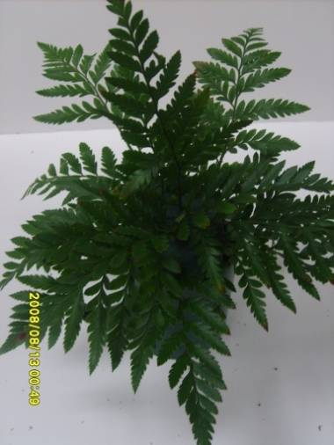
Step 4 Add remaining leather leaf to fill in and
cover the foam.

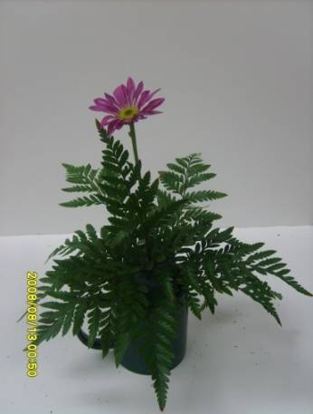
Step 5 Add first flower approximately 2 times
the height of the cup.

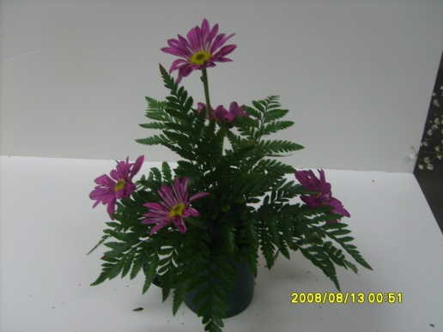
Step 6 Add additional flowers

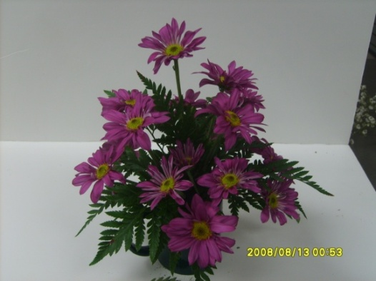
Step 7 Add remaining flowers (15-18) flower so
that they do not touch another flower.

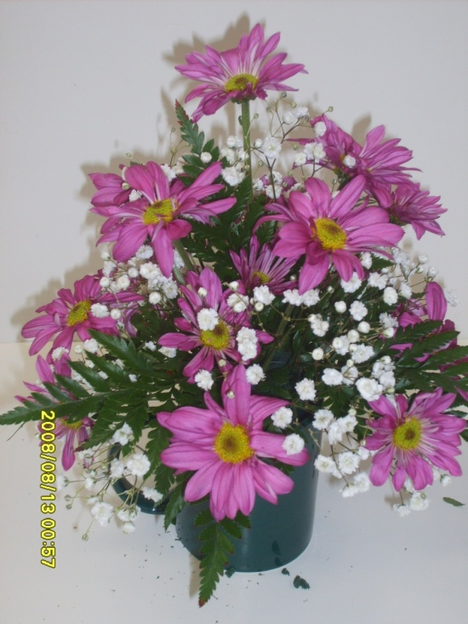
Step 8 Add Gypsophila to fill in arrangement.
Gypsophila should not extend pass the flowers.

Step 9 Clean area and tell judge you have completed the design.
Flower Identification Pictures
Cut Flowers
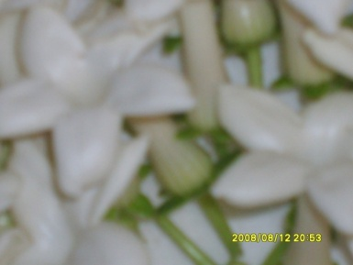
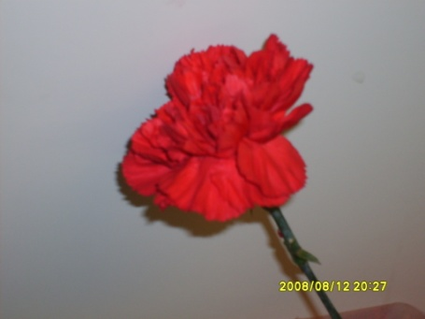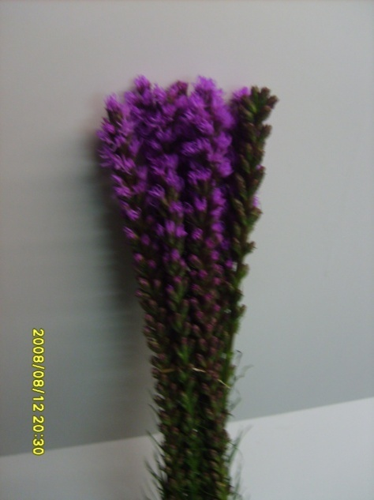
Carnation Liatris Stephanotis
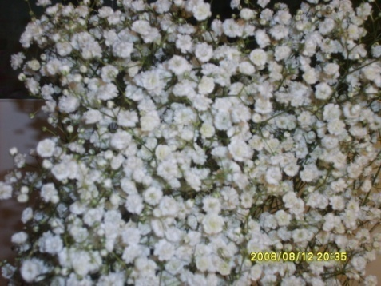
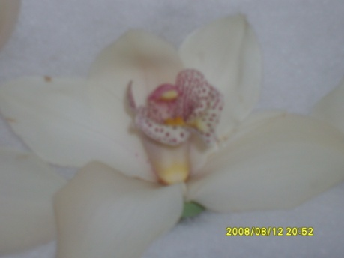
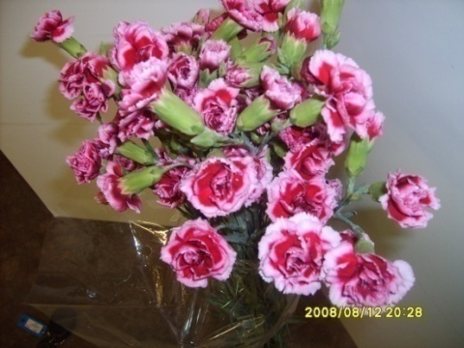 Miniature Carnation Cattelya Orchid Gypsophila

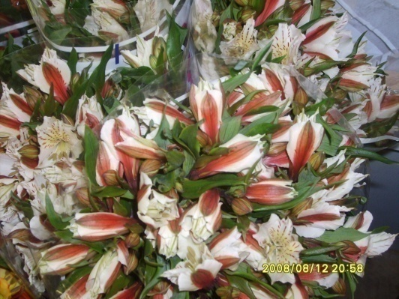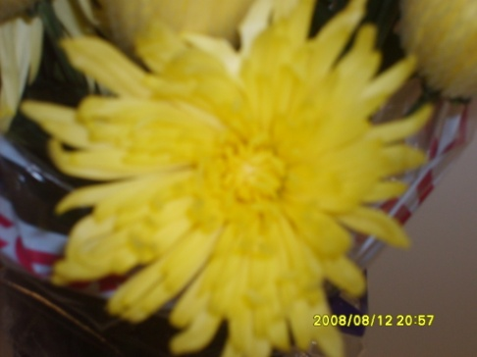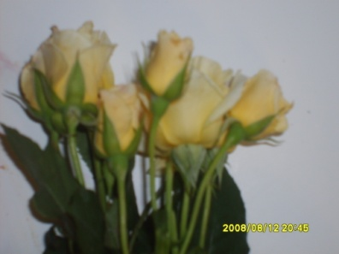
Alstroemeria Chrysanthemum Spray Rose
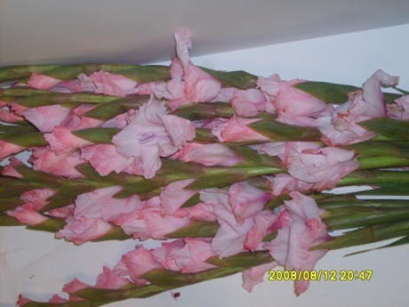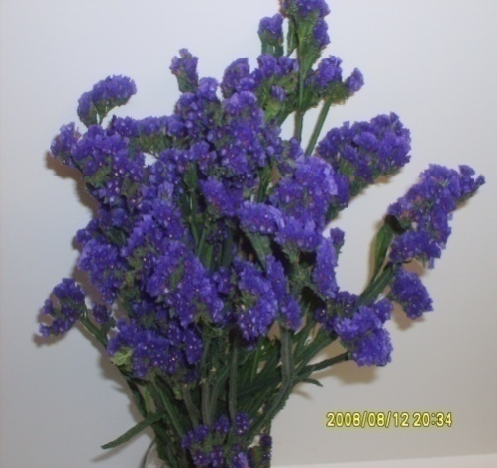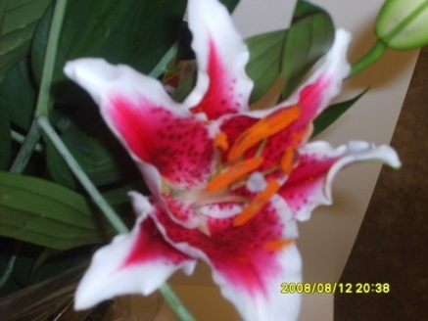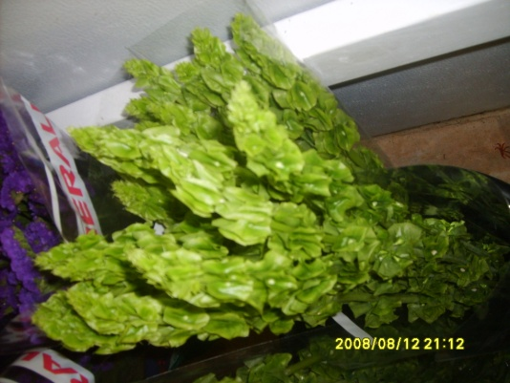
Gladiolus Statice Rubrum Lily Bells of Ireland

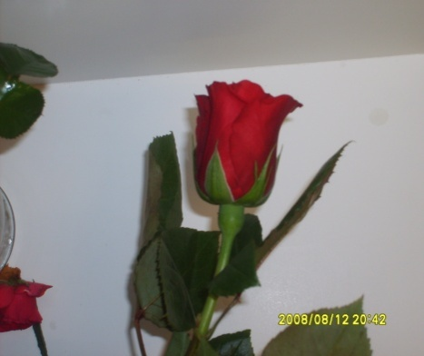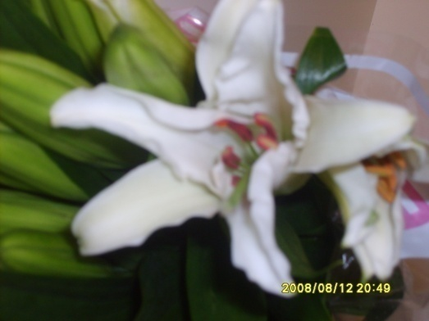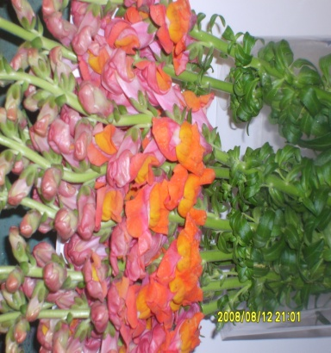
Hybrid Tea Rose Hybrid Lily Snapdragon
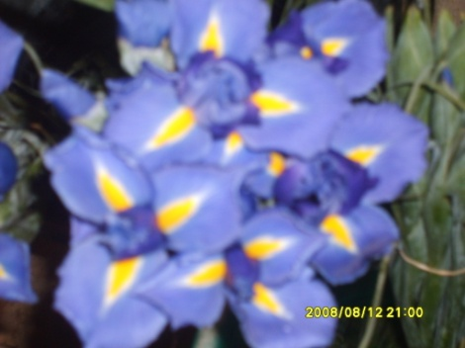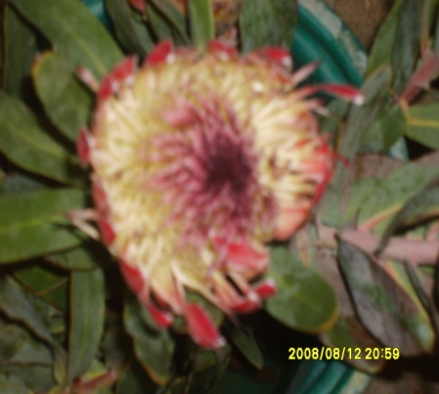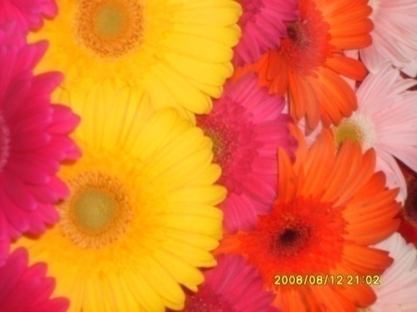
Iris Protea Daisy

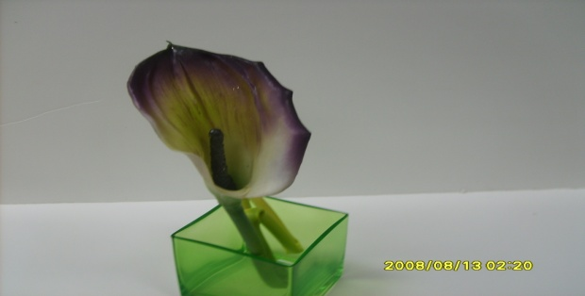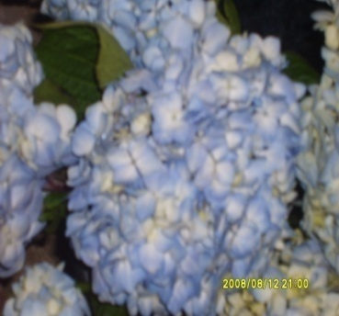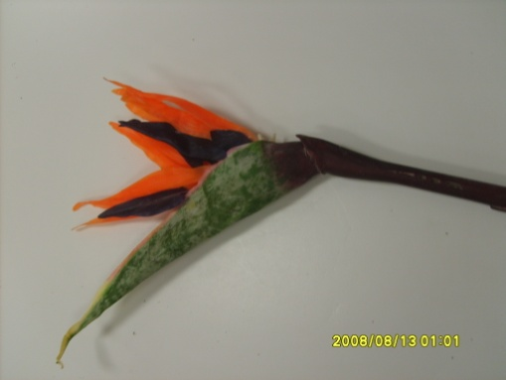
Calla Hydrangea Bird of Paradise
Foliages

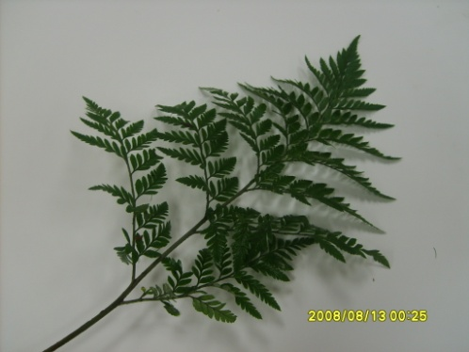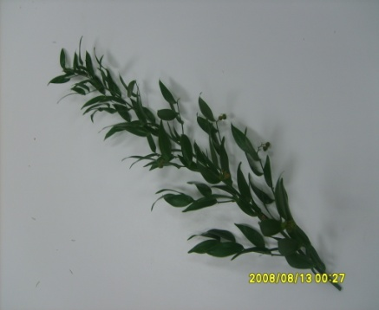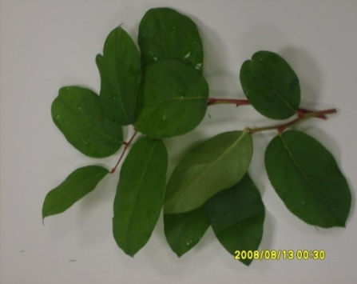
Leatherleaf Italian Ruscus Lemon Leaf
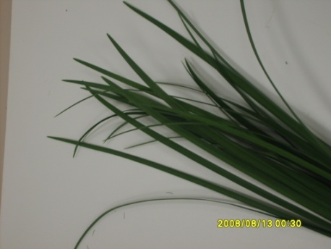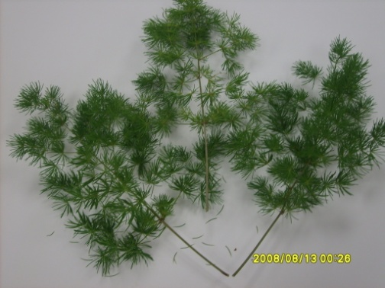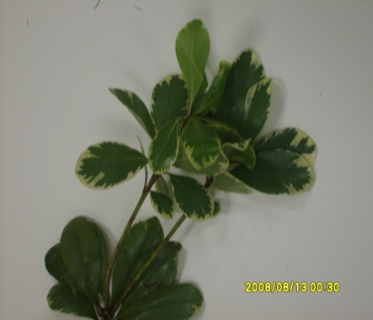
Lily Grass Ming Fern Pittosporum
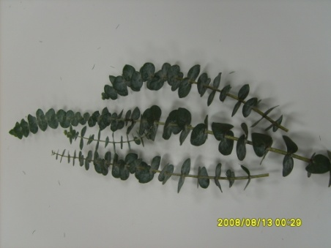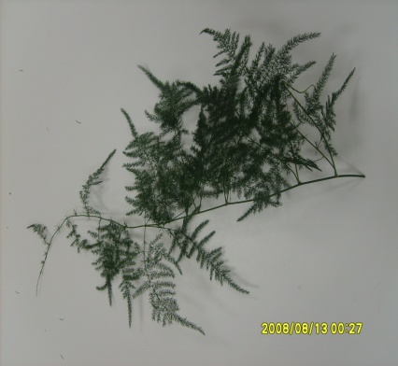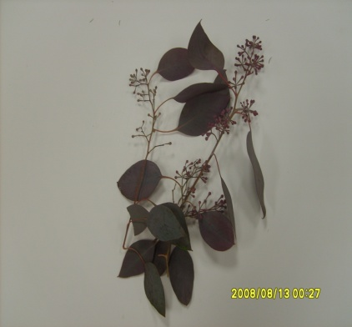
Baby Blue Eucalyptus Plumose Seeded Eucalyptus

Potted Plants

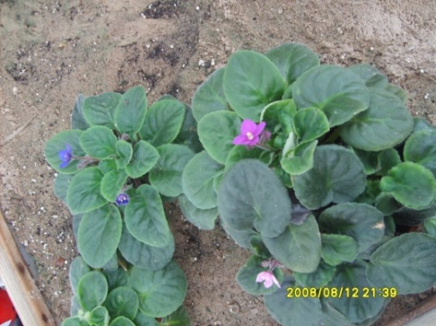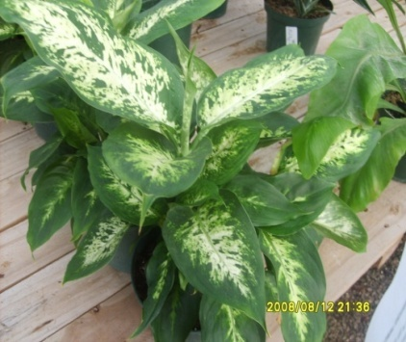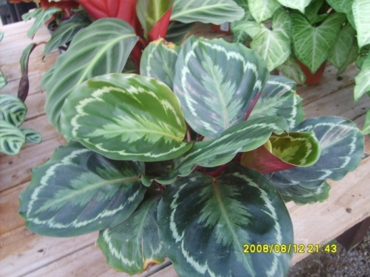
African Violet Dumb Cane Prayer Plant

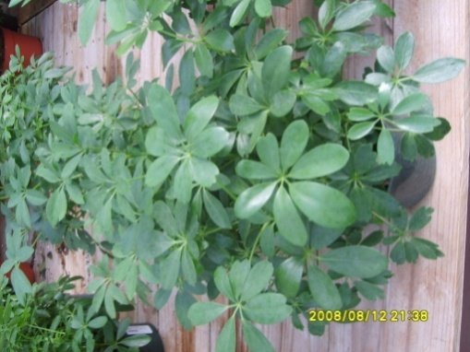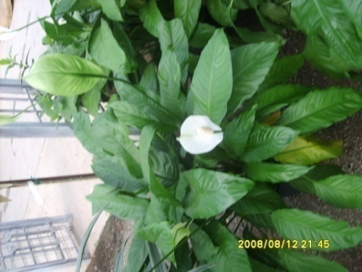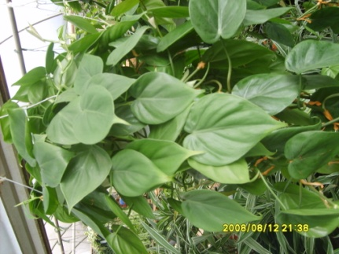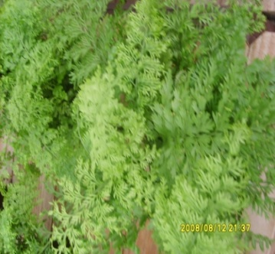
Schefflera Peace Lily Philodendron Fern

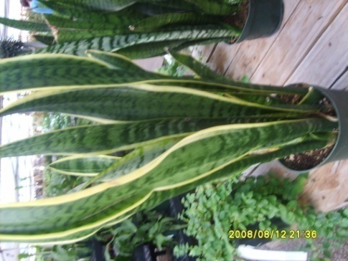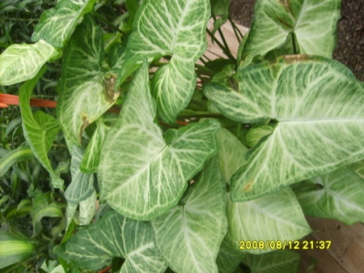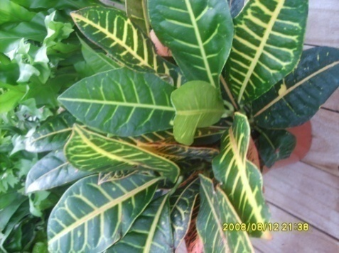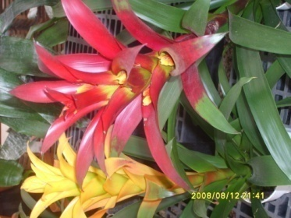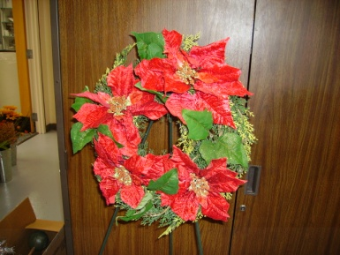
Snake Plant Arrowhead Croton Bromeliad Poinsettia
Violet

FLORAL DESIGN CONTEST
RATING SHEET
Indicate the degree to which this student has utilized the following principles of flower design.
Category | 5 4 | 3 | 2 1 | Total
Design | Shows high quality of design. Needs little or no improvement. | Shows some use of design. Needs improvement. | Shows little or no use of design. Needs much improvements
Balance | Shows visual and actual balance. Needs little or no improvement. | Shows attempt at balance Needs some improvements. | Not balanced. Needs much improvement.
Proportion | Container and flowers are in good proportion. Needs no improvement. | Shows attempt at proportion. Needs some improvement. | Shows lack of proportion. Needs much improvement.
Harmony | Component parts blend together. Needs little or no improvement. | Component parts blend together somewhat. Needs some improvement | Component parts do no blend together.
Focal Point | Definite establishment of focal point. Needs little or no improvement. | Focal point established but needs some improvement. | Focal point not established. Needs much improvement.
Rhythm | Shows good use of rhythm. Eye moves smoothly through arrangement. Needs little or no improvement. | Show some use of rhythm but needs improvement. | Shows little or no use of rhythm. Needs much improvement.
Repetition | Shows use of repetition to add interest to arrangement. | Shows use of repletion but needs some improvement. | Incorrect use of repletion. Needs much improvement.
Unity | Whole composition is a complete unit. Needs little or no improvement. | Shows use of unity but needs improvement to become a complete unit. | Complete lack of unity. Needs much improvement.
Color | Combination of color is pleased and appropriate for occasion | Combination of color needs improvement. | Poor use of color or is not suitable for occasion
Sales ability  And Clean-up | Excellent sales ability. Better than average of retail flower shops.  Clean-up station | Shows good sales ability. Average for retail shops | Poor sales ability. Not suitable for sale in flower shop  Didn’t Clean station

DESIGN SCORE ___________ FLOWER ID SCORE_________ TOTAL SCORE_____________

