Small Engine Parts Identification

Contest Guidelines

Each contestant must be able to identify the parts of the small engine and be able to give the purpose of each part. The engine parts will be identified on a disassembled engine, not on an assembled engine. The contestant will look at each part and give its name and its purpose to the judge orally*. Each contestant will also take a fill-in-the-blank vocabulary test while in the holding room. There will be a word bank at the top of the test page.

Engine Parts:

Air Cleaner | Exhaust Valve
Armature | Fuel Tank
Camshaft | Flywheel
Carburetor | Flywheel Key
Combustion Chamber | Intake Valve
Connecting Rod | Oil Filler Plug
Crankcase | Piston
Crankshaft | Piston Head
Cylinder | Piston Ring
Cylinder Block | Spark Plug
Cylinder Head

The judge will ask each contestant to identify two parts that are not on the list. This will be used as a tiebreaker only and will not count against the students regular test score.

Each contestant must work independently and without assistance*. Any outside assistance may disqualify the contestant. Contestants will be kept in a holding area until their competition begins.

*Students who communicate through an interpreter may use their interpreter during the oral testing. Students who require reading assistance may request to have the test read to them.

Small Engine Parts Identification

Information Sheet

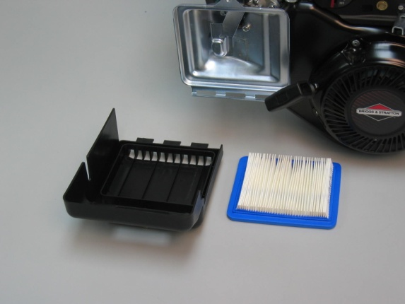  Air Cleaner: a device that filters the air that is mixed with the fuel in the engine. | 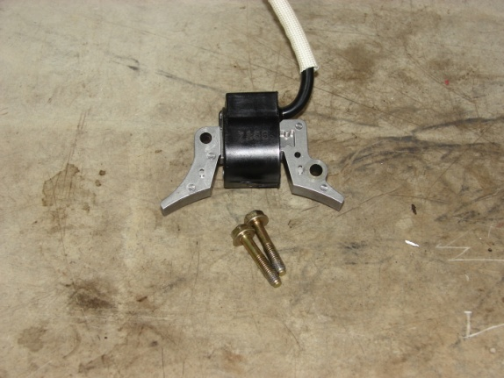  Armature: a part consisting of coils of wire around an iron core that induces an electric current when it is rotated in a magnetic field.
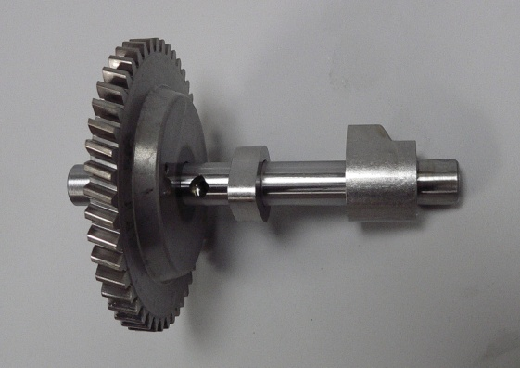  Camshaft: the shaft containing lobes or cams which rotate to raise and lower the valves. | 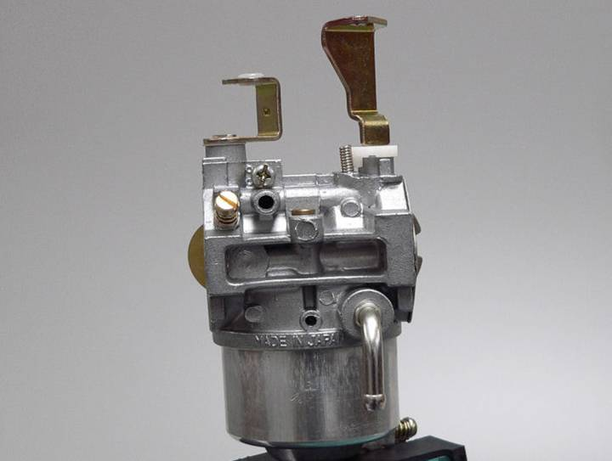  Carburetor: a device for automatically mixing fuel in the proper proportion with air to produce a combustible gas.
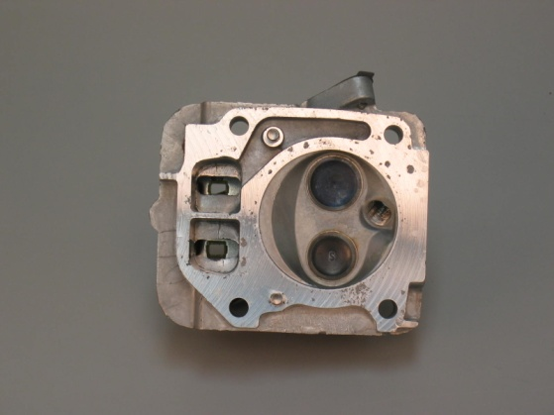  Combustion Chamber: the volume of the cylinder above the piston with the piston at top dead center. | 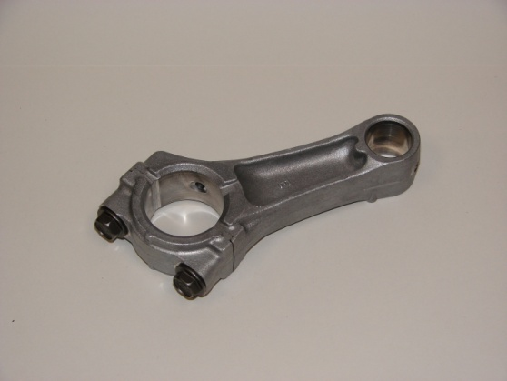  Connecting Rod: a rod that connects the piston to the crankshaft.

Small Engine Parts Identification

Information Sheet

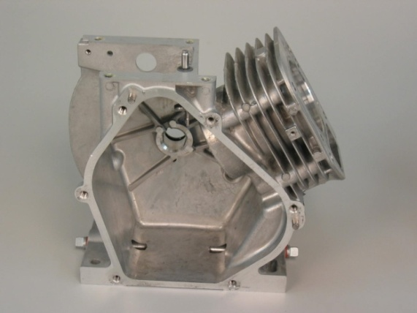  Crankcase: the housing where the crankshaft and many other parts of the engine operate. | 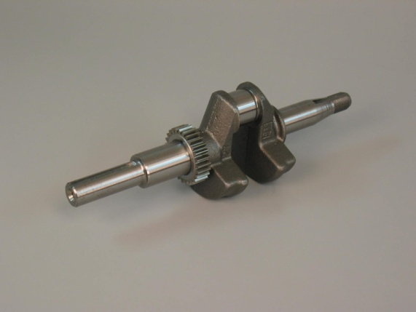  Crankshaft: the main shaft of the engine which, in conjunction with the connecting rod, changes the reciprocating motion of the piston into rotary motion.
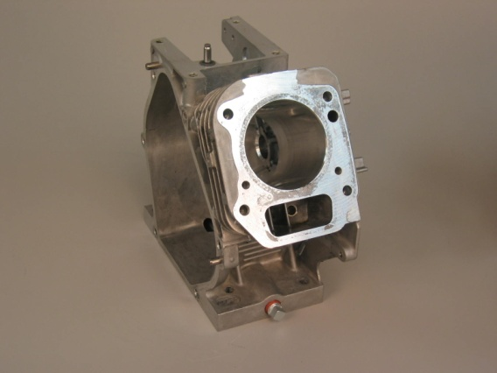  Cylinder: a round hole having some depth bored to receive a piston. Sometimes referred to as a bore or barrel. | 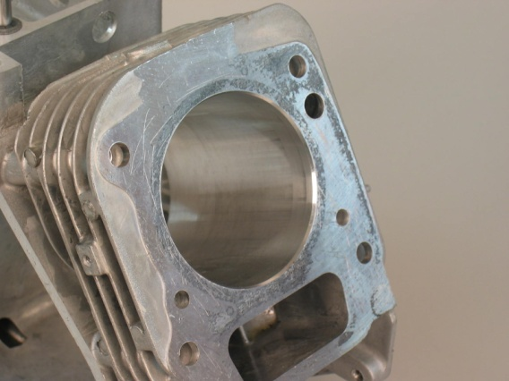  Cylinder Block: the largest single part of an engine; the main mass of metal where the cylinders are bored or placed.
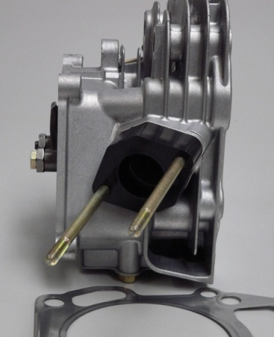  Cylinder Head: a detachable portion of an engine fastened securely to the cylinder block that contains all or part of the combustion chamber. | 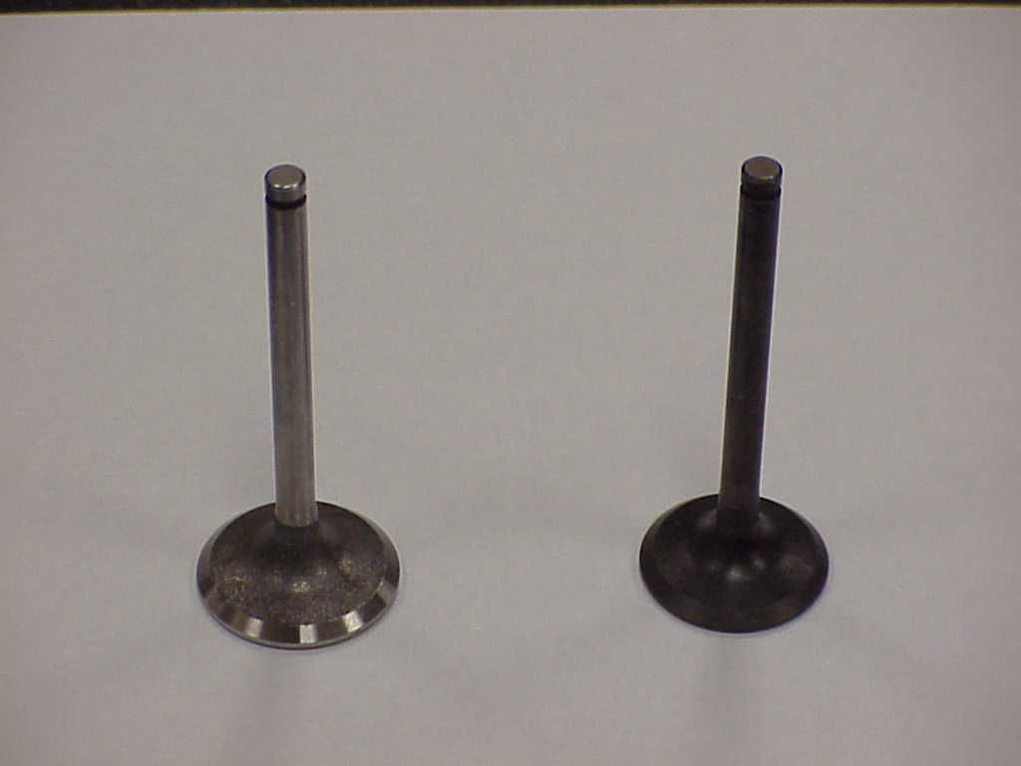  Exhaust Valve: a valve that permits the remains of the burned fuel to leave the combustion chamber.
Small Engine Parts Identification

Information Sheet

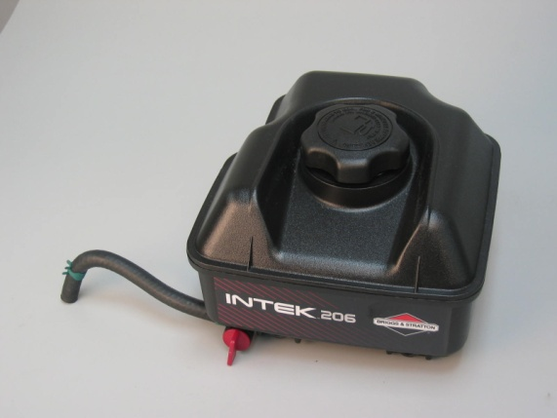  Fuel Tank: the device which contains the fuel to be burned in the engine. | 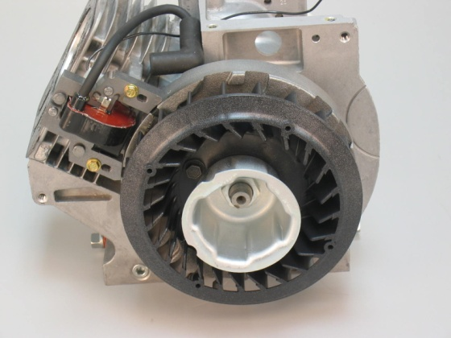  Flywheel: a heavy wheel that maintains the speed of the engine while it is running.
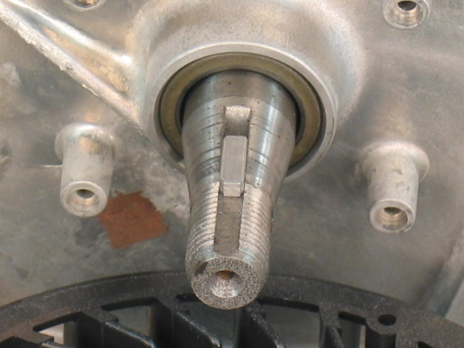  Flywheel Key: a device that holds the flywheel in place. | Intake Valve: a valve that permits the air- fuel mixture to enter the combustion chamber and seals its exit.
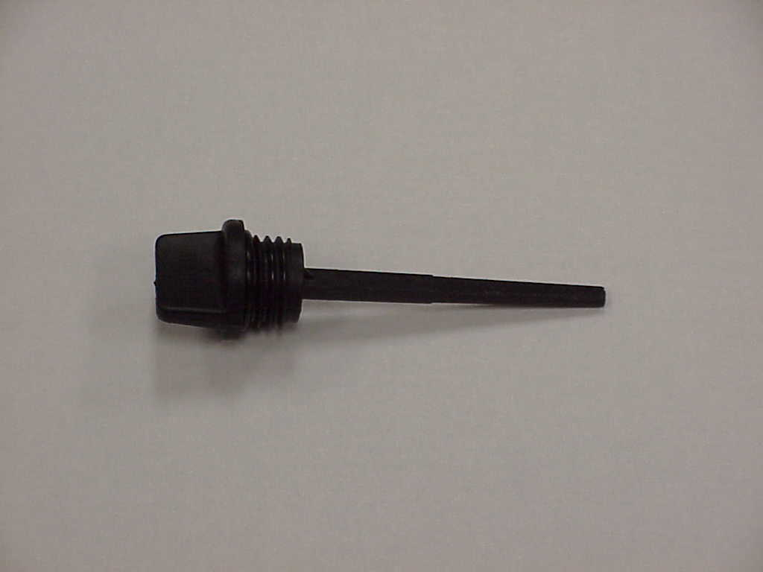  Oil Filler Plug: the device that closes the opening where the crankcase is filled with oil. | 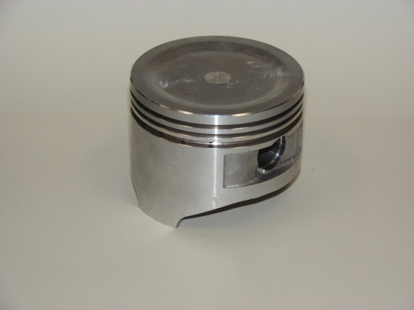  Piston: a cylindrical part closed at one end that is connected to the crankshaft by the connecting rod.

Small Engine Parts Identification

Information Sheet

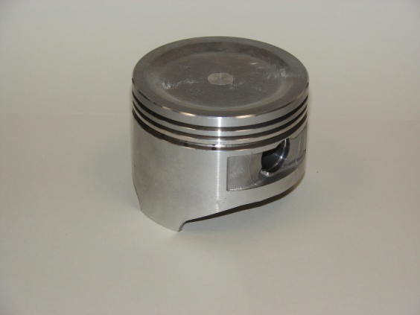  Piston Head: the part of the piston above the rings. | 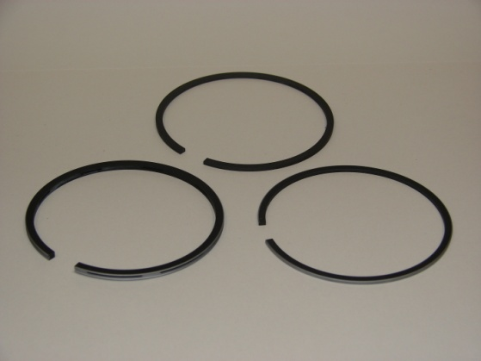  Piston Rings: expanding rings placed in the grooves of the piston to create a seal that prevents the passage of fluid or gas past the piston.
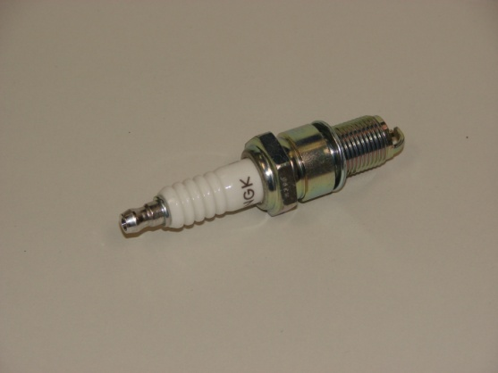

Spark Plug: a device inserted into the combustion chamber of an engine that contains an insulated control electrode for conducting current.

Contestant # ______

Small Engine Parts Identification

ID and Purpose

Part | Identification |  |  |  |  |  | Total | Definition |  |  |  |  |  | Total
Fuel Tank | 10 | 8 | 6 | 4 | 2 | 0 |  | 10 | 8 | 6 | 4 | 2 | 0
Spark Plug | 10 | 8 | 6 | 4 | 2 | 0 |  | 10 | 8 | 6 | 4 | 2 | 0
Cylinder Block | 10 | 8 | 6 | 4 | 2 | 0 |  | 10 | 8 | 6 | 4 | 2 | 0
Armature | 10 | 8 | 6 | 4 | 2 | 0 |  | 10 | 8 | 6 | 4 | 2 | 0
Air Cleaner | 10 | 8 | 6 | 4 | 2 | 0 |  | 10 | 8 | 6 | 4 | 2 | 0
Crankshaft | 10 | 8 | 6 | 4 | 2 | 0 |  | 10 | 8 | 6 | 4 | 2 | 0
Intake Valve | 10 | 8 | 6 | 4 | 2 | 0 |  | 10 | 8 | 6 | 4 | 2 | 0
Piston Head | 10 | 8 | 6 | 4 | 2 | 0 |  | 10 | 8 | 6 | 4 | 2 | 0
Piston Rings | 10 | 8 | 6 | 4 | 2 | 0 |  | 10 | 8 | 6 | 4 | 2 | 0
Connecting Rod | 10 | 8 | 6 | 4 | 2 | 0 |  | 10 | 8 | 6 | 4 | 2 | 0
Piston | 10 | 8 | 6 | 4 | 2 | 0 |  | 10 | 8 | 6 | 4 | 2 | 0
Camshaft | 10 | 8 | 6 | 4 | 2 | 0 |  | 10 | 8 | 6 | 4 | 2 | 0
Cylinder Head | 10 | 8 | 6 | 4 | 2 | 0 |  | 10 | 8 | 6 | 4 | 2 | 0
Exhaust Valve | 10 | 8 | 6 | 4 | 2 | 0 |  | 10 | 8 | 6 | 4 | 2 | 0
Flywheel | 10 | 8 | 6 | 4 | 2 | 0 |  | 10 | 8 | 6 | 4 | 2 | 0
Flywheel Key | 10 | 8 | 6 | 4 | 2 | 0 |  | 10 | 8 | 6 | 4 | 2 | 0
Crankcase | 10 | 8 | 6 | 4 | 2 | 0 |  | 10 | 8 | 6 | 4 | 2 | 0
Oil Filler Plug | 10 | 8 | 6 | 4 | 2 | 0 |  | 10 | 8 | 6 | 4 | 2 | 0
Carburetor | 10 | 8 | 6 | 4 | 2 | 0 |  | 10 | 8 | 6 | 4 | 2 | 0
Cylinder | 10 | 8 | 6 | 4 | 2 | 0 |  | 10 | 8 | 6 | 4 | 2 | 0
Combustion Chamber | 10 | 8 | 6 | 4 | 2 | 0 |  | 10 | 8 | 6 | 4 | 2 | 0
 | Total Identification Score  (210 points possible) |  |  |  |  |  |  | Total Definition Score  (210 points possible)

Contestant # ______

Small Engine Parts Identification

Score Sheet

Vocabulary Score (105 possible)

Verbal Score (420 possible)

Total Score (525 possible)

