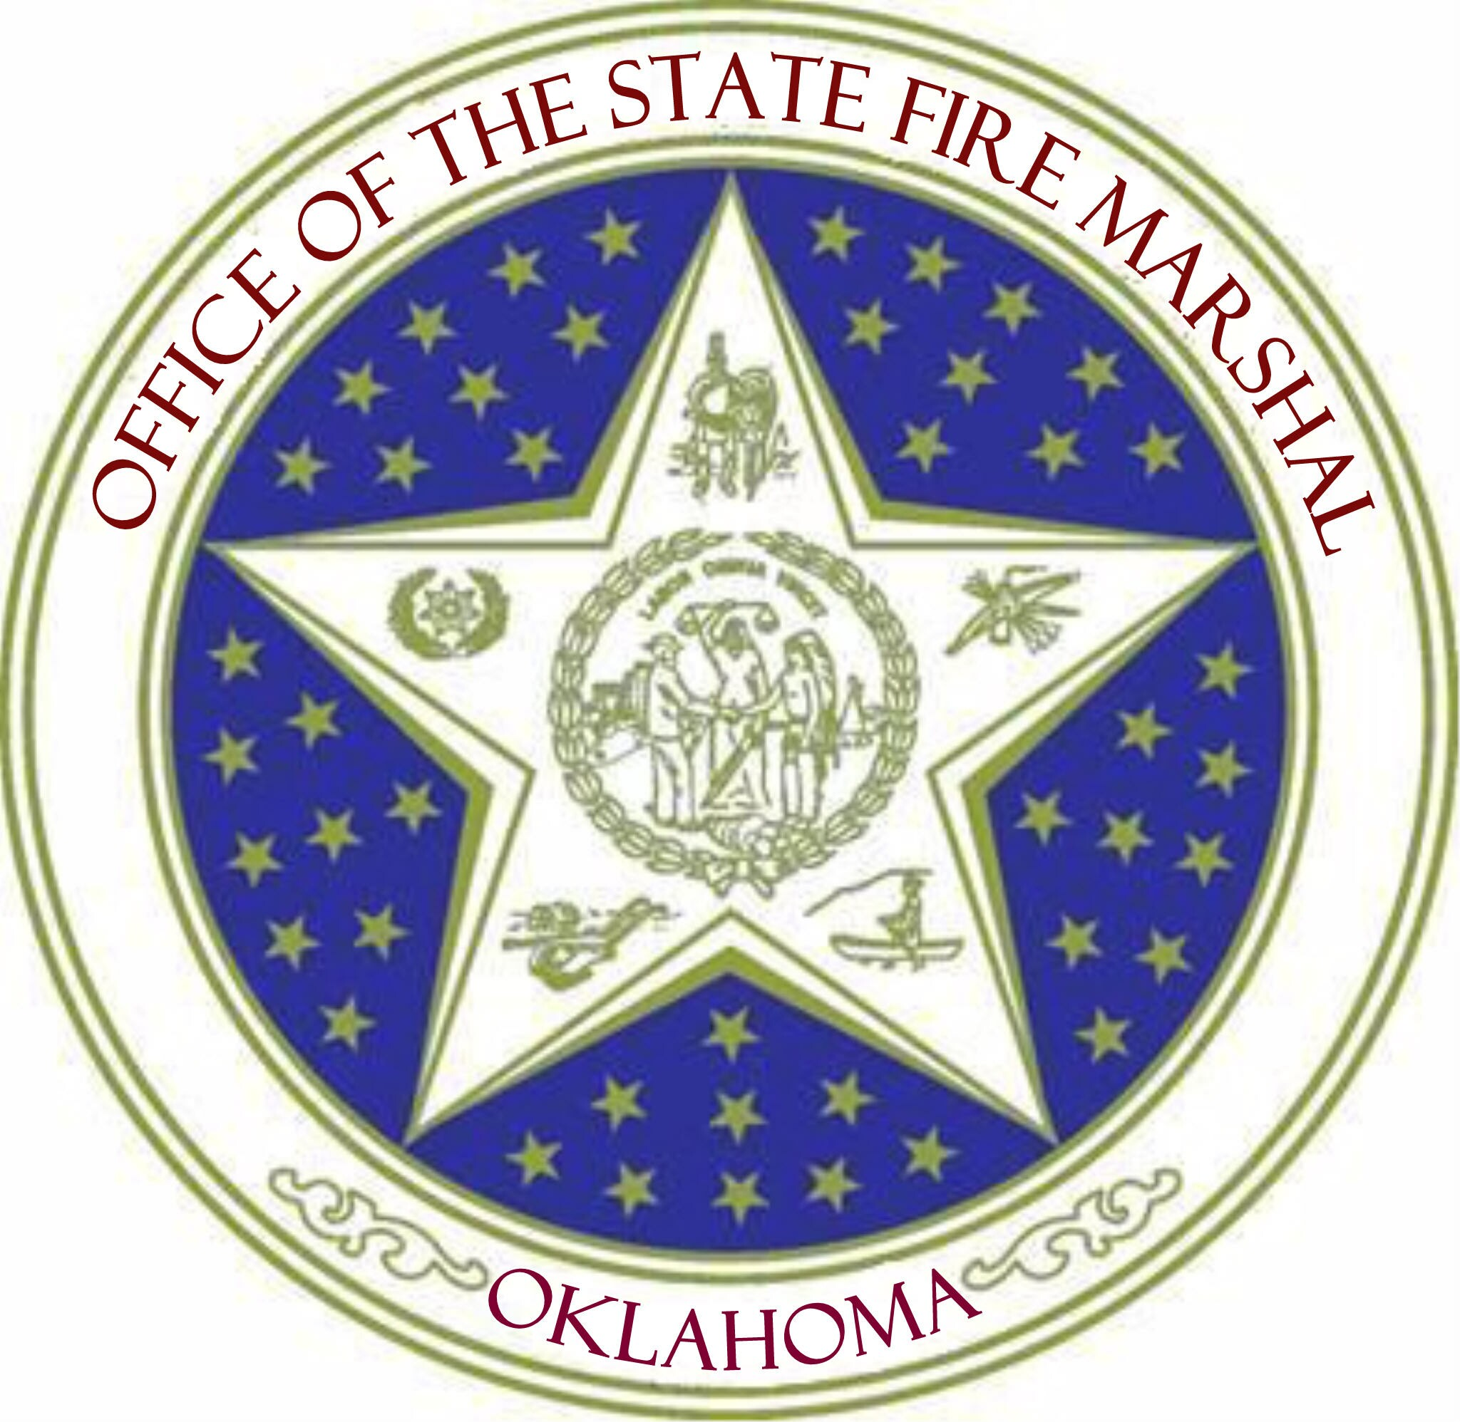

Oklahoma State Fire Marshal
2401 NW 23rd Street, Suite 4
Oklahoma City, Oklahoma 73107
405/522-5005 405/522-5028 (Fax)

All Fireworks Displays in the State of Oklahoma MUST BE under the supervision of a state licensed display operator!

This is a new Oklahoma law that took place effective January 1, 2013.

What does this mean? If you are planning on having a fireworks display in your town, the person in charge of firing the fireworks MUST have a Display Operator License that is issued by the Oklahoma State Fire Marshal’s office.

How does a person get licensed? A person must fulfill certain requirements and pass an exam.

What are the requirements?
1. The individual MUST take a “Display Operator Training Class” that has been approved and certified by the Oklahoma State Fire Marshal’s office.
2. The individual MUST have worked under complete supervision on at least three (3) fireworks displays within 3-years immediately preceding his/her application. (*This must be verified and signed by a licensed display operator, or a licensed fireworks company officer.)
3. The individual/applicant will then go to the nearest Oklahoma Career Tech Facility (formerly called Vo-tech). The applicant will pay the fee to take the exam. The exam will be administered by computer. The applicant must answer a minimum of 70% questions correctly to pass. (You will know within 1 minute if you pass or fail).
4. The individual/applicant MUST complete and submit an Application form (available on-line) to the Oklahoma State Fire Marshal. (An application must be accompanied with a $75 fee and 2 passport photos.)
5. The individual/applicant will receive their license from the Oklahoma State Fire Marshal’s office by mail when all requirements are met.
6. The list of licensed operators SHALL be posted on the State Fire Marshal’s website.

Please understand…this is NOT A CHOICE! This is a state law!

