State of Oklahoma
FIREFIGHTER TRAINING ADVISORY COMMITTEE
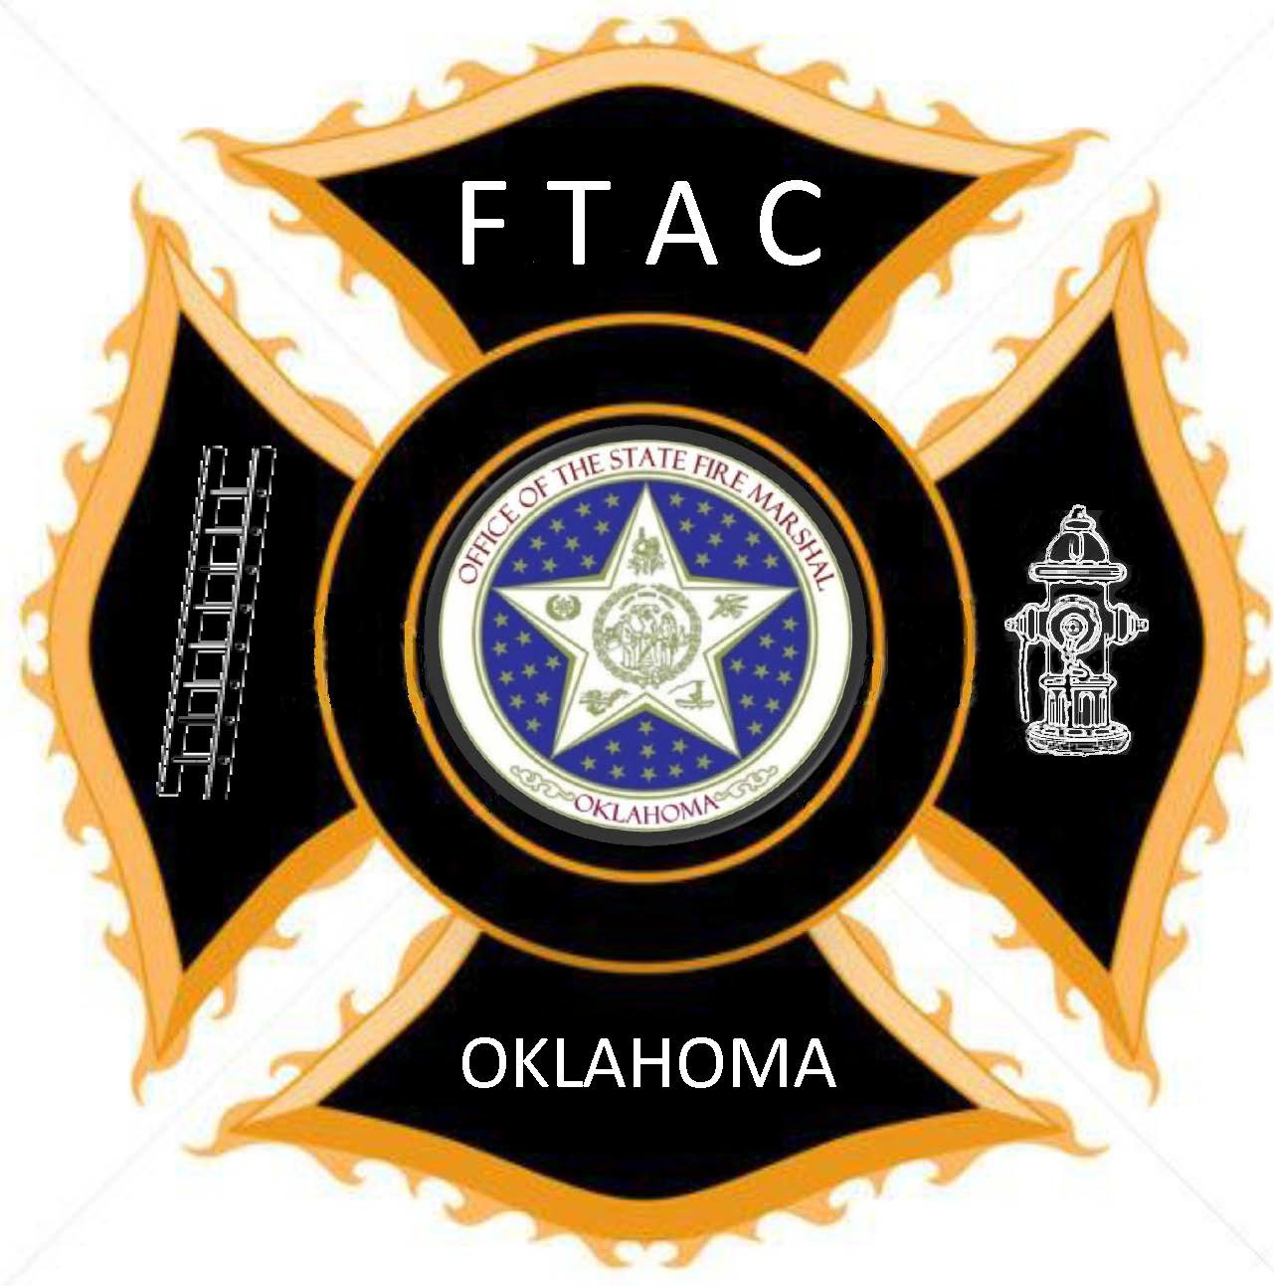
Five Levels of Firefighter

A professional development plan for Oklahoma Firefighters.
Support Firefighter

Wildland Firefighting Fundamentals or Equivalent -16 hours
Emergency Vehicle Operations Course – 8 hours
NIMS ICS – 100/200/700 - 8 hours
CPR Healthcare Provide - 4 hours
Personal Protective Clothing – 4 hours
Total Hours - 40
Support Firefighter Level prepares a Firefighter to work on the fire scene in a support capacity, operating rigs and assisting with wildland firefighting set-up and preparations.

Basic Firefighter

Complete Support Level
Volunteer Firefighter Practices or greater - 30 hours
Wildland Firefighting Skills or Equivalent - 16 hours
Water Supply or Pump Operations - 8 hours
Hazardous Materials Awareness - 8 hours
Electives: Local Departments Choice
EMS/Rescue Electives - 16 hours
Total Hours - 78

Basic Firefighter Level builds on the Support Firefighter Level and prepares a Firefighter to effectively combat wildland fires and respond to various types of accidents (automobile, etc.).

Intermediate Firefighter
Complete Basic Level
Structural Firefighter or greater - 48 hours
Electives: Local Departments Choice
Fire Electives – 12 hours
EMS/Rescue Electives - 12 hours
Total Hours - 72

Intermediate Firefighter Level is the Minimum Training Level for Paid Firefighters. Intermediate Firefighter Level is the minimum Level for Interior Structure Fire Attack for all Firefighters Paid & Volunteer.
Advanced Firefighter
Complete Intermediate Level
Firefighter I or greater – 104 hours
Hazardous Materials Operations – 40 hours
Electives: Local Departments Choice
Fire Electives – 16 hours
EMS/Rescue Electives- 16 hours
Total Hours - 176 hours

Advanced Firefighter Level requires the completion of Firefighter I, or an Equivalent or Greater program. Paid Firefighters must be completed within 24 months of employment.

Master Firefighter
Complete Advanced Level
Firefighter II or greater - 48 hours
Electives: Local Departments Choice
Fire Electives - 16 hours
EMS/Rescue - 16 hours
Total Hours - 80

Highest Level of Firefighter (Master Firefighter) requires completion of Firefighter II or greater program and EMT Basic. Paid Firefighters must complete within 36 months of employment. Optional for Volunteer Departments based on the local authority having jurisdiction.

