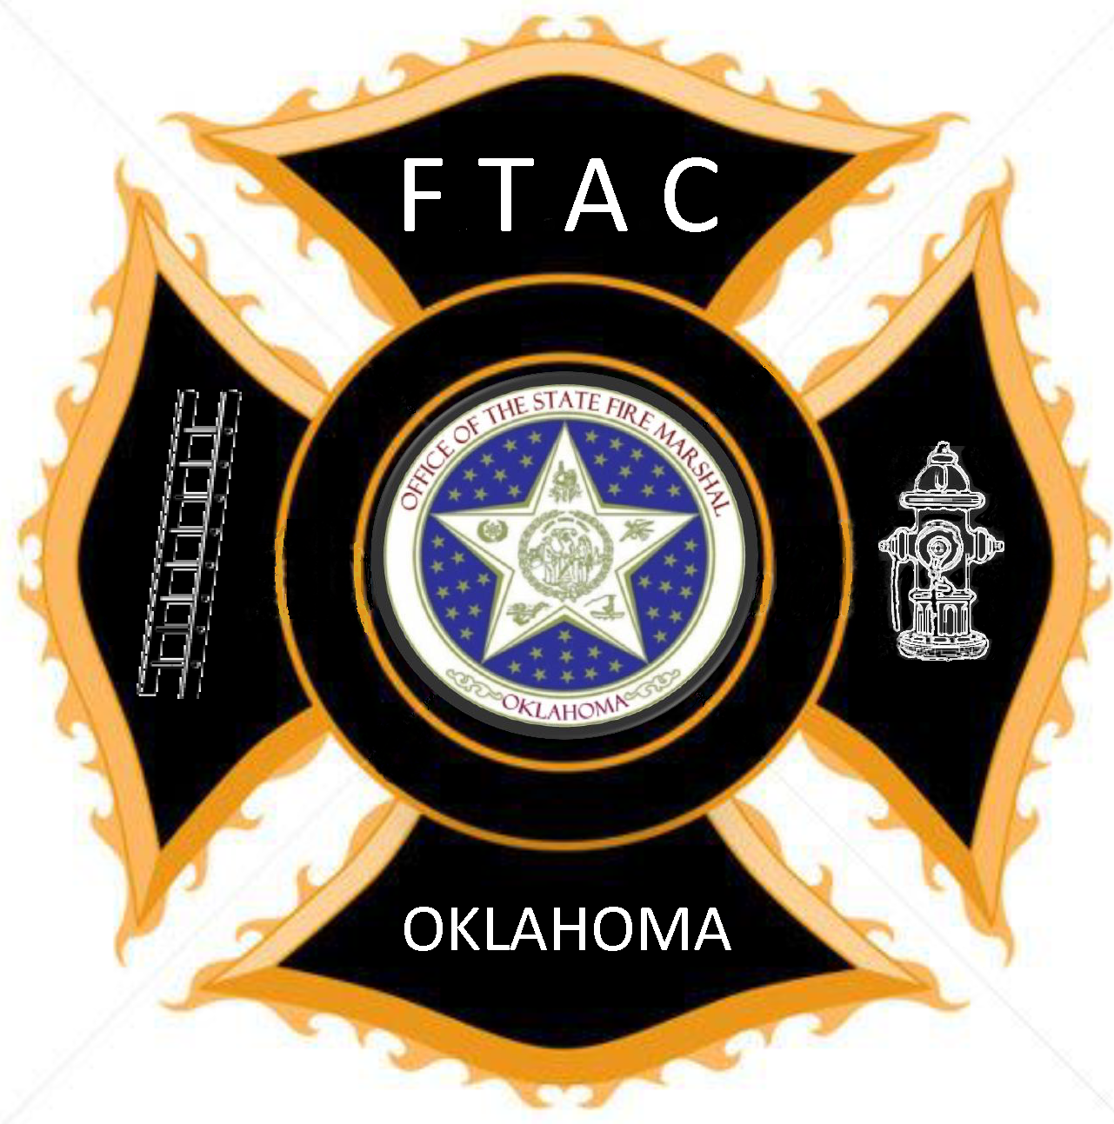

Advanced Firefighter
Paid Firefighters complete in 24 months

Complete Intermediate Level

Firefighter I or greater - 104 hrs

Hazardous Materials Operations – 40 hrs

Electives: Local Department Choice

Fire - 16 hrs

EMS/Rescue - 16 hrs

Total Hours - 176 hrs

The Advanced Firefighter Level requires the completion of Firefighter I or an Equivalent or Greater program. Paid Firefighters must complete within 24 months of employment.

