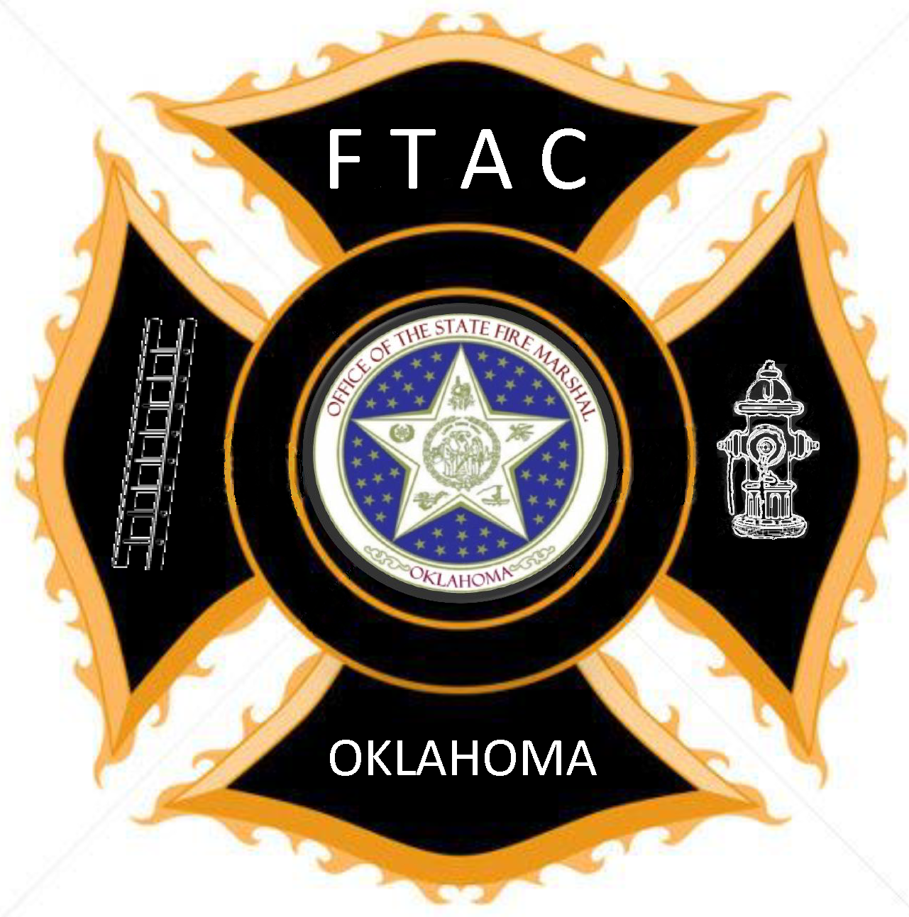

Basic Firefighter

Complete Support Level

Volunteer Firefighter Practices (VFFP) or greater - 30 hrs

Wildland Firefighting Skills or Equivalent - 16 hrs

Water Supply or Pump Operations - 8 hrs

Hazardous Materials Awareness - 8 hrs

Electives: Local Department Choice

EMS/Rescue - 16 hrs

Total Hours - 78 hrs

The Basic Firefighter Level builds on the Support Level and prepares a Firefighter to effectively combat wildland fires and respond to various types of accidents (automobile, etc.).

