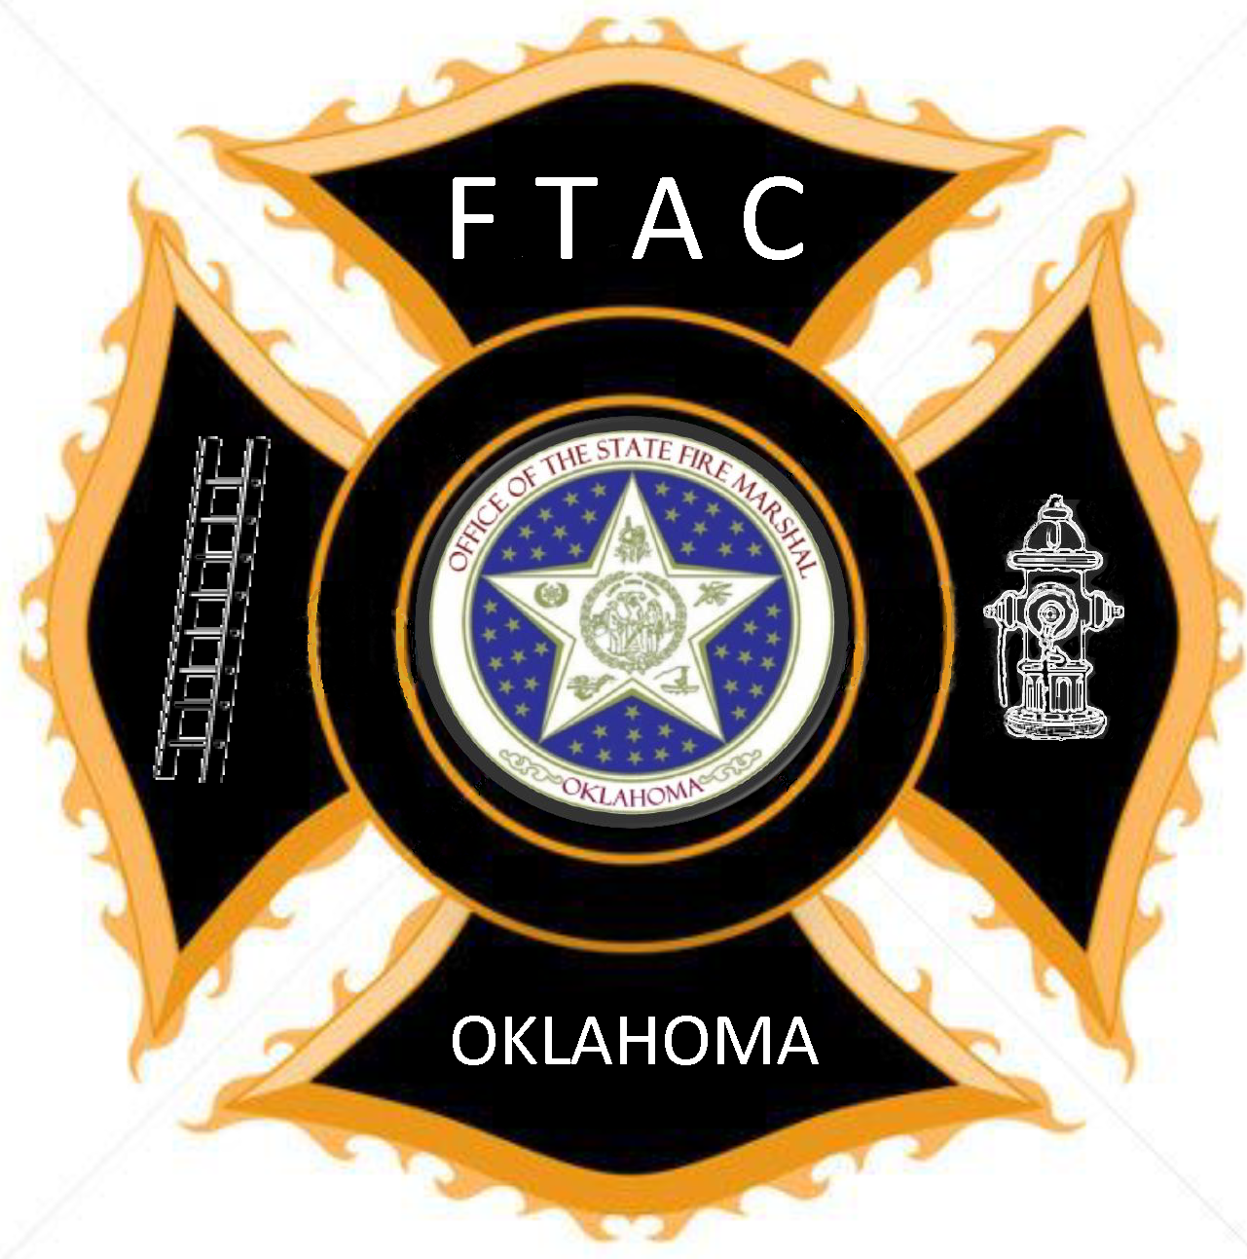

Master Firefighter
Paid Firefighters complete in 36 months. Volunteer Firefighters optional

Complete Advanced Level

Firefighter II or greater - 48 hrs

Electives: Local Department Choice

Fire - 16 hrs

EMS/Rescue - 16 hrs

Total Hours - 80 hrs

The Master Firefighter Level (highest level) requires the completion of Firefighter II or an Equivalent or Greater program. Paid Firefighters must complete within 36 months of employment. Optional for Volunteer Departments based on local authority having jurisdiction.

