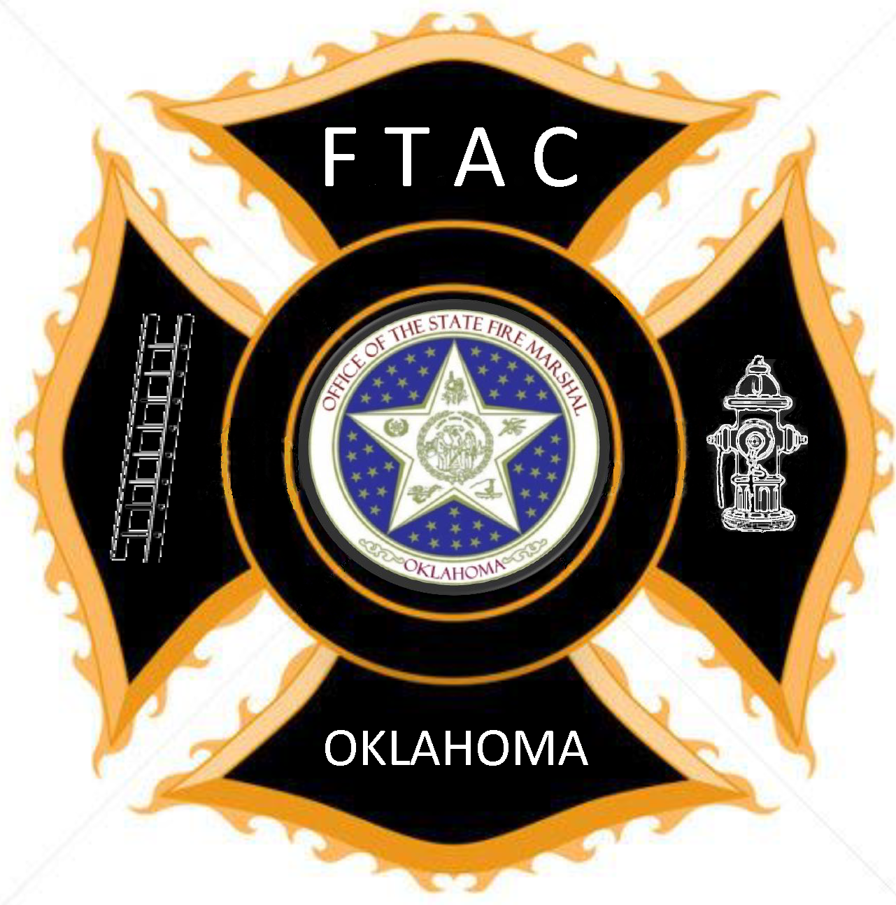

Support Firefighter

Wildland Fundamentals or Equivalent - 16 hrs

Emergency Vehicle Operation Course - 8 hrs

NIMS ICS 100/200/700 - 8 hrs

CPR Healthcare Provider - 4 hrs

Personal Protective Clothing (PPE) – 4 hrs

Total Hours - 40 hrs

The Support Firefighter Level prepares a firefighter to work on the fire scene in a support capacity, operating rigs and assisting with wildland firefighting set-up and preparations.

