Oklahoma State Fire Marshal’s Office
Official Interpretation and Code Directive 2013-6

Fire Alarm System Requirements for Shunting Gas Lines-Requirements for Additions to Existing Buildings and/or Remodels of Existing Buildings

Effective June 1, 2013 (Revised 2-12-2018)

The guidelines set forth through the codes adopted by the Oklahoma Uniform Building Code Commission (OUBCC) and enforced by the Oklahoma State Fire Marshals Office can help to establish the requirements for an addition and/or remodels taking place. This directive is to help simplify and bring clarity as to what is required to be installed.

Any addition and/or remodel to an Occupancy Classification identified in the International Building Code must adhere to the requirements to the adopted International Building Code (IBC), International Fire Code (IFC), and the adopted Life Safety Code 101 as it relates to remodels. Providing safety to occupants as they evacuate and responding fire department personnel is paramount.

When an addition is attached to an existing building the entire building’s fire alarm system must meet the current requirements of the International Building Code, International Fire Code, and the adopted Life Safety Code 101 as it relates to remodels. The activation of the fire alarm system shall shut down all gas lines supplying lab testing areas and/or open flame locations.

When a remodel to an existing building is being performed the entire building’s fire alarm system must meet the current requirements of the International Building Code, International Fire Code, and the adopted Life Safety Code 101 as it relates to remodels. The activation of the fire alarm system shall shut down all gas lines supplying lab testing areas and/or open flame locations.

A complete set of plans be submitted to our office for review of all buildings that fall within our jurisdiction.

It is our hope that we can work together to develop new sites while remaining committed to maintaining the utmost level of life safety by making Oklahoma structures as safe as possible through congruent code enforcement.

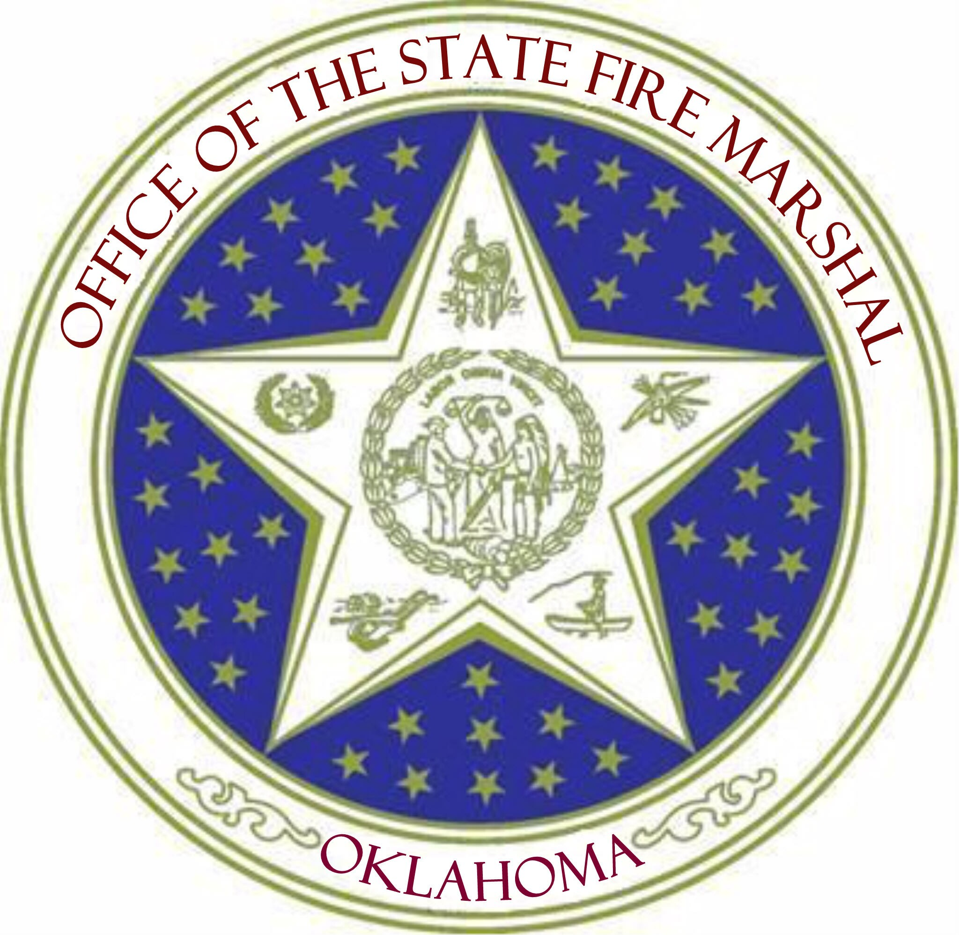

Robert Doke
State Fire Marshal

