Oklahoma State Fire Marshal’s Office
Official Interpretation and Code Directive 2013-7

Hood Suppression System Requirements for Cooking Appliances
Used for Warming Purposes Only

Effective June 1, 2013 (Revised 2-12-2018)

The guidelines set forth through the codes adopted by the Oklahoma Uniform Building Code Commission and enforced by the Oklahoma State Fire Marshals Office can help to establish the requirements for non-commercial warming devices. This directive is to help simplify and bring clarity as to what is required to be installed.

Any cooking device used to warm foods within an Occupancy Classification identified in the International Building Code must adhere to the requirements to the adopted International Building Code (IBC), International Fire Code (IFC), and the adopted Life Safety Code 101 as it relates to remodels.

In lieu of a commercial hood suppression system being installed over cooking devices used to warm foods only, an alternative hood suppression system shall be acceptable as long as that particular suppression system is in compliance with the current adopted International Mechanical Code (IMC), current adopted International Fire Code (IFC), LC1031(Exhaust Type II Hood with an integrated fire suppression system for domestic cooking appliances in commercial applications), UL Subject 300A (Extinguishing System Units for residential top cooking surfaces), and UL 507 (Standard for Electric Fans). An ICC Evaluation Service Report is required to confirm compliance.

Upon the activation of the hood suppression system the exhaust fan shall turn on if in the off position, shall remain on if in the on position, shall shunt all gas and electrical systems to the cooking equipment, shall have a pull station provided for manual activation, shall sound a local alarm once activated, and shall be tied to the fire alarm system if present.

A complete set of plans be submitted to our office for review of all buildings that fall within our jurisdiction. Provide the ICC Evaluation Service report.

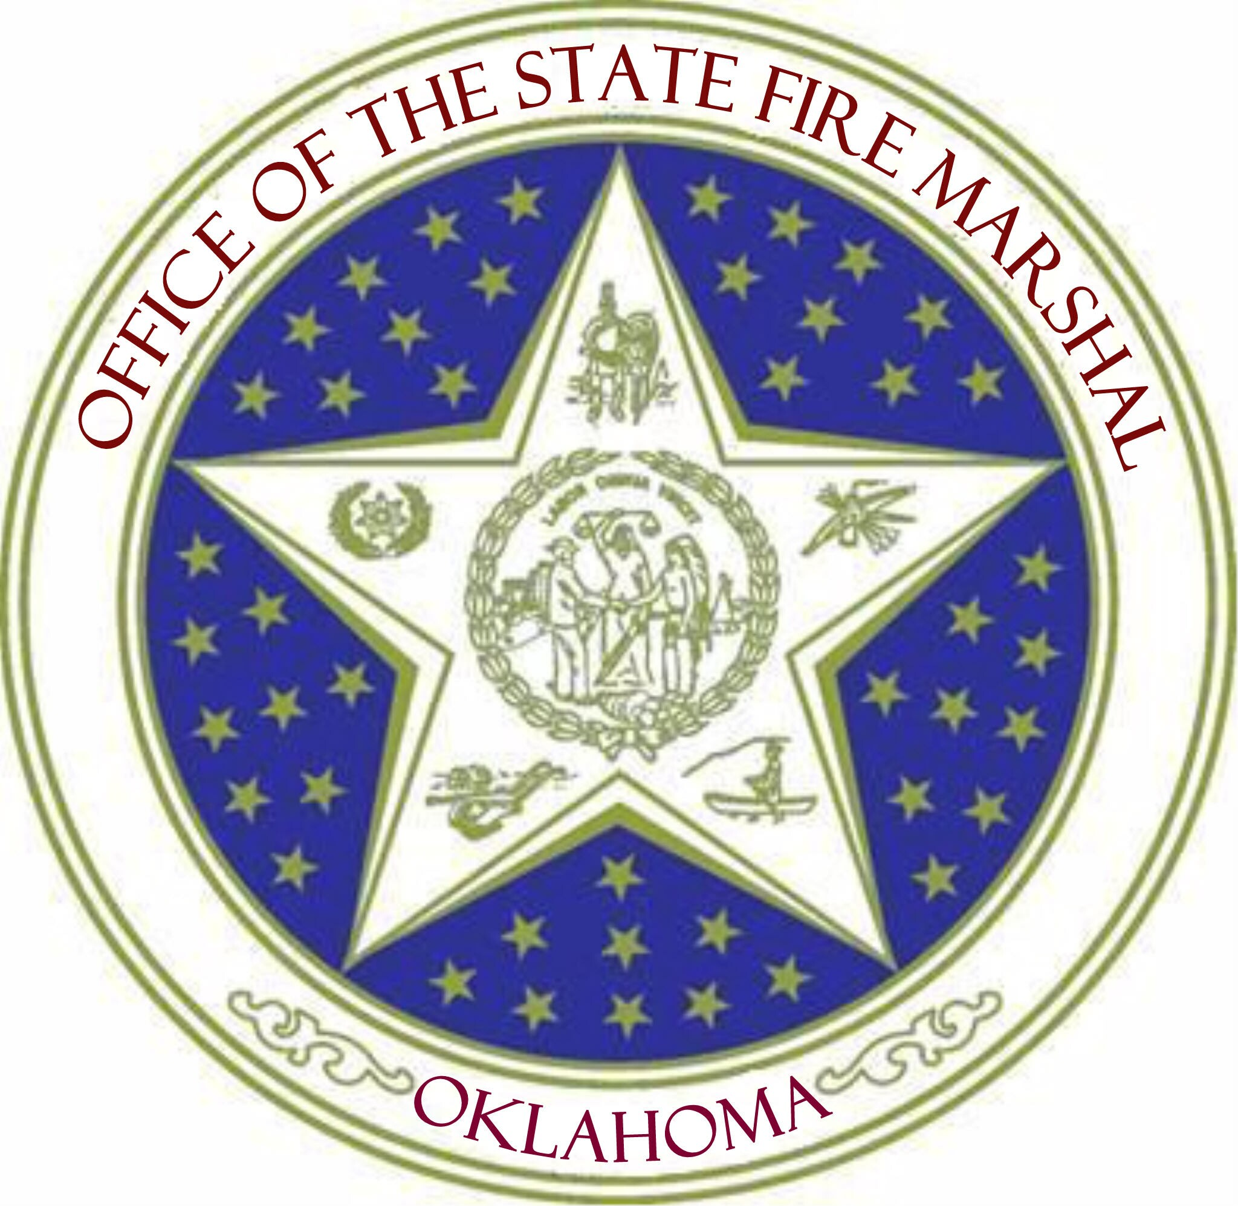
It is our hope that we can work together to develop new sites while remaining committed to maintaining the utmost level of life safety by making Oklahoma structures as safe as possible through congruent code enforcement.

Robert Doke
State Fire Marshal

