710-A R08
MVC

SPECIAL LICENSE PLATE APPLICATION FOR

PRE-NUMBERED FUND RAISING PLATES

Submit all applications to your local tag office or the Oklahoma Tax Commission at the address on the reverse side of this application. License plates are issued for a period of one (1) year. Renewal decals may be obtained at your local tag office.

Name

Address

City, State, Zip

Daytime Phone Number
Please Check One:

Original or Replacement Fee: $37.00
License plate & decal
($35.00 fee plus $2.00 mail fee. Allow 8 weeks for
pre-numbered.)

Renewal Fee: $36.00
Decal Only
($35.00 fee plus $1.00 mail fee.)
(Allow 8 weeks.)

Remittance made payable to the Oklahoma Tax Commission must accompany the application. Driver license number must appear on your check or money order.

A portion of the fee will be deposited to the organization as shown below.
Choose only one (1) type.
√ | Code | License Plate Type | A Portion Of The Fee Will Be Deposited To The:
 | RLN | Adoption Creates Families | Dept. of Human Services for Stronger Oklahoma Families Act.
 | AA | Agricultural Awareness | Ag in the Classroom Education Fund, State Dept. of Agriculture.
 | CA | Child Abuse Prevention | Child Abuse Prevention Revolving Fund ,  State Dept. of Health.
 | CLN | Choose Life | Choose Life Assistance Program, Dept. of Human Services.
 | CON | Color Oklahoma | Color Oklahoma Fund, Oklahoma Native Plant Society.
 | CV | Crime Victim Awareness | Attorney General's Fund for Services to Crime Victims.
 | BC | Fight Breast Cancer | Breast Cancer Act Fund.
 | 2FN | Future Farmers Of America | Oklahoma Dept Of Career & Technology Education Agriculture Fund.
 | HR | Heart Of The Heartland | Heart Of The Heartland Scholarship Fund, Oklahoma State Regents for Higher Education.
 | RT | Historic Route 66 | Oklahoma Historical Society Fund, Rt. 66 Museum in Clinton
 | OH | Oklahoma History | Oklahoma Historical Society Fund, Education Purposes
 | QHN | Oklahoma Quarter Horse Association | Oklahoma Quarter Horse Fund , Oklahoma Horse Racing Commission
 | ST | Oklahoma Statehood Centennial | Oklahoma Capitol Complex and Centennial Commemoration Fund
 | SK | Oklahoma Safe Kids Association | Children’s Hospital, Oklahoma Safe Kids Fund
 | RAN | Realtor’s Association – Attach a copy of Realtor ID | Oklahoma Housing Foundation
 | PGN | State Parks Supporter-Golf Ball | Oklahoma Tourism And Recreation Dept. Fund
 | PPN | State Parks Supporter–Pavilion | Oklahoma Tourism And Recreation Dept. Fund
 | PRN | State Parks Supporter–Recreational Veh.. | Oklahoma Tourism And Recreation Dept. Fund
 | ED | Support Education | Education Reform Revolving Fund, Higher Education Revolving Fund, State Career Technology Fund, And Teachers Retirement Benefit Fund.
 | UFN | Urban Forestry & Beautification | Urban Forestry And Beautification Fund, Dept of Agriculture

The boxes below are required to be completed. This information can be found on your current vehicle registration. I certify that the license plate will be displayed on the following vehicle:
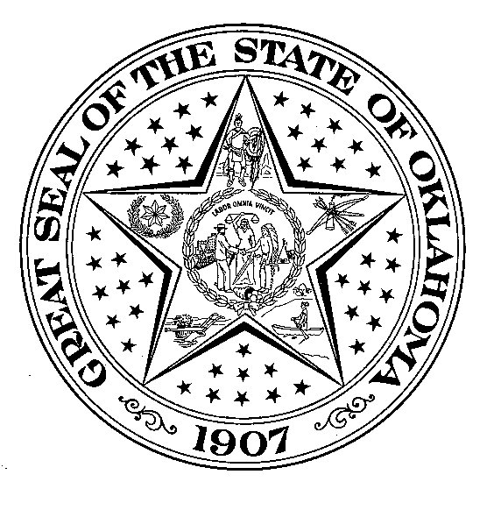  Oklahoma Title Number  (Not VIN Number) | Year & Make | Regular license plate Number | Decal # on Regular license plate (Example: 0F00000) | Regular Decal  Expiration

Signature Executed under penalties of perjury.

READ REVERSE SIDE CAREFULLY

PLEASE READ ALL INSTRUCTIONS BEFORE COMPLETING APPLICATION

1. This special plate registration is in addition to, not in lieu of, your regular registration (i.e. standard license plate). Your regular registration must be kept current at all times. Failure to renew the regular registration in a timely manner may result in a delinquent registration penalty and/or possible law enforcement citation.

2. Once a special license plate has been assigned to an applicant, that applicant shall have priority to such license plate for succeeding years, provided a timely paid application for renewal is submitted. To insure that you receive a renewal application each year, please notify the Oklahoma Tax Commission of any change in your address.

.3 A special license plate may be transferred to another vehicle upon the owner’s submission of a completed Request to Transfer Form (OTC Form 783-A) to the Motor Vehicle Division, Special License Plate Section. This form may be obtained from your local tag agency, through the Oklahoma Tax Commission web site at www.tax.ok.gov., or from the Oklahoma Tax Commission.

- The special license plate is to be displayed on the rear of the vehicle for which it is issued. The regular license plate should be kept inside the vehicle and produced upon request by law enforcement.

Oklahoma Tax Commission
Motor Vehicle Division
Special Plate Section
2501 Lincoln Blvd.
Oklahoma City, Ok 73194-0013

Telephone: 405-521-2468 Toll Free: 1-800-522-8165, ext. 1-2468

