Development and analysis of ODOT Standards for Projecting Database Needs

ANNUAL PROJECT STATUS REPORT ~ FFY XXXX
ODOT SP&R ITEM NUMBER XXXX

Submitted to:
John R. Bowman, P.E.
Planning & Research Division Engineer
Oklahoma Department of Transportation

Submitted by:
John Doe, Ph.D., P.E.
Richard R. Roe, Ph.D. Candidate
Jane Q. Public, Ph.D., P.E.
John Smith, Ph.D. Candidate
School of Transportation Engineering
Anytown State University

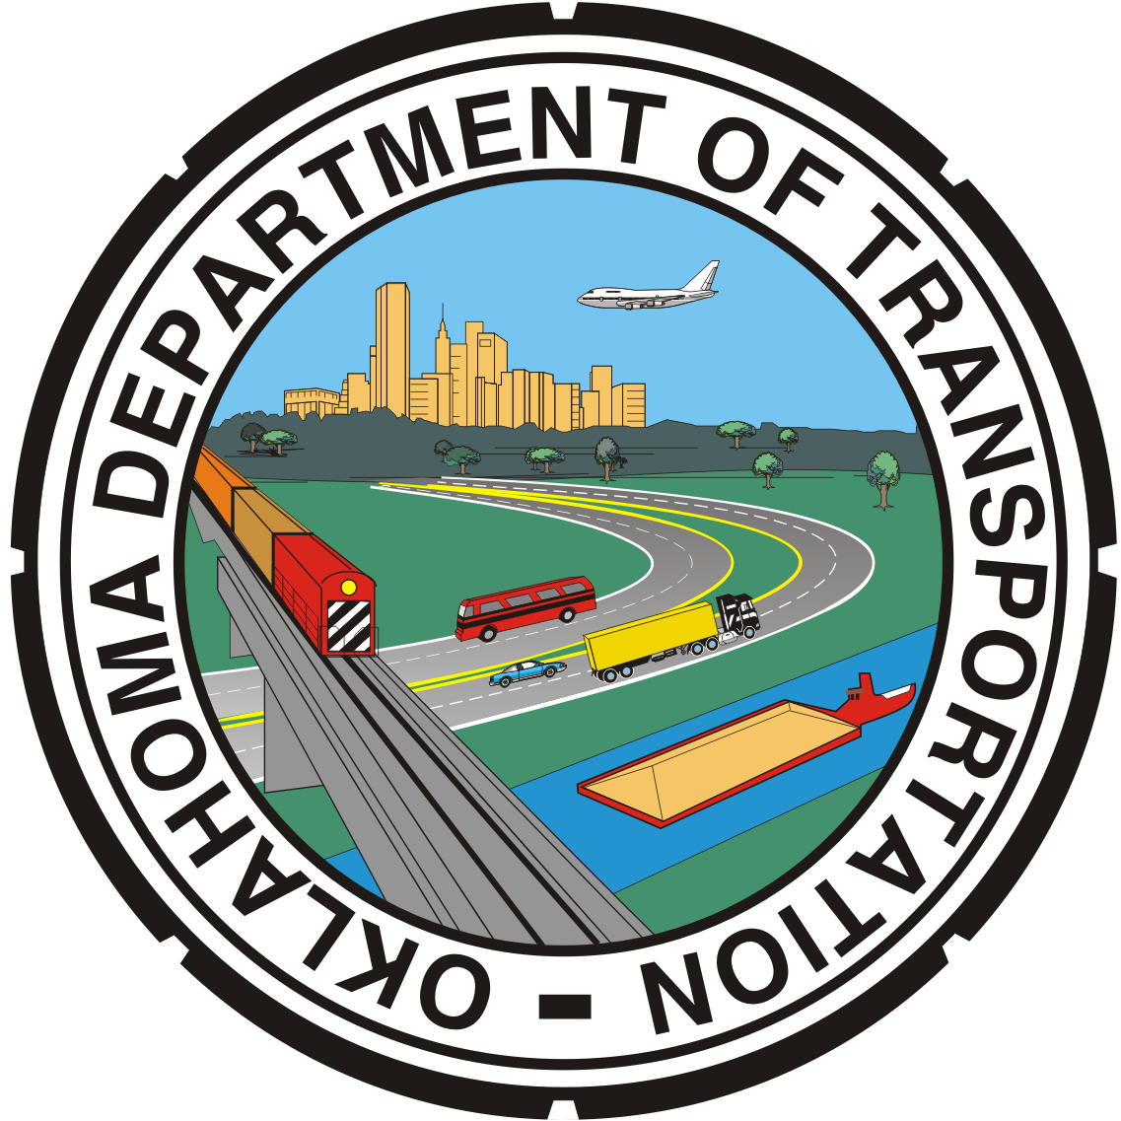

March 2012

