COR121 Deposit/Transfer Entry Manual

Authorized by: [_EBS_] Original Issue: [12/01/2014]
Maintained by: [____Accounts Receivable Lead___]
Review Date: [12/01/2014]

Table of Contents

Document History 4
System Overview 5
Deposits 5
Payments 5
Transfers 5
Batch Codes 5
Accounting Entry 5
Deposit Unit 5
Advice of Deposit 6
Step 1: Enter and Save A Regular Deposit 6
Totals Page 7
Payments Page 9
Step 2: Create Accounting Entries For Regular Deposit 11
Accounting Entries Page 12
Deposit Control Page 15
Federal Wire and ACH Deposit 16
Step 1: Enter and Save a Regular Deposit 16
Totals Page 17
Payments Page 19
Step 2: Deposit Approval by OST 20
Approval Page 21
Step 3: Create Accounting Entries for Approved Deposit 22
Accounting Entries Page 23
Deposit Control Page 26
Transfers 27
Create a Deposit Transfer 27
Totals Page 28
Payment Misc Dst Page 29
Inquiry and Reports 36
Deposit Inquiry 36
All Deposits Page 37
Payment Inquiry 38
All Payments Page 39
Accounting Entry Inquiry 40
Directly Journalled Payments Page 41
Appendix A 42
System Profile 42
General Profile Information 43

Document History
Doc Rev | Date | Description
1.0  1.1  1.2  1.3 | 11/03/2008  10/01/2007  12/03/2009  12/11/2009 | Initial Document  Upgrade 9.0  Streamline Process  Changed Screen Shots to Better Reflect Process
2.0 | 12/01/2014 | Upgrade 9.2

System Overview
The PeopleSoft Accounts Receivable module provides full deposit, posting and reporting functionality for the receipt of funds. Deposits can be applied against open invoices, customers or as miscellaneous receipts. These features will be available for State of Oklahoma Agency users and will be integrated into the Oklahoma State Treasurer business process requirements.

This manual describes the pages and functionality used to create Deposits, record Payments, manage Transfers, process Fed Wires and ACH transactions and run related reports.

This manual is intended for use by agencies which are not currently using the integrated Accounts Receivable Module. Agencies using the Accounts Receivable module will follow separate instructions for recording payments on account.

Deposits
Represents a customer Payment or group of Payments that are batched together for posting. Deposits contain banking information, control totals, processing dates and all related Payment information. For purposes of this manual, a Deposit ID may equate to a Deposit Ticket.

Payments
Payments received from customers are recorded in the system with related data elements including Payment ID, Amount and Payment Type. For the purpose of this manual, a Payment will equate to a total or group of payments (e.g. Deposit Ticket).

Transfers
Represent transfer of dollars between Funds or Accounts in the system. Funds or Accounts are represented by the Class Funding chartfield. Transfers can be made between Clearing Accounts and ASA Accounts and from Clearing or ASA Accounts to Agency Fund Accounts.

Batch Codes
Batch Codes determines the type of Deposit or Transfer being entered into the system and the processing rules and defaults that will apply to the Deposit or Transfer.

Accounting Entry
Accounting Entries represent a two-sided entry of a Debit and Credit that is used to update the General Ledger for Deposits, Fed Wires, ACH transactions and Transfers.

Deposit Unit
Equates to an Agency Business Unit. Defines the Agency in which a group of deposits will be created.

Advice of Deposit
The Advice of Deposit feature allows users to create Deposits for miscellaneous payments received from customers generally in the form of cash or checks. These Deposits can be posted to any fund and do not require approval of OST. The OST Batch Code of 99 defines this type of Deposit.

Deposits are entered into the system by Deposit Unit and Deposit ID. Deposit Unit will default to the Agency Business Unit value. Deposit ID will be defaulted by the system using an autonumbering format with an agency business unit mask.

Step 1: Enter and Save A Regular Deposit

Navigation: Accounts Receivable > Payments > Online Payments > Regular Deposit > Add a New Value

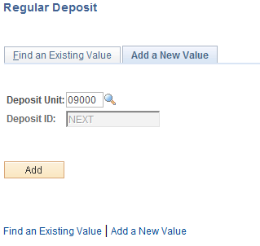

Deposit Unit – is the Agency Business Unit depositing the funds. The Business Unit will default based on User Preferences.

Deposit ID – defaults to NEXT. The sytem will use autonumbering to assign the next available DeposIt ID number. The number will start with the 3-digit agency number.

NOTE: The Deposit ID in the system should equate to a Deposit Ticket for the agency.

Click to enter the Regular Deposit pages.

Totals Page
The Deposit Totals page contains OST Batch Code, Bank Information, Processing Dates, User ID’s and Control Total information. The Deposit Totals page functions as the control mechanism for all deposits entered on the Payments page. The Bank information populated on the Deposit Totals page will apply to payments recorded on the subsequent Payment page and Control Totals must match the sum of all payments entered for the Deposit.

NOTE: The Deposit ID will change from “NEXT” to a number when the Deposit is saved. Each Deposit ID will begin with the Agency number.

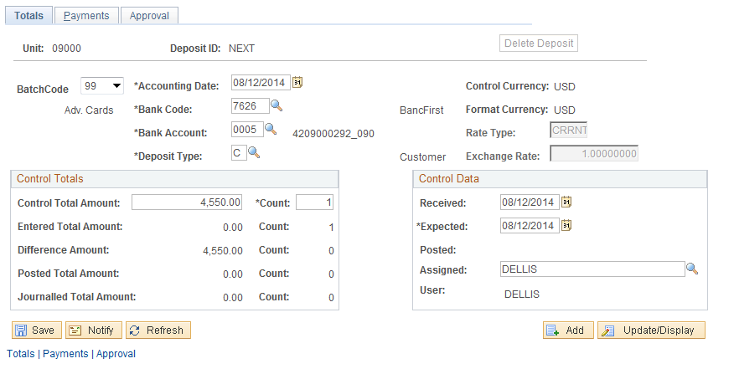

Batch Code – this field is the OST Deposit Batch Code. The value will default to 99, but can be changed by the user. Available values will be controlled by user security based on the type of deposit the user is authorized to create.
Agency Users can select the following Batch Codes:
07 – Fed Wires and ACH Transactions deposited to Clearing and ASA Accounts
61 – Fed Wires and ACH Transactions deposited to Agency Funds
99 – Deposits to Financial Institutions

For this type of Deposit, select the Batch Code = 99. Batch Codes 07 and 61 will be discussed in a separate section.

Accounting Date – defaults to today’s date. The value should not be changed.

Bank Code – Bank Code indicates which bank facility will be used for the deposit. The value should be selected by the user for this type of Deposit. The available values for Bank Code selection will be limited by Deposit Unit.

Bank Account – The Bank Account identifies the account within the banking facility that the deposit will be directed to. For this type of Deposit, the value should be selected by the user. The available values for Bank Account selection will be limited by the Deposit Unit and Bank Code.

Deposit Type –this field defaults from the Bank configuration. Deposit Types are used to categorize different types of deposits within the system.

Control Currency – will default to USD and can not be changed.

Format Currency - default to USD and can not be changed.

Rate Type – defaults to CRRNT

Exchange Rate – defaults to 1.0000000.

Control Total Amount – this field should reflect the total for all payments received in the Deposit. The value in this field will be edited against the sum of all payments to ensure the control total is correct.

Count – this field should hold the total number of payments in this Deposit. For this type of Deposit the Count value will generally be 1.

NOTE: Agencies can record each Payment separately in the Deposit, thereby increasing the Count value in this field to equal the number of Payments. However, each Payment will require a corresponding Accounting Entry and must be Completed and Budget Checked separately.

Entered Total Amount/Count – these fields reflect the total amount of payments and payment counts entered by the user.

Difference Amount/Count – these fields reflect any discrepancy between the Total Amount/Count defined by the user and the sum of payments and payments count entered on the Payments page.

Posted Total Amount/Count – this field reflects Deposits posted to accounts.

Journalled Total Amount/Count – this field reflects any Direct Journal activity.

Received Date – for Batch Code 99 the field will default in as current.

Expected Date –for Batch Code 99 the field will default in as current date and should not be changed.

Funds Available Date – leave this field blank. This field used by OST for Batch 07 and 61 processing.

Assigned – by default this field holds the User ID of the person creating the deposit.

Payments Page
The deposit Payments page contains details for each payment in the deposit. This includes payment type or method, payment ID, amount, etc. The Reference Information identifies the Item that the payment will be applied to. This functionality is related to Accounts Receivable balances and should not be used by agencies which have not implemented that module.

For this type of Deposit, the payments page should reflect only “summary information” for the Deposit. For example, there generally will be only one Payment identified on this page, the Amount will reflect the sum of all payments included in the Deposit and the Payment ID could indicate the “Bag Number” or “Deposit Ticket Number” for the Deposit, rather than an individual Check number.

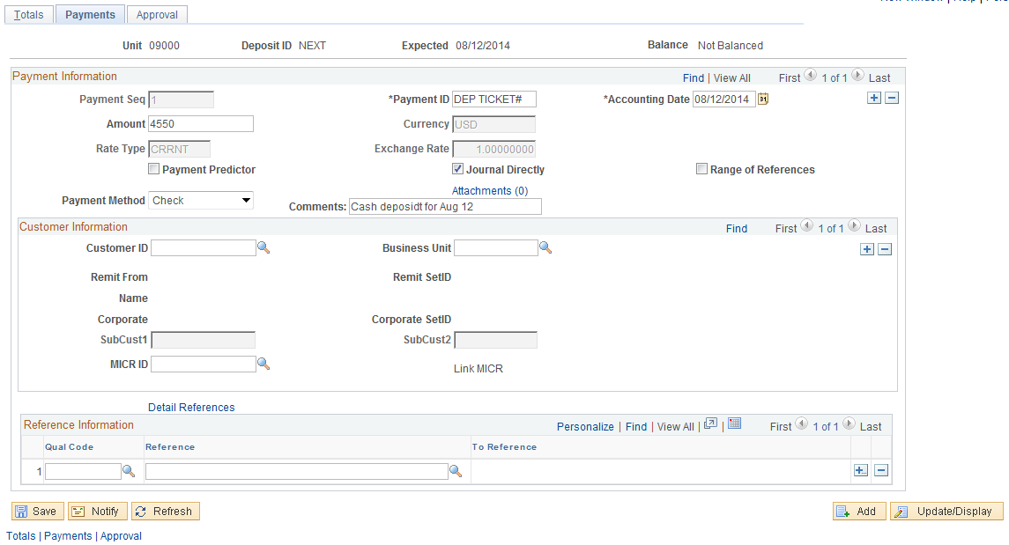

Payment ID – for this type of Deposit, the Payment ID can be populated with any meaningful agency data element. This could be Bag Number, representing the Deposit Bag being used for the transaction. Since this type of Deposit will not be applied to an Open Invoice, the actual Payment ID (customer check number, etc.) is not required in this field.

Accounting Date – defaults to today’s date. This value should not be changed.

Amount – for this type of deposit, enter the total amount of the Deposit. This amount should match the Control Total Amount from the Totals page. Since this type of Deposit will not be applied to an Open Invoice, the individual Payment Amount is not required in this field.

Journal Directly – for this type of deposit, always select this checkbox. This feature is used to make deposits that are not applied to an open item or invoice in the Accounts Receivable module.

Payment Method – select the method of payment from the available values.

Comments – the Comments field can be populated by the agency with any type of description or comment that is applicable to the Deposit. The Comment field can hold up to 30 characters.

NOTE: For this type of Deposit, the Payments page reflects only TOTAL information for the Deposit. Therefore the button is not necessary to add additional rows for INDIVIDUAL payment details.

When all payments have been entered for this Deposit, click to save the Deposit.

NOTE: Once the Deposit is Saved and is Balanced, the Apply Payment hyperlink will be visible. Use this hyperlink to access the Direct Journal pages to finish the Deposit. (See Step 2 below)

NOTE: The Balance message in the top right hand corner of the Deposit entry pages indicates whether the Deposit is in “Balance” or “Not Balanced”.

NOTE: Use the button on the Totals page to delete the Deposit. The user will be prompted to verify the delete before the action is completed.

NOTE: The Deposit cannot be Deleted after the Accounting Entries in Step 2 below have been marked Complete and Budget Checked.

Step 2: Create Accounting Entries For Regular Deposit
When all payment information has been entered completely in a Deposit, the associated Accounting Entries must be created. This process, called Direct Journaling in the system is to define the Revenue accounting entry that will be associated with the Deposit.

NOTE: Amounts Deposited will not be available, posted, budget checked or transmitted to OST until this step is completed.

There are two (2) alternatives when navigating to the Accounting Entries page. Both are shown below.

From the Payment Tab above, select the Apply Payment hyperlink.

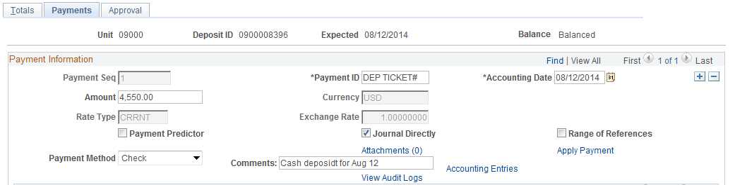

OR

Navigation: Accounts Receivable > Payments > Direct Journal Payments > Create Accounting Entries > Find an Existing Value

Accounting Entries Page
The Accounting Entries page allows the user to define the Revenue accounting entry that will be associated with a Deposit. This page allows the user to enter the Revenue side of the accounting entry, create the Cash side of the accounting entry, as well as balance and budget check the entry.

The user will populate the Revenue side of the accounting entry and the system will build the Cash side of the accounting entry. Once both sides of the entry are populated, it can be saved, marked as complete and budget checked.

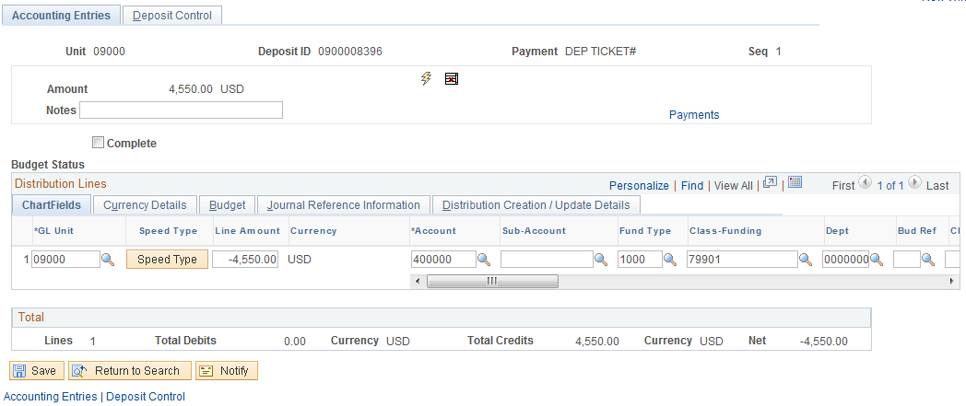

GL Unit – the General Ledger Business Unit will default to the Deposit Unit or agency business unit number.

Optionally use the button to populate chartfields using this feature. This feature is only applicable to those agencies configured to use Speed Types.

Line Amount – populate the Line Amount field with the deposit amount. This value is also shown at the top of the page in the Amount field. Since the first line of the accounting entry is the revenue or credit side of the entry, this number should be keyed as a Negative.

Account – select the Revenue account to which the deposit will be booked. The account value of 400000 should only be used when depositing to the Clearing Account.

Sub-Account – if the depositing agency uses this chartfield in the deposit account entry, populate that value.

Fund Type – populate the Fund Type for the deposit.

Class Funding – populate the class funding for the deposit. For this type of deposit, the Class Funding value generally will be 799XX or another designated clearing account. Agencies may deposit directly to Funds if the money received meets the criteria set forth in the state statutes.
Class Affiliate – this is a field that optionally allows agencies to track the ultimate destination of funds originally deposited into a Clearing Account. A separate public query will be provided that will give amounts to be transferred at a later date (also see Deposit Transfers). This field can also be used for reconciliation purposes.

Dept – populate the Department for the deposit.

Oper Unit – if the depositing agency is using Operating Unit in the deposit accounting entry, populate that value.

NOTE: Use the button to insert new accounting lines as necessary.

When all Revenue lines of the entry are complete, click to save your work.

Click to create the Cash lines of the Accounting Entry. The system will create the Cash or Debit side of the entry.

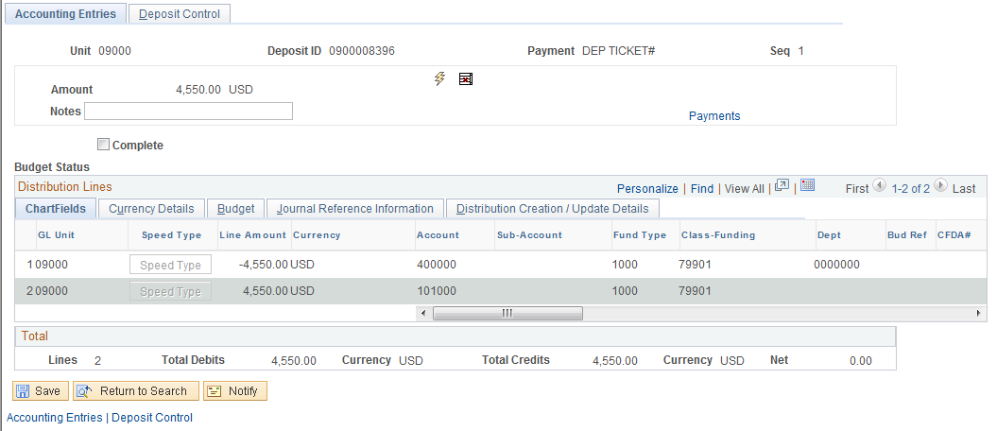

NOTE: Once the button is selected to create the Cash line of the entry, the chartfields will be inactive and not editable. Use to delete the Cash line of the accounting entry and start over.

Complete – when the Accounting Entry is correct and all lines of the entry have been created, select the Complete checkbox. This checkbox will mark the accounting entry as complete and ready the entry for the Chartfield Combination Edit process.

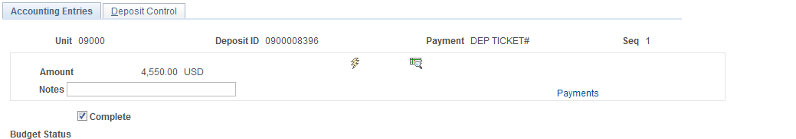

Once the Complete checkbox has been selected, click to execute the Chartfield Combination Edit process.

Once the Accounting Entry is marked as Complete, the icon will be displayed allowing the user to Budget Check the entry.

Click to Budget Check the entry.

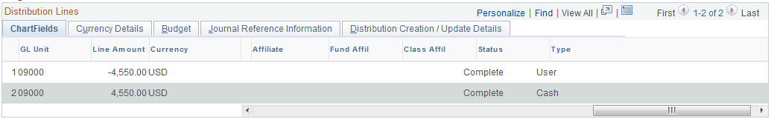

Ensure the Chartfield Edit status at the far right hand of the Chartfields Tab is set to Complete for all lines in the accounting entry.

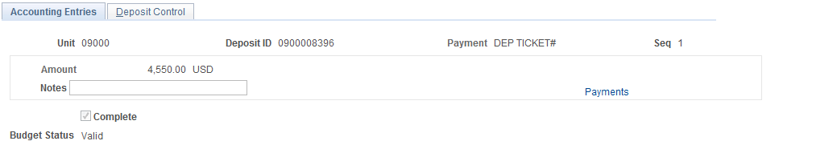

Ensure the Budget Status is set to Valid after the Budget Check process has completed.

NOTE: If the user marks the Accounting Entry as Complete, but DOES NOT execute the Budget Check process from this page, they must navigate to the “Modify Accounting Entries” page to Budget Check the Accounting Entry. Once marked Complete, the Accounting Entry will not be available in this page to select at a later date.

Modify Accounting Entries

Navigation: Accounts Receivable > Payments > Direct Journal Payments > Modify Accounting Entries > Find an Existing Value

Deposit Control Page
The Deposit Control page is the same as the Regular Deposit – Totals page from above. The information on this page is read-only and shown for control total and balancing informational purposes. The page displays banking, control total, processing dates, currency and User ID details.

Federal Wire and ACH Deposit
Federal Wire and ACH Deposits are designed to accommodate Deposits for Fed Wires and ACH (Automated Clearing House) transactions. These types of Deposits require the approval of OST (Oklahoma State Treasurer) and are generally deposited to a fund account. Use the OST Batch Code of 07 or 61 to define this type of Deposit.

OST Batch Code 07 represents Fed Wires and ACH Transactions deposited to Clearing and ASA Accounts. OST Batch Code 61 represents Fed Wires and ACH Transactions deposited to Agency Funds.

These types of Deposits are entered into the system by Agency users and require approval of OST. This approval is controlled thru workflow designed to notify both OST and Agency personnel when the Deposit is pending approval and when the Deposit receives final approval.

Deposits are entered into the system by Deposit Unit and Deposit ID. Deposit Unit will default to the Agency Business Unit value. Deposit ID will be defaulted by the system using an autonumbering format with an agency business unit mask.

Step 1: Enter and Save a Regular Deposit

Navigation: Accounts Receivable > Payments > Online Payments > Regular Deposit > Add a New Value

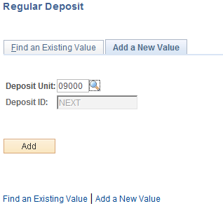

Deposit Unit – is the Agency Business Unit depositing the funds. The Business Unit will default based on User Preferences.

Deposit ID – defaults to NEXT. The sytem will use autonumbering to assign the next available Depost ID number. The number will start with the 3-digit agency number.

Click to enter the Regular Deposit pages.

Totals Page
The Deposit Totals page contains OST Batch Code, Bank Information, Processing Dates, User ID’s and Control Total information. The Deposit Totals page functions as the control mechanism for all deposits entered on the Payments page. The Bank information populated on the Deposit Totals page will apply to payments recorded on the subsequent Payment page and Control Totals must match the sum of all payments entered for the Deposit.

NOTE: The Deposit ID will change from “NEXT” to a number when the Deposit is saved. Each Deposit ID will begin with the Agency number.

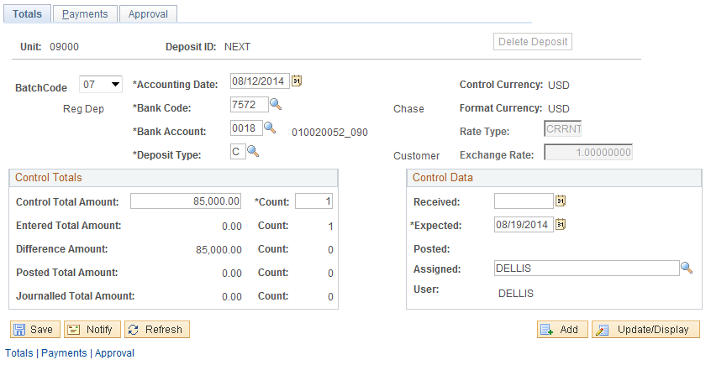

Batch Code – this field is the OST Deposit Batch Code. The value will default to 99, but can be changed by the user. Available values will be controlled by user security based on the type of deposit the user is authorized to create.
Agency Users can select the following Batch Codes:
07 – Fed Wires and ACH Transactions deposited to Clearing and ASA Accounts
61 – Fed Wires and ACH Transactions deposited to Agency Funds
99 – Deposits to Financial Institutions

For this type of Deposit, select the Batch Code = 07 or 61.

Accounting Date – defaults to today’s date. The value should not be changed.

Bank Code – Bank Code indicates which bank facility will be used for the deposit. For this type of Deposit, the Bank Code will default when the Batch Code of 07 or 61 is selected by the User. Do not change the default values.

Bank Account – The Bank Account identifies the account within the banking facility that the deposit will be directed to. For this type of Deposit, the Bank Code will default when the Batch Code of 07 or 61 is selected by the User. Do not change the default values.

Deposit Type –this field defaults from the Bank configuration. Deposit Types are used to categorize different types of deposits within the system.

Control Currency –defaults to USD and cannot be changed.

Format Currency - defaults to USD and cannot be changed.

Rate Type – defaults to CRRNT

Exchange Rate – defaults to 1.0000000

Control Total Amount – this field should reflect the total for all payments received in the Deposit. The value in this field will be edited against the sum of all payments to ensure the control total is correct.

Count – this field should hold the total number of payments in this Deposit. For this type of Deposit (Wire) the Count value will generally be 1.

NOTE: Agencies can record each Payment separately in the Deposit, thereby increasing the Count value in this field to equal the number of Payments. However, each Payment will require a corresponding Accounting Entry and must be Completed and Budget Checked separately.

Entered Total Amount/Count – these fields reflect the total amount of payments and payment counts entered by the user.

Difference Amount/Count – these fields reflect any discrepancy between the Total Amount/Count defined by the user and the sum of payments and payments count entered on the Payments page.

Posted Total Amount/Count – this field reflects Deposits posted to accounts.

Journalled Total Amount/Count – this field reflects any Direct Journal activity.

Received Date – When using Batch Codes 07 and 61 the value will default as blank. This field should be left blank and is reserved for OST usage only. For all other Batch Codes the field will default in as current date.

Expected Date –When using Batch Codes 07 and 61, the field must be populated by the user to reflect the agencies “Expected Date”. Example: if the user is entering the deposit on Monday and are expecting the Fed Wire to arrive on Wednesday, the user will enter Wednesday’s date in the Expected Date field.

Assigned – by default this field holds the User ID of the person creating the deposit.

Payments Page
The deposit Payments page contains details for each payment in the deposit. This includes payment type or method, payment ID, amount, etc. Customer ID and additional reference information can be included in the payment details.

For this type of Deposit, the payments page should reflect only “summary information” for the Deposit. For example, there generally will be only one Payment identified on this page, the Amount will reflect the sum of all payments (Fed Wires) included in the Deposit and the Payment ID could indicate the Wire Number for the Deposit, rather than an individual Check number.

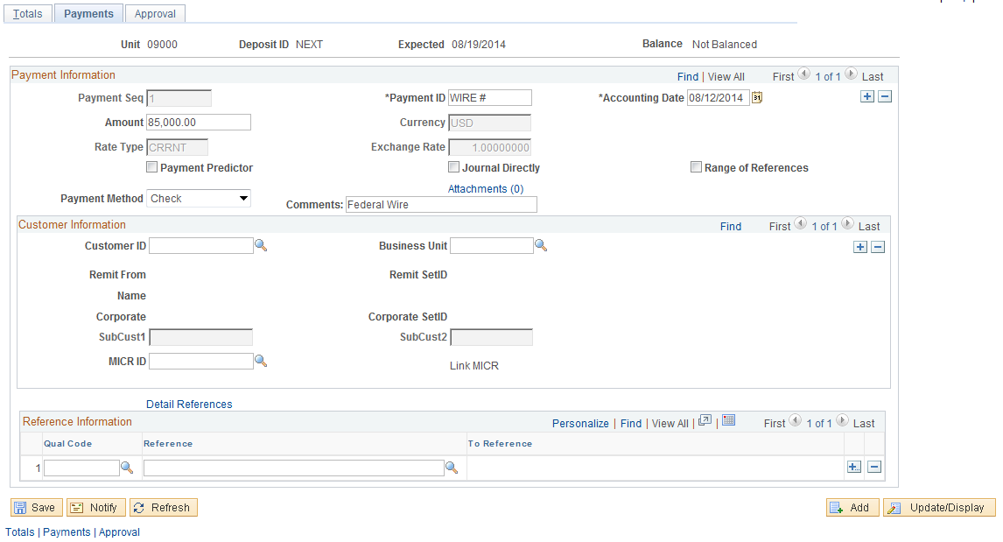

Payment ID – for this type of Deposit, the Payment ID can be populated with any meaningful agency data element. This could be Wire Number, Draw Number or other Wire specific information. Since this type of Deposit will not be applied to an Open Invoice, the actual Payment ID (customer check number, etc.) is not required in this field.

Accounting Date – defaults to today’s date. This value should not be changed.
Amount – for this type of Deposit, enter the total amount of the Deposit (Wire). This amount should match the Control Total Amount from the Totals page. Since this type of Deposit will not be applied to an Open Invoice, the individual Payment Amount is not required in this field.

Journal Directly – for this type of Deposit, always select this checkbox. This feature is used to mark deposits that are not applied to an open item or invoice in the Accounts Receivable module.

Payment Method – select the method of payment from the available values.

Comments – the Comments field should be populated by the agency with a description or comment that assists in identifying the Deposit. For example, a Fed Wire from US DHHS would include DHHS in the comment field to help OST identify the funds. The Comment field can hold up to 30 alphanumeric characters.

NOTE: For this type of Deposit, the Payments page reflects only TOTAL information for the Deposit. Therefore, the button is not necessary to add additional rows for INDIVIDUAL payment details.

When all payments have been entered for this Deposit, click to save the Deposit.

NOTE: The Balance message in the top right hand corner of the Deposit entry pages indicates whether the Deposit is in “Balance” or “Not Balanced”. For this type of Deposit, the Balance indicator should be set to “Not Balanced”, pending approval by OST.

NOTE: Use the button on the Totals page to delete the Deposit. The user will be prompted to verify the delete before the action is completed.

NOTE: The Deposit cannot be Deleted after the Accounting Entries in Step 2 below have been marked Complete and Budget Checked.

NOTE: At this point in the Deposit processing, a workflow notification email will be sent to OST to indicate a Deposit (Wire) is pending approval. OST must approve the Deposit before any agency user can process the Deposit further.

Step 2: Deposit Approval by OST
When the Fed Wire Deposit has been completed and saved by the agency user, a workflow email notification will be sent to the Oklahoma State Treasurer indicating that the Deposit needs to be approved. OST personnel must approve the Deposit before it can be completed by the agency.

The illustrations below are for reference only. The agency user will not see these approval pages.

Approval Page

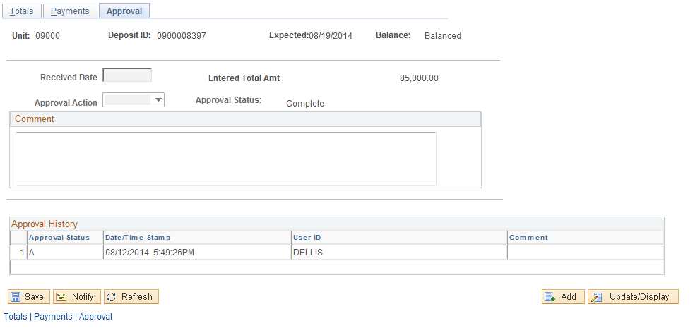

When OST recognizes the receipt of the funds, the Deposit will be approved by OST staff by populating Received Date, Approval Action and Comment. When the page has been completed and saved, a workflow email notification will be sent back to the agency indicating that the Deposit has been approved and should be completed by creating the corresponding accounting entries as soon as possible.

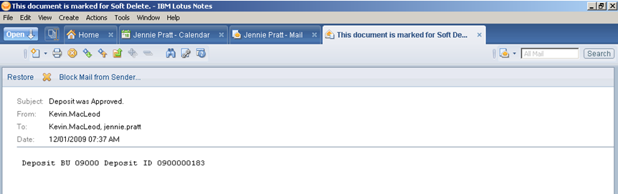

The email Subject indicates approval by OST. The body of the email will display the Deposit BU (Agency Number) and Deposit ID. Use the Deposit ID to access the deposit and complete it in the Step 3 below.

Step 3: Create Accounting Entries for Approved Deposit
When the Deposit has been approved by OST, the agency user must retrieve the approved deposit and finish the deposit processing by creating the associated Accounting Entries. This process, called Direct Journaling in the system is to define the Revenue accounting entry that will be associated with the Deposit.

It should be noted that this step is required by agencies to correctly reflect cash position. If the Deposit, (Step 1) is created without the corresponding Accounting Entries (Step 3), cash will not be available for agency use.

The workflow email notification sent to the agency user upon Approval by OST will have the Deposit Unit and Deposit ID listed in the email. Use these values to search for the correct Deposit to create the accounting entries and finish the deposit processing.

Navigation: Accounts Receivable > Payments > Direct Journal Payments > Create Accounting Entries > Find an Existing Value

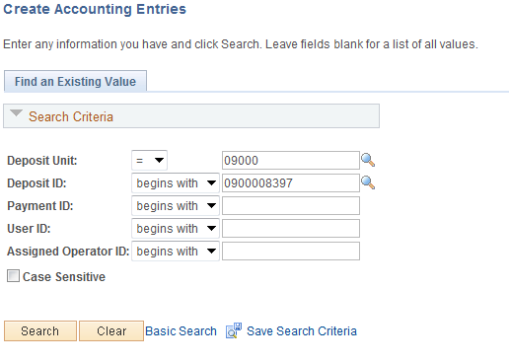

Deposit Unit – is the Agency Business Unit depositing the funds. The Business Unit will default based on User Preferences.

Deposit ID – populate with the Deposit ID for which the Accounting Entries will be created. This Deposit ID was created in Step 1 above.

Click to retrieve the Deposit.

Accounting Entries Page
The Accounting Entries page allows the user to define the Revenue accounting entry that will be associated with a Deposit. This page allows the user to enter the Revenue side of the accounting entry, create the Cash side of the accounting entry, and balance and budget check the entry.

The user will populate the Revenue side of the accounting entry and the system will build the Cash side of the accounting entry. Once both sides of the entry are populated, it can be saved, marked as complete and budget checked.

NOTE: For these types of Deposits, the Accounting Entry page will be available to update ONLY AFTER OST has approved the Deposit.

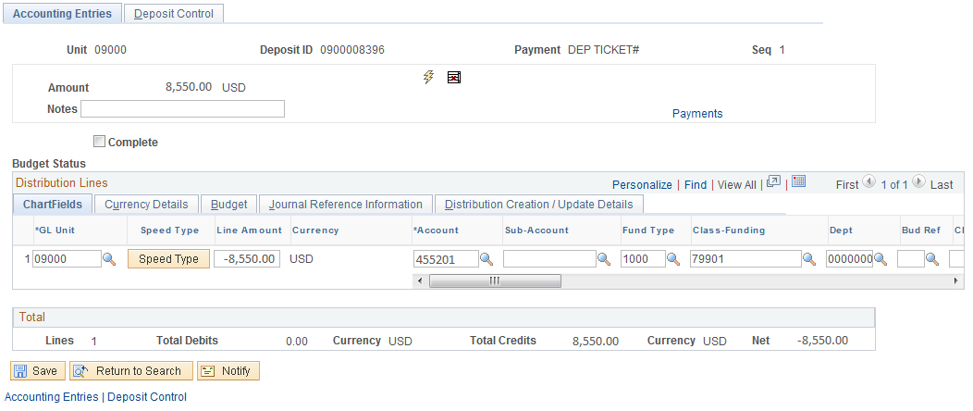

GL Unit – the General Ledger Business Unit will default to the Deposit Unit or agency business unit number.

Optionally use the button to populate chartfields using this feature. This feature is only applicable to those agencies configured to use Speed Types.

Line Amount – populate the Line Amount field with the deposit amount. This value is also shown at the top of the page in the Amount field. Since the first line of the accounting entry is the revenue or credit side of the entry, this number should be keyed as a Negative.

Account – select the Revenue account to which the deposit will be booked.

Sub-Account – if the depositing agency uses this chartfield in the deposit account entry, populate that value.

Fund Type – populate the Fund Type for the deposit.

Class Funding – populate the Class Funding for the deposit. For this type of deposit, the Class Funding value will be edited against the Batch Code to ensure a valid Class Fund is being used.

Class Affiliate - this is a field that optionally allows agencies to track the ultimate destination of funds originally deposited into a Clearing Account. A separate public query will be provided that will give amounts to be transferred at a later date (also see Deposit Transfers).

Dept – populate the Department for the deposit (not required when using Account 4000000 in 799XX Class Funding).

Oper Unit – if the depositing agency is using Operating Unit in the deposit accounting entry, populate that value.

NOTE: Use the button to insert new accounting lines as necessary.

Click to create the Cash side of the Accounting Entry. The system will create the Cash or Debit side of the entry.

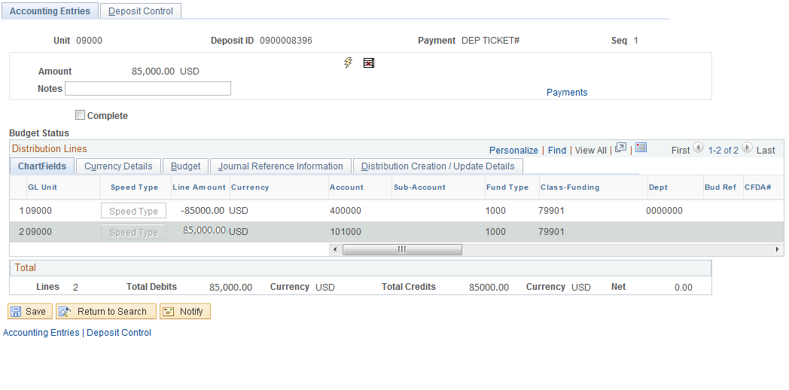

Once the Cash side of the Accounting Entry page is complete the chartfields will be inactive and not editable. To make changes, use to delete the Cash side of the accounting entry and start over.

Complete – when the Accounting Entry is correct and both sides of the entry have been created, select the Complete checkbox. This checkbox will mark the accounting entry as complete.

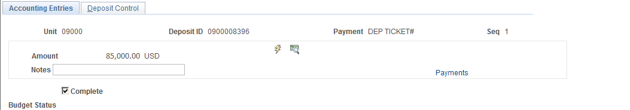

Once the Complete checkbox has been selected, click to execute the Chartfield Combination Edit process.

Once the Accounting Entry is marked as Complete, the icon will be displayed allowing the user to Budget Check the entry.

Click to Budget Check the entry.

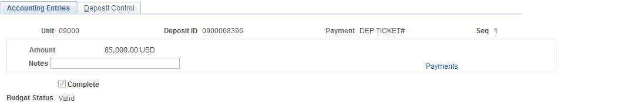

Ensure the Budget Status is set to Valid after the Budget Check process has completed.

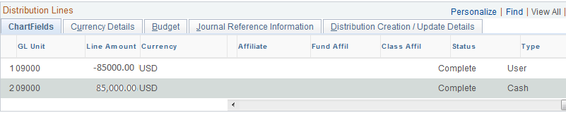

Ensure the Chartfield Edit status at the far right hand of the Chartfields Tab is set to Complete for all lines in the accounting entry.

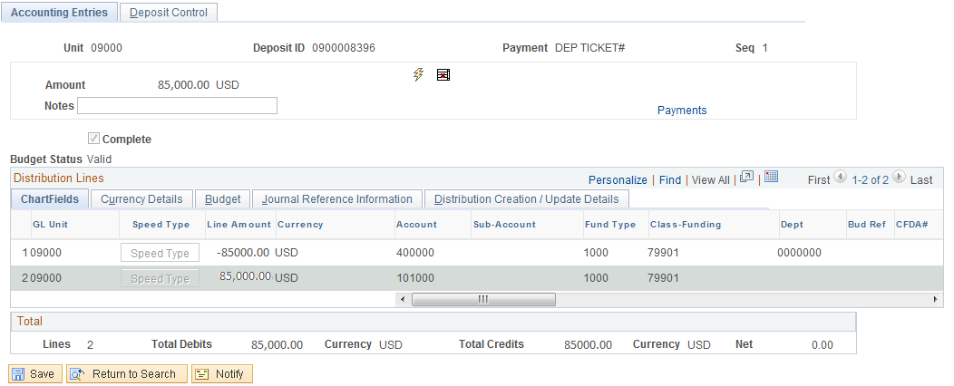

Once the accounting entry is marked as Complete and the Budget Status is valid the accounting entry is ready to send to the General Ledger and OST.

NOTE: If the user marks the Accounting Entry as Complete, but DOES NOT execute the Budget Check process from this page, he must navigate to the “Modify Accounting Entries” page to Budget Check the Accounting Entry. Once marked Complete, the Accounting Entry will not be available in this page to select at a later date.

Modify Accounting Entries

Navigation: Accounts Receivable > Payments>Direct Journal Payments > Modify Accounting Entries > Find an Existing Value

Deposit Control Page
The Deposit Control page is the same as the Regular Deposit – Totals page from above. The information on this page is read-only and shown for control total and balancing informational purposes. The page displays banking, control total, processing dates, currency and user ID details.

Transfers
Within the system, Transfer is the mechanism used to move monies between funds. This movement can be from Agency, Clearing or ASA accounts. OST Batch Codes of 64 (Agency to Fund) and 52 (Agency to Agency) will be used to define transfers in the system.

Create a Deposit Transfer

Navigation: Accounts Receivable > Payments > Online Payments > Deposit Transfers > Add a New Value

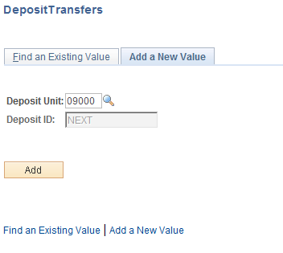

Deposit Unit – is the Agency Business Unit depositing the funds. The Business Unit will default based on User Preferences.

Deposit ID – defaults to NEXT. Leave this value as NEXT to allow the system to assign the next available number. The Transfer ID will have a mask of “TR”.

Click to enter the Deposit Transfer pages.

Totals Page
The Totals page defines the control information for the Transfer including Batch Code, Banking information, Control Totals, User information and processing Dates. The Batch Code values available for selection will be limited by User security. Two (2) batch codes available to agency users are 52 and 64.

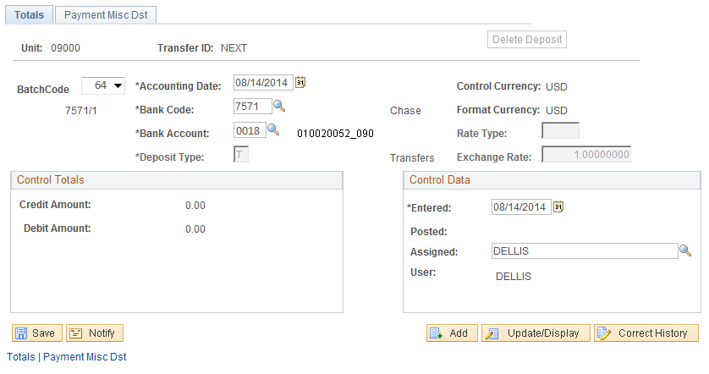

Batch Code – this field is the OST Batch Code. The value will default to 64, but can be changed by the user. Available values will be controlled by user security based on the type of transfer the user is authorized to create.
Agency Users can select the following Batch Codes:
52 – Agency to Agency Transfer
64 – Agency to Fund Transfer

For these types of Transfers, select the either Batch Code 52 or 64.

Accounting Date – defaults to today’s date. The value should not be changed.

Bank Code – Bank Code indicates which bank facility will be used for the Transfer. For these types of Transfers, the Bank Code will default when a Batch Code of 52 or 64 is selected by the User and should not be changed. For Batch Code 52 the Bank Code will be 7572, for Batch Code 64 the Bank Code will be 7571.

Bank Account – The Bank Account identifies the account within the banking facility that the transfer will be directed to. For these types of Transfers, the Bank Code will default when the Batch Code of 52 or 64 is selected by the User. This should not be changed.

Deposit Type –this field defaults from the Bank configuration. Deposit Type should default to “T” representing Transfer.
Control Currency – will default to USD and cannot be changed.

Format Currency - default to USD and cannot be changed.

Rate Type – defaults to CRRNT.

Exchange Rate – defaults to 1.0000000.

Control Total Credit Amount – this field should reflect the total Credit Amount for the Transfer. This amount will be defined on the next tab – Payment Misc Dst.

Control Total Debit Amount – this field should reflect the total Debit Amount for the Transfer. This amount will be defined on the next tab – Payment Misc Dst.

Entered Date –For both Batch Codes 52 and 64, the Entered Date will default as the current date and should not be changed. .

Assigned – by default this field holds the User ID of the person creating the Transfer.

Payment Misc Dst Page
The Payment Misc Dst Page functions to create the Accounting Entry required for the Transfer. This page is similar to the Deposit Accounting Entries (Direct Journal) page illustrated above but functions in a slightly different manner.

In contrast to the Deposit Accounting Entries page where the system creates all debits for the entry, the Payment Misc Dst Page requires the user to create both the Debit and Credit sides of the entry before the cash lines are built by the system. This allows the user to define each of the transfer accounts (funds) that will be used.

First, the user will define the debit side of the accounting entry. This will be the account or fund that the transfer will be made from. There should be only one debit entry for each transfer.

NOTE: The initial or first line in the accounting entry is defined with a line # of “1”.

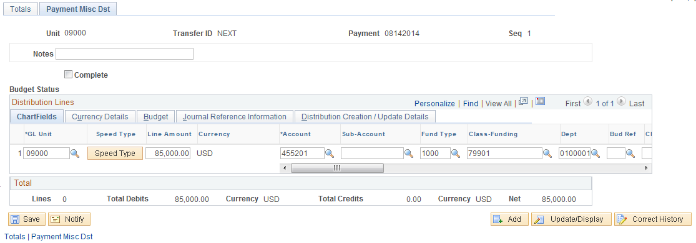

GL Unit – the General Ledger Business Unit will default to the Deposit Unit or agency business unit number.
Agencies may use the button to populate chartfields using this feature. This feature is only applicable to those agencies configured to use Speed Types.

Line Amount – populate the Line Amount field with the transfer amount. Since the first line of the accounting entry is the decrease to revenue or debit side of the entry, this number should be keyed as a Positive.

Account – select the Revenue account to which the transfer will be booked.

Sub-Account – if the agency uses this chartfield in the transfer account entry, populate that value.

Fund Type – populate the Fund Type for the transfer.

Class Funding – populate the Class Funding for the Debit side of the Transfer. The Class Funding value will be edited against the Batch Code to ensure a valid Class Fund is being used. For all Transfers the Class Fund value on the Debit side of the accounting entry should be 799xx or 8XXXX.

Class Affiliate - this is a field that optionally allows agencies to track the ultimate destination of funds originally deposited into a Clearing Account. A separate public query will be provided that will give amounts to be transferred at a later date.

Dept – populate the Department for the transfer.

Oper Unit – if the depositing agency is using Operating Unit in the deposit accounting entry, populate that value.

Second, the user will define the Credit side of the accounting entry. This will be the accounts or funds that the transfer will be made to.

NOTE: For Transfers using Batch Code 52, the Line Amount on line 2 of the Accounting Entry represents the transfer to an “Agency Account”. For Transfers using Batch Code 64, the Line Amount on line 2 of the Accounting Entry represents a transfer to a “Fund Account”.

Use the button to add another accounting entry row that will represent the Credit side of the entry.

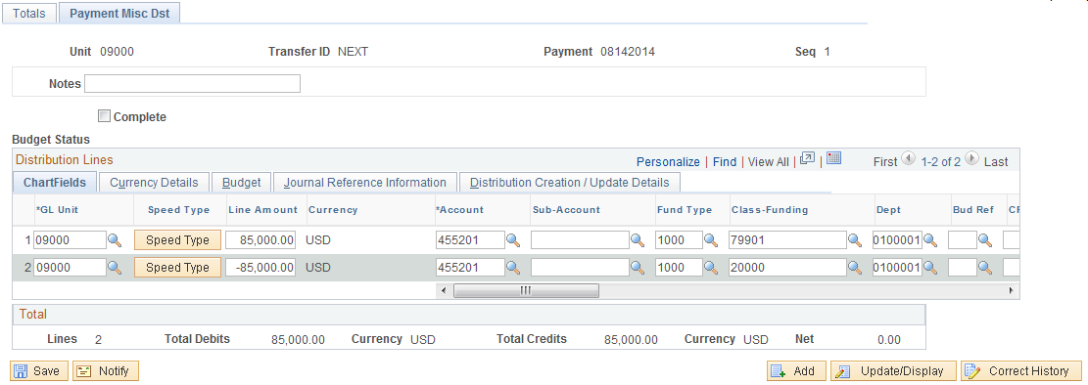

GL Unit – the General Ledger Business Unit will default to the Deposit Unit or agency business unit number. This should be the Business Unit to which the Transfer is being made.

Line Amount – populate the Line Amount field with the transfer amount. The Credit line of the accounting entry (line 2 above) should be a Negative number.

Account – select the Revenue account to which the transfer will be booked. This will be the Account value that you wish to transfer into.

Sub-Account – if the agency uses this chartfield in the transfer account entry, populate that value.

Fund Type – populate the Fund Type for the transfer.

Class Funding – populate the Class Funding for the Credit side of the Transfer. The Class Funding value will be edited against the Batch Code to ensure a valid Class Fund is being used. For Batch Code 52, the Class Fund value on the Credit side of the accounting entry should be 799xx or 8XXXX. For Batch Code 64 the Class Fund value on the Credit side of the accounting entry CAN NOT BE 799xx or 8XXXX.

Dept – populate the Department for the deposit.
Class Affiliate - this is a field that optionally allows agencies to track the ultimate destination of funds originally deposited into a Clearing Account. A separate public query will be provided that will give amounts to be transferred at a later date.

Oper Unit – if the depositing agency is using Operating Unit in the deposit accounting entry, populate that value.

NOTE: Repeat the Credit line as many times as necessary to complete the Transfer.

When the Credit sides of the entry are complete, click .

NOTE: Do not click until all Credit Lines have been added to the Accounting Entry.

Click to create the Cash side of the Accounting Entry. The system will create the corresponding Cash sides of the accounting entry.

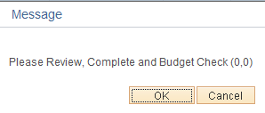

The user will receive a Warning message, prompting them to Review, Complete and Budget Check. Select to proceed.

The system will bring the user to the Totals page again.

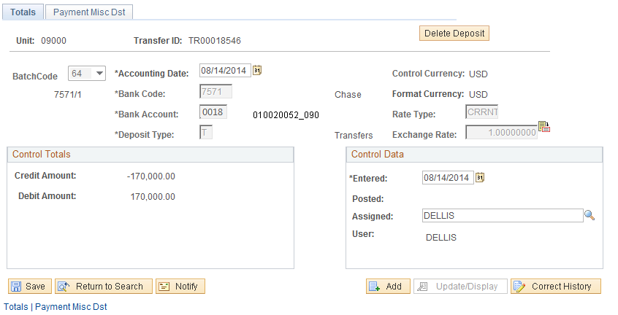

NOTE: The Credit Amount and Debit Amount reflect the Revenue AND Cash transfer activity in the Accounting Entry.

Select the Payment Misc Dst Tab to return to the Accounting Entry to mark as Complete and Budget Check the Transfer.

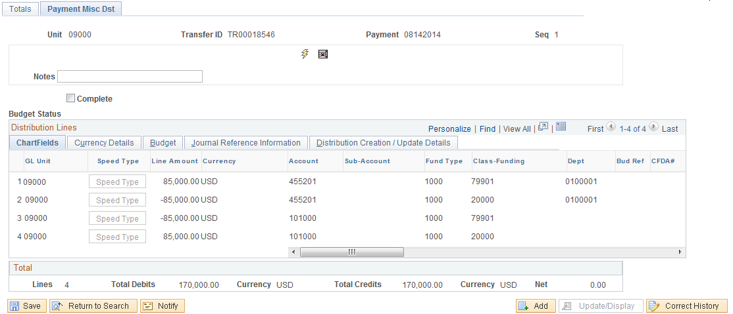

NOTE: When you return to the Payment Misc Dst page to Complete the Accounting Entry, the cash sides of the entry are visible.

Once the Cash side of the Accounting Entry page is complete the chartfields will be inactive and not editable. To make changes, use to delete the Cash side of the accounting entry and start over.

Complete – when the accounting entry is correct and both sides of the entry have been created, select the Complete checkbox. This checkbox will mark the accounting entry as complete ready the entry for the Combination Edit process.

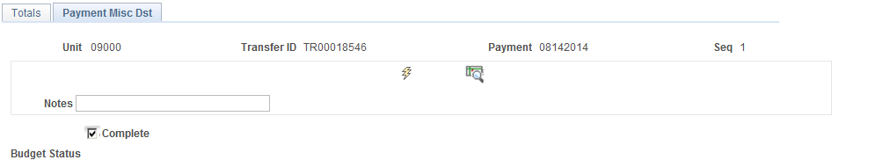

Once the Complete checkbox has been selected, click to execute the Chartfield Combination Edit process.

Once the accounting entry is marked as Complete, the icon will be displayed allowing the user to Budget Check the entry.

Click to Budget Check the entry.

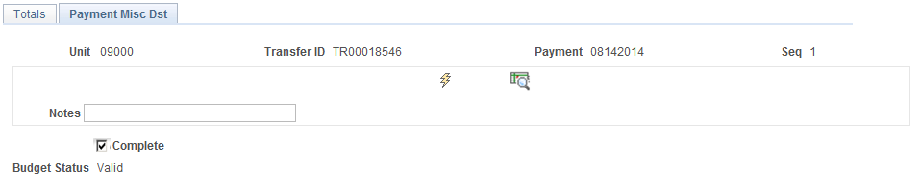

Ensure the Budget Status is set to Valid after the Budget Check process has completed.

NOTE: Also ensure the Chartfield Edit status at the far right hand of the Chartfields Tab is set to Complete.

NOTE: If the user marks the Accounting Entry as Complete, but DOES NOT execute the Budget Check process from this page, they must navigate to the “Modify Accounting Entries” page to Budget Check the Accounting Entry. Once marked Complete, the Accounting Entry will not be available in this page to select at a later date.

Modify Accounting Entries

Navigation: Accounts Receivable > Payments > Direct Journal Payments > Modify Accounting Entries > Find an Existing Value

Inquiry and Reports
When Deposits, Corrections and Transfers have been Completed, Budget Checked and Posted, they are not available for viewing in the data entry pages illustrated above. The users must use the Review Payment pages to access and inquiry on these completed transactions.

Deposit Inquiry

Navigation: Accounts Receivable > Payments > Review Payments > All Deposits > Find an Existing Value

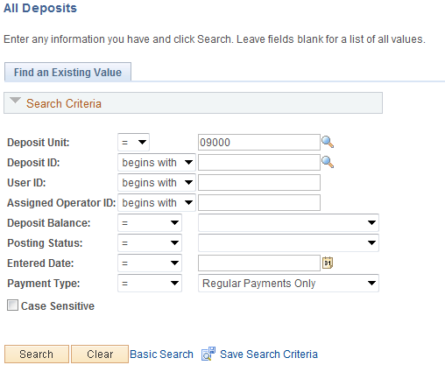

Use the Search Fields to find the Deposit, Transfer or Correction that you would like to view.

Click to retrieve the Deposit, Transfer or Correction.

All Deposits Page
The All Deposits page displays general information about the Deposit, Transfer or Correction. This page is similar to the Totals page displayed above for Deposits, Transfers and Corrections.

This page is display only indicating changes to Budget Checked and Posted transactions is not allowed.

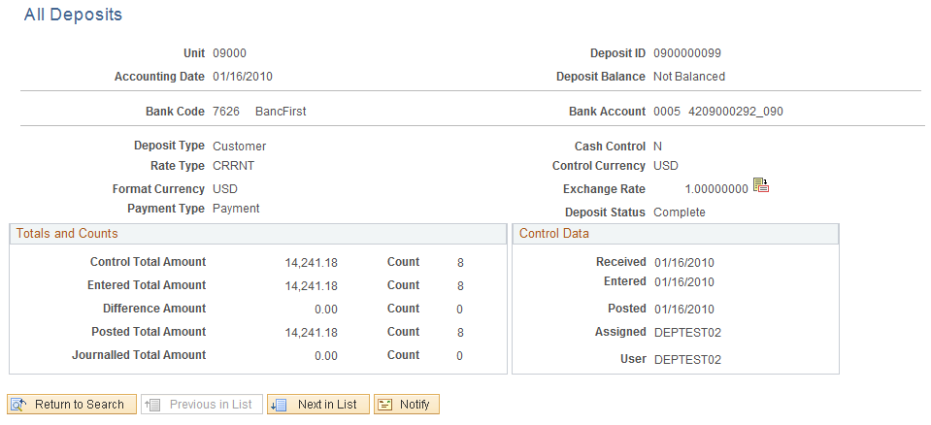

Payment Inquiry
Navigation: Accounts Receivable > Payments > Review Payments > All Payments > Find an Existing Value

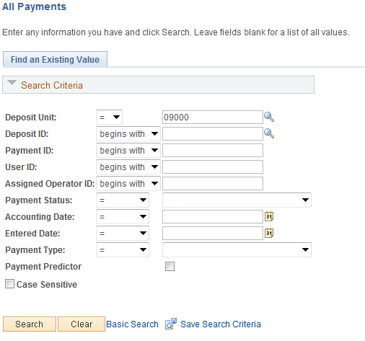

Use the Search Fields to find the Deposit, Transfer or Correction that you would like to view.

Click to retrieve the Deposit, Transfer or Correction.

All Payments Page
The All Payments page displays Payment Detail information for each Payment in the Deposit, Transfer or Correction.

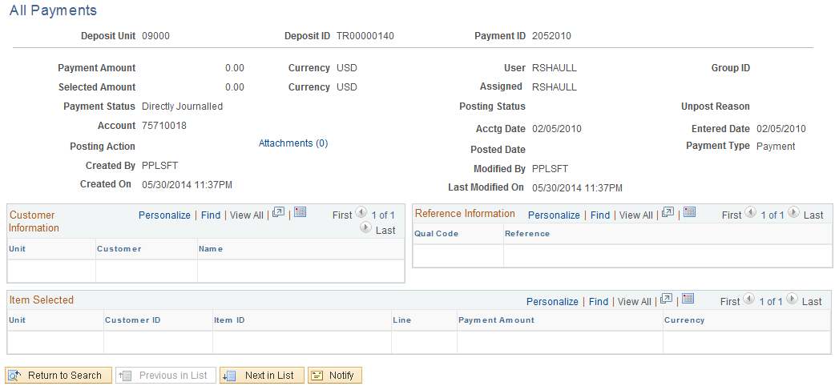

Accounting Entry Inquiry

Navigation: Accounts Receivable > Payments > Direct Journal Payments > Modify Accounting Entries > Find an Existing Value

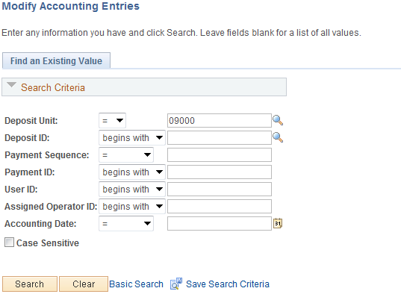

Use the Search Fields to find the Deposit, Transfer or Correction Accounting Entries that you would like to view.

Click to retrieve the Deposit, Transfer or Correction.

Directly Journalled Payments Page
The Modify Accounting Entry page can be used as an Inquiry page for Accounting Entries that have been Completed and Budget Checked. Also, when an Accounting Entry has been Completed, but not Budget Checked, this page can be used to Budget Check the Accounting Entry.

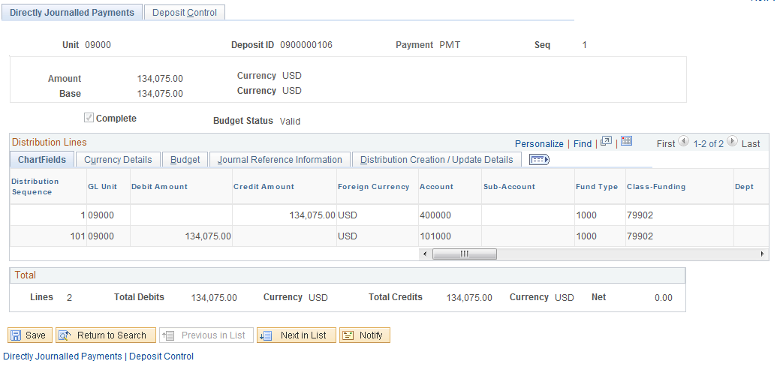

Appendix A
The Deposit workflow notification illustrated above is dependent on the configuration of Workflow Attributes in the system. These attributes are tied to each User ID in the system and must be populated for workflow notification emails to be sent automatically when Deposit transactions requiring approval are saved.

All Deposit Notification Users must navigate to the following pages and populate the Workflow Attributes and Email fields to receive workflow email notification for Deposit transactions.

System Profile
Navigation: System Profile

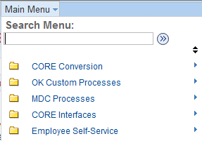


General Profile Information
The General Profile Information holds User features that are global to the entire system. This includes Password information, Default values and Workflow Attributes.

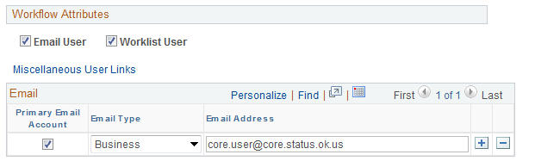

Email User – for all Deposit Notification Users this checkbox must be selected.

Worklist User - for all Deposit Notification Users this checkbox must be selected.

Primary Email Account – select for all Deposit Notification Users

Email Type – set to Business

Email Address –this field identifies where the Deposit Notification emails will be sent for this User.

