COR404 Accounts Receivable –

Receivable Maintenance Manual

Table of Contents

Document History 4
Receivables Maintenance 5
Key Terms 5
Account Receivable Business Unit 5
Billing Business Unit 5
Customer 5
Customer ID 5
Bill (Invoice) 5
Distribution Code 5
Pending Item 6
Maintenance Worksheet 6
Process Flows 6
Guidelines, Concepts and Alternatives 7
Debit/Credit Memos 8
Debit/Credit Memos 8
Group Control Page 9
Pending Item 1 Page 10
Accounting Entries Page 11
Group Action Page 13
Maintenance Worksheet 15
Create a Maintenance Worksheet 15
Worksheet Selection Page 16
Worksheet Application Detail Page 19
Worksheet Action Page 22
Transfer Worksheet 24
Create a Transfer Worksheet 24
Transfer Selection Page 25
Worksheet 2 Page 28
Transfer Action Page 29
Aging Receivables Items 30
Request Aging Process 30
Aging Page 31
Aging Summary by Bill Type Report 33
Aging Summary by Bill Type Page 34
Aging Detail by Unit Report 36
Aging Detail By Unit Page 37
Aging Summary by Unit Report 39
Aging Summary By Unit Page 40
Aging By Unit Page 42
Unit Aging Chart Page 44
Review Customer Accounts 47
Customer Account Overview 47
Balance Page 47
Profile Page 49
Customer Activity Overview 50
Item Activity Page 50
Review Item Activity 53
Item List By Customer 53
Item List Page 53
Advanced Search Page 54
Item Billing Data 59
Item List Page 60
Item Activity By Group 61
Item Activity From A Group Page 62
Customer Statements 63
Step 1: Create Customer Statements 63
Statement Parameters Page 64
Step 2: Print Statements 66
Statement Print Page 67
Receivables Inquiry 69
Unit Activities 69
Unit Activity Page 69
Unit Cash 71
Unit Cash Page 71
Item Activity By Payment 73
Item Activity From A Payment Page 74
Items With Accounting Entries 75
Payment Control Page 76
Payment 1 Page 77
Accounting Entries Page 78
Receivables Reports 79
Business Unit Activity Report 79

Document History
Doc Rev | Date | Description
1.0  2.0 | 04/15/2010  10/01/2014 | Initial Document  Upgrade Update

Receivables Maintenance
When customer receivables are created in Accounts Receivable, they must be managed to reflect necessary changes in a customer account. Receivables can be written off, off set , refunded or adjusted. Receivables are maintained in a Worksheet where required action can be taken on the receivables item.

Receivables maintenance can be done automatically by matching customer debits and credits together using automatic maintenance rules.

Key Terms

Account Receivable Business Unit
Each agency has one, and only one Billing Business Unit. The Business Unit is the 3 digit agency code, plus 00. For example, Office of State Finance is 09000.

Billing Business Unit
Each agency has one, and only one Billing Business Unit. The Business Unit is the 3 digit agency code, plus 00. For example, Office of State Finance is 09000.

Customer
A customer is an external entity that is defined in a Contract to receive invoices and from which revenue is recognized. Customers can be individuals, businesses or federal grantors.

Customer ID
Customer ID is a unique identifier for Customers within the system. Customer ID’s can be assigned by the system or keyed manually by a user. Each agency will have unique list of Customer ID’s with which they do business (generate revenue).

Bill (Invoice)
The transaction containing invoice information for a Customer (bill header, bill lines, amounts, due dates, etc.). Bills are created then ‘Finalized’ in the Billing Module to become a completed Invoice to which customer cash can be applied. The term Bill and Invoice can be used interchangeably.

Distribution Code
Distribution codes simplify the process of generating accounting entries by defining a valid combination of Chartfield values that are used as defaults on other pages. Distribution Codes can be defined for Revenue or Accounts Receivable.

Pending Item
Pending Items are Customer Receivables that have been created in the system but are not yet Posted to the Customer Account. Pending Items can come from outside of Accounts Receivable, like invoices from Billing or they can be created in Accounts Receivable.

Maintenance Worksheet
A worksheet that allows receivables items to be written-off, adjusted or offset. In a worksheet Items are retrieve and desired action taken to reflect item activity.

Process Flows
Diagram 1: Accounts Receivable Module Integration

Guidelines, Concepts and Alternatives
PeopleSoft Billing uses extensive defaults to automatically populate bill information. Since Accounts Receivable uses finalized bills extensively in processing, this hierarchy also impacts the Receivables module.

During online Bill entry, as certain fields are populated, the system automatically populates other fields on the Bill Header based on the defaults that are configured by the agency. Automatic field population also occurs during the Billing Interface process (BIIF0001) when a field that has possible default information is left blank.

For example, an agency may extend different ‘Payment Terms’ to customers based on the ‘Type’ of invoice that is being generated. If Payment Terms are defined by Bill Type, then each time a Bill Type is selected onto an invoice the corresponding Payment Terms are defaulted to the Bill Header.

Since Accounts Receivable uses Customers extensively, the Billing default hierarchy impacts processing in Receivables as well. Within the default hierarchy values defined at the Lower-level of the diagram below “Override” values at a Higher-level in the hierarchy. For example, Payment Terms defined for the Customer would override Payment Terms defined for the Bill Type. When creating invoice on-line the system will search for the lowest level value in the hierarchy to populate a particular default field.

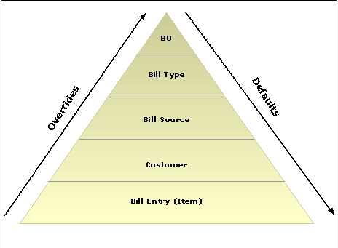

Diagram 2: Billing Default Hierarchy

Debit/Credit Memos
Credit and Debit Memos can be added to the system to reflect changes in an Item or Customer Account. Debit and Credit Memos can originate from Accounts Receivables or be interfaced from the Billing Module.

The Online Pending Item component is used to create a Debi/Credit Memo. The Debit/Credit Pending Item will be entered in a Group and have a different Entry Type and Entry Reason reflecting the action being taken.

Debit/Credit Memos

Navigation: Accounts Receivable > Pending Items > Online Items > Group Entry > Add a New Value

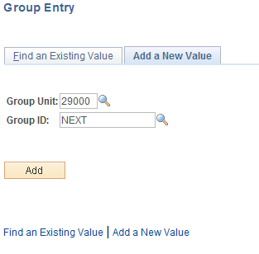

Group Unit – enter the agency business unit value.

Group ID – leave this value as ‘NEXT’ to have the system assign the next available Group ID number, or key the desired Group ID.

Click to enter the Debit/Credit Memo.

Group Control Page

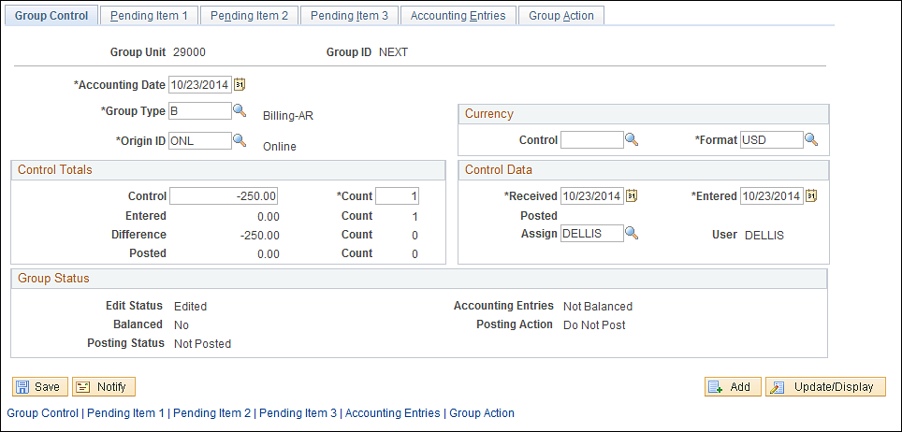

Use the Group Control page to enter the Group Information for the Debit/Credit Memo.

Accounting Date – this value is the date that the accounting entries for the Debit/Credit Memo Group will be posted to the General Ledger.

Group Type – this value represents the source of the Group.
Origin ID – where did the object originate

Control – this amount represents the total amount of all Debit/Credit Items in the Group.

Count – represents the total count of Items in the Group.

The Group Status section of the page displays various status values for the Group:
Balanced – indicates whether or not the Group is balanced. The Online Group will initially be created as ‘No’.
Posting Status – indicates whether or not the Group has been posted to customer accounts thru the Receivables Update process. Once processed by Receivable Update the status will be ‘Complete’ or ‘Errors’.
Accounting Entries – indicates whether the Group Accounting Entries are in balance.
Posting Action – indicates what Posting Action the group is currently set to. The Group can be set to ‘Post Now’, ‘Do Not Post’, Batch Standard’ and ‘Batch Priority’.

Click the Tab.

Pending Item 1 Page

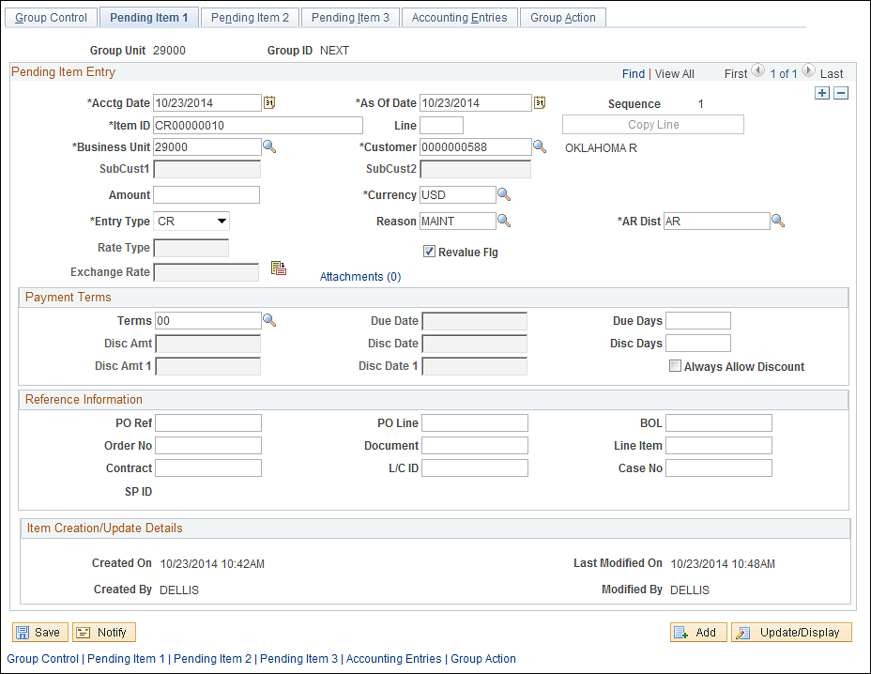

The Pending Item 1 page allows for Debit/Credit Items to be entered into the Group individually. Each Item will house its own separate properties within the Group.

NOTE: Use the button to add additional rows in the Group to accommodate multiple Debit/Credit Items.

Item ID – enter an Item number for the Debit/Credit memo.

Customer – enter the customer ID for the memo.

Amount – this field holds the individual Item amount.

Entry Type – for Debit memos enter the Entry Type of ‘DR’, for Credit memos enter the Entry Type of ‘CR’.

Entry Reason – further define the accounting entries for the Debit/Credit memo by selecting the appropriate Entry Reason for the action being taken.

AR Dist - enter the distribution code that governs the Chartfields that are used when the system generates accounting entries.

Click the Tab.

Accounting Entries Page

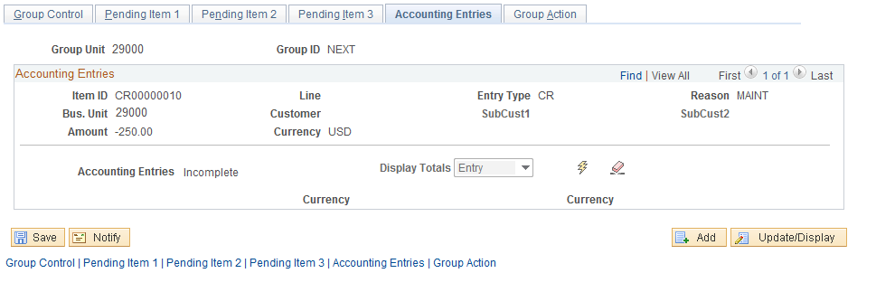

Use the Accounting Entries page to create accounting entries for the Debit/Credit Items. The page initially is displayed without entry lines.

The accounting entry status will display Incomplete initially.

Click the icon to have the system create accounting entries for each Item in the Group.

Accounting Entries page continued

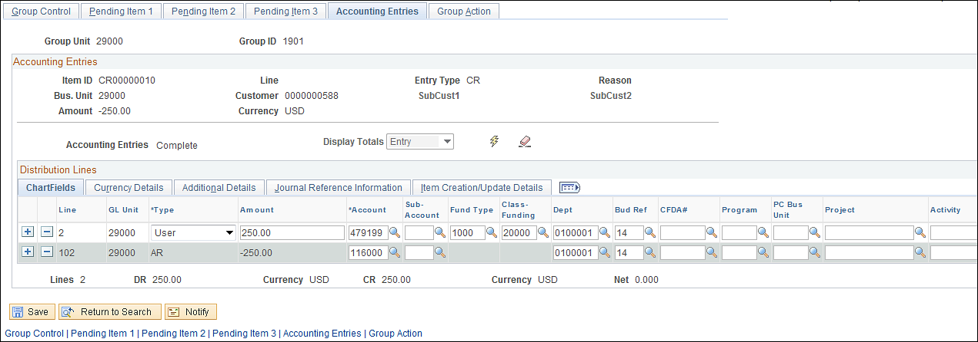

Once the Create accounting entries icon has been selected, both sides of the entry should be visible.

Amount – the amount values for the entry should default from the Item amount defined by the user.

Chartfields – populate both sides of the entry with the desired chartfield values.

NOTE: When creating Debit and Credit memos, the accounting entries will be different than invoice Items. For example, a Credit memo will credit the Accounts Receivable account and debit the Revenue account.

NOTE: Use the button to Item accounting entry and start over.

NOTE: The accounting entry status should be set to ‘Complete’.

Group Action Page
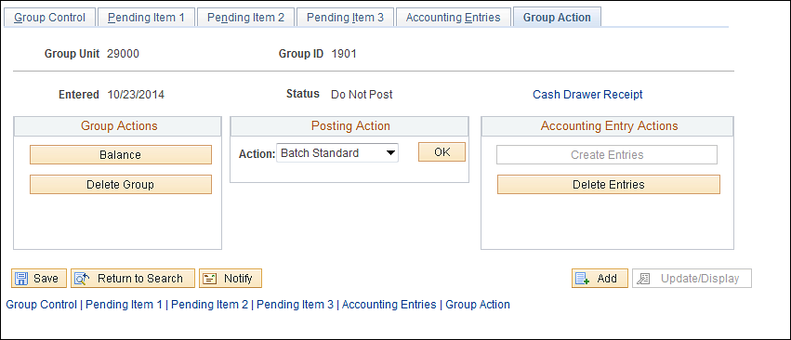

The Group Action page displays different actions that can be take on the Group.

The Posting Actions allow the user to set the Group to Post:

Use the Do Not Post button to save the Group but set it in a Non-Postable status.

Click the Batch Priority button to ensure the Group will be processed next time the Receivables Update process is executed.

Click Batch Standard button to make the Group eligible to be picked up the next time Receivables Update is executed.

One the desired action is selected (Batch Standard for Posting the Debit/Credit Memo), click to set the Group to post.

Click the Tab.

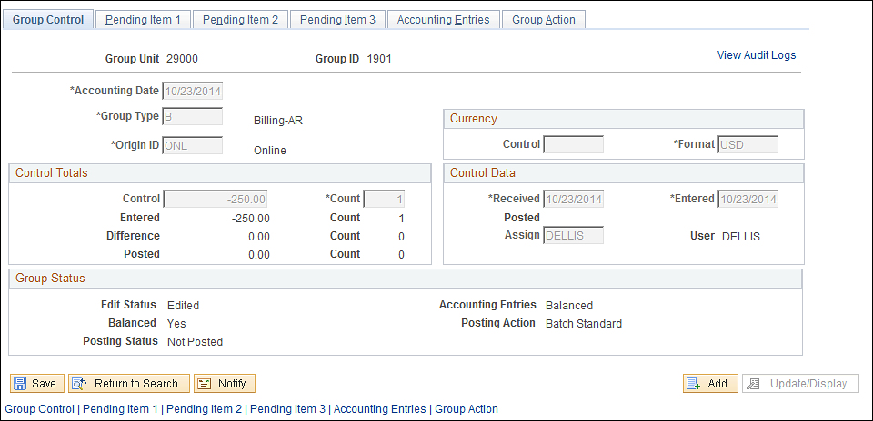

The Group should be Edited, Balanced, Not Posted (until Receivables Update has been run), Accounting Entries Balanced and set to Post (Batch Standard)

NOTE: Once the Online Pending Item Group has been balanced, accounting entries complete and set to Post, the Group will be ready to be selected by the Receivables Update process and posted to the customer’s accounts(s).

Click to save the Group.

Maintenance Worksheet
Maintenance Worksheets are used to Adjust, Write-off or Offset an Item. Items with credit balances can also be refunded in a Maintenance worksheet.

Maintenance Worksheets can be used to create new Items for Credit Memos, Debit Memos, Refund a remaining Credit or Write-off a remaining Debit/Credit.

Create a Maintenance Worksheet

Navigation: Accounts Receivable > Receivables Maintenance > Maintenance Worksheet > Create Worksheet > Add a New Value
.
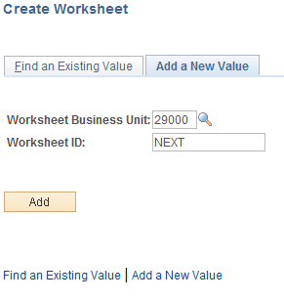

Worksheet Business Unit – enter the agency business unit value.

Worksheet ID – leave this value as ‘NEXT’ for the system to assign the next available worksheet ID.

Click to enter the Maintenance Worksheet pages.

NOTE: Not all fields in the Receivables Maintenance pages are illustrated in this manual. Only those fields that are required or generally used will be explained.

Worksheet Selection Page

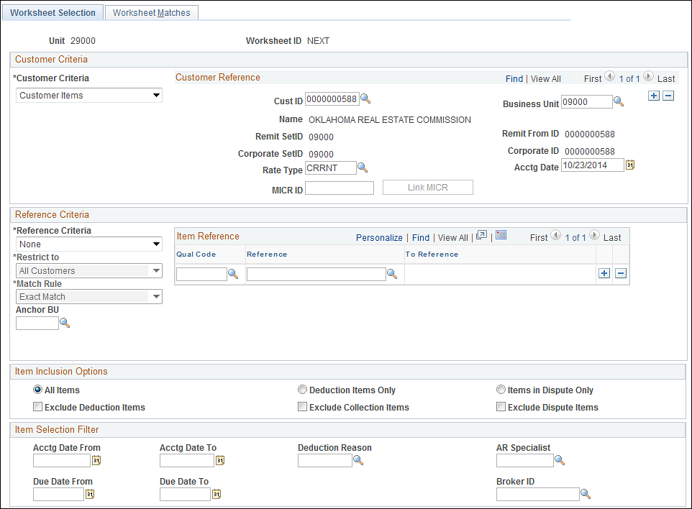
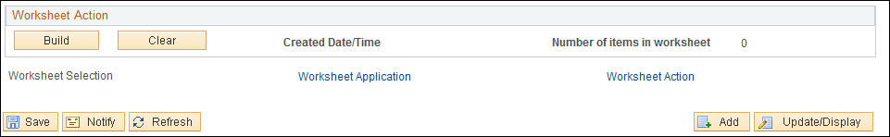

Use the Worksheet Selection page to determine which Items will be pulled into the worksheet.

Customer Criteria - select the type of customer that you want to include in the worksheet. Generally, this value will be ‘Customer Items’.

Customer ID – select the Customer ID that will be used to search for Items.

Business Unit – enter the agency business unit value. This is the business unit in which the Items exist.

Accounting Date - for new worksheets, select the accounting date that you want to apply to all items that you select on the worksheet

Use the Reference Criteria section of the page to provide additional information used to identify Items for the worksheet:

NOTE: The Reference Criteria section of the page is optional and allows the user to provide additional data elements associated with desired Items that allows the system to search for and find Items more specifically.

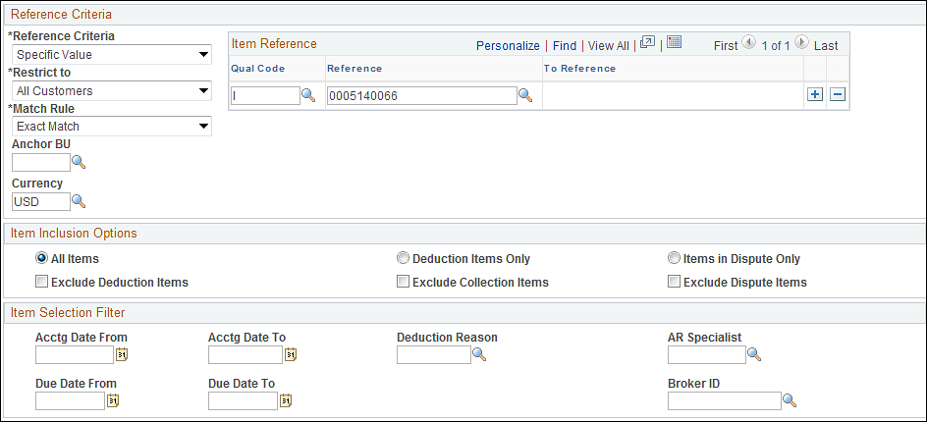

Reference Criteria – select from the pre-defined values that indicate how Items will be searched for and added to the worksheet:
Specific Values – identify a specific value for the worksheet.
Restrict To – select a value to restrict the selection by customer.
Match Rule – select whether the system will use an ‘Exact Match’ or ‘Like Match’ when selecting Items. Like Match allows the user to use a wildcard (%) to search by partial information.
Reference Qualifier Code (Qual Code) – select from the pre-defined list of documents.
Reference – enter the specific Item reference value.

NOTE: Use the button to add additional reference values if necessary.

Use the Item Inclusion Options section to determine which types of Items will be included in the worksheet.

Use the Item Selection Filter section of the page to provided additional criteria for Item selection:
Accounting Date From/To – define a period of time that will be used to select only Items with an Accounting Date falling within that period.
AR Specialist – to retrieve only those Items assigned to a particular AR Specialist.

Click to create the worksheet based on the criteria provided.
Worksheet Application Page

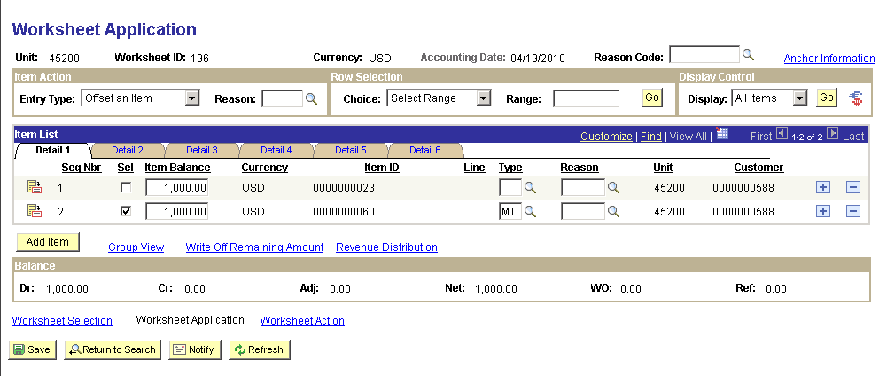

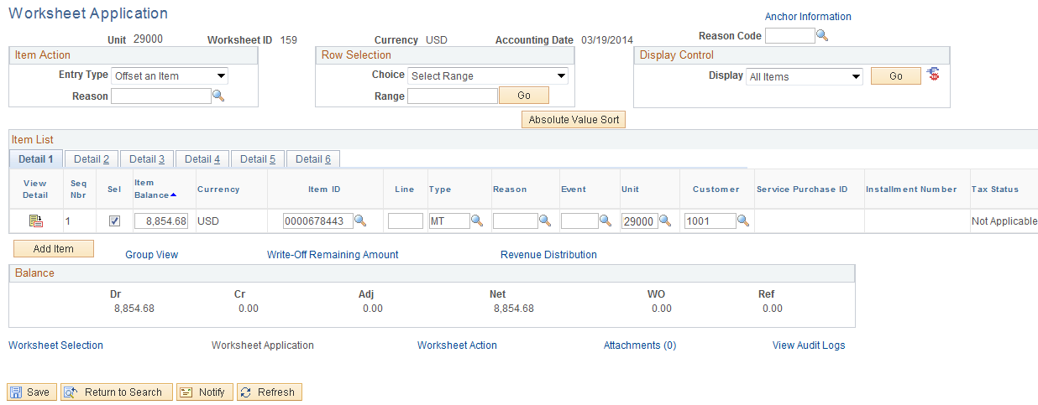

The Worksheet Application page displays all Items that match the Worksheet selection criteria provided by the user.
Entry Type – select the Entry Type from available values of ‘Write-Off’, ‘Offset’ or ‘Refund’.

Reason – select a valid Entry Reason for the maintenance action.

Use the Row Selection feature to select Items in the worksheet.

Use the Display Control feature to filter the Items in the worksheet.
Click to execute the Selection or Display feature.

Click to view Item Details.

Worksheet Application Detail Page

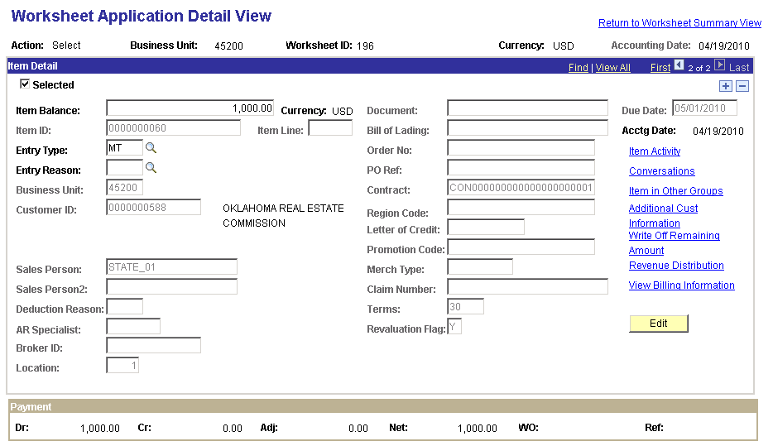

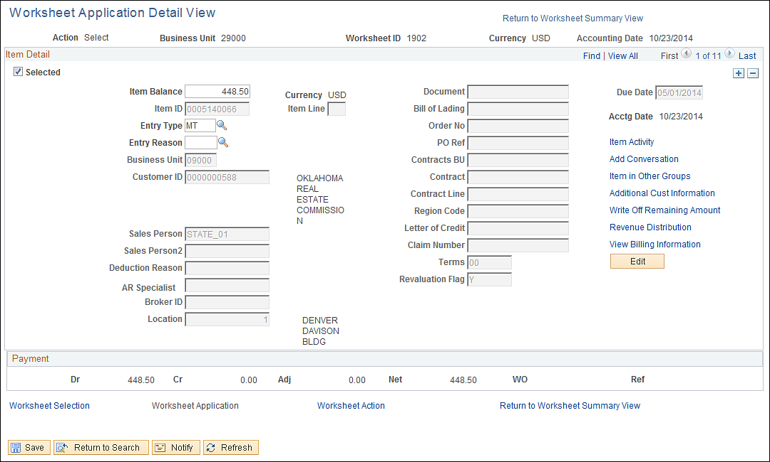

Use the Worksheet Application Detail View page to review Item information.
Use the hyperlinks on the right side of the page to navigate to associated Item information.

Click the Return to Worksheet Summary View hyperlink.

Worksheet Application page continued

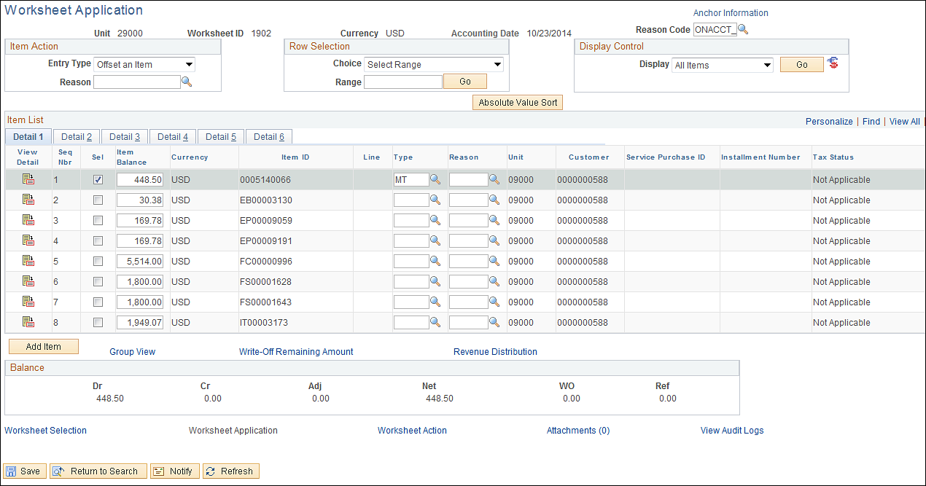

Select – use this checkbox to individually select the Item that will have action take on it. This checkbox will default on for items matching the Reference Criteria if used.

Item Balance - displays the amount of the item on which action is being taken.

Item ID – for existing Items, this field displays the Item ID (invoice, etc.)

Type – enter the desired Entry Type for the action being taken on the Item.

Reason – enter the desired Entry Reason for the action being taken on the Item.

NOTE: Use the button to add additional items to the worksheet.

Click to add a new Item in the worksheet. This will require a Customer ID, Business Unit and Item ID.

Click to save the maintenance worksheet.

Click the Worksheet Action hyperlink.

Worksheet Action Page

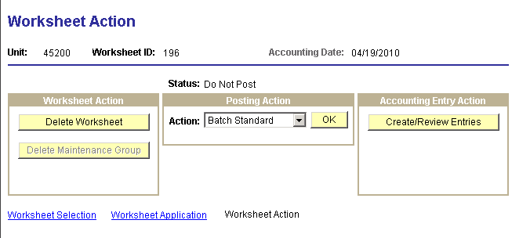

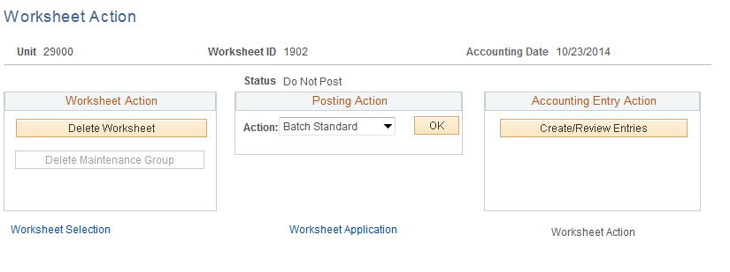

Use the Worksheet Action page to set the worksheet to Post, Delete the worksheet or review Accounting Entries.

NOTE: The Receivables Update process will create Accounting Entries associated with the maintenance worksheet action.

Action – select ‘Batch Standard’ to set the maintenance worksheet to post the next time Receivables Update is executed.

Click to save the Posting action.

NOTE: The maintenance worksheet action will be posted to the customer account next time Receivables Update process is executed.

NOTE: To correct Posting Errors navigate to Accounts Receivable > Receivables Update > Correct Posting Errors > Worksheet.

Transfer Worksheet
Transfer Worksheets are useful when an Item needs to be transferred to another Customer or Business Unit (agency). This could be the case when an invoice is created with the wrong Customer ID and needs to be changed to reflect the correct Customer.

Once the Transfer Worksheet is complete and a Posting action is selected, run the Receivable Update process to transfer the items, create accounting entries, and post the results.

Create a Transfer Worksheet

Navigation: Accounts Receivable > Receivables Maintenance > Transfer Worksheet > Create a Worksheet > Add a New Value
.
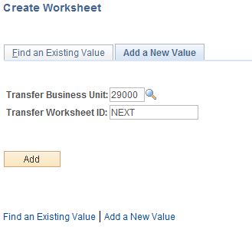

Transfer Business Unit – enter the agency business unit value.

Transfer Worksheet ID – leave this value as ‘NEXT’ for the system to assign the next available worksheet ID.

Click to enter the Transfer Worksheet pages.

Transfer Selection Page

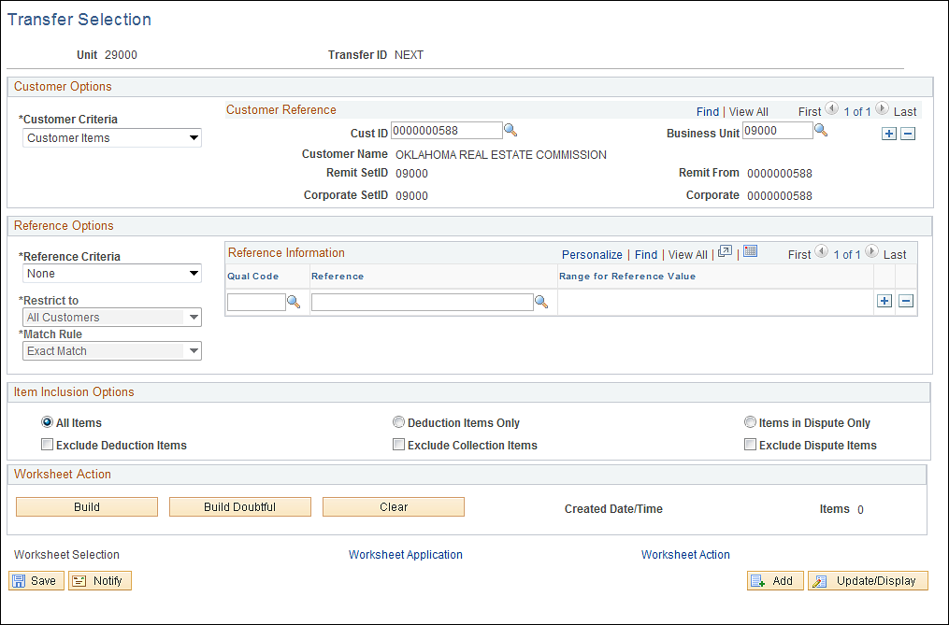

Use the Transfer Selection page to determine which Items will be pulled into the worksheet for transfer.

Customer Criteria - select the type of customer that you want to include in the worksheet. Generally, this value will be ‘Customer Items’.

Customer ID – select the Customer ID that will be used to search for Items. This is the Customer that the Item will be transferred “From’.

Business Unit – enter the agency business unit value. This is the business unit in which the Items exist.

Use the Reference Criteria section of the page to provide additional information used to identify Items for the worksheet:

NOTE: The Reference Criteria section of the page is optional and allows the user to provide additional data elements associated with desired Items that allows the system to search for and find Items more specifically.

Reference Criteria – select from the pre-defined values that indicate how Items will be searched for and added to the worksheet:
Specific Values – identify a specific value for the worksheet.
Restrict To – select a value to restrict the selection by customer.
Match Rule – select whether the system will use an ‘Exact Match’ or ‘Like Match’ when selecting Items. Like Match allows the user to use a wildcard (%) to search by partial information.
Reference Qualifier Code (Qual Code) – select from the pre-defined list of documents.
Reference – enter the specific Item reference value.

NOTE: Use the button to add additional reference values if necessary.

Use the Item Inclusion Options section to determine which types of Items will be included in the worksheet.

Click to create the transfer worksheet based on the criteria provided.
Worksheet 1 Page

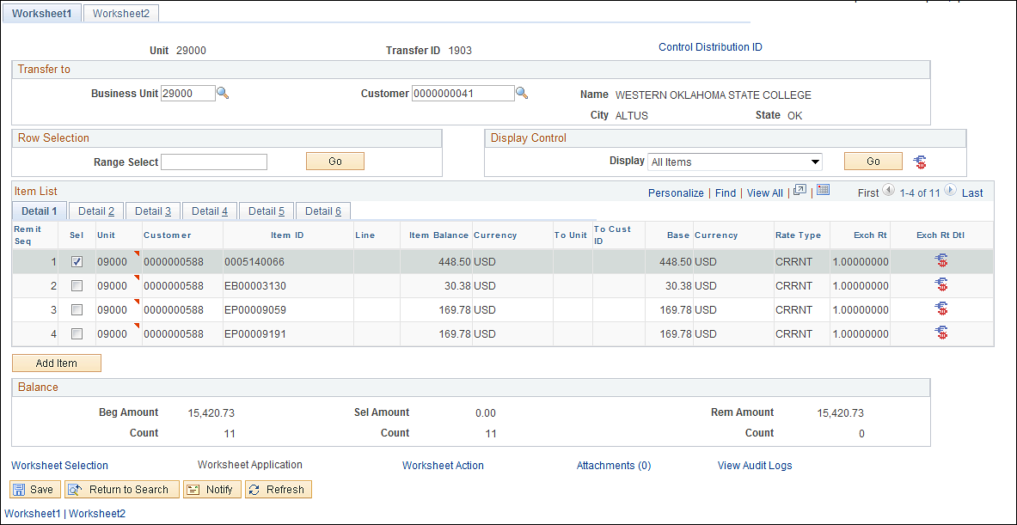

Use the Worksheet 1 page to determine how the Item will be transferred. This includes the Customer that the Item will be transferred ‘To’.

Business Unit – enter the Business Unit that the item will be transferred To. If the transfer is to another customer only, enter the same agency business unit value.

Customer - enter the Customer that the item will be transferred To.

Use the Row Selection feature to select Items in the worksheet. For example use ‘1-4’ to select only those Items in the displayed list.

Use the Display Control feature to filter the Items in the worksheet.
Click to execute the Selection or Display feature.

Remit Sequence – displays the order in which the Items originally appeared on the page.

Select – use this checkbox to indicate which Item will be transferred.

Click the Tab.

Worksheet 2 Page

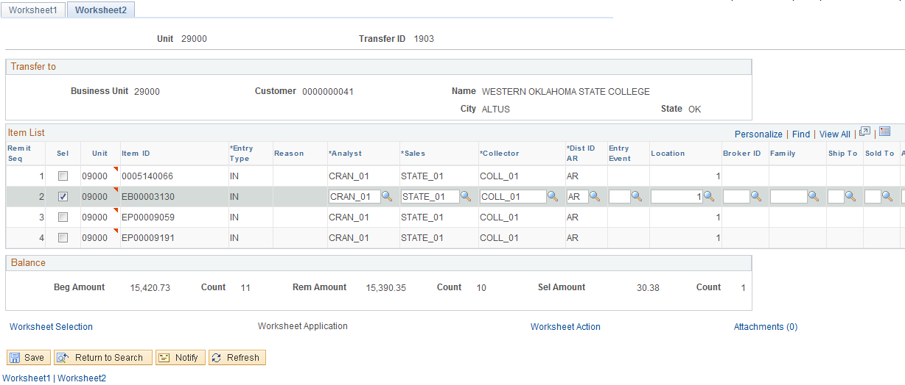

Use the Worksheet 2 page to change values for the Item being transferred. This could be the case when the transferring of the Item requires different maintenance or default values.

Click the button to save the Transfer Worksheet.

Click the Worksheet Action hyperlink.

Transfer Action Page

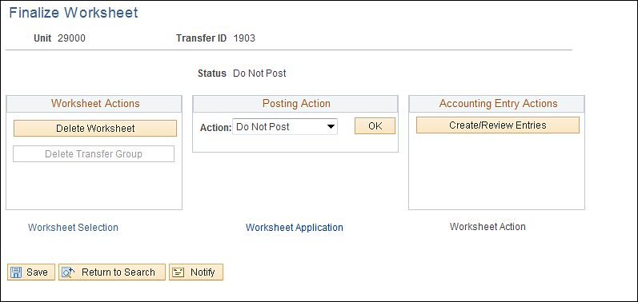

Use the Transfer Action page to set the worksheet to Post, Delete the worksheet or review Accounting Entries.

NOTE: The Receivables Update process will create Accounting Entries associated with the maintenance worksheet action.

Action – select ‘Batch Standard’ to set the transfer worksheet to post the next time Receivables Update is executed.

Click to save the Posting action.

NOTE: The transfer worksheet action will be posted to the customer account next time Receivables Update process is executed.

NOTE: To correct Posting Errors navigate to Accounts Receivable > Receivables Update > Correct Posting Errors > Transfer.

Aging Receivables Items
Aging is a Receivables Item analysis tool that displays outstanding (unpaid) Items by day’s late category. Generally, the aging categories are 0-30 days, 31-60 days, 61-90 days, 91-120 days and 212+ days. Aging categories in the system are represented by Aging ID’s that are configured for each business unit (agency).

Customer Aging analysis within the system is done in a two-step process. First a batch process is executed to populate aging tables. Second, aging analysis can be done through delivered pages. The Aging batch process automatically processes all customers in all business units specified on the aging request.

Request Aging Process

Navigation: Accounts Receivable > Receivables Analysis > Aging>Request Aging Process > Find an Existing Value
.
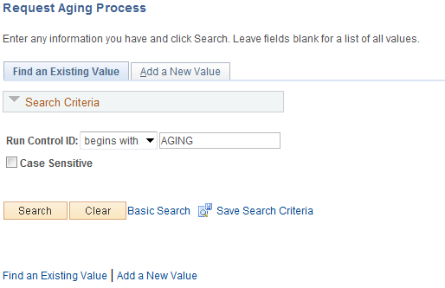

Use an Existing Run Control value or create a New Value.

Click to use an existing Run Control value.

Aging Page

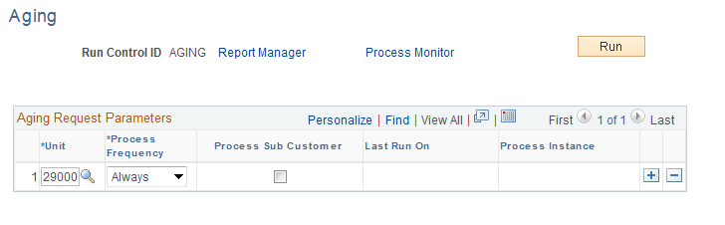

Unit – define the agency business unit for which the aging process will be executed.

Process Frequency – set to ‘Always’

Click to execute the Aging process.

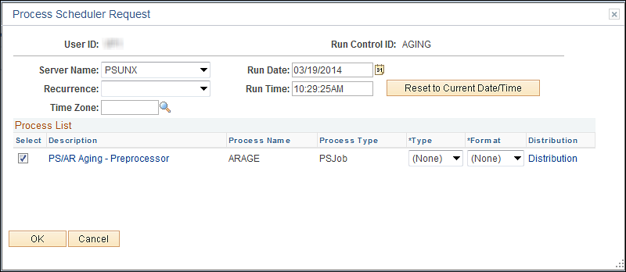

Select the checkbox next to the desired process (ARAGE).

Click to execute the process. Navigate to the Process Monitor to view the Process instance.

Aging Summary by Bill Type Report

Navigation: Accounts Receivable > Receivables Analysis > Aging > Aging Summary by Bill Type > Find an Existing Value
.
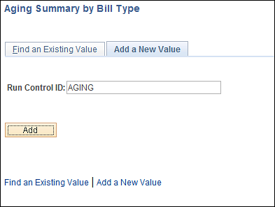

Use an Existing Run Control value or create a New Value.

Click to use an existing Run Control value.

Aging Summary by Bill Type Page

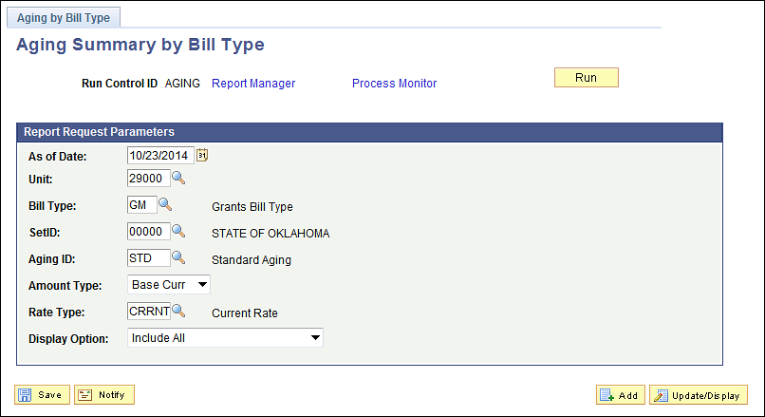

As of Date – define a date at which the aging will be calculated and displayed.

Unit – populate with the agency business unit.

Bill Type – choose a Bill Type value for the report. Items with this Bill Type will be shown on the report.

Aging ID – choose a pre-defined aging ID to categorize Items.

Display Option – choose which Items will be included in the aging report.

Click to execute the Aging by Bill Type report.

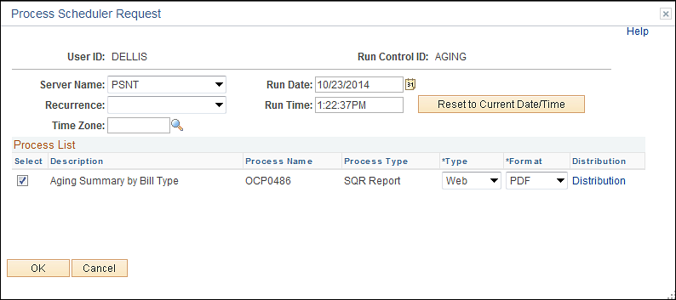

Select the checkbox next to the desired process (OCP0486).

Click to execute the process. Navigate to the Process Monitor to view the Process instance.

Aging Detail by Unit Report

Navigation: Accounts Receivable > Receivables Analysis > Aging > Aging Detail by Unit Rpt > Find an Existing Value
.
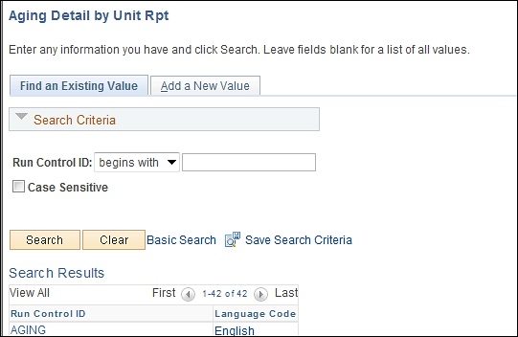

Use an Existing Run Control value or create a New Value.

Click to use an existing Run Control value.

Aging Detail By Unit Page

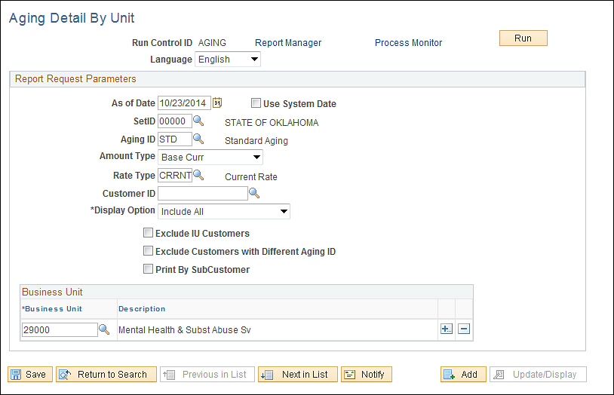

As of Date – define a date at which the aging will be calculated and displayed.

Aging ID – choose a pre-defined aging ID to categorize Items.

Customer ID – choose a customer ID to narrow the aging results by Customer.

Display Option – choose which Items will be included in the aging report.

Business Unit – populate with the agency business unit.

Click to execute the Aging by Unit report.

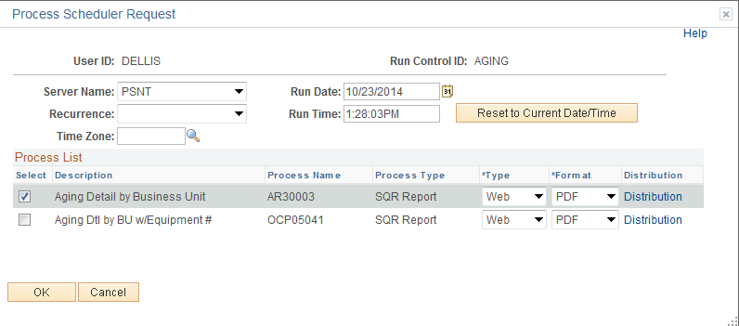

Select the checkbox next to the desired process.

Click to execute the process. Navigate to the Process Monitor to view the Process instance.

Aging Summary by Unit Report

Navigation: Accounts Receivable > Receivables Analysis > Aging > Aging Summary by Unit Rpt > Find an Existing Value
.
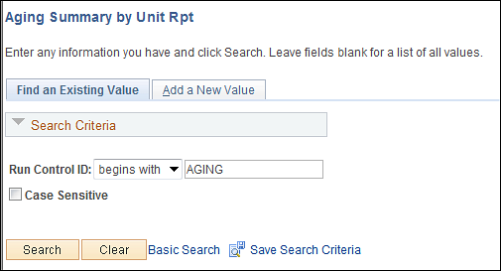

Use an Existing Run Control value or create a New Value.

Click to use an existing Run Control value.

Aging Summary By Unit Page

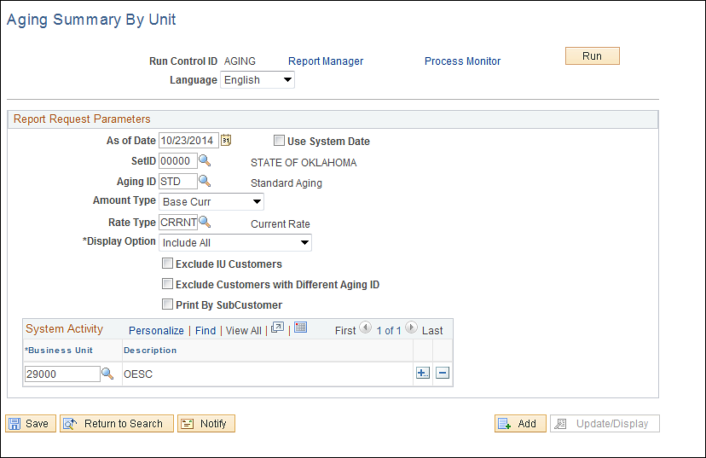

As of Date – define a date at which the aging will be calculated and displayed.

Unit – populate with the agency business unit.

Aging ID – choose a pre-defined aging ID to categorize Items.

Display Option – choose which Items will be included in the aging report.

Click to execute the Aging by Unit report.

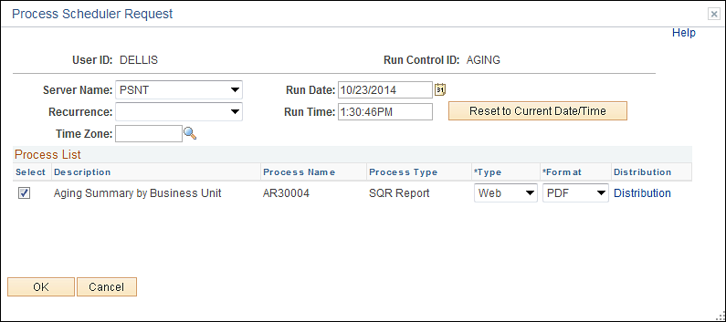

Select the checkbox next to the desired process.

Click to execute the process. Navigate to the Process Monitor to view the Process instance.

Aging By Unit Page

Navigation: Accounts Receivable > Receivables Analysis > Review Receivables Information > Unit Aging

Unit Aging Page
.
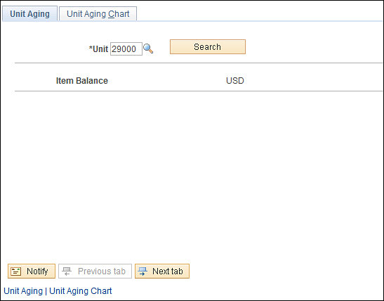

The Unit Aging page displays aging information by business unit.

Item Balance – displays the total amount of aging Items for the business unit.

Click to retrieve Aging Items by aging category.

Unit Aging page continued

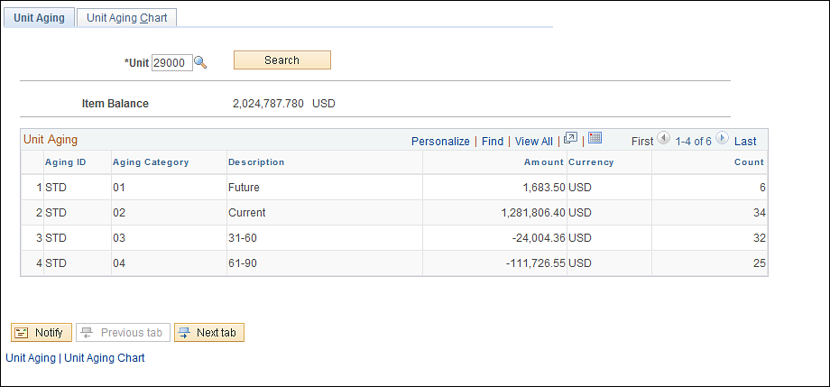

Aging Category – displays the category and description for each aging category.

Amount – displays the total amount of Items at each aging category level.

Count – displays the total number of Items in each aging category.

Click the Unit Tab.

Unit Aging Chart Page

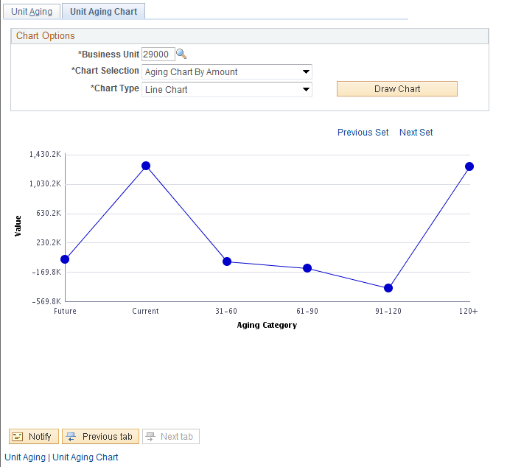

The Unit Aging Chart Page displays the aging information for the business unit by amount or count and category in a graph/chart format.

Chart Selection – choose whether the chart will be built by aging amount or count of Items.

Chart Type – select the type of graph or chart that will be displayed.

Click to display the desired Chart Type.

Navigation: Accounts Receivable > Customer Accounts > Customer Information > Customer Aging

Customer Aging Page

Use the Customer Aging page to define search parameters for the aging information.

SetID – populate with the agency business unit value.

Unit - populate with the agency business unit value.

Customer – select the customer for which the aging will be displayed.

Click to retrieve the aging.

Customer Aging page continued

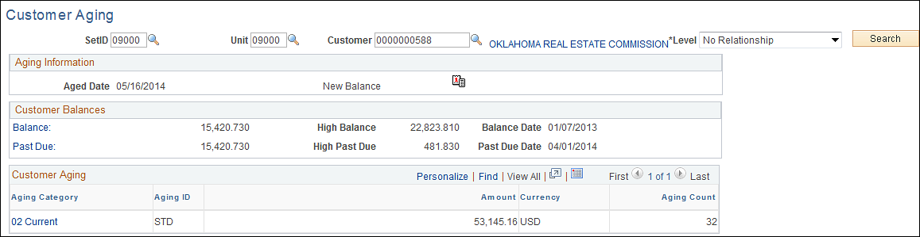

Balance – displays the customer balance by amount and count of Items. Use the Balance hyperlink to drill-down to the Items that make up the customer balance.

Past Due - displays the customer past due balance by amount and count of Items. Use the Past Due hyperlink to drill-down to the Items that make up the customer balance.

Use the Customer Aging section of the page to view aging by category.

Review Customer Accounts
The Account Overview component provides a central location to research information for each customer. The component enables the user to analyze a customer's account at a high level. The component allows drill-down functionality to allow the user to research what makes up a customer balance.

The Account Overview pages allow the user to view various customer balances, the most recent item and payment activity, and summarized aging information.

Customer Account Overview

Navigation: Accounts Receivable > Customer Accounts > Customer Information > Account Overview

Balance Page

Use the Balances page to define search parameters for the Account Overview information.

SetID – populate with the agency business unit value.

Unit - populate with the agency business unit value.

Customer – select the customer for which the account overview will be displayed.

Click to retrieve the customer information.

Balance page continued

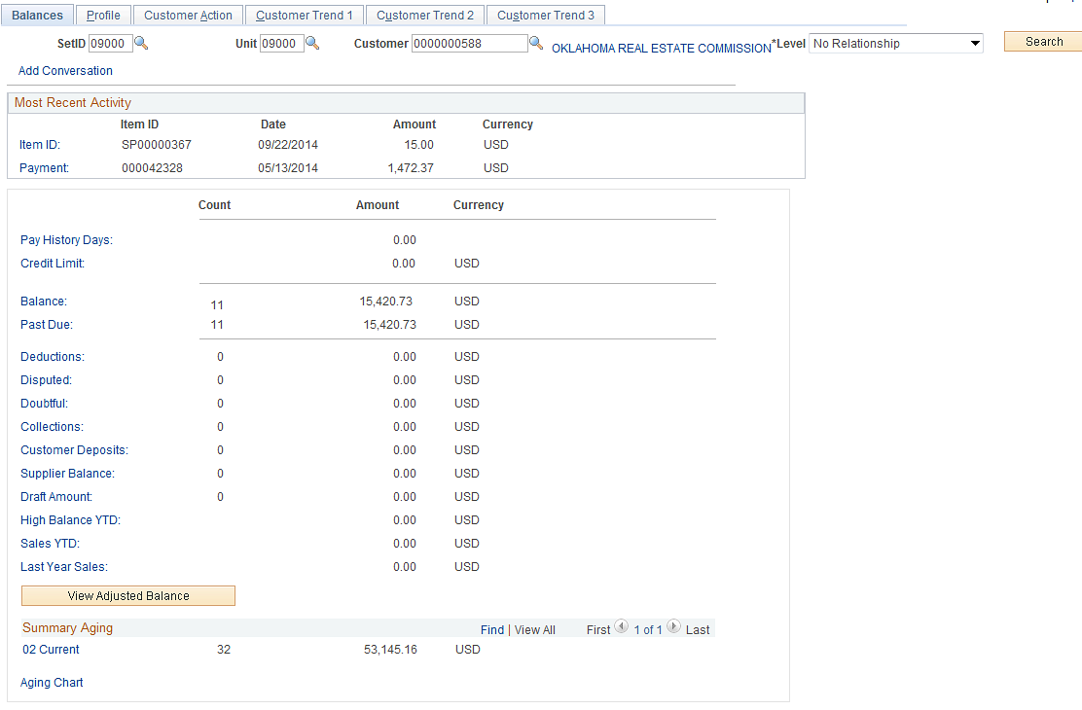

The Balance page displays Customer information for recent activity, balance, past due amounts, etc.

The Most Recent Activity section of the page displays the most recent Item and Payment activity to be posted to the customer account.

Balance – displays the customer balance by amount and count of Items. Use the Balance hyperlink to drill-down to the Items that make up the customer balance.

Past Due - displays the customer past due balance by amount and count of Items. Use the Past Due hyperlink to drill-down to the Items that make up the customer balance.

The Summary Aging section of the page displays the customer balance by aging category. Click the aging category (01 Future) to view the Items that make up that aging category.

Click the Aging Chart hyperlink to view the aging information in a chart format.

Click the Tab.

Profile Page

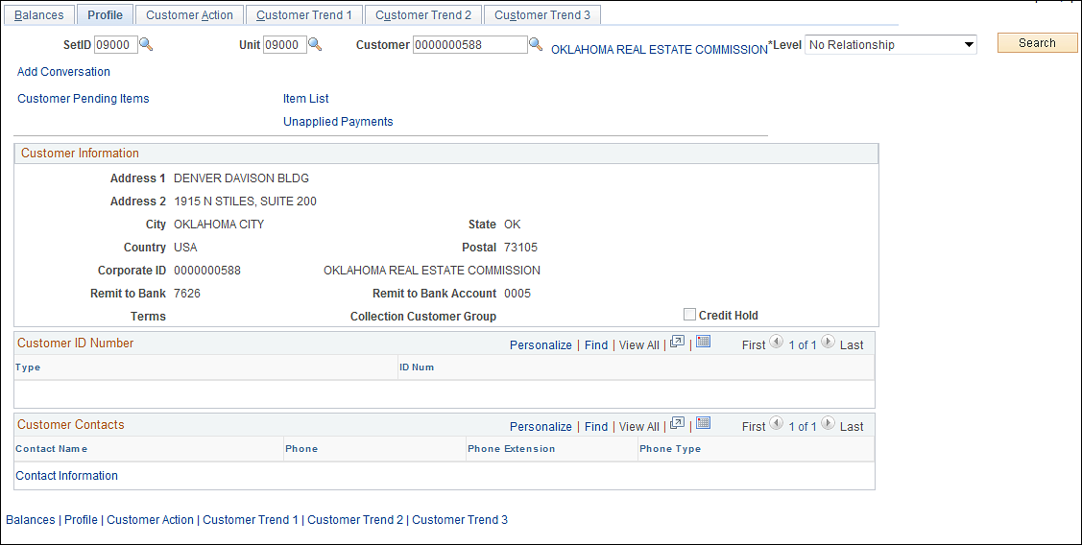

Use the Profile page to view Customer properties including address, bank, payment terms, etc.

Click the Contact Information hyperlink to drill-down to the customer contact information.

Customer Activity Overview

Navigation: Accounts Receivable > Customer Accounts > Customer Information > Customer Activity

Item Activity Page

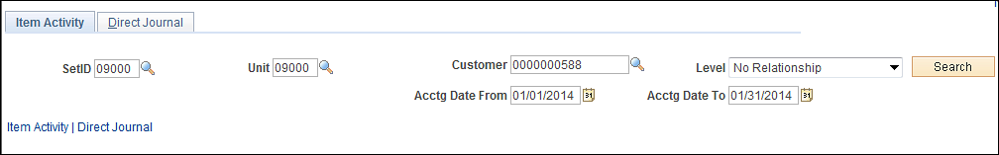

Use the Item Activity page to define search parameters for the Customer Activity information.

SetID – populate with the agency business unit value.

Unit - populate with the agency business unit value.

Customer – select the customer for which the activity will be displayed.

Accounting Date From/To – define a period of time from which customer activity will be retrieved.

NOTE: These fields can be left blank to retrieve all customer activity regardless of date.

Click to retrieve the customer information.

Item Activity page continued

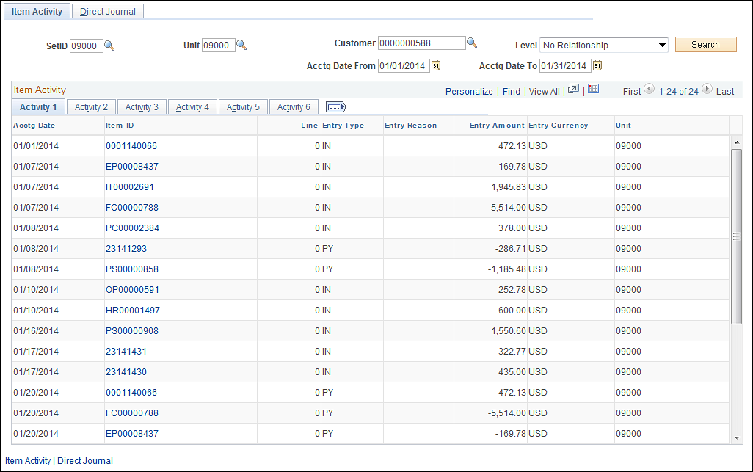

The Item Activity section of the page shows all customer activity matching the search criteria provided.

Accounting Date – displays the Accounting Date for each item.

Item ID – use the item hyperlinks to drill-down to the Item for more details.

Entry Type – determines the type of activity (Invoice, Payment, etc.)

Entry Amount – displays the amount of the Item.

Click the Tab to view Contract information for the Item if applicable.
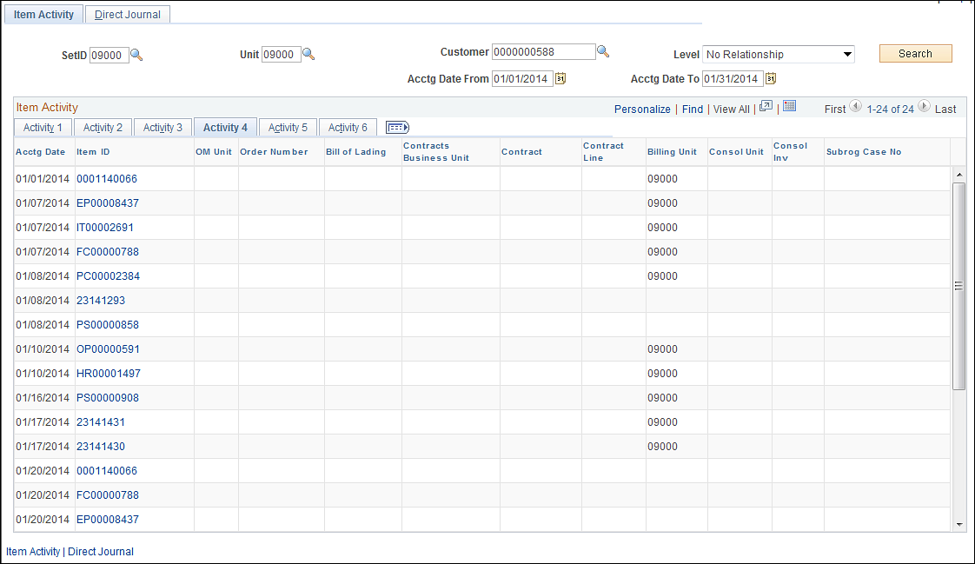
Use the Tab to view direct journal activity for the Customer.

Review Item Activity
Item Activity pages allow the user to view Item Activity related to Billing data, by Group and in Summary format. Items can be retrieved and accessed using the drill-down features available in the Item Review pages.

The Item Activity pages display Item information by Customer ID. This provides a mechanism to research all Items related to a particular customer and take desired action on the Item.

Item List By Customer

Navigation: Accounts Receivable > Customer Accounts > Item Information > Item List

Item List Page

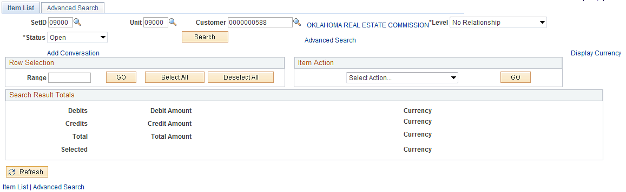

Use the Item List page to define search parameters for the Customer Activity information.

SetID – populate with the agency business unit value.

Unit - populate with the agency business unit value.

Customer – select the customer for which the activity will be displayed.

Click the Advanced Search hyperlink.

Advanced Search Page
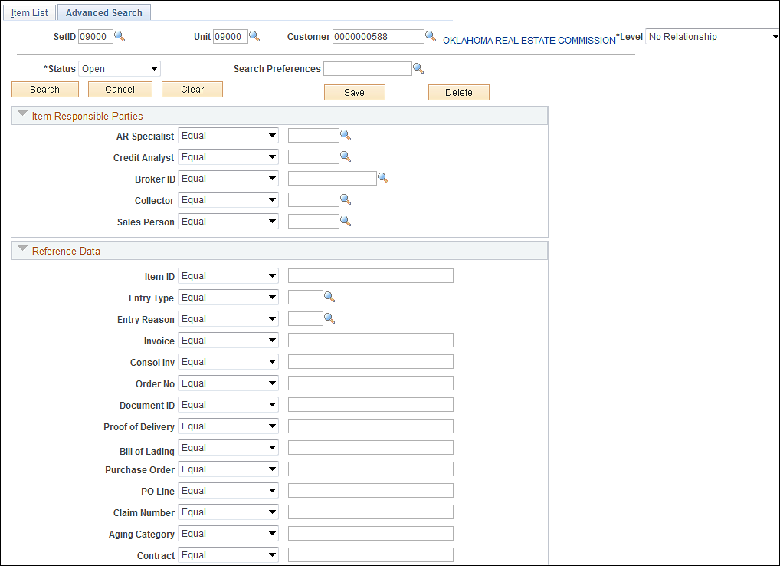

Advanced Search page continued

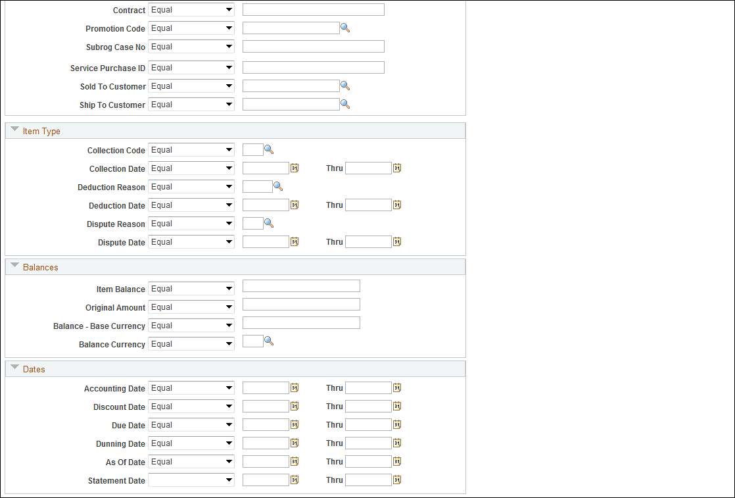

Status – define the Item list by Item Status.

Use the Item Responsible Parties section of the page to filter the Item list by AR Specialist, Credit Analyst, etc. that is assigned to the Item.

Advanced Search page continued

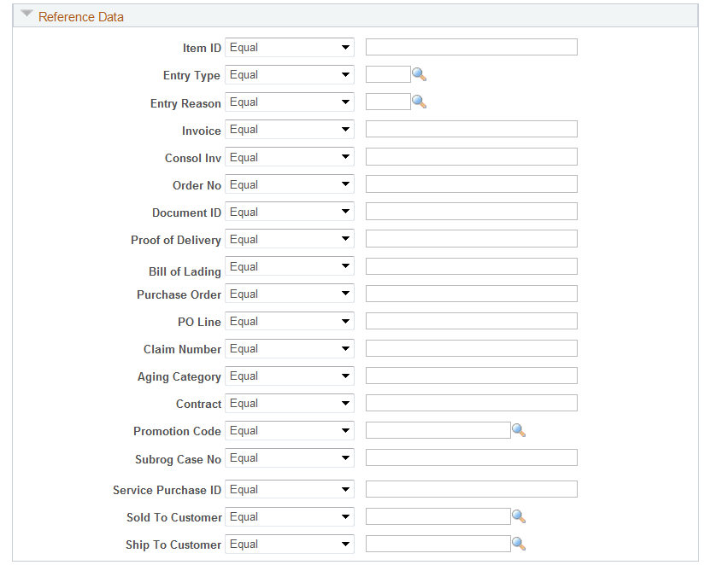

Use the Reference Data section of the page to define Item properties like Entry Type, Entry Reason and Contract ID to filter the Item list.

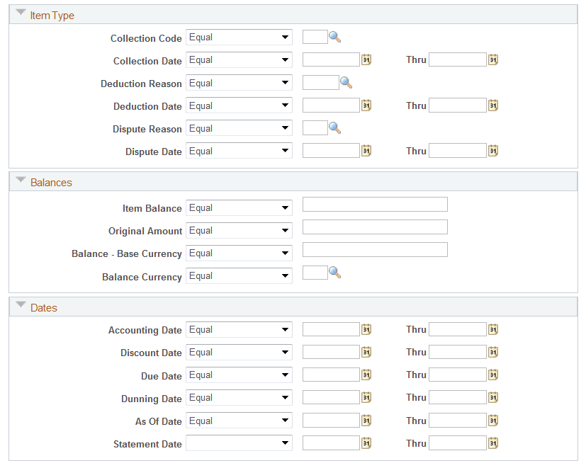

Use the Item Type, Balances and Dates sections of the page to define more search criteria for the Item List..

Click to search for Items by the defined criteria.

Item List page continued

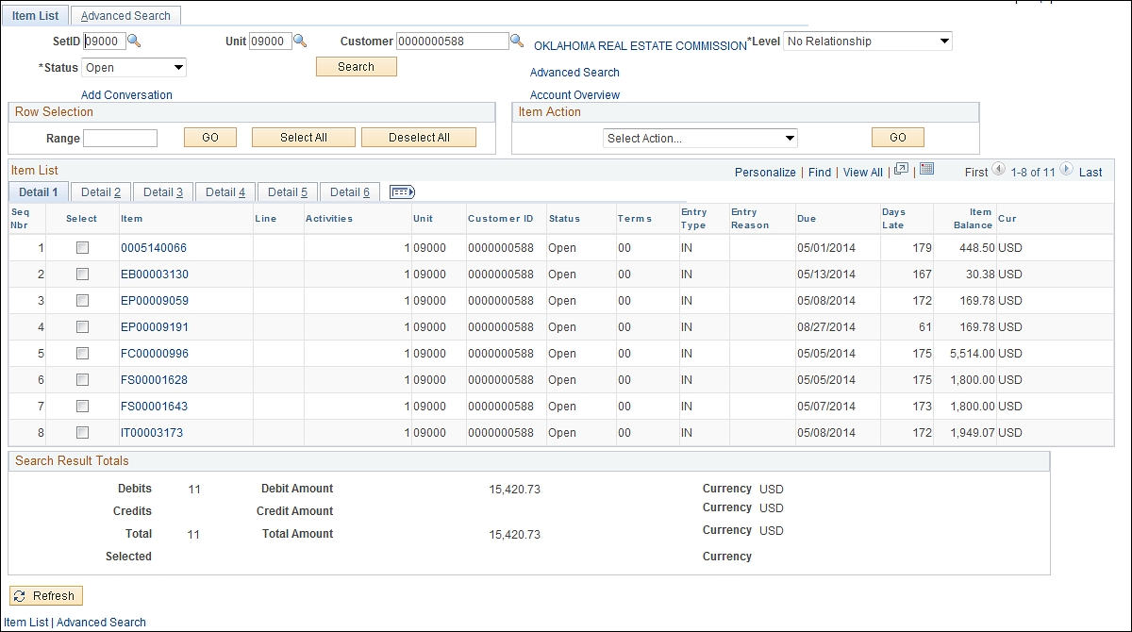

Item – use any Item hyperlink to drill-down to Item properties.

Due – displays each Items Due Date.

Days Late – displays Days Late for each Item.

NOTE: Negative Days Late indicates the Item is not late or will be due in the number of days displayed.

Item Balance – displays the current Item balance for Open Items.

Use the Checkbox next to each Item in combination with the Item Action drop-down to take an action on a particular Item.

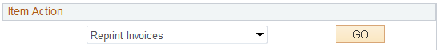

Click the button to execute the Action selected.

Item Billing Data

Navigation: Accounts Receivable > Customer Accounts > Item Information > Item Billing Data

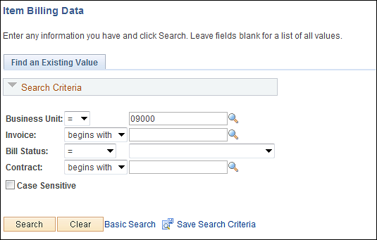

Use the Search criteria to find the desired Bill/Invoice.

Business Unit – populate this field with the agency business unit number.

Invoice – search by Invoice ID.

Bill Status – retrieve all bills in a particular Bill Status.

Contract – search by Contract ID.

Click to enter the Item Billing Data pages.

Item List Page

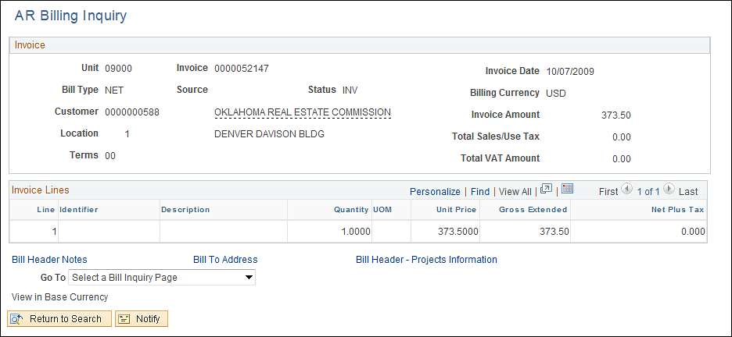

Use the AR Billing Inquiry page to view billing properties for the Item.

Bill Type – displays the Bill Type for the Item (invoice).

Invoice Amount – the total amount of the Item.

Use the Invoice Lines section of the page to view all Item Lines.

Use the hyperlinks at the bottom of the page to drill-down to other Item Billing pages.



Use the Go To drop-down menu to navigate to a related billing page.

Item Activity By Group

Navigation: Accounts Receivable > Customer Accounts > Item Information > Item Activity From a Group

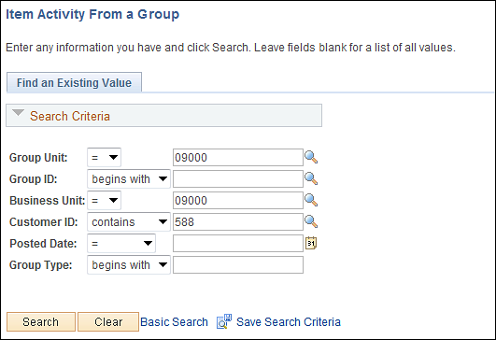

Use the Search criteria to find Items by Group.

Group Unit – populate this field with the agency business unit number.

Group ID – search by a particular Group ID.

Business Unit – populate this field with the agency business unit number.

Customer ID – search for Items in a Group by Customer ID.

Click to retrieve Items matching the search criteria.

Item Activity From A Group Page

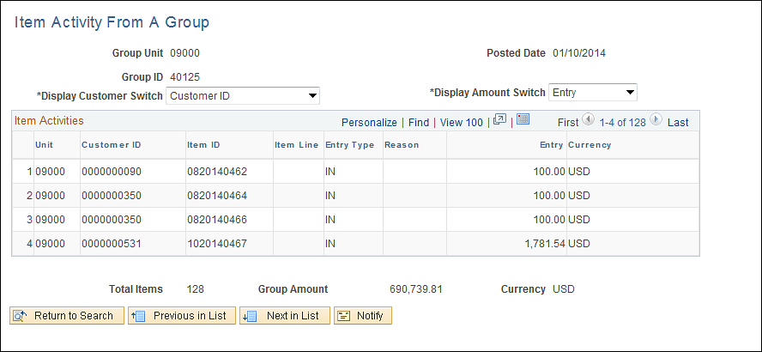

The Item Activity From a Group page shows all Items within a particular Item Group.

Display Customer Switch – select to view the Items in the Group by ‘Customer ID’ or ‘Customer Name’.

Total Items – displays a count of Items in the Group.

Group Amount – displays the total of all Items in the Group.

Customer Statements
Customer Statements are generated to provide customer correspondence on Item balances and activity. The Customer Statement process is a two-step approach. First, the Statements process (AR_STMTS) extracts data from customer and item records and populates statement records. Second, the Statements Print process (ARSTPRT) merges data from the statement records with predefined layouts and prints delivered statement reports (balance forward and open item).

Customer statements are based on current customer balances and open item information, which are updated by the Receivable Update Application Engine process (ARUPDATE).

Step 1: Create Customer Statements

Navigation: Accounts Receivable > Customer Interactions > Statements > Create Customer Statements

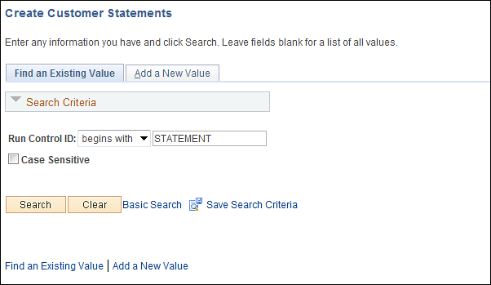

Use an Existing Run Control value or create a New Value.

Click to use an existing Run Control value.

Statement Parameters Page

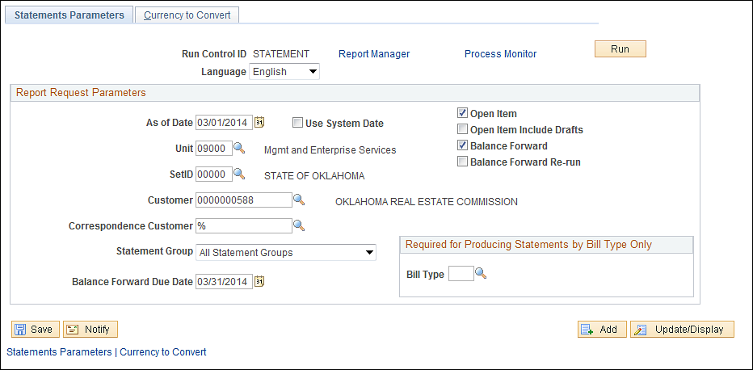

Use the Statement Parameters page to define how the process will populate the customer statement reports.

As of Date – define the date at which the statement data will be calculated. This value defaults to today’s date.

Unit – populate with the agency business unit value. This value will created statement s for all customers in the business unit.

Customer – select the customer on which the statement process will be executed. If this field is left blank, a statement will be created statement s for all customers in the business unit.

Open Item or Balance Forward – select the desired checkbox to run both or one statement type in the same statement run.

NOTE: Customers are defined as ‘Open Item’ or ‘Balance Forward’ customers. It may be necessary to determine how the customer is set up before running the statement process.

Statement Group – enter a statement group to create statements for all groups or only for customers who belong to a selected statement group. Groups are a customer property.

Balance Forward Due Date - Enter the due date to print on the statements, when running balance forward statements.

NOTE: Use the wildcard field (%) in the Unit or Customer Fields to run the statement process for all values that begin with a particular string of characters.

Click to execute the Statement process.

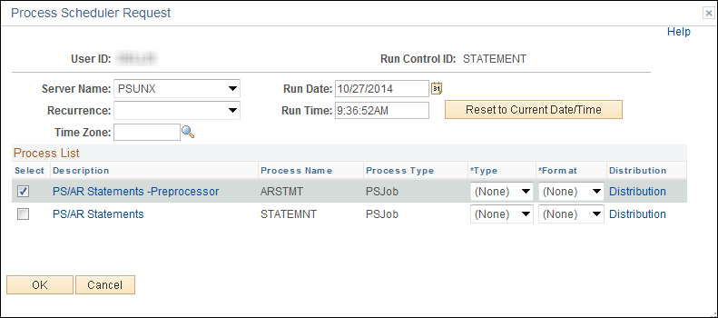

Select the checkbox next to the desired process (ARSTMT).

Click to execute the process. Navigate to the Process Monitor to view the Process instance.

Step 2: Print Statements

Navigation: Accounts Receivable > Customer Interactions > Statements > Print Statements

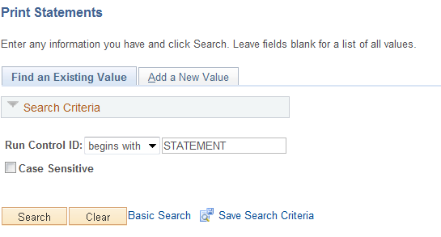

Use an Existing Run Control value or create a New Value.

Click to use an existing Run Control value.

Statement Print Page

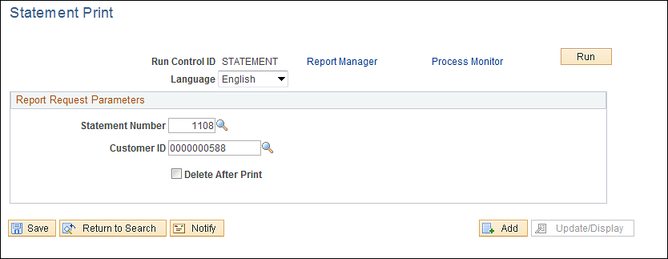

Statement Number – select from the available Statement Numbers. This field displays the most recent number for the run control ID that is not printed.

NOTE: Each time the Create Customer Statements process is executed, it creates a Statement Number. The most recent Statement Number will be available on this page and initially populated if the user uses the same Run Control value for the Statement Report as was used on the Statement Process.

Click to execute the Statement Print process.

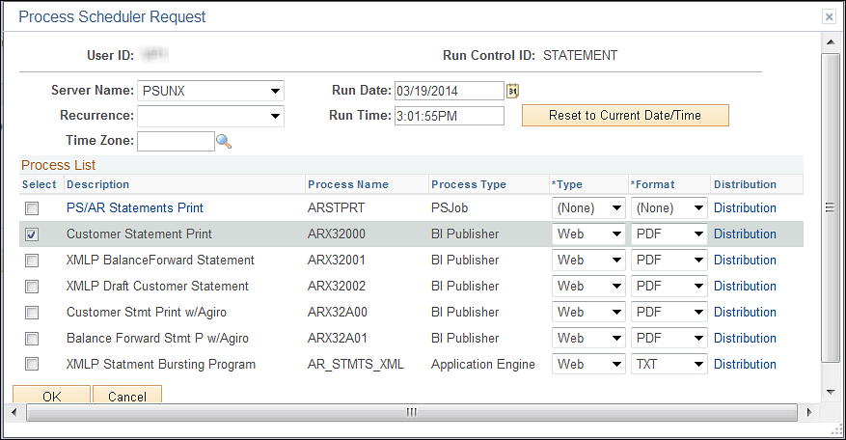

Select the checkbox next to the desired report.

Click to execute the process. Navigate to the Process Monitor to view the Process instance and Report.

Receivables Inquiry
The Receivables Analysis features allow the user to view receivables activity by Unit, Customer, Item, etc.

Business Unit Activity inquiry includes activity posted to a business unit. The system includes only payments that are completely posted in the totals. Business Unit Cash inquiry includes an overview of cash applied and cash received by business unit.

Payment Inquiry pages display all activity associated with a Deposit and/or Payment(s). This includes payment ID, payment amount and Item information

Unit Activities

Navigation: Accounts Receivable > Receivables Analysis > Review Receivables Information > Unit Activities

Unit Activity Page

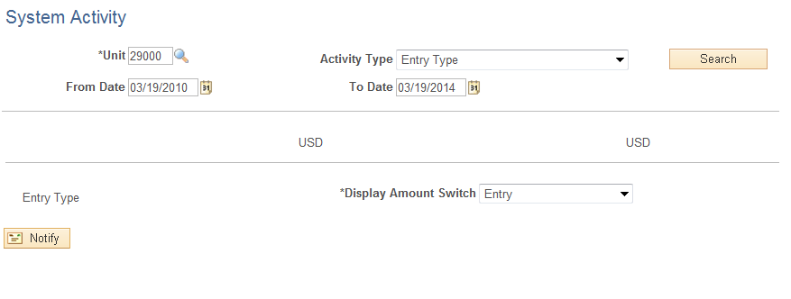

Use the Unit Activity page to search for Items posted to a business unit.

Unit – enter the agency business unit value.

Activity Type – select the type of business unit activity to display.

From/To Date – enter a period of time from which business unit activity will be selected.

NOTE: Leave the Date fields blank to pull all Activity for the Business Unit.

Click to retrieve Unit Activity.
Unit Activity page continued

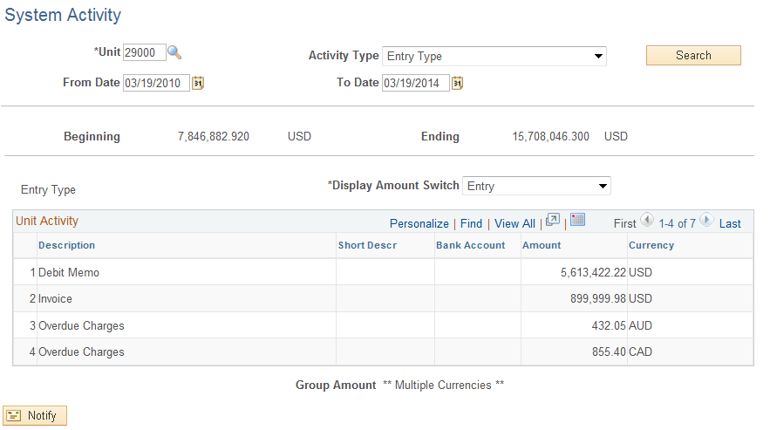

Beginning – displays the total of unit activity at the start of the period defined.

Ending - displays the total of unit activity at the start of the period defined.

The Unit Activity section of the page displays all activity posted to the business unit by type (Invoice, Payment, etc.).

Range Total – displays the balance for the business unit for the time period defined.

Unit Cash

Navigation: Accounts Receivable > Receivables Analysis > Review Receivables Information > Unit Activities

Unit Cash Page

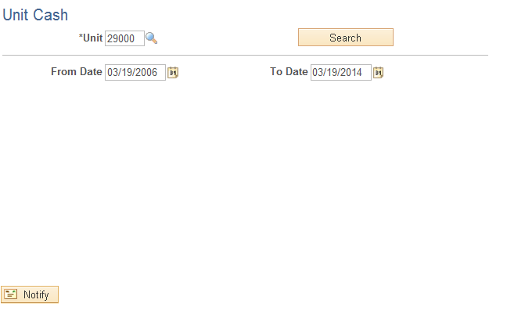

Unit – populate with the agency business unit value.

From/To Date – enter a period of time from which the unit activity will be selected.

NOTE: Leave the Date fields blank to pull all Cash Activity for the Business Unit.

Click to retrieve Unit Activity.

Unit Cash page continued

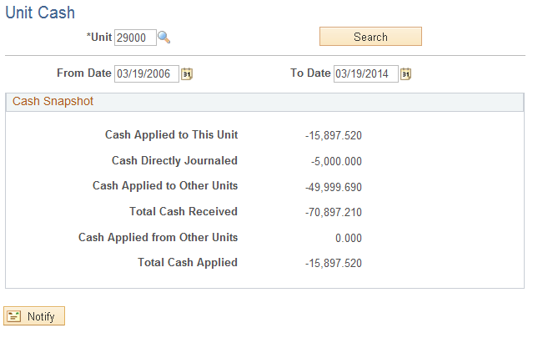

The Cash Snapshot section of the page displays different types of cash/deposits that have been received by the business unit for the date range defined.

Cash Applied to This Unit – displays a total of cash applied to Items.

Cash Directly Journaled – shows a total of all cash directly journaled (not applied to Items).

Total Cash Received – the sum of Applied Cash and Directly Journaled Cash.

Item Activity By Payment

Navigation: Accounts Receivable > Receivables Update > Posting Results-Payments > Item Activity From Payment

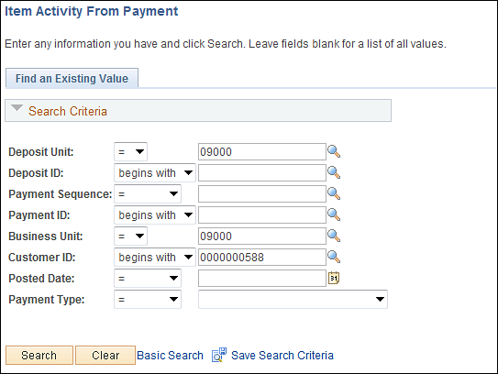

Use the Search criteria to find the desired payment.

Deposit Unit – enter the agency business unit value.

Deposit ID – to search by Deposit ID, enter that value.

Payment ID – enter the payment ID (check number, etc.).

Business Unit - enter the agency business unit value.

Click to enter the Item Activity from Payment pages.

Item Activity From A Payment Page

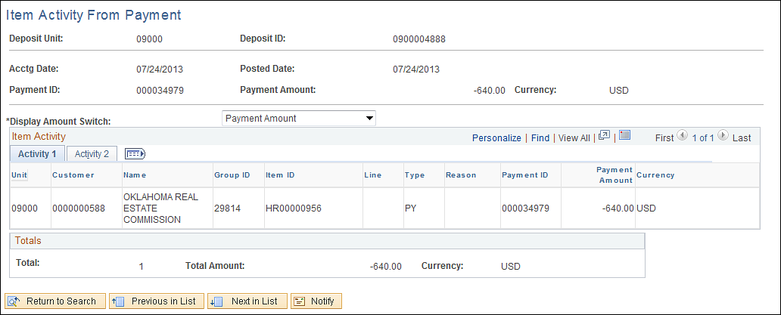

The Item Activity From A Payment page displays Deposit information related to the payments and Items that the payment was applied to.

Payment ID- displays the payment number (check number, etc.).

Item ID – shows the Item that the payment was applied to.

Total – displays the count of Items in the Deposit.

Items With Accounting Entries
Navigation: Accounts Receivable > Receivables Update > Posting Results-Payments > Items w/ Accounting Entries

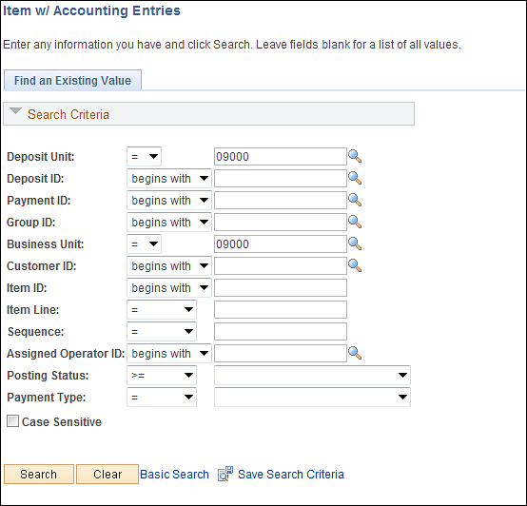

Use the Search criteria to find the desired payment.

Deposit Unit – enter the agency business unit value.

Deposit ID – to search by Deposit ID, enter that value.

Payment ID – enter the payment ID (check number, etc.).

Group ID – enter the Pending Item Group if known.

Posting Status – search for payments by Posting Status.

Click to enter the Item Activity from Payment pages.

Payment Control Page

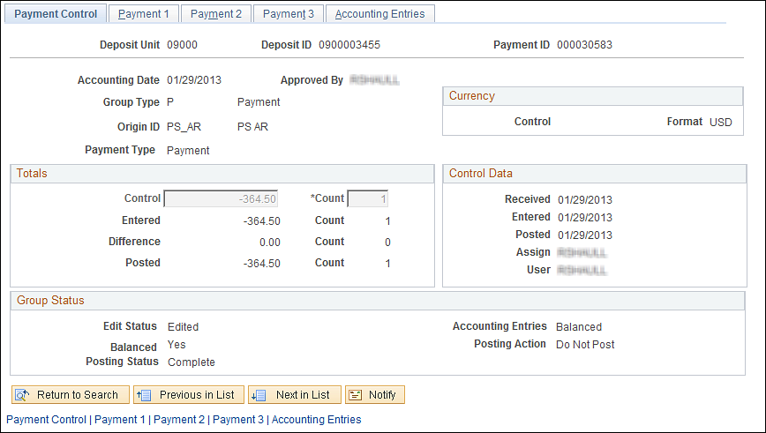

The Payment Control page displays much of the same information as appears on a Deposit or Pending Item Group.

Click the Tab.

Payment 1 Page
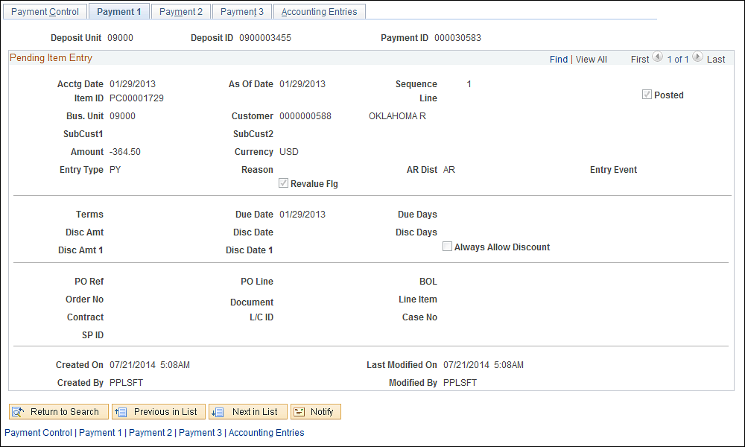

The Payment 1 page displays the Item that was paid by the Deposit.

Accounting Date – displays the accounting date of the payment.

Item ID – displays the Item that the payment was applied to.

Posted – when checked, indicates that the payment has been posted to the customer’s account.

Click the Tab.

Accounting Entries Page

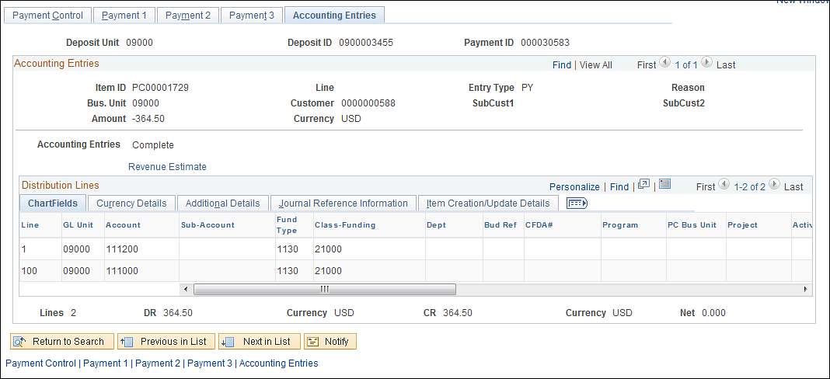

The Accounting Entries page displays the cash accounting entries that affect Accounts Receivable and Cash.

Receivables Reports
Delivered reports are available for Pending Items, Payments, Customer Information and Receivables Analysis.

Business Unit Activity reports show totals by agency business unit for Items, Payments and Balance.

Business Unit Activity Report
Navigation: Accounts Receivable > Receivables Analysis > Recievables Reports > Business Unit Activities > Find an Existing Value

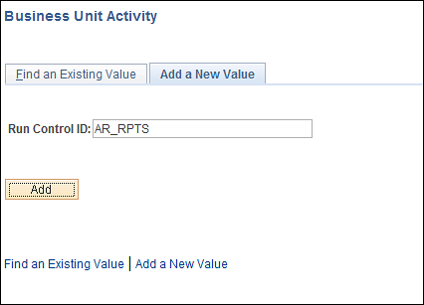

Use an Existing Run Control value or create a New Value.

Click to use an existing Run Control value.
Unit Activity Report Page

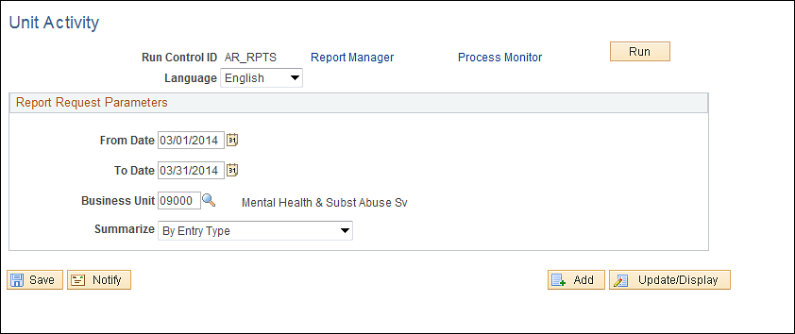

From/To Date – define a date range that will be used to select business unit activity onto the report.

Unit – populate with the agency business unit value.

Summarize – select a pre-defined summary option from the list that will be used to display results on the report.

Click to execute the Statement Print process.

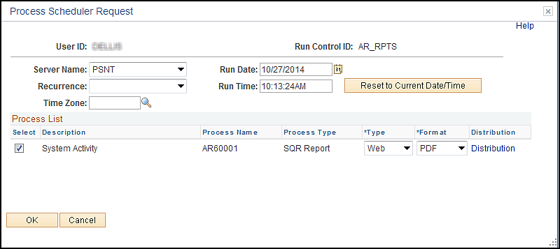

Select the checkbox next to the desired report.

Click to execute the process. Navigate to the Process Monitor to view the Process instance and Report.

