COR411 Asset Management –

Asset Entry and Update Manual

Authorized by: [_EBS_] Original Issue: [05/01/2014]
Maintained by: [____Asset Management Lead___]
Review Date: [05/01/2014]

Table of Contents
Document History 5
Asset Direct Entry Overview 6
Key Terms 7
Process Flows 9
Asset Entry and Update Diagram 9
Asset Entry and Update Process Flows 10
Guidelines, Concepts, Alternatives 11
Asset Groupings 15
Adding Assets Directly Into Asset Management 17
Add an Asset Using Express Add 17
Cost/Asset Information Page 18
Depreciation Information Page 24
Viewing and Updating an Asset 26
Retrieve an Asset to View and Update 26
General Information Page 27
Operation/Maintenance Page 30
Hazardous Assets Code Sub-Page 31
Asset Acquisition Detail Page 34
Acquisition Details Sub-Page 35
Acquisition Detail ChartField Sub-Page 37
Location/Comments/Attributes Page 38
Manufacture/License/Custodian Page 41
Asset Copy 44
Create a New Asset Using the Copy Feature 44
Create Asset Copies Page 45
Creating Parent-Child Assets 50
Step 1: Create a Parent Asset 50
General Information Page 51
Step 2: Create a Child Asset 53
General Information Page 54
Step 3: Search for Parent/Child Assets 56
Parent and Child Assets Page 57
Step 4: Search for Parent/Child Assets Net Book Value 59
Asset Detail Page 60
Net Book Value Page 61
Child Asset Page 62
Asset Search 63
Search for an Asset Page 64
More Filter Options Sub-Page 66

Document History
Document Revision | Date | Description
1.0  2.0 | 03/18/2010  05/01/2014 | Initial Document  Upgrade Update

Asset Direct Entry Overview
The PeopleSoft Asset Management module provides full Addition, Depreciation, Transfer, Adjustment, and Retirement functionality for Owned and Leased Assets. The state requires asset additions to be added through the integration functionality with Purchasing and Accounts Payable modules, but when a purchase order is not used to acquire an asset, it must be added manually on-line or copied from existing Assets in the Asset Management Module. This will commonly occur for the following asset acquisitions:
Assets purchased with the P-Card
Donated assets
Constructed assets for agencies not using Projects Module
Assets transferred from another agency
This manual describes the pages and functionality used to Add and Update Assets, create Parent-Child Asset relationships, and Search for Assets within the Asset Management module.

Key Terms
Asset Management Business Unit: Each agency has one Asset Management Business Unit. The Business Unit is the three (3) digit agency code, plus 00. For example, Office of State Finance is 09000.
Asset ID: Each Asset in the system has a unique Asset ID assigned automatically when the asset is added. The Asset ID is the key number used by the system to track each individual asset. Use this number to search for a particular asset in the system and view or make changes.
Tag Number: All Assets in the Asset Management system can have a Tag Number that matches the physical tag on the asset.
Asset Physical Information: An Asset’s Physical information includes tag number, location, custodian, serial number, and Manufacturer ID.
Asset Financial Information: An Asset’s Financials information includes cost, quantity, useful life, and ChartField values.
Profile ID: Profile ID is a “template” for the Asset that defaults values into the asset used for grouping and depreciation processing. This includes Asset Category, Asset Type, Useful Life, and Depreciation Method and Convention.
Asset Category: Asset Category groups assets together by major asset type for financial reporting purposes. Categories are Land, Land Improvements, Buildings, Infrastructure, Machinery and Equipment, IT Systems, Artifacts and Treasures, Intangibles, Capital Lease – Buildings, Capital Lease – Equipment, and Operating Leases. Asset category is required and included in the Profile ID.
Asset Type: Asset Type is a classification type to report assets within an asset category. Types are IT Hardware, IT Software, Equipment, Property, Fleet, Furniture, Facility, Intangibles, and Other. Asset type is required and included in the Profile ID.
Asset Subtype: Subtype groups assets within Asset Types at a more granular level for internal reporting purposes. Subtypes are optional in Asset Management and are not included in the Profile ID; however, Office of State Finance does require subtypes be included for IT Assets.
Asset Class: Class defines assets within Asset Categories for internal reporting purposes. Asset Classes currently set up were provided by Department of Central Services for assets that are machinery and equipment in nature. Classes are optional in Asset Management and not included in the Profile ID; however, Department of Central Services does require the class be included on the DCS-FORM_SS_001A when an asset is sent to surplus.
CAFR Asset: A capital asset with a cost of $25,000 or more is reportable on the Comprehensive Annual Financial Report (CAFR). The cost of individual assets acquired as part of a group to be used together but can be used as a separate asset must individually meet the $25,000 capitalization policy even though they are connected to other components of the group. Asset grouping is limited to individual components that cannot be used without being connected to other components. Refer to GAAP Package H, Reportable Capital Assets, under Key Terms for specific guidelines.
Cost Type: A Cost Type is used to differentiate between CAFR reportable and non-reportable assets. The cost type, in conjunction with category and asset transaction, will record the accounting entries needed by the CAFR group.
IT Asset: Telecommunication voice response systems and electronic information technology applications, including but not limited to mainframe computers, minicomputers, or microcomputers, word processing equipment, office automation systems, Internet, eGovernment, broadband, WI-FI or wireless networking, radio, including the interoperable radio communications system for state agencies, or Global Positioning Systems (GPS). Refer to the categories and descriptions in the Information Technology and Telecommunications Plan at http://www.ok.gov/cio/Policy_and_Standards/ select the 2011 Annual Report.
Transaction Date: Date on the Asset that reflects the actual date the Asset transaction took place. In the case of a new Asset addition, this is the date the Asset was acquired.
Accounting Date: Date on the Asset that will determine when the Asset transaction will be posted to the General Ledger.
Asset Management Books: Asset Books store financial information about an asset including cost, depreciation rules, and retirement rules. The state will support only one book called ‘STATE’.
Location: The address of where the asset is physically located. The code can be a building or a site, or it can be more specific and include a wing, floor, room, etc. The state requires a location code for each asset.
Custodian: The person responsible for or assigned the asset. The custodian is generally an employee but can be someone other than an employee

Process Flows

Asset Entry and Update Diagram
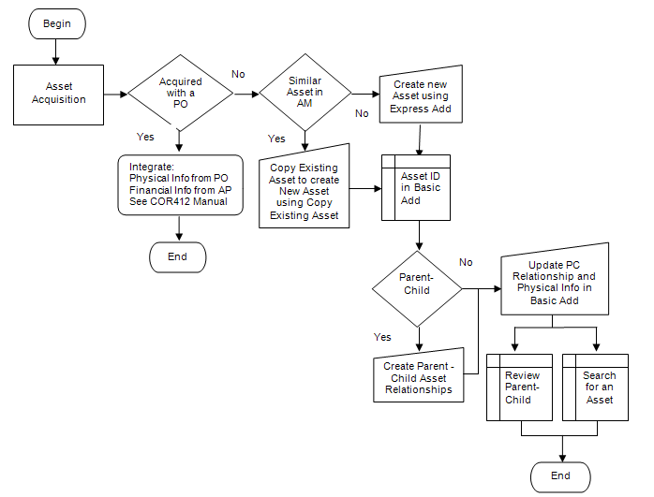

Asset Entry and Update Process Flows
Begin Process
Are Assets acquired with a PO?
If yes, integrate Physical Info from PO and Financial Info from AP (See COR412 Manual) - End

If Assets are not acquired with a PO, is there a similar Asset in Asset Management?
If yes, use ‘Copy Existing Asset’ to create new asset and view in Asset Basic Add.
If no, use ‘Express Add’ to create new asset and view in Asset Basic Add.

Is there a Parent-Child relationship?
If yes, establish Parent Child Relationships and update Physical Info in Asset Basic Add.
If no, update Physical Info in Asset Basic Add.

Use ‘Review Parent Child’ to search for Parent-Child Relationships.
Use ‘Search for an Asset’ using Asset ID or Physical Information to search for all Assets.
End

Guidelines, Concepts, Alternatives
What is a Capital Asset?
The term capital assets includes land, improvements to land, easements, buildings, building improvements, vehicles, machinery, equipment, works of art and historical treasures, infrastructure, and all other tangible or intangible assets that are used in operations and that have initial useful lives extending beyond a single reporting period. (GASB S34, par. 19)
The State of Oklahoma’s capitalization threshold for capital assets is $25,000.

How Should Assets Acquired as Part of a Group be Treated?
The cost of individual assets acquired or leased as part of a group to be used together but can be used as a separate asset must individually meet the $25,000 capitalization policy even though they are connected to other components of the group. Asset grouping is limited to individual components that cannot be used without being connected to other components. Refer to GAAP Package H, Reportable Capital Assets, under Key Terms for specific guidelines.

What Assets, in Addition to Capitalized Assets, Should be Included in Asset Management?
The Asset Management system will be used to track “tangible assets” costing $2,500 or more to meet Department of Central Services reporting requirements per the Administrative Rule 580:70-1-3(a). “Tangible assets" mean machinery, implements, tools, furniture, livestock, vehicles and other apparatus that an agency may use repeatedly without material impairment of its physical condition and have a calculable period of service and a value exceeding the reporting threshold the Director of Central Services establishes for the entity. [74 O.S., Section 110.1(D)]”
The system will also be used to track telecommunication and electronic information technology applications costing $500 or more to meet the requirements specified in Title 62, § 34.12, Subsection 6. Telecommunication and electronic information technology applications “include but are not limited to the use of mainframe computers, minicomputers, or microcomputers, word processing equipment, office automation systems, Internet, eGovernment, broadband, WI-FI or wireless networking, radio, including the interoperable radio communications system for state agencies, or Global Positioning Systems (GPS).2 Refer to the Information Technology and Telecommunications Plan for a more detailed listing of “Defined Categories and Descriptions” at OMES website for IT Information http://www.ok.gov/cio/Policy_and_Standards/ select the 2011 Annual Report.

Asset Management can also be used to track items costing less than $2,500 ($500 if an electronic information technology asset) if they are sensitive for one or more of the following reasons:
Items that require special attention to ensure legal compliance. Legal or contractual provisions may require a higher than ordinary level of accountability over certain capital-type items (e.g., items acquired through grant contracts);
Items that require special attention to protect public safety and avoid potential liability. Some capital-type items by their very nature pose a risk to public safety and could be the source of potential liability (e.g., police weapons);
Items that require special attention to compensate for a heightened risk of theft (“walk away” items). Some capital-type items are both easily transportable and readily marketable or easily diverted to personal use (e.g., sound equipment). 3

What are the State’s Major Asset Categories for Owned Assets?
The State of Oklahoma uses the following major categories:
Art, Artifacts, and Treasures – This includes collections of works of art, historical treasures, and similar items. For art or a collection to be categorized as Art, Artifact, or Treasure, its purpose must be to display or research, and the collection items must be adequately maintained and preserved. Additionally, proceeds from the sale of collection items must be used to purchase other items for the collections. Such collections are often considered to have an indefinite useful life and will generally appreciate in value; thus, assets in this category are not depreciated.
Land – “Land is often associated with some other asset (e.g., land under a building or road). Land should be treated separately; thus, the land purchased with an existing building should not be capitalized as part of the cost of the building. The cost of the land should include the acquisition cost and the cost of initially preparing land for its intended use, provided these preparations have an indefinite useful life, like the land itself. Ownership of land can include separable elements (e.g., mineral rights). These various elements should not be treated as separate assets in their own rights unless they are acquired separately. Land, unless compromised by use, has an indefinite life and is not depreciated.” 4
Land Improvements – This is used for permanent improvements that add value to the land but do not have an indefinite useful life. Examples include fences, retaining walls, parking lots, and most landscaping. Moveable items should be classified as furnishing and equipment.
Buildings – All permanent structures are included in the building category. The cost of an improvement will be treated as a separate asset in the Asset Management System, but can be linked in a Parent-Child relationship.
Infrastructure – “Long-lived capital assets that normally are stationary in nature and normally can be preserved for a significantly greater number of years than most capital assets.” 4 Examples include roads, bridges, tunnels, drainage systems, water and power systems, dams, and lighting systems.
Machinery and Equipment – This category is used for vehicles, furnishings, and similar moveable items, but does exclude assets included in the IT Systems category. It also can be used for collections that do not appreciate in value (e.g., general library collections).
IT Systems – This category was set up separately from machinery and equipment to satisfy the requirements of Title 62, § 34.12. Subsection 6. Assets include telecommunication voice response systems and electronic information technology applications. See the paragraph defining information technology assets in the question on the previous page addressing which assets are tracked in the Asset Management system.
Construction in Progress – Costs incurred to construct or develop a tangible or intangible asset before it is ready to be placed in service. Construction in Progress will be tracked in the PeopleSoft Projects Module and will be classified into the appropriate asset category when the asset is placed in service. If the Projects Module is not utilized, then Construction in Progress totaling $25,000 or more will be reported separately to the CAFR group until the asset is added to the Asset Management Module at the time the asset is placed in service.

How Should a Donated Capital Asset be Valued?
Generally accepted accounting principles state that “donated capital assets should be reported at their estimated fair value at the time of acquisition plus ancillary charges, if any.” 4 The appropriate fair value is the amount that the agency would have had to pay to acquire the asset, not the amount for which the donated asset might be resold.

How Should Bundled Costs be Assigned to Individual Assets?
“Capital assets often are purchased or constructed in bundles (e.g., the purchase of a building and land). An appropriate portion of the cost must be assigned to each.” 4

How Should Assets Obtained through Trade-Ins be Valued?
“If a capital asset is traded-in in the process of purchasing another similar capital asset, the newly acquired capital asset should be recorded at an amount equal to the book value of the asset that was surrendered plus any additional monetary consideration provided to seller.” 4

What is the Acquisition Cost of Internally Generated Software?
Generally accepted accounting principles “prohibit the capitalization of any cost associated with the preliminary project stage of software development. Conversely, costs connected with the application development stage should be capitalized, but only if incurred subsequent to the completion of the preliminary project stage. Even then, capitalization is limited to situations where management authorizes and commits to funding, at least through the current period. Finally, costs incurred as part of the post-implementation/operations stage should never be capitalized.” 4

How Should Significant Costs Incurred after the Asset is Acquired be Treated?
Significant costs incurred in connection with capital assets in periods subsequent to the initial acquisition need to be distinguished between improvements and repairs and maintenance.
“An improvement provides additional value. Such added value is achieved either by 1) lengthening a capital asset’s estimated useful life or 2) increasing a capital asset’s ability to provide services (i.e., greater effectiveness or efficiency). In contrast to improvements, repairs and maintenance retain value rather than provide additional value.” Improvements are capitalized and repairs and maintenance are expensed.
“Often a single project will have elements of both repair and an improvement. In that case, the relative cost of each should be determined and treated separately.” 4
The State will treat an improvement as a separate capital asset and depreciate it over its own estimated useful life. It can be linked in a Parent-Child relationship.

Which Items Should be Depreciated or Amortized and How?
Capital assets that have a definite useful life are depreciated. The State of Oklahoma uses the Straight Line depreciation method, the Half Year convention, and no salvage value to compute depreciation.

How are the Useful Lives of Assets Estimated?
Straight line depreciation is calculated by dividing the asset cost by the estimated useful life in years. Each agency determines the useful life of the assets and should be the period over which services are expected to be provided by the asset based on the agency’s own experience. Factors to consider when estimating a life are materials and construction, specific use, physical environment, maintenance policies, and the risk of technological obsolescence. Refer to GAAP Package H, Reportable Capital Assets, Schedule A, for common life ranges for capital assets. For assets not meeting the CAFR threshold of $25,000 or not subject to the federal capitalization threshold of $5,000 for purposes of federal reimbursement, a useful life of one year has been set up in Asset Management for categories with assets that have a definite useful life.
Estimated useful lives selected for depreciation purposes must be reviewed regularly for reasonableness. “If a change in estimates proves necessary, it should be treated prospectively (i.e., as an adjustment to future charges).” 4

Which Capital Assets Should be Tagged?
Tagging assets with a unique identification number provides an accurate method of identifying individual assets and aids in the taking of the physical inventory. Generally, machinery and equipment type assets are tagged. “Tags should be placed in a location that allows them to be seen and read without having to move the property items. Tags also should always be placed in the same position for a given type of item. Finally, the location of a tag should minimize the danger of disfigurement or removal.” 4 If an asset is not conducive to physically affixing the tag on it, the tag must be maintained in a “central location readily accessible to inventory control officers.” 5
Tags designed simply to indicate the agency’s ownership for items costing less than the reportable threshold of $2,500 may also be used to aid in controlling small dollar, non-sensitive items.

How Often Should a Physical Inventory be Performed?
Asset Management, if used as designed, adds assets from the purchasing process, but does not have an automatic trigger to retire assets. Consequently, agencies should undertake regular physical inventories to account for all the assets no less than once each year.

How can Control over Property Not Maintained in Asset Management be Accomplished?
While agencies are required to maintain control over all tangible assets, there are more efficient means to accomplishing this goal other than tracking small dollar, non-sensitive items in Asset Management. An example of an alternative might be to compute an “office cost package” for items (i.e., desks, chairs, filing cabinets) costing less than the reportable threshold and applying the packaged cost to similarly equipped offices, conference rooms, etc. Tags designed simply to indicate the agency’s ownership can be placed on these items and possession can be validated with digital photos stored in an imaging system or an offsite facility. Photos would be updated during the annual physical audit.

“Individual departments, rather than a centralized finance, normally should be the focus of control efforts. Departments should assign responsibility for different groups of controlled capital-type items to one or more specific individuals. That assignment should be documented within the department and communicated to the centralized accounting function.” 4 The central accounting function should verify the reliability and completeness of the “office cost package” or other alternative procedures concerning controlled items for each department no less than once every three years.

DCS Administrative Rule 580:70-1-2
2 OSF Information Technology and Telecommunications Plan, Fiscal Year 2010, General Background
3GFOA best practice on “Establishing Control over Non Capitalized Items” (2006)
4 GFOA Accounting for Capital Assets – A Guide for State and Local Governments (2008)
5 DCS Administrative Rule 580:70-5-1

Asset Groupings
Asset Category – (Required Field) Groups assets together by major asset type for financial reporting purposes.
Asset Profiles – (Required Field) A template containing default values for an Asset type. Default values include asset category, life (designated by the number in the profile ID), acquisition code, and asset type.
Asset Type – (Required Field and included in profiles) PeopleSoft delivered classification to report assets within an asset category. Types are: IT Hardware (010), IT Software (020), Equipment (040), Property (050), Fleet (060), Furniture (080), Facility (090), Intangibles (100), and Other (999).
Useful Life – Estimated Useful Life of the Asset used in deprecation calculations.

Asset Category - Owned | Asset Profile | Asset Type | Useful Lives
ARTIF – Art and Artifacts | ART_ARTIF | Property | Non Depreciable
LAND - Land | LAND | Property | Non Depreciable
LAND - Land | ROW (Right of Way) | Property | Non Depreciable
LAND - Land | Easement | Intangible | Non Depreciable
LDIMP – Land Improvements | PROPERTYXX * | Property | 1, 5, 10, 15, 20, 25, 30, 40, 50
INFRA – Infrastructure | INFRASTRUCTURE30 | Property | 30
BLDG – Building | FACILITYXX | Facility | 1, 5, 10, 15, 20, 25, 30, 40, 50, 60
ITSYS – IT Systems | HARDWAREXX | IT Hardware | 1, 3, 5
ITSYS – IT Systems | SOFTWAREXX | IT Software | 1, 3, 5
MA_EQ – Machinery & Equipment | EQUIPXX | Equipment | 1, 4, 5, 6, 7, 8, 10, 15, 20
MA_EQ – Machinery & Equipment | FLEETXX | Fleet | 1, 3, 4, 5, 6, 7, 8, 10, 12, 15, 20
MA_EQ – Machinery & Equipment | FURN_EQXX | Furniture | 1, 5, 7, 10, 12

* XX – represents multiple Useful Life values for a Profile ID.

Adding Assets Directly Into Asset Management
The Asset Express component will be used to initially add Assets directly into Asset Management. The Asset Basic Add component will be used to update an asset’s information (generally Physical information) once it has been added in Asset Management.

Add an Asset Using Express Add
Navigation: Asset Management>Asset Transactions>Owned Assets>Express Add>Add a New Value
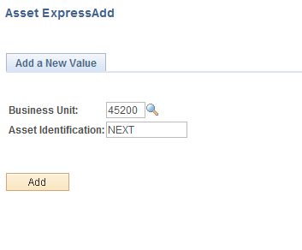
Business Unit – is the Agency in which the Asset will be created. This should default based on the User Preferences setup for the person adding the Asset.
Asset Identification – leave this value as ‘NEXT’, as the system will sequentially assign the actual Asset ID upon completing and saving the Asset.
Click to enter the Asset Express Add pages.

Cost/Asset Information Page
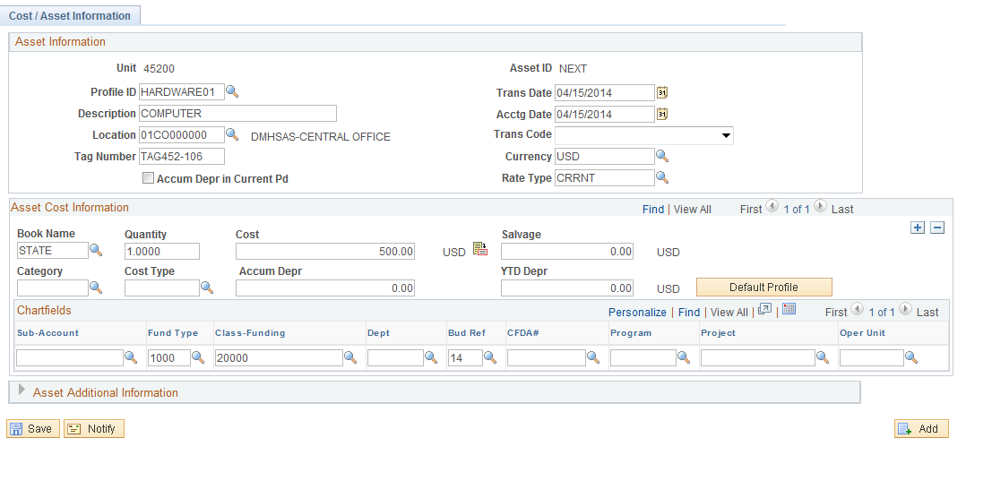

When the user adding the asset initially enters the Cost/Asset Information page, the page will contain only those values that have defaulted from the system configuration. Among other values, these include Dates, Currency information, and Asset Cost information. This is the starting point from which you will begin adding additional asset information to create and save this asset.

NOTE: DO NOT SAVE the page until all information for the Asset is correct and complete! Once the Asset has been saved, the Asset will be “Capitalized” in the system and Financial Information cannot be updated or changed from the Asset Express Add pages. Only changes to Physical information can be made directly to the Asset in Basic Add. All changes to Financials information must be done through an Adjustment or Transfer action (see the COR415 Asset Adjustments and Transfers manual).

NOTE: The Assets capitalization status is stored on the Asset Acquisition Details page (see the following section regarding Viewing and Updating an Asset).

NOTE: The fields referenced and explained below are mentioned in this manual because they are generally required for Assets to be created and processed successfully in the system. Fields not referenced and explained below are either optional for Asset Management functionality or should not be changed from the default value.

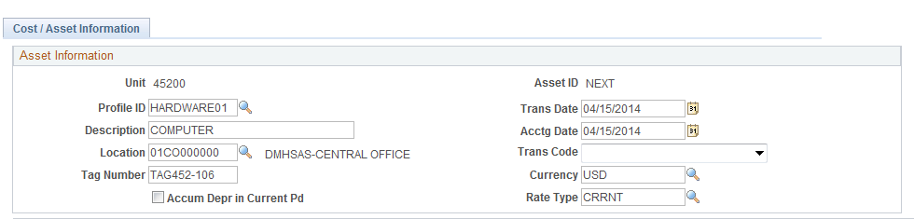

Profile ID – the Profile ID is the starting point for adding an Asset directly into Asset Management and defaults depreciation information into the Asset including Asset Category, Asset Type, Acquisition Code, and Useful Life.

NOTE: Refer to the Asset Groupings page to select the correct Asset Profile for the Asset Type. Select a Profile ID with a useful life of 1 year for assets costing less than $25,000 and a Profile ID with a useful life of more than 1 year for assets qualifying for federal reimbursement or costing $25,000 or more.

Description – the Description field holds 30 characters, alpha-numeric description for the Asset being added. The description entered should conform to agency defined conventions to facilitate agency required reporting.
Location – the Location field defines the physical location for the Asset. The Location values will be specific to each State Agency and are predefined in the system. Use the prompt feature to look-up all valid Locations values for the agency.
Tag Number – the Tag Number field is a free-form field that holds the tag number assigned to the Asset. This generally will be the tag number that is physically affixed to the Asset.
Trans Date – the Transaction Date field holds the date that the Asset Transaction took place. In the case of a new Asset being added to the system, this date would be the Acquisition Date.

NOTE: Assets should be added timely. The Transaction Date is critical for CAFR Assets as it is the date used to drive depreciation calculations.

Acctg Date – the Accounting Date determines in which period the Asset Transaction will be recorded in the General Ledger. The value defaults to current date and should be left as that value.
Currency – this field defaults to ‘USD’ and should not be changed.
Rate Type – this field defaults to ‘CRRNT’ and should not be changed.

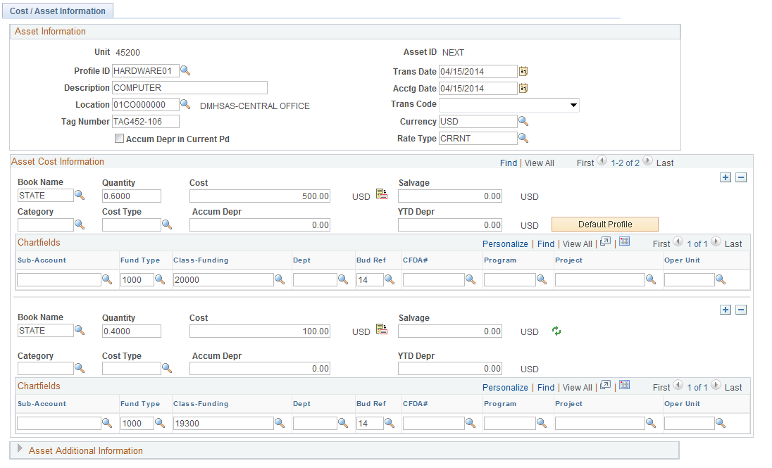

NOTE: The Asset can have one or more Cost rows. Multiple Cost rows would be the case when an Asset is “Split-Funded” between more than one (1) ChartField combinations. The quantity defaults with 1.0000 in each cost row. Leave the quantity in the first row and change the quantity for each additional row to zero.
Use the button to add additional Cost rows to the Asset as necessary. This would be the case if the Asset was purchased with multiple lines of funding (e.g., split funded).

Book Name – the Asset Book field will default to ‘STATE’. The State supports only one Book at this time.
Quantity – the Quantity field will default to 1 (one) and generally will be left at this value unless more than one cost row is used. The Quantity field should only be populated for the first row of the Asset for an Asset that has multiple Cost rows. All other rows should have a value of zero in the Quantity field.
Cost – the Cost field holds the Asset’s monetary cost.
Salvage – do not use the Salvage Value field. The state does not require this information.
Category – the Category defines a grouping of similar Asset’s in Asset Management that is used for reporting and accounting purposes. Leave the Category field BLANK as the Profile ID will populate this field automatically.
Cost Type – the Cost Type field defines an Asset as CAFR reportable. Select the Cost Type of ‘C’ if the Asset is equal to or greater than $25,000.00.
Accumulated Depreciation – do not populate the Accumulated Depreciation field for newly acquired assets.
ChartField Values – based on the funding used to purchase the Asset, populate:
Sub-Account – this field is optional for agency use.
Fund Type – a value must be entered in this field.
Class Funding - a valid five digit value must be entered in this field.
Department - this field is optional for agency use. If used, a valid seven digit department must be entered.
Bud Ref – this field is optional for agency use.
CFDA – this field is optional for agency use.
Operating Unit – this field is optional for agency use.

NOTE: If Fund Type and Class Fund are not entered, the Journal Generation process that creates the Asset Journal in the General Ledger module will fail.

Click to populate the Asset with default values from the Profile ID selected above.

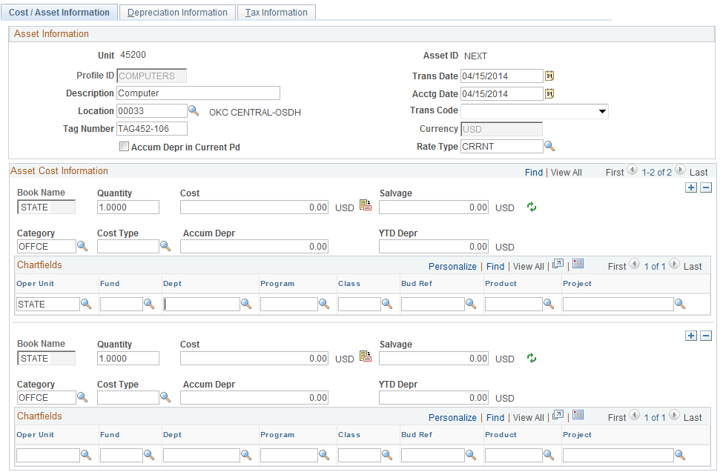
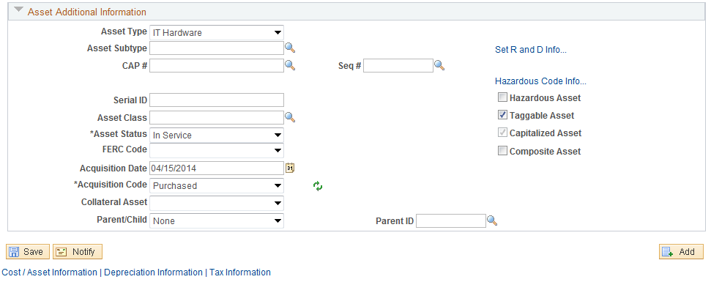

Once the is selected, the Asset Additional Information section page will be expanded and the Tab will be available. The Asset Category field will populate in the Asset Cost Information section of the page and the Asset Type and Acquisition Code will be populated in the Asset Additional Information section of the page.

Asset Type – the Asset Type field should default from the Profile ID selected for this Asset.
Asset Subtype – the Asset Subtype is an optional field for agency use that is a more granular breakdown of the Asset Type value; however, Office of State Finance requires subtypes for ITSYS assets.
Serial ID – the Serial Number field holds the Serial Number of the Asset being added. This value can be up to 20 characters in length. If the serial number exceeds 20 characters, ensure that the Serial ID entered includes the numbers unique to the asset. This may be the last 20 characters.
Asset Class – the Asset Class is an optional field for agency use that groups similar Assets by class.
Acquisition Date – the Acquisition Date defaults from the Transaction Date and should reflect the date the Asset was acquired.
Acquisition Code – the Acquisition Code field will default in as ‘Purchased’. Generally, this field will be left as the default value for new Asset additions to the system but it can be changed to Construct, Donated, or Transfer if the asset is acquired by one of these means.
Click Tab.

Depreciation Information Page
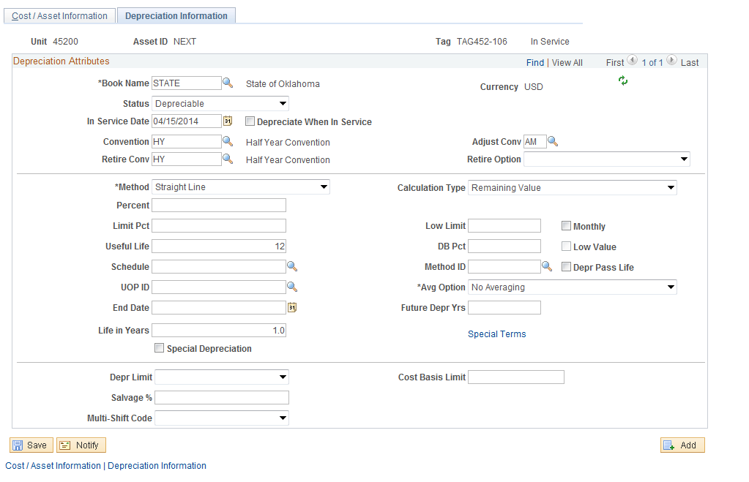

In Service Date – the In Service Date field defaults from the Transaction Date. This field should reflect the date that the Asset was placed in service. This date could be different than the Transaction, Accounting, or Acquisition Dates entered on the Cost/Asset Information page.
Useful Life – the Useful Life field will default from the Profile ID selected on the previous page. This value can be changed to reflect the actual life of the Asset if there is not a Profile ID configured to match the actual life. However, a change to the Useful Life field should be rare.
Click to Save the Asset and assign the Asset ID.

NOTE: DO NOT SAVE the page until all information for the Asset is correct and complete! Once Saved, the Asset will be “Capitalized” in the system and Financial Information cannot be updated or changed from the Asset Express Add pages. Only changes to Physical information can be made directly to the Asset. All changes to Financial information must be done through an Adjustment or Transfer action (see the COR415 Asset Adjustments and Transfers manual).

NOTE: The Asset ID will remain ‘NEXT’ until the Save button has been clicked and the Asset has been saved. Until this time, any values populated in the page will not have been saved in the system.

NOTE: The Asset ID assigned by the system is the next number in a consecutive auto-numbering scheme.

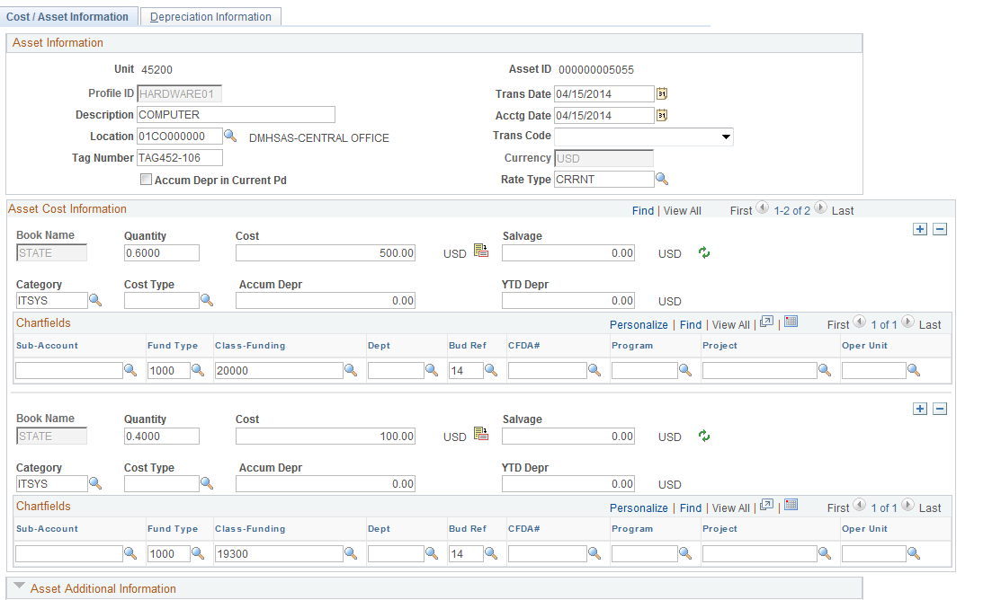

When the Asset has been saved successfully, the Asset ID will be visible at the top of the page.

Viewing and Updating an Asset
Once an Asset has been created and saved using the Asset Express pages above, it cannot be viewed later through those same pages. The Asset can only be retrieved, reviewed, and the Physical information updated using the Asset Basic Information pages.
In contrast to the Asset Express Add pages that allow you to enter general information for the Asset, the Asset Basic Information pages allow you to add additional, more specific information pertaining to the Asset. This includes such information as Manufacturer ID, Model Number, Comments, and Custodian.
The Asset Basic Information pages also provide a mechanism to update physical information that has been added previously to the Asset. Description, Location and Tag Number are examples of information that can be updated in the Asset Basic Information pages.
Finally, only updates to an Asset’s Physical information, not Financial Information, can be made through the Asset Basic Information pages.

Retrieve an Asset to View and Update
Navigation: Asset Management> Asset Transactions > Owned Assets > Basic Add > Find an Existing Value

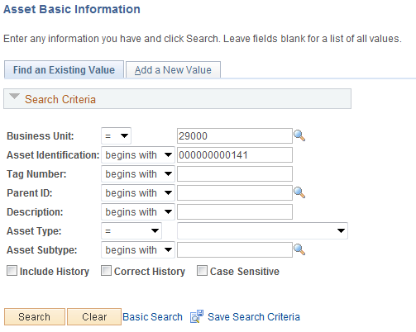

Use the Search Criteria for the Asset Basic Information pages to retrieve the Asset you are looking for.
Generally, the Asset ID, Tag Number, or Description would be Search Criteria used to retrieve a particular Asset.
Click to retrieve the Asset based on the Search Criteria provided.

General Information Page

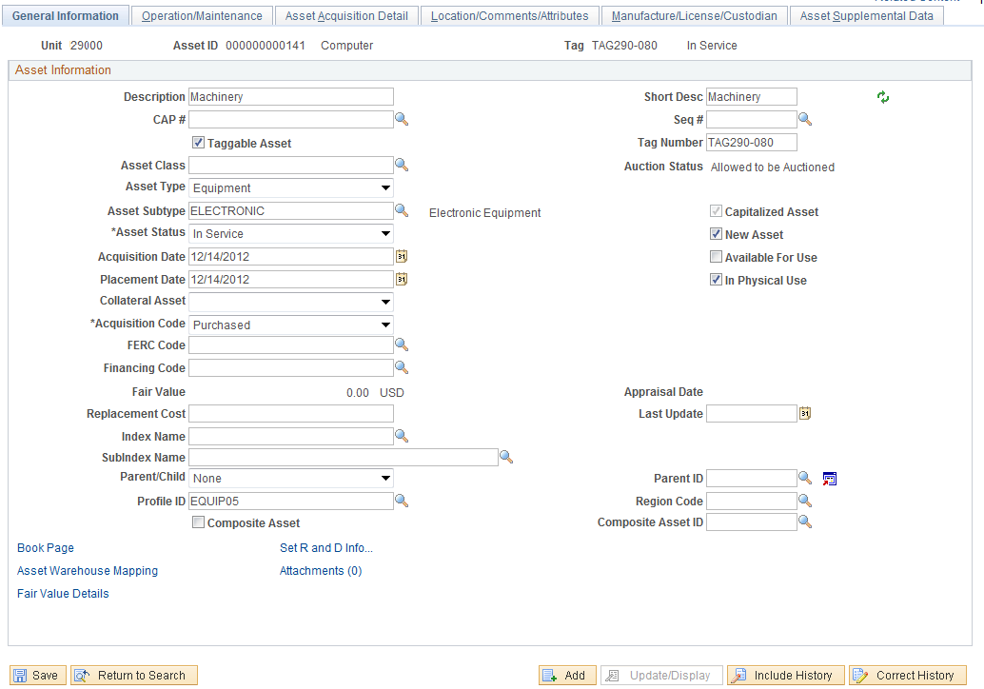

The Tab holds information about the Asset that was added when the Asset was created manually in the Express Add pages (Information for assets created from the Purchasing/Accounts Payable interface will also be viewable in Basic Add). The following fields are available for update or review on this page:
Description – the Description can be provided when the Asset is added directly in Asset Management or from the Purchase Order/Voucher.
Short Description – the Short Description holds a 10 character field to describe the Asset. This value could be similar to an acronym for the Asset and can be used to search for the Asset in the system.
Taggable Asset – this value defaults from the Profile ID and indicates whether or not the Asset should carry a Tag Number. Tag numbers will be necessary to perform physical inventories for taggable assets when the Asset Management Physical Inventory application becomes available.
Tag Number – this field holds the tag number for the Asset. Typically this is the tag number affixed to the Asset.
Asset Class - the Asset Class can be provided when the Asset is added directly into Asset Management and is updateable at any time.
Asset Type – the Asset Type is defaulted from the Profile ID when either the Asset was added directly in Asset Management or it was integrated from the Purchase Order/Voucher.
If the Asset Type is incorrect, most likely the incorrect Profile ID was selected. Although the Asset Type is an updateable field on the General Information page, it should be updated only if the incorrect and correct Asset Types are grouped in the same Asset Category.
For example, if a Profile ID with an Asset Type of Equipment was originally selected for a Fleet asset, the Asset Type can be changed to Fleet since both the Equipment and Fleet Asset Types are grouped in the Machinery and Equipment Asset Category.

Conversely, if a Profile ID with an Asset Type of Equipment was originally selected for an IT Asset, the Asset Type field should not be updated to Hardware since it is grouped in the IT Systems Asset Category. A Re-categorization Financial Transaction will be necessary to make the correction. See the COR415 Asset Adjustments and Transfers manual.
Asset Subtype- the Asset Subtype can be provided when the Asset is added directly into Asset Management and is updateable at any time.
Acquisition Date – the Acquisition Date can be provided when the Asset is added directly in Asset Management or from the Purchase Order/Voucher.
Placement Date – the Placement Date is the date the asset was placed in service and can be provided when the Asset is added directly in Asset Management. If it is incorrect, the In Service Date on the Book – Depreciation Page should be updated. See the screen shot on the next page.
Acquisition Code – the Acquisition Code can be provided when the Asset is added directly into Asset Management or comes from the Purchasing/Accounts Payable interface and is updateable at any time.
Replacement Cost – Department of Central Services requests this value be populated for Buildings and should be updated annually.
Parent/Child – the Parent/Child functionality will be defined in a subsequent section of this manual.
Profile ID – the Profile ID is assigned when the Asset is added directly in Asset Management or from the Purchase Order/Voucher. Once an asset has been assigned an Asset ID, this value should not be changed here. The Profile ID functions as a default for other Asset information including Asset Category, Asset Type, Acquisition Code, and Useful Life.

NOTE: Changing the Profile ID for the Asset in the Asset Basic pages will not dynamically change the information that was defaulted into the Asset from the Profile ID when the Asset was created! Those types of change must be made directly to the Asset information itself. For example, changing the Profile ID from an Equipment Profile to a Furniture Profile will not change the Asset Type from Equipment to Furniture. Because information that defaulted from the Profile ID can be updated, Asset Management offers no reports that include Profile ID.

Click Book Page link to transfer to the Asset Book pages.

Click to save the changes made in the Asset Basic pages and transfer to the Book pages.

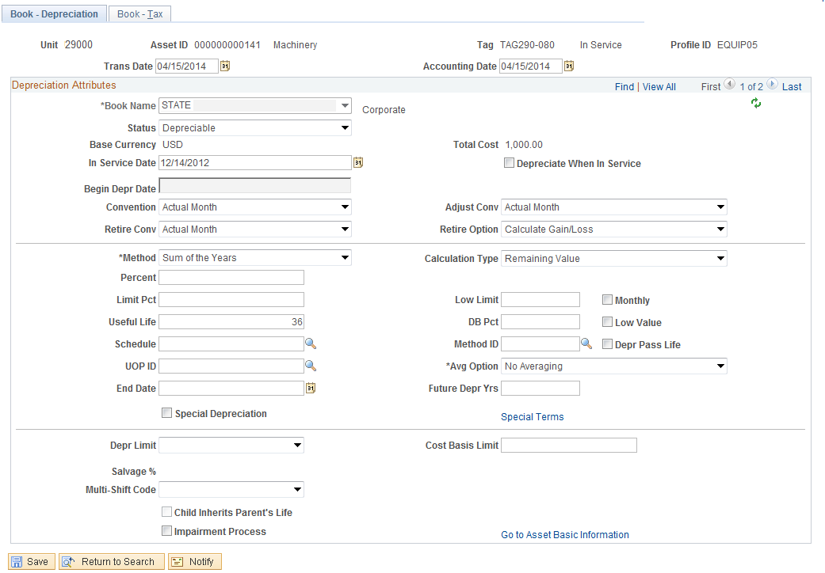

Use the Book - Depreciation page to review the Asset Depreciation Attributes. These values were added when the Asset was created manually in Express Add pages. (Depreciation information for assets created from the Purchasing/Accounts Payable interface is also viewable on this page.) The following fields are available for review or update on this page:
Status – the Depreciation Status for the Asset cannot be changed.
In Service Date – the In Service Date can be changed to reflect the date the Asset was placed in service.
Convention – the State’s Depreciation Convention is Half Year and cannot be changed.
Retirement Convention – the Retirement Convention cannot be changed.
Depreciation Method – the Depreciation Method cannot be changed. Straight Line method will be used by the State.
Useful Life – the Asset’s Useful Life value can be changed to reflect the correct useful life if there is no Profile ID to match the desired useful life for the Asset.
Click Go to Asset Basic Information link to return to the Asset Basic Information pages.
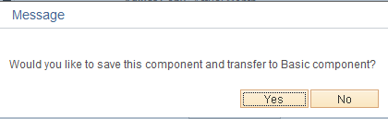
Click to save the changes made in the Asset Book pages and transfer to the Basic Information pages.

NOTE: No date changes are proposed in this page due to Half Year Convention.

Click Tab to access the Operation/Maintenance page.

Operation/Maintenance Page
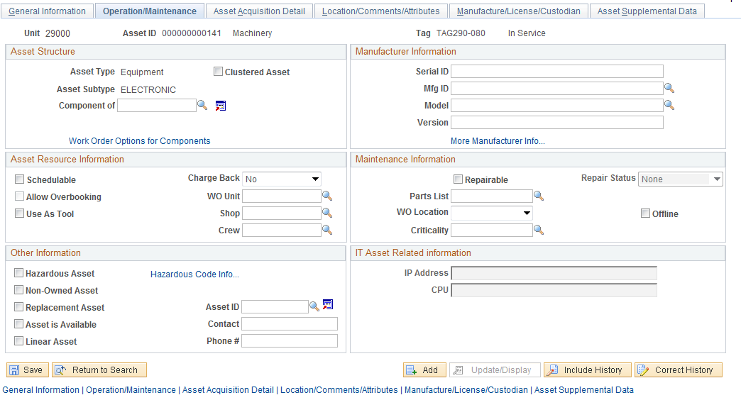
The Tab holds various kinds of Asset Physical information that can be maintained on the Asset.
Hazardous Asset – select this checkbox to indicate the Asset as being Hazardous in nature.
Non-Owned Asset - select this checkbox if the Asset is not owned by the Agency.
Serial ID – the Serial ID can be populated on the Asset Express Add, here on the Basic Add pages, or through the Asset Receiving process in the Purchasing Module. If necessary, update that value for the Asset here.
Mfg ID – the Manufacturer ID field holds the Asset manufacturer value. This is a pre-defined value that must be added to the system before it can be selected for an Asset on this page. If the manufacturer is not pre-defined, submit a help desk case to request it be added. DCS requires manufacturer ID for machinery and equipment per OAC 580:70-3-1 (c) (4).

NOTE: The Manufacture ID can be added to the Asset on this page or the Manufacturer/License/ Custodian page illustrated below. Adding the Manufacturer ID on either page is the same.

Click the Hazardous Code Info… link to select a Hazardous Asset Code if the asset is a Hazardous Asset.

Hazardous Assets Code Sub-Page

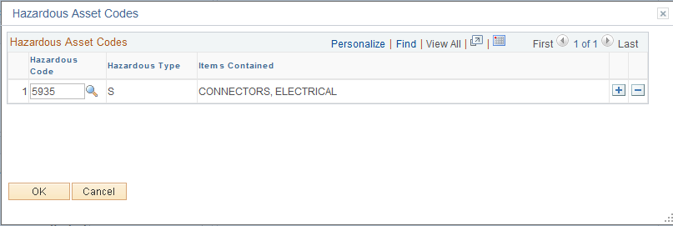

Hazardous Code – if applicable, select the Hazardous Code that Applies to this asset. Codes are:

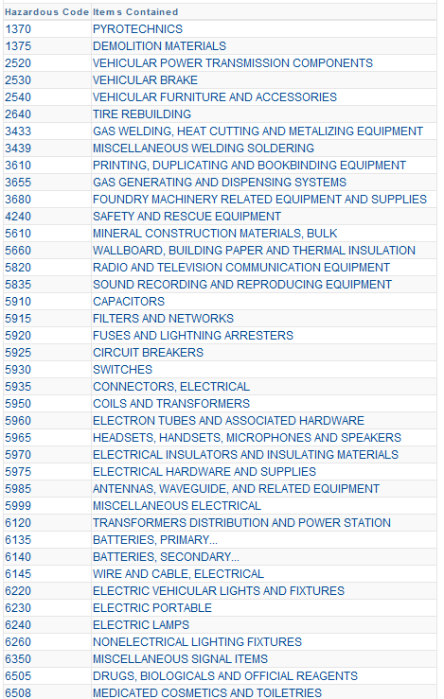
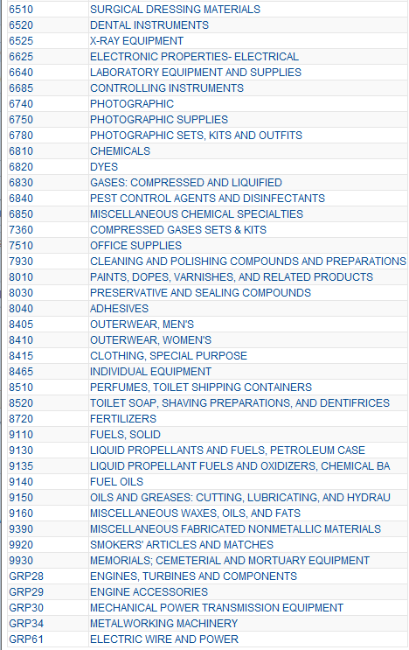
Click to return to the Operation/Maintenance page.
Click Tab to access the Asset Acquisition Detail page.

Asset Acquisition Detail Page

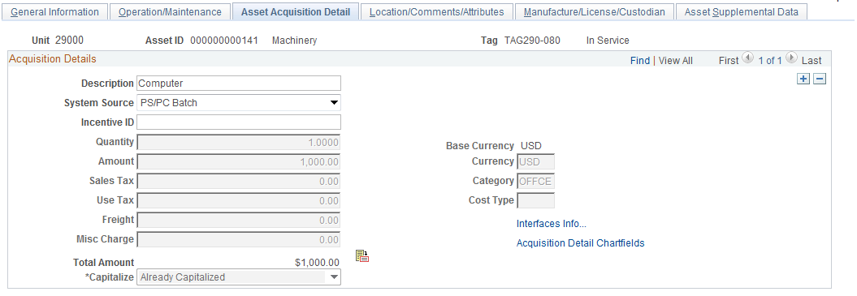

The Asset Acquisition Detail page holds additional information related to the Asset’s purchase or creation. This includes quantity and monetary amounts as well as ChartField distribution and any interface information from Purchasing, Accounts Payable, or Project Costing where the Asset was interfaced from.

NOTE: The Acquisition Details section of the page may have multiple rows indicating an Asset that was funded by more than one distribution line.

Description – the Description field reflects description entered on the Asset if created in the Asset Express page or from the Purchase Order or Accounts Payable Voucher Line.
System Source – the System Source indicator reflects the origin of the Asset (Accounts Payable or Purchasing). The System Source will be blank if the Asset was created manually in the Asset Management module.
Quantity – this field reflects the Quantity of the Asset when it was created.
Amount – this field reflects the Cost of the Asset, or Amount of the Distribution Line if multiple rows exist, when the Asset was created.
Capitalized – when the Asset is created in the Asset Express pages, the Capitalization indicator is set to ‘Already Capitalized’. Once the status of an Asset is ‘Already Capitalized’, the Financial data fields on the page and in the Acquisition Details ChartFields link are grayed out and can no longer be updated in the Basic Add component.
Click Interfaces Info link to view or add more Acquisition Details information.

Acquisition Details Sub-Page

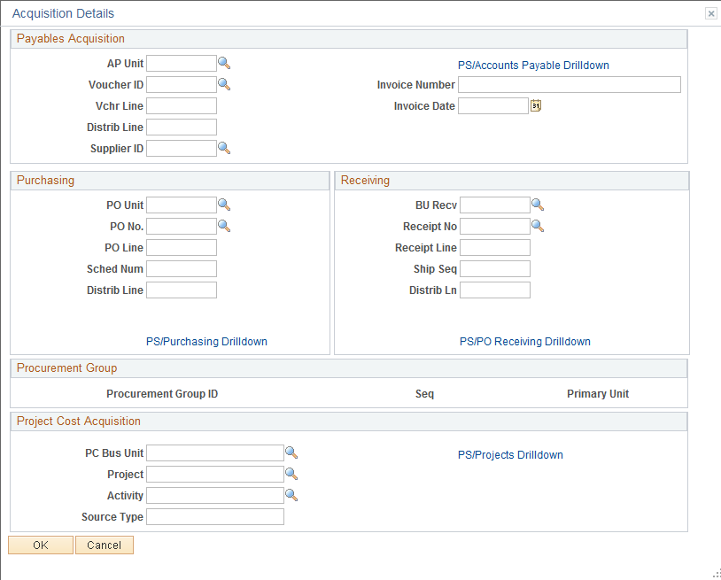

The Acquisition Details page shows transactional information for an Asset that is interfaced from Purchasing or Accounts Payable. If the Asset was created manually in Asset Management, you can add Purchase Order or Accounts Payable Voucher detail in this page.
Payables Acquisition:
AP Unit – Agency Accounts Payable Business Unit value
Invoice Number – Vendor Invoice number for the Asset
Voucher ID – Accounts Payable voucher that created the Asset
Invoice Date – Invoice Date from the Vendor Invoice
Voucher Line – Accounts Payable Voucher Line
Distribution Line – Accounts Payable Voucher Distribution Line
Vendor ID - Accounts Payable Vendor
The PS/Accounts Payable Drill Down link allows you to drill down to the Accounts Payable Voucher that paid for the Asset.
Purchasing:
PO Unit - Agency Purchasing Business Unit value
PO Number – Purchase Order number that created the Asset
PO Line – Purchase Order Line number
Schedule Number - Purchase Order Schedule number
Distribution Line - Purchase Order Distribution Line number
The PS/Purchasing Drill Down link allows you to drill down to the Purchase Order for the Asset.
Receiving:
Receiving BU – the Agency Business Unit the Asset was received in
Receipt Number – the Receiver Number that created the Asset
Receipt Line – the Receiver Line Number
Ship Sequence – the Receiver Shipping Sequence Number
Distribution Line – the Receiver Distribution Line Number
The PS/PO Receiving Drill Down link allows you to drill down to the Receipt for the Asset.
Click to return to the Asset Acquisition Detail page.

From the Asset Acquisition Detail page, click Acquisition Detail ChartFields link to view ChartField information for the Asset.

Acquisition Detail ChartField Sub-Page

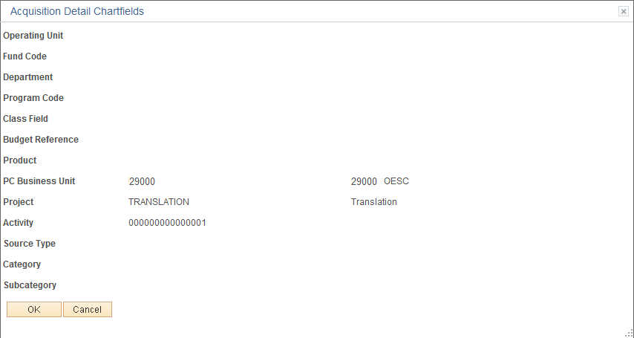

The Acquisition Detail ChartFields page displays the funding ChartField values used to purchase the Asset. These values are display only. To make ChartField changes to the Asset, see the COR415 Asset Adjustments and Transfers manual.
Click to return to the Asset Acquisition Detail page.
Click Tab to access the Location, Comments, and Attributes page.

Location/Comments/Attributes Page

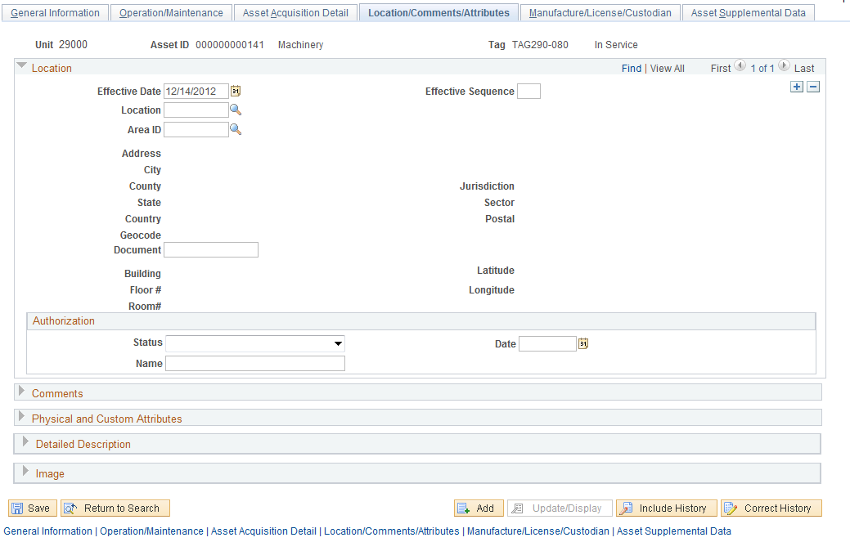

The Location/Comments/Attributes page holds Physical information including the Location of the Asset, Comments related to the Asset, Physical properties of the Asset, and any Images.
Effective Date – use the Effective Date value to indicate the date that the Location value is effective. This allows you to track Location changes by date in the Asset’s physical location.

NOTE: To change the Location for an existing Asset you must add a new Location row using the button to insert a new row. Populate the Effective Date to reflect the date of the Location change.

Location – choose the Location Code for the Asset’s physical location. This value must be a pre-defined Location value for the Agency.

NOTE: The Location Address details are stored with the Location value and are display only values. Use the prompt feature to look-up all valid Locations values for the agency.

Click to expand the Comments information section of the page.

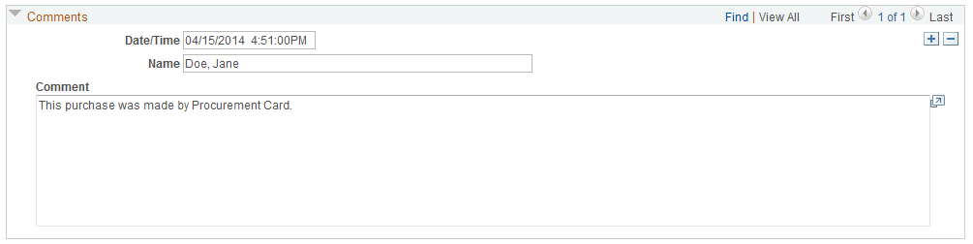
Date/Time – this field defaults to the current date and time to track when Comments are added to the Asset.
Name – use the Name field to reflect the user who added the Comment. The field must be populated in the format of Last,First with no spaces if it is not left blank.
Comment – use the Comment section to type any kind of information related to the Asset. This could be other acquisition, maintenance, or retirement information for the Asset.

NOTE: To add more Comments to the Asset use the button to insert a new row. Use the Date/Time field to track all Comments added to the Asset.

Click to expand the Physical and Custom Attributes section of the page.

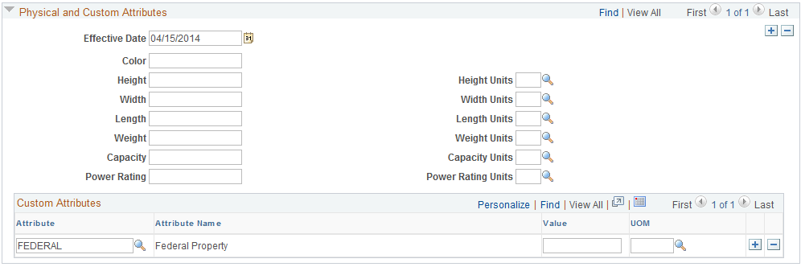

Effective Date - use the Effective Date value to indicate the date that the Physical properties are effective.
Add additional information about the Asset’s Color, Dimensions, or Weight.
Attribute - select from the available values the Attribute to further define the Asset.
Federal’ – select Federal Attribute value to reflect an Asset purchased with Federal dollars (i.e., Grant Funded Asset purchase). Choose Federal in the Attribute field, enter the number (or partial number) of the Federal Grant in the Value field. This attribute is intended for agencies that want to track grant related Assets, but are not yet using the Grants Management module.

Click to expand the Detailed Description section of the page.

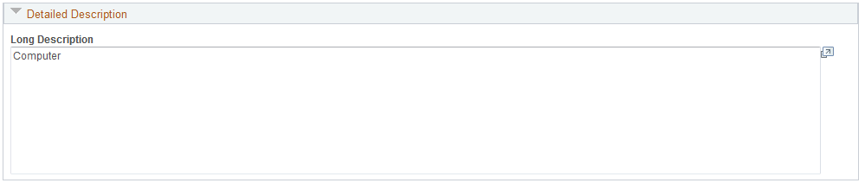
Use the Long Description to add a detailed description of the asset.
Select to expand the Image section of the page.
The Image section of the page allows you to attach a picture of the Asset in the system.

NOTE: Only attach an Image to the Asset if there is a specific benefit for doing so.

Click Tab to access the Manufacture, License, and Custodian section of the page.

Manufacture/License/Custodian Page

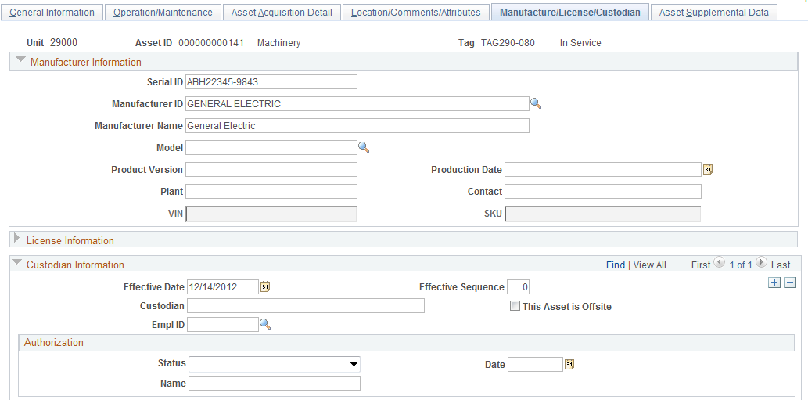
The Manufacturer/License/Custodian page holds Asset Manufacturer details, License Information, and Asset Custodian.
Serial ID – maintain the Asset’s Serial Number or ID in this field.
Manufacturer ID - the Manufacturer ID field holds the Asset manufacturer value. This is a pre-defined value that must be added to the system before it can be selected for an Asset on this page. If the manufacturer is not pre-defined, submit a help desk case to request it be added. DCS requires manufacturer ID.

NOTE: This field is required by the Department of Central Services for machinery and equipment per OAC 580:70-3-1 (c) (4).

Manufacturer Name – this field is populated by default when the Manufacture ID is selected.
Model – this field is a free form field. The Model is required by DCS for machinery and equipment per OAC 580:70-3-1 (c) (3).
VIN – this field is active for Assets with an Asset Type of ‘Fleet’. The VIN field should be populated here rather than as a Serial Number.
Click to expand the License Information section of the page.

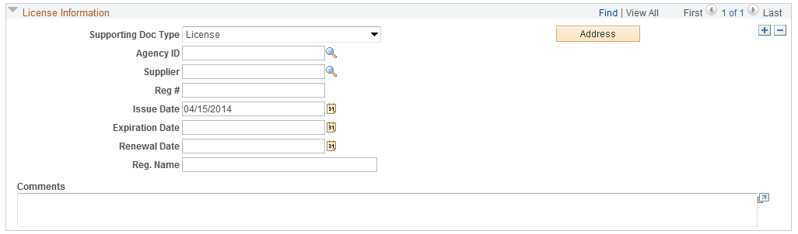

Optionally, use the License Information section of the page to record any required license information for the Asset. This could include the Agency issuing the license, related Vendor information, Issue and Expiration Dates, or Renewal dates.

NOTE: The Agency field is a predefined list of entities that issue Asset licenses. If the license issuing agency is not available in the list, please contact the Help Desk to add another value.

NOTE: The benefit to using the License Information feature lies in the ability to track an Asset’s license Expiration Date.

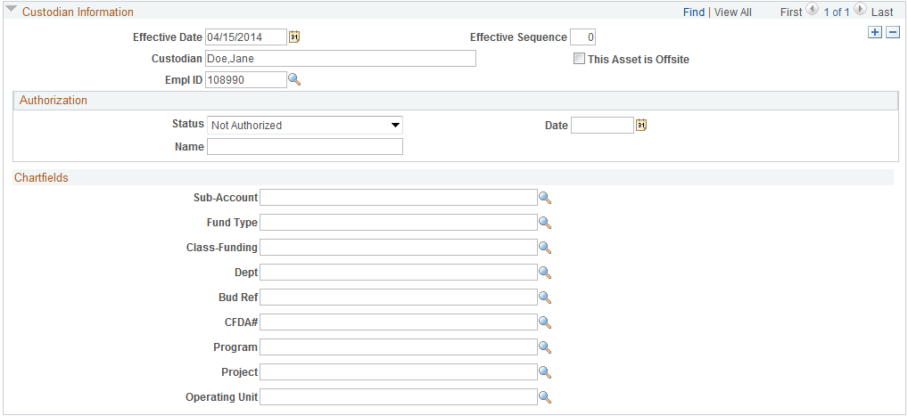

Use the Custodian Information section of the page to add and update the Custodian of the Asset. The Custodian should be the person who is responsible for the Asset. The ‘Empl ID’ can be used to select the Asset Custodian. Alternatively, populate the Custodian field with a non-employee or employee by using the Last, First format and manually add the individual’s name.
Effective Date – use the Effective Date value to indicate the date that the Custodian is made responsible for the Asset. This allows you to track Custodian changes by date as the Asset moves within the Agency.

NOTE: To change the Custodian for an existing Asset you must add a new Custodian row using the button to insert a new row. Populate the Effective Date to reflect the date of the Custodian change.

EmplID – choose the Employee ID for the Asset’s Custodian. This value is a unique, pre-defined value for each Employee in the State.
Custodian – the Employee name (Last,First) is populated when the Employee ID is selected. Alternatively, add a non-employee’s or employee’s first and last name (Last,First).
Click to Save the updates you have made to the Asset.

NOTE: The Custodian Security Role allows users to access and update the Location and Custodian information only for the Asset.

Asset Copy
In cases where an Asset is being added directly into Asset Management and the Asset is similar to an existing Asset, the Asset Copy features allow you to create a copy of the existing asset and modify it to meet the specifications of the new asset. An Asset can be copied multiple times to create many new assets if desired.
When considering the Asset Copy feature, ONLY Assets that have the same Profile ID and number of Distribution lines should be candidates for copy. This is because the Profile default information and the number of Distribution Lines cannot be changed after the Asset has been copied.

Create a New Asset Using the Copy Feature
Navigation: Asset Management>Asset Transactions>Owned Assets>Copy an Existing Asset>Find an Existing Value
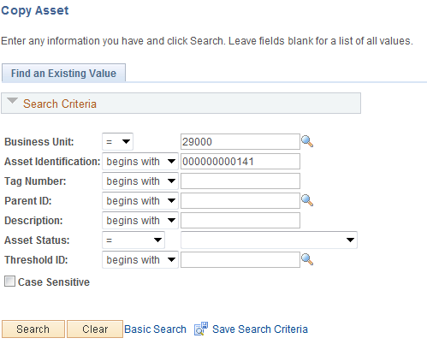
Business Unit – is the Agency in which the existing Asset is housed. This should default based on the User Preferences setup for the person copying the Asset.
Asset Identification, Tag Number, Parent ID, Description, Asset Status – use these fields as search criteria to find the Asset that will be copied.
Click to enter the Asset Copy pages.

Create Asset Copies Page

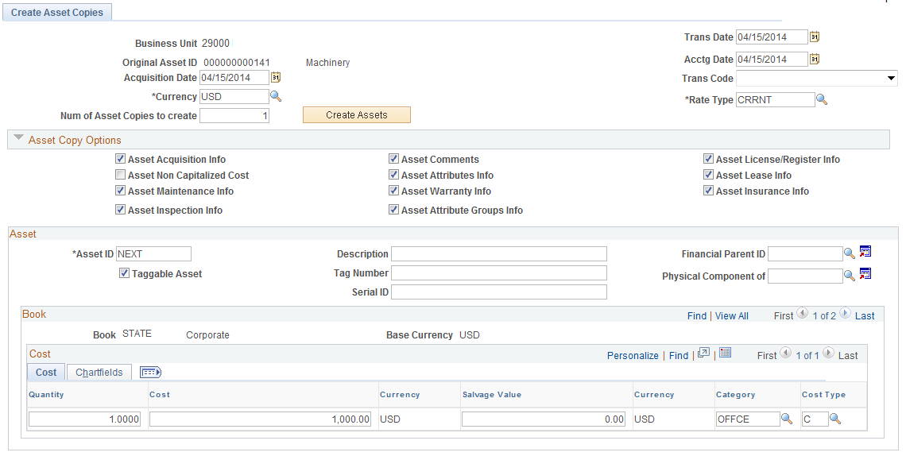

The Create Asset Copies page shows the original or ‘Source” Asset initially on the page. The Asset Copy Options are critical in how the new Asset will be created.

NOTE: Only copy Assets with the same Profile ID and the same number of Distribution Lines.

NOTE: The Profile ID of the existing asset you are copying is not identified on the Create Asset Copy page, so you will need to be familiar with the Profile ID used on existing asset. The page allows changes to the Financial and Physical Information that is different between the existing asset and the new asset.

NOTE: Children Assets can be copied, but Parent Assets cannot be copied. See the Creating Parent-Child Assets section for additional information about the Parent-Child relationship.

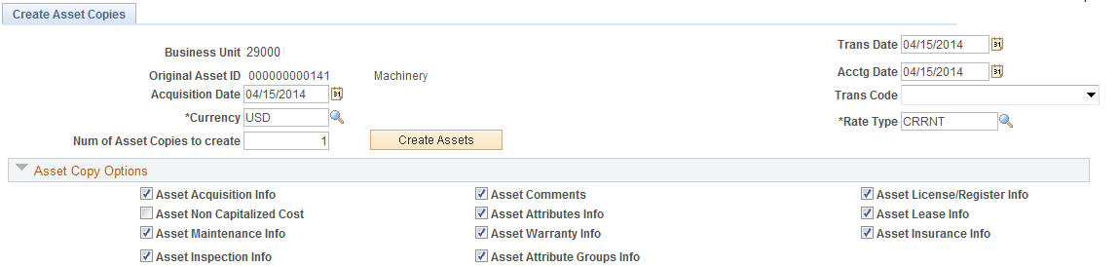
Number of Asset Copies to Create – enter the number of Assets you want to create in the copy.
Transaction Date – the Transaction Date field represents when the Asset was acquired.
Accounting Date – the Accounting Date defaults to current date and determines in what period the Asset transaction will be posted to the General Ledger.
Click to create rows for the new Assets.

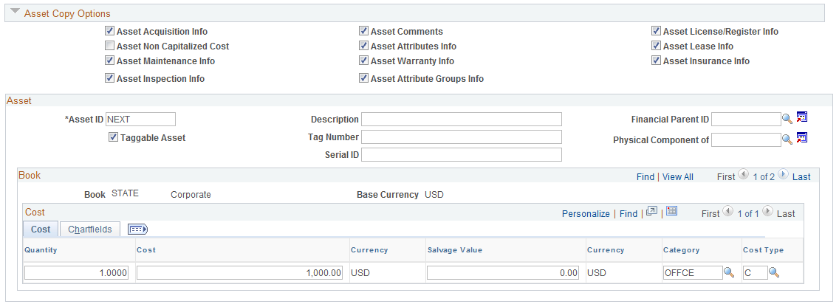

For each Copy that you create, an Asset row will be created. Each row can be updated to reflect Asset information to match the properties of the new Asset.

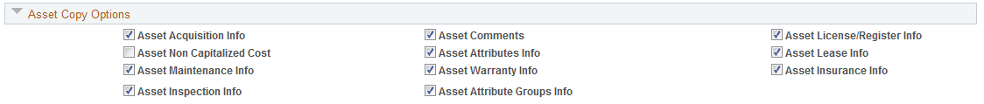

Asset Copy Options – uncheck any values in this section of the page that you do not want to copy to the New Asset. It may be necessary to view the Source Asset in the Asset Basic Add pages to determine whether or not you want this information to be copied.

NOTE: The Location and Custodian values from the Source Asset will be copied to the new Asset. These value are not available to change on the Create Asset Copies page but can be updated using the Asset Basic Add pages illustrated.

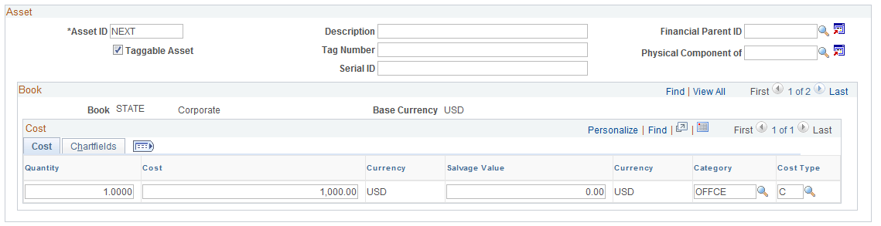

Asset ID – the Asset ID field will display ‘NEXT’, ‘NEXT2’, etc. to represent the next available Asset ID’s in the auto-numbering sequence of numbers.
Description – enter the Description of the new Asset(s).
Parent ID – if the new Asset is a Child Asset, enter the Parent Asset ID in this field.
Tag Number – if the new Asset is a taggable Asset, enter the Tag Number in this field.

NOTE: The Taggable Asset checkbox is defaulted based on the Profile ID and signifies if the asset should have a Tag Number. Tag numbers will be necessary to perform physical inventories when the Asset Management Physical Inventory application becomes available.

Serial ID – populate this field with the new Asset’s Serial ID number.
Quantity – enter the Quantity of the new Asset if different than the Source Asset.
Cost – enter the Cost of the new Asset if different than the Source Asset.
Category – ensure the Category is correct for the new Asset.
Cost Type – if the cost for the new Asset is different than the Source Asset, verify that the Cost Type is set to ‘C’ if the new cost is equal to or greater than 25,000.00
Click Tab to make changes to the new Assets ChartField values.

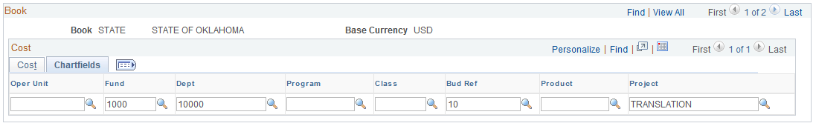

Change any ChartField values required for the new Asset(s).
Click to Save your changes and create the new Asset(s).

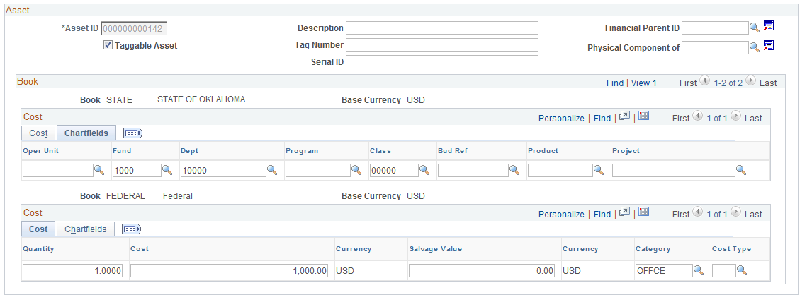

The New Asset ID(s) have been created and are read only on the page.

NOTE: Remember the Location and Custodian values from the Source Asset will be copied to the new Asset. These values must be changed in the Asset Basic Add pages if different from the copied asset.

NOTE: Once the Save button has been clicked and the Asset ID(s) have been assigned, no further updates can be made on the Create Asset Copies page. Physical updates can be done through the Asset Basic Add pages. All Financial updates after this Save must be done through the Adjustment/Transfer pages (see the COR415 Asset Adjustments and Transfers manual).

Creating Parent-Child Assets
The system allows Assets to be created and linked in a Parent-Child relationship. In this type of Asset relationship, there exists only one Parent Asset but many Child Assets can exist for that Parent Asset.
Child Assets have their own Cost and Depreciation rules. Although they do not inherit the Parent’s Financial Information, the Physical Information for a Child Asset can be updated at the same time as the Parent.

Step 1: Create a Parent Asset
Navigation: Asset Management>Asset Transactions>Owned Assets>Basic Add>Find an Existing Value

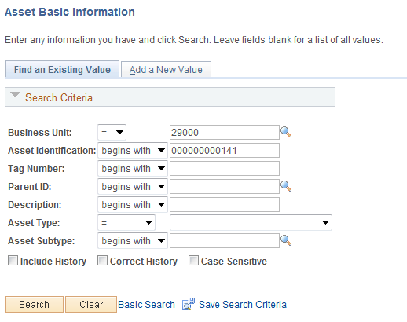
Business Unit – is the Agency in which the Asset is housed. This should default based on the User Preferences setup for the person copying the Asset.
Asset Identification, Tag Number, Parent ID, Description, Asset Status, Asset Subtype – use these fields as search criteria to find the Asset that will become the Parent Asset.
Click to enter the Asset Basic Add pages.

General Information Page

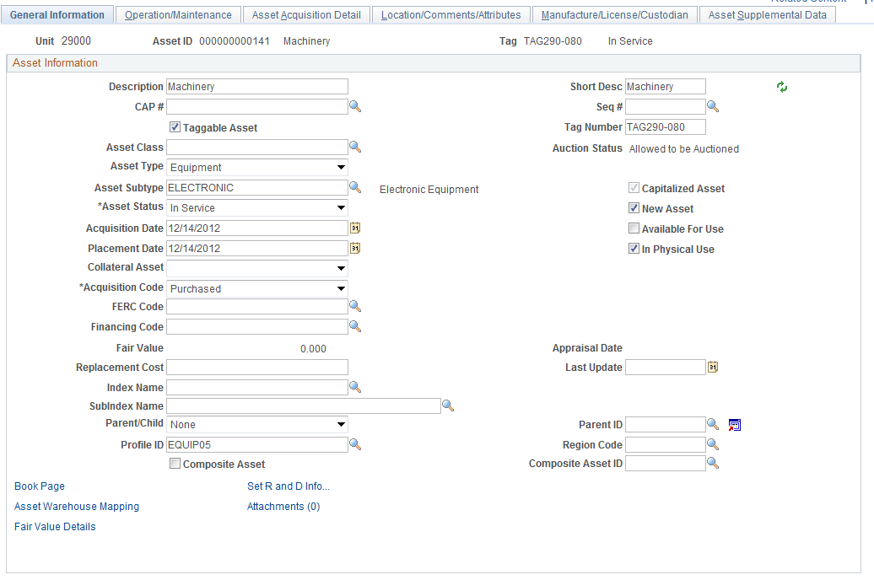
The General Information page displays Asset Details that were added to the Asset when it was created directly in Asset Management or through the Purchasing/Accounts Payable Interface. The Parent Asset must be created before a Child Asset can be linked in a Parent-Child relationship.

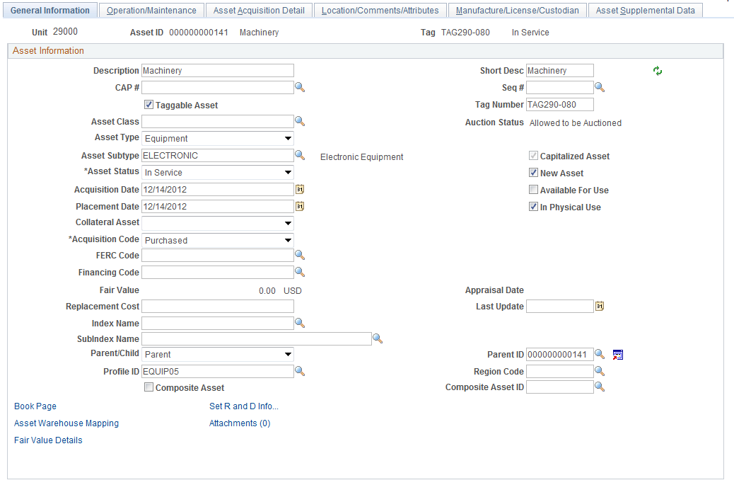
Parent/Child – set the Parent/Child indicator to Parent for the Asset that will be the Parent Asset.
Click to save the Asset as a Parent.
Parent ID – the Parent ID will be populated with the Asset ID of this Asset (the Parent) when you click .

NOTE: This is the first step in a two-step process. Once the Parent Asset has been saved, the Child Asset(s) must also be created.

Step 2: Create a Child Asset
Navigation: Asset Management>Asset Transactions>Owned Assets>Basic Add>Find an Existing Value

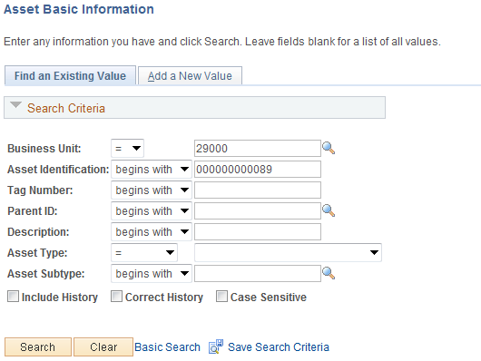

Business Unit – is the Agency in which the Asset is housed. This should default based on the User Preferences setup for the person copying the Asset.
Asset Identification, Tag Number, Parent ID, Description, Asset Status, Asset Subtype – use these fields as search criteria to find the Asset that will become the Child Asset.
Click to enter the Asset Basic Add pages.

General Information Page

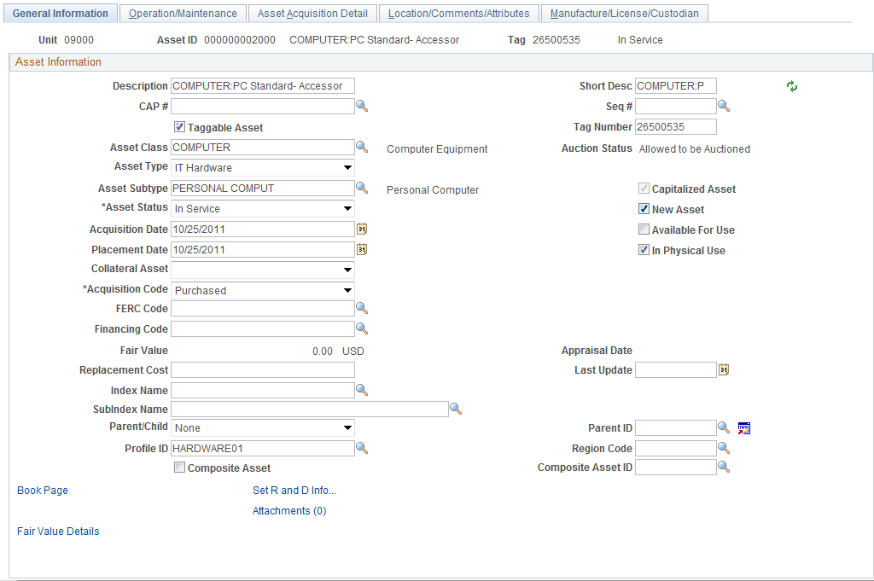

The General Information page displays Asset Details that were added to the Asset when it was created directly in Asset Management or through the Purchasing/Accounts Payable Interface. The Child Asset will be created after the Parent Asset.
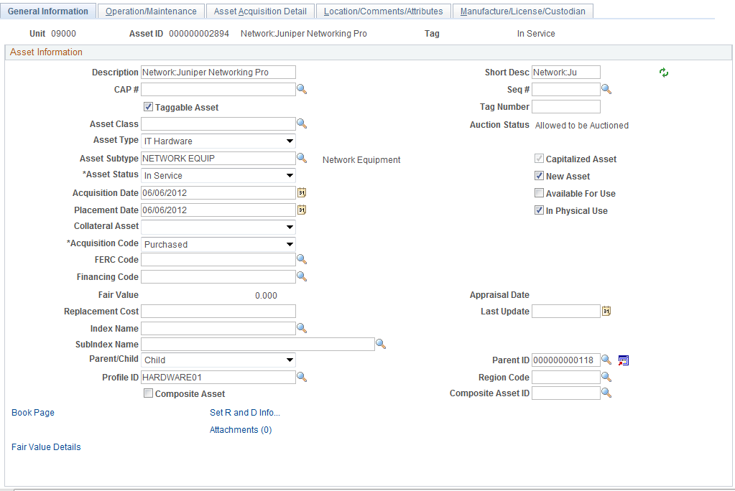

Parent/Child – set the Parent/Child indicator to Child for the Asset that will be the Child Asset.
Parent ID – select the Parent ID for this Child Asset.

NOTE: The Parent Asset must have already been created for the Child Asset to be linked. Also, you need to know the Asset ID of the Parent Asset before you search for and link the Child Asset. Tag Number is not a search criteria when looking for a Parent Asset on this page.

Click to save the Asset as a Child.

NOTE: If the Parent Asset’s ‘Parent’ designation is removed, the Child Assets should be assigned to a different Parent Asset. This practice prevents Child Assets from being “Orphaned” in the system.

NOTE: Parent-Child Assets can also be created in the Asset Express Add pages. If the Asset added in Express Add is the Parent, populate “Parent” in the Parent/Child field and the Asset ID assigned to the asset will also populate in the Parent ID field when the Asset is Saved. If the Asset added in Express Add is the Child, populate “Child” in the Parent/Child field and enter the Parent ID. Remember, the Parent Asset must be created before the Child Asset can be linked.

NOTE: Child Assets can be linked to Parent Assets in Copy Existing Asset pages. Additionally, Child Assets can be copied, but Parent Assets cannot.

Step 3: Search for Parent/Child Assets
Navigation: Asset Management>Asset Transactions>Parent-Child Relationship>Review
Parent-Child>Find an Existing Value

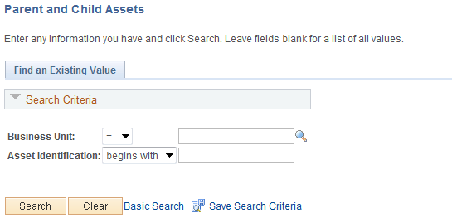

Business Unit – is the Agency in which the Asset exists. This should default based on the User Preferences setup for the person reviewing the Asset.
Asset Identification – populate this search field with the Parent Asset Number. Since this search feature does not use Tag Number, Description, etc., the Parent Asset Number must be known before Assets can be reviewed.
Click to enter the Parent-Child pages.

Parent and Child Assets Page

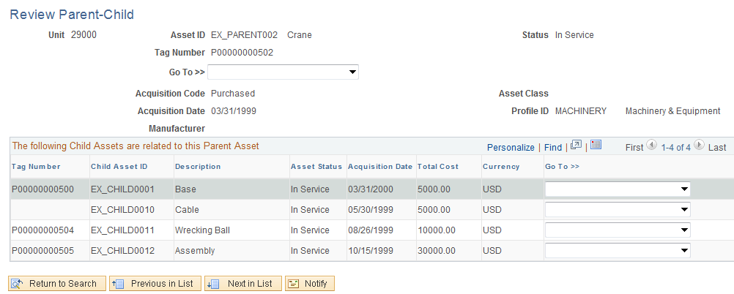

The Review Parent-Child page allows you to view information about the Parent Asset and all related Child Assets. The information on this page is not editable but you can drill down to other useful pieces of information about the Parent-Child Assets.
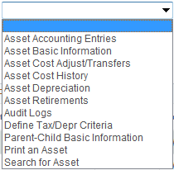
Use the menu to select other pages that provide additional details about the Parent or Child Asset. Other detailed Asset Information can be found in:
Asset Accounting Entries – the Accounting Entries associated with this Asset’s transactions (additions, adjustments, etc.).
Asset Basic Information – the Basic Add pages illustrated.
Asset Cost Adjust/Transfers – Used for recategorizations and transfers on composite assets.
Asset Cost History – the transactional history of the Asset related to the Asset’s Cost and ChartFields.
Asset Depreciation – for CAFR or Federal Assets view the history of Depreciation for the Asset.
Asset Retirements – drill to the Retirement/Reinstate pages.
Audit Logs
Define Tax/Depreciation Criteria – this link provides the Asset Book page to view depreciation information.
Print an Asset – the printable view of the Asset is available.
Search for an Asset – the Asset Search Utility is available with related Drill-Down capability.

NOTE: Depending on your security access within the Asset Management module, all pages in the drop down menu may not be available.

Step 4: Search for Parent/Child Assets Net Book Value
Navigation: Asset Management>Asset Transactions>Parent-Child Relationship>Review Parent-Child NBV>Find an Existing Value

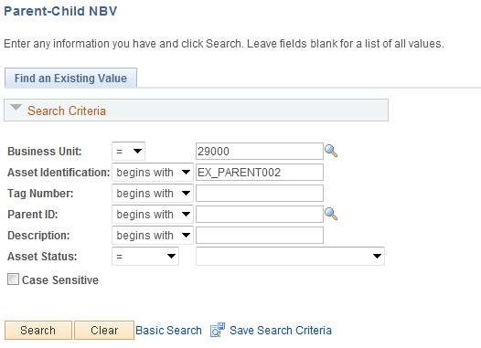

Business Unit – is the Agency in which the Parent Asset is housed. This should default based on the User Preferences setup for the person reviewing the Asset.
Asset Identification, Tag Number, Parent ID, Description, Asset Status – use these fields as search criteria to find the Parent Asset.
Click to enter the Parent-Child NBV pages.

Asset Detail Page

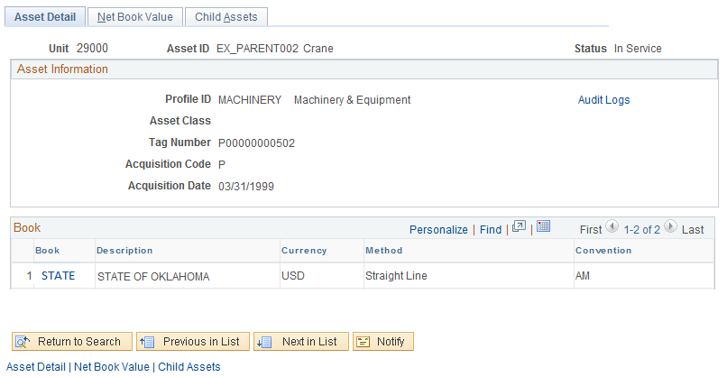
The Asset Detail page shows some Physical information about the Parent Asset plus general Book Information. Information on this page cannot be changed but can be viewed only.
Click Tab to view the Parents Net Book Value information.

NOTE: The information on the Net Book Value page may be useful for only CAFR or Federal Assets.

Net Book Value Page

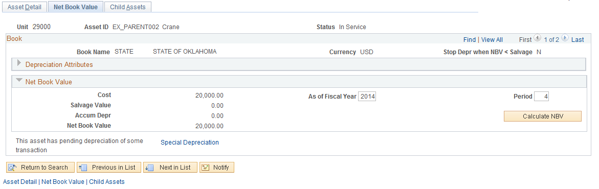

The Net Book Value page displays Book and Depreciation information on the Asset.
Click to expand the Depreciation Attributes Section of the page and view Depreciation Rules for this Asset.

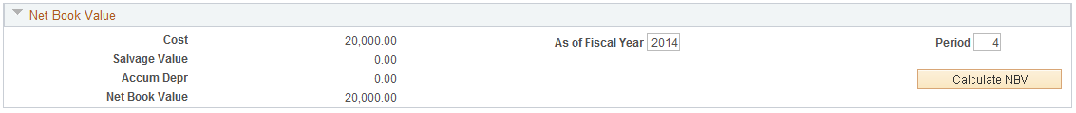
Use the As of Fiscal Year and Period fields, in combination with the button to calculate the Asset’s Net Book Value in future periods.

NOTE: If the Asset has Pending Depreciation transactions, the Calculate NBV feature may not display the correct Net Book Value for the Asset.

NOTE: Pending Depreciation transactions refers to the process of populating the Asset’s depreciation schedule in the system. A batch process is executed to complete this process.

The Special Depreciation link will provide a breakdown of period depreciation for the Asset

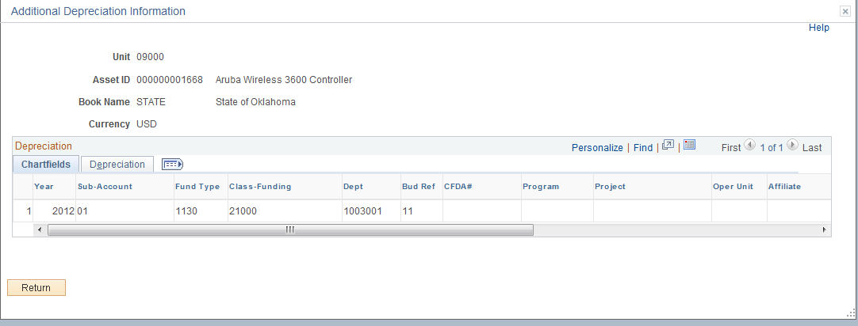

The Additional Depreciation Information page shows a row for each period of depreciation for this Asset. The Depreciation ChartField information is also available for display.
Click to return to the Net Book Value Tab.
Click Tab to view the Child Assets to this Parent.

Child Asset Page

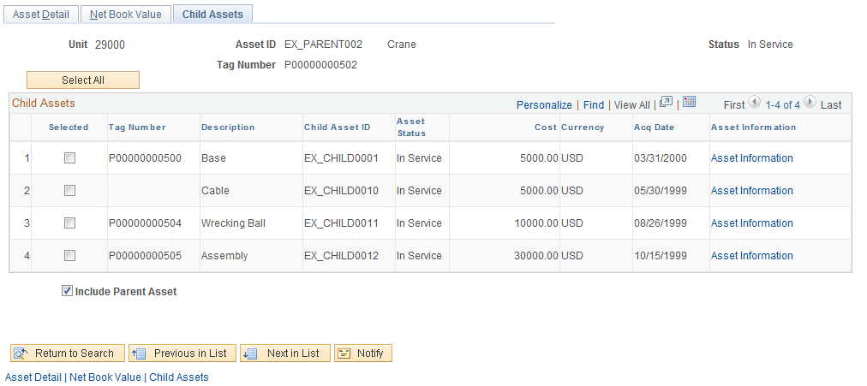
The Child Assets page displays all Child Assets linked to the Parent Asset.
Click Asset Information link, drill down to the Child Assets Depreciation properties and amounts.

Asset Search
Asset Search capabilities in the system allow you to search for an Asset by various characteristics and properties, both Physical and Financial in nature. You can view and print the Asset, drill down to other pages that display additional information, or allow Asset modifications to be made.
The Asset Search pages can be a powerful tool to find Assets when not all critical information is available (i.e. Asset ID, Tag Number, etc.). The Search features can retrieve one or more Assets based on the search criteria you provide. The more narrow the search criteria, the fewer number of Assets that will be retrieved.
This feature should be used to view Financial information for Assets in the system. This page is a better alternative than the Basic Add component for Financial information because it shows the most current data for Financial information like ChartFields and Asset Category. Changes to an Asset’s Financial Information are not updated in Basic Add.
Navigation: Asset Management>Search for an Asset

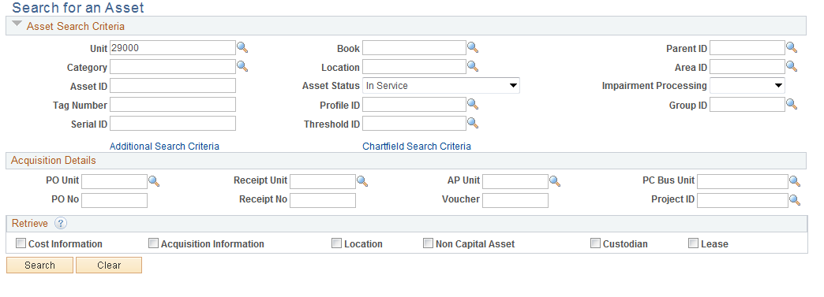

The Search for an Asset page provides both Physical and Financial information as Search Criteria for an Asset. Once the Asset is found, you can drill down further into the Asset records to view and change additional data.

NOTE: The Asset Status flag is set to ‘In Service’ when you initially retrieve the page. Change this value if necessary.

Search for an Asset Page

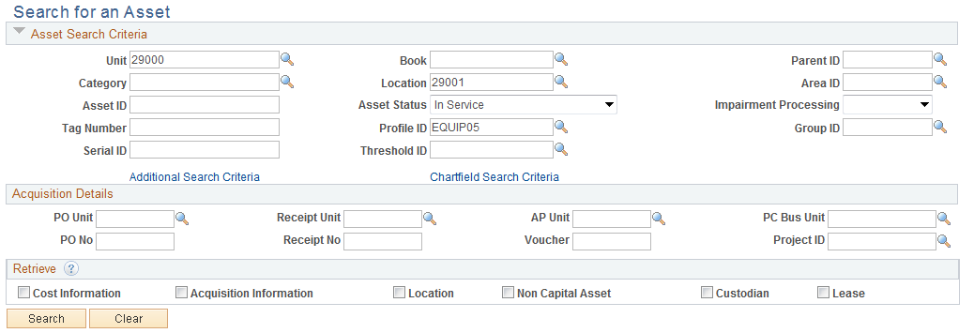

Populate the Asset Search Criteria section of the page with the data elements that are known about the Asset you want to find. When the desired search criteria are provided, the Search button will retrieve all Assets that match the search values. The search criteria can be changed when desired to retrieve different sets of Assets that match the search values. Once the Assets are retrieved in the Search List, you can drill down into the Asset for additional information.
Available Fields are:
Business Unit – Agency
Book – always ‘STATE’
Parent ID – if applicable
Category – if the Asset Category is know
Location – Physical Location assigned to the Asset
Asset ID – system assigned Asset ID
Asset Status – select Assets only in a particular status

NOTE: The Asset Status can be set to blank. This will retrieve all Assets matching other Search Criteria regardless of the Assets Status.

Tag Number – if the Asset Tag Number is known
Profile ID – the Profile ID that was assigned to the Asset
Serial ID – if the Serial Number on the Asset is known

You may use the Acquisition Details section of the page if the Asset was created from the Purchasing, Accounts Payable, or Project Costing Modules. Use this section of the page if you know Purchase Order Number, Receipt Number, AP Voucher Number, or Project ID.

NOTE: The PO Number, Receipt Number, and AP Voucher ID do not have prompt values available. This means that the transaction number must be know and cannot be searched.

Use the Retrieve section of the page to define which types of Asset information you would like to display for the Assets that are retrieved.

NOTE: It is not always necessary to select the Retrieve checkboxes when searching for an Asset. For example, if Location is used as a Search Criteria, the Location value for the Asset(s) will be displayed. If the Location is not used as part of the Search Criteria, you will need to select the Location checkbox to display the Location value for the Asset.

Use the Additional Search Criteria link to add more search values.

More Filter Options Sub-Page

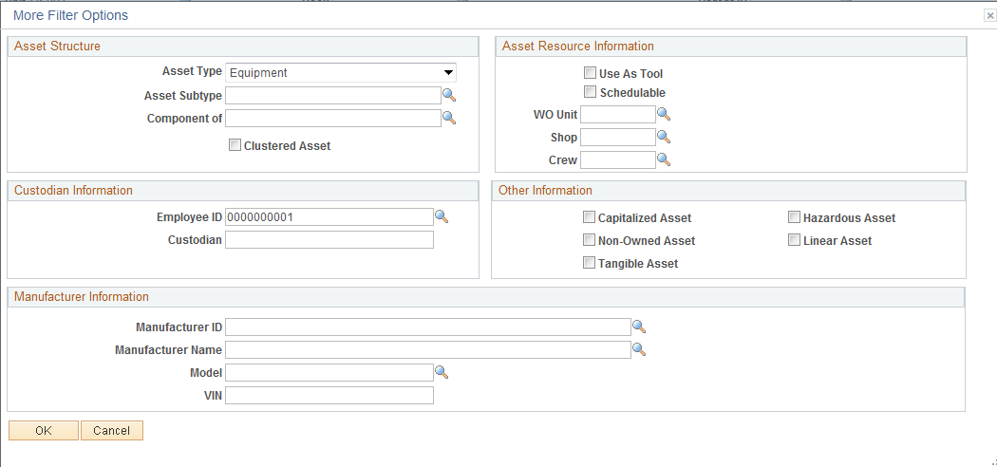

Use more search fields like Asset Type or Employee ID (custodian) to search for Assets.
Click to save the additional search criteria.
Click ChartField Search Criteria link to add ChartFields to your search values.

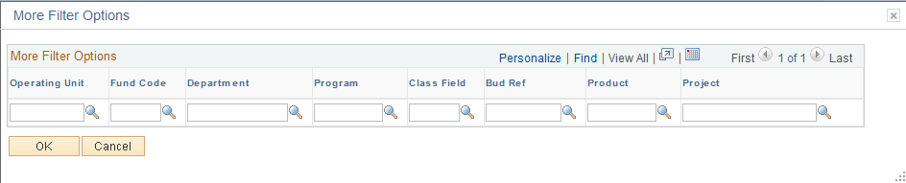

Use any available ChartFields values for additional search criteria.
Click to save the additional search criteria.

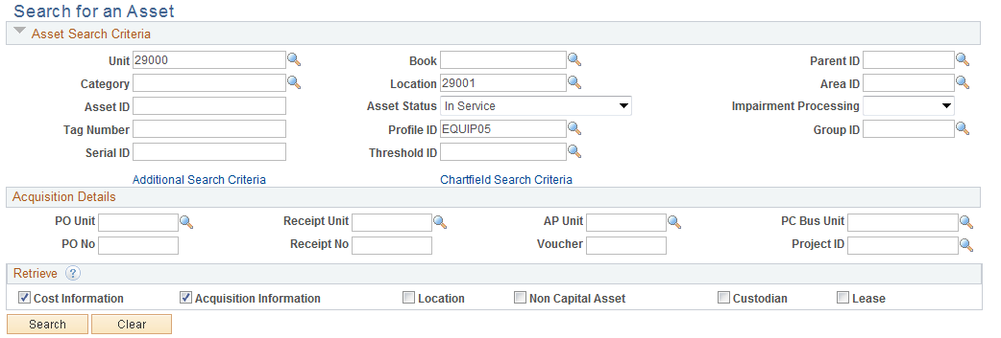

From the Search for an Asset Page, click to retrieve Assets matching the defined criteria.

NOTE: The Additional Search Criteria and ChartField Search Criteria will not be seen on this page but will be included in the search execution.

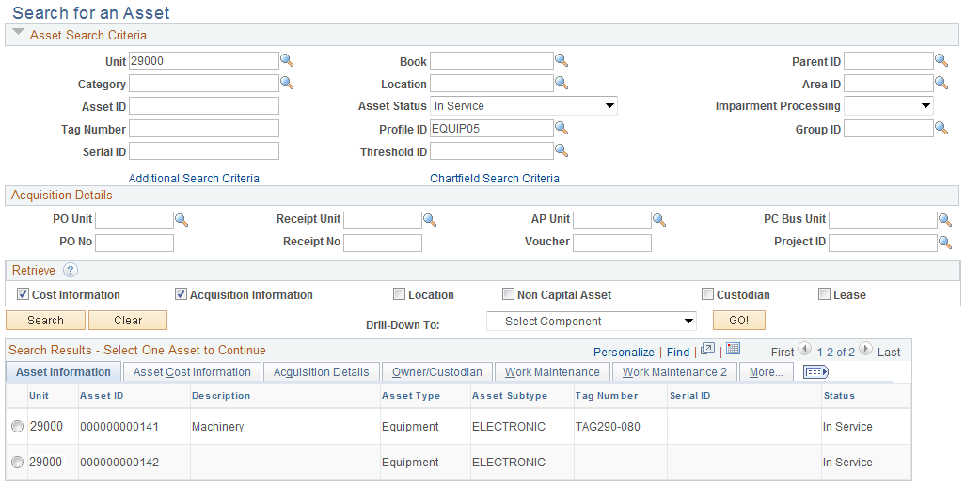

The page will display all of the Assets that meet the search criteria defined.

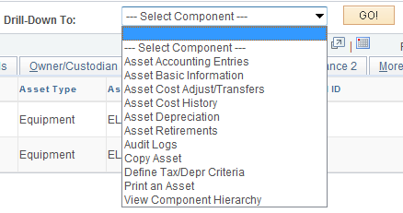

Use the drop-down menu to select other Asset pages that will provide additional Asset details. The following pages are available:
Asset Accounting Entries – the Accounting Entries associated with this Asset’s transactions (additions, adjustments, etc.)
Asset Basic Information – the Basic Add pages illustrated in the Viewing Assets chapter
Asset Cost Adjust/Transfers – Used to perform transactions on asset.
Asset Cost History – the transactional history of the Asset related to the Asset’s Cost and ChartFields
Asset Depreciation – for CAFR or Federal Assets view the history of Depreciation for the Asset
Asset Retirements – drill to the Retirement/Reinstate pages
Audit Logs – If Audit Logging is enabled, events you want tracked will be logged.
Copy Asset – drill to the Asset Copy pages
Define Tax/Depreciation Criteria – this link provides the Asset Book page
Print an Asset – the printable view of the Asset is available
Search for an Asset – the Asset Search Utility is available with related Drill-Down capability
Use to remove all search criteria and start the search again.

