COR412 Asset Management – Integrating Asset Management with PO and AP

Table of Contents
Document History 5
Asset Integration Overview 6
Key Terms 7
Process Flows 10
Asset Integration Diagram 10
Asset Integration Process Flow 11
Guidelines, Concepts and Alternatives 12
Asset Groupings 17
Entering Asset Information in Purchasing and Accounts Payable 18
Asset Requisition 18
Asset Purchase Order 19
Asset Receipt – Scenario #1, Serialized Item 21
Asset Receipt – Scenario #2, Multiple Distribution Lines for One Asset 26
Asset Voucher 31
Loading and Reviewing the AM Interface Tables – Physical Information 33
Step 1: Loading the Pre-AM Tables – Physical Information 34
Step 2: Reviewing the AM Interface Tables - Physical Information 37
Review-A Page 38
Consolidating Physical Load Lines 41
Physical Transactions A Page 43
Step2: Consolidate Load Lines 46
Excluding Load Lines 48
Consolidating 49
To Assets Page 50
Step 3: Review the Newly Consolidated Load Lines 52
Physical Transactions A Page 54
Unitizing Physical Asset Load Lines 55
Step1: Reviewing the Interface Tables for Load Lines to Unitize 55
Physical Transactions A Page 58
Step2: Unitize Load Lines 59
FROM Asset Page 60
TO Assets Page 62
Step 3: Review the Newly Unitized Load Lines 64
Physical Transaction A Page 66
Reviewing the Transaction Loader Process – Physical Information 67
Transaction Loader process 67
Review Assets after the Transaction Loader is Complete 68
General Information Page 69
Operation/Maintenance Page 70
Asset Acquisition Detail Page 71
Location/Comments/Attributes Page 72
Manufacture/License/Custodian Page 73
Reviewing the AM Pre-Interface Tables – Financial Information 74
Review Financial Information in the AM Pre-Interface Tables 75
Pre-AM Financial Page 76
Pre-AM Physical Page 77
Loading and Reviewing the AM Interface Tables – Financial Information 83
Step 1: Load Financial Information into the AM Interface Tables 83
Step 2: Review Financial Information in the AM Interface Tables 86
Financial Transactions A Page 89
The Transaction Loader Process – Financial Information 91
Transaction Loader process 91
Review Assets after the Transaction Loader is complete 91
General Information Page 92
Operation/Maintenance Page 93
Asset Acquisition Detail Page 94
Location/Comments/Attributes Page 98
Manufacture/License/Custodian Page 99
Asset Integration Checklist 100

Authorized by: [_EBS_] Original Issue: [05/01/2014]
Maintained by: [____Asset Management Application Lead___]
Review Date: [05/01/2014]

Document History

Document Revision | Date | Description
1.0 | 03/18/2010 | Initial Document
2.0 05/01/2014 Upgrade Update

Asset Integration Overview
The PeopleSoft Asset Management module provides trigger points to ensure Owned Assets are added to Asset Management. To utilize the module to its full potential, it is important to understand the points and timing of integration between Asset Management and the Purchasing and Accounts Payable modules.
Here is the basic flow describing the transfer of information to the Asset Management module:
A Profile ID will be included on Item IDs that are capital assets and are expected to cost $500 or more for telecommunication and information technology assets, and $2,500 or more for all other assets.
The Profile ID will copy onto Requisitions and/or Purchase Order Distribution Lines when these Item IDs are selected by the requisitioner or CPO.
If a Purchase Order Distribution Line specifies a Profile ID, the Receipt is identified as an asset purchase and provides an Asset Management Information page to record physical data, including serial ID, tag ID, custodian, etc. The receipt passes the information to Asset Management so the asset can be added with its Physical Information.
If a Receipt Distribution Line specifying a profile ID is copied to the Accounts Payable Voucher, it is identified as an asset purchase and passes the Financial Information from the invoice to Asset Management to capitalize the asset.
The system is designed to flow in this sequence. Receiving is an important part of the process and is not optional for asset purchases. It ensures that assets are added to Asset Management and Physical Information is captured at the time of purchase. Timing of the integration points is critical and many of the queries designed to manage the timing include Receipt numbers in the criteria.
This manual describes the process flow, pages, functionality, and timing used to integrate Asset Management with Purchasing (Receiving) and Accounts Payable (Payment Vouchers). Each of these feeder modules to Asset Management interfaces a different type of information for Asset creation. Each of the types of information is required to properly capitalize an asset in the system.

Key Terms
Asset Management Business Unit: Each agency has one Asset Management Business Unit. The Business Unit is the 3 digit agency code, plus 00. For example, Office of State Finance is 09000.
Asset ID: Each Asset in the system has a unique Asset ID assigned automatically when the asset is added. The Asset ID is the key number used by the system to track each individual asset. Use this number to search for a particular asset in the system and view or make changes.
Tag Number: All Assets in the Asset Management system can have a Tag Number that matches the physical tag on the asset.
Asset Financial Information: An Asset’s Financial information includes cost, quantity, useful life, and ChartField values.
Asset Physical Information: An Asset’s Physical information includes tag number, location, custodian, serial number, and Manufacturer ID.
Profile ID: Profile ID is a template for the Asset that defaults values into the asset used for grouping and depreciation processing. This includes Asset Category, Asset Type, Useful Life and Depreciation Method and Convention.
Asset Category: Group assets together by major asset type for financial reporting purposes. Categories are Land, Land Improvements, Buildings, Infrastructure, Machinery and Equipment, IT Systems, Artifacts and Treasures, Capital Lease – Buildings, Capital Lease – Equipment, and Operating Leases. Asset category is required and included in the Profile ID.
Asset Type: Classifications to report assets within an asset category. Types are IT Hardware, IT Software, Equipment, Property, Fleet, Furniture, Facility, Intangibles, and Other. Asset type is required and included in the Profile ID.
Asset Subtype: Group assets within Asset Types at a more granular level for internal reporting purposes. Subtypes are optional in Asset Management and are not included in the Profile ID; however, Office of State Finance does require subtypes be included for IT Assets
Asset Class: Defines assets within Asset Categories for internal reporting purposes. Asset Classes currently set up were provided by Department of Central Services for assets that are machinery and equipment in nature. Classes are optional in Asset Management and not included in the Profile ID; however, Department of Central Services does require the class be included on the DCS-FORM_SS_001A when an asset is sent to surplus.
CAFR Asset: A capital asset with a cost of $25,000 or more reportable on the Comprehensive Annual Financial Report (CAFR). The cost of individual assets acquired as part of a group to be used together but can be used as a separate asset must individually meet the $25,000 capitalization policy even though they are connected to other components of the group. Asset grouping is limited to individual components that cannot be used without being connected to other components. Refer to GAAP Package H, Reportable Capital Assets, under Key Terms for specific guidelines.
Cost Type: A Cost Type is used to differentiate between CAFR and non-CAFR assets. The cost type, in conjunction with category and asset transaction, will record the accounting entries needed by the CAFR group.
IT Asset: Telecommunication voice response systems and electronic information technology applications, including but not limited to mainframe computers, minicomputers, or microcomputers, word processing equipment, office automation systems, Internet, eGovernment, broadband, WI-FI or wireless networking, radio, including the interoperable radio communications system for state agencies, or Global Positioning Systems (GPS). Refer to the categories and descriptions in the Information Technology and Telecommunications Plan at http://www.ok.gov/cio State IT Standards select the 2011 Annual Report.
Transaction Date: Date on the Asset that reflects the actual date the Asset transaction took place. In the case of a new Asset addition, this is the date the Asset was Acquired.
Accounting Date: Date on the Asset that will determine when the Asset transaction will be posted to the General Ledger.
Asset Management Books: Asset Books store financial information about an asset including cost, depreciation rules and retirement rules. The state will support only one book called STATE.
Location: The address of where the asset is physically located. The code can be a building or a site, or it can be more specific and include a wing, floor, room, etc. The state requires a location code for each asset.
Custodian: The person responsible for or assigned the asset. The custodian is generally an employee but can be someone other than an employee.
Unitize: The process of splitting one Receiver or Voucher line into multiple Assets.
Consolidate: The process of combining more than one Receiver or Voucher line into one Asset.
Serialize: The process of assigning Serial Numbers to multiple Items on one Receiver Line so that the system can separate each Item as a unique Asset.
Load Lines: Load Lines are Receiver or AP Voucher lines, with Asset information, that are being interfaced from Purchasing and Accounts Payable respectively, but are not yet Assets.
Pre AM Tables: The first interface table used by the system when creating Assets from Receiver or AP Voucher information. This table holds Load Lines.
Interface Tables: The table between the Pre AM tables and the Asset Management tables. This is where unitization and consolidation takes place. This table holds Load Lines.
Interface ID: An Interface ID is assigned to each group of Asset load lines that you move in a batch to the Interface table during the Interface process.

Process Flows

Asset Integration Diagram

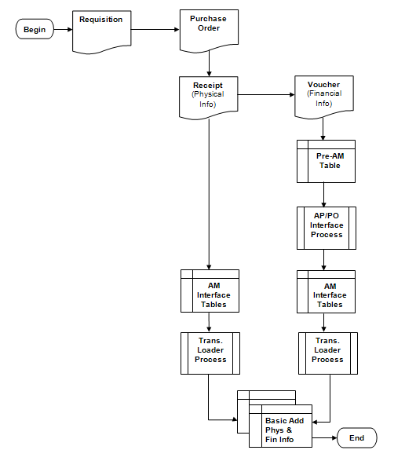

Asset Integration Process Flow
Begin Process
Create an Asset Requisition
Source the Asset Requisition to a Purchase Order
Receive the Asset and record Physical Information on the Receipt
Push the receiver to the AM Interface Table (the Pre-AM Table is populated but bypassed)
The Transaction Load Process runs, selects the Receipt Interface ID, and creates the Asset ID

Source the Receipt to the Voucher
Push the Voucher to the Pre-AM Interface Table
Run the AP/PO Interface Process to load the AM Interface Table
The Transaction Load Process runs, selects the Voucher Interface ID, and capitalizes the Asset already created.

Guidelines, Concepts and Alternatives
What is a Capital Asset?
The term capital assets includes land, improvements to land, easements, buildings, building improvements, vehicles, machinery, equipment, works of art and historical treasures, infrastructure, and all other tangible or intangible assets that are used in operations and that have initial useful lives extending beyond a single reporting period. (GASB S34, par. 19)
The State of Oklahoma’s capitalization threshold for capital assets is $25,000.
How Should Assets Acquired as Part of a Group be Treated?
The cost of individual assets acquired or leased as part of a group to be used together but can be used as a separate asset must individually meet the $25,000 capitalization policy even though they are connected to other components of the group. Asset grouping is limited to individual components that cannot be used without being connected to other components. Refer to GAAP Package H, Reportable Capital Assets, under Key Terms for specific guidelines.
What Assets, in Addition to Capitalized Assets, Should be Included in Asset Management?
The Asset Management system will be used to track “tangible assets” costing $2,500 or more to meet Department of Central Services reporting requirements per the Administrative Rules 580:70-1-3(a). “Tangible assets" mean machinery, implements, tools, furniture, livestock, vehicles and other apparatus that an agency may use repeatedly without material impairment of its physical condition and have a calculable period of service and a value exceeding the reporting threshold the Director of Central Services establishes for the entity. [74 O.S., Section 110.1(D)]”
The system will also be used to track telecommunication and electronic information technology applications costing $500 or more to meet the requirements specified in Title 62, § 34.12, Subsection 6. Telecommunication and electronic information technology applications “include but are not limited to the use of mainframe computers, minicomputers, or microcomputers, word processing equipment, office automation systems, Internet, eGovernment, broadband, WI-FI or wireless networking, radio, including the interoperable radio communications system for state agencies, or Global Positioning Systems (GPS).2 Refer to the Information Technology and Telecommunications Plan for a more detailed listing of “Defined Categories and Descriptions” at http://www.ok.gov/cio/Policy_and_Standards/ select the 2011 Annual Report.
Asset Management can also be used to track items costing less than $2,500 ($500 if an electronic information technology asset) if they are sensitive for one or more of the following reasons:
- Items that require special attention to ensure legal compliance. Legal or contractual provisions may require a higher than ordinary level of accountability over certain capital-type items (e.g., items acquired through grant contracts);
- Items that require special attention to protect public safety and avoid potential liability. Some capital-type items by their very nature pose a risk to public safety and could be the source of potential liability (e.g., police weapons);
- Items that require special attention to compensate for a heightened risk of theft (“walk away” items). Some capital-type items are both easily transportable and readily marketable or easily diverted to personal use (e.g., sound equipment). 3

What are the State’s Major Asset Categories for Owned Assets?
The State of Oklahoma uses the following major categories:
Art, Artifacts, and Treasures – This includes collections of works of art, historical treasures, and similar items. For art or a collection to be categorized as Art, Artifact, or Treasure, its purpose must be to display or research, and the collection items must be adequately maintained and preserved. Additionally, proceeds from the sale of collection items must be used to purchase other items for the collections. Such collections are often considered to have an indefinite useful life and will generally appreciate in value; thus, assets in this category are not depreciated.
Land – “Land is often associated with some other asset (e.g., land under a building or road). Land should be treated separately; thus, the land purchased with an existing building should not be capitalized as part of the cost of the building. The cost of the land should include the acquisition cost and the cost of initially preparing land for its intended use, provided these preparations have an indefinite useful life, like the land itself. Ownership of land can include separable elements (e.g., mineral rights). These various elements should not be treated as separate assets in their own rights unless they are acquired separately. Land, unless compromised by use, has an indefinite life and is not depreciated.” 4
Land Improvements – This is used for permanent improvements that add value to the land but do not have an indefinite useful life. Examples include fences, retaining walls, parking lots, and most landscaping. Moveable items should be classified as furnishing and equipment.
Buildings – All permanent structures are included in the building category. The cost of an improvement will be treated as a separate asset in the Asset Management System, but can be linked in a Parent-Child relationship.
Infrastructure – “Long-lived capital assets that normally are stationary in nature and normally can be preserved for a significantly greater number of years than most capital assets.” 4 Examples include roads, bridges, tunnels, drainage systems, water and power systems, dams, and lighting systems.
Machinery and Equipment – This category is used for vehicles, furnishings, and similar moveable items, but does exclude assets included in the IT Systems category. It also can be used for collections that do not appreciate in value (e.g., general library collections).
IT Systems – This category was set up separately from machinery and equipment to satisfy the requirements of Title 62, § 34.12. Subsection 6. Assets include telecommunication voice response systems and electronic information technology applications. See the paragraph defining information technology assets in the question on the previous page addressing which assets are tracked in the Asset Management system.
Construction in Progress – Costs incurred to construct or develop a tangible or intangible asset before it is ready to be placed in service. Construction in Progress will be tracked in the PeopleSoft Projects Module and will be classified into the appropriate asset category when the asset is placed in service. If the Projects Module is not utilized, then Construction in Progress totaling $25,000 or more will be reported separately to the CAFR group until the asset is added to the Asset Management Module at the time the asset is placed in service.

How Should a Donated Capital Asset be Valued?
Generally accepted accounting principles state that “donated capital assets should be reported at their estimated fair value at the time of acquisition plus ancillary charges, if any.” 4 The appropriate fair value is the amount that the agency would have had to pay to acquire the asset, not the amount for which the donated asset might be resold.
How Should a Donated Capital Asset be Valued?
Generally accepted accounting principles state that “donated capital assets should be reported at their estimated fair value at the time of acquisition plus ancillary charges, if any.” 4 The appropriate fair value is the amount that the agency would have had to pay to acquire the asset, not the amount for which the donated asset might be resold.
How Should Assets Obtained through Trade-Ins be Valued?
“If a capital asset is traded-in in the process of purchasing another similar capital asset, the newly acquired capital asset should be recorded at an amount equal to the book value of the asset that was surrendered plus any additional monetary consideration provided to seller.” 4
What is the Acquisition Cost of Internally Generated Software?
Generally accepted accounting principles “prohibit the capitalization of any cost associated with the preliminary project stage of software development. Conversely, costs connected with the application development stage should be capitalized, but only if incurred subsequent to the completion of the preliminary project stage. Even then, capitalization is limited to situations where management authorizes and commits to funding, at least through the current period. Finally, costs incurred as part of the post-implementation/operations stage should never be capitalized.” 4
How Should Significant Costs Incurred after the Asset is Acquired be Treated?
Significant costs incurred in connection with capital assets in periods subsequent to the initial acquisition need to be distinguished between improvements and repairs and maintenance.
“An improvement provides additional value. Such added value is achieved either by 1) lengthening a capital asset’s estimated useful life or 2) increasing a capital asset’s ability to provide services (i.e., greater effectiveness or efficiency). In contrast to improvements, repairs and maintenance retain value rather than provide additional value.” Improvements are capitalized and repairs and maintenance are expensed.
“Often a single project will have elements of both repair and an improvement. In that case, the relative cost of each should be determined and treated separately.” 4
The State will treat an improvement as a separate capital asset and depreciate it over its own estimated useful life. It can be linked in a Parent-Child relationship.

How Should Significant Costs Incurred after the Asset is Acquired be Treated?
Significant costs incurred in connection with capital assets in periods subsequent to the initial acquisition need to be distinguished between improvements and repairs and maintenance.
“An improvement provides additional value. Such added value is achieved either by 1) lengthening a capital asset’s estimated useful life or 2) increasing a capital asset’s ability to provide services (i.e., greater effectiveness or efficiency). In contrast to improvements, repairs and maintenance retain value rather than provide additional value.” Improvements are capitalized and repairs and maintenance are expensed.
“Often a single project will have elements of both repair and an improvement. In that case, the relative cost of each should be determined and treated separately.” 4
The State will treat an improvement as a separate capital asset and depreciate it over its own estimated useful life. It can be linked in a Parent-Child relationship.
How are the Useful Lives of Assets Estimated?
Straight line depreciation is calculated by dividing the asset cost by the estimated useful life in years. Each agency determines the useful life of the assets and should be the period over which services are expected to be provided by the asset based on the agency’s own experience. Factors to consider when estimating a life are materials and construction, specific use, physical environment, maintenance policies, and the risk of technological obsolescence. Refer to GAAP Package H, Reportable Capital Assets, Schedule A, for common life ranges for capital assets. For assets not meeting the CAFR threshold of $25,000 or not subject to the federal capitalization threshold of $5,000 for purposes of federal reimbursement, a useful life of one year has been set up in Asset Management for categories with assets that have a definite useful life.
Estimated useful lives selected for depreciation purposes must be reviewed regularly for reasonableness. “If a change in estimates proves necessary, it should be treated prospectively (i.e., as an adjustment to future charges).” 4
Which Capital Assets Should be Tagged?
Tagging assets with a unique identification number provides an accurate method of identifying individual assets and aids in the taking of the physical inventory. Generally, machinery and equipment type assets are tagged. “Tags should be placed in a location that allows them to be seen and read without having to move the property items. Tags also should always be placed in the same position for a given type of item. Finally, the location of a tag should minimize the danger of disfigurement or removal.” 4 If an asset is not conducive to physically affixing the tag on it, the tag must be maintained in a “central location readily accessible to inventory control officers.” 5
Tags designed simply to indicate the agency’s ownership for items costing less than the reportable threshold of $2,500 may also be used to aid in controlling small dollar, non-sensitive items.

How Often Should a Physical Inventory be Performed?
Asset Management, if used as designed, adds assets from the purchasing process, but does not have an automatic trigger to retire assets. Consequently, agencies should undertake regular physical inventories to account for all the assets no less than once each year.
How can Control over Property Not Maintained in Asset Management be Accomplished?
While agencies are required to maintain control over all tangible assets, there are more efficient means to accomplishing this goal other than tracking small dollar, non-sensitive items in Asset Management. An example of an alternative might be to compute an “office cost package” for items (i.e., desks, chairs, filing cabinets) costing less than the reportable threshold and applying the packaged cost to similarly equipped offices, conference rooms, etc. Tags designed simply to indicate the agency’s ownership can be placed on these items and possession can be validated with digital photos stored in an imaging system or an offsite facility. Photos would be updated during the annual physical audit.
“Individual departments, rather than a centralized finance, normally should be the focus of control efforts. Departments should assign responsibility for different groups of controlled capital-type items to one or more specific individuals. That assignment should be documented within the department and communicated to the centralized accounting function.” 4 The central accounting function should verify the reliability and completeness of the “office cost package” or other alternative procedures concerning controlled items for each department no less than once every three years.

DCS Administrative Rule 580:70-1-2
2 OSF Information Technology and Telecommunications Plan, Fiscal Year 2010, General Background
3GFOA best practice on “Establishing Control over Non Capitalized Items” (2006)
4 GFOA Accounting for Capital Assets – A Guide for State and Local Governments (2008)
5 DCS Administrative Rule 580:70-5-1

Asset Groupings
Asset Category – (Required Field) Groups assets together by major asset type for financial reporting purposes.
Asset Profiles – (Required Field) A template containing default values for an Asset type. Default values include asset category, life (designated by the number in the profile ID), acquisition code, and asset type.
Asset Type – (Required Field and included in profiles) PeopleSoft delivered classification to report assets within an asset category. Types are IT Hardware (010), IT Software (020), Equipment (040), Property (050), Fleet (060), Furniture (080), Facility (090), Intangibles (100), and Other (999).
Useful Life – Estimated Useful Life of the Asset used in deprecation calculations.

Asset Category - Owned | Asset Profile | Asset Type | Useful Lives
ARTIF – Art and Artifacts | ART_ARTIF | Property | Non Depreciable
LAND - Land | LAND | Property | Non Depreciable
LAND - Land | ROW (Right of Way) | Property | Non Depreciable
LAND - Land | Easement | Intangible | Non Depreciable
LDIMP – Land Improvements | PROPERTYXX * | Property | 1, 5, 10, 15, 20, 25, 30, 40, 50
INFRA – Infrastructure | INFRASTRUCTURE30 | Property | 30
BLDG – Building | FACILITYXX | Facility | 1, 5, 10, 15, 20, 25, 30, 40, 50, 60
ITSYS – IT Systems | HARDWAREXX | IT Hardware | 1, 3, 5
ITSYS – IT Systems | SOFTWAREXX | IT Software | 1, 3, 5
MA_EQ – Machinery & Equipment | EQUIPXX | Equipment | 1, 4, 5, 6, 7, 8, 10, 15, 20
MA_EQ – Machinery & Equipment | FLEETXX | Fleet | 1, 3, 4, 5, 6, 7, 8, 10, 12, 15, 20
MA_EQ – Machinery & Equipment | FURN_EQXX | Furniture | 1, 5, 7, 10, 12
* XX – represents multiple Useful Life values for a Profile ID.

Entering Asset Information in Purchasing and Accounts Payable
Assets can be created directly in the Asset Management module through the Express Add pages, or Assets can be created automatically through the Purchasing/Accounts Payable Interface process. The Purchasing/Accounts Payable Interface process is a multi-step process that allows many Assets to be created in a single batch. Most Assets purchased, other than P-Card purchases, will be integrated into Asset Management.
Before Asset information can be used to automatically create Assets, the information must first be entered on purchasing transactions – Receipts and Payables Vouchers. These transactions must hold the required data elements for the system to recognize the purchase as an Asset purchase and automatically interface Financial and Physical date into Asset Management module.
The following sections describe the process for entering Asset information on Requisitions, Purchase Orders, Receipts, and AP Vouchers. This information will provide you with a background for the Asset Information sections that follow in this manual.

Asset Requisition
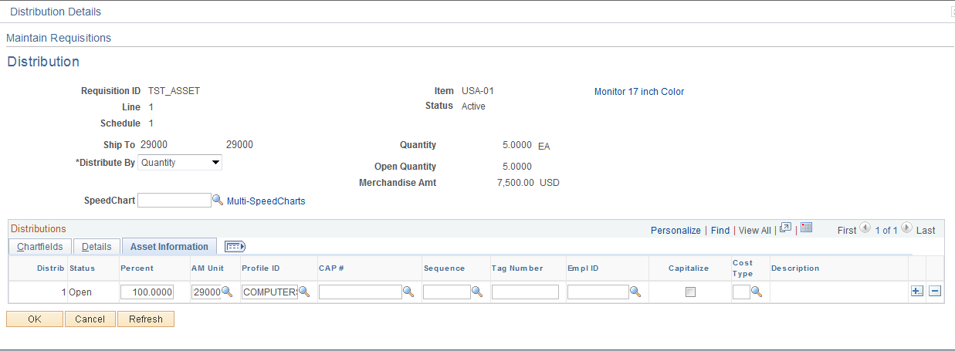

The required Asset information on a Requisition is found on the Requisition Distribution Line.
When entering an Asset Requisition, certain Asset information can default onto the Requisition Distribution Line depending on the Item ID used on the Requisition Line. This Asset information may need to be altered to match the Asset that is being requisitioned (Profile ID, etc.). If the Asset information is not defaulted onto the Distribution Line from the Item, you can manually populate the data. When multiple Distribution lines are being used (as is illustrated above) each Distribution Line must have the appropriate Asset information populated.
AM Unit – is the Agency in which the Asset will be created. Without this value, the requisition will not be flagged as an Asset eligible for integration into Asset Management.
Profile ID – is the gateway to Asset Management and is used to default properties and depreciation rules into the Asset. The Profile ID will default onto the Distribution Line based on the Item ID selected on the Requisition Line. In cases when an asset item is ordered by description on the Requisition and the unit cost exceeds the $500 threshold for telecommunication and information technology assets, and $2,500 threshold for all other assets, the system will prompt the user for a Profile ID if the requisition is saved without the Profile ID.

NOTE: A Profile ID with a useful life of 1 year will be included on Item IDs that are capital assets and are expected to cost $500 or more for telecommunication and information technology assets, and $2,500 or more for all other assets. The Profile ID will need to be changed to a useful life of more than 1 year if the asset cost is $25,000 or more or qualifies for federal reimbursement. A Profile ID may need to be added for low dollar, sensitive items that do not meet the criteria for adding the Profile ID as an item default, because without this value, the requisition will not be flagged as an Asset eligible for integration into Asset Management.

Tag Number – if the Tag Number is known at the time of the request, enter that information. Generally, the Tag Number will not be known at this point in the purchasing process.
EmplID – define the Custodian if know at requisition time.
Cost Type – for CAFR Assets this field should be populated with ‘C’. The system will default the Cost Type value to ‘C’ for purchases with a unit price greater than or equal to $25,000.00.

Asset Purchase Order
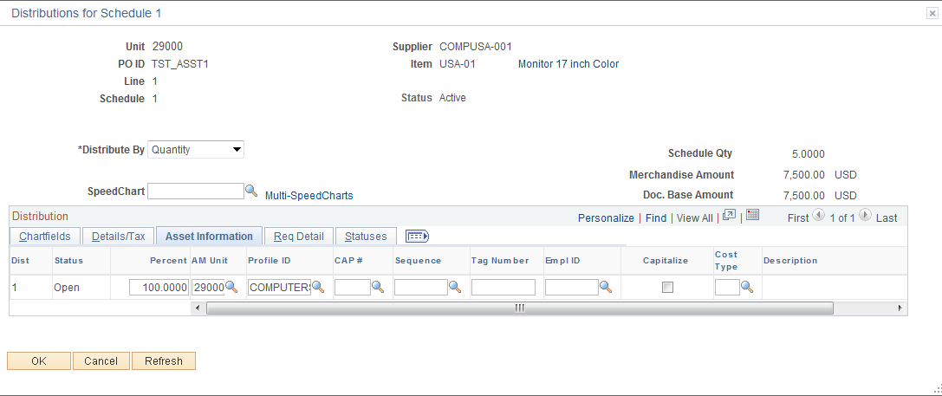
The required Asset information on a Purchase Order is also found on the Purchase Order Distribution Line.
The required Asset information on a Purchase Order will be copied from the Requisition if the Purchase Order is created from the Requisition (through Copy or AutoSourcing). If the Asset purchase begins with a Purchase Order (no Requisition required or used), the Asset information will need to be entered onto the Purchase Order for the transaction to be interfaced to Asset Management.

NOTE: If the wrong Asset Information (Profile ID, etc.) is entered on the requisition, it can be corrected on the Purchase Order. The correct Asset information must be on the Purchase Order before the Receipt can be properly entered and interfaced to Asset Management.

NOTE: The way in which the Purchase Order Line is created impacts the need for Serialization or Consolidation in the Receipt.
- Example: If a quantity of 3 is used on the Purchase Order Line and the purchase is for 3 separate and distinct Assets, the Load Line on the Receipt will need to be Serialized to separate the Quantity of 3 into 3 separate Assets.
- Example: If a quantity of 1 is used on the Purchase Order Line and the purchase is distributed on more than one PO Distribution Line, the Load Lines on the Receipt will need to be Consolidated to combine the lines into 1 asset.
Most Item IDs will be set to Serialize, negating the need for Serialization on the Receipt. Serialized Asset purchases with multiple PO Line Quantities will be “split” into separate Load Lines on the Receipt.

AM Unit – is the Agency in which the Asset will be created. Without this value, the purchase order will not be flagged as an Asset eligible for integration into Asset Management.
Profile ID – is the gateway to Asset Management and is used to default properties and depreciation rules into the Asset. The Profile ID will default onto the Distribution Line based on the Item ID selected on the Requisition Line or the Purchase Order (if no requisition is used). In cases when an asset item is ordered by description on the Purchase Order and the unit cost exceeds the $500 threshold for telecommunication and information technology assets, and $2,500 threshold for all other assets, the system will prompt the user for a Profile ID if the requisition is saved without the Profile ID.

NOTE: A Profile ID with a useful life of one year will be included on Item IDs that are capital assets and are expected to cost $500 or more for telecommunication and information technology assets, and $2,500 or more for all other assets. The Profile ID will need to be changed to a useful life of more than one year if the asset cost is $25,000 or more or qualifies for federal reimbursement. A Profile ID may need to be added to low dollar, sensitive items that do not meet the criteria for adding the Profile ID as an item default, because without this value, the requisition will not be flagged as an Asset eligible for integration into Asset Management.

Tag Number – if the Tag Number is known at the time of the request, enter that information. Generally, the Tag Number will not be known at this point in the purchasing process.
EmplID – define the Custodian if know at requisition time.
Cost Type – for CAFR Assets this field should be populated with ‘C’. The system will default the Cost Type value to ‘C’ for purchases with a unit price greater than or equal to $25,000.00.

Asset Receipt – Scenario #1, Serialized Item

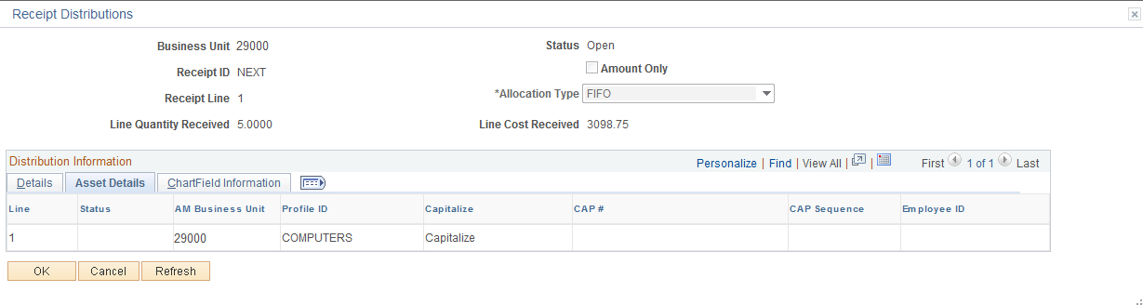
The required Asset information on a Receipt is also found on the Receipt Distribution Line.
The required Asset information on a Receipt will be copied from the Purchase Order. This is the only way that Asset information can appear on a Receipt. It cannot be entered manually on the Receipt pages.
AM Unit – is the Agency in which the Asset will be created. Without this value, the Receipt will not be flagged as an Asset eligible for integration into Asset Management.
Profile ID – is the gateway to Asset Management and is used to default properties and depreciation rules into the Asset. The Profile ID will default onto the Distribution Line based on the Item ID selected on the Requisition or Purchase Order Line. Without this value, the Receipt will not be flagged as an Asset eligible for integration into Asset Management.
Capitalize – Purchasing sends receipts as non-capitalized assets: they are capitalized from the invoice information passed from Accounts Payable.
Accessed from AM Status link (e.g., Pending, Moved) link on Receiver page.
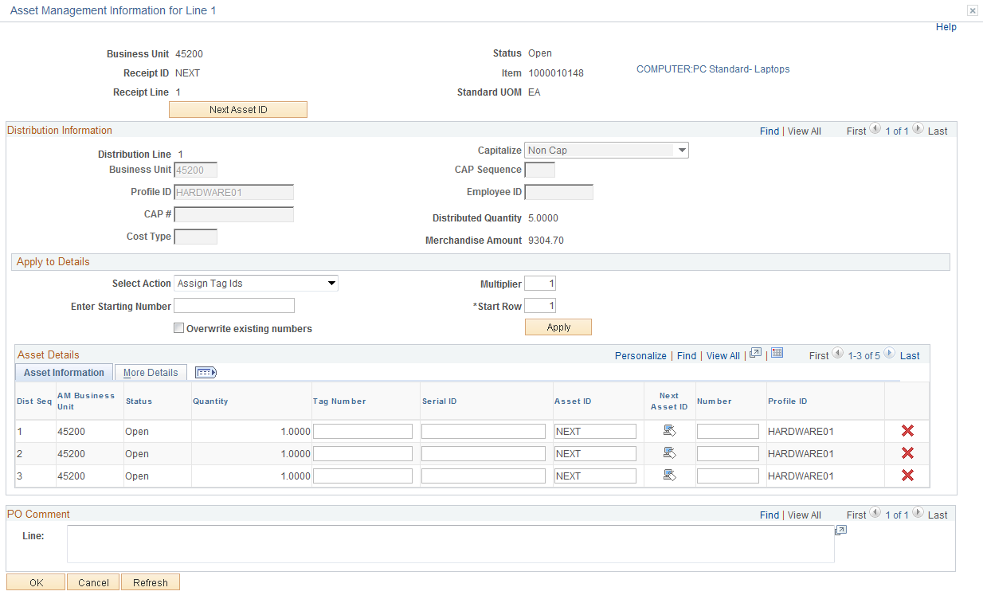

Quantity – this field holds the quantity for the Purchase Order line. If the Item ID is not set to be
Serialized, then one row is generated with a quantity equal to the Purchase Order line. The Quantity can be separated by selecting the Serial box on the Receiver page (not illustrated), or by clicking the button on the Asset Management Information for Line page, into multiple lines that can be assigned a Tag Number and will become separate Load Lines in the AM Interface tables. The Serial ID field will not be available for entry on the Receiver. The page would look similar to the illustration above.

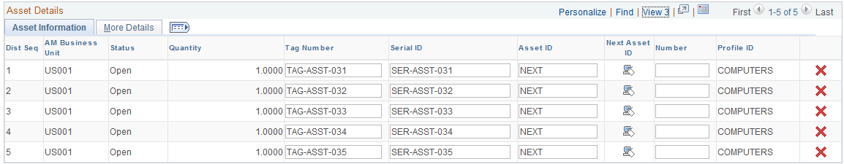

When the Item ID is designated as Serialized, the number of rows generated on the Receiver is equal to the distribution quantity converted to the item’s unit of measure. The Asset Information Tab will allow you to enter Tag Numbers, and a Serial ID must be entered for each of the Quantities in the line before the Receipt can be saved. The page would look similar to the illustration above.
Tag Number – the Asset Tag number should be entered here as part of the Physical Information that is interfaced to Asset Management.
Serial ID – If the receipt line is serial controlled, the field will be available for entry and a Serial ID must be entered when receiving the Asset PO. DCS requires serial IDs for machinery and equipment per OAC 580:70-3-1 (c) (3).

NOTE: If the receipt line is serial controlled, but there is no Serial ID, the field can be populated with the tag number. If a Serial ID is not available at the time of receipt, enter a value that will alert the agency Asset Manager that this ID must be obtained and entered correctly in Asset Management after the physical information is passed to Asset Management.

Asset ID - The default value is NEXT, which is passed to Asset Management, where the next Asset ID is assigned. Do not override the default.

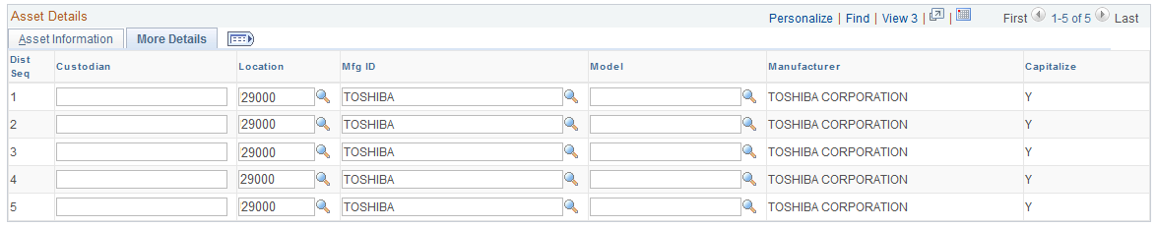

The More Details Tab holds additional Asset Physical Information.
Custodian – if the Asset Custodian is know at this time the name can be entered now.

NOTE: Names must be entered into the system as Last, First with no spaces.

Location – this field holds the Agency internal location where the Asset will be located. Use the prompt feature to look-up all valid Locations values for the agency.
Mfg ID –Mfg ID can be assigned at time of receipt as part of the Asset Physical information. If the manufacturer is not pre-defined, submit a help desk case to request it be added. DCS requires manufacturer ID for machinery and equipment per OAC 580:70-3-1 (c) (4).
Model – Enter the model name or number. DCS requires the model for machinery and equipment per OAC 580:70-3-1 (c) (3).

NOTE: The Receipt Asset information will be interfaced into the AM Interface tables on-line when the Receipt is saved. This eliminates the need for a user to execute the load process for their Agency. Each Receipt Distribution Sequence Line that is interfaced into the AM Interface tables will be a separate Load Line.

NOTE: If any Physical Information is missed when creating the Receipt, it can be added to the Asset through the Asset Basic Add pages after the Asset has been interfaced to Asset Management.

Asset Receipt – Scenario #2, Multiple Distribution Lines for One Asset

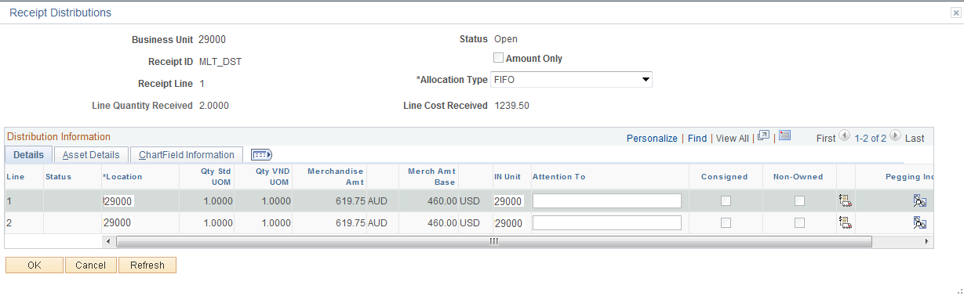

The required Asset information on a Receipt is also found on the Receipt Distribution Line.
The required Asset information on a Receipt will be copied from the Purchase Order. This is the only way that Asset information can appear on a Receipt. It cannot be entered manually on the Receipt pages.
AM Unit – is the Agency in which the Asset will be created. Without this value, the Receipt will not be flagged as an Asset eligible for integration into Asset Management.
Profile ID – is the gateway to Asset Management and is used to default properties and depreciation rules into the Asset. The Profile ID will default onto the Distribution Line based on the Item ID selected on the Requisition or Purchase Order Line. Without this value, the Receipt will not be flagged as an Asset eligible for integration into Asset Management.
Capitalize – Purchasing sends receipts as non-capitalized assets; they are capitalized from the invoice information passed from Accounts Payable.
Accessed from AM Status link(e.g. Pending) link on Receiver page

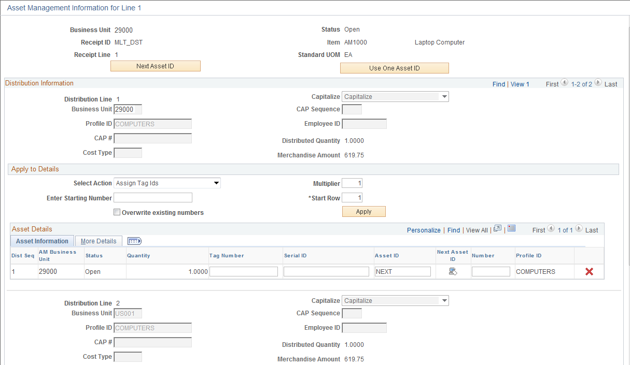
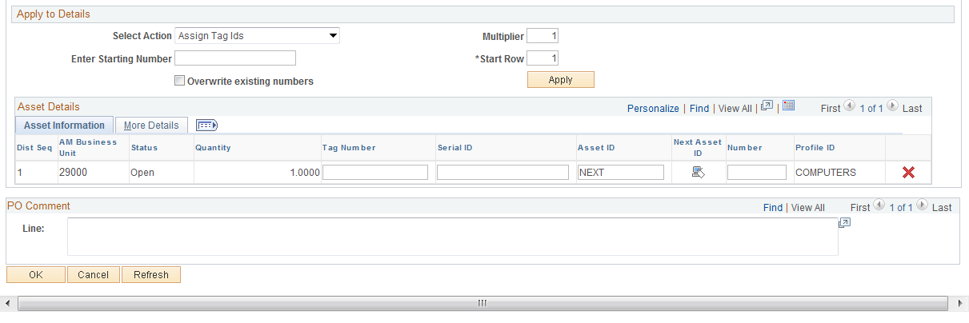

The example above has two split Distribution Lines indicated by the multiple rows available on the page (1 of 2). These Purchase Order Distribution Lines can be combined into one Asset by using the . This will essentially consolidate the two Distribution Lines into One Load Line in the AM Interface Tables.

Distribution Line #1

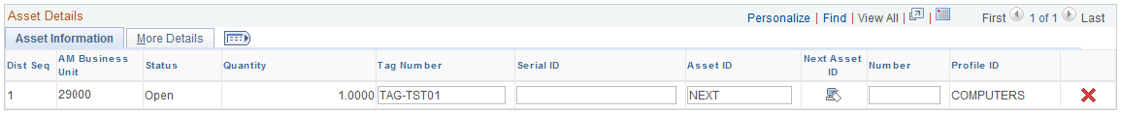

Distribution Line #2

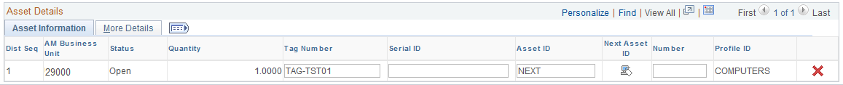
By using the Use One Asset ID feature, both Distribution Lines for this Purchase Order Line have the Number field set to ‘1’. This will ensure the Distribution Lines will be combined into one Load Line in the Interface Tables; yet, retain the split ChartField information in Asset Management.
Quantity – this field holds the quantity for the Purchase Order Distribution Line. If the Purchase Order Line (and Schedule) has two Distribution Lines, the Quantity will match the split quantity from the PO Line.
Tag Number – the Asset Tag number should be entered here as part of the Physical Information that is interfaced to Asset Management.
Serial ID – when receiving the Asset PO, populate this field with the Serial Number for each Asset. The Item and/or Receipt line must be marked to Serialize for this field to be available. This field is required for Serialized Items. If no serial number exists for the Asset, you can use the Tag Number in this field. If a Serial ID is not available at the time of receipt, enter a value that will alert the agency Asset Manager that this ID must be obtained and entered correctly in Asset Management after the physical information is passed to Asset Management.
Asset ID - The default value is NEXT, which is passed to Asset Management, where the next Asset ID is assigned. Do not override the default.

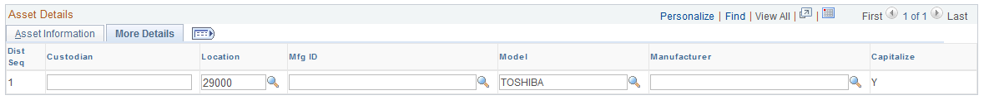

The More Details Tab holds additional Asset Physical Information.
Custodian – if the Asset Custodian is know at this time the name can be entered now.

NOTE: Names must be entered into the system as Last, First with no spaces.

Location – this field holds the Agency internal location where the Asset will be located. Use the prompt feature to look-up all valid Locations values for the agency.
Mfg ID – Mfg ID can be assigned at time of receipt as part of the Asset Physical information. If the manufacturer is not pre-defined, submit a help desk case to request it be added. Department of Central Services requires manufacturer IDs for machinery and equipment per OAC 580:70-3-1 (c) (4).
Model – Enter the model name or number. Department of Central Services requires the model for machinery and equipment per OAC 580:70-3-1 (c) (3).

NOTE: The Receipt Asset information will be interfaced into the AM Interface tables on-line when the Receipt is saved. This eliminates the need for a user to execute the load process for their Agency. Each Receipt Line that is interfaced into the AM Interface tables will be a separate Load Line.

NOTE: If any Physical Information is missed when creating the Receipt, it can be added to the Asset through the Asset Basic Add pages after the Asset has been interfaced to Asset Management.

Asset Voucher

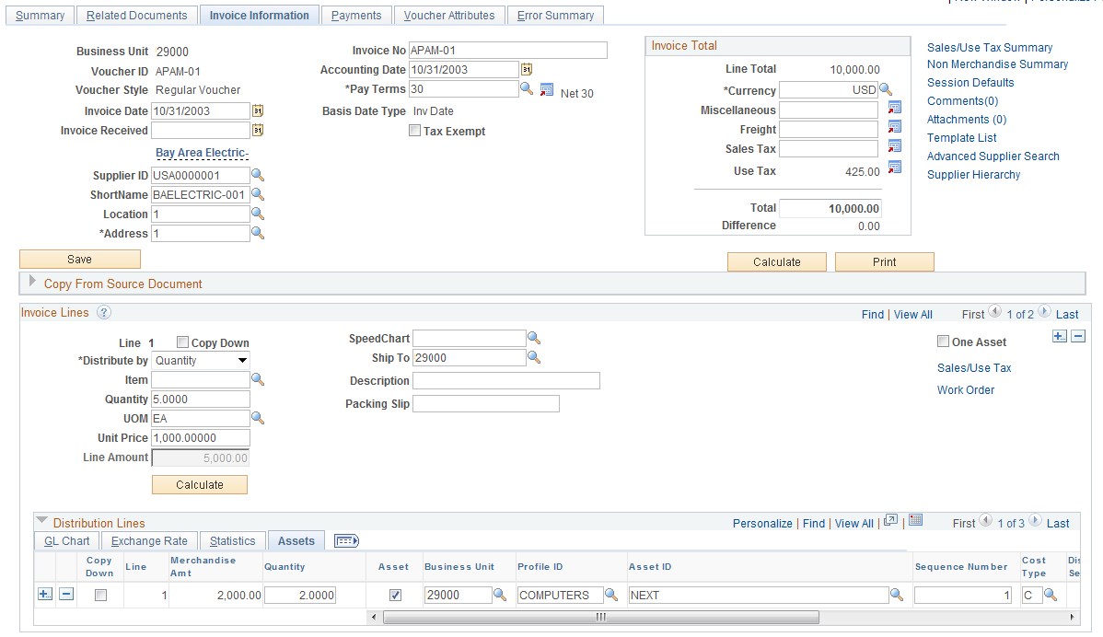

The Voucher carries Financial Information into the Pre-AM tables for interface into the Asset Management module. If receiving is used, the Financial Information will be married with the Physical information previously entered into Asset Management through the Receipt.
The AP Voucher for an Asset Purchase should be copied from the Receiver.
The required Asset information on a Voucher is found on the Voucher Distribution Line.
AM Unit – is the AM BU in which the Asset will be created. Without this value, the Voucher will not be flagged as an Asset eligible for integration into Asset Management.
Profile ID – is the gateway to Asset Management and is used to default properties and depreciation rules into the Asset. The Profile ID will default onto the Distribution Line based on the Profile ID on the Receipt. The Profile ID can be changed on the voucher but should only be done on instruction from the Asset Manager to the accounts payable supervisor.

NOTE: In cases when an asset account number is entered on the voucher distribution line and the unit cost exceeds the $500 threshold for telecommunication and information technology assets, and $2,500 threshold for all other assets and there is no Profile ID, the system will prompt the user for a Profile ID. This can occur if the asset is purchased on an authority order (not recommended) or the account number on the receipt or purchase order was overridden with an asset account number.

Asset ID - The default value is NEXT, which is passed to Asset Management, where the next Asset ID is assigned. Do not override the default.

NOTE: The Tag Number and Employee ID that are available on the Requisition, Purchase Order, and Receipt are not available on the Voucher. This is because the Voucher only carries Financial Information to Asset Management, not Physical Information.

Cost Type – for CAFR Assets with field should be populated with ‘C’. The system will default the Cost Type value to ‘C’ for purchases with a unit price greater than or equal to $25,000.00.

NOTE: Each Line on the Voucher becomes a separate Load Line in the Pre-AM Interface Tables.

Loading and Reviewing the AM Interface Tables – Physical Information

A batch process is required to move Physical Information from the Purchasing Receipt tables into the AM Interface Tables. The Physical information from the Receipt is loaded into the AM Interface tables as Load Lines. This information is not editable but must be reviewed and approved before an asset ID is assigned.

NOTE: The process actually inserts Load Lines into the Pre-AM tables before the Load Lines are inserted into the AM Interface Tables. This process is transparent to the user.

The Batch process will be executed automatically in real time when saving the Receipt if the Interface Receipt box is checked on the Receiving page. The box default can be to check the box automatically based on the user preference setup.

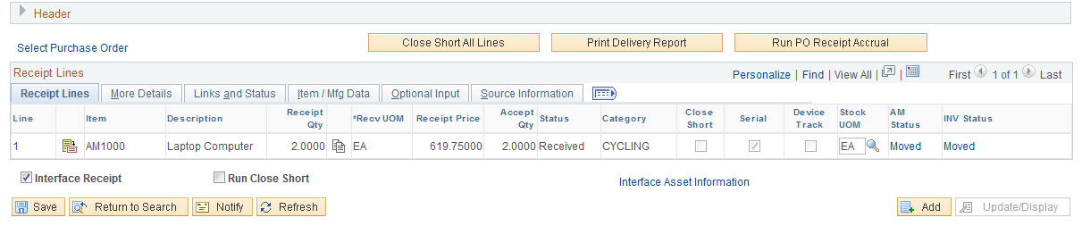

NOTE: There may be occasion when user preferences are not set up to default a checked Interface Receipt box, or the checkmark could possibly be removed before the receipt is saved. A query has been designed to identify asset -related receivers that are not pushed to Asset Management. The Query is:
OCP_AM_RCVR_NOT_PUSHED_TO_AM
The Asset Manager should run this query timely based on the number of agency transactions. Request should be made to the purchasing department to check the Interface Receipt box and resave Receipts identified on the query, or obtain the go-ahead to process the receipts as illustrated beginning on the next page. This ensures that assets are accounted for at time of receipt and that the physical information is loaded to Asset Management before the assets are capitalized from Accounts Payable.

Step 1: Loading the Pre-AM Tables – Physical Information
Navigation: Purchasing>Receipts>Process Receipts>Find an Existing Value.

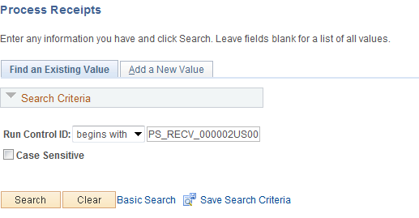

Run Control ID – populate with a new or existing Run Control ID.

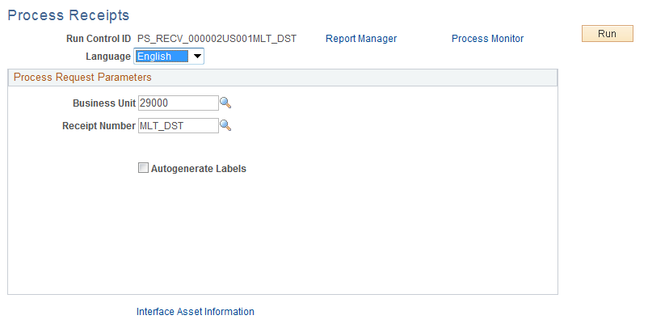

Business Unit – populate this field with the Business Unit that the Receipt was created in.
Receipt Number – Populate with the Asset Receipt Number that will push Asset information to the AM Interface tables.
Click to execute the Receipt Push process.

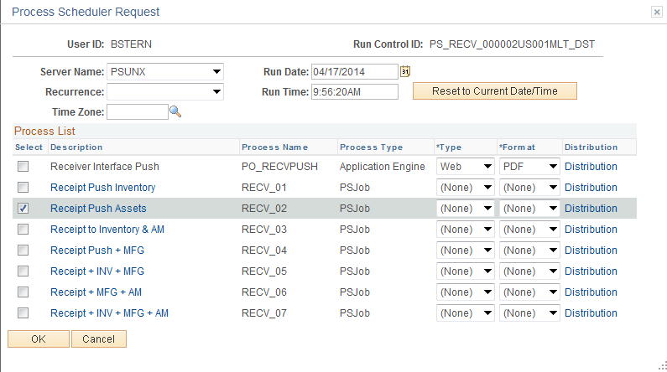
Select the Receipt Push process for Asset Management – RECV_02.

Click to execute the process that populates the AM Interface tables.

NOTE: The process actually inserts Load Lines into the Pre-AM tables first and then the Load Lines are inserted into the AM Interface Tables. This two-step process is transparent to the user.

NOTE: In the integration from Purchasing and Accounts Payable for Physical and Financial information respectively, Load Lines can be set to an Errored Status when data is incorrect or duplicated. This situation is generally an exception but could occur from time to time. When Load Lines are found in Error Status, they should be reported to OSF Help Desk for corrective action.

Step 2: Reviewing the AM Interface Tables - Physical Information
The AM Interface tables are initially populated with an Asset’s Physical information when the Receipt is saved. The tables hold Asset Load Lines that are created from Receipt Lines with Asset information. You can search for Physical Load Lines in the AM Interface tables by various data elements including Business Unit, Interface ID, and System Source.
The data on this page is not editable but is provided for review and approval. The information displayed should be reviewed and any corrections identified should be documented so that changes to the Asset can be made in the Asset Basic Add pages when the Asset is created.
Also, if Load Lines need to be Consolidated or Unitized those features can be utilized while the lines are in the Interface Tables. Those functions are described in subsequent sections of this manual.

NOTE: The Interface ID is a system assigned number that represents the batch of Load Lines with Physical Information from the Receipt.

Navigation: Asset Management > Send/Receive Information > Approve Physical Information > Review A > Find an Existing Value
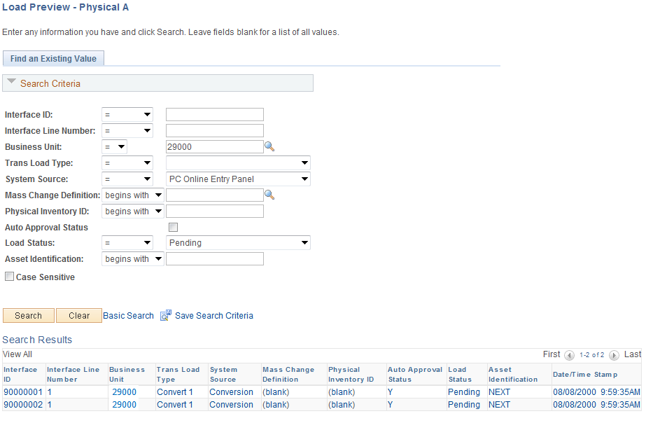

Business Unit – is the Agency in which the Load Lines are stored. This field is required.
System Source – for Receipt Load Lines this value will be PO Online Entry Panel.
Auto Approval Status – the box for new Load Lines from Purchasing Receipt will be unchecked.
Load Status – new Load Lines from Purchasing Receipts will be Pending.
Click to retrieve all the Load Lines that match the criteria provided.

The Search Results can have many Load Lines that match the criteria provided. Select the Load Line that you want to review by clicking on the Interface ID link.

Review-A Page

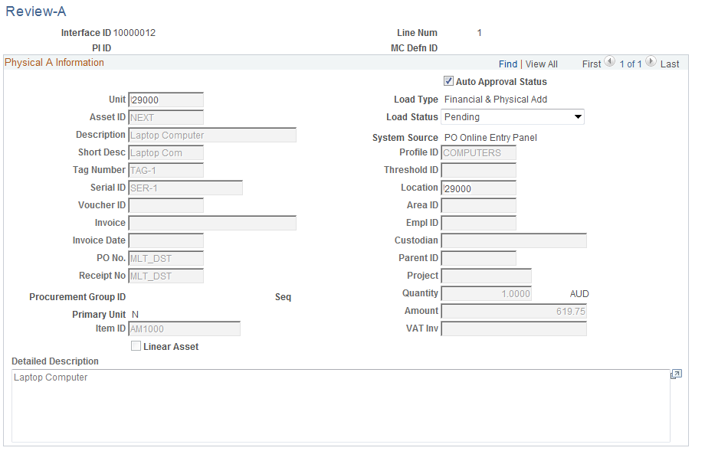
The Physical Transaction A page shows Physical Information for the Load Line. This information is not editable on this page. Any corrections that are identified on this page will need to be made in the Asset Basic Add pages when the Asset is created.
Auto Approval Status – the default approval status is not checked. The Asset Manager must check the box signifying that the data has been reviewed and the Load Line can be loaded into the Asset Management module to create the Asset. The fields that should be reviewed on this page before the Load Line is approved are as follows:
Asset ID – the asset ID should be NEXT unless the Use One Asset ID feature was applied in the receipt.

NOTE: Load Lines using the Use One Asset ID feature will be combined with other Load Lines from the receipt. This is evidenced by the Asset ID already being assigned in the Interface Tables.

Description – Verify that the description conforms to agency defined conventions to facilitate agency required reporting. Changes to the description can be made on the Asset Basic Add page after the asset is created.
Short Desc – Changes to the description may require the Short Description be changed on the Asset Basic Add page after the asset is created.
Tag Number – If a tag number was not entered for a machinery and equipment asset at time of receipt, it must be entered on the Asset Basic Add page after the asset is created.
Serial ID – If a Serial ID was not entered for machinery and equipment asset at time of receipt, it must be entered on the Asset Basic Add page after the asset is created. The receiver may have entered a value signifying to the agency Asset Manager that this information was not available at time of receipt If the receipt line was serial controlled. The ID will need to be obtained and the field updated on the Asset Basic Add page after the asset is created.
Profile ID – Verify that the correct Profile ID was used for the asset purchased. The Profile ID defaults the Asset Category, Asset Type, and Useful Life.

NOTE: Changing an incorrect Profile ID on the Asset Basic Add page after the asset is created will not correct the Asset Category, Asset Type, and/or Useful Life because Assets are capitalized from the voucher. An incorrect Profile ID can be corrected on the voucher, but this will require the Asset Manager work with the Accounts Payable Department. Otherwise, the Asset Manager can make note of the Asset ID with an incorrect Profile ID and make the correction(s) after the asset has been capitalized.
A Profile ID for an asset with an incorrect Asset Category (i.e., information technology asset recorded as machinery and equipment) will require Re-categorization after the asset is capitalized.
A Profile ID for an asset with an incorrect Asset Type (i.e., Equipment instead of Fleet) will require the Asset Type be updated on the Asset Basic Add page after the Asset is created or capitalized.
A Profile ID with an incorrect useful life will require the Useful Life on the Book Depreciation page be updated after the Asset is capitalized.

Location – If a location was not entered at time of receipt, it can be entered on the Asset Basic Add page after the asset is created.
EmplID – If an Employee ID was not entered at time of receipt, it can be entered on the Asset Basic Add page after the asset is created.
Custodian – If a Custodian was not entered at time of receipt, it can be entered on the Asset Basic Add page after the asset is created.
Parent ID - If the asset is a Parent or Child asset, the Parent or Child Asset ID can be entered on the Asset Basic Add page after the asset is created.
Quantity – Verify the quantity to ensure the asset will create with the correct quantity.
If the Asset Quantity is less than 1 and there is no asset ID assigned, the asset must be Consolidated with other Load Lines from the Receipt. If the asset ID is more than ‘1’, it must be Unitized to create additional Load Lines.
Amount – Review for amounts equal to or greater than $25,000 or $5,000 for assets qualifying for federal reimbursement to ensure the Profile ID has a useful life greater than ‘01’. Also review for non-sensitive items with amounts less than the thresholds for telecommunication and information technology assets and all other assets to hold the Load Lines from processing if the items should not be an asset in Asset Management. See the Note associated with Load Status.
Load Status – the default Load Status is set to Pending. This makes the Load Line eligible to be picked up in the batch process that creates Assets in the Asset Management module once the Auto Approval Status box is checked.

NOTE: The Load Status is the one field that is editable on the page. It can be changed to On Hold to prevent the transaction from creating an asset if a Load Item was mistakenly passed to Asset Management.

Click to save the Approval Status for the Load Line.

NOTE: The Physical Transactions A Page is not editable so missing or incorrect Physical Information, or incorrect Financial Information due to an incorrect Profile ID, should be documented and tracked for correction in the Asset Basic Add pages after the Asset ID is created or capitalized. A query has been designed to help review, document, and track the AM Interface Load Lines. The Query is:
OCP_AM_PHY_A_RCPTS_TO_REVIEW
This Query displays Load Lines that are not approved in the AM Interface table and provides additional information such as Quantity, Amount, Profile ID, Purchase Order, and Receipt information, and other physical information that is not available on the Load Preview Physical A search page.

Consolidating Physical Load Lines
It may be necessary to combine multiple Load Lines in the Interface Tables into one Asset. This could be the case when many distribution lines from a Purchase Order exist, but the purchase is for a single Asset. This process of combining multiple Load Lines into a single Load Line (or Asset) is called Consolidating.
For example, if a purchase is “split-funded” by an Agency, but the split distribution lines represent a single Asset, the split distribution lines (Load Lines) can be Consolidated together to make one Asset. If these distribution lines are not Consolidated, they will create separate Assets in the Asset Management module.

NOTE: The preferable method is to utilize the Use One Asset feature on the Receipt to properly combine Receipt Lines into one Asset because the accounting entries and depreciation will be allocated across the split distribution. Using the Consolidated feature in Asset Management forces the transaction to be recorded to just one funding.

Load Lines that are candidates for Consolidation can be viewed in the Interface tables described in the previous section. Review those lines and determine if Consolidation is necessary. When Consolidation is necessary, Load Lines must be combined before the Transaction Loader process loads the lines into the Asset Management module.

NOTE: Generally, the Consolidation feature will not need to be used and should be utilized only in a correction situation. For example, if the Purchase Order or Receipt was not created correctly and Load Lines that should have been combined on these documents were not, the Consolidation process can be used to correct those lines.

In the following Example, two Load Lines that are separate Distribution Lines from the Receipt are going to be consolidated into one Load Line. This consolidation could have been avoided if the Use One Asset ID feature would have been used on the Receipt.
Step1: Reviewing the Interface Tables for Load Lines to Consolidate
Navigation: Asset Management > Send/Receive Information > Approve Physical Information > Review A > Find an Existing Value

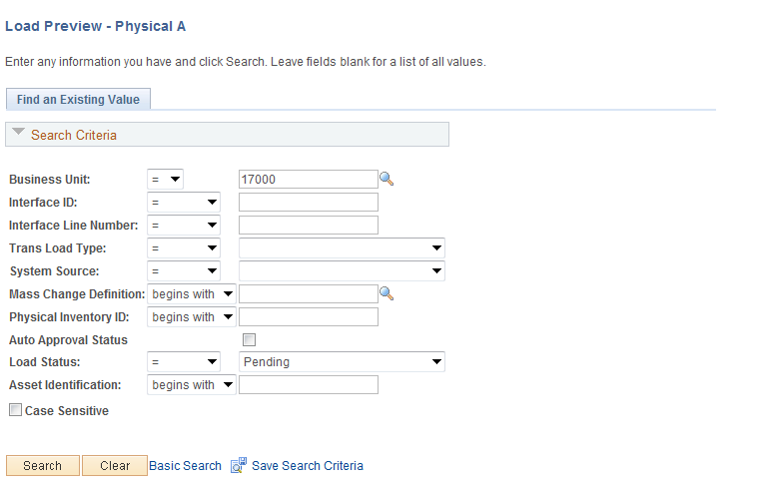

Business Unit – is the Agency in which the Load Lines are stored.
System Source – for Receipt Load Lines this value will be PO Online Entry Panel.
Load Status – new Load Lines from Purchasing Receipts will be Pending. The Load Lines to Consolidate must be in Pending status.
Click to retrieve all the Load Lines that match the criteria provided.

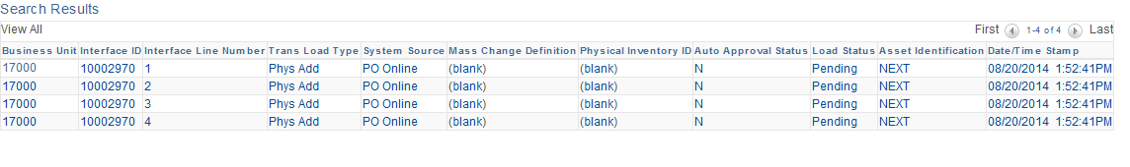

The Search Results can have many Load Lines that match the criteria provided. Select the Load Line that you want to review. The Interface ID, Interface Line Number are some key values that can be used to retrieve Load Lines and consolidate them. These key data elements will be necessary to execute the Consolidation action in the next section.

Physical Transactions A Page
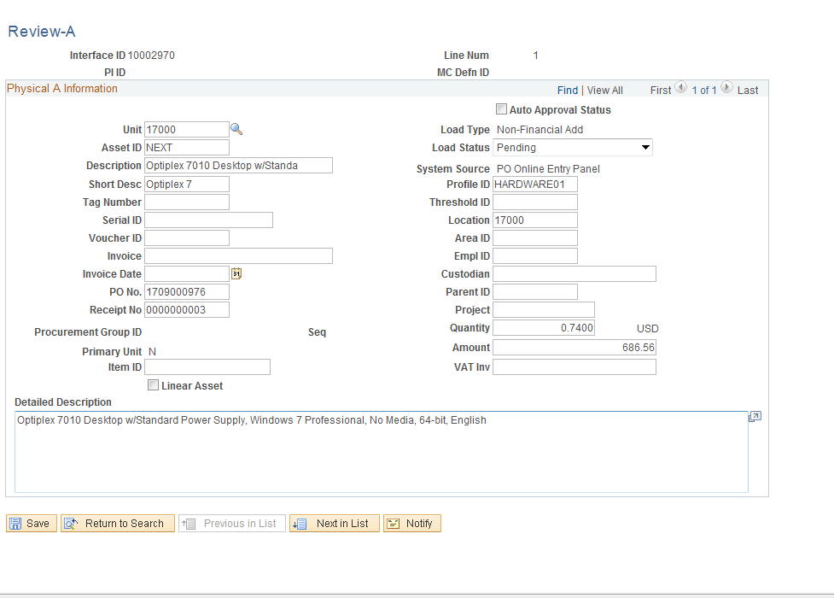

The Physical Transaction page displays all physical information related to the Load Line including PO Number, Receipt Number, Quantity, and Amount.

NOTE: The first criterion for Asset Consolidation is Asset Quantity. If the Asset Quantity is less than 1 and there is no Asset ID assigned, the Asset must be Consolidated with other Load Lines from the Receipt.

NOTE: The Interface ID, Interface Line Number, and Receipt Number should be noted for the Consolidation action in the next section.

NOTE: In this example, the Load Line illustrated above is from a Receipt with two Distribution Lines. The Use One Asset ID feature was NOT used to combine the Requisition Distribution lines into one Asset, so the Consolidation feature will be use to make the correction.

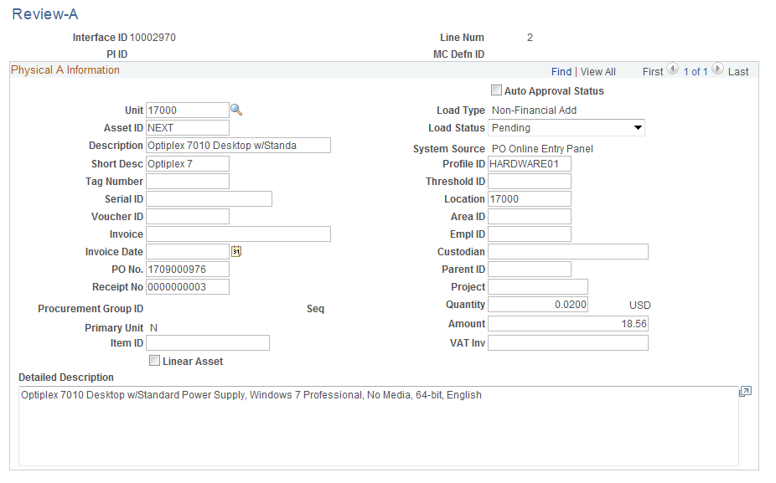

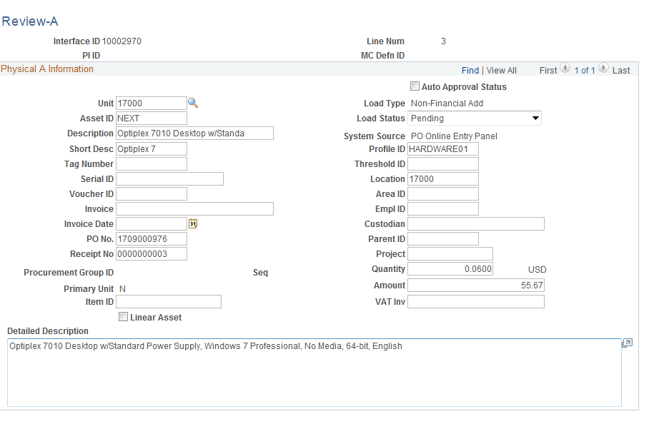

The Physical Transactions A page shows the second Load Line matching the second Distribution Line from the Receipt. This Load Line needs to be combined with the Load Line from the illustration above to make one Asset.

NOTE: If the Consolidation is not done at this point, the system will create two Assets, one for each Distribution line. The Interface ID, PO Number, or Receipt Number can be used to retrieve and Consolidate these two Load Lines.

Step2: Consolidate Load Lines
Navigation: Asset Management > Send/Receive Information > Load Transactions > Consolidate Assets > Add a new Value
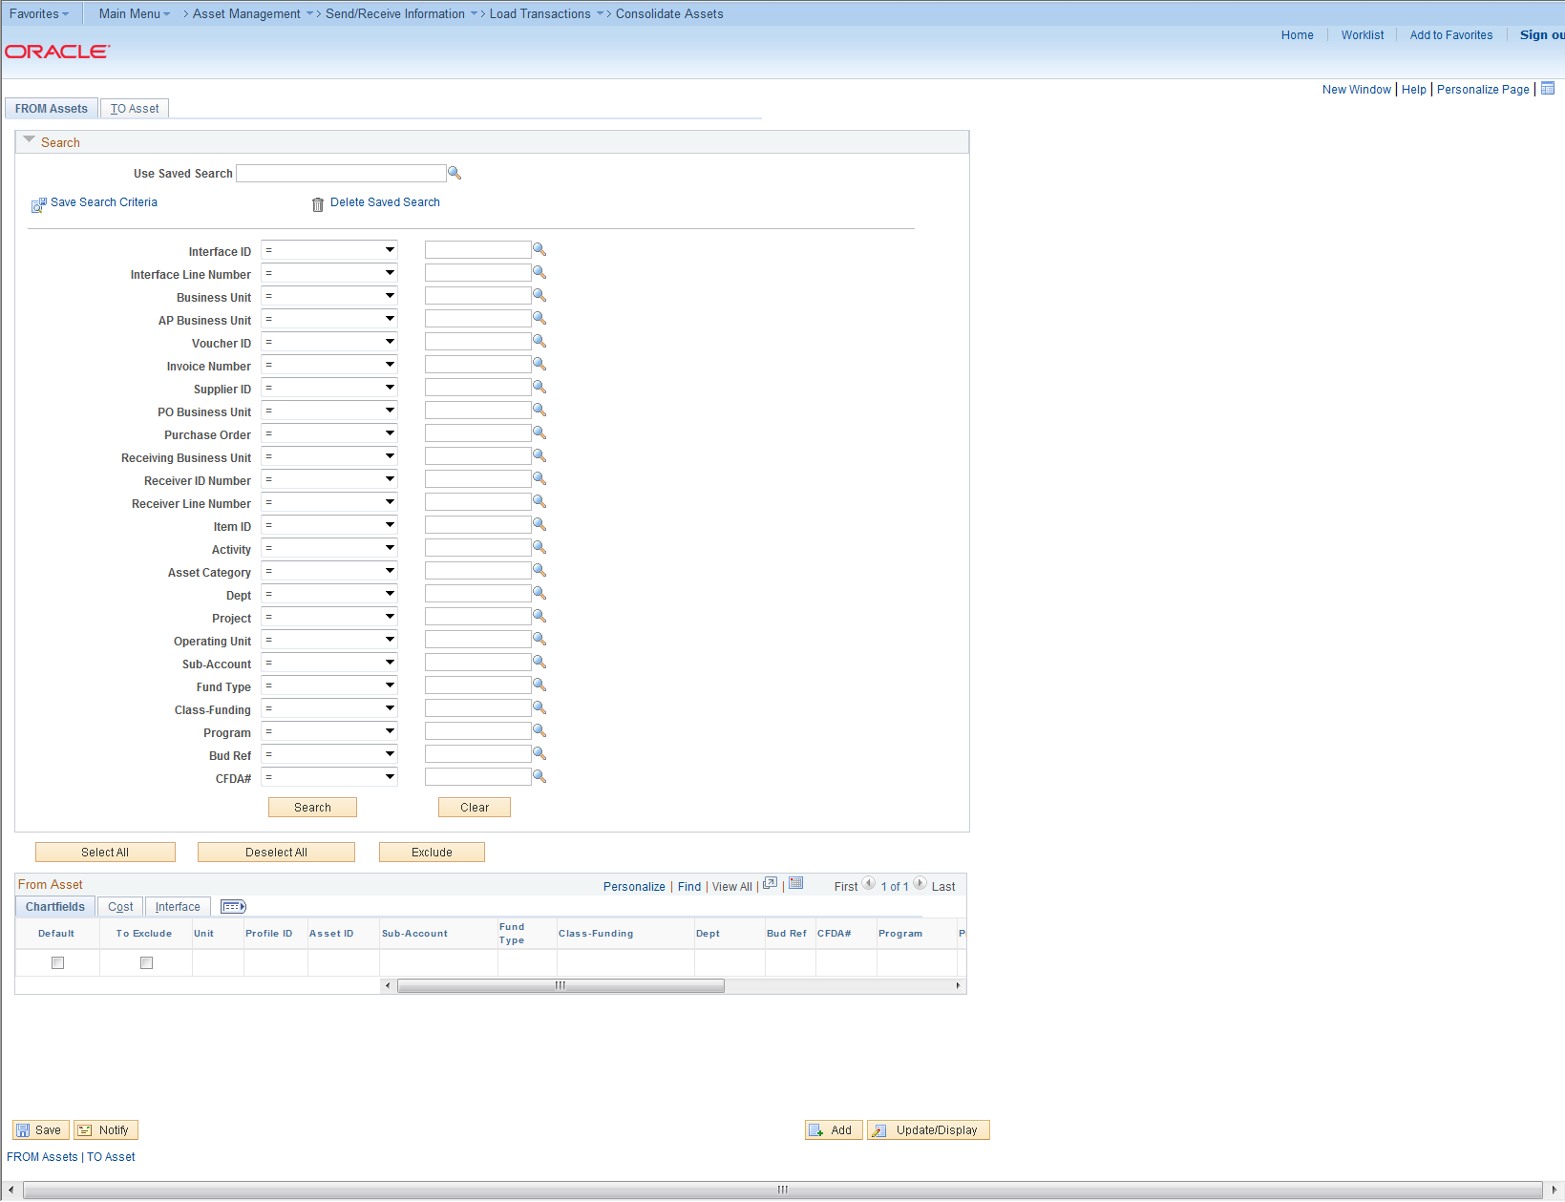

Consolidate - The process of combining more than one Receiver or Voucher line into one Asset.
Business Unit – is the Agency in which the Load Lines are stored.
Select an Interface ID, Voucher ID or Purchase Order number to see the assets to consolidate.
Interface ID - An Interface ID is assigned to each group of Asset load lines that you move in a batch to the Interface table during the Interface process.
Interface Tables - The table between the Pre AM tables and the Asset Management tables. This is where unitization and consolidation takes place. This table holds Load Lines.
The From Asset Search page has been enhanced to pull up the specific assets you wish to consolidate.
Value – Once the Field Name(s) are selected, a list of values associated with Pending Load Lines is available to select for the Field. Not all values listed need to be consolidated. Select the appropriate value for the Load Lines that you want to Consolidate by putting a check mark in the “To Exclude” column.

NOTE: Physical transaction information from the Receipt such as Receipt Number or Purchase Order can be useful values to identify the Load Lines to Consolidate.

Use the FROM Assets page to select the Asset Load Lines you wish to Consolidate. You must select how you want to search for the Asset Load Lines that will be Consolidated. Use the Fields in the Search Criteria field area to identify the data to select Load Lines.

Field Name – Identify the Field Name that you want to use to search for Load Lines. There are now 23 field options from which to choose:
Interface ID
Interface Line Number
Business Unit
AP Business Unit
Voucher ID
Invoice Number
Supplier ID
PO Business Unit
Purchase Order
Receiving Business Unit
Receiver ID Number
Receiver Line Number
Item ID
Activity
Asset Category
Department
Project
Operating Unit
Product
Fund Code
Class Field
Program Code
Budget Reference

All of the Load Lines that match the search criteria will be retrieved to be consolidated into one asset.

Excluding Load Lines

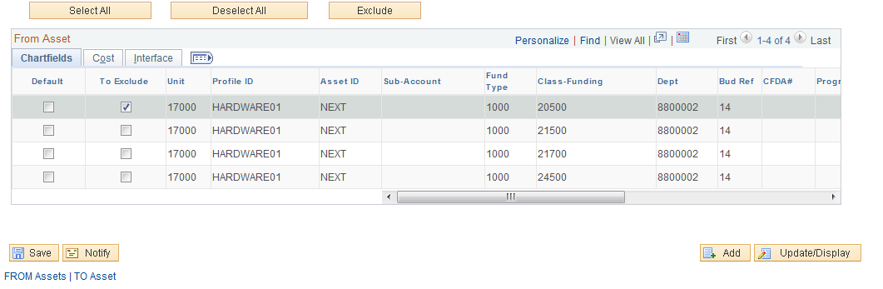

Click on the “To Exclude” Column to select the lines you DO NOT want to include in the Consolidating of the asset.
Then click the button. This will remove multiple lines at one time from being included in the consolidation or you can delete each line individually by using the button to the far right.

Consolidating

All of the Load Lines that match the search criteria will be retrieved to be consolidated into one asset.

Use the Default radio button to default information from one of the Load Lines into the new Consolidated Load Line.

NOTE: In this example, the multiple Receipt Distribution lines that need to be consolidated into one Asset are visible.

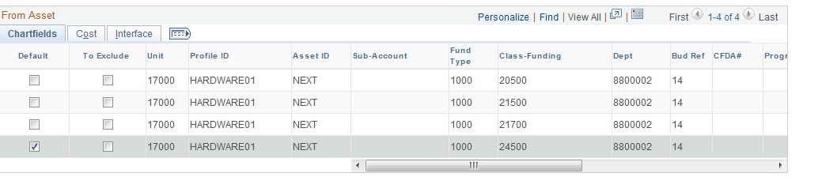

Click tab to retrieve all the Load Lines that are being consolidated.

NOTE: When consolidating Load Lines, the Physical Information from only one of the Load Lines can be carried into Asset Management with the Asset. For example, if two Distribution Lines are consolidated into one Load Line, the Department ID from only one of the original Load Lines can be carried into Asset Management. Because of this, the Consolidation feature should only be used as a correction feature and any combining of physical lines should be done through careful structuring of Purchase Order Lines or through the Receipt functionality.

Click Tab.

To Assets Page

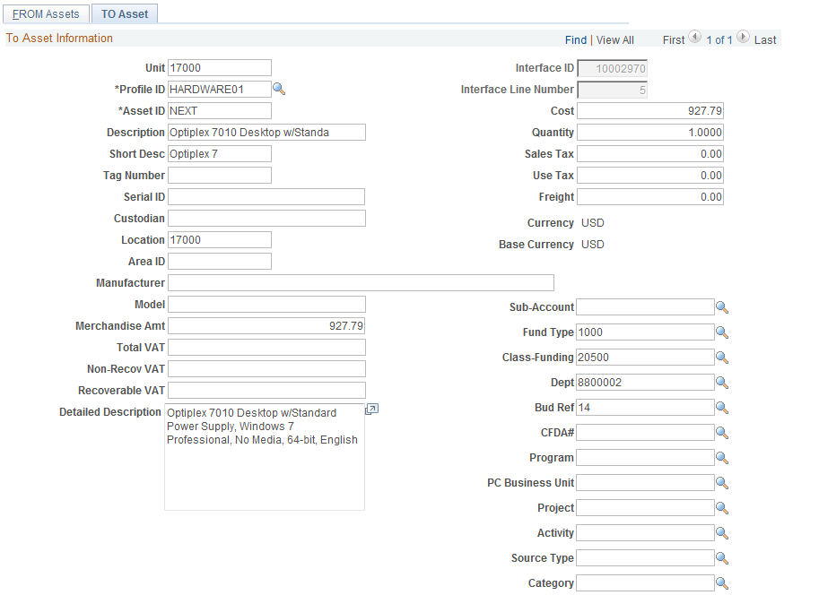

Use the TO Asset page to enter information for consolidating the Load Lines. The information on this page becomes the consolidated Asset’s information. Change the quantity to one if it doesn’t come in that way.
Profile ID – this value is the Profile ID from the Load Line.
Asset ID – leave the Asset ID as NEXT. This will be the new Asset ID for the consolidated Asset.
Cost – this field displays the Cost of the combined Asset (or combined Load Lines).
Tag Number – for the consolidated Asset, enter the Tag Number.
Serial ID - for the consolidated Asset, enter the Serial Number.

NOTE: If you are Consolidating Purchase Order Lines (not Load Lines in this case), consider the Cost of the new consolidated Asset. If the new Cost of the Asset is greater than $25,000.00, the Cost Type should be set to ‘C’. For example, if consolidating two PO Lines of $15,000.00 each, the Cost Type would not be ‘C’ of each line individually, but would be ‘C’ when both lines are combined ($30,000.00 together). See the COR415 Adjust and Transfer Manual.

Click to create the Consolidated Asset.

Step 3: Review the Newly Consolidated Load Lines
Navigation: Asset Management >Send/Receive Information> Approve Physical Information> Review A > Find an Existing Value

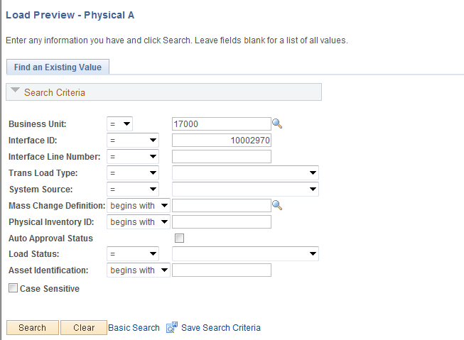

Business Unit – is the Agency in which the Load Lines are stored.
Interface ID – in this example, the Interface ID from the two (2) Load Lines that were consolidated is used a Search Criteria.
System Source – for Receipt Load Lines this value will be PO Online Entry Panel.
Load Status – for the Load Lines that have been consolidated, the Load Status will be Consolidate.
Click to retrieve all the Load Lines that match the criteria provided.

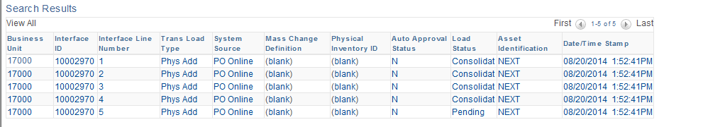

The Load Line with the Status of Consolidate represents the Load Lines that have been consolidated.

NOTE: For the Load Lines that have been consolidated, ensure the Status is Consolidate.

The Load Line with the Status of Pending represents the newly consolidated Load Lines.

NOTE: For the Load Line that has been consolidated, ensure the Status is Pending. In the example, the two (2) Load Lines from the Receipt are consolidated into one Load Line that will become one Asset ID.

Select the Load Line with the Pending status.

Physical Transactions A Page

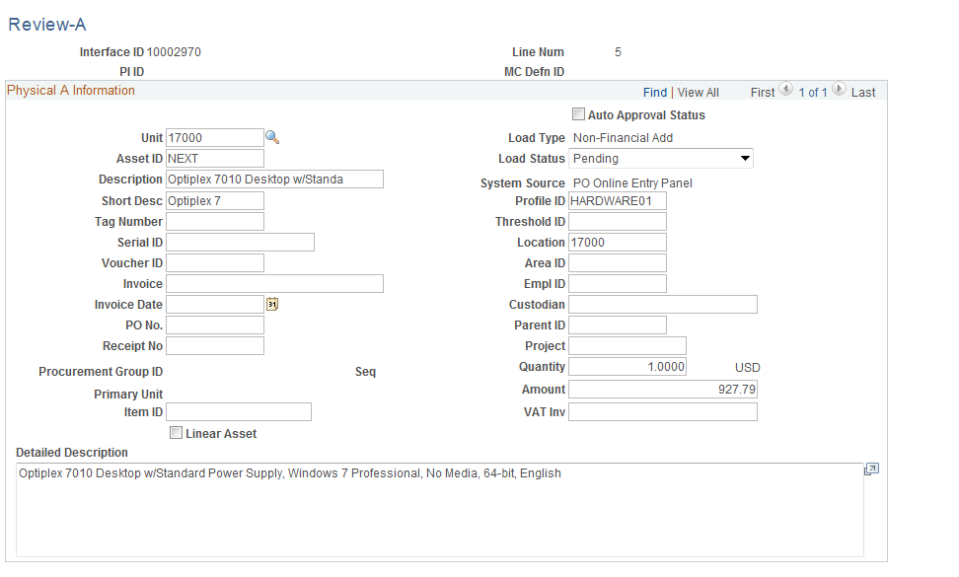

The newly consolidated Load Line is in Pending Status. The Physical Properties should match those properties that were defined on the To Page illustrated previously. The Amount should reflect the combined amounts from the two individual Load Lines that were consolidated.

NOTE: The PO No and Receipt No fields are blank on the newly consolidated Load Line because it is considered to be a different transaction than the transaction passed from the Receipt. No Purchase Order or Receipt numbers on Asset transactions make it more challenging to query for Asset data when the criteria needs to include the Purchase Order or Receipt. This is another reason the preferable method to combine Receipt Lines into one Asset is to utilize the Use One Asset feature on the Receipt.

Unitizing Physical Asset Load Lines
In situations where multiple Assets are purchased on one Purchase Order Line and not separated into separate Load Lines through the Serialization feature on the Receipt, these Assets must be separated into individual Load Lines in order for the system to create individual Asset IDs. This process is called Unitization.
In this situation a single Load Line includes more than one asset. You will need to Unitize the Load Line before you run the Transaction Loader process (discussed in the next section) to create Assets in Asset Management. Unitizing a Load Line divides the line into more than one Asset.
Load Lines that are to be Unitized should have a Quantity of greater than 1. This indicates that there are multiple Assets existing on one Load Line that need to be separated into individual Asset IDs.

Step1: Reviewing the Interface Tables for Load Lines to Unitize
Navigation: Asset Management > Send/Receive Information > Approve Physical Information > Review A > Find an Existing Value

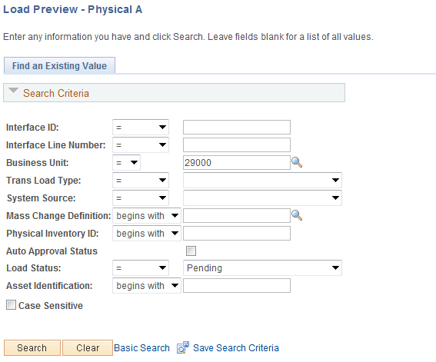

Business Unit – is the Agency in which the Load Lines are stored.
System Source – for Receipt Load Lines this value will be PO Online Entry Panel.
Load Status – new Load Lines from Purchasing Receipts will be Pending. The Load Lines to be Unitized must be in Pending status.
Click to retrieve all the Load Lines that match the criteria provided.

NOTE: These Load Lines will need to be reviewed to determine if any of them need to be Unitized. The Quantity of the Load Lines to be unitized should be greater than 1.

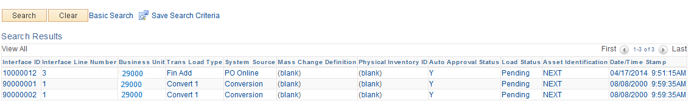

The Search Results can have many Load Lines that match the criteria provided. Select the Load Line that you want to review. The Interface ID, Interface Line Number, and Receipt Number are some key values that can be used to retrieve Load Lines and Unitize them. These key data elements will be necessary to execute the Unitization action in the next section.

Physical Transactions A Page
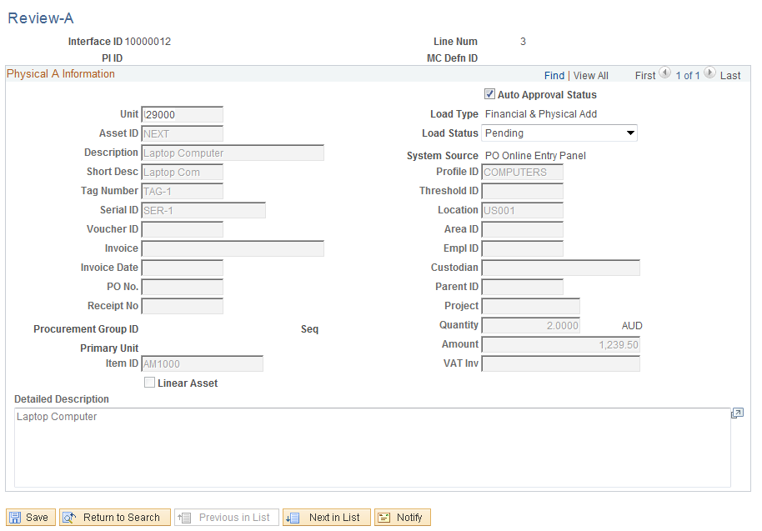

The Physical Transaction A page displays the Load Line physical information. The Load Lines that need to be consolidated will have a Quantity greater than 1.

NOTE: If the Unitization is not done at this point, the system will create one Asset ID for multiple quantities. The Interface ID, Purchase Order ID, or Receipt Number will be used to retrieve and Unitize this Load Line.

NOTE: When you determine the Load Line that needs to be Unitized, the Interface ID or PO Number should be noted. This is an easy way to select the Load Line in the unitization feature and take the unitization action.

Step2: Unitize Load Lines
Navigation: Asset Management > Send/Receive Information > Load Transactions > Unitize Assets > Find an Existing Value

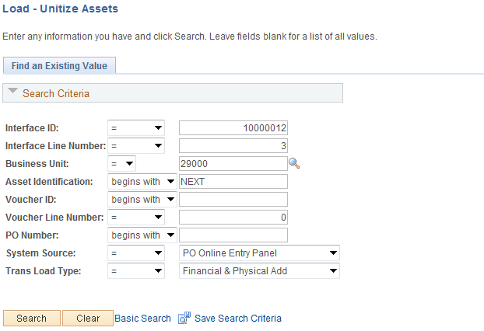

Business Unit – is the Agency in which the Load Lines are stored.
Interface ID – If known, populate with the Interface ID from the Load Line that will be Unitized.
Interface Line Number - populate with the Interface Line Number from the Load Line that will be Unitized.
PO Number – If known, PO ID can be used to search for the Load Line that will be Unitized.
System Source – for Receipt Load Lines this value will be PO Online Entry Panel.
Click to retrieve all the Load Lines that match the criteria provided.

FROM Asset Page

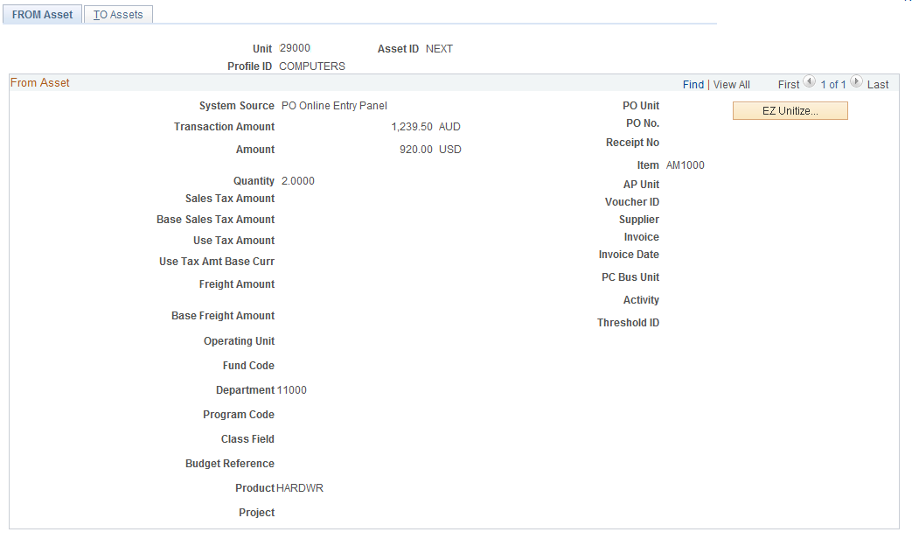

The FROM Asset page displays physical information for the Load Line that will be consolidated.
Original Profile ID – this value is listed at the top of the page and represents the Profile ID from the original Distribution Line on the transaction.
Transaction Amount – this value represents the total on the Distribution Line or the amount of all Quantities added together.
Quantity – this field holds the Quantity that will be Unitized into separate Assets.

NOTE: Identify the Quantity. This value will be used in the Unitization process.

Click to enter the Proportional Unitization Defaults page.

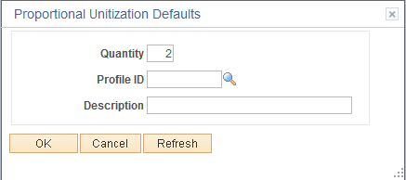

Use the Proportional Unitization Defaults page to enter information that tells the system how to divide this Asset Load Line into separate Assets. When you Unitize this Asset, the system will divide the Asset Load Line into equal pieces to become the new, separate assets.
Quantity – populate the Quantity field with the quantity and cost amount shown on the FROM Asset page, to create multiple assets. The system divides the Load Line into the number of Assets that you enter in this field.
Profile ID – do not enter a value in this field. Even if the Profile ID from the original Load Line is incorrect, changing it on this page will have no effect because the Assets will be capitalized with the Profile ID on the Accounts Payable voucher.
Description – only populate the Description if the newly unitized Assets need different Descriptions than the original Load Line. The Description can be found on the FROM Asset page.
Click to return to the TO Asset page.

NOTE: The TO Asset page should now have a row of Physical Information for each newly Unitized Asset.

NOTE: If by unitizing the Asset Load Line the Cost of the individual unitized Load Lines is less than $25,000.00, the Cost Type may need to be changed from ‘C’ to blank, or no Cost Type. See the COR415 Adjust and Transfer Manual.

TO Assets Page
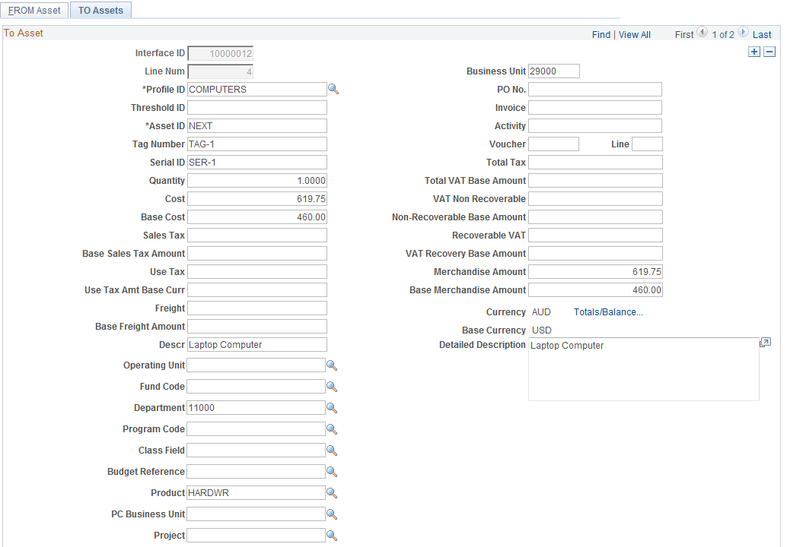

The TO Assets page shows the results of the Unitized Load Line. Use the TO Assets page to enter details for each Asset that you created by unitizing this Load Line. The number of rows should equal the Quantity defined on the Proportional Unitization Defaults page on the previous page.
Use the arrows to scroll through the new unitized load lines. The number of Load Lines should equal the Quantity that was displayed on the FROM Asset page.
Line Number – this represents the new Load Line numbers for the unitized Asset.
Profile ID – the Profile ID from the original Load Line.
Tag Number – the Tag Number for each individual Load Line should be entered. This will be the Asset Tag Number when the Load Line is interfaced into Asset Management.
Serial ID - the Serial Number for each individual Load Line should be entered. This will be the Asset Serial Number when the Load Line is interfaced into Asset Management.

NOTE: Ensure that each of the rows on the To Assets page has a Tag Number and Serial ID if desired. Use the scroll arrows to scroll through the multiple rows and assign these values.

Click to create the Unitized Assets.

Step 3: Review the Newly Unitized Load Lines
Navigation: Asset Management > Send/Receive Information > Approve Physical Information > Review A > Find an Existing Value

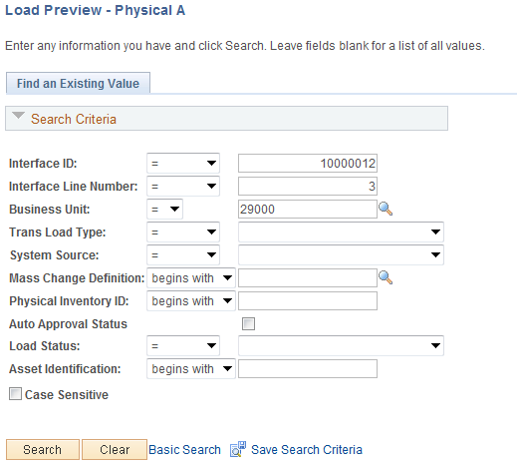

Business Unit – is the Agency in which the Load Lines are stored.
Interface ID – if known, the Interface ID can be used to retrieve the Unitized Load Lines. The Interface ID of the newly created Load Lines will be the same as the original Load Line.
System Source – for Receipt Load Lines this value will be PO Online Entry Panel.
Load Status – for the Load Lines that have been Unitized, the Load Status will be Pending. The Load Status can be used to narrow the search results.
Click to retrieve all the Load Lines that match the criteria provided.

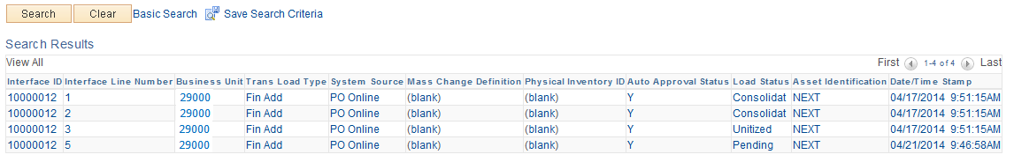
The Load Line with the Status of Unitized represents the Load Lines that were Unitized.
The Load Line with the Status of Pending represents the newly Unitized Load Lines.

NOTE: For the newly Unitized Load Lines, ensure all of their status value are Pending. This will allow these lines to be interfaced to Asset Management.

NOTE: The Interface Line Numbers of the Load Lines that have been Unitized should follow the original Load Line Interface Line Number. For example, 2, 3, n.

Select one of the Load Line with the Pending status.

Physical Transaction A Page

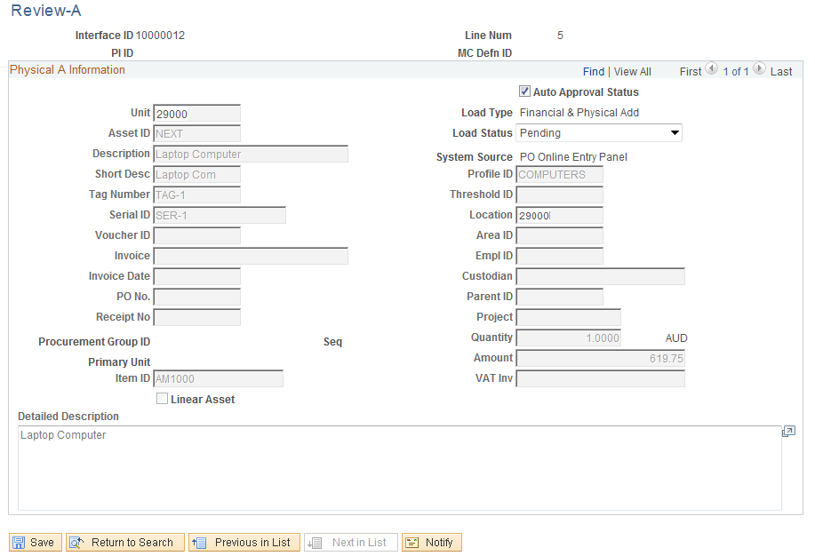

The Physical Transaction A page displays Physical Information for the newly Unitized Load Line. There should be one row for each Asset after the Unitization.
Auto Approval Status – this field must be checked for the Unitized Load Line to be interfaced to Asset Management.
Load Status – ensure the Load Status is Pending.
Quantity – the Quantity should now be 1 for each Unitized Load Line.

NOTE: Ensure that each of the new Unitized Load Lines are Approved so they can be interfaced to Asset Management. Without the Auto Approval Status selected on each new Load Line, the Assets will not be created.

Click to save the Unitized Asset.

Reviewing the Transaction Loader Process – Physical Information
After the Interface process has been completed the Consolidate and/or Unitize Asset Load Lines as necessary. The Transaction Loader process creates newly purchased assets in Asset Management.
Load Lines must be in Pending Status and have been Approved for the Transaction Loader process to pick them up and create Assets in the system.

Transaction Loader process
The Transaction Loader process will be ran daily by the State Office to move agency Assets from the AM Interface Tables into the Asset Management module and all required Asset Management Tables. Once this process has been executed and the Assets have been created, use the Asset Basic Add component to search for, find, and update any required Asset Information (See the COR411 Entry and Update manual).

NOTE: In the integration from Purchasing and Accounts Payable for Physical and Financial information, respectively, Load Lines can be set to an Error Status when data is incorrect or duplicated. This situation is generally an exception but could occur from time to time. When Load Lines are found in Error Status, they should be reported to OSF Help Desk for corrective action.

Review Assets after the Transaction Loader is Complete
Navigation: Asset Management > Asset Transactions > Owned Assets > Basic Add > Find an Existing Value

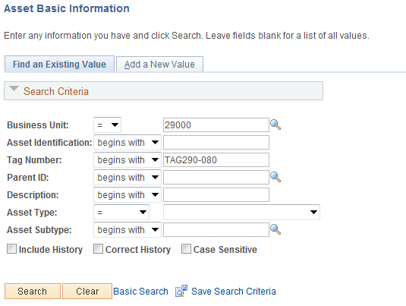

Use the Search Criteria for the Asset Basic Information pages to retrieve a particular Asset.
Generally, the Asset ID, Tag Number, or Description would be Search Criteria used to retrieve a particular Asset.
Click to retrieve the Asset based on the Search Criteria provided.

General Information Page

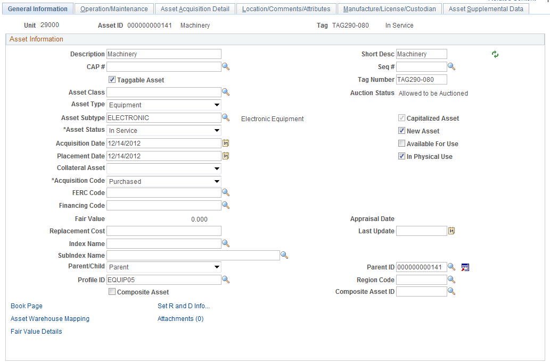

Ensure that the General Information page has the correct information for the Asset that was interfaced. Physical information included on this page for the Asset could be Description, Tag Number, and Profile ID.

NOTE: The Asset can be updated with Financial Information when the Accounts Payable voucher is interfaced and ‘Married’ with the Physical information from the Receipt and Purchase Order.

Operation/Maintenance Page

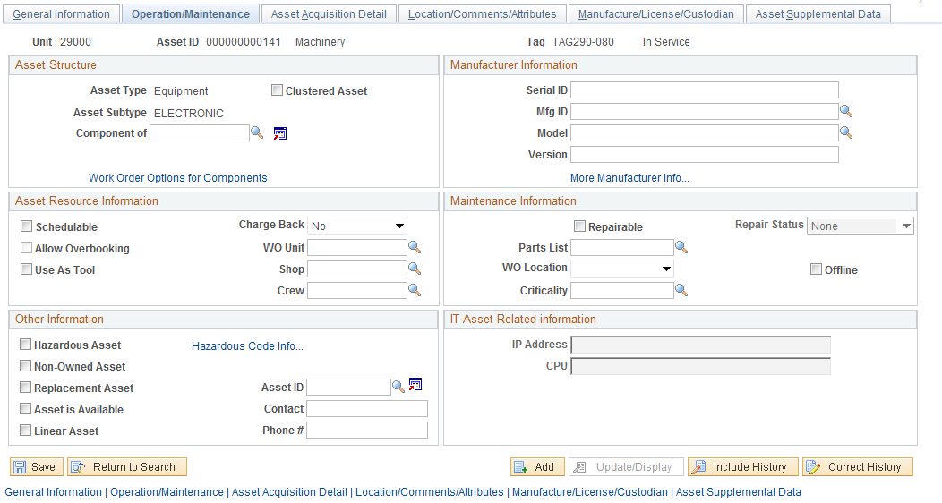

Ensure the Operation/Maintenance Tab has the correct physical information. This could include Serial ID, Manufacture ID, and Model.

Asset Acquisition Detail Page

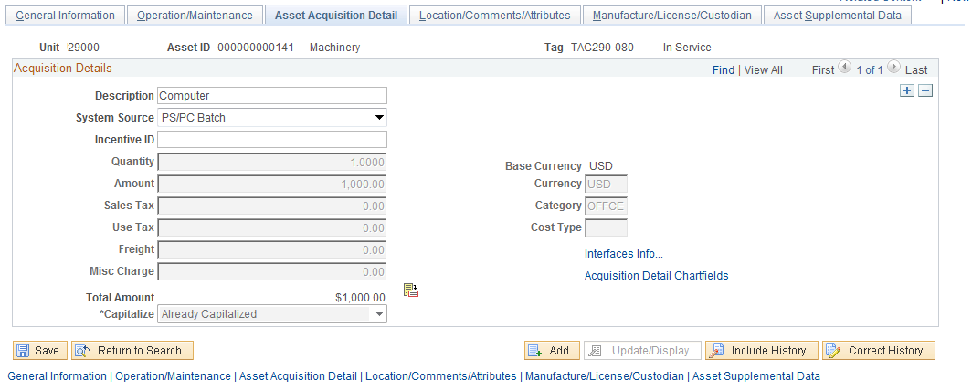

Ensure the  Tab has the correct information. This includes System Source, Quantity (PO Quantity), and Amount (PO and Receipt Amount).

NOTE: The Asset Capitalized status is set to ‘To Be Capitalized’. Since this Asset only holds Physical Information at this point, it is not yet ‘Already Capitalized’. When the Accounts Payable voucher is interfaced to Asset Management, this status will change.

The Interfaces Info… link should display the physical interface transaction information. This includes Receipt and Purchase Order details.

Location/Comments/Attributes Page

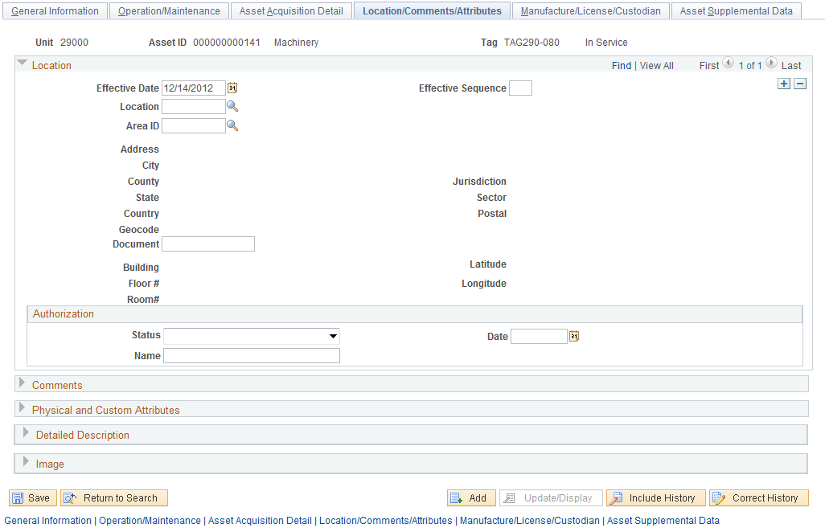

The Tab should display the Assets physical Location from the Requisition or Purchase Order.
The Comments, Physical and Custom Attributes, and Image sections of the page are available to update at this point.

Manufacture/License/Custodian Page

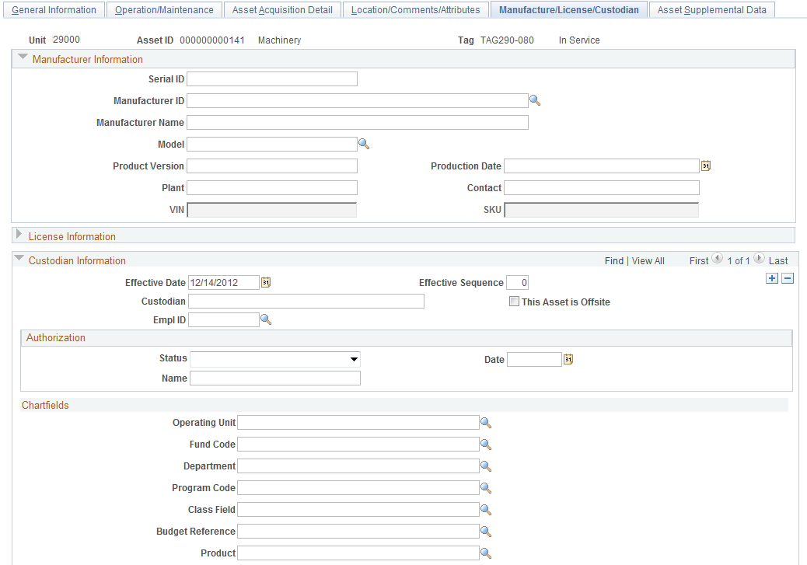
Ensure the Tab is correct. Physical information including Serial ID, Manufacture ID and Name, Model, and possibly VIN can be updated to reflect the correct Physical information for this Asset.

NOTE: The VIN number will be available if the Asset Type defaulted from the Profile ID is set to allow this value to be stored on the Asset. The Asset Type should be Fleet for this field to be available.

The License Information and/or Custodian Information can be entered or updated at this point on the Asset.

Reviewing the AM Pre-Interface Tables – Financial Information
Asset information from the Receipt can be copied into the Accounts Payable Voucher when Vendor payment is made. This Asset information, coupled with the vendor payment information is interfaced into the AM Pre-Interface tables. The information captured on the voucher for the Asset purchase is called Financial Information.
In order for Financial Information from an AP Voucher to be interfaced to the AM Pre-Interface tables, the voucher must be Budget Checked, Matched, Document Tolerance complete, and Posted.
Financial Information is sent to the AM Pre-Interface tables nightly by a batch process. The Load Lines in the AM Pre-Interface table must be reviewed and approved before they can be interfaced into the AM Interface Tables. The AM Interface tables are the final review and approval point before the Financial Information creates or updates an existing Asset in Asset Management (See the Asset Integration Diagram discussed earlier in this manual).

NOTE: The integration process for an Assets Receipt (Physical Information) MUST be completely pushed to Asset Management before the integration process for the Asset Voucher (Financial Information) is started. Queries have been developed to help manage this process.

NOTE: In the integration from Purchasing and Accounts Payable for Physical and Financial information respectively, Load Lines can be set to an Error Status when data is incorrect or duplicated. This situation is generally an exception but could occur from time to time. When Load Lines are found in Error Status, they should be reported to OSF Help Desk for corrective action.

Review Financial Information in the AM Pre-Interface Tables
Navigation: Asset Management > Send/Receive Information > Preview AP/PO Information > Find an Existing Value

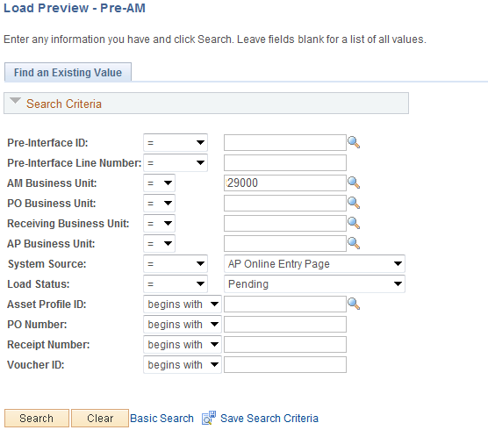

AM/PO/Receiving/AP Business Unit – is the agency in which the Voucher is housed. The AM Business Unit is required. For Financial Information, populating the AP Business Unit in tandem with the AM Business Unit will provide a list of Vouchers to choose from.
System Source – for Financial Information, use the System Source of AP Online Entry Page.
Load Status - all new Load Lines with Financial Information will have a status of Pending.
Purchase Order/Receipt/Voucher – if these transaction IDs are known, use them to search for the desired Load Lines. For Financial Information, the Voucher ID can be used to search for Load Lines.

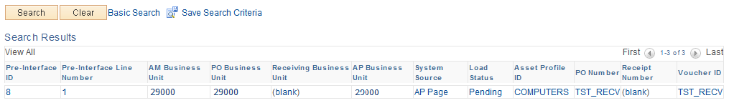

There could be one or more Load Lines that meet your selection criteria. Select the Load Line that you want to review.

Pre-AM Financial Page

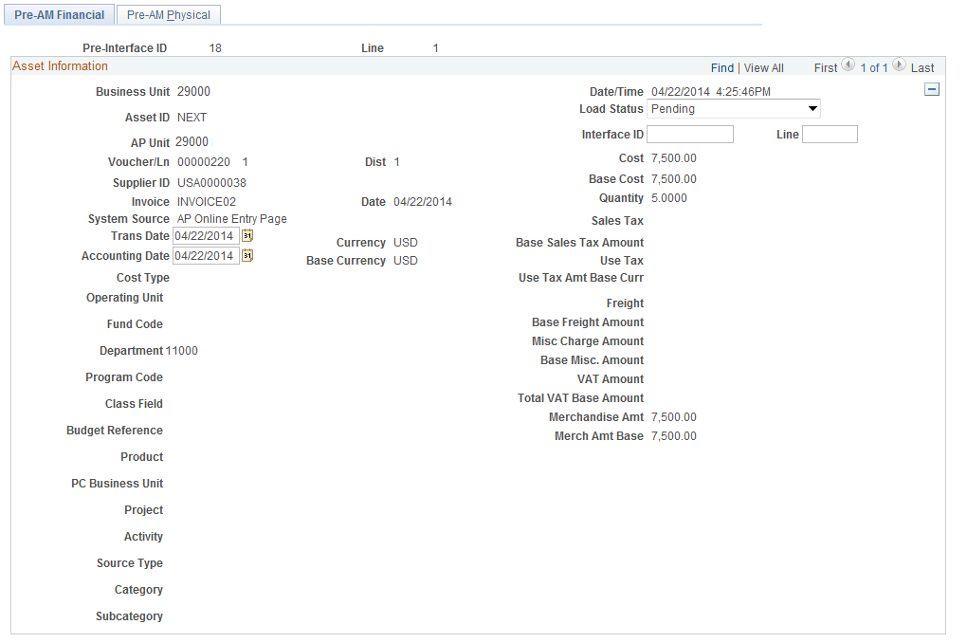

Pre-AM Physical Page

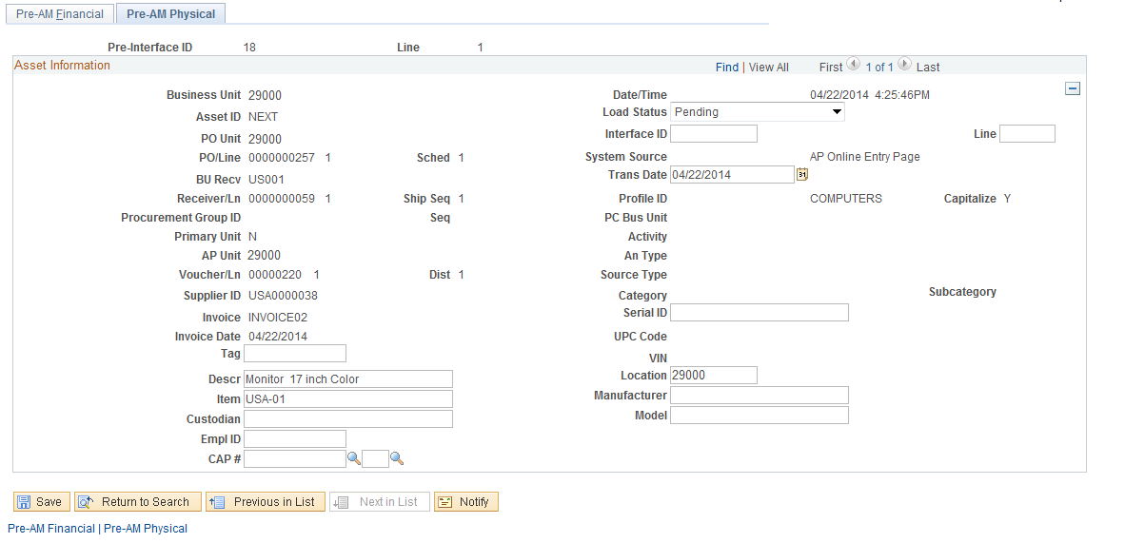
The Pre-AM Financial and the Pre-AM Physical pages display the Financial and Physical Information for the Load Line. The Purchase Order, Receipt, and Voucher are all displayed. The Asset Cost and Quantity are also displayed on the page. Changes to physical data like Tag Number and Description can be made to the Financial Load Line at this point if they were not already updated in the Asset Basic Add page after the asset was created when the Load Preview – Physical A page was approved.
Pre-Interface ID – this is the batch number representing all of the Financial (Voucher) information that was pulled from Accounts Payable.
Pre-Interface Line Number – this is the individual line number of the Load Line from the Voucher.
Load Status – the default Load Status is Pending for all new Financial Load Lines. This field can be changed to On Hold to keep the transaction from processing further if a Load Item was mistakenly passed to Asset Management.
Trans Date – this is the invoice date recorded on the voucher. Do not change this date. The State uses the Half Year convention for depreciation, so changing it has little impact on the current year depreciation calculation.
Accounting Date – This is the accounting date on the voucher. Do not change this date.

NOTE: Load Lines with Quantity values greater than 1 may have been Unitized in the AM Interface tables when the Receipt was processed. The Quantity displayed here with the Financial Information (Voucher) will still display the Line Quantity from the Purchase Order and Receipt. In this scenario, the Asset does not need to be Unitized again.

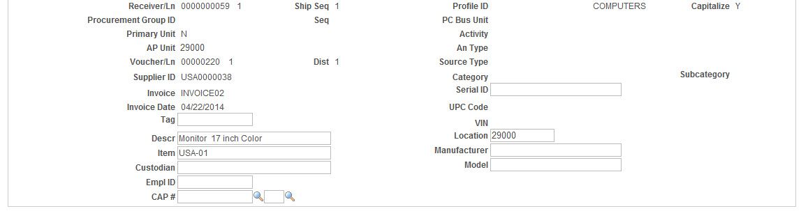

Profile ID – the value for Profile ID on the Financial Load Line comes from the AP Voucher. This value is critical as it will override the Profile ID from the Receipt if it is different. The Profile ID defaults the Asset Category, Asset Type, and Useful Life.

NOTE: The Asset will capitalize with the Profile ID on the AM Pre-Interface table. An incorrect Profile ID here will require correction(s) after the Asset is Capitalized.
- A Profile ID for an asset with an incorrect Asset Category (i.e., information technology asset recorded as machinery and equipment) will require Re-categorization after the asset is capitalized.
- A Profile ID for an asset with an incorrect Asset Type (i.e., equipment instead of Fleet) will require the Asset Type be updated on the Asset Basic Add page after the Asset is created or capitalized.
- A Profile ID with an incorrect useful life will require the Useful Life on the Book Depreciation page be updated after the Asset is capitalized.

NOTE: The Cost amount on the Financial Load Line will be the cost from the Voucher when interfaced into Asset Management. This could be different than the Cost on the Receipt due to volume discount or shipping or other miscellaneous charges not accounted for on the Receipt.

NOTE: BEFORE any Financial Load Lines are interfaced into the AM Interface tables, a Query should be executed to ensure that the Physical information from the Receipt has been completely and successfully loaded into Asset Management. The Query is:
OCP_AM_PRE_AM_VCHRS_NEXT_ID
This Query displays vouchers without an Asset ID in the AM Pre Interface Table and the corresponding information in the AM Interface Table for the Receipt on the voucher. Vouchers with associated Receipts that have already been completely interfaced to Asset Management can be interfaced to the AM Interface Tables.

Examples of the query results and how to review the vouchers follow. The vouchers listed in the examples are for illustration purposes only and do not represent actual asset acquisitions. Not all columns in the query are shown.
Example 1
Five Vouchers are listed in Example 1. The number of rows a voucher lists in the query is equal to the number of Asset Load Lines created from Receipt Lines associated with the Receipt on the Voucher. The query results can be analyzed as follows:
Voucher 00018386 – The Receipt Load Line in the AM Interface Load Line was placed On Hold. You should determine if the Voucher should also be placed On Hold to prevent the transaction from creating an Asset. The query will exclude Vouchers with a Load Status of On Hold.
Voucher 00018394 – When the Transaction Loader Batch process ran to create Assets from the Receipt Lines associated with Receipt #0000000024, two were assigned Asset IDs and one erred. The error must be corrected before the Voucher is loaded to the AM Interface Tables.
Vouchers 00018399 and 00018400 – Asset IDs were created from the Receipt Load Lines. The Vouchers can be interfaced into the AM Interface Tables.
Voucher 00018403 – Asset IDs have not been created from the Receipt Load Lines. The Load Lines need to be reviewed and approved, and the Transaction Loader Batch Process run first to create the Asset IDs before the Voucher can be interfaced into the AM Interface Tables.

Voucher | PreIntfcID | PreIDLine | Receipt No | Descr | Phys A Asset ID | Phys A Load Stat
00018386 | 167 | 42 | 0000000017 | Filing Cabinet | NEXT | HLD
00018394 | 167 | 32 | 0000000024 | Monitor | NEXT | ERR
00018394 | 167 | 32 | 0000000024 | Monitor | 000000000045 | DON
00018394 | 167 | 32 | 0000000024 | Monitor | 000000000046 | DON
00018399 | 167 | 17 | 0000000029 | Filing Cabinet | 000000000074 | DON
00018400 | 167 | 12 | 0000000031 | Dodge Charger | 000000000073 | DON
00018403 | 167 | 6 | 0000000043 | Tractor | NEXT | NEW
00018403 | 167 | 7 | 0000000043 | Tractor | NEXT | NEW

Example 2
Voucher 00004015 – The Auto Approval flag was checked on four of the five Load Lines created from the Receipt Lines. The Load Line needs to be reviewed and approved, and the Transaction Loader Batch Process run first to create the Asset ID before the Voucher can be interfaced into the AM Interface Table.

Voucher | PreIntfcID | PreIDLine | Receipt No | Descr | Phys A Asset ID | Phys A Load Stat
00018386 | 167 | 42 | 0000000017 | Filing Cabinet | NEXT | HLD
00018394 | 167 | 32 | 0000000024 | Monitor | NEXT | ERR
00018394 | 167 | 32 | 0000000024 | Monitor | 000000000045 | DON
00018394 | 167 | 32 | 0000000024 | Monitor | 000000000046 | DON
00018399 | 167 | 17 | 0000000029 | Filing Cabinet | 000000000074 | DON
00018400 | 167 | 12 | 0000000031 | Dodge Charger | 000000000073 | DON
00018403 | 167 | 6 | 0000000043 | Tractor | NEXT | NEW
00018403 | 167 | 7 | 0000000043 | Tractor | NEXT | NEW

NOTE: The query, OCP_AM_PRE_AM_VCHRS_NEXT_ID, does not include Voucher IDs for AM Interface Load Lines that were Consolidated. The original Receipt numbers are not retained on the Consolidated Load Lines because they are considered to be a different transactions than the transactions passed from the Receipt. Such transactions can be identified on the following query:
OCP_AM_ASSET_ID_NOT_CAPITALIZE
This query displays Asset IDs that have not been capitalized (see Loading and Reviewing the AM Interface Tables – Financial section). Asset IDs without PO or Receipt Information were Consolidated. The associated Voucher ID will need to be identified and interfaced in the AM Interface tables.

NOTE: It is possible for Financial Information to be sent to the AM Pre-Interface table from Accounts Payable and there not be corresponding Physical Information in the AM Interface tables. A query should be executed to identify vouchers sent to the AM Pre-Interface tables that cannot be “married” with the Physical information. The query is:
OCP_AM_VCHR_BEFORE_RECVR
The source PO or receipt on the voucher should be researched to determine why the Physical Information was not entered into Asset Management through the Receipt.

Once the Asset Load Lines have been reviewed and any necessary query results have been verified, they need to be loaded into the AM Interface tables.

Loading and Reviewing the AM Interface Tables – Financial Information
Once the Financial Information from the AP Voucher has been reviewed in the AM Pre-Interface tables, the Load Lines must be interfaced to the AM Interface tables. The AM interface tables are the final point that the Load Lines can be reviewed and approved before the Assets are capitalized.

Step 1: Load Financial Information into the AM Interface Tables
Navigation: Asset Management > Send/Receive Information > Retrieve Info from AP/PO > Find an Existing Value

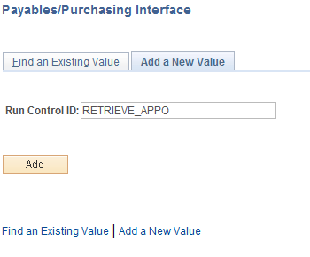

Run Control ID – populate with a new or existing Run Control ID. Append the run control with your initials and/or Business Unit to make it unique.

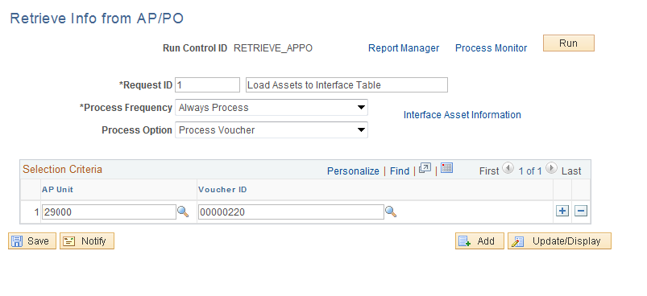

Request ID – this field can be populated with the number ‘1’. The next field should hold a description of the process.
Process Frequency – always use the value Always Process.
Process Options – the Process Voucher option selects all of the Load Lines for a Voucher. Use the sign to add additional vouchers.

NOTE: When processing a Voucher, if the Physical Information from the Load Lines from the Receipt has not yet created the Asset ID, the Financial Load Line will be set to Error status.

Click to execute the Payables/Purchasing Interface.

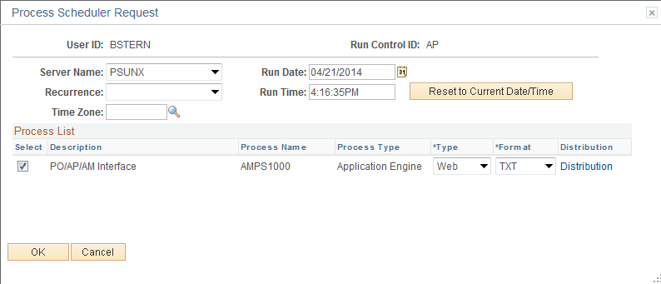
Select the AMPS1000 process for PO/AP/AM Interface.
Click to execute the process that populates the AM Interface tables.

Step 2: Review Financial Information in the AM Interface Tables
The AM Interface tables are initially populated with an Asset’s Physical information when the Receipt is saved. The tables hold Asset Load Lines that are created from Receipt Lines with Asset information. These are the Load Lines that were reviewed and approved before the Asset ID was created.
When the Voucher containing Financial Information is processed and interfaced through the AM Pre-Interface tables and into the AM Interface tables, these Load Lines can also be seen. Because the Load Lines created from the Vouchers have already been reviewed in the AM Pre Interface tables, the Auto Approval Status Flag is automatically checked.
The data on this page is not editable but is provided for review. The information displayed should be reviewed and any corrections identified should be documented so that changes to the Asset can be made in the Asset Basic Add pages after the Asset is capitalized.

NOTE: The Interface ID is a system assigned number that represents the batch of Load Lines with Financial Information from the Receipt.

Navigation: Asset Management > Send/Receive Information > Approve Financial Information > Review > Find an Existing Value

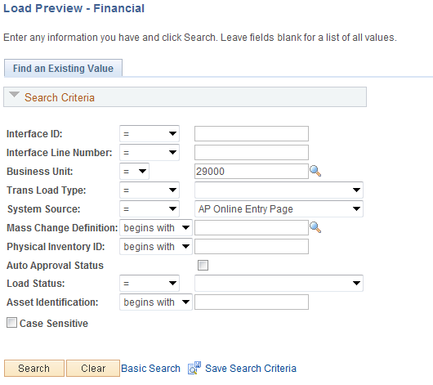

Business Unit – is the Agency in which the Load Lines are stored. This is a required field.
System Source – for Voucher Load Lines this value will be AP Online Entry Page.
Load Status – new Load Lines from Vouchers will be Pending.
Click to retrieve all the Load Lines that match the criteria provided.

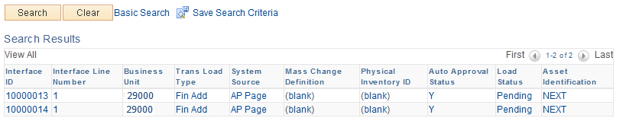
The Search Results can have many Load Lines that match the criteria provided. Select the Load Line that you want to review. Select the Load Line link for the line that you want to review.

NOTE: If the Asset has been Unitized in the Receipt load process, you will see the Voucher Financial Information be “split” to match that Unitization in the AM Interface tables. This effectively unitizes the Voucher to match the Receipt information already loaded into Asset Management.

Select the Load Line that you want to review and click Interface ID link.

Financial Transactions A Page

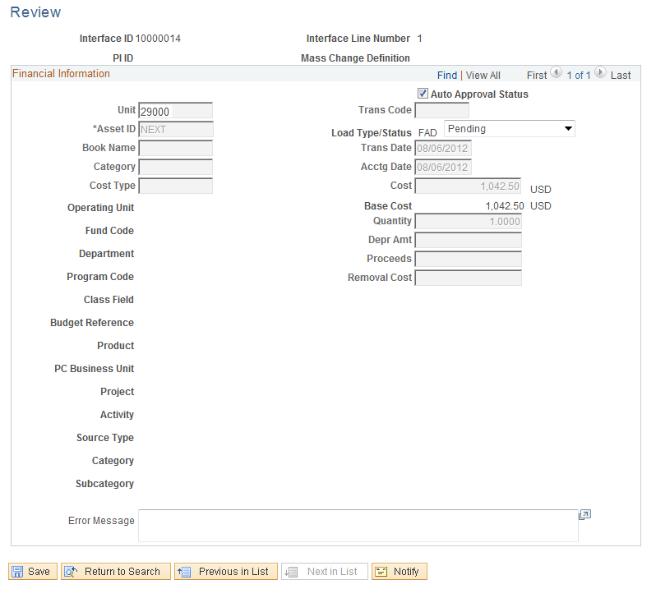

The Financial Transaction A page shows Financial Information for the Load Line. This information is not editable on this page. Any corrections that are identified on this page will need to be made in the Asset Basic Add pages after the Asset is capitalized.
Auto Approval Status – the Load Line must have this checkbox selected before it can be loaded into the Asset Management module to capitalize the Asset. The default is for the Financial Load Lines to be automatically approved.
Load Status – the Load Status should be set to Pending. This makes the Load Line eligible to be picked up in the batch process that capitalizes the Assets in the Asset Management module.
Click to save the Approval Status for the Load Line.

The Transaction Loader Process – Financial Information
After the Load Lines in the AM Interface tables are approved, the Transaction Loader process used to create the new Assets in Asset Management “marries” the Financial Information with the existing Physical information from the Receipt for an Asset purchase and capitalizes the Asset.
Load Lines must be in Pending Status and have been Approved for the Transaction Loader process to pick them up and capitalize Assets in the system.

Transaction Loader process
The Transaction Loader process will be ran daily by the State Office to move agency Assets from the AM Interface Tables into the Asset Management module and all required Asset Management Tables. Once this process has been executed and the Assets have been created, use the Asset Basic Add component to search for, find, and update any required Asset Information (See the COR411– Entry and Update manual).

Review Assets after the Transaction Loader is complete
Navigation: Asset Management > Asset Transactions > Owned Assets > Basic Add > Find an Existing Value
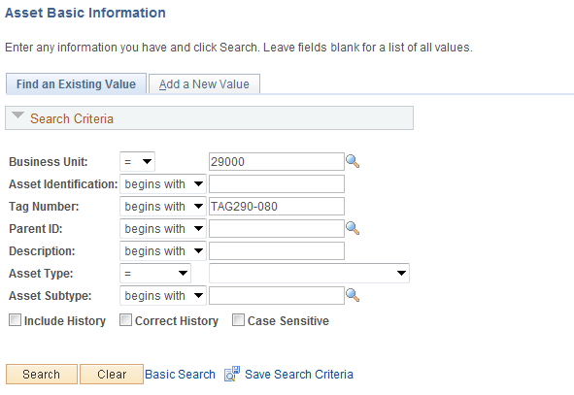
Use the Search Criteria for the Asset Basic Information pages to retrieve the Asset.
Generally, the Asset ID, Tag Number, or Description would be Search Criteria used to retrieve a particular Asset.
Click to retrieve the Asset based on the Search Criteria provided.

General Information Page

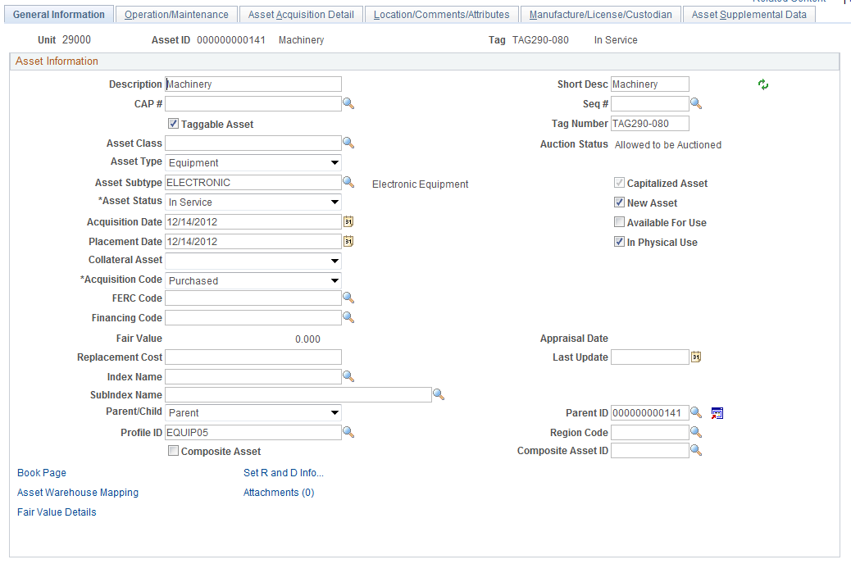

Ensure that the General Information page has the correct information for the Asset that was interfaced. Physical Information included on this page is largely populated by the Receipt that was interfaced before the Voucher.
Acquisition Date – this value is updated from the Financial Information on the AP Voucher.
Placement Date – this value is updated from the Financial Information on the AP Voucher.
Use the Book Page link to Asset Book Depreciation page and make changes to an Asset’s life if necessary.

Operation/Maintenance Page

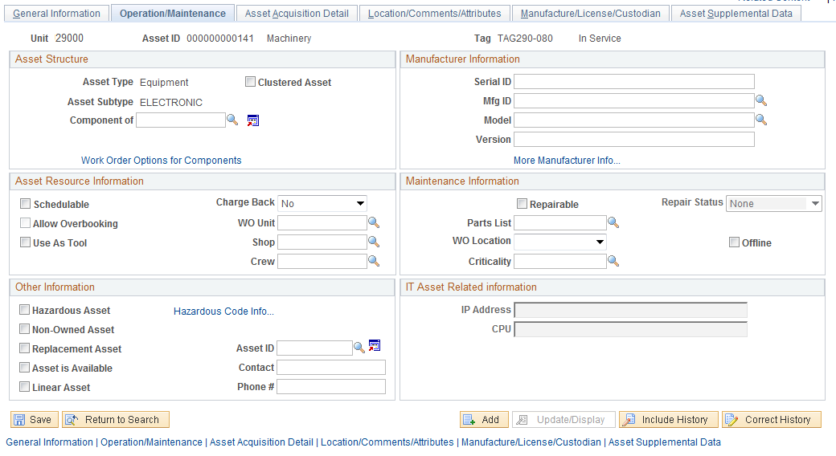

The Operation/Maintenance page can be updated to reflect the correct Physical Information if that data was not added when the Receipt was interfaced to Asset Management. This could include Serial ID, Manufacture ID, and Model.

Asset Acquisition Detail Page

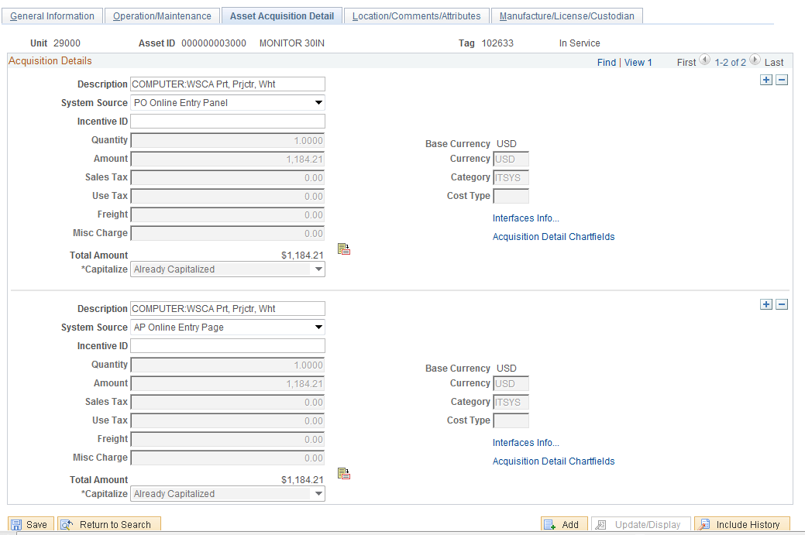

The Asset Acquisition Detail page for the Asset is changed when the AP Voucher is interfaced into Asset Management. The Asset now has two (2) rows on the page, one for the Physical Information interfaced from the Receipt and one for the Financial Information interfaced from the AP Voucher.
Use the arrows to scroll from the Physical information row on the Asset to the Financial Information row on the Asset.
System Source – the System Source indicates whether the Asset row is a Physical row or a Financial row. PO Online Entry Panel identifies the Physical row.
Capitalize – the Capitalize status is changed from “To be Capitalized” to “Already Capitalized”. This indicates that the AP Voucher has been interfaced into Asset Management and has been “married” with the Receipt information.
Click the Interfaces Info link to view the Physical interface information.

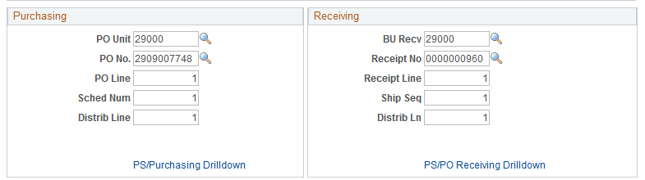
The Purchase Order and Receipt information is displayed in the Acquisition Details page. Use the PS/Purchasing Drilldown or the PS/PO Receiving Drilldown links to drill to those respective transactional pages.
Click to return to the Asset Acquisition Details page.

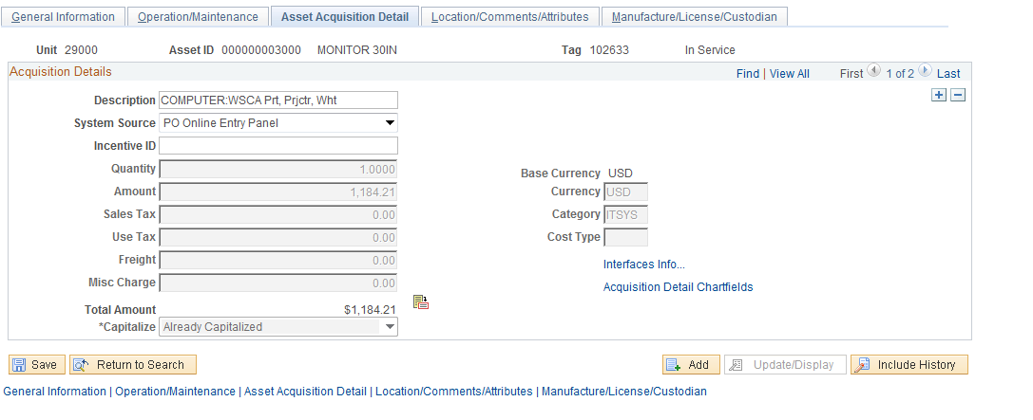
Use the arrows to move from the Physical information row to the Financial Information row.

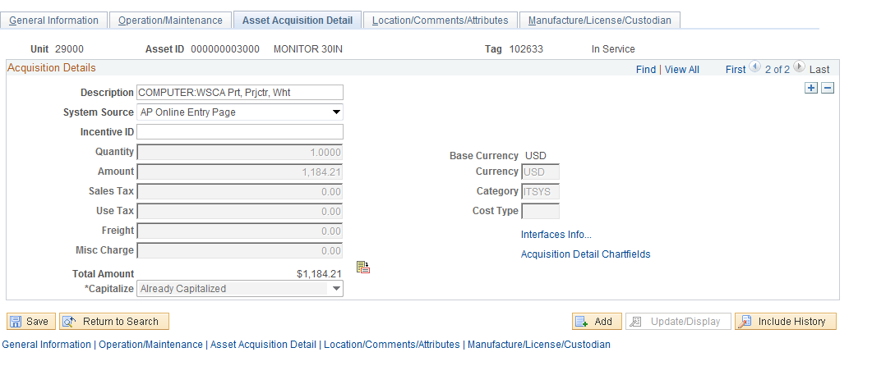
The Financial Information row on the Asset Acquisition Details page displays Asset information derived from the AP Voucher.
System Source - the System Source indicates whether the Asset row is a Physical row or a Financial row. AP Online Entry Page identifies the Financial row.
Capitalize – the capitalize status is also set to “Already Capitalized” for the Financial row.
Use the Acquisition Detail ChartFields link to view the Financial ChartField data.

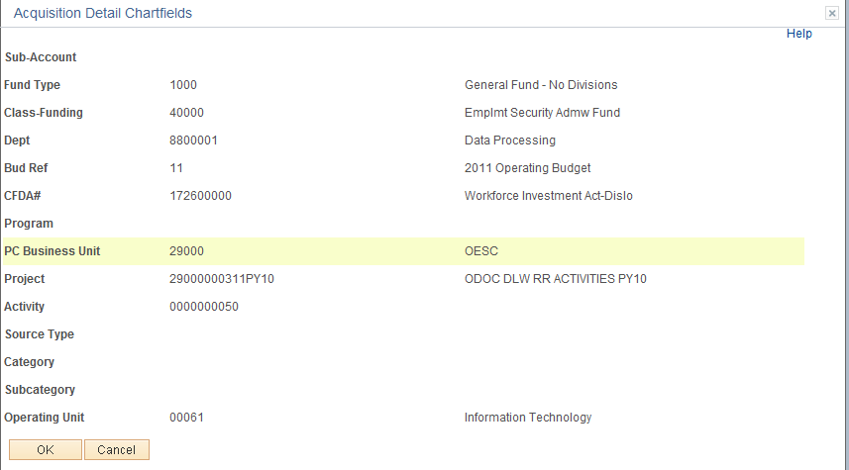

Click to return to the Asset Acquisition Details page.

Location/Comments/Attributes Page

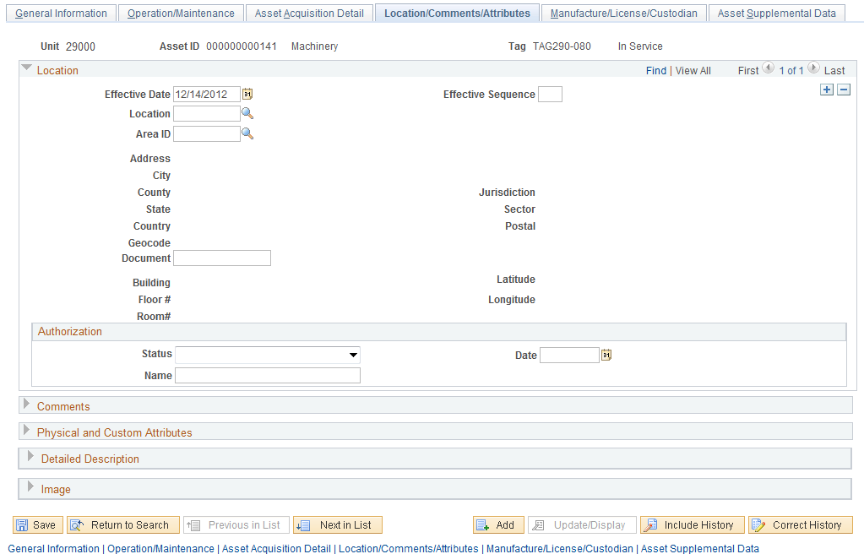

The Location/Comments/Attributes page should display the Assets physical Location from the Requisition or Purchase Order.
The Comments, Physical and Custom Attributes and Image sections of the page are available to update at this point.

Manufacture/License/Custodian Page

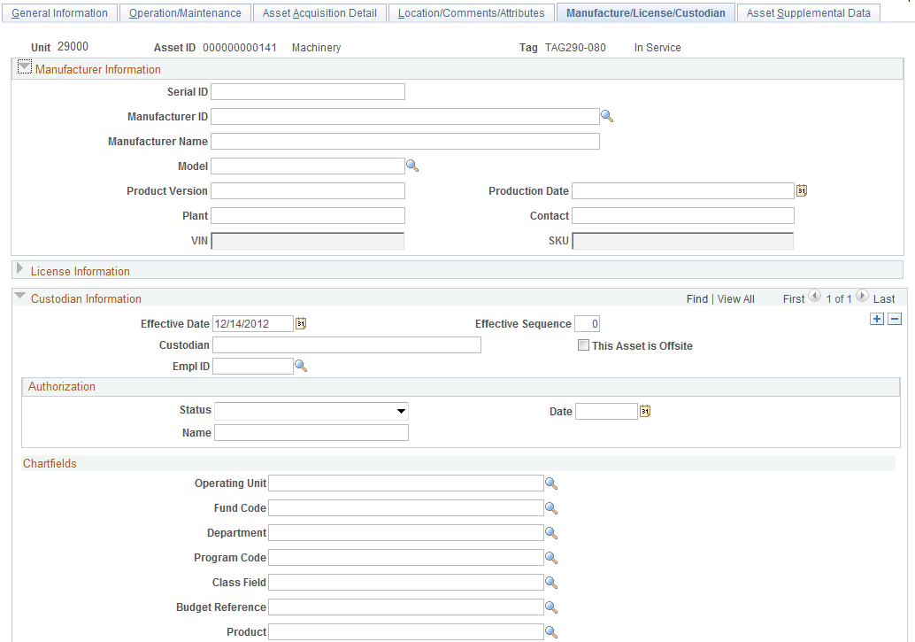
`
Ensure the Manufacture/License/Custodian page is correct. Physical information including Serial ID, Manufacture ID and Name, Model, and possibly VIN can be updated to reflect the correct Physical information for this Asset.

NOTE: The VIN number will be available if the Asset Type defaulted from the Profile ID is set to allow this value to be stored on the Asset. The Asset Type should be Fleet for this field to be available.

The License Information and/or Custodian Information can be entered or updated at this point on the Asset.

Asset Integration Checklist
 | Task | Initials | Date | Comment
1.01 | Run OCP_AM_RCVR_NOT_PUSHED_TO_AM query to identify asset-related receivers not pushed to AM when receiver was created.
 | - Contact appropriate personnel and ask if there is any reason the receipt should not be pushed.
 | - Run Process Receipts (Purchasing>Receipts>Process Receipts) for asset-related receipts that can be pushed.
1.02 | Run OCP_AM_PHY_A_RCPTS_TO_REVIEW query to identify physical Load Lines that are not Approved (Load Lines will have a status of Pending, Errored, or In Process).
 | - Asset Management>Send/Receive Information>Approve Physical Information>Review A> Find an Existing Value
 | - Verify the Quantity.
 | - Quantity > 1 – Unitize to create additional Load Lines
 | - Quantity < 1 – Consolidate with the other Load Lines from the receipt
 | - Verify the Profile ID is correct for asset purchased.
 | - Review for amount > or = to $25,000 (or $5,000 for assets qualifying for federal reimbursement) to ensure Profile ID has a useful life greater than 01.
 | - Review items with an amount < the telecommunication and information technology or tangible threshold. Place Load Line(s) On Hold unless item is regulatory, a source of potential liability, or a “walk-away” asset.
- Make note to correct an incorrect profile ID either on the voucher or in Basic Add after the voucher has been capitalized. Correction can be:
- Re-categorize an asset with an incorrect Asset Category, i.e., ITSYS vs. MA_EQ
- Update Asset Type on Asset Basic Add after the Asset is created or capitalized, i.e., Equipment vs. Fleet
- Update Useful Life on the Book Depreciation page after the asset is capitalized.
 | - Review Physical data and update additions or changes in Asset Basic Add the next business day after the Asset ID is created.
 | - Call helpdesk for help to resolve Physical Load Line(s) with an Error status.
 | - Check Auto Approval Status so Transaction Loader batch process will select the Load Lines and create Asset ID.
2.01 | Run OCP_AM_PRE_AM_VCHRS_NEXT_ID query to identify vouchers in the AM Pre Interface Table not interfaced to AM.  NOTE: This query does not pick up Receipt Load Lines created from the Consolidation feature. (See step 3.01-a.)
 | - Asset Management>Send/Receive Information>Preview AP/PO Information>Find an Existing Value
 | - Check Receipt Load Line(s) placed On Hold to determine if the corresponding Voucher Load Line(s) should also be placed On Hold.
 | - Check Receipt Load Lines in Error status and correct before the Voucher Load Lines are interfaced to AM.
 | - Check Receipt Load Lines with a Phy A Asset ID status of NEXT.
 | - Multiple Receipt Lines associated with a voucher should all be interfaced to AM before interfacing Voucher to AM. None should have NEXT Asset ID.
 | - Return to Phy A Review Page to review and approve Receipt Load Lines with an Asset ID of NEXT so Receipt can be interfaced to AM before Voucher is interfaced to AM.
 | - Research Voucher Load Lines in Error status.
 | - Job to interface Voucher Load Line to AM may have run before Receipt Load Line was interfaced. Interface Receipt Load Lines and after Asset ID is created, reset Error status to Pending on Voucher Load Line. Re-interface Voucher Load Line (step 2.01-b-1.)
 | - Call the helpdesk for help to resolve other Voucher Load Line(s) with Error status.
 | - Interface Voucher Load Lines with associated Receipts completely interfaced to AM.
 | - Asset Management>Send/Receive Information>Retrieve Info from AP/PO>Voucher ID (Load Financial Tables)
 | - Asset Management>Send/Receive Information>Approve Financial Information>Review>Find an Existing Value
 | - Review Financial data before Transaction Loader batch process selects Voucher Load Lines to “marry” with existing Asset ID from Physical information from the Receipt.
- Make changes to financial data in Basic Add if profile ID is incorrect after financial data is interfaced to AM.
- Re-categorize an asset with an incorrect Asset Category, i.e., ITSYS vs. MA_EQ
- Update Asset Type on Asset Basic Add after the Asset is created or capitalized, i.e., Equipment vs. Fleet
- Update Useful Life on the Book Depreciation page after the asset is capitalized.
2.02 | Run OCP_AM_VCHR_BEFORE_RECVR query to identify vouchers that may have been pushed to AM before the receipt.
 | - Research to locate Receipt.
 | - If Voucher is interfaced before Receipt is pushed to AM, the physical data from the Receipt cannot be loaded to AM.
3.01 | Run OCP_AM_ASSET_ID_NOT_CAPITALIZED query to identify Asset IDs not capitalized timely.
 | - Asset IDs without Receipt IDs were Consolidated in AM. Locate the Voucher Load Line and interface to AM (step 2.01-b-1).
 | - Contact Accounts Payable to determine if Voucher has or has not been paid.

