COR414 Asset Management

Retire and Reinstate Assets
Table of Contents
Document History 4
Retirement Overview 5
Key Terms 5
Process Flows 7
Asset Management Retire and Reinstate Process Flows 8
Guidelines, Concepts and Alternatives 9
Asset Groupings 10
Stage an Asset for Retirement 12
Step 1 & 2: Change Asset Status and Assign Asset Class 12
General Information Page 13
Step 3: Change Asset Location to Surplus Location 14
Location/Comments/Attributes Page 14
Step 4: Assign a Surplus Code as an Asset Attribute 16
Fully Retire an Asset 16
Step 1: Fully Retire the Asset 17
Retire Assets Page 18
Step 2: Review the Asset Retirement 21
Cost History List Page 22
Cost History Detail Page 23
Partially Retire an Asset 25
Step 1: Partially Retire the Asset 26
Retire Assets Page 27
Step 2: Review the Asset Partial Retirement 31
Cost History List Page 32
Cost History Detail Page 33
Retire a Parent-Child Asset 35
Step 1: Retire a Parent-Child Asset 35
Retire Assets Page 36
Child Assets Page 37
Step 2: Review the Parent-Child Asset Retirement 40
Cost History List Page 41
Cost History Detail Page 42
Reinstate a Retired Asset 44
Step 1: Reinstate an Asset 44
Retire Assets Page 45
Step 2: Review the Asset Reinstatement 46
Cost History List Page 47
Cost History Detail Page 48

Authorized by: [_EBS_] Original Issue: [05/01/2014]
Maintained by: [____Asset Management Application Lead___]
Review Date: [05/01/2014]

Document History
Doc Rev | Date | Description
1.0 | 03/18/2010 | Initial Document
2.0 05/01/2014 Upgrade Update

Retirement Overview
Assets can be Retired for various reasons including surplus, sale, theft, loss, destruction, donation, or transfer upon Department of Central Services approval If an Asset has been retired in error, you can reinstate the Asset to bring it back into service.
For CAFR Assets, all related accounting entries to remove the Assets Cost and Accumulated Depreciation are automatically created when the Asset is retired. The Asset Retirement can be dated with a Transaction Date that matches the retirement or surplus date when the agency no longer has possession. This provides the ability to retroactively create the correct accounting entries for the Asset Retirement.
Assets can be fully retired or partially retired. This provides the ability to take an entire Asset or only a component of the Asset out of service. Parent-Child Assets can also be retired. This provides the ability to retire the Parent Asset and any Child Assets that should also be retired.
This manual describes the pages and functionality used to Retire and Reinstate Assets within the Asset Management Module.

Key Terms
Asset Management Business Unit: Each agency has one Asset Management Business Unit. The Business Unit is the three (3) digit agency code, plus 00. For example, Office of State Finance is 09000.
Asset ID: Each Asset in the system has a unique Asset ID assigned automatically when the asset is added. The Asset ID is the key number used by the system to track each individual asset. Use this number to search for a particular asset in the system and view or make changes.
Tag Number: All Assets in the Asset Management system can have a Tag Number that matches the physical tag on the asset.
Asset Physical Information: An Asset’s Physical information includes tag number, location, custodian, serial number, and Manufacturer ID.
Asset Financial Information: An Asset’s Financial information includes cost, quantity, useful life, and ChartField values.
Retire: Retire an Asset due to surplus, scrap, transfer, or destruction. Retiring an Asset changes the Asset Status to Retired and removes Cost and Accumulated Depreciation from the system.
Reinstate: Reinstate a previously Retired Asset to bring it back into service for the agency. Reinstate could be to correct an improperly Retired Asset.
Profile ID: Profile ID is a “template” for the Asset that defaults values into the asset used for grouping and depreciation processing. This includes Asset Category, Asset Type, Useful Life and Depreciation Method and Convention.
Asset Category: Group assets together by major asset type for financial reporting purposes. Categories are Land, Land Improvements, Buildings, Infrastructure, Machinery and Equipment, IT Systems, Artifacts and Treasures, Capital Lease – Buildings, Capital Lease – Equipment, and Operating Leases. Asset category is required and included in the Profile ID.
Asset Type: Classifications to report assets within an asset category. Types are IT Hardware, IT Software, Equipment, Property, Fleet, Furniture, Facility, Intangibles, and Other. Asset type is required and included in the Profile ID.
Asset Subtype: Group assets within Asset Types at a more granular level for internal reporting purposes. Subtypes are optional in Asset Management and are not included in the Profile ID; however, Office of State Finance does require subtypes be included for IT Assets.
Asset Class: Defines assets within Asset Categories for internal reporting purposes. Asset Classes currently set up were provided by Department of Central Services for assets that are machinery and equipment in nature. Classes are optional in Asset Management and not included in the Profile ID; however, Department of Central Services does require the class be included on the DCS-FORM_SS_001A when an asset is sent to surplus.
CAFR Asset: A capital asset with a cost of $25,000 or more reportable on the Comprehensive Annual Financial Report (CAFR). The cost of individual assets acquired as part of a group to be used together but can be used as a separate asset must individually meet the $25,000 capitalization policy even though they are connected to other components of the group. Asset grouping is limited to individual components that cannot be used without being connected to other components. Refer to GAAP Package H, Reportable Capital Assets, under Key Terms for specific guidelines.
Cost Type: A Cost Type is used to differentiate between CAFR and non-CAFR assets. The cost type, in conjunction with category and asset transaction, will record the accounting entries needed by the CAFR group.
IT Asset: Telecommunication voice response systems and electronic information technology applications, including but not limited to mainframe computers, minicomputers, or microcomputers, word processing equipment, office automation systems, Internet, eGovernment, broadband, WI-FI or wireless networking, radio, including the interoperable radio communications system for state agencies, or Global Positioning Systems (GPS). Refer to the categories and descriptions in the Information Technology and Telecommunications Plan at http://www.ok.gov/OSF/Information_Services/ISD_Publications.html.
Transaction Date: Date on the Asset that reflects the actual date the Asset transaction took place. In the case of a new Asset addition, this is the date the Asset was Acquired.
Accounting Date: Date on the Asset that will determine when the Asset transaction will be posted to the General Ledger.
Asset Management Books: Asset Books store financial information about an asset including cost, depreciation rules and retirement rules. The state will support only one book called ‘STATE’.

Process Flows
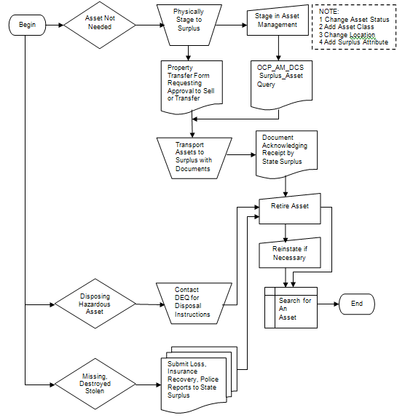

Asset Management Retire and Reinstate Process Flows
Begin Process

The decision is made that an asset is no longer needed.
The asset is physically staged until an appointment is made with State Surplus to send the asset to surplus.

The asset is also staged in Asset Management by:
Changing the Asset Status
Adding an Asset Class
Changing the location
Adding Surplus Attributes

The OCP_AM_DCS_Surplus_Asset query will include the asset staged for surplus in Asset Management.
The query results can be attached to the Property Transfer Form requesting approval to surplus.
Transport the surplus asset to State Surplus with the documents.
Obtain documents from DCS acknowledging receipt of surplus asset.
Retire the asset in Asset Management.

The decision is made that an asset with hazardous material needs to be disposed.
Contact Department of Environmental Quality for disposal instructions.
Upon disposal, retire the asset in Asset Management.

The decision is made that an asset is missing, destroyed, or stolen.
Submit the Loss, Insurance Recovery, and Police reports to State Surplus.
Retire the asset in Asset Management.

Reinstate retired assets if necessary.

Search for retired or reinstated assets in Search for An Assets.

End process.

Guidelines, Concepts and Alternatives
How Should Disposals be Handled?
Disposal of state owned property must be in accordance with the Department of Central Services State Surplus Property Administrative Rules at http://www.ok.gov/DCS/documents/DCS-RULES-SS.pdf.

How Should Assets Obtained through Trade-Ins be Valued?
If a capital asset is traded-in in the process of purchasing another similar capital asset, the newly acquired capital asset should be recorded at an amount equal to the book value of the asset that was surrendered plus any additional monetary consideration provided to seller.

Are Significant Costs Incurred after the Asset is Acquired an Improvement or a Repair?
Significant costs incurred in connection with capital assets in periods subsequent to the initial acquisition need to be distinguished between improvements and repairs and maintenance.
“An improvement provides additional value. Such added value is achieved either by 1) lengthening a capital asset’s estimated useful life or 2) increasing a capital asset’s ability to provide services (i.e. greater effectiveness or efficiency). In contrast to improvements, repairs and maintenance retain value rather than provide additional value.” Improvements are capitalized and repairs and maintenance are expensed. Often a single project will have elements of both repair and an improvement. In that case, the relative cost of each should be determined and treated separately.” 1
Repairs and maintenance expenses capitalized in error should be retired as an ‘Invalid Entry’.

How Often Should a Physical Inventory be Performed?
Asset Management, if used as designed, adds assets from the purchasing process, but does not have an automatic trigger to retire assets. Consequently, agencies should undertake regular physical inventories to account for all the assets no less than once every year.
1 GFOA Accounting for Capital Assets – A Guide for State and Local Governments (2008)

Asset Groupings
Asset Category – (Required Field) Groups assets together by major asset type for financial reporting purposes.
Asset Profiles – (Required Field) A template containing default values for an Asset type. Default values include asset category, life (designated by the number in the profile ID), acquisition code, and asset type.
Asset Type – (Required Field and included in profiles) PeopleSoft delivered classification to report assets within an asset category. Types are IT Hardware (010), IT Software (020), Equipment (040), Property (050), Fleet (060), Furniture (080), Facility (090), Intangibles (100), and Other (999).
Useful Life – Estimated Useful Life of the Asset used in deprecation calculations.
Asset Category - Owned | Asset Profile | Asset Type | Useful Lives
ARTIF – Art and Artifacts | ART_ARTIF | Property | Non Depreciable
LAND - Land | LAND | Property | Non Depreciable
LAND - Land | ROW (Right of Way) | Property | Non Depreciable
LAND - Land | EASEMENT | Intangible | Non Depreciable
LDIMP – Land Improvements | PROPERTYXX * | Property | 1, 5, 10, 15, 20, 25, 30, 40, 50
INFRA – Infrastructure | INFRASTRUCTURE30 | Property | 30
BLDG – Building | FACILITYXX | Facility | 1, 5, 10, 15, 20, 25, 30, 40, 50, 60
ITSYS – IT Systems | HARDWAREXX | IT Hardware | 1, 3, 5
ITSYS – IT Systems | SOFTWAREXX | IT Software | 1, 3, 5
MA_EQ – Machinery & Equipment | EQUIPXX | Equipment | 1, 4, 5, 6, 7, 8, 10, 15, 20
MA_EQ – Machinery & Equipment | FLEETXX | Fleet | 1, 3, 4, 5, 6, 7, 8, 10, 12, 15, 20
MA_EQ – Machinery & Equipment | FURN_EQXX | Furniture | 1, 5, 7, 10, 12
* XX – represents multiple Useful Life values for a Profile ID.

Asset Category - Leased | Asset Profile | Asset Type | Useful Lives
LSBLD – Building Capital Lease | LEASE_BLDG | Facility | Life of Lease Determines
LSEQP – Equipment Capital Lease | LEASE_EQ | Equipment | Life of Lease Determines
LSEQP – Equipment Capital Lease | LEASE_HARD | IT Hardware | Life of Lease Determines
LSEQP – Equipment Capital Lease | LEASE_SOFT | IT Software | Life of Lease Determines
 | LSOPR_EQ | Non Capital
 | LSOPR_BLDG | Non Capital

Stage an Asset for Retirement
“State owned property shall not be destroyed, sold, transferred, traded-in, traded, discarded, donated, or otherwise disposed of without prior written approval of the Administrator” per the Administrative Rule 580:65-3-1(c), Until the agency receives official approval of its disposal, most Assets are physically staged for surplus before Department of Central Services (DCS) takes possession. Before an Asset can be retired in the system, it must first be staged for Retirement. The retirement staging results in reports required for DCS business process. The staging steps are illustrated below.

Step 1 & 2: Change Asset Status and Assign Asset Class
Navigation: Asset Management>Asset Transactions>Owned Assets>Basic Add>Find an Existing Value
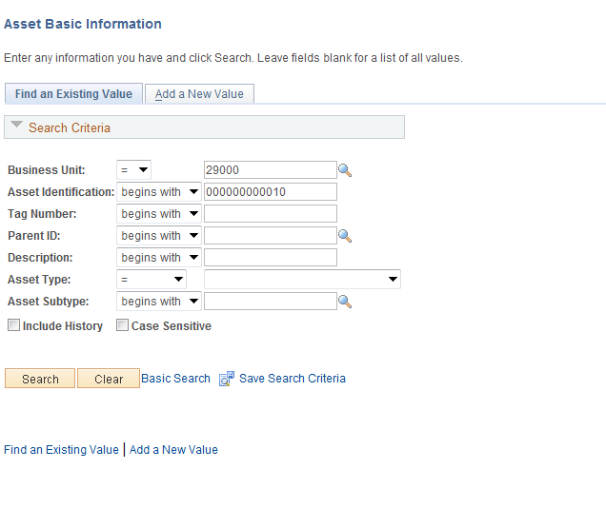

Business Unit – is the Agency in which the existing Asset is housed. This should default based on the User Preferences setup for the person Staging the Asset for retirement.
Asset Identification, Tag Number, Parent ID, Description, Asset Status – use these fields as search criteria to find the Asset that will be Staged for retirement.
Click to enter the Asset Basic Information pages.

General Information Page
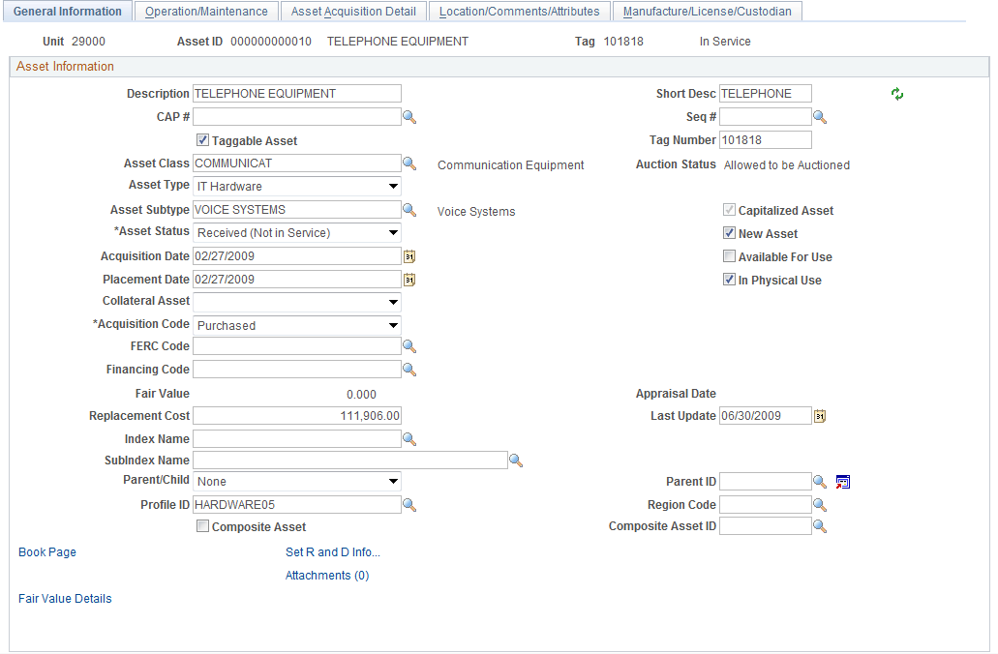
Before the Retirement action can be taken in the system, the Asset must first be Staged as an Asset to be Retired. This is done by retrieving the Asset and (1) changing the Status, (2) assigning the Asset Class (if not previously done), (3) changing the Location and (4) assigning a Surplus Attribute to the Asset. These Four steps are described below.
Asset Class – if the Asset Class is not populated for the Asset being retired, this field must be populated. Department of Central Services uses the Asset Class in their Asset Surplus business process. Surplus reports showing Assets staged for retirement will hold the Asset Class value.

NOTE: There are multiple Asset Class values available that have been defined by DCS. Select from those available values.

Asset Status – change the Asset Status to Received (Not in Service). This status change is required to flag the Asset and indicate that the intent is to Retire or Surplus the Asset.
Click the Location/Comments/Attributes Tab.

Step 3: Change Asset Location to Surplus Location

Location/Comments/Attributes Page
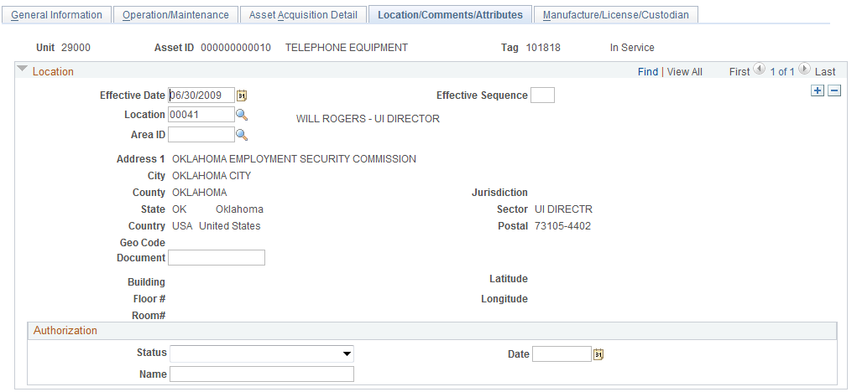
On the Location/Comments/Attributes page, two changes must be made. The first is to change the Assets Location from the physical location where the Asset is located to a ‘Surplus’ location. This will flag the Asset as a surplus Asset in the system. Second, the Physical and Custom Attributes section of the page must be updated to provide required surplus classification.
Click to insert a new Effective Dated row for the Surplus Location.

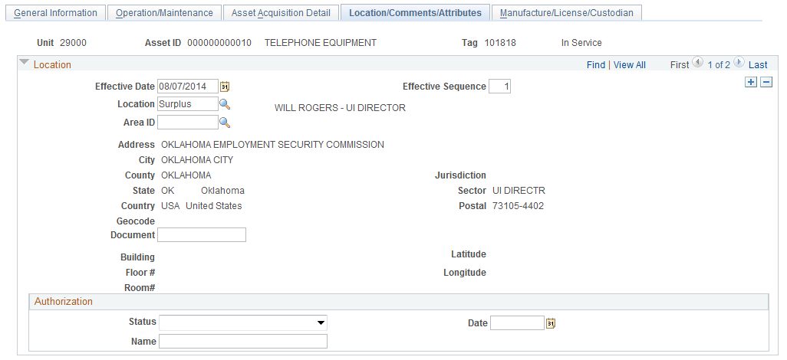
Effective Date – the Effective Date field should display the day that the Asset was moved into Surplus. This value can default to the current date.
Location – select the Location value for the Surplus location in the Agency. A location code of ‘Surplus’ may be set up if surplus property is staged in one location. Specific surplus location codes will need to be set up if the agency stores surplus property in more than one location.
Click to expand that section of the page.

NOTE: Changing the location may also require changing the custodian on the Manufacture/License/Custodian page.

Step 4: Assign a Surplus Code as an Asset Attribute

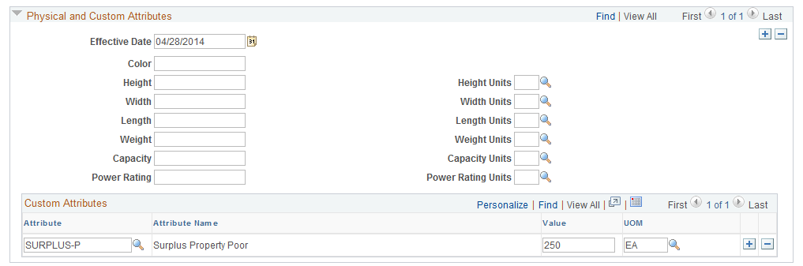

If a Custom Attribute already exists for the Asset you must click to insert a new Effective Dated row.

NOTE: Use the button directly across from the Effective Date field to insert a new Effective Dated row for the Custom Attribute. The button further down the page is used to add additional Custom Attribute values.

Effective Date – populate with the new Effective Date for the Custom Attribute added to the Asset. Generally, this will match the new Effective Date row for the Surplus Location assigned above in the page.
If necessary, use the button to create a new row for the Surplus Attribute.
Attribute – select from one of the Surplus Attribute values that best describes the condition of the Asset to be retired.
Value – provide the approximate salvage value for the Asset being retired.
Click to Save the new Asset Staging changes.

NOTE: Run the OCP_AM_DCS_Surplus_Assets Query to obtain DCS Asset Surplus listing. This report accompanies the Surplus Property Transfer Form, found at http://www.ok.gov/DCS/State_Surplus/.

Fully Retire an Asset
Once an Asset has been correctly Staged for Retirement, the Asset can be retired from the system. This includes changes in Asset Status, Cost History, and accounting entry creation for CAFR Assets.
To Fully Retire an Asset means to retire the complete Cost and Quantity of the Asset. Full retirement will change the Asset Status to ‘Disposed’.

Step 1: Fully Retire the Asset
Navigation: Asset Management > Asset Transactions > Asset Disposal > Retire/Reinstate the Asset > Find an Existing Value

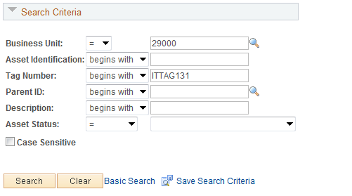

Business Unit – is the Agency in which the existing Asset is housed. This should default based on the User Preferences setup for the person Retiring the Asset.
Asset Identification, Tag Number, Parent ID, Description, Asset Status – use these fields as search criteria to find the Asset that will be Retired.
Click to enter the Asset Retire/Reinstate pages.

Retire Assets Page

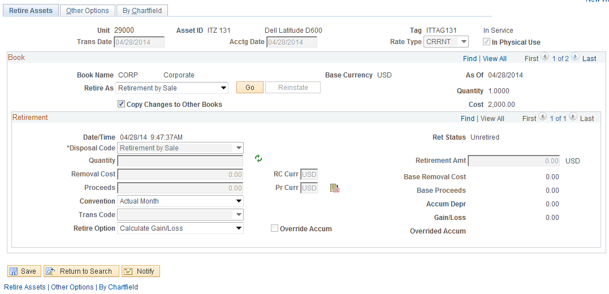

The Retire Assets page displays key Asset information for the Asset to be retired including, Asset ID, Asset Description, and Tag Number. Most fields on the page will not be editable at this point until the retirement action is initiated.

NOTE: The Asset Status is displayed in the upper right-hand corner of the page. If the Asset was properly staged for retirement, the Asset Status should be ‘Received’.

Retire As – the ‘Retire As’ field provides different Asset Retirement Disposal Codes. The value defaults to Surplus. These codes allow you to identify the reason for the retirement. Retire an Asset as:
Casualty Loss – use for an Asset loss that is sudden, unexpected, or unusual in nature
Disposal Due to Theft – use when an Asset has been stolen
Donated to External Group - use if an Asset has been donated to another entity
Invalid Entry – use if an Asset ID was created in error
Missing Asset – use when an Asset is missing
Retirement by Sale – use if an Asset is sold
Scrapped Asset – use if an Asset has been scrapped
Surplus – use for an Asset sent to Surplus
Trade in for another Asset – use if an Asset has been traded-in
Select the desired Retire As code for your Asset Retirement.

NOTE: The ‘Retire As’ Field defaults to Surplus because this is the most common disposal method for most agencies. Use of other disposal codes, except Invalid Entry, must have a prior approval from DCS. “Invalid Entry” disposals do not report on the OCP_AM_DCS_Surplus_Assets Query.

Click to initiate the Retirement.

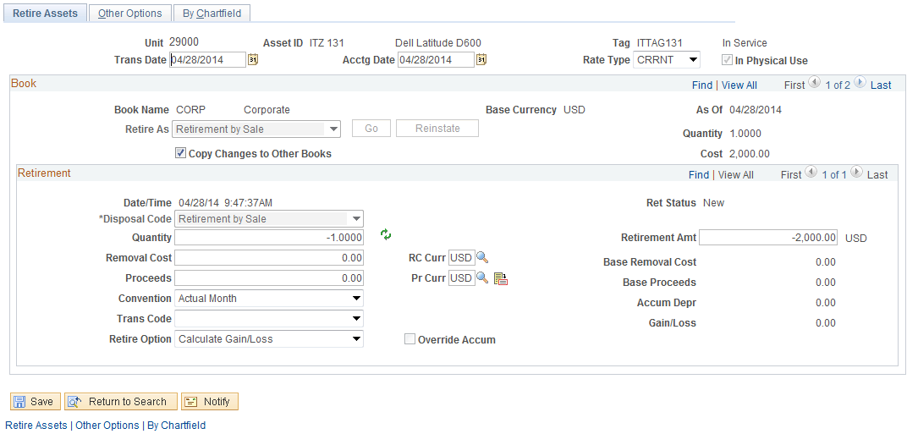

When the Go button is selected to initiate the Retirement, the Retire Assets page displays more fields as active to allow changes to be made if necessary.
Quantity – displays the Asset Quantity as a negative number to reflect a full retirement of the Assets quantity.
Removal Cost – the Removal Cost field can hold any additional amount required to remove the Asset. This amount will impact the accounting entries of CAFR Assets.
Convention – the Asset Retirement Convention is Half Year Convention.
Retirement Amount – the Retirement Amount field allows you to fully or partially retire an Asset. The amount defaults in as a full retirement amount.
Click to Save the Full Asset Retirement.

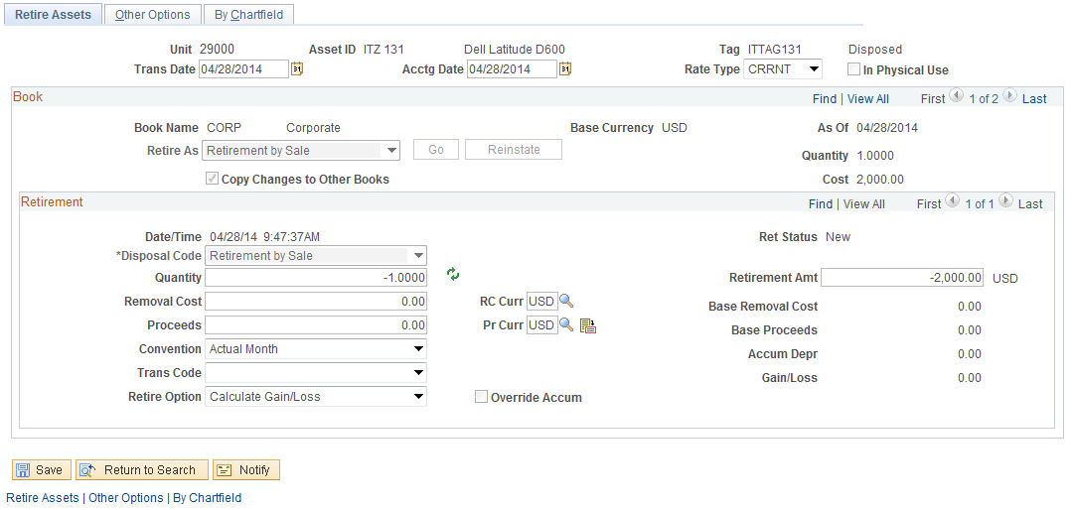

When the Asset has been successfully saved, the Asset Status will change from Received to Disposed.

Step 2: Review the Asset Retirement
Navigation: Asset Management > Asset Transactions > History > Review Cost > Find an Existing Value

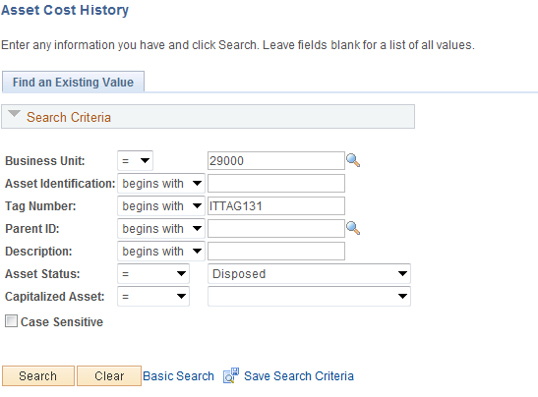

Business Unit – is the Agency in which the existing Asset is housed. This should default based on the User Preferences setup for the person reviewing the Asset.
Asset Identification, Tag Number, Parent ID, Description, Asset Status – use these fields as search criteria to find the Asset that will be reviewed. Since the Asset has been retired, the Asset Status will be Disposed.
Click to enter the Asset Cost History pages.

Cost History List Page

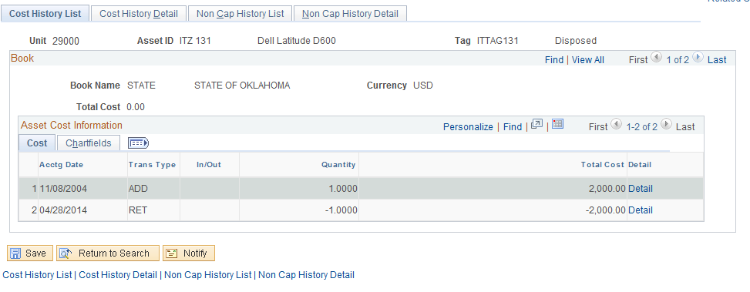

The Cost History List page displays the Cost History of the Asset. For the Retirement, the Transaction Type is RET to represent Retirement. The Quantity and Total Cost columns should reflect the Retirement amount as a negative number.
Click Tab to display the Cost History Detail page.

Cost History Detail Page

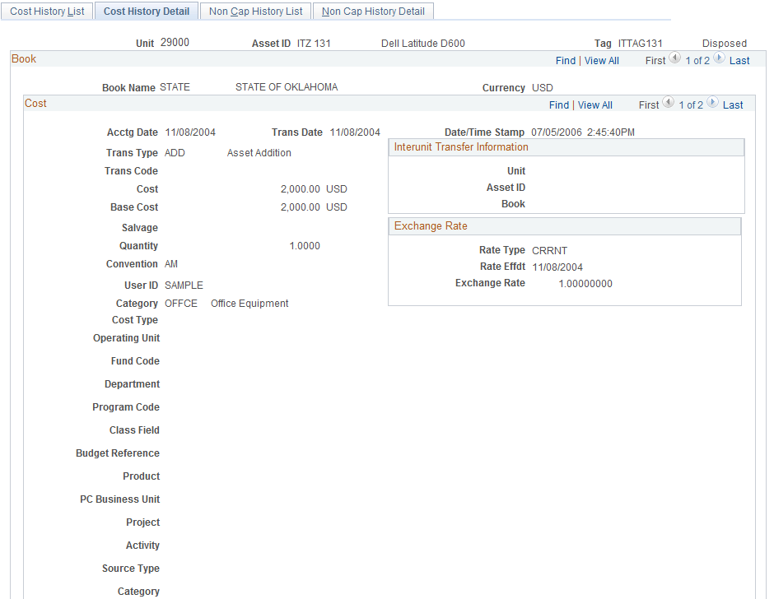
The Cost History Detail page shows the same Asset rows as are visible on the Cost History page, but with more details. There could be many Cost rows, corresponding with the Cost Rows on the Cost History List page, visible on this page representing the Cost history of the Asset. The Transaction Type of ADD represents the original Addition of the Asset.

NOTE: The row count - - indicates that multiple rows are available to view on this page.

Click to view the row that corresponds with the Transaction Type = RET on the Cost History List page.

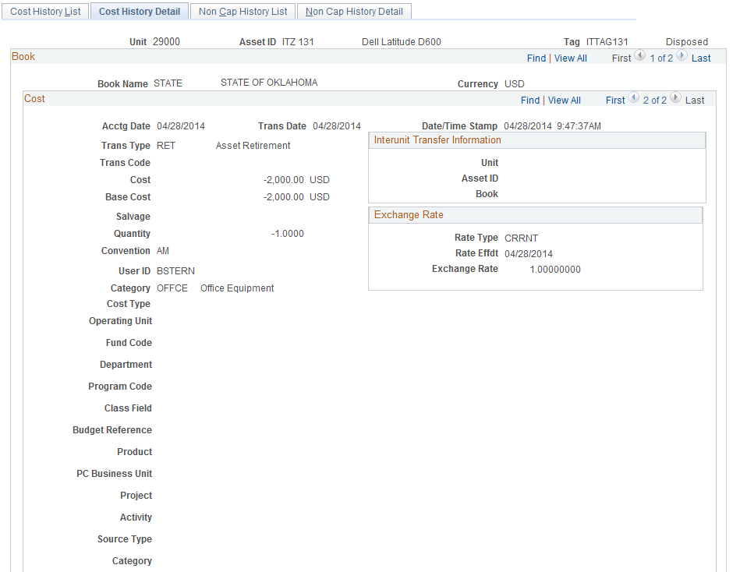
The Retirement row on the page represents the retirement done on the Asset. The Transaction Type indicates RET and the negative Cost reflects the full retirement amount. More detailed Asset information is available on this page including Transaction Date of the Retirement, User ID who completed the Retirement, and ChartField information.

Partially Retire an Asset
Once an Asset has been correctly staged for Retirement, the Asset can be retired from the system. This action can include a change in Asset Status (for Full Retirements) and retirement accounting entry creation for CAFR Assets.
To Partially Retire an Asset means to retire a Cost and/or Quantity amount that is less than the entire amount of the Asset. Partial retirement will remove only part of the Asset from the system.
Partial Retirements might be necessary when an Asset has multiple Cost Rows or Components as is the case with Assets created from Project Costing or when a Cost Addition action has been taken on the Asset. In these cases, a part or component of the Asset may need to be replaced that requires only that piece of the Asset to be retired while leaving the remainder of the Asset In-Service.
For Partial Retirements, the Asset may have multiple Cost rows that represent the different components of the Asset as shown here:
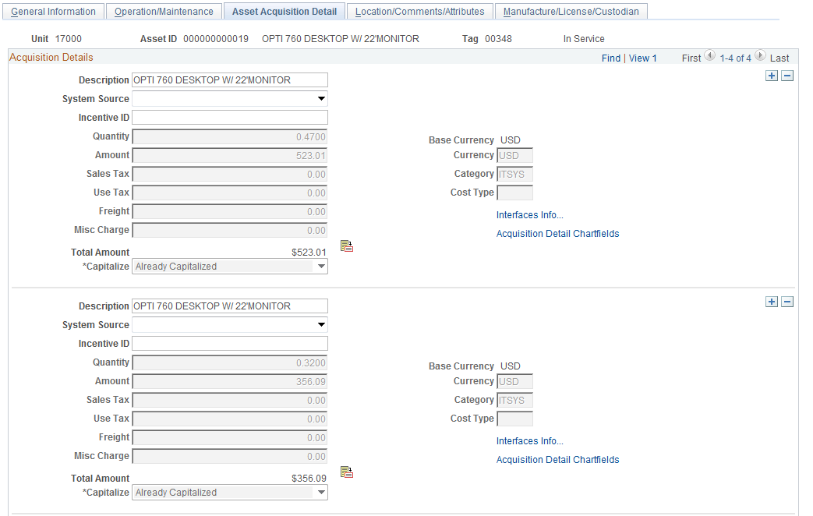
This Asset is comprised of two different Components each with their own Acquisition Details information. In a Partial Retirement, one of these two components would be retired. This could occur for any number reasons including damage, theft, or replacement.

NOTE: The page above is the Asset Acquisition Detail page available in the Asset Basic Add feature.

Step 1: Partially Retire the Asset
Navigation: Asset Management > Asset Transactions > Asset Disposal > Retire/Reinstate the Asset > Find an Existing Value
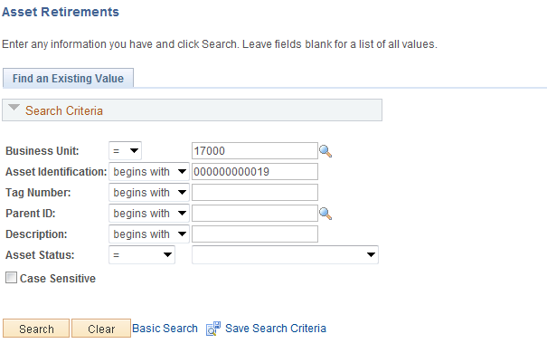

Business Unit – is the Agency in which the existing Asset is housed. This should default based on the User Preferences setup for the person Retiring the Asset.
Asset Identification, Tag Number, Parent ID, Description, Asset Status – use these fields as search criteria to find the Asset that will be Retired.
Click to enter the Asset Retire/Reinstate pages.

Retire Assets Page

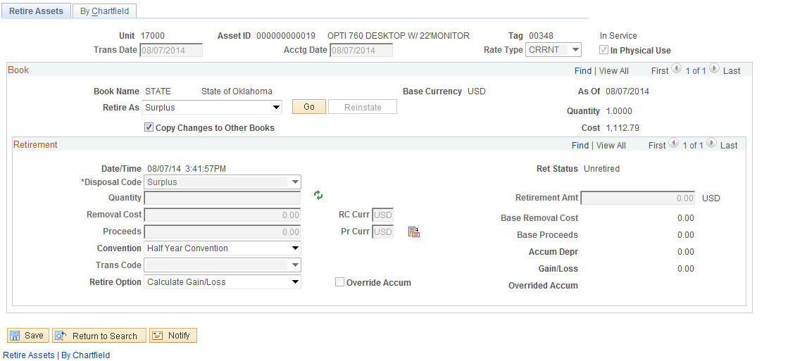
The Retire Assets page displays key Asset information for the Asset to be retired including Asset ID, Asset Description, and Tag Number. Most fields on the page will be visible only at this point until the retirement action is initiated.

NOTE: The Asset Status is displayed in the upper right-hand corner of the page. For a Partial Retirement, the Asset Status could still be ‘In Service’ indicating that the portion of the Asset that will not be retired will remain in service.

Retire As – the ‘Retire As’ field provides different Asset Retirement Disposal Codes. These codes allow you to identify the reason for the retirement. Retire an Asset as:
Casualty Loss – use for an Asset loss that is sudden, unexpected or unusual in nature
Disposal Due to Theft – use when an Asset has been stolen
Donated to External Group - use if an Asset has been donated
Invalid Entry – use if Asset ID was created in error
Missing Asset – use when an Asset is missing
Retirement by Sale – use if an Asset is sold
Scrapped Asset – use if an Asset has been scrapped
Surplus – use for an Asset sent to Surplus
Trade in for another Asset – use if an Asset has been traded-in
Select the desired Retire As code for your Asset Retirement.
Click to initiate the Retirement.
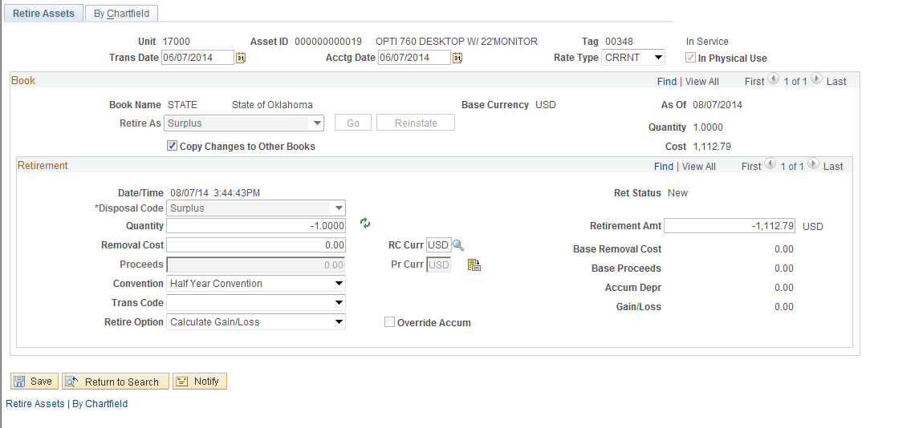

When the Go button is selected to initiate the Retirement, the Retire Assets page displays more fields as active to allow changes to be made if necessary. The Quantity field displays the Asset total Quantity and the Retirement Amount field displays the total Asset Amount.

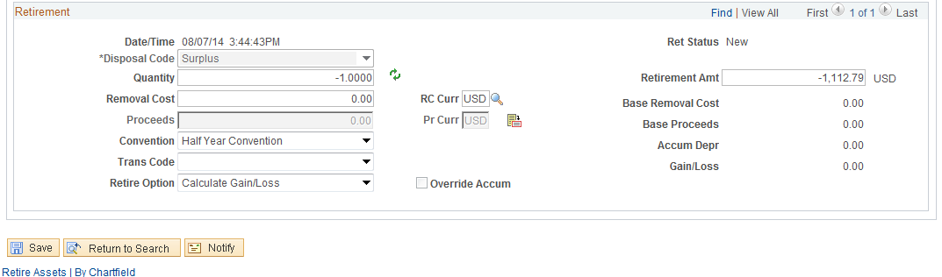

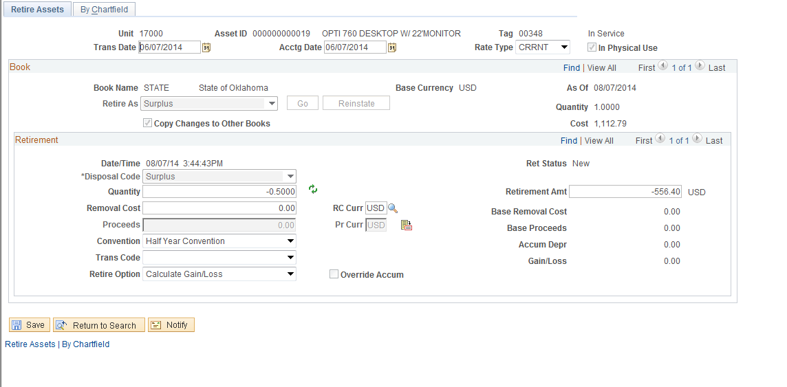

The Quantity and/or Amount fields should be changed to reflect the correct values for the Partial Retirement.

NOTE: In the case of a Partial Retirement, the Quantity and Retirement Amount will be less than the total Quantity and Amount. In cases where an Asset has multiple Cost Rows or Components the Quantity and Retirement Amount fields should match the Cost Row being retired.
In this example, the second Cost Row from the Asset above is being retired. The Quantity of that row is 1 and the Amount is 2,500.

Quantity – displays the Asset Quantity as a negative number to reflect a retirement of the Assets quantity. For a Partial Retirement this value should be something less than the full Quantity of the Asset.

NOTE: Assets should not have a partial quantity. Therefore, if you partially retire an Asset, you should then do an Adjustment transaction to change the Quantity back to 1.0000. See the COR415 Asset Adjustments and Transfers manual.

Removal Cost – the Removal Cost field can hold any additional amount required to remove the Asset. This amount will impact the accounting entries or CAFR Assets.
Convention – the Asset Retirement Convention is Half Year Convention.
Retirement Amount – the Retirement Amount field allows you to fully or partially retire an Asset. The amount defaults in as a full retirement amount. For a Partial Retirement this value should be something less than the full Amount of the Asset.

NOTE: The Retirement Amount or Quantity fields can be used to inversely effect a partial retirement. When populating one or the other of these fields, the other field should reflect a matching amount.

Click to Save the Full Asset Retirement.

Since this is a Partial Retirement, the Asset Status will remain In Service.

NOTE: Assets should not have a partial quantity. The Quantity may change to a value that does not match your retirement scenario. If that is the case you must do a Quantity Adjustment to change the Quantity to the desired value (See the COR415 Asset Adjustments and Transfers manual for instructions).
For example, the Quantity of the Asset above changed to a value less than one. This would need to be adjusted to a value of 1.

Step 2: Review the Asset Partial Retirement
Navigation: Asset Management > Asset Transactions > History > Review Cost > Find an Existing Value

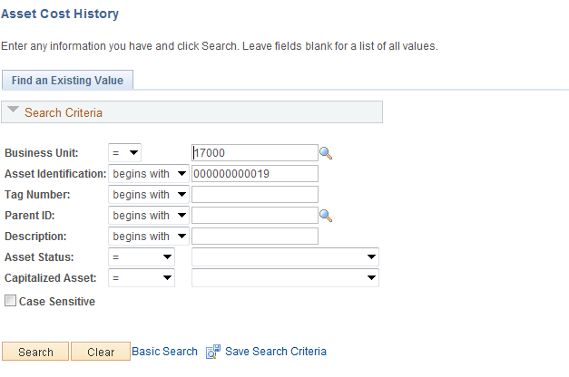

Business Unit – is the Agency in which the existing Asset is housed. This should default based on the User Preferences setup for the person reviewing the Asset.
Asset Identification, Tag Number, Parent ID, Description, Asset Status – use these fields as search criteria to find the Asset that will be reviewed.
Click to enter the Asset Cost History pages.

Cost History List Page

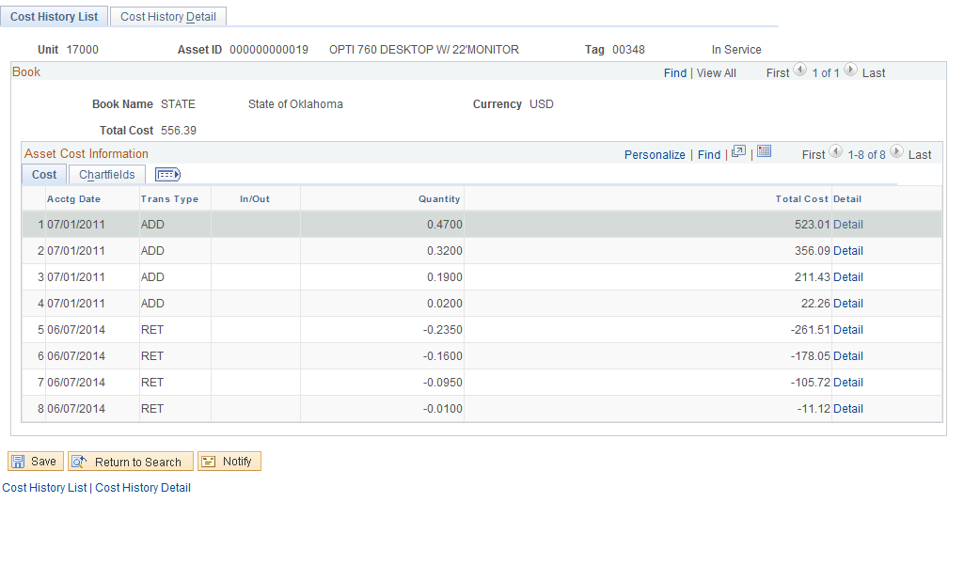
The Cost History List page displays the Cost History of the Asset. For the Retirement, the Transaction Type is RET to represent Retirement. The Total Cost column should reflect the Retirement amount as a negative number.

NOTE: The Partial Retirement was taken proportionately from each of the two Cost Rows for this Asset.

Click Tab to display the Cost History Detail page.

Cost History Detail Page

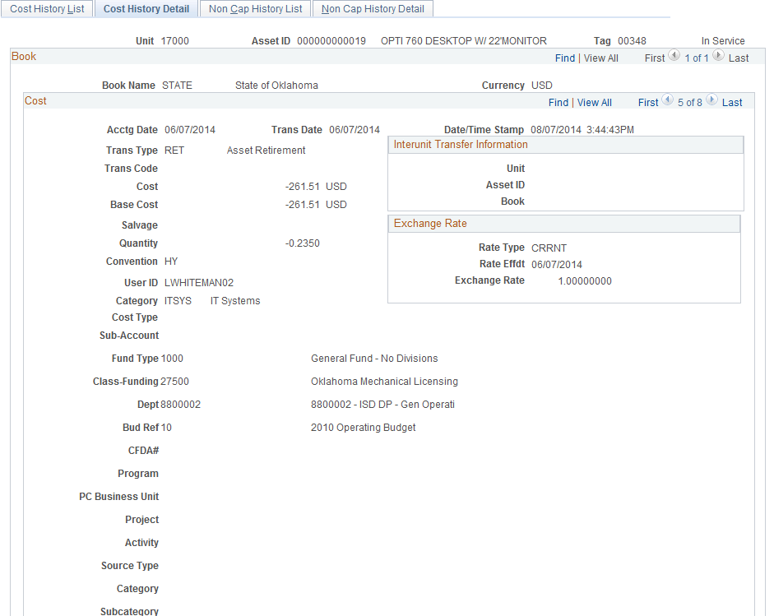

The Cost History Detail page shows the same Asset rows as are visible on the Cost History List page, but with more details. There could be many rows, corresponding with the Cost Rows on the Cost History List page, visible on this page representing the Cost history of the Asset. The Transaction Type of ADD represents the original Addition of the Asset.

NOTE: The row count - - indicates that multiple rows are available to view on this page.

Click to view the row that has the Transaction Type = RET.

The Retirement row on the page represents the retirement done on the Asset. The Transaction Type indicates RET and the negative Cost reflects the full retirement amount. More detailed Asset information is available on this page including Transaction Date of the Retirement, User ID who completed the Reinstatement, and ChartField information.

NOTE: Since this Partial Retirement was done on an Asset with more than one Cost Row, there are two RET rows displayed in the page, one each for the respective Cost Rows in this Asset.

Retire a Parent-Child Asset
Parent-Child Asset can also be retired in the system. The Parent-Child Assets are subject to similar Asset Retirement steps as regular Assets with additional options available.

Step 1: Retire a Parent-Child Asset

Navigation: Asset Management > Asset Transactions > Asset Disposal > Retire/Reinstate the Asset > Find an Existing Value

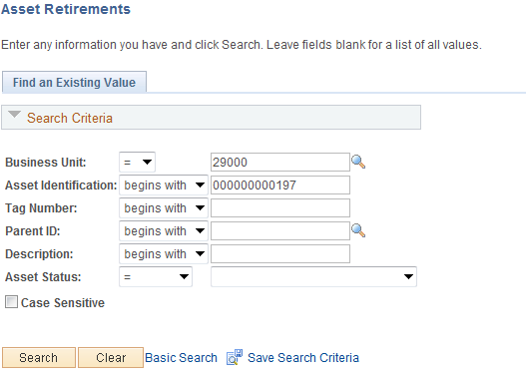

Business Unit – is the Agency in which the existing Asset is housed. This should default based on the User Preferences setup for the person Retiring the Asset.
Asset Identification, Tag Number, Parent ID, Description, Asset Status – use these fields as search criteria to find the Asset that will be reinstated.
Click to enter the Asset Retire/Reinstate pages.

Retire Assets Page
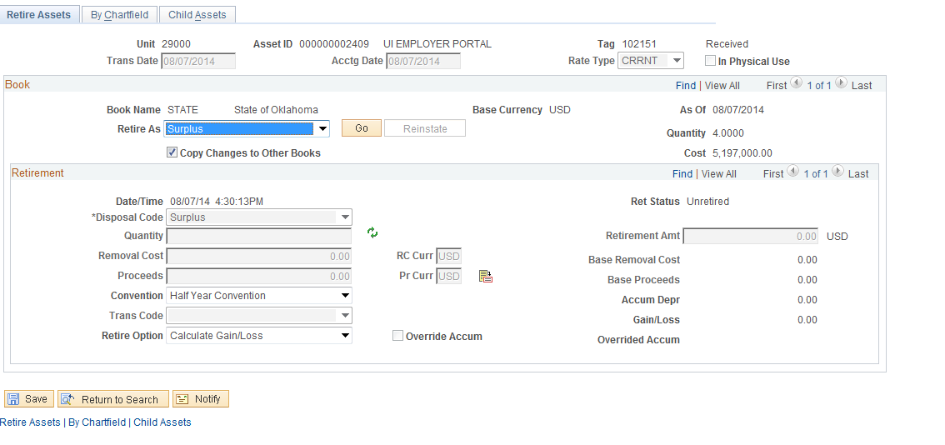
The Retire Assets page displays key Asset information for the Asset to be retired including Asset ID, Asset Description, and Tag Number. Most fields on the page will be visible only at this point until the retirement action is initiated.

NOTE: The Asset Status is displayed in the upper right-hand corner of the page. If the Asset was properly staged for retirement, the Asset Status should be Received.

Retire As – the ‘Retire As’ field provides different Asset Retirement Disposal Codes. These codes allow you to identify the reason for the retirement and are defined by DCS rules. Retire an Asset as:
Casualty Loss – use for an Asset loss that is sudden, unexpected, or unusual in nature
Disposal Due to Theft – use when an Asset has been stolen
Donated to External Group - use if an Asset has been donated to another entity
Invalid Entry – use is an Asset ID was entered incorrectly
Missing Asset – use when an Asset is missing
Retirement by Sale – use if an Asset is sold
Scrapped Asset – use if an Asset has been scrapped
Surplus – use for an Asset sent to Surplus
Trade in for another Asset – use if an Asset has been traded-in
Select the desired Retire As code for your Asset Retirement.
Click the Child Asset Tab to view the associated Child Assets.

Child Assets Page

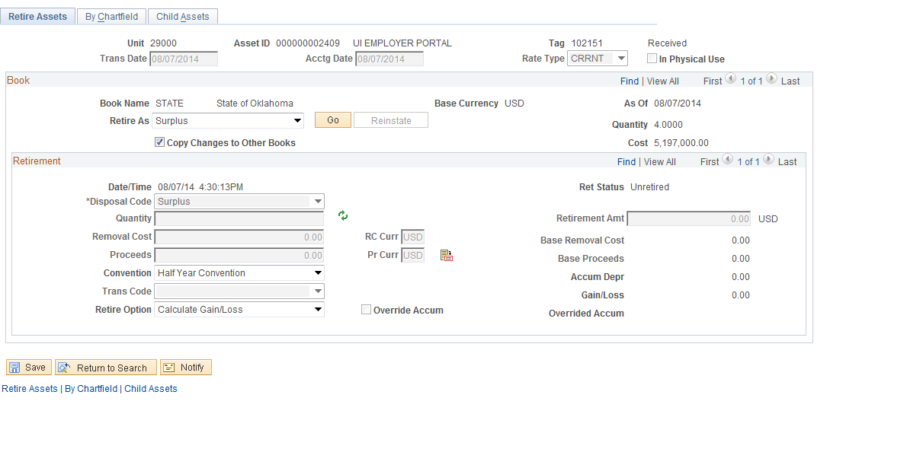

The Child Assets page displays all associated Child Assets for the Parent Asset in the first page. The system provides the ability to retire Child Assets along with the Parent Asset by selecting them on this page. Use the Selected checkbox to identify the Child Assets to retire.

NOTE: When retiring Child Assets along with the Parent Asset, all Assets must use the same Disposal Code.

Click Retire Asset Tab to return to the main Retire Assets page. Alternatively, use the Retire Assets link at the bottom of the page.

Once you’ve selected all the Child Assets to retire with the Parent Asset and have returned to the Retire Assets page, you are ready to initiate the retirement.
Click to initiate the Retirement.

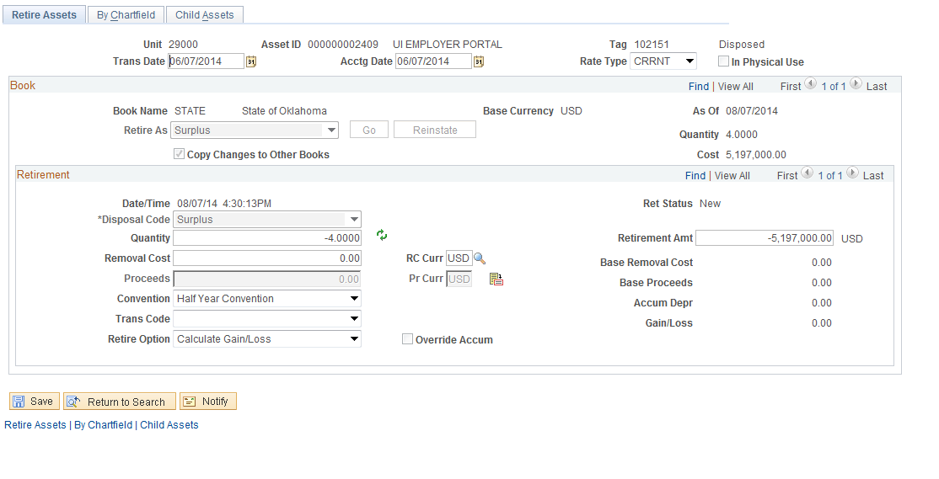

When the Go button is selected to initiate the Retirement, the Retire Assets page displays more fields as active to allow changes to be made if necessary.
Quantity – displays the Asset Quantity as a negative number to reflect a full retirement of the Assets quantity. This is the Quantity for the Parent Asset.
Removal Cost – the Removal Cost field can hold any additional amount required to remove the Asset. This amount will impact the accounting entries of CAFR Assets.
Convention – the Asset Retirement Convention is Half Year Convention.
Retirement Amount – the Retirement Amount field allows you to fully or partially retire an Asset. The amount defaults in as a full retirement amount. This is the Amount of the Parent Asset.

NOTE: The Retirement Amount and Quantity fields on this page display ONLY the Parent Asset values.

Click to Save the Parent-Child Asset Retirement.
When the Asset has been successfully saved, the Asset Status will change from Received to Disposed.

Step 2: Review the Parent-Child Asset Retirement
Navigation: Asset Management > Asset Transactions > History > Review Cost > Find an Existing Value

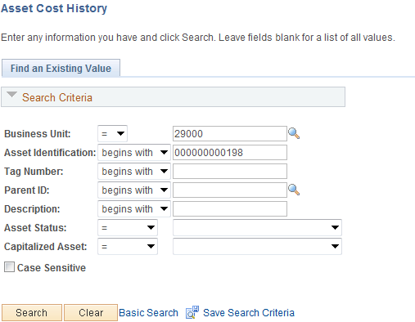

Business Unit – is the Agency in which the existing Asset is housed. This should default based on the User Preferences setup for the person reviewing the Asset.
Asset Identification, Tag Number, Parent ID, Description, Asset Status – use these fields as search criteria to find the Asset that will be reviewed. Since the Asset has been retired, the Asset Status will be Disposed.
Click to enter the Asset Cost History pages.

Cost History List Page

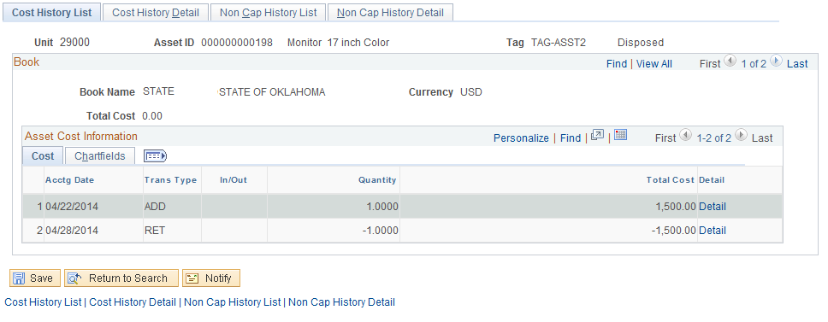

The Cost History List page displays the Cost History of the Asset. For the Retirement, the Transaction Type is RET meaning Retirement. The Total Cost column should reflect the Retirement amount as a negative number.
Click Cost History Detail Tab to display the Cost History Detail page.

Cost History Detail Page
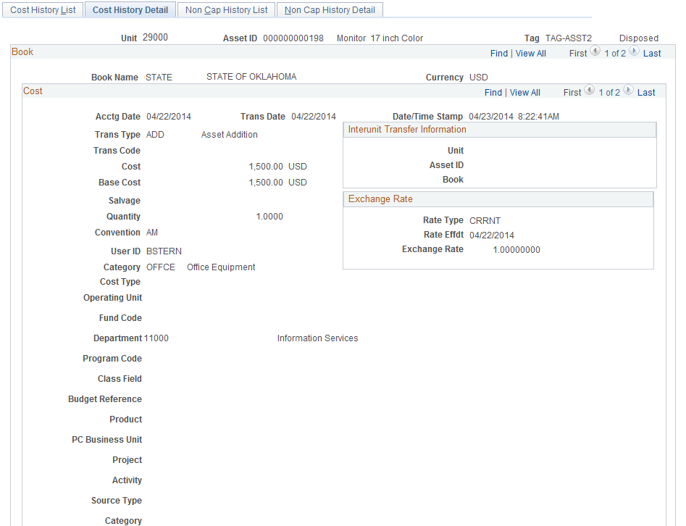

The Cost History Detail page shows the same Asset rows as are visible on the Cost History page, but with more details. There could be many Cost rows, corresponding with the Cost Rows on the Cost History List page, visible on this page representing the Cost History of the Asset. The Transaction Type of ADD represents the original Addition of the Asset.

NOTE: The row count - - indicates that multiple rows are available to view on this page.

Click to view the row that has the Transaction Type = RET.

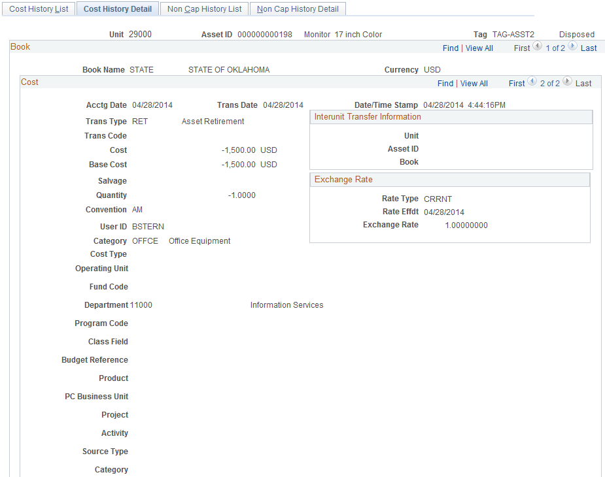

The Retirement row on the page represents the retirement done on the Asset. The Transaction Type indicates RET and the negative Cost reflects the full retirement amount. More detailed Asset information is available on this page including Transaction Date of the Retirement, User ID who completed the Retirement, and ChartField information.

NOTE: The Review Cost pages only display one Asset at a time. Therefore, the Child Assets retirement information is not visible on this page along with the Parent. The Child retirement information is visible by retrieving the Child Assets independently in this page.

Reinstate a Retired Asset
Occasionally an Asset that has been Retired needs to be put back In-Service. This could be due to a retirement mistake or change in the Assets status.
To put a previously retired Asset back into service, a Reinstatement action must be taken in the system. The reinstatement is done in the same pages as the Asset retirement with slightly different options selected.
Navigation: Asset Management > Asset Transactions > Asset Disposal > Retire/Reinstate Asset > Find an Existing Value

Step 1: Reinstate an Asset

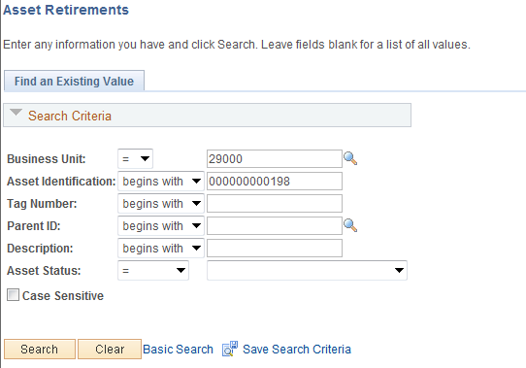

Business Unit – is the Agency in which the existing Asset is housed. This should default based on the User Preferences setup for the person Reinstating the Asset.
Asset Identification, Tag Number, Parent ID, Description, Asset Status – use these fields as search criteria to find the Asset that will be Reinstated. There is an Asset Status of ‘Disposed’ that will retrieve only those Assets that have been retired.
Click to enter the Asset Retire/Reinstate pages.

Retire Assets Page

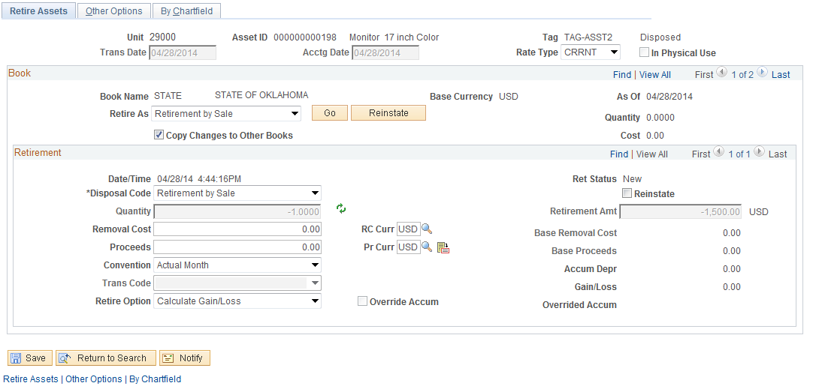

The Retire Assets page displays key Asset information for the Asset to be reinstated including Asset ID, Asset Description, and Tag Number. When the Asset has been retired, most of the fields on the page are active and available to change.

NOTE: The Asset Status is displayed in the upper right-hand corner of the page. When the Asset has been retired previously, the Asset Status will be ‘Disposed’.

Click to Reinstate the Asset.

The Retire Asset page will now display most fields as inactive and not available for change.
Accounting Date – the Accounting Date will default to current date. Do not change this value.
Click to Save the Asset Reinstatement.

When the Asset has been successfully saved, the Asset Status will change from Disposed to In Service.

Step 2: Review the Asset Reinstatement
Navigation: Asset Management > Asset Transactions > History > Review Cost > Find an Existing Value

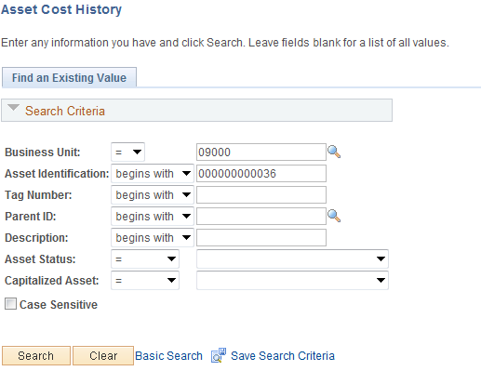

Business Unit – is the Agency in which the existing Asset is housed. This should default based on the User Preferences setup for the person reviewing the Asset.
Asset Identification, Tag Number, Parent ID, Description, Asset Status – use these fields as search criteria to find the Asset that will be reviewed.
Click to enter the Asset Cost History pages.

Cost History List Page

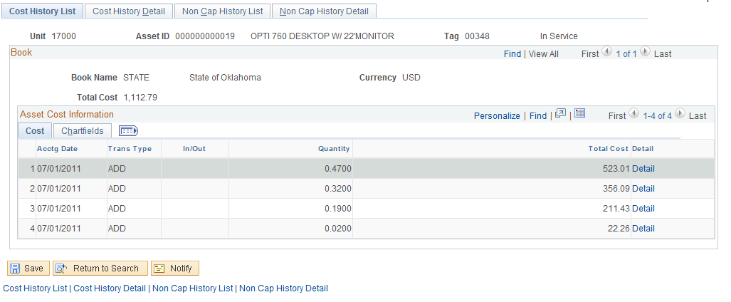

The Cost History List page displays the Cost History of the Asset. For the Reinstatement, the Transaction Type is REI to represent Retirement Reinstatement. The Total Cost column should reflect the reinstatement amount as a positive number.
Click Cost History Detail Tab to display the Cost History Detail page

Cost History Detail Page

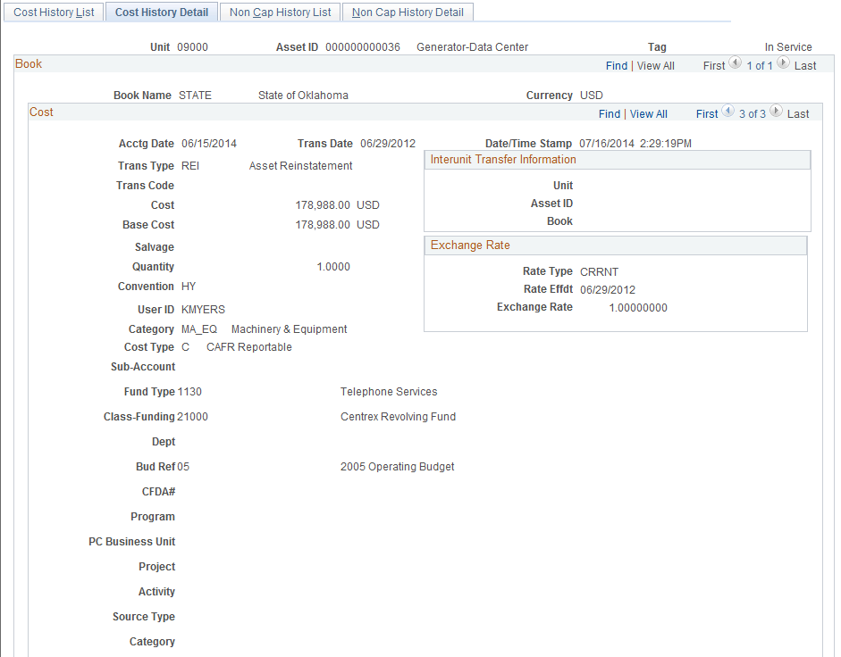
The Cost History Detail page shows the same Asset rows as are visible on the Cost History page, but with more details. There could be many Cost rows, corresponding with the Cost Rows on the Cost History Detail page, visible on this page representing the Cost history of the Asset. The Transaction Type of ADD represents the original Addition of the Asset.

NOTE: The row count - - indicates that multiple rows are available to view on this page.

Click to view the row that has the Transaction Type = REI.

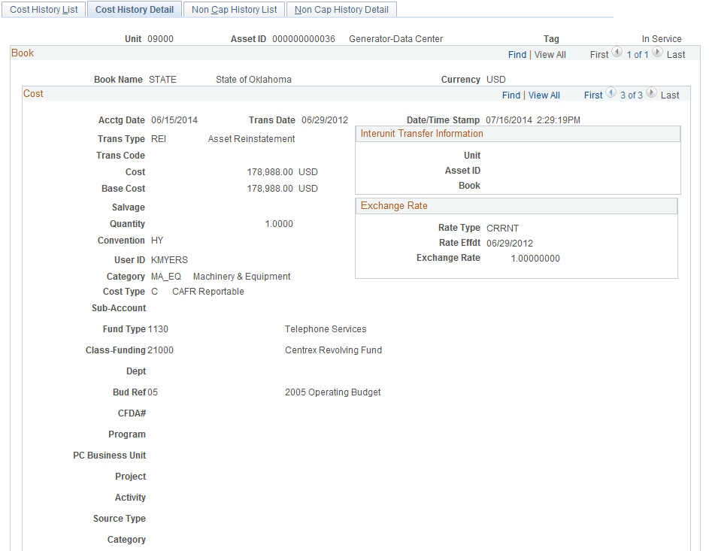

The Retirement Reinstatement row on the page represents the reinstatement done on the Asset. The Transaction Type indicates REI and the positive Cost reflects the reinstatement of the original Asset retirement. More detailed Asset information is available on this page including Transaction Date of the Reinstatement, User ID who completed the Reinstatement, and ChartField information.

NOTE: When the Asset is retired and reinstated after the depreciation calculation process runs, the retirement and reinstatement transactions are maintained in the COST table and can be seen on the Cost History page. The history of the retirement actions is maintained. This scenario could occur when you retire an Asset and then identify days or weeks later that it must be reinstated.

NOTE: When the Asset is retired and then reinstated before the depreciation calculation process runs for that Asset, the original retirement and reinstatement transactions are cleared from the COST table and the Cost History. In this scenario, no history is maintained for the transactions. This scenario could occur when you retire something but then realize right away that the retirement was performed in error and you reinstate the Asset that same day.

