COR415 Asset Management -

Asset Adjustments & Transfers Manual

Table of Contents
Document History 4
Cost Adjustment and Transfer Overview 5
Key Terms 6
Process Flows 8
Asset Cost Adjustment/Transfer Diagram 8
Asset Cost Adjustment/Transfer Process Flows 9
Guidelines, Concepts and Alternatives 10
Asset Groupings: 14
Adjust Asset Cost or Quantity 15
Step 1: Adjust an Assets Cost 15
Main Transaction Tab 16
Cost Information Tab 18
Step 2: Review the Cost Adjustment 21
Cost History List Tab 22
Cost History Detail Tab 23
Cost or Quantity Addition 25
Step 1: Add Cost to an Asset 25
Main Transaction Tab 26
Step 2: Review the Cost Addition 29
Cost History List Tab 30
Cost History Detail Tab 31
Asset Transfer 33
Step 1: Transfer an Asset 33
Main Transaction Tab 34
Cost Information Tab 35
Step 2: Review the Asset Transfer 36
Cost History List Tab 38
Asset Recategorization 42
Step 1: Recategorize an Asset 42
Main Transaction Tab 43
Cost Information Tab 44
Step 2: Review the Asset Recategorization 45
Cost History List Tab 46
Deleting Pending Asset Transactions 49
Step 1: Review Financial Detail Information 49
Pending Trans Update/Delete Tab 50
Step 2: Delete Financial Transaction Pending Depreciation 51

Authorized by: [_EBS_] Original Issue: [05/01/2014]
Maintained by: [____Asset Management Lead___]
Review Date: [05/01/2014]

Document History
Doc Rev | Date | Description
1.0  2.0 | 04/25/2011  05/01/2014 | Initial Document  Upgrade Update

Cost Adjustment and Transfer Overview
Once an Asset has been added to the Asset Management system through the Purchasing/Accounts Payable Interface or manually in Asset Management, any changes to Cost, Quantity, Asset Category, or Chartfields must be done through the Asset Adjustment features. These types of Adjustments are all categorized as Financial Adjustments.

Asset Adjustment will often be accompanied by depreciation adjustments and/or related accounting entries. All Adjustments are tracked within the system and the history of Adjustments can be viewed through the Review pages.

Due to the accounting implications of executing the Adjustment process, these features will only be granted to those state users demonstrating the ability to successfully manage the Adjustment process.

Adjustment is used when an asset’s cost or quantity is incorrect. An incorrect cost can occur when a voucher is unposted and the Asset amount is changed on the voucher after the Load Asset Request updates the Asset financial information in Asset Management. An incorrect quantity will occur when cost rows are added to an asset ID through Accounts Payable and each cost row increases the quantity.

When an Asset’s Cost or Quantity needs to be increased, use the Cost Addition features. In contrast to the Asset Adjustment features, the Asset Cost Addition features generally are used to reflect an increase in the Assets Cost during the life of the Asset. For example, a P-card purchase for an item that is part of an existing Asset could require that the Asset Cost to be increased.

Do not use a Cost Addition when you need to correct an error made in the cost or quantity of an Asset. Use Asset Adjustment to correct entry errors in cost or quantity.

When an Asset’s Chartfield values are not correct or need to be changed to reflect movement of the Asset within the agency, an Asset Transfer action must be taken on the Asset. For example, if an Asset moves from one Department in an agency to another Department (and the agency tracks and reports by Department), an Asset Transfer must be completed to correctly reflect this move.

The Transfer action will ‘Transfer’ the Asset from the old Chartfield combination to the new Chartfield combination. In doing so, the system creates two transactions. The first takes the Asset out of the old Chartfield combination and the second puts the Asset into its new Chartfield combination

Changes to an Asset’s Category are called Recategorization in the system. Typically, Recategorizations are done when the Asset’s Category was entered incorrectly or Cost Type needs to be changed (to reflect a change in CAFR reporting).

Similar to Asset Transfers, when an Asset Recategorization is done, the system creates two transactional rows. The first represents the transfer ‘Out’ of the original Asset Category; the second represents the transfer ‘In’ to the new Asset Category.

Key Terms
Asset Management Business Unit: Each agency has one Asset Management Business Unit. The Business Unit is the 3 digit agency code, plus 00. For example, Office of State Finance is 09000.

Asset ID: Each Asset in the system has a unique Asset ID assigned automatically when the asset is added. The Asset ID is the key number used by the system to track each individual asset. Use this number to search for a particular asset in the system and view or make changes.

Tag Number: All Assets in the Asset Management system can have a Tag Number that matches the physical tag on the asset.

Asset Financial Information: An Assets Financial information includes cost, quantity, useful life, and ChartField values.

Asset Physical Information: An Assets Physical information includes tag number, location, custodian, serial number, and Manufacturer ID.

Profile ID: Profile ID is a “template” for the Asset that defaults values into the asset used for grouping and depreciation processing. This includes Asset Category, Asset Type, Useful Life, and Depreciation Method and Convention.

Asset Category: Groups assets together by major asset type for financial reporting purposes. Categories are Land, Land Improvements, Buildings, Infrastructure, Machinery and Equipment, IT Systems, Artifacts and Treasures, Capital Lease – Buildings, Capital Lease – Equipment, and Operating Leases. Asset category is required and included in the Profile ID.

Asset Type: Classifications to report assets within an asset category. Types are IT Hardware, IT Software, Equipment, Property, Fleet, Furniture, Facility, Intangibles, and Other. Asset type is required and included in the Profile ID.

Asset Subtype: Groups assets within Asset Types at a more granular level for internal reporting purposes. Subtypes are optional in Asset Management and are not included in the Profile ID; however, Office of State Finance does require that subtypes be included for IT Assets.

Asset Class: Defines assets within Asset Categories for internal reporting purposes. Asset Classes currently set up were provided by Department of Central Services for assets that are machinery and equipment in nature. Classes are optional in Asset Management and not included in the Profile ID; however, Department of Central Services does require the class be included on the DCS-FORM_SS_001A when an asset is sent to surplus.
CAFR Asset: A capital asset with a cost of $25,000 or more reportable on the Comprehensive Annual Financial Report (CAFR). The cost of individual assets acquired as part of of a group to be used together, but can be used as a separate asset, must individually meet the $25,000 capitalization policy even though they are connected to other components of the group. Asset grouping is limited to individual components that cannot be used without being connected to other components. Refer to GAAP Package H, Reportable Capital Assets, under Key Terms for specific guidelines.

Cost Type: A Cost Type is used to differentiate between CAFR and non-CAFR assets. The cost type, in conjunction with category and asset transaction, will record the accounting entries needed by the CAFR group.

IT Asset: Telecommunication voice response systems and electronic information technology applications, including but not limited to mainframe computers, minicomputers, or microcomputers, word processing equipment, office automation systems, Internet, eGovernment, broadband, WI-FI or wireless networking, radio, including the interoperable radio communications system for state agencies, or Global Positioning Systems (GPS). Refer to the categories and descriptions in the Information Technology and Telecommunications Annual Report Plan on the OMES website.

Transaction Date: Date on the Asset that reflects the actual date the Asset transaction took place. In the case of a new Asset addition, this is the date the Asset was Acquired.

Accounting Date: Date on the Asset that will determine when the Asset transaction will be posted to the General Ledger.

Process Flows
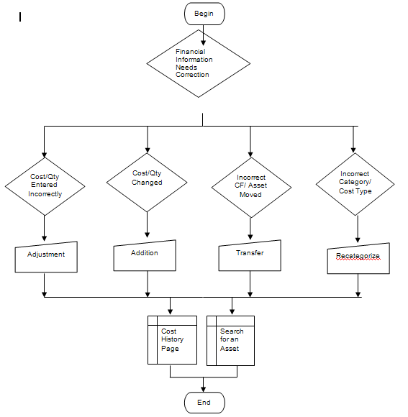

Asset Cost Adjustment/Transfer Diagram

Asset Cost Adjustment/Transfer Process Flows

Begin Process

Financial Transaction needs correction.

If an asset cost or quantity is incorrect, perform an Adjustment.

If an existing asset cost or quantity needs to be added and a Cost Row was not added through the voucher, perform an Addition.

If an asset has an incorrect Chartfield or was moved from one department to another department and the agency tracks and reports by department, perform a Transfer.

If an asset has an incorrect category or cost type, perform a Recategorization.

Use Asset Cost History or Search for an Asset pages to view updated Financial Information online.

End

Guidelines, Concepts and Alternatives

What is a Capital Asset?
The term capital assets includes land, improvements to land, easements, buildings, building improvements, vehicles, machinery, equipment, works of art and historical treasures, infrastructure, and all other tangible or intangible assets that are used in operations and that have initial useful lives extending beyond a single reporting period. (GASB S34, par. 19)

The State of Oklahoma’s capitalization threshold for capital assets is $25,000.

What Assets, in Addition to Capitalized Assets, Should be Included in Asset Management?
The Asset Management system will be used to track “tangible assets” costing $2,500 or more to meet Department of Central Services reporting requirements per the Administrative Rule 580:70-1-3(a). “Tangible assets" mean machinery, implements, tools, furniture, livestock, vehicles and other apparatus that an agency may use repeatedly without material impairment of its physical condition and have a calculable period of service and a value exceeding the reporting threshold the Director of Central Services establishes for the entity. [74 O.S., Section 110.1(D)]”

The system will also be used to track telecommunication and electronic information technology applications costing $500 or more to meet the requirements specified in Title 62, § 34.12, Subsection 6. Telecommunication and electronic information technology applications “include but are not limited to the use of mainframe computers, minicomputers, or microcomputers, word processing equipment, office automation systems, Internet, eGovernment, broadband, WI-FI or wireless networking, radio, including the interoperable radio communications system for state agencies, or Global Positioning Systems (GPS).2 Refer to the Information Technology and Telecommunications Plan for a more detailed listing of “Defined Categories and Descriptions” at http://www.ok.gov/cio/Policy_and_Standards/ select the 2011 Annual Report.

Asset Management can also be used to track items costing less than $2,500 ($500 if an electronic information technology asset) if they are sensitive for one or more of the following reasons:
- Items that require special attention to ensure legal compliance. Legal or contractual provisions may require a higher than ordinary level of accountability over certain capital-type items (e.g., items acquired through grant contracts);
- Items that require special attention to protect public safety and avoid potential liability. Some capital-type items by their very nature pose a risk to public safety and could be the source of potential liability (e.g., police weapons);
- Items that require special attention to compensate for a heightened risk of theft (“walk away” items). Some capital-type items are both easily transportable and readily marketable or easily diverted to personal use (e.g., sound equipment). 3

What are the State’s Major Asset Categories for Owned Assets?
The State of Oklahoma uses the following major categories:

Art, Artifacts, and Treasures – This includes collections of works of art, historical treasures, and similar items. For art or a collection to be categorized as Art, Artifact, or Treasure, its purpose must be to display or research, and the collection items must be adequately maintained and preserved. Additionally, proceeds from the sale of collection items must be used to purchase other items for the collections. Such collections are often considered to have an indefinite useful life and will generally appreciate in value; thus, assets in this category are not depreciated.

Land – “Land is often associated with some other asset (e.g., land under a building or road). Land should be treated separately; thus, the land purchased with an existing building should not be capitalized as part of the cost of the building. The cost of the land should include the acquisition cost and the cost of initially preparing land for its intended use, provided these preparations have an indefinite useful life, like the land itself. Ownership of land can include separable elements (e.g., mineral rights). These various elements should not be treated as separate assets in their own rights unless they are acquired separately. Land, unless compromised by use, has an indefinite life and is not depreciated.” 4

Land Improvements – This is used for permanent improvements that add value to the land but do not have an indefinite useful life. Examples include fences, retaining walls, parking lots, and most landscaping. Moveable items should be classified as furnishing and equipment.

Buildings – All permanent structures are included in the building category. The cost of an improvement will be treated as a separate asset in the Asset Management System, but can be linked in a Parent-Child relationship.

Infrastructure – “Long-lived capital assets that normally are stationary in nature and normally can be preserved for a significantly greater number of years than most capital assets.” 4 Examples include roads, bridges, tunnels, drainage systems, water and power systems, dams, and lighting systems.

Machinery and Equipment – This category is used for vehicles, furnishings, and similar moveable items, but does exclude assets included in the IT Systems category. It also can be used for collections that do not appreciate in value (e.g., general library collections).

IT Systems – This category was set up separately from machinery and equipment to satisfy the requirements of Title 62, § 34.12. Subsection 6. Assets include telecommunication voice response systems and electronic information technology applications. See the paragraph defining information technology assets in the question on the previous page addressing which assets are tracked in the Asset Management system.

Construction in Progress – Costs incurred to construct or develop a tangible or intangible asset before it is ready to be placed in service. Construction in Progress will be tracked in the PeopleSoft Projects Module and will be classified into the appropriate asset category when the asset is placed in service. If the Projects Module is not utilized, then Construction in Progress totaling $25,000 or more will be reported separately to the CAFR group until the asset is added to the Asset Management Module at the time the asset is placed in service.

How Should a Donated Capital Asset be Valued?
Generally accepted accounting principles state that “donated capital assets should be reported at their estimated fair value at the time of acquisition plus ancillary charges, if any.” 4 The appropriate fair value is the amount that the agency would have had to pay to acquire the asset, not the amount for which the donated asset might be resold.

How Should Bundled Costs be Assigned to Individual Assets?
“Capital assets often are purchased or constructed in bundles (e.g., the purchase of a building and land). An appropriate portion of the cost must be assigned to each.” 4

How Should Assets Obtained through Trade-Ins be Valued?
“If a capital asset is traded-in in the process of purchasing another similar capital asset, the newly acquired capital asset should be recorded at an amount equal to the book value of the asset that was surrendered plus any additional monetary consideration provided to seller.” 4

What is the Acquisition Cost of Internally Generated Software?
Generally accepted accounting principles “prohibit the capitalization of any cost associated with the preliminary project stage of software development. Conversely, costs connected with the application development stage should be capitalized, but only if incurred subsequent to the completion of the preliminary project stage. Even then, capitalization is limited to situations where management authorizes and commits to funding, at least through the current period. Finally, costs incurred as part of the post-implementation/operations stage should never be capitalized.” 4

How Should Significant Costs Incurred after the Asset is Acquired be Treated?
Significant costs incurred in connection with capital assets in periods subsequent to the initial acquisition need to be distinguished between improvements and repairs and maintenance.

“An improvement provides additional value. Such added value is achieved either by 1) lengthening a capital asset’s estimated useful life or 2) increasing a capital asset’s ability to provide services (i.e., greater effectiveness or efficiency). In contrast to improvements, repairs and maintenance retain value rather than provide additional value.” Improvements are capitalized and repairs and maintenance are expensed.

“Often a single project will have elements of both repair and an improvement. In that case, the relative cost of each should be determined and treated separately.” 4

The State will treat an improvement as a separate capital asset and depreciate it over its own estimated useful life. It can be linked in a Parent-Child relationship.

Which Items Should be Depreciated or Amortized and How?
Capital assets that have a definite useful life are depreciated. The State of Oklahoma uses the Straight Line depreciation method, the Half Year convention, and no salvage value to compute depreciation.

How are the Useful Lives of Assets Estimated?
Straight line depreciation is calculated by dividing the asset cost by the estimated useful life in years. Each agency determines the useful life of the assets and should be the period over which services are expected to be provided by the asset based on the agency’s own experience. Factors to consider when estimating a life are materials and construction, specific use, physical environment, maintenance policies, and the risk of technological obsolescence. Refer to GAAP Package H, Reportable Capital Assets, Schedule A, for common life ranges for capital assets.

For assets not meeting the CAFR threshold of $25,000 or not subject to the federal capitalization threshold of $5,000 for purposes of federal reimbursement, a useful life of one year has been set up in Asset Management for all categories with assets that have a definite useful life.

Estimated useful lives selected for depreciation purposes must be reviewed regularly for reasonableness. “If a change in estimates proves necessary, it should be treated prospectively (i.e., as an adjustment to future charges).” 4

1 DCS Administrative Rule 580:70-1-2
2 OSF Information Technology and Telecommunications Plan, Fiscal Year 2010, General Background
3 GFOA best practice on “Establishing Control over Non Capitalized Items” (2006)
4 GFOA Accounting for Capital Assets – A Guide for State and Local Governments (2008)

Asset Groupings:
Asset Category: (Required Field) Groups assets together by major asset type for financial reporting purposes.

Asset Profiles: (Required Field) A template containing default values for an Asset type. Default values include asset category, life (designated by the number in the profile ID), acquisition code, and asset type.

Asset Type: (Required Field and included in profiles) PeopleSoft delivered classification to report assets within an asset category. Types are IT Hardware (010), IT Software (020), Equipment (040), Property (050), Fleet (060), Furniture (080), Facility (090), Intangibles (100), and Other (999).

Useful Life: Estimated Useful Life of the Asset used in deprecation calculations.

Asset Category - Owned | Asset Profile | Asst Type | Useful Lives
ARTIF – Art and Artifacts | ART_ARTIF | Property | Non Depreciable
LAND - Land | LAND | Property | Non Depreciable
LAND - Land | ROW (Right of Way) | Property | Non Depreciable
LDIMP – Land Improvements | PROPERTYXX * | Property | 1, 5, 10, 15, 20, 25, 30, 40, 50
INFRA – Infrastructure | INFRASTRUCTURE30 | Property | 30
BLDG – Building | FACILITYXX | Facility | 1, 5, 10, 15, 20, 25, 30, 40, 50, 60
ITSYS – IT Systems | HARDWAREXX | IT Hardware | 1, 3, 5, 10, 20
ITSYS – IT Systems | SOFTWAREXX | IT Software | 1, 3, 5, 8
MA_EQ – Machinery & Equipment | EQUPXX | Equipment | 1, 4, 5, 6, 7,8, 10, 15, 20
MA_EQ – Machinery & Equipment | FLEETXX | Fleet | 1, 3, 4, 5, 6, 7, 8, 10, 12, 15, 20
MA_EQ – Machinery & Equipment | FURN_EQXX | Furniture | 1, 5, 7, 10, 12

* XX – represents multiple Useful Life values for a Profile ID.

Adjust Asset Cost or Quantity

Step 1: Adjust an Asset’s Cost
Navigation: Asset Management > Asset Transactions > Financial Transactions > Cost Adjust/Transfer Asset > Find an Existing Value

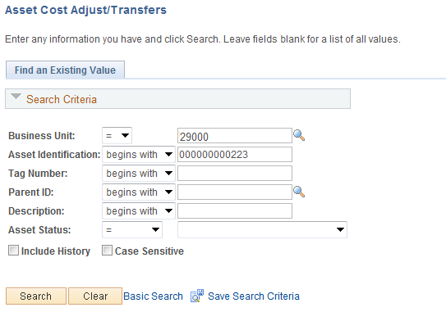

Business Unit – is the Agency in which the existing Asset is housed. This should default based on the User Preferences setup for the person Adjusting the Asset.

Asset Identification, Tag Number, Parent ID, Description, Asset Status – use these fields as search criteria to find the Asset that will be Adjusted.

Click to enter the Asset Cost Adjust/Transfer pages.

Main Transaction Tab

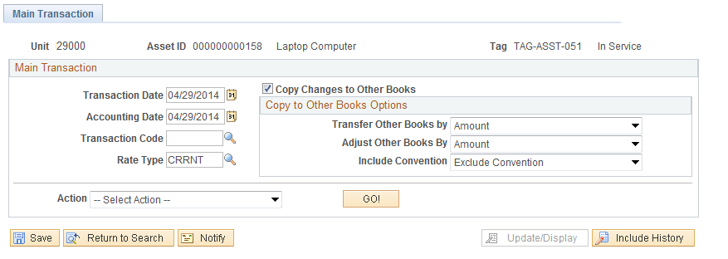

Transaction Date – the Transaction Date will default to current date. This value should not be changed.

Accounting Date – the Transaction Date will default to current date. This value should not be changed.

Action - Adjustments can be done for Cost Adjustments, Cost Additions, Transfers of Chartfields and changes in Asset Category or Cost Type called Recategorizations.

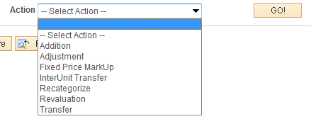

Use the drop down to select the Action of Adjustment.

Copy Changes to Other Books – leave this field as the default value.

Transfer Other Books by – leave this field as the default value.

Adjust Other Books by – leave this field as the default value.

Include Convention – leave this field as the default value.

Click to initiate the Adjustment and view the Cost Information Page.

NOTE: If the cost adjustment reduces the cost below $25,000, then the asset must be re-categorized to a non-CAFR asset. Likewise, if the Asset cost is adjusted to over $25,000.00, Cost Type ‘C’ is required.

Cost Information Tab

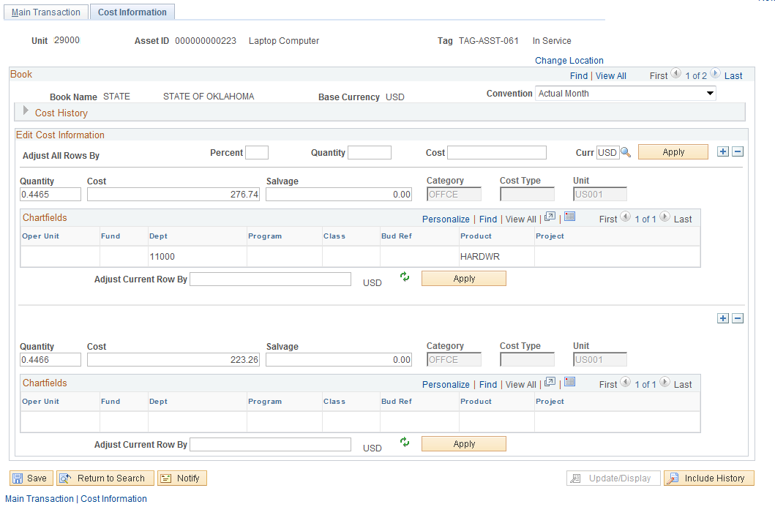

The Cost History can be expanded to review the Cost Rows and their associated chartfields for the Asset.

The Cost Information page allows you to define a Cost or Quantity Adjustment for the Asset. The Asset will be adjusted using the Cost information displayed in the Edit Cost Information section. The Asset can be adjusted by changing the Quantity or Cost fields directly, or by using the Adjust Current Rows By feature illustrated on the next page.

NOTE: The Adjust All Rows By option ONLY needs to be used if the Asset has multiple Cost Rows. If the Asset has only one Cost row, simply adjust the Asset by using the Quantity or Cost fields on the Cost Line for the Asset, or use the Adjust Current Row By feature.

The Adjust All Rows By option allows you to adjust the Asset by:
- Percentage – define the Cost Asset adjustment by percent.
- Quantity – use this field to adjust the Assets Quantity.
- Cost – define the Cost adjustment by Amount.

If using the Adjust All Rows By feature, click to apply the Adjustments to all rows.

Quantity – Adjust the Quantity to the desired Quantity value for the Asset.

NOTE: When an asset is partially Retired or partially Transferred in the system, the Quantity value will decrease. When a cost row is added to an existing Asset through the Voucher, the Quantity value will exceed 1. Use Quantity Adjustment to increase or decrease the Quantity to 1.

Cost – Populate the Cost with the desired Cost value for the Asset.

NOTE: The Cost field should be populated with the Cost of the Asset that is desired, not the amount of the Adjustment. For example, if the Cost is 5,000.00 and the desired cost is 5,500.00, the Cost field should be populated with 5,500.00 rather than 500.00.

Adjust Current Row By – Alternatively, use the Adjust Current Row By feature to enter the ‘Adjustment Amount’ and have the system calculate the new Asset Cost.

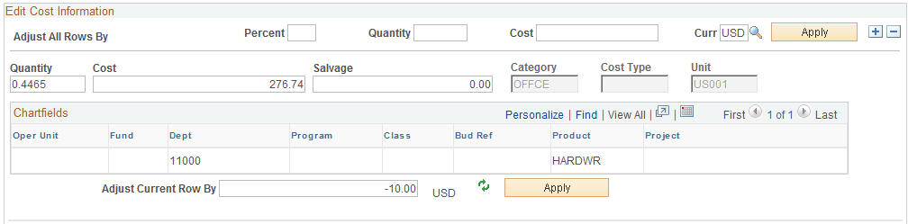

Click to apply the adjustments to the Cost row and have the system calculate the new Asset Cost.

NOTE: When using the Adjust Current Row By feature populates the field with a Negative number to reduce the Cost of the Asset.

NOTE: When the Asset Adjustment reduces the Cost of the Asset to below $25,000.00 (as illustrated above), an Asset Recategorization must be done to change the Asset Cost Type from ‘C’ to no Cost Type (blank). Likewise, if the Asset Cost Adjustment increases the Cost to over $25,000.00, the Cost Type should be Recategorized to ‘C’.

Click to Save your Adjustment.

Step 2: Review the Cost Adjustment
Navigation: Asset Management >Asset Transactions > History > Review Cost > Find an Existing Value

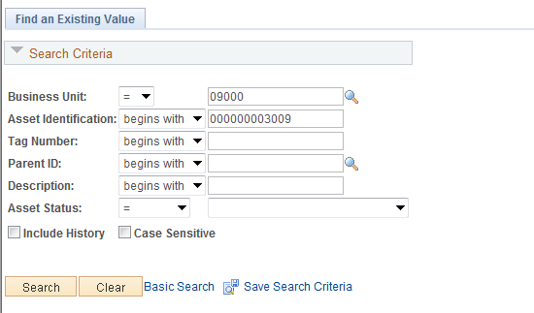

Business Unit – is the Agency in which the existing Asset is housed. This should default based on the User Preferences setup for the person reviewing the Asset.

Asset Identification, Tag Number, Parent ID, Description, Asset Status – use these fields as search criteria to find the Asset that will be reviewed.

Click to enter the Asset Cost History pages.

NOTE: Cost and Quantity Adjustments are not updated in the Asset Basic Add page. Users will need to use Asset Management reports and queries to report on Asset Financial Information. The Asset Cost History provides detail about a specific asset or transaction.

Cost History List Tab

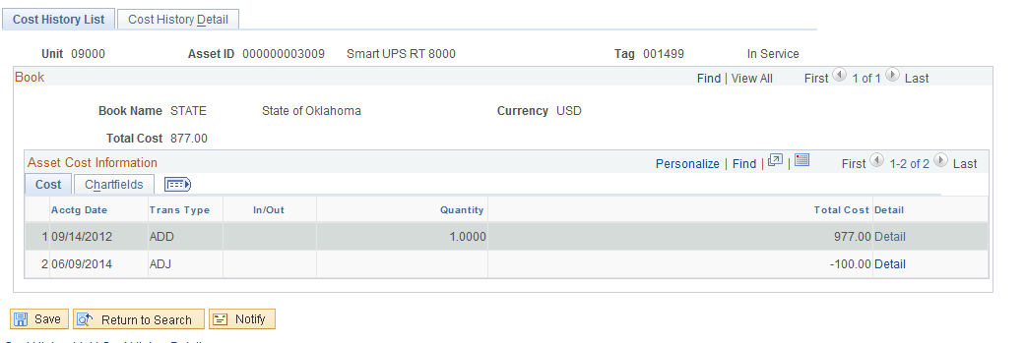

The Cost History List Tab displays the Cost History of the Asset. For the Adjustment, the Transaction Type is ADJ to represent Cost Adjustment. The Total Cost column should reflect the adjustment amount.

Click Cost History Detail Tab to access the top of the Cost History Detail Tab or the Detail link to access the specific transaction row on the Cost History Detail page.

Cost History Detail Tab

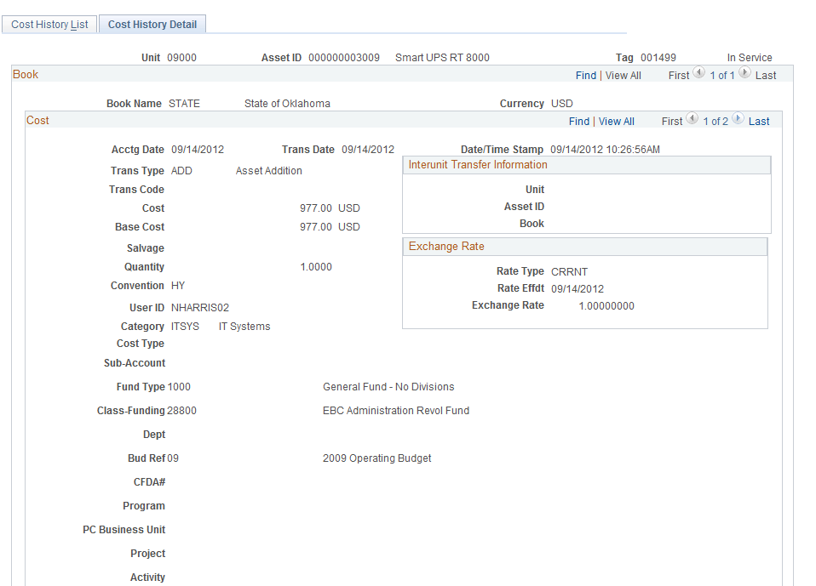

The Cost History Detail Tab shows the same Asset rows as are visible on the Cost History page, but with more details. The Transaction Type of ADD represents the original addition of the Asset.

NOTE: The row count - - indicates that multiple rows are available to view on this page. The page initially defaults to row 1 when selecting the Cost History Detail Tab. Row 1 will be the same row as is displayed at the top of the previous page. You will need to scroll through the rows to find the one applicable to your transaction.

Click to view the next row on the page.

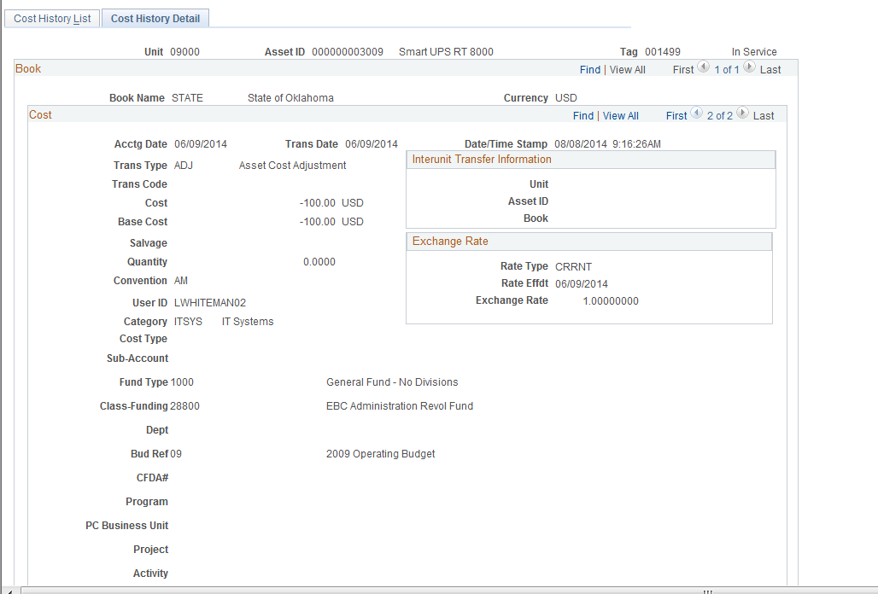

The Adjustment row on the page represents the adjustment done on the Asset. The Transaction Type indicates ADJ (Adjustment) and the Cost reflects the reduction in Cost.

NOTE: More detailed Asset information is available on this page including Transaction Date of the Adjustment, User ID who completed the Adjustment, and Chartfield information.

Cost or Quantity Addition

Step 1: Add Cost to an Asset
Navigation: Asset Management > Asset Transactions > Financial Transactions > Cost Adjust/Transfer Asset > Find an Existing Value

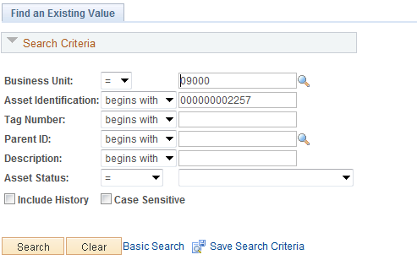

Business Unit – is the Agency in which the existing Asset is housed. This should default based on the User Preferences setup for the person adding Cost to the Asset.

Asset Identification, Tag Number, Parent ID, Description, Asset Status – use these fields as search criteria to find the Asset that will be changed.

Click to enter the Asset Cost Adjust/Transfer pages.

Main Transaction Tab

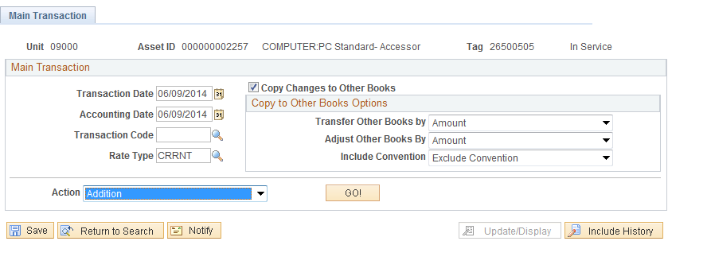

Transaction Date – the Transaction Date will default to current date. This value should not be changed.

Accounting Date – the Transaction Date will default to current date. This value should not be changed.

Action - Adjustments can be done for Cost Adjustments, Cost Additions, Transfers of Chartfields and changes in Asset Category or Cost Typed called Recategorizations.

Use the drop down to select the Action of Addition.

Click to initiate the Cost Addition and view the Cost Information Page.

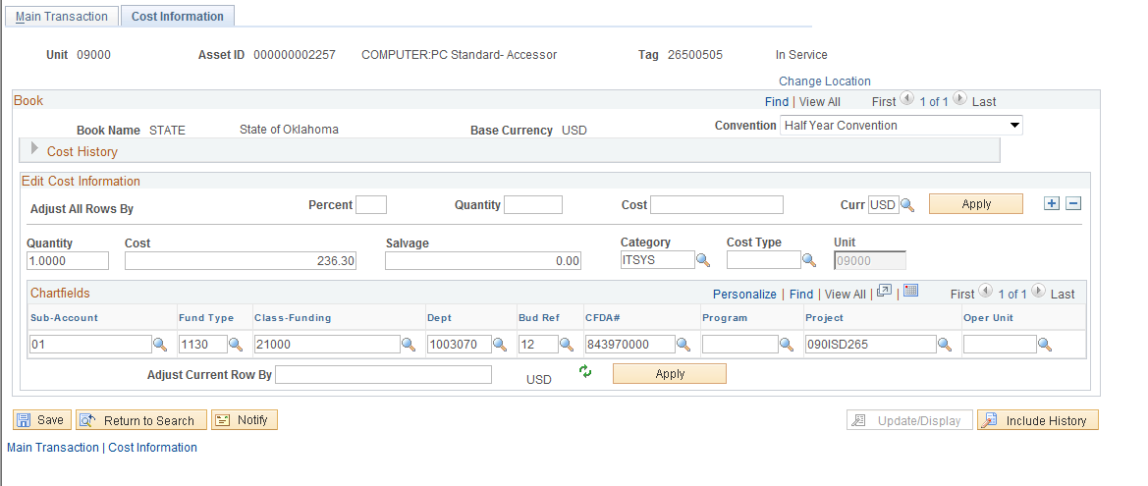

The Cost History can be expanded to review the Cost Rows and their associated chartfields for the Asset.
The Cost Information page allows you to define a Cost or Quantity Addition for the Asset. The Asset will be changed using the Cost information in the Edit Cost Information section of the page. The Asset Cost can be increased by changing the Quantity or Cost fields directly as illustrated in the next page, or by using the Adjust Current Rows By feature.

NOTE: The Adjust All Rows By option ONLY needs to be used if the Asset has multiple Cost Rows. If the Asset has only one Cost row, simply adjust the Asset by using the Quantity or Cost fields on the Cost Line for the Asset. Or use the Adjust Current Row By feature.

The Adjust All Rows By option allows you to adjust the Asset by:
- Percentage – define the Cost Asset adjustment by percent.
- Quantity – use this field to adjust the Assets Quantity
- Cost – define the Cost adjustment by Amount.

If using the Adjust All Rows By feature, click to apply the adjustments to all rows.

Quantity – Adjust the Quantity to the desired Quantity value for the Asset.

Cost – Populate the Cost with the desired Cost value for the Asset.

NOTE: The Cost field should be populated with the Cost of the Asset that is desired, not the amount of the Adjustment. For example, if the Cost is 5,000.00 and the desired cost is 5,500.00, the Cost field should be populated with 5,500.00 rather than 500.00.

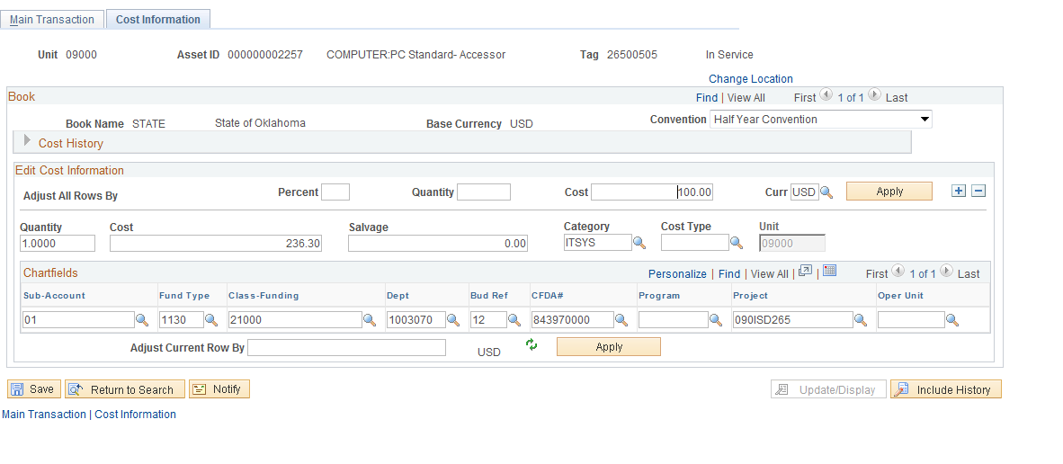

The example above illustrates updating the Cost field directly to reflect the additional Asset Cost of 100.00.

Adjust Current Row By – Alternatively, use the “Adjust Current Row By” feature to enter the ‘Addition Amount’ and have the system calculate the new Asset Cost. In this example, you would enter 200.00 in the Adjust Current Row By field.

Click to Save your Cost Addition.

NOTE: It should be rare to use Cost Addition. Improvements incurred in connection with capital assets in periods subsequent to the initial acquisition will either be a separate asset and linked in a Parent-Child relationship, or additional Cost Rows will be added through the Voucher. Cost adjustments are used when asset costs are entered incorrectly.

Step 2: Review the Cost Addition
Navigation: Asset Management > Asset Transactions > History > Review Cost > Find an Existing Value

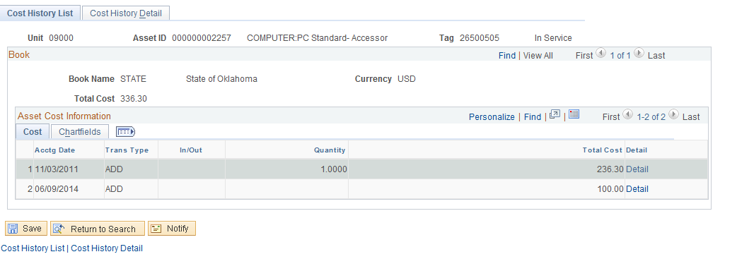

Business Unit – is the Agency in which the existing Asset is housed. This should default based on the User Preferences set up for the person reviewing the Asset.

Asset Identification, Tag Number, Parent ID, Description, Asset Status – use these fields as search criteria to find the Asset that will be reviewed.

Click to enter the Asset Cost History pages.

NOTE: Cost and Quantity Additions are not updated in the Asset Basic Add page. Users will need to use Asset Management reports and queries to report on Asset Financial Information. The Asset Cost History provides detail about a specific asset or transaction.

Cost History List Tab

The Cost History List page displays the Cost History of the Asset. For the Asset Cost Addition, the Transaction Type is ADD to represent Cost Addition. The Total Cost column should reflect the Addition amount.

NOTE: The system has inserted an additional Cost row for the amount of the Cost Addition. This keeps the original ‘ADD’ row intact and the Cost Addition row separate.

Click Cost History Detail Tab to display the Cost History Detail page or the Detail Link to access the specific transaction row on the Cost History Detail page.

Cost History Detail Tab

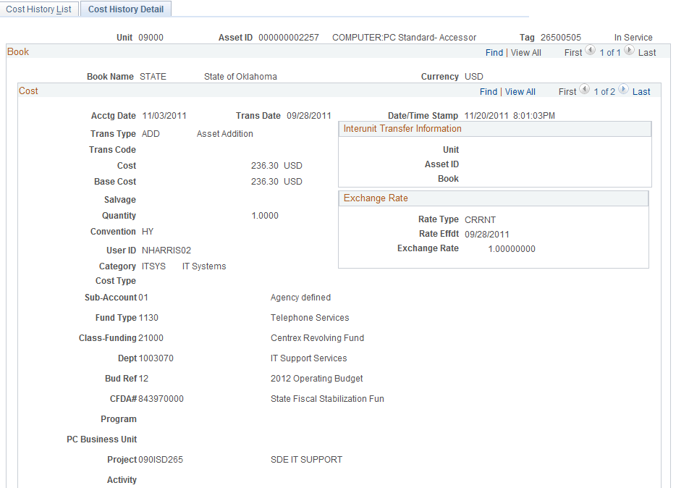

The Cost History Detail page shows the same Asset rows as are visible on the Cost History page, but with more details. The Transaction Type of ADD represents the original Addition of the Asset.

NOTE: The row count - - indicates that multiple rows are available to view on this page. The page initially defaults to row 1 when selecting the Cost History Detail Tab. Row 1 will be the same row as is displayed at the top of the previous page. You will need to scroll through the rows to find the one applicable to your transaction.

Click to view the next row on the page.

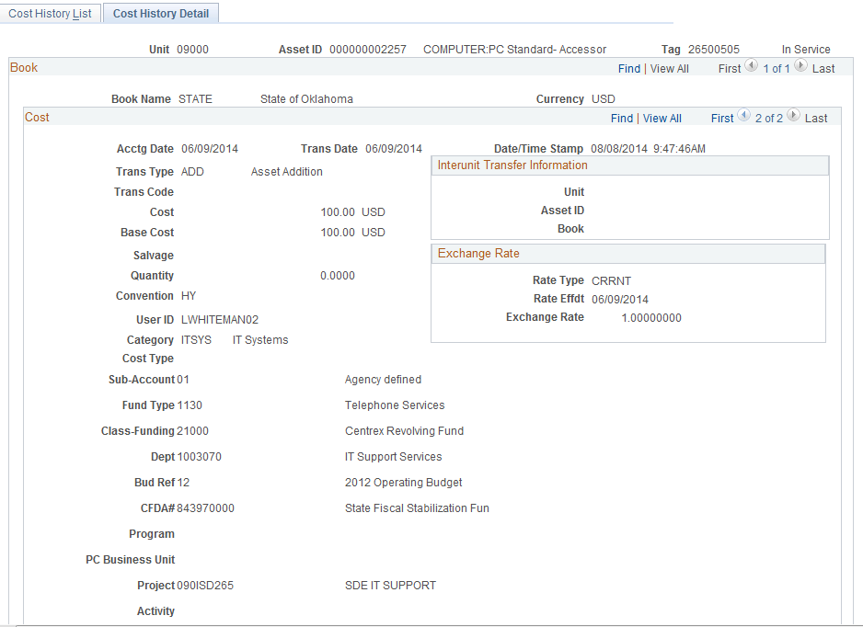

The Addition row on the page represents the addition done on the Asset. The Transaction Type indicates ADD (Addition) and the Cost reflects the increase in Cost.

NOTE: More detailed Asset information is available on this page including Transaction Date of the Adjustment, User ID who completed the Adjustment, and Chartfield information.

Asset Transfer

Step 1: Transfer an Asset
Navigation: Asset Management > Asset Transactions > Financial Transactions > Cost Adjust/Transfer Asset > Find an Existing Value

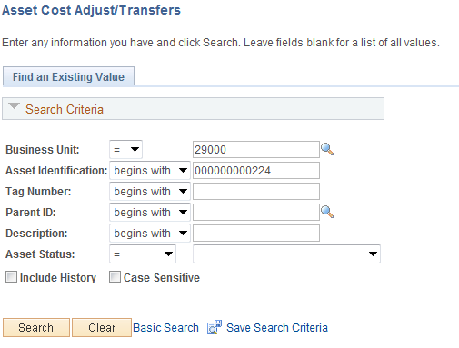

Business Unit – is the Agency in which the existing Asset is housed. This should default based on the User Preferences set up for the person Transferring the Asset.

Asset Identification, Tag Number, Parent ID, Description, Asset Status – use these fields as search criteria to find the Asset that will be Transferred.

Click to enter the Asset Cost Adjust/Transfer pages.

Main Transaction Tab

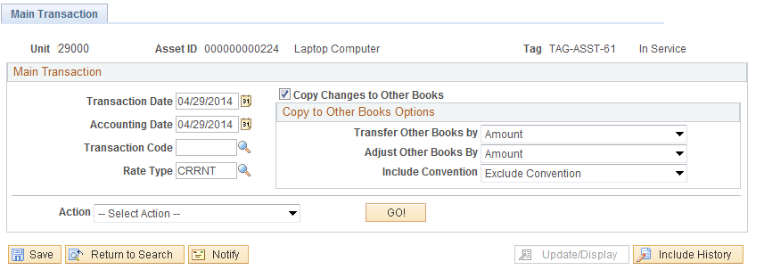

Transaction Date – the Transaction Date will default to current date. This value should not be changed.

Accounting Date – the Transaction Date will default to current date. This value should not be changed.

Action - Adjustments can be done for Cost Adjustments, Cost Additions, Transfers of Chartfields and changes in Asset Category called Recategorizations.

Use the  drop down to select the Action of Transfer.

Click to initiate the Transfer and view the Cost Information Page.

Cost Information Tab

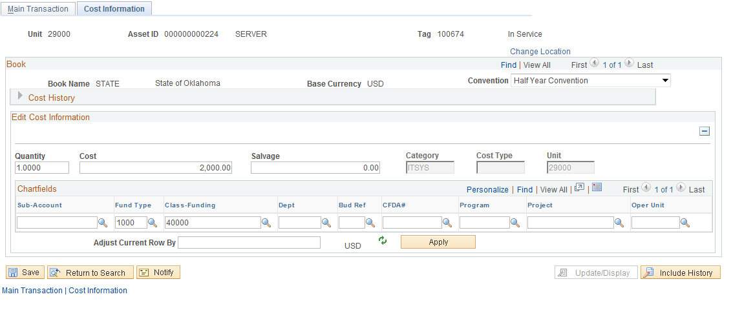

The Cost Information page allows you to change any Chartfield values in the Edit Cost Information section of the page.

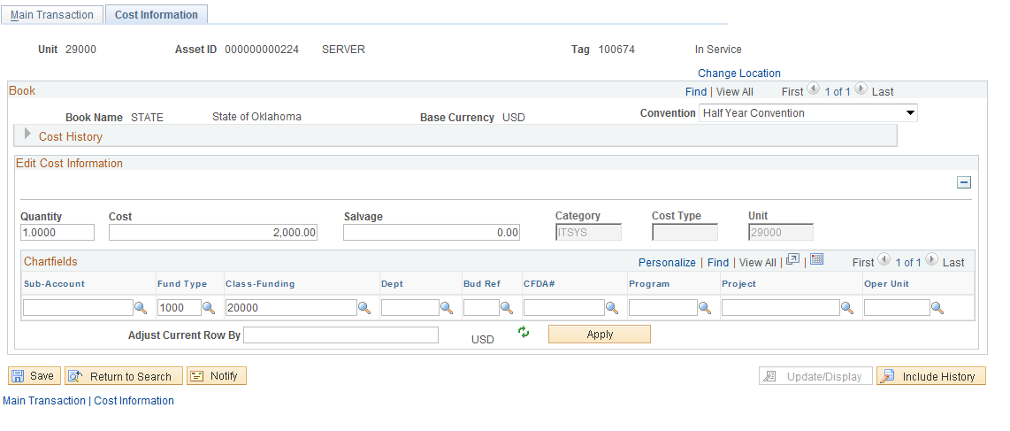

Make any necessary changes to the Chartfield information to initiate the Transfer. In this example, the Department ID value has been changed from 11000 to 14000.

Click o Save your Transfer.

Step 2: Review the Asset Transfer

Navigation: Asset Management > Asset Transactions > History > Review Cost > Find an Existing Value

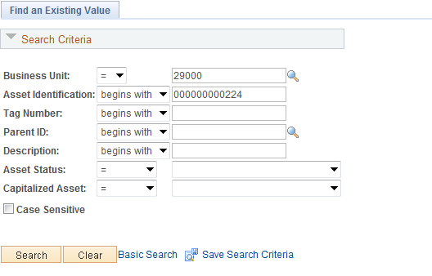

Business Unit – is the Agency in which the existing Asset is housed. This should default based on the User Preferences setup for the person reviewing the Asset.

Asset Identification, Tag Number, Parent ID, Description, Asset Status – use these fields as search criteria to find the Asset that will be reviewed.

Click to enter the Asset Cost History pages.

NOTE: Changes to the ChartField Information are not updated in the Asset Basic Add page. Users will need to use Asset Management reports and queries to report on Asset Financial Information. The Asset Cost History provides detail about a specific asset or transaction.

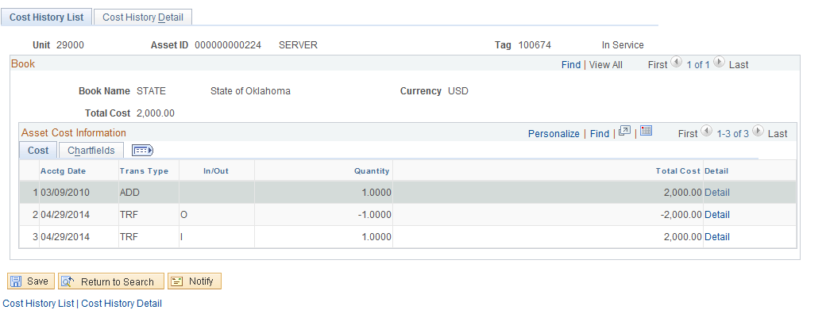

Cost History List Tab

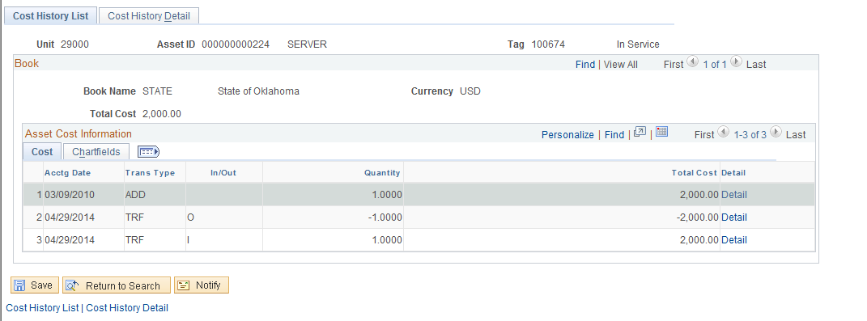

The Cost History Tab displays the history of all Cost changes made to an Asset. With a Transfer, the system creates two transactions. The first represents the transfer out (In/Out column = ‘O’) of the old Chartfield combination, the second represents the transfer in (In/Out column = ‘I’) to the new Chartfield combination.

The Transaction Type is equal to TRF to reflect a Transfer of the Asset. The Quantity and Total Cost columns also reflect the “Out” and “In” rows for the transfer.

Click Chartfields Tab to view the history of the Chartfield changes.

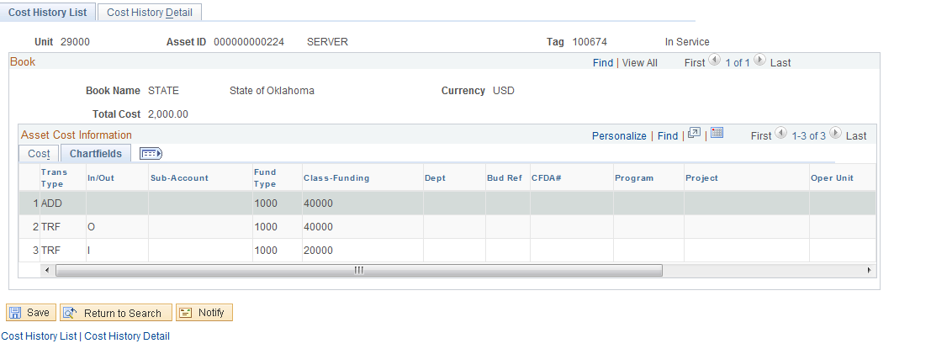

The Chartfields Tab show the “Out” transaction that represents the old Chartfield combination - in this case, the Asset has been transferred between Department’s – and the “In” transaction representing the new Chartfield combination.

Click Cost History Detail Tab to display the Cost History Detail page or the Detail Link to access the specific transaction row on the Cost History Detail page.

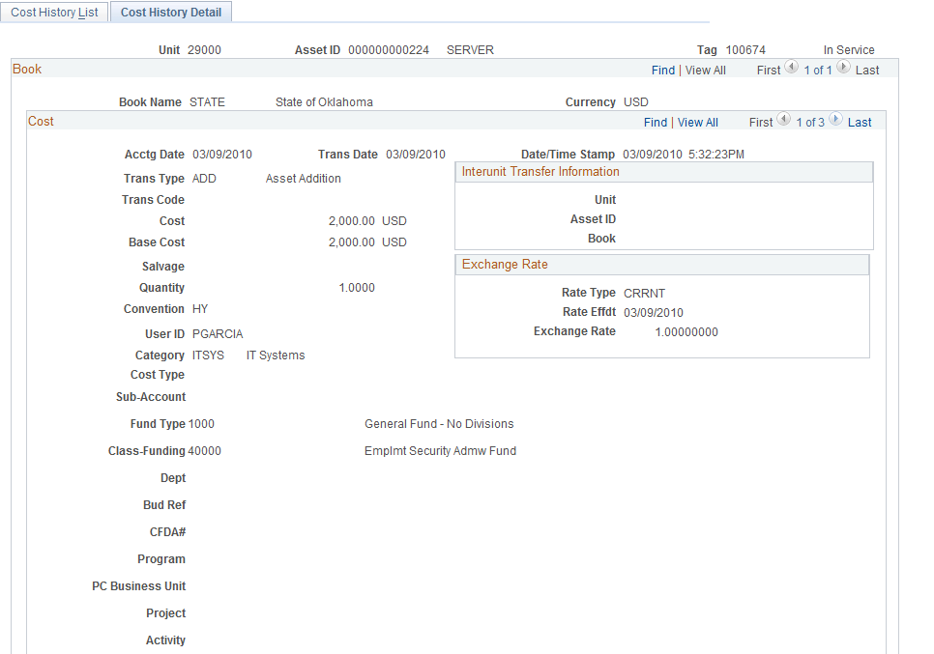

The Cost History Detail Tab shows the same Asset rows as are visible on the Cost History page, but with more details. The Transaction Type of ADD represents the original Addition of the Asset.

NOTE: The row count - - indicates that multiple rows are available to view on this page. The page initially defaults to row 1 when selecting the Cost History Detail Tab. Row 1 will be the same row as is displayed at the top of the previous page. You will need to scroll through the rows to find the one applicable to your transaction.

Click to view the next row on the page

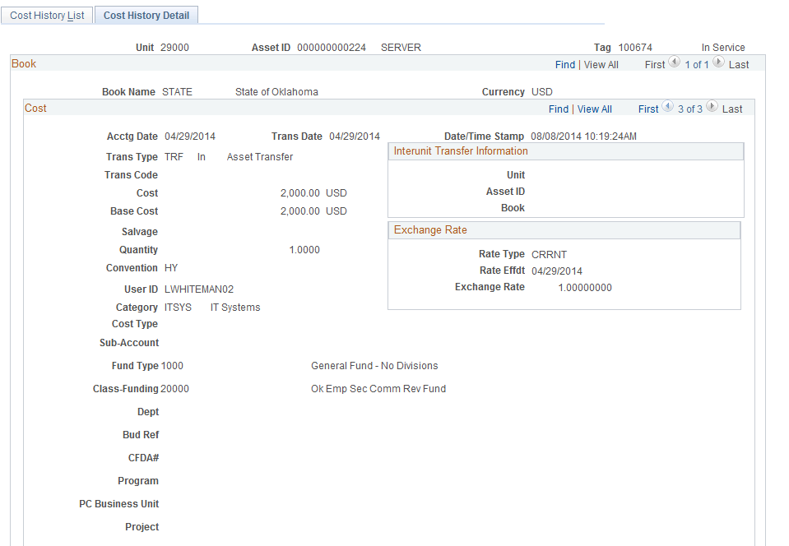

The Transfer row on the page represents the transfer into the new Department. The Transaction Type TRF (Transfer) reflects the transfer.

NOTE: More detailed Asset information is available on this page including Transaction Date of the Adjustment, User ID who completed the Transfer, and Chartfield information.

Asset Recategorization

Step 1: Recategorize an Asset
Navigation: Asset Management > Asset Transactions > Financial Transactions > Cost Adjust/Transfer Asset > Find an Existing Value

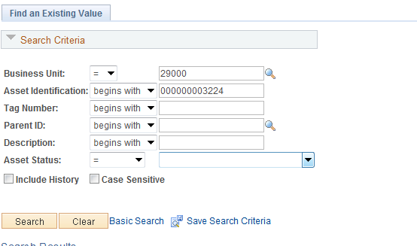

Business Unit – is the Agency in which the existing Asset is housed. This should default based on the User Preferences set up for the person Recategorizing the Asset.

Asset Identification, Tag Number, Parent ID, Description, Asset Status – use these fields as search criteria to find the Asset that will be Recategorized.

Click to enter the Asset Cost Adjust/Transfer pages.

Main Transaction Tab

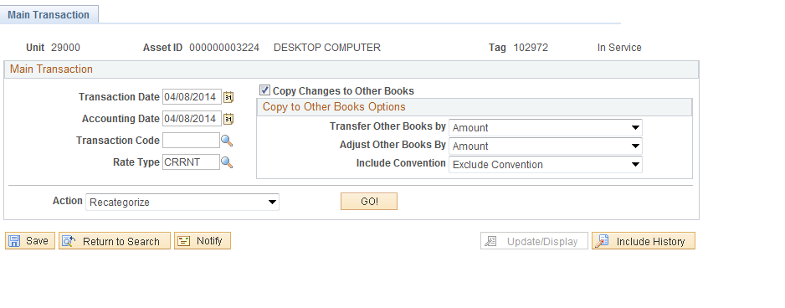

Transaction Date – the Transaction Date will default to current date. This value should not be changed.

Accounting Date – the Transaction Date will default to current date. This value should not be changed.

Action - Adjustments can be done for Cost Adjustments, Cost Additions, Transfers of Chartfields and changes in Asset Category called Recategorizations.

Use the  drop down to select the Action of Recategorize.

Click to initiate the Transfer and view the Cost Information Page.

Cost Information Tab
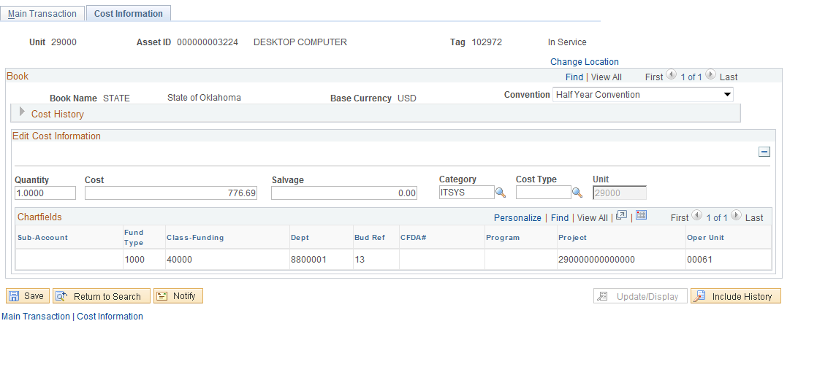

For a Recategorization transaction, the Cost Information page displays the Cost Row(s) for the Asset including the current Asset Category value.

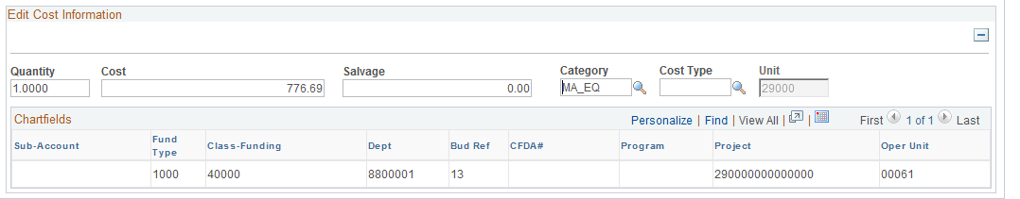

Category – change the Category field to the correct value. In this example, the Asset Category value was changed from OFFCE to COMP.

Click to Save your Recategorization.

Step 2: Review the Asset Recategorization
Navigation: Asset Management > Asset Transactions > History > Review Cost > Find an Existing Value

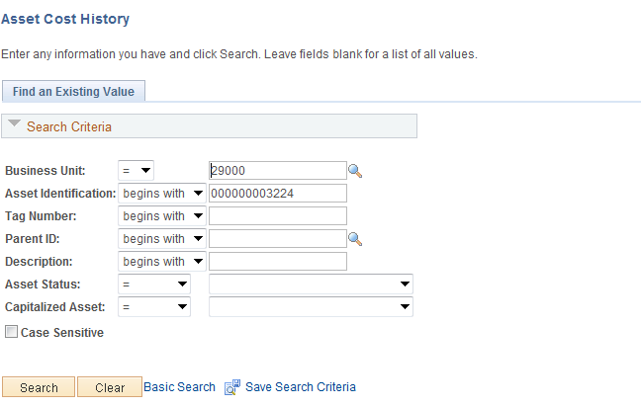

Business Unit – is the Agency in which the existing Asset is housed. This should default based on the User Preferences setup for the person reviewing the Asset.

Asset Identification, Tag Number, Parent ID, Description, Asset Status – use these fields as search criteria to find the Asset that will be reviewed.

Click to enter the Asset Cost History pages.

NOTE: Recategorizations are not updated in the Asset Basic Add page. Users will need to use Asset Management reports and queries to report on Asset Financial Information. The Asset Cost History provides detail about a specific asset or transaction.

Cost History List Tab
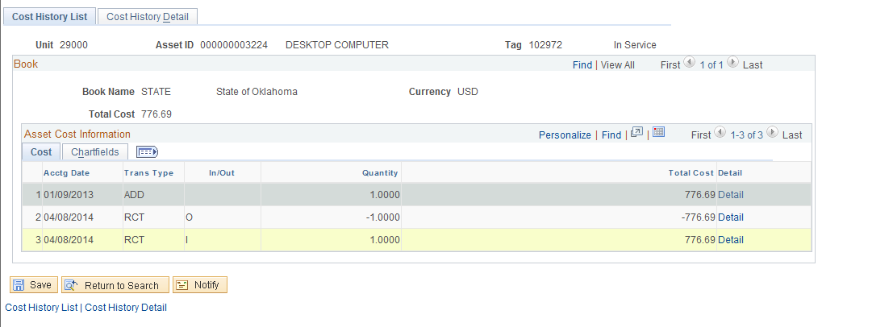

The Cost History Tab displays the history of all Cost changes made to an Asset. With a Recategorization, the system creates two transactions. The first represents the Recategorization out (In/Out column = ‘O’) of the old Asset Category value, the second represents the Recategorization in (In/Out column = ‘I’) to the new Asset Category value.

The Transaction Type will be equal to ‘RCT’ for Recategorization. The Quantity and Total Cost columns also reflect the “Out” and “In” rows for the transfer.

Click Cost History Detail Tab to display the Cost History Detail Tab or the Detail Link to access the specific transaction row on the Cost History Detail Tab.
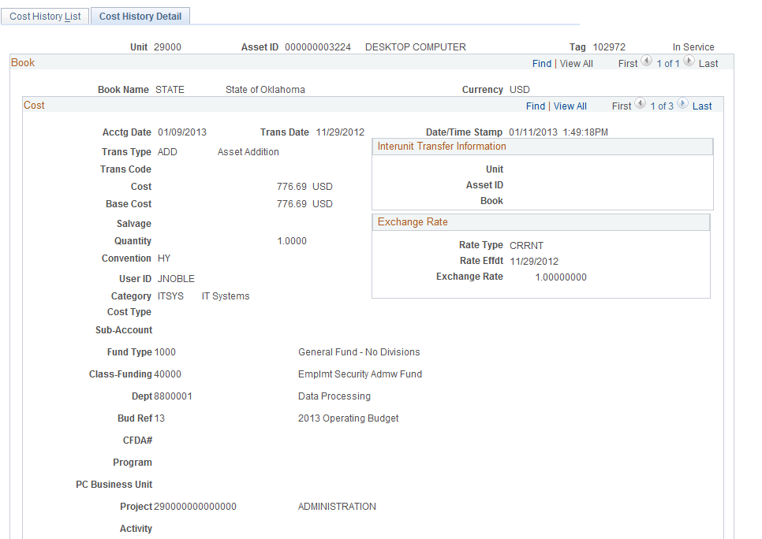

The Cost History Detail Tab shows the same Asset rows as are visible on the Cost History Tab, but with more details. The Transaction Type of ADD represents the original Addition of the Assets Cost.

NOTE: The row count - - indicates that multiple rows are available to view on this page. The page initially defaults to row 1 when selecting the Cost History Detail Tab. Row 1 will be the same row as is displayed at the top of the previous page. You will need to scroll through the rows to find the one applicable to your transaction.

Click to view the next row on the page.

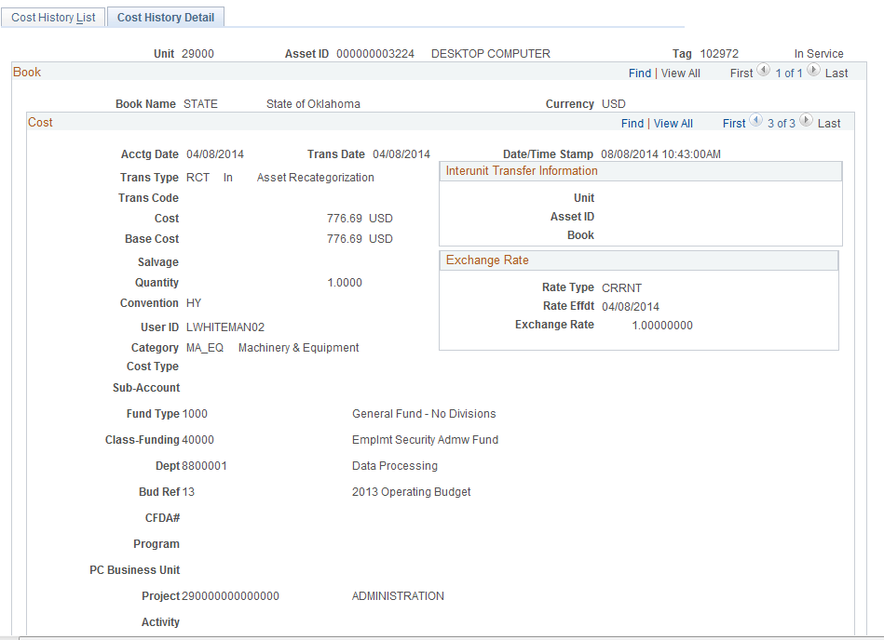

The Recategorization row on the page represents the change in the Assets Category. The Transaction Type indicates RCT (Recategorization) and the Cost reflects the transfer into the new Category value.

NOTE: More detailed Asset information is available on this page including Transaction Date of the Adjustment, User ID who completed the Adjustment, and Chartfield information.

Deleting Pending Asset Transactions

Step 1: Review Financial Detail Information
Navigation: Asset Management > Asset Transactions > Financial Transactions > Change/Delete Pending Trans

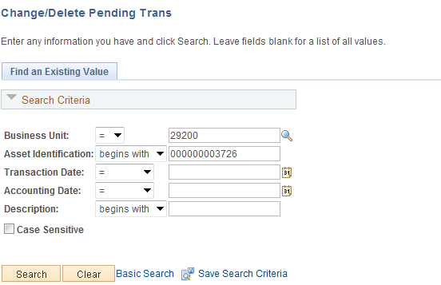

Business Unit – is the Agency in which the existing Asset is housed. This should default based on the User Preferences setup for the person reviewing the Asset.

Asset Identification, Transaction Date, Accounting Date, Description – use these fields as search criteria to find the Asset transaction that will be deleted.

Click to access the Pending Trans Update/Delete page.

NOTE: Adds, Adjustments, Transfers, and Recategorizations that are pending depreciation (Asset Capitalize status is Already Capitalized) can be deleted prior to running the depreciation calculation.

Retirement transactions, leased asset transactions, or parent/child asset transactions cannot be deleted in this screen.

Pending Trans Update/Delete Tab

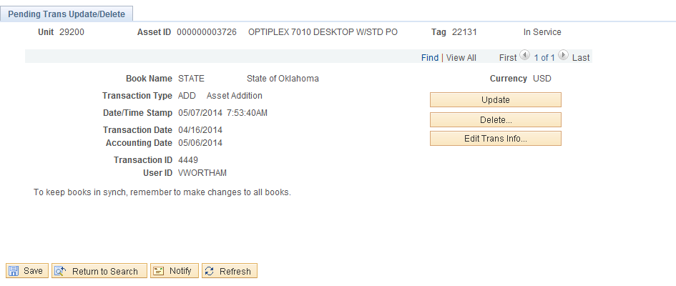

Review the information and the Transaction Type to ensure the intended transaction is the one that will be deleted.

Click to review the transaction information and the delete it.

Step 2: Delete Financial Transaction Pending Depreciation

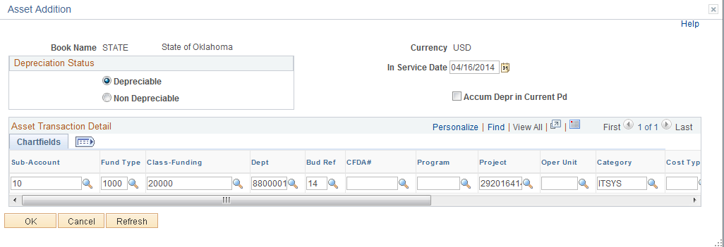

Review the detail transaction information. In this example, a recategorization was done to remove the Cost Type. Since this asset is less than $25,000, the Cost Type of “C” should not have been added. It is proper to delete this transaction

Click to return to the Pending Trans Update/Delete Tab and receive the following message.

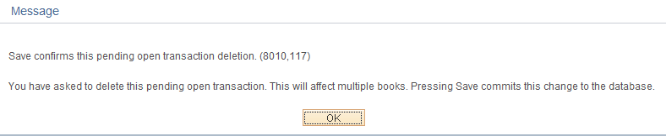

Click for the message.

Click to complete the deletion.

