COR417 Asset Management –

Month End Processes

Table of Contents
Document History 4
System Overview 5
Key Terms 6
Asset Groupings 9
Review Asset Book History 11
List Page 12
Detail Page 13
Review Asset Cost 14
Cost History Page 15
Cost History Detail Page 16
Asset Depreciation 17
Review Asset Open Transactions 17
Open Transaction Detail Page 19
Review Asset Depreciation 20
Asset Page 21
Depreciation Page 22
Period Deprecation Page 23
Review Asset Depreciation by Cost Type 24
Asset Page 25
Book Detail Page 26
Net Book Value Page 27
Depreciation Page 28
Review Asset Accounting Entries 30
Review Accounting Entries List Page 31
Review Accounting Entries List Page 32
Review Accounting Entries List Page Continued 33
Review Accounting Entries List Continued 34
Review Accounting Entries List Continued 35
Month End Processes 37
STEP 1 – Identify and Resolve Unloaded Pre-AM, Physical, and Financial Transactions 37
Run Queries to Identify Unloaded Transactions 37
Review AP/PO Interface Tables 39
Review Financial Tables 40
STEP 2 –Process Depreciation 41
Review Open Transactions 41
Run the Depreciation Calculation Process 42
Review the Depreciation Processing Results for Errors 44
Confirms Depreciation Calc Status is Complete 45
STEP 3 - Load Reporting Tables 46
The types of Asset Information stored in each table are: 46
Load Depreciation Reporting Table 46
Load Asset Net Book Value Reporting Table 48
Load Asset Net Book Value Reporting Table - Continued 49
STEP 4 - Run Asset Net Book Value Report/Query 50
Net Book Value Report Parameters Page 51
Net Book Value Report Parameters Page Continued 52
Asset Net Book Value Query Parameters 56
Analyzing Net Book Value Query Results 57
STEP 5 – Request and Review Accounting Entries 58
List Page 59
Detail Page 60
Detail Page Continued 61
Detail Page Continued 62
Accounting Entries recorded in the Ledgers 62
Accounting Entries – ADD Transaction 63
Accounting Entries – RETIRE Transaction 64
Accounting Entries – CAPITAL LEASE Purchase Transaction 65
Step 6 – Review Asset Journals 66
Asset Journals 67
Step 7 – Review Ledger Information 69
Ledger Inquiry 70
Ledger Summary 72
Asset Month/Year-End Checklist 73
Financial Reports 76
List of Reports and Queries 76

Authorized by: [_EBS_] Original Issue: [05/01/2014]
Maintained by: [____Asset Manager __]
Review Date: [05/01/2014 ]

Document History
Doc Rev | Date | Description
1.0 | 04/25/2011 | Initial Document
1.1  2.0 | 06/17/2013  05/01/2014 | Update for Accessibility  Upgrade Update

System Overview
Asset Management provides a central repository for Asset Maintenance including Depreciation, Accounting Entries, Search Capabilities, and related Reporting.

The first part of the manual describes the pages and functionality used to Inquire on Assets and their historical transactions.

The second part of the manual describes the processes that should be taken each month end to ensure the daily transactions within the month have been properly accounted for, depreciation is computed, and accounting entries are created.

Assets are created when assets are manually entered into the computer or interfaced from Purchasing and Accounts Payable transactions when assets are received and payments are made. The Asset Manager should be reviewing these transactions regularly and following the steps outlined in the COR412 – Integrating Asset Management with PO and AP manual to create and capitalize the assets timely. Problem transactions should also be resolved timely to facilitate month end processes.

This chapter explains the Month End Processes an agency Asset Manager should perform just prior to month end so that when the Office of Management and Enterprise Services runs the jobs used to create and journal generate the monthly Asset and Depreciation entries, assets are properly accounted for and recorded timely.

Key Terms
Accounting Date: Date on the Asset that will determine when the Asset transaction will be posted to the General Ledger.

Asset Category: Groups assets together by major asset type for financial reporting purposes. Categories are Land, Land Improvements, Buildings, Infrastructure, Machinery and Equipment, IT Systems, Artifacts and Treasures, Capital Lease – Buildings, Capital Lease – Equipment, and Operating Leases. Asset category is required and included in the Profile ID.

Asset Class: Defines assets within Asset Categories for internal reporting purposes. Asset Classes currently set up were provided by Department of Central Services for assets that are machinery and equipment in nature. Classes are optional in Asset Management and not included in the Profile ID; however, Department of Central Services does require the class be included on the DCS-FORM_SS_001A when an asset is sent to surplus.

Asset ID: Each Asset in the system has a unique Asset ID assigned automatically when the asset is added. The Asset ID is the key number used by the system to track each individual asset. Use this number to search for a particular asset in the system and view or make changes.

Asset Financial Information: An Assets Financial information includes cost, quantity, useful life, and ChartField values.

Asset Management Book: Asset Books store financial information about an asset including cost, depreciation rules, and retirement rules. The state will support only one book called ‘STATE’.

Asset Management Business Unit: Each agency has one Asset Management Business Unit. The Business Unit is the 3 digit agency code, plus 00. For example, Office of State Finance is 09000.

Asset Physical Information: An Assets Physical information includes tag number, location, custodian, serial number, and Manufacturer ID.

Asset Subtype: Groups assets within Asset Types at a more granular level for internal reporting purposes. Subtypes are optional in Asset Management and are not included in the Profile ID; however, Office of State Finance does require that subtypes be included for IT Assets.

Asset Type: Classifications to report assets within an asset category. Types are IT Hardware, IT Software, Equipment, Property, Fleet, Furniture, Facility, Intangibles, and Other. Asset type is required and included in the Profile ID.
CAFR Asset: A capital asset with a cost of $25,000 or more reportable on the Comprehensive Annual Financial Report (CAFR). The cost of individual assets acquired as part of of a group to be used together, but can be used as a separate asset, must individually meet the $25,000 capitalization policy even though they are connected to other components of the group. Asset grouping is limited to individual components that cannot be used without being connected to other components. Refer to GAAP Package H, Reportable Capital Assets, under Key Terms for specific guidelines.

Consolidate: The process of combining more than one Receiver or Voucher lines into one Asset.

Cost Type: A Cost Type is used to differentiate between CAFR and non-CAFR assets. The cost type, in conjunction with category and asset transaction, will record the accounting entries needed by the CAFR group.

Custodian: The person responsible for or assigned the asset. The custodian is generally an employee but can be someone other than an employee.

Depreciation Calculation: Depreciation must be run to account for every transaction performed on an Asset. Assets added in AM are eligible for depreciation when they are Capitalized, either by manually keying an Asset in AM or by loading a Voucher into AM. Other financial transaction performed on an Asset, such as Adjustment, Transfer, Retirement, Reinstatement, Re-categorization, and Book Adjustment (adjustment to depreciation life), require depreciation to be recalculated

IT Asset: Telecommunication voice response systems and electronic information technology applications, including but not limited to mainframe computers, minicomputers, or microcomputers, word processing equipment, office automation systems, Internet, eGovernment, broadband, WI-FI or wireless networking, radio, including the interoperable radio communications system for state agencies, or Global Positioning Systems (GPS). Refer to the categories and descriptions in the Information Technology and Telecommunications Annual Report Plan at: http://www.ok.gov/cio/Policy_and_Standards/ select the 2011 Annual Report.

Interface ID: An Interface ID is assigned to each group of Asset load lines that you move in a batch to the Interface table during the Interface process.

Interface Table: The table between the Pre-AM tables and the Asset Management tables. This is where unitization and consolidation takes place. This table holds Load Lines.

Load Lines: Load Lines are Receiver or AP Voucher lines, with Asset information, that are being interfaced from Purchasing and Accounts Payable respectively, but are not yet Assets.

Location: The address of where the asset is physically located. The code can be a building or a site, or it can be more specific and include a wing, floor, room, etc. The state requires a location code for each asset.
Pre AM Table: The first interface table used by the system when creating Assets from Receiver or AP Voucher information. This table holds Load Lines.

Profile ID: Profile ID is a “template” for the Asset that defaults values into the asset used for grouping and depreciation processing. This includes Asset Category, Asset Type, Useful Life, and Depreciation Method and Convention.

Serialize: The process of assigning Serial Numbers to multiple Items on one Receiver Line so that the system can separate each Item as a unique Asset.

Tag Number: All Assets in the Asset Management system can have a Tag Number that matches the physical tag on the asset.

Transaction Date: Date on the Asset that reflects the actual date the Asset transaction took place. In the case of a new Asset addition, this is the date the Asset was Acquired.

Unitize: The process of splitting one Receiver or Voucher line into multiple Assets.

Asset Groupings
Asset Category: (Required Field) Groups assets together by major asset type for financial reporting purposes.

Asset Profiles: (Required Field) A template containing default values for an Asset type. Default values include asset category, life (designated by the number in the profile ID), acquisition code, and asset type.

Asset Type: (Required Field and included in profiles) PeopleSoft delivered classification to report assets within an asset category. Types are IT Hardware (010), IT Software (020), Equipment (040), Property (050), Fleet (060), Furniture (080), Facility (090), Intangibles (100), and Other (999).

Useful Life: Estimated Useful Life of the Asset used in deprecation calculations.

Asset Category - Owned | Asset Profile | Asst Type | Useful Lives
ARTIF – Art and Artifacts | ART_ARTIF | Property | Non Depreciable
LAND - Land | LAND | Property | Non Depreciable
LAND - Land | ROW (Right of Way) | Property | Non Depreciable
LDIMP – Land Improvements | PROPERTYXX * | Property | 1, 5, 10, 15, 20, 25, 30, 40, 50
INFRA – Infrastructure | INFRASTRUCTURE30 | Property | 30
BLDG – Building | FACILITYXX | Facility | 1, 5, 10, 15, 20, 25, 30, 40, 50, 60
ITSYS – IT Systems | HARDWAREXX | IT Hardware | 1, 3, 5, 10, 20
ITSYS – IT Systems | SOFTWAREXX | IT Software | 1, 3, 5, 8
MA_EQ – Machinery & Equipment | EQUPXX | Equipment | 1, 4, 5, 6, 7,8, 10, 15, 20
MA_EQ – Machinery & Equipment | FLEETXX | Fleet | 1, 3, 4, 5, 6, 7, 8, 10, 12, 15, 20
MA_EQ – Machinery & Equipment | FURN_EQXX | Furniture | 1, 5, 7, 10, 12

* XX – represents multiple Useful Life values for a Profile ID.

Asset Category - Leased | Asset Profile | Asst Type | Useful Lives
LSBLD – Building Capital Lease | LEASE_BLDG | Facility | Life of Lease Determines
LSEQP – Equipment Capital Lease | LEASE_EQ | Equipment | Life of Lease Determines
LSEQP – Equipment Capital Lease | LEASE_HARD | IT Hardware | Life of Lease Determines
LSEQP – Equipment Capital Lease | LEASE_SOFT | IT Software | Life of Lease Determines
LSEQP – Equipment Non Capital Lease | LSOPR_EQ | Non Capital
LSEQP – Building Non Capital Lease | LSOPR_BLDG | Non Capital

Review Asset Book History
Navigation: Asset Management > Asset Transactions > History > Review Book

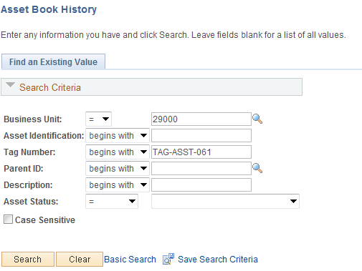

Business Unit - The Agency in which the existing Asset exists. This should default based on the User Preferences setup for the person reviewing the Asset.

Asset Identification, Tag Number, Parent ID, Description, Asset Status – Use these fields as search criteria to find the Asset that will be reviewed.

Click to enter the Asset Book History pages.

List Page

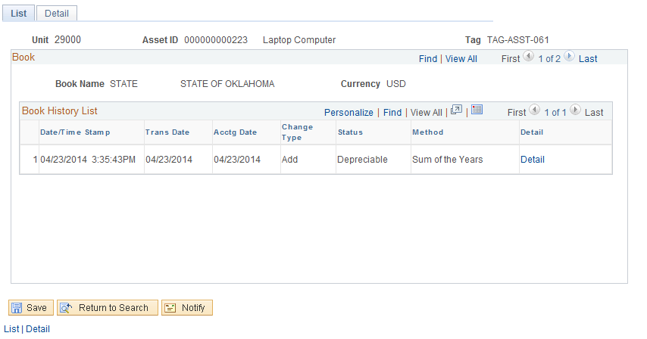

The List page shows the Assets Book history transactions. The details are displayed by Asset Book – ‘STATE’. These transaction details list Time of the Book transaction, Transaction and Accounting dates, Type of transaction, Status, and Method.

NOTE: This page can display multiple rows of Book transaction detail depending on what types of transactions have been executed on the Asset. These could include Additions, Adjustments, or Retirements.

Click the Detail tab to view Book transactions for the Asset.

Detail Page

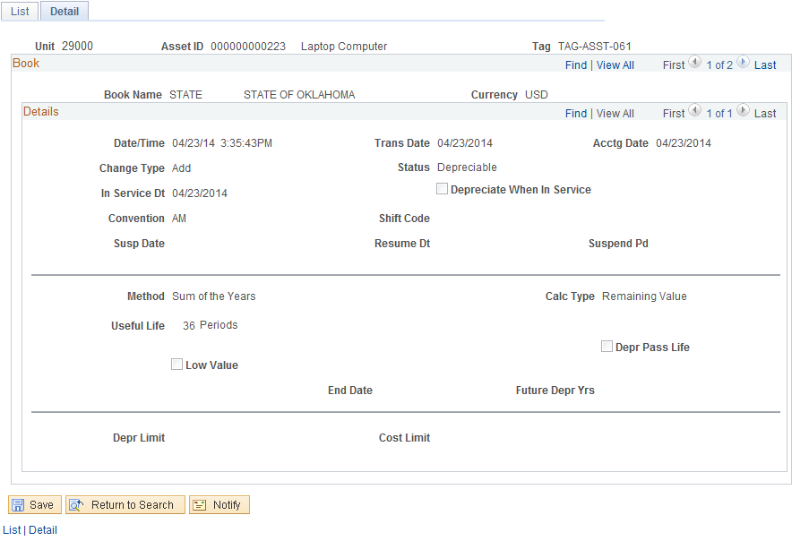

The Detail page displays the more detailed information for the Book transactions displayed on the List page. The depreciation properties for the Book transaction are available on this page..

In the Details section of the page, click to view the next row on the page. These rows will match the rows displayed on the List page..

Review Asset Cost
Navigation: Asset Management > Asset Transactions > History > Review Cost

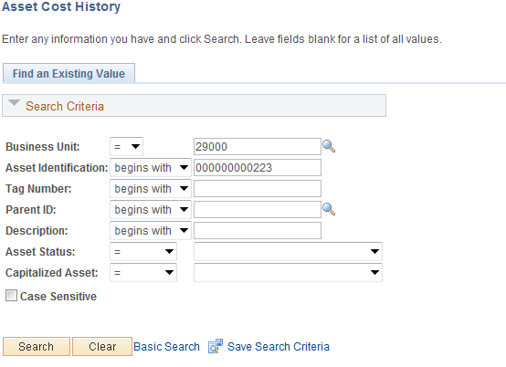

Business Unit - The Agency in which the existing Asset exists. This should default based on the User Preferences setup for the person reviewing the Asset.

Asset Identification, Tag Number, Parent ID, Description, Asset Status – Use these fields as search criteria to find the Asset that will be reviewed..

Click to enter the Asset Cost History pages.

Cost History Page

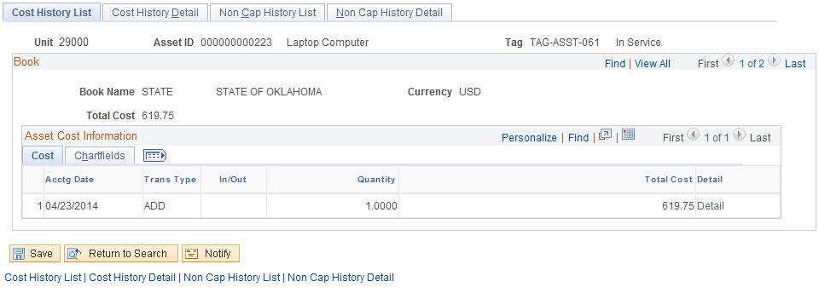

The Cost History page displays Asset Cost transactions by Book. The page displays Accounting Date, Transaction Type, Quantity, and Cost.

NOTE: This page can display multiple rows of Cost transaction detail depending on what types of transactions have been executed on the Asset. These could include Additions, Adjustments, or Retirements. The Transaction Type indicates the type of Cost transaction for the Asset. See the COR415-Adjustment and Transfers manual for specific examples.

Click the Cost History tab to display the Cost History Detail page

Cost History Detail Page

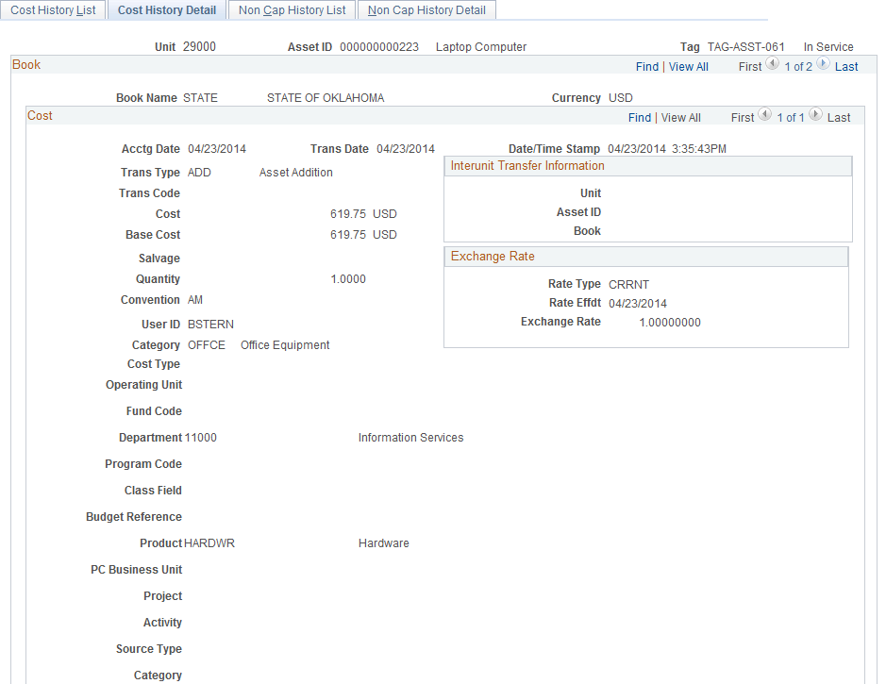

In the Cost section of the page, click to view the next row on the page.

The Cost section of the page shows the Transaction Type indicating the type of Cost Row.

Asset Depreciation
Transaction details for Assets created in the system are stored for review and reporting purposes. These transactions contain both Physical and Financial Information from the Asset purchase and payment.

When Assets are Added, Adjusted, Transferred, or Retired, the system creates an Open Transaction for the action taken on the Asset. Before the Asset is updated to reflect the action, the Open Transaction must be processed to completion for the appropriate tables to be updated and the Asset updated. Depreciation Calculation is the batch process that finalizes Open Transactions. Finally, Open Transactions can only be viewed before the system selects them for processing.

Reviewing Asset Depreciation activity can be useful for CAFR and Federal Assets. Depreciation activity is stored in the system for the entire depreciation schedule of the Asset. However, before the depreciation schedule is built and viewable in the system, the Open Transaction for the depreciation must be processed. The Asset Manager will be the one running this process monthly.

Review Asset Open Transactions
Navigation: Asset Management > Depreciation > Open Transactions > Review

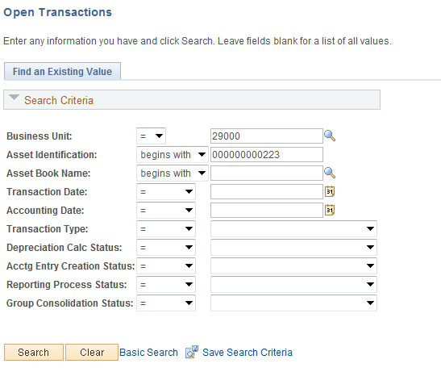

Business Unit – The agency in which the Open Trasaction is housed..
Asset Identfication – Asset for which the Open Transaction is created.

Asset Book Name – Book name for the Open Transaction. This will be the value of ‘STATE’.

Transaction Date, Accounting Date – Defines the Date for the Open Transaction.

Transaction Type – Identifies the type of Open Transaction.

Status – Indicators to view Open Transactions in a particular status.

Click to enter the Asset Open Transactions page.

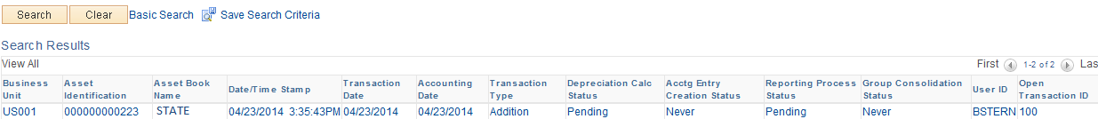

Open Transaction Detail Page

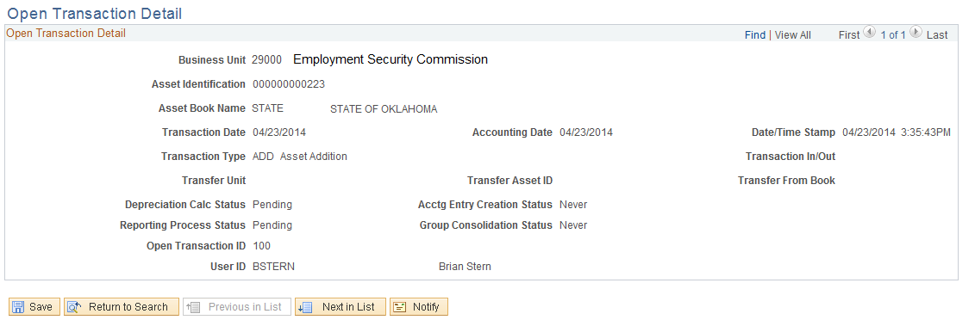

The Open Transaction Detail page displays information about the Asset transaction.

NOTE: Open Transactions are viewable only before they are processed to completion in the system. Once an Open Transaction is processed and the Asset updated, it is not available in this component. .

Transaction Type – Indicates the type of Open Transaction. Open Transactions are created whenever an Asset Financial Transaction is created. The more common transactions at the State are Asset Adds (ADD), Transfers (TRF), Retirements (RET), Adjustments (ADJ) and Recategorizations (RECAT).

Deprecation Calc Status – Indicates whether or not the Depreciation process has been run for this Open Transaction.

Accounting Entry Creation Status – Indicates whether or not the Accounting Entries have been created for Open Transaction.

Reporting Process Status – Indicates whether or not the Depreciation and Net Book Value Reporting Tables have been loaded (illustrated in Load Reporting Tables section.)

Open Transaction ID – Each Open Transaction has a unique, sequential number assigned to it.

User ID – User ID that executed the action on the Asset that created the Open Transaction.

Review Asset Depreciation
Navigation: Asset Management > Depreciation > Review Depreciation Info > Asset Depreciation

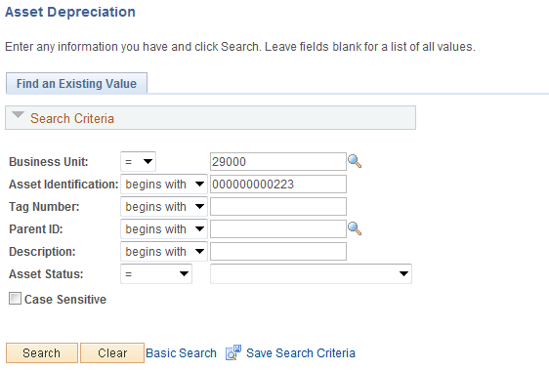

Business Unit - Agency in which the existing Asset exists. This should default based on the User Preferences setup for the person reviewing the Asset.

Asset Identification, Tag Number, Parent ID, Description, Asset Status – Use these fields as search criteria to find the Asset Depreciation that will be reviewed.

Click to enter the Asset Depreciation pages.

Asset Page

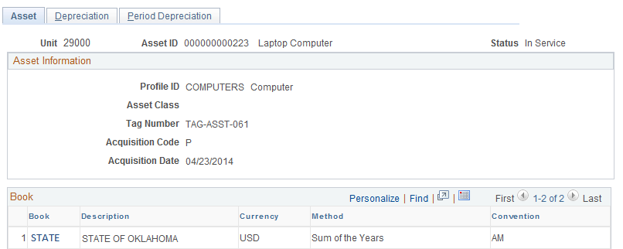

The Asset page displays Asset information like Tag Number, Asset Class, Acquisition Code, and Profile ID.

The Book section of the page displays depreciation rules for the Asset..

Click the Depreciation tab.

Depreciation Page

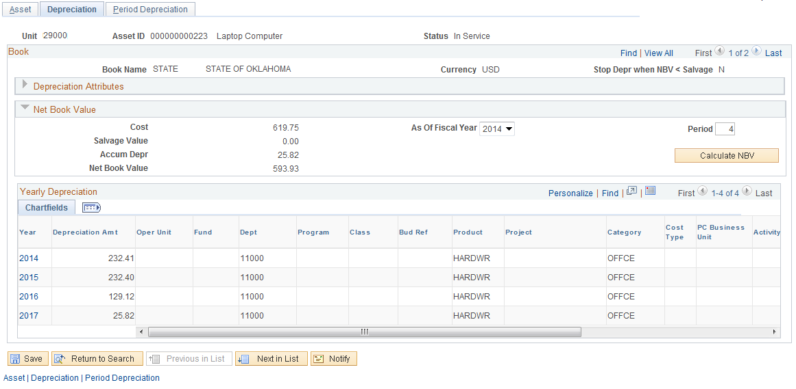

The Depreciation page displays depreciation schedule information for the Asset by Book.

Use the button in combination with the ‘As of Fiscal Year’ and ‘Period’ fields to calculate the Accumulated Depreciation and Net Book Value for the Asset in future periods.

The Yearly Depreciation section of the page displays the depreciation amounts by year and ChartField for the Asset.
.

Click the Period Depreciation tab.

Period Deprecation Page

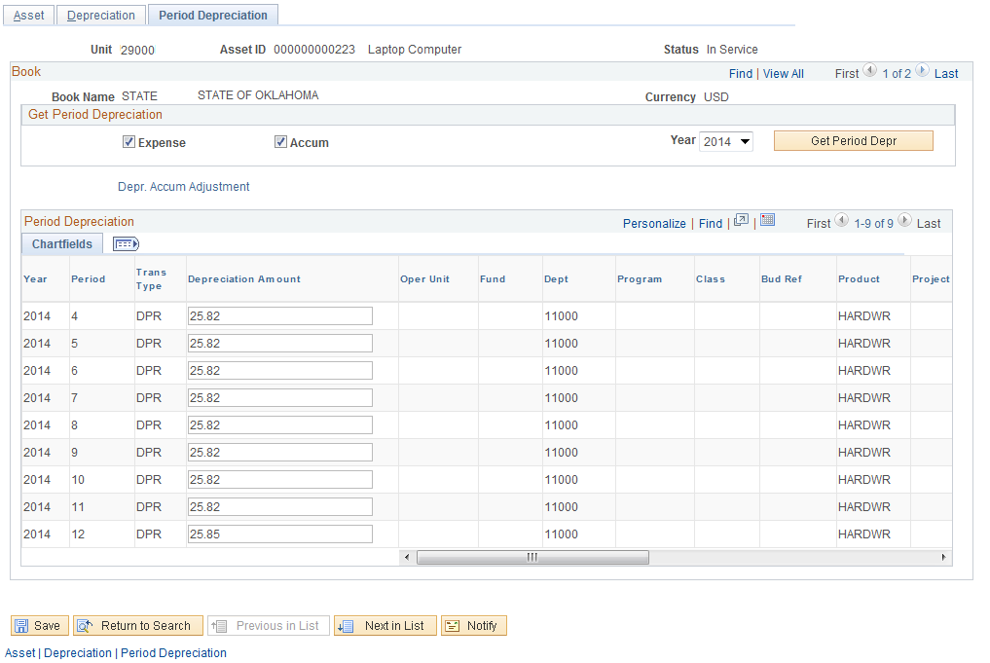

The Period Depreciation page displays the Asset depreciaiton schedule for the Asset by Period and ChartField combination.

Since the Get Period Depreciation section of the page and corresponding button are not accessible on this page, change the As of Fiscal Year field on the Depreciation page (see previous page) to retrieve Period depreciation (monthly) for a particular Fiscal Year.

Review Asset Depreciation by Cost Type
Navigation: Asset Management > Depreciation > Review Depreciation Info > Depr Summary by Cost Type

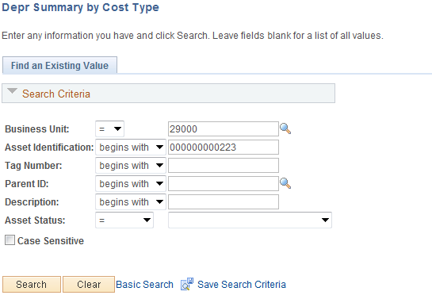

Business Unit - The Agency in which the existing Asset exists. This should default based on the User Preferences setup for the person reviewing the Asset

Asset Identification, Tag Number, Parent ID, Description, Asset Status – Use these fields as search criteria to find the Asset Depreciation that will be reviewed.

Click to enter the Depreciation Summary by Cost pages.

Asset Page

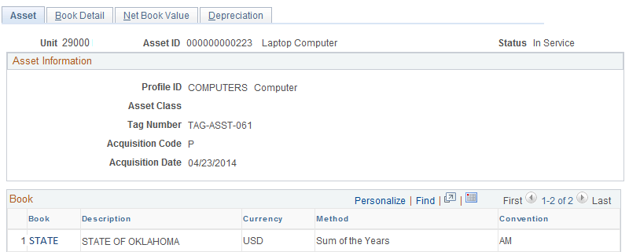

The Asset Detail page shows some Physical information about the Asset including Profile ID, Asset Class, Tag Number, Acquisition Code, and Date..

Click STATE hyperlink to access the Net Book Value page and calculate the NBV for the asset..

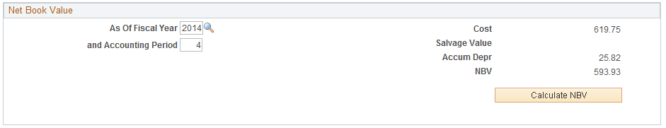

Use the button, plus the As of Fiscal Year field and Accounting Period to dynamically calculate the Net Book Value of the Asset. This is useful for Federal and CAFR Assets.

Click the Book Detail tab.

Book Detail Page

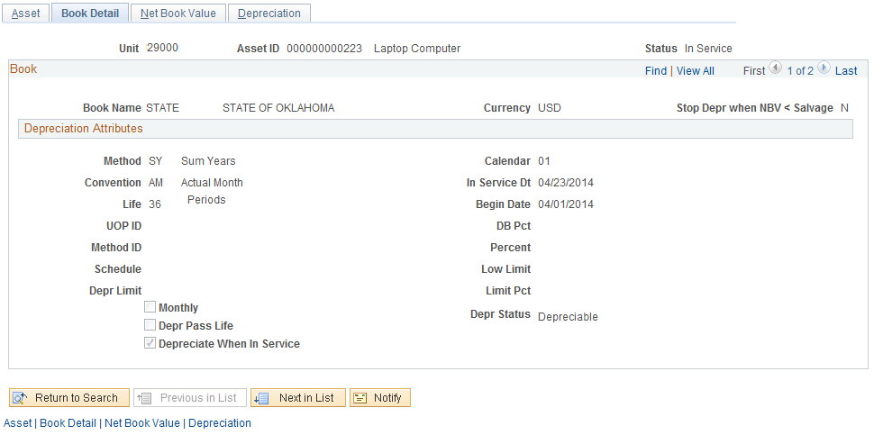

The Book Detail page displays Book depreciation rules for the Asset.

In Service Date – this field usually defines the receipt date for the Asset.

Begin Date – this field is the depreciation ‘Begin’ date for the Asset..

Click the Net Book Value tab.

Net Book Value Page

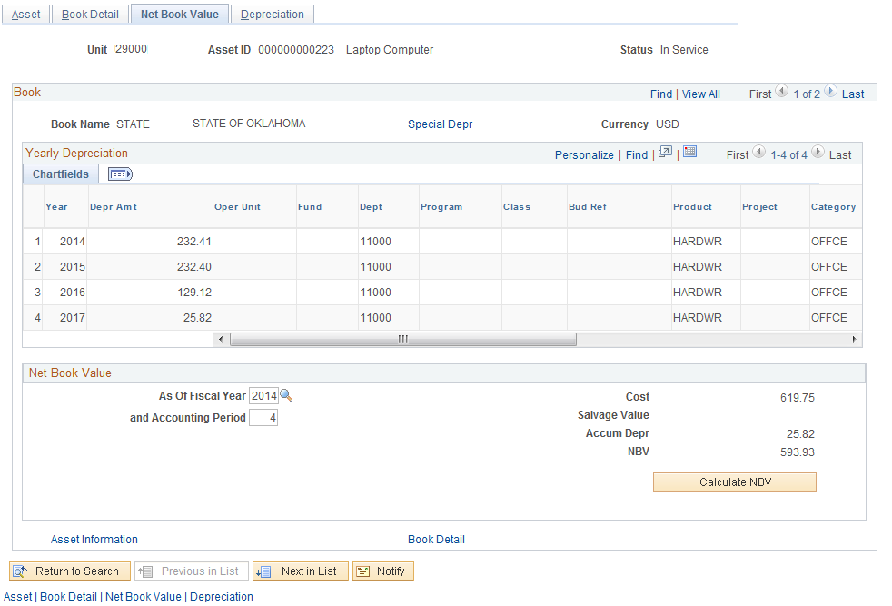

The Net Book Value page displays the depreciation schedule for the Asset by Year and ChartField combination. The Asset Category value is also displayed.

NOTE: You may need to use the Customize hyperlink to make all the ChartField values and Asset Category visible.

Use the button, plus the As of Fiscal Year field and Accounting Period, to dynamically calculate the Net Book Value of the Asset. This is useful for Federal and CAFR Assets.

Click the Depreciaion tab.

Depreciation Page

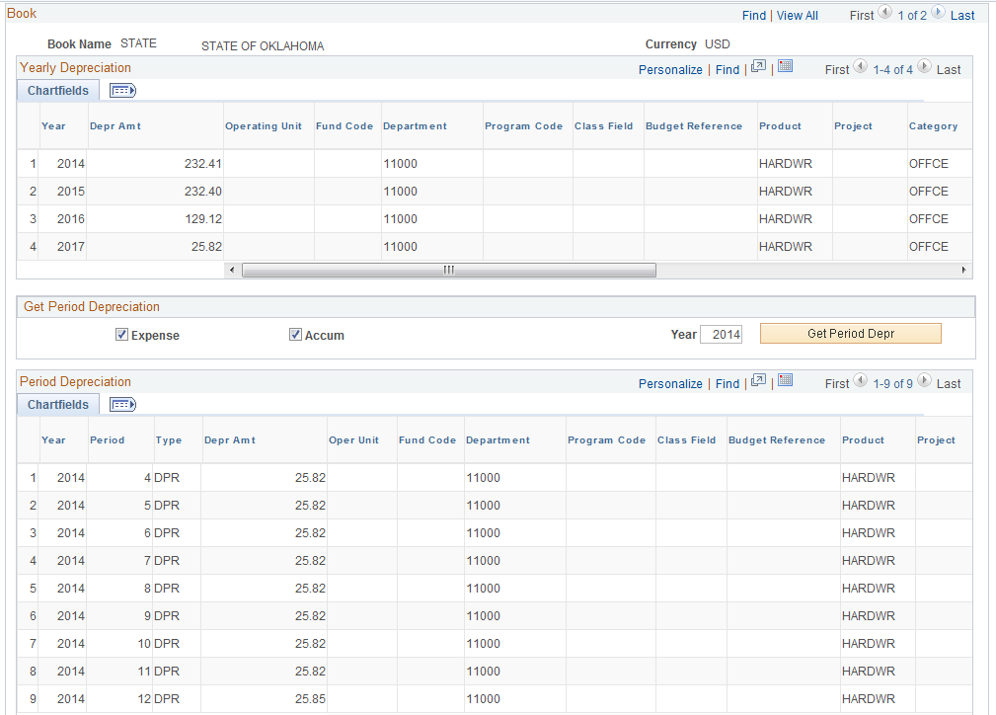

The Depreciation page displays the depreciation schedule for the Asset by Year and Period (month) with full ChartField values.

NOTE: You may need to use the Customize hyperlink to make all the ChartField values and Asset Category visible.
.

Use the Get Period Depreciation section of the page to change the depreciation schedule and display another Year.

When the year is changed, the depreciation schedule will change and reflect the new year.

Review Asset Accounting Entries
Navigation: Asset Management > Accounting Entries > Review Financial Entries

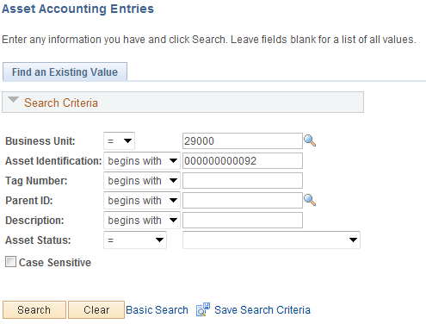

Business Unit - The Agency in which the existing Asset exists. This should default based on the User Preferences setup for the person reviewing the Asset

Asset Identification, Tag Number, Parent ID, Description, Asset Status – Use these fields as search criteria to find the Asset Depreciation that will be reviewed -

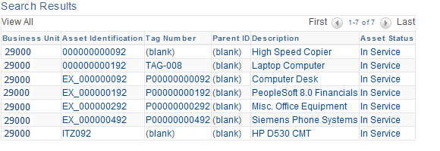

Review Accounting Entries List Page

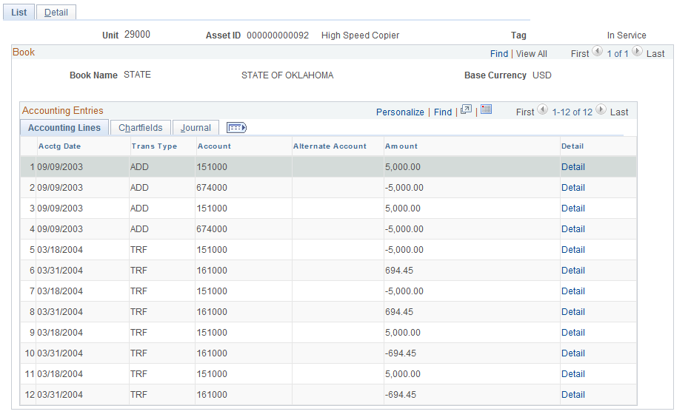

The Accounting Lines Tab displays information about the Accouning Entries, it show the Accounting Date, Transaction Type, Account, Suby Account and Chartfield Information.

Transaction Type – Indicates the type of Open Transaction. Open Transactions are created whenever an Asset Financial Transaction is created. The more common transactions at the State are Asset Adds (ADD), Transfers (TRF), Retirements (RET), Adjustments (ADJ) and Recategorizations (RECAT).

Review Accounting Entries List Page

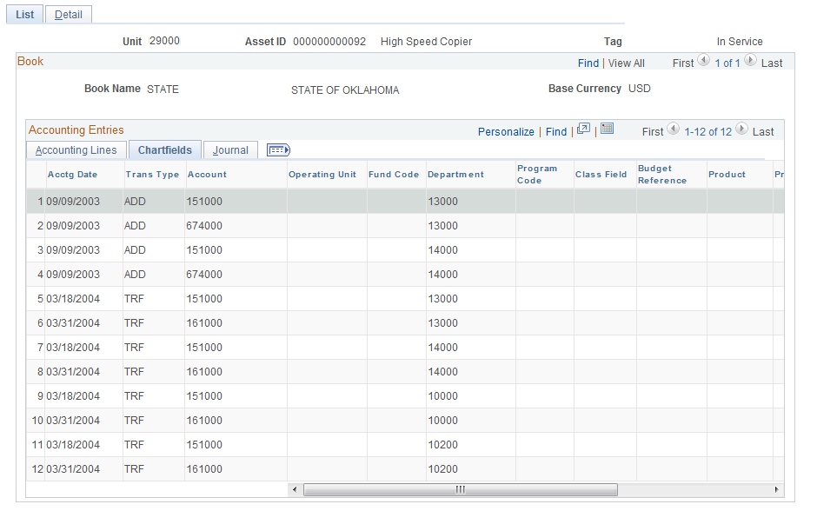

The Chartfields Tab displays information about the Chartfiled Information, it show the Accounting Date, Transaction Type, Account,.

Transaction Type – Indicates the type of Open Transaction. Open Transactions are created whenever an Asset Financial Transaction is created. The more common transactions at the State are Asset Adds (ADD), Transfers (TRF), Retirements (RET), Adjustments (ADJ) and Recategorizations (RECAT

Review Accounting Entries List Page Continued

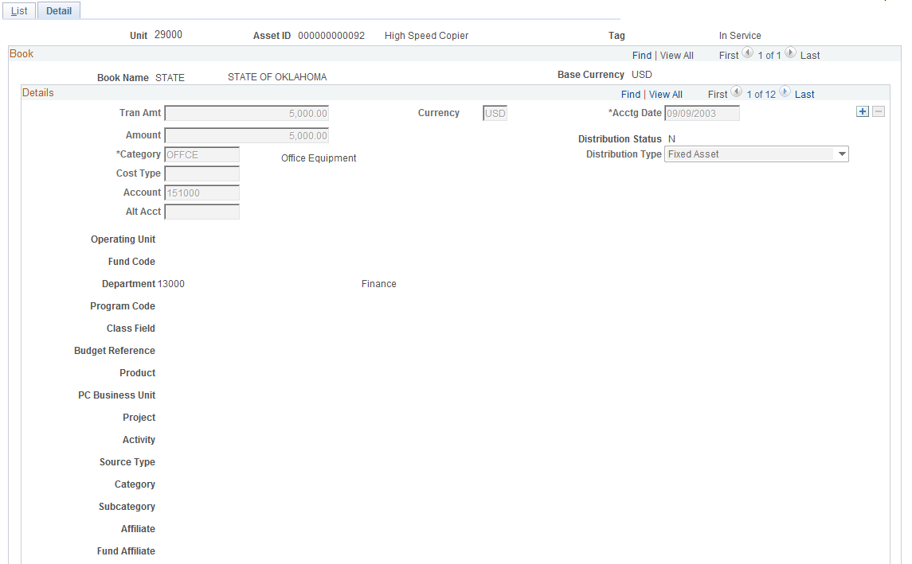

The Detail Link opens up the page and displays the information in detail.

Click on View All to see all the detail panels.

Review Accounting Entries List Continued

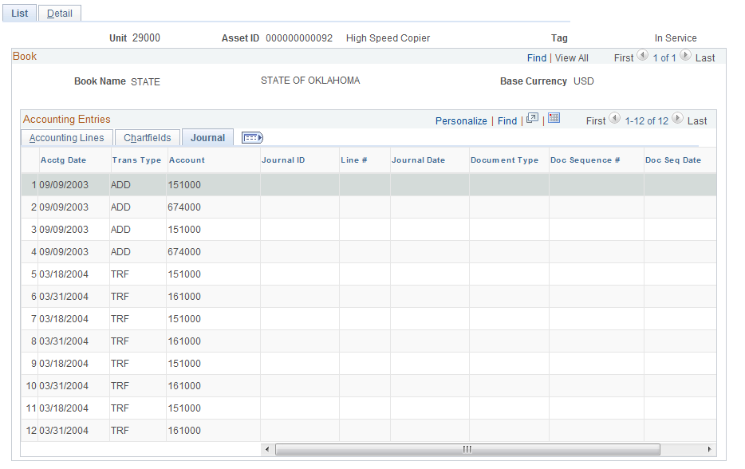

The Journal Tab displays information about the Journals, it show the Accounting Date, Transaction Type, Account,Journal ID and Journal Date.

Transaction Type – Indicates the type of Open Transaction. Open Transactions are created whenever an Asset Financial Transaction is created. The more common transactions at the State are Asset Adds (ADD), Transfers (TRF), Retirements (RET), Adjustments (ADJ) and Recategorizations (RECAT

Review Accounting Entries List Continued

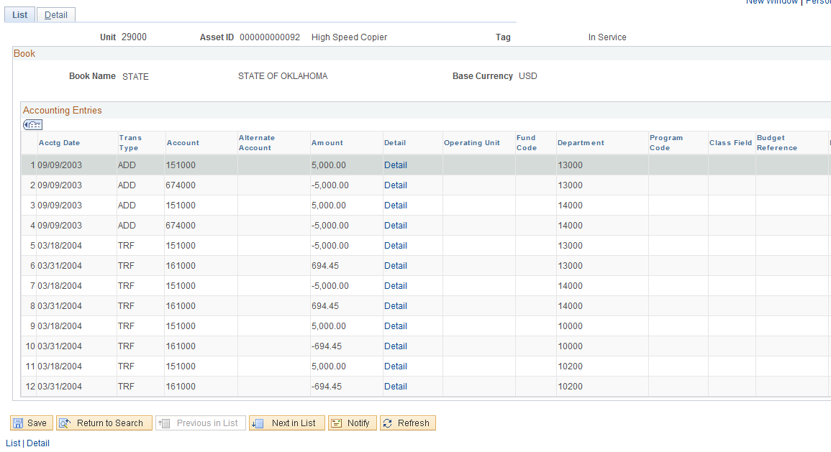

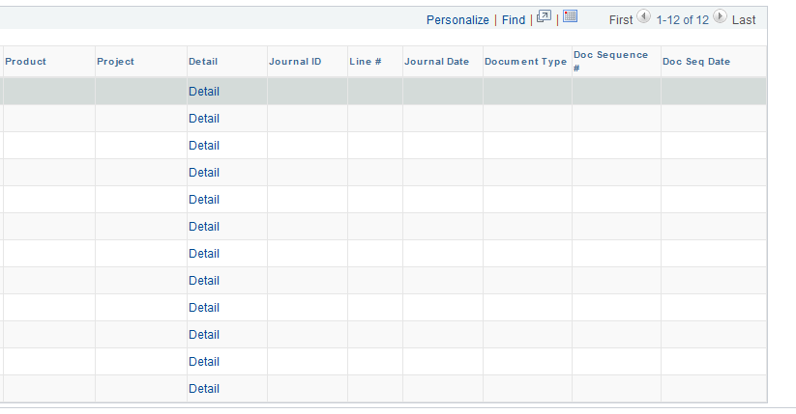

Click on the link to open up additional information.

The page displays information about the chartfields, it show the Accounting Date, Transaction Type, Account,and chartfield infomartion.

Transaction Type – Indicates the type of Open Transaction. Open Transactions are created whenever an Asset Financial Transaction is created. The more common transactions at the State are Asset Adds (ADD), Transfers (TRF), Retirements (RET), Adjustments (ADJ) and Recategorizations (RECAT

Month End Processes
Assets are created when assets are manually entered into the computer or interfaced from Purchasing and Accounts Payable transactions when assets are received and payments are made. The Asset Manager should be reviewing these transactions regularly and following the steps outlined in the COR412 – Integrating Asset Management with PO and AP manual to create and capitalize the assets timely. Problem transactions should also be resolved timely to facilitate month end processes.

This chapter explains the Month End Processes an agency Asset Manager should perform just prior to month end so that when the Office of Management and Enterprise Services runs the jobs used to create and journal generate the monthly Asset and Depreciation entries, assets are properly accounted for and recorded timely.

STEP 1 – Identify and Resolve Unloaded Pre-AM, Physical, and Financial Transactions

Run Queries to Identify Unloaded Transactions

Run the following queries to identify transactions that need to be reviewed and processed prior to month end.
- OCP_AM_RCVR_NOT_PUSHED_TO_AM – Identifies asset-related receivers not pushed to Asset Management. A request should be made to the purchasing department to check the Interface Receipt box on the Receipt identified on the query and resave if it needs to be moved to AM.
- OCP_AM_PHY_A_RCPTS_TO_REVIEW – Designed to help review, document, and track the AM Interface Physical Load Lines as Assets are received. Approve transactions that should create an Asset ID after reviewing Quantity, Amount, Profile ID, and other physical information. Quantities > 1 should be unitized and quantities < 1 should be consolidated first. The new load line(s) should be approved. Research transactions in Error or In Process Status.
- OCP_AM_PRE_AM_VCHRS_NEXT_ID – Displays vouchers without an Asset ID in the Pre-AM Interface Table and the corresponding information in the Physical Interface Table for the Receipt on the voucher. Vouchers with associated Receipts that have already been completely loaded to Asset Management can be retrieved from AP to the AM Interface Tables.
- OCP_AM_PRE_AM_NEW_ERR_INP – After retrieving vouchers with corresponding asset ID(s) identified in the prior query, run this query to identify:
- Pending transactions without corresponding Physical Information in the AM Interface tables
- Transactions in an Error or In Process status
- Vouchers with an Asset ID used to add a cost row to the existing Asset ID
- P-Card Vouchers

Research vouchers without a Receipt or Asset ID to determine why the Physical Information was not entered into Asset Management through the Receipt. Retrieve voucher only if an Asset should be created. Research the transactions in Error or In Process Status.

Access Pre-AM and Interface Tables for Pending, Error, or In Process Transactions Identified in Queries

Once the queries identify the transactions in Pending, Error, or an In Process Status, access the following screens to research or resolve them. Only the Asset Manager has access to these screens

Navigation: Asset Management > Send/Receive Information > Approve Physical Information > Review A > Find an Existing Value

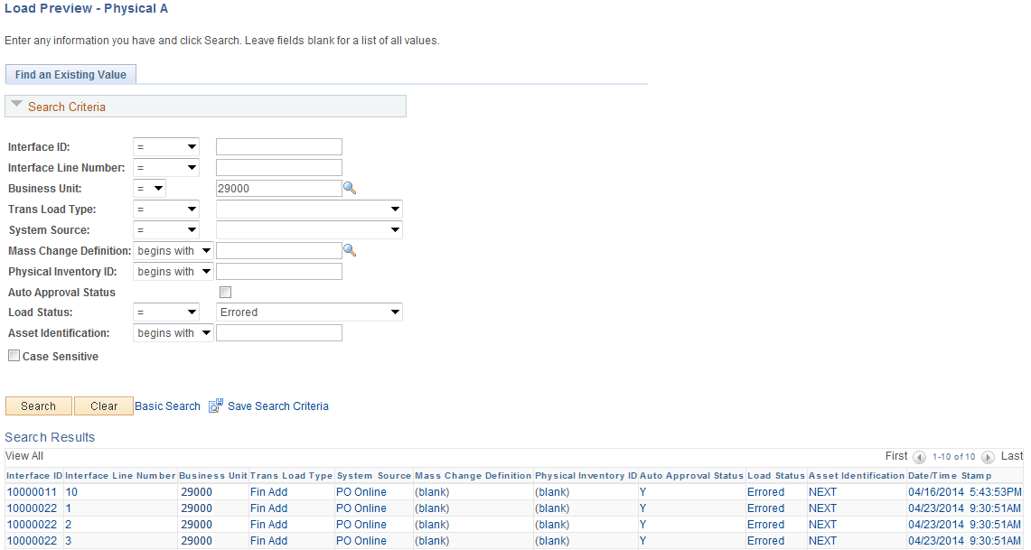

Business Unit - The Agency in which the existing Asset exists. This should default based on the User Preferences setup for the person reviewing the Asset

Interface ID, Trans Load Type,Load Status, Asset Identification – Use these fields as search criteria to find the Asset Depreciation that will be reviewed

Enter the Business Unit and Interface ID, or search for items where the Load Status does not equal
Loaded or is equal to Pending, Error, and In Process. Review the transaction in Pending, Error, or In Process Load Status.

NOTE: Transactions that are in Error Status in the Physical A Table usually have a duplicate Tag number or the AM Accounting Date is not open. Submit a helpdesk case so the tag ID can be corrected or the AM dates can be opened. If the error occurs after the voucher has been retrieved, the Load Preview – Financial Page, illustrated on page after the next one, includes the Error message..

Review AP/PO Interface Tables

Navigation: Asset Management > Send/Receive Information > Preview AP/PO Information > Find an Existing Value

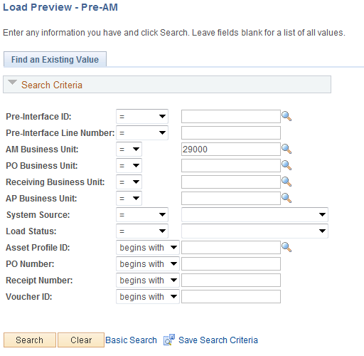

Enter the Business Unit and Interface ID, or search for items where the Load Status does not equal Loaded or is equal to Pending, Error and In Process. Review the transaction in Pending, Error, or In Process Load Status.

NOTE: Transactions that are in Error Status in the Pre-AM Interface Table usually have another transaction on the same PO Line and Distribution Line in the Physical Interface Table. The Physical A Table transaction must be loaded first in order to resolve the Error.

Review Financial Tables
Navigation: Asset Management > Send/Receive Information > Approve Financial Information > Review > Find an Existing Value

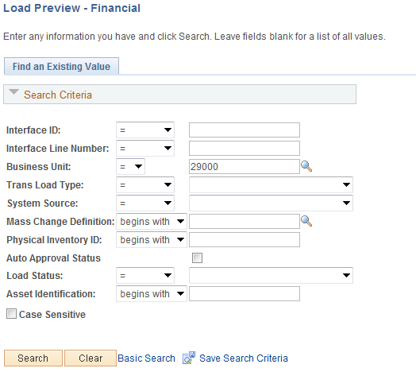

Enter the Business Unit and Interface ID, or search for items where the Load Status does not equal Loaded or is equal to Pending, Error and In Process. Review the transaction in Pending, Error or In Process Load Status

NOTE: Transactions that are in Error Status in the Physical A Table usually have a duplicate Tag number or the AM Accounting Date is not open. Submit a helpdesk case so the tag ID can be corrected or the dates can be opened. The page has an Error Message field.

NOTE: Transactions that are In Process on the Pre-AM or Interface Tables occurred because some process did not complete for the Pre-AM Interface ID or Interface ID. Submit a helpdesk case so OMES can research the problem.

STEP 2 –Process Depreciation
The Depreciation Calculation (Depr Calc) must be run to account for every transaction performed on an Asset. Assets added in AM are eligible for depreciation when they are Capitalized, either by manually keying an Asset in AM or by loading a Voucher into AM. Other financial transaction performed on an Asset, such as Adjustment, Transfer, Retirement, Reinstatement, Recategorization, and Book Adjustment (adjustment to depreciation life), require depreciation to be recalculated. The system creates an Open Transaction for each of these actions.

Review Open Transactions
Navigation: Asset Management > Depreciation > Open Transaction > Review > Find an Existing Value

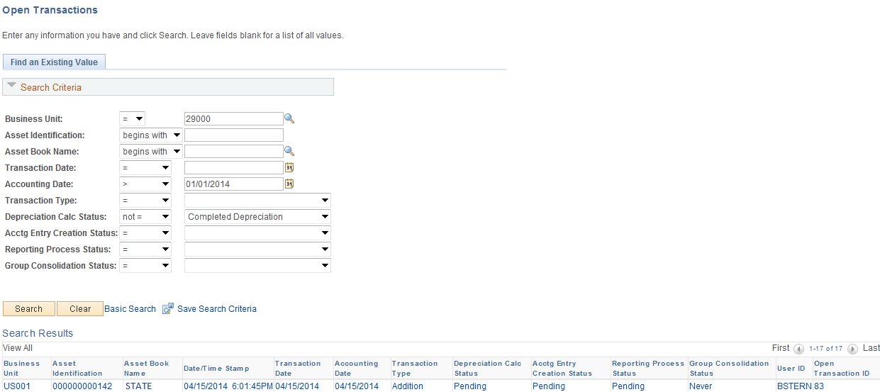

Enter the Business Unit and search for Open Transaction where the Depreciation Calc Status does not equal Completed Depreciation. Make note of the beginning and ending Asset ID.

NOTE: The Review Open Transaction page displays only the first 300 transactions. The query, OCP_ASSET_OPEN_TRANS_ROWS, can also be run to identify Open Transactions

NOTE: Once depreciation calculation has been run an Open Transaction, the asset cannot be deleted.

Run the Depreciation Calculation Process
Navigation: Asset Management > Depreciation > Processing > Calculate

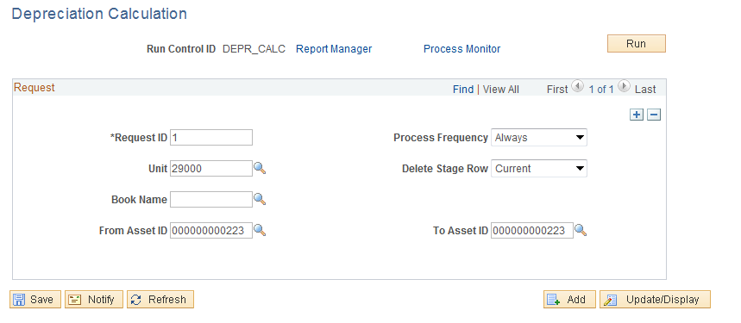

Request ID – Enter 1 since only one request at a time will be run

Process Frequency – Change to Always

Delete Stage Row – Default is Current. Do not change.

Unit – Enter the Agency Business Unit

Book Name – Populate with the STATE book

From Asset ID/To Asset ID – Populate to run Depreciation for the range the Assets identified from searching the Open Transactions

Click to execute the job. Run on the PSUNX server or leave Server Name field blank.

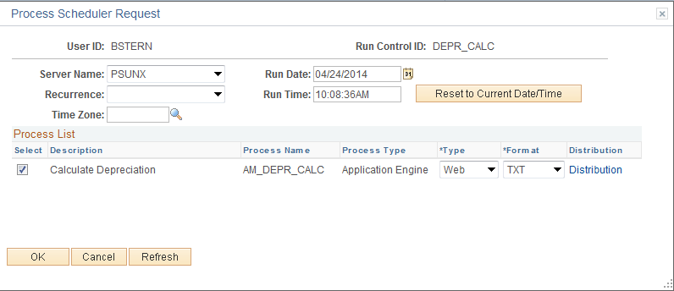

NOTE: Note the Process Instance Number of the AMDPCALC job for the next step..

Review the Depreciation Processing Results for Errors
Navigation: Asset Management > Depreciation > Depreciation Process Log

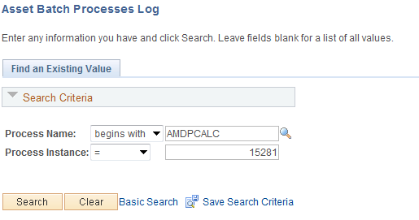

Process Name – Enter or select AMDPCALC.

Process Instance – Enter or search for the Process Instance number of the AMDPCALC job.

Click to display the Asset Process Error Log.

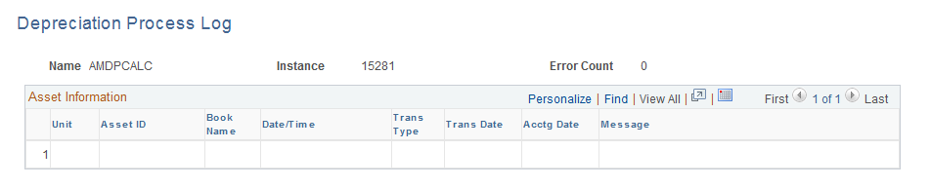

Confirm Error Count is zero. Submit a helpdesk case if one or more errors are listed.

Confirm Depreciation Calc Status is Complete
Navigation: Asset Management > Depreciation > Open Transaction > Review > Find an Existing Value

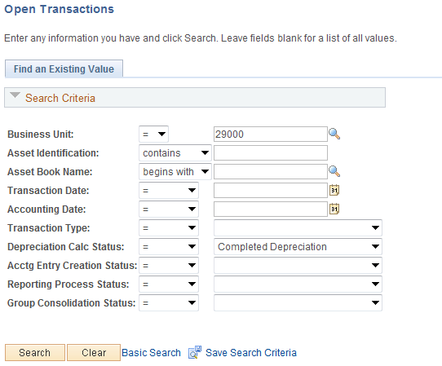

Enter the Business Unit and search for Open Transaction where the Depreciation Calc Status does not equal Completed Depreciation. If depreciation was computed on all Open Transactions, the search should return the message, “No matching values were found.”

NOTE: The query, OCP_ASSET_OPEN_TRANS_ROWS, can also be run to confirm there are no Open Transactions to depreciate.

STEP 3 - Load Reporting Tables
Before reports with Depreciation and Net Book Value can be run, Reporting Tables must be populated with Asset Information that the reports use to display desired results. A separate process is executed for the different Reporting Tables to populate depreciation and cost information that delivered reports use to produce results.

The types of Asset Information stored in each table are:

Depreciation Reporting Table (DEPR_RPT) – stores Depreciation information for an Asset by Year and Period with ChartField detail. The data includes period depreciation, year-to-date depreciation, and life-to-date depreciation.

Net Book Value Reporting Table (ASSET_NBV_TBL) – stores Cost, Depreciation and Net Book Value information for an Asset with ChartField detail. The data also includes Asset Location, Description, and Category.

Load Depreciation Reporting Table
Navigation: Asset Management > Financial Reports > Load Reporting Tables > Depr Reporting Table

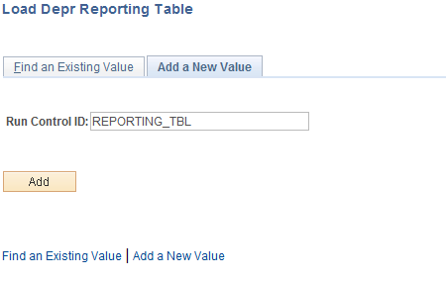

Run Control ID – populate with a new or existing Run Control ID. Use this same Run Control ID to load the Net Book Value table and to run the OCP_AM_ASSET_NET_BOOK_VALUE query.

NOTE: Run the load processes once at the beginning of the year for all assets, and on a monthly or regular basis thereafter for new open transactions.

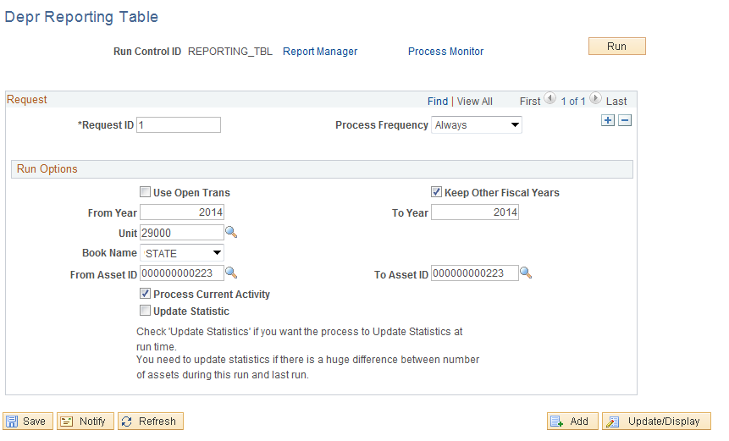

Request ID – Enter 1 since only one request at a time will be run

Process Frequency – Change to Always

Use Open Trans – Select to execute the load process on only those depreciation transactions that are new from the last time the process was executed to pull new Asset activity into the Reporting Tables

Keep Other Fiscal Years – Select to run the load for a new Fiscal Year, but keep the old Fiscal Years that are already in the Reporting Table. Load only the current Fiscal Year or at most two Fiscal Years to improve system performance. This process can select many rows of Asset Information and can take an extended period of time to complete.

From/To Year – Populate with From and Thru values to populate the table with Asset depreciation transactions within this time frame when “Keep Other Fiscal Years” checkbox is selected

Unit – Enter the Agency Business Unit

Book – Populate with the STATE book

From/To Asset ID – Populate to load the Reporting Table with information for a range of Assets

Process Current Activity – Select to load current activity from the system

Click to execute the Load Process. Run on the PSUNX server or leave Server Name field blank.

Load Asset Net Book Value Reporting Table
Navigation: Asset Management >Financial Reports > Load Reporting Tables > Net Book Value Table

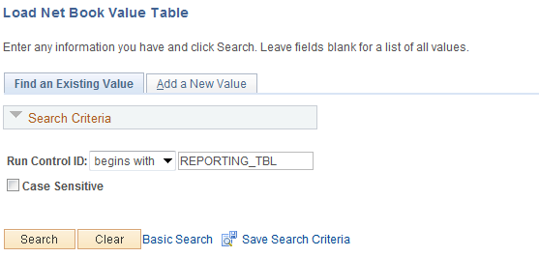

Run Control ID – populate with the Run Control ID used to Load the Depreciation Reporting Table

Load Asset Net Book Value Reporting Table - Continued

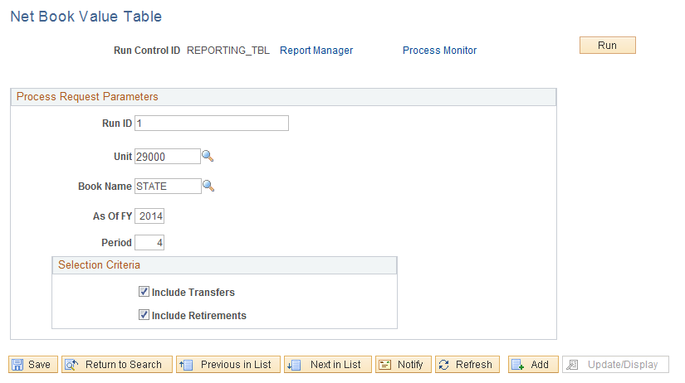

Run ID – Enter 1 since only one request at a time will be run

Business Unit – Enter the Agency Business Unit.

Book Name – Populate with the STATE book.

As Of Fiscal Year and Period – Populate with the Fiscal Year and Period through which the load process will be run.

Include Transfers – Select to load Transfer activity.

Include Retirements – Select to load Retirement activity.

Click to execute the Report. Run on the PSUNX server or leave Server Name field blank.

NOTE: Once the Net Book Value Reporting Table has been populated, there are multiple Crystal Reports that can be run against that data.

STEP 4 - Run Asset Net Book Value Report/Query
Run the Asset Net Book Value Report or Query and review the assets listed and their associated costs, accumulated depreciation, and net book value for completeness and accuracy.

Navigation: Asset Management > Financial Reports > Cost and Depreciation > Asset Net Book Value

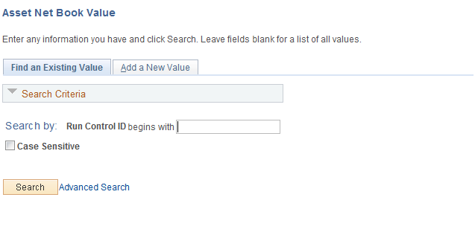

Run Control ID – populate with Run Control ID used to Load the Net Book Value Reporting Table

Net Book Value Report Parameters Page

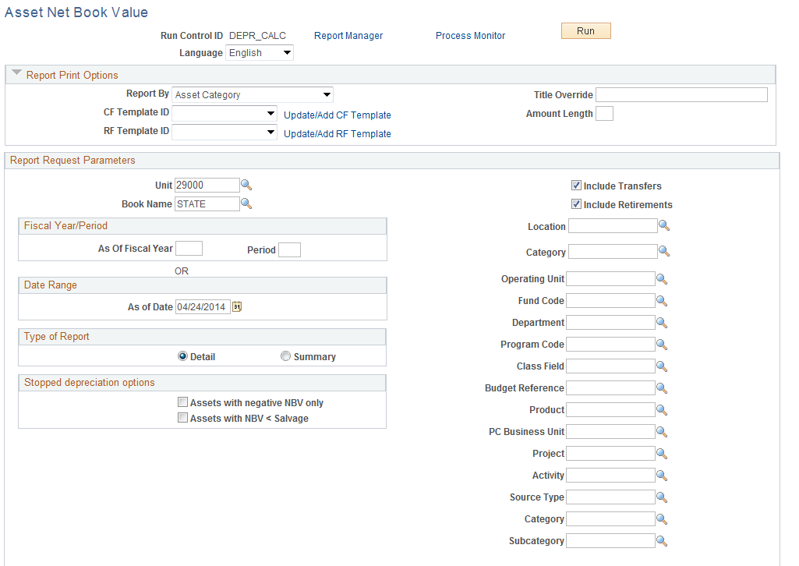

The “Net Book Value” reports will produce a list of Assets with depreciation and net book value information. Populate the Parameters page with the desired values.

Expand the Report Print Options section of the page. For this report, a Template ID that indicates which Asset fields to include on the report is required

Expand the Report Print Options section of the page. For this report, a Template ID that indicates which Asset fields to include on the report is required.

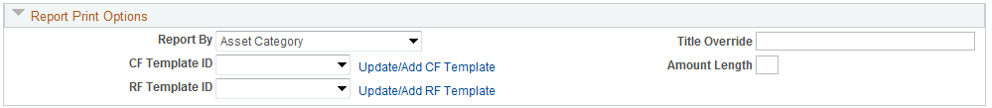

Select the Update/Add CF Template link.

NOTE: If you have previously created a Template for this report a new Template is not required. Simply select the Template that you used previously.

Net Book Value Report Parameters Page Continued

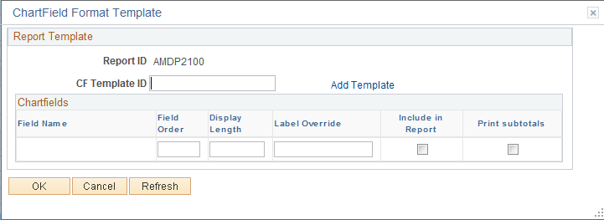

Populate the Template Id field with a name for the Template.

Click the Add Template hyperlink.

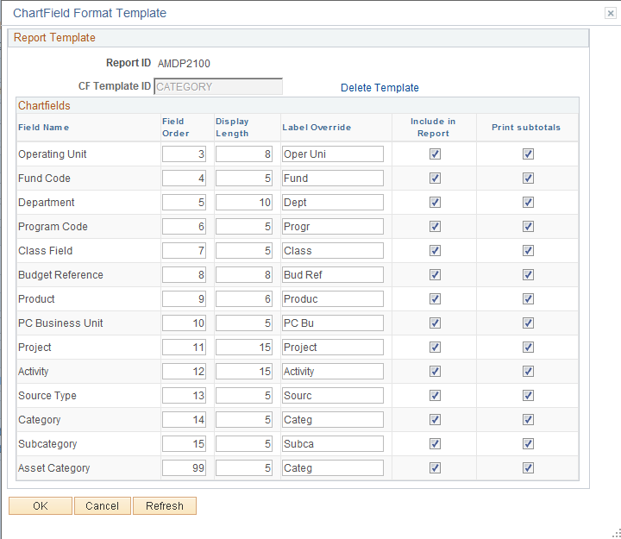

The Chartfield Report Format Template page allows you to define which ChartFields (plus Asset Category) will be included in the results of the report.

Field Order – select the order in which the available fields will be displayed on the Report.

Label Override – to change the column label for a field populate an alternative label.

Include in Report – select each field that you would like to be displayed on the Report.

NOTE: For reports that have been customized in the system (see List of Reports and Queries in this section of the manual), all field values on the Template MUST BE selected..

Print Subtotals – select each field for which you would like a subtotal. The subtotals will be displayed on the Report by field.

Select to complete the template.

There is a new Report Fields Format Template option as well.

Select the Update/Add CF Template link.

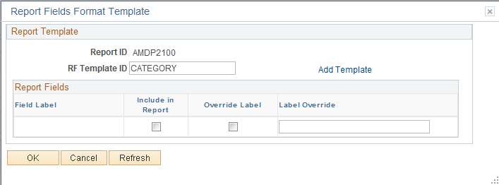

Populate the Template Id field with a name for the Template.

Click the Add Template link.

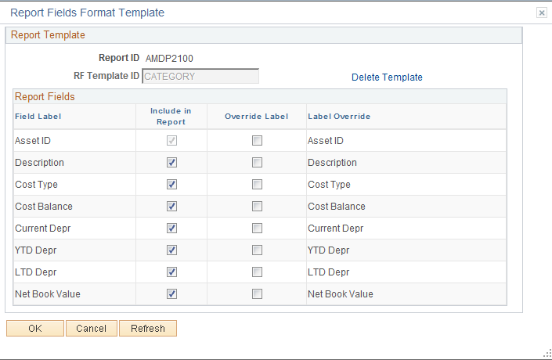

This template allow you to choose the fields you wish to see on the report. There is also an option to rename these fields by choosing Override Label allowing you to type in your own Description.

After you have selected your fields and customized labels, click .

NOTE: If you have previously created Templates for this report new Templates are not required. Simply select the Template that you used previously.

Unit – populate with the Agency Business Unit.

Book – populate with the ‘STATE’ book value.

Fiscal Year/Period Range – populate with From and Thru values to retrieve the Assets between those dates. Alternatively use a Date Range to define the period of time.

Location – populate a desired value to further define the list of Assets by Location.

ChartFields – populate with desired ChartField values to narrow the List of Assets by Location to those meeting the ChartField values.

Include Transfers/Retirements – select to include these Asset transactions in the report.

Click to execute the Report. Run on the PSUNX server or leave Server Name field blank.

Asset Net Book Value Query Parameters

The Asset Net Book Value Query can be run to obtain the data in an Excel format. The query gives the same information as the Asset Net Book Value report, except that it sorts by Asset ID.

Navigation: Reporting Tools > Query Viewer > OCP_AM_ASSET_NET_BOOK_VALUE

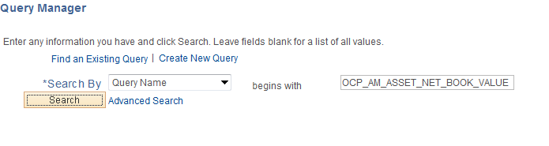

Select the Excel link to open the following window:

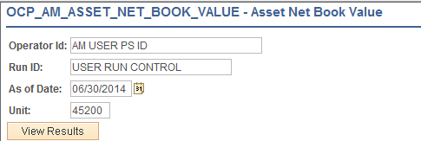

Operator Id – populate with your Operator ID.

Run ID – populate with the same Run Control ID used to load the Reporting Tables

As of Date – populate with the same “As of Date” used to load the Net Book Value Table

Unit – populate with the Agency Business Unit.

NOTE: Schedule the query if your agency has several assets. The assets that report in the query are the assets that are loaded in the Depreciation Reporting Table..

Analyzing Net Book Value Query Results

The following are guidelines for steps that can be taken to analyze the data in the Query.

- Validate missing Asset IDs
- Highlight Asset ID column
- In Word 2007, while on cell C3, click the Home ribbon > Conditional Formatting > New Rule > Use a formula to determine which cells to format.
- In the formula box, enter “+(C4-C3)>1”
- Click Format, Fill Tab, and select a color
- Filter by color and research missing Asset IDs (may be retired, deleted, not capitalized, etc.)

- Filter to Identify:
- Asset IDs without Tag IDs
- Orphan Child Assets
- Incorrect Asset Status (if disposals were included)
- Descriptions that should be revised in Basic Add
- Incorrect Categories for recently added Assets
- Blank Asset Subtypes for ITSYS Assets
- Blank Fund Type and Class Funding (and any other agency required funding) for assets entered manually
- In Service Assets with a Cost Type of “C” and lives not greater than 12 months and/or costs < $25,000
- Standalone Assets > or = to $25,000 without a Cost Type of “C”
- Incomplete or incorrect locations

- Update Basic Add or perform a Financial Transaction to correct incorrect or missing information. Financial Transactions require Depr_Calc to be run in order for accounting entries to generate for the transaction.

STEP 5 – Request and Review Accounting Entries

Once the data on the Net Asset Book Value report is complete and accurate, request OSF to create the month end entries.

When Assets are added, retired, leased, or modified in the system, i.e. adjustments, transfers, recategorizations, etc., corresponding Accounting Entries are created. These Accounting Entries will be Journal Generated to the FullAccrue General Ledger to reflect these modifications. Accounting Entries can be viewed once they have been created and stored in the system.
Review Asset Financial Entries

Navigation: Asset Management > Accounting Entries> > Review Financial Entries > Find an Existing Value

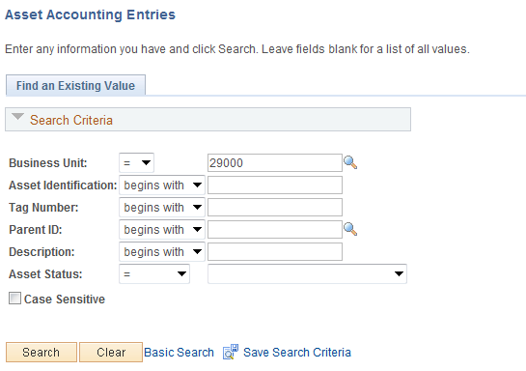

Business Unit - The Agency in which the existing Asset exists. This should default based on the User Preferences setup for the person reviewing the Asset.

Asset Identification, Tag Number, Parent ID, Description, Asset Status – Use these fields as search criteria to find the Asset Accounting Entries that will be reviewed.

Click to enter the Asset Accounting Entries pages.

List Page

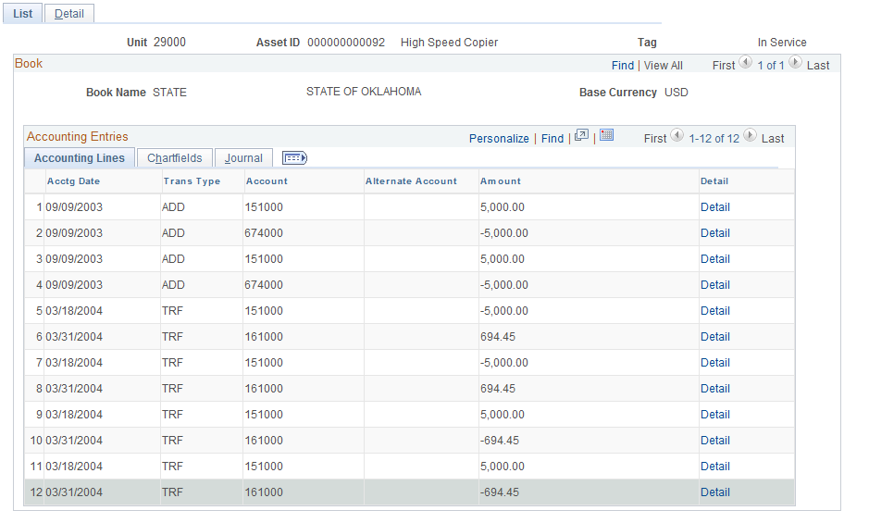

The Accounting List page displays by Book the history of Accounting Entries for the Asset. The Accounting Entries will be comprised of a Debit (positive amount) and a Credit (negative amount). The corresponding ChartFields are also listed on both sides of the Accounting Entry.

The Journal tab will display Journal ID’s for the Accounting Entries once they are Journal Generated to the General Ledger.

Click the Detail tab.

Detail Page

The Detail page displays the same Accounting Entry Lines as are visible on the List page. The ChartField descriptions are also available on this page.

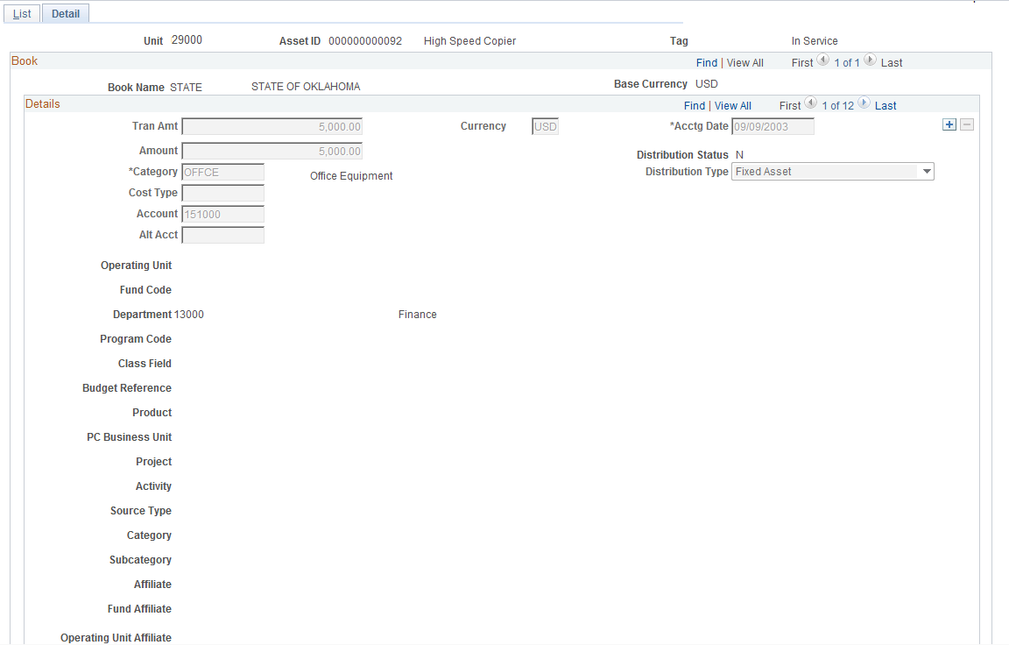

In the Details section of the page, click to view the next Accounting Row on the page.

NOTE: There will be a row on the Detail page for both the Debit and Credit sides of the Accounting Entry.

Detail Page Continued

The second detail page has the account distribution information for the Contra asset account.

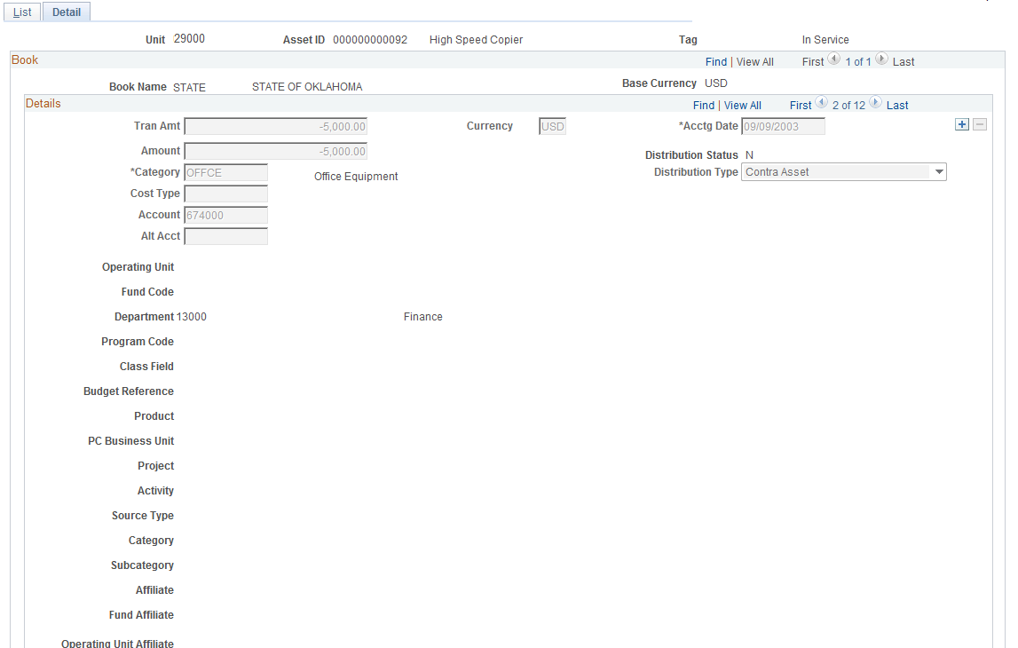

Detail Page Continued
The third detail page has the monthly distribution total for the accumulated depreciation.

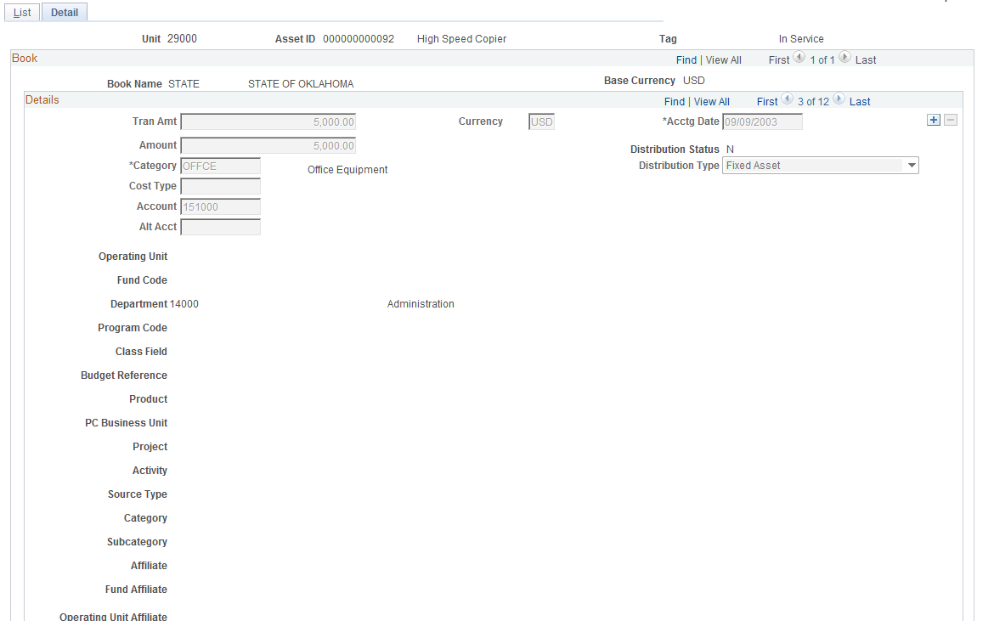

Accounting Entries recorded in the Ledgers

Following are examples of CAFR asset accounting entries recorded in the Actuals and FullAccrue ledgers when assets are purchased, disposed, or leased.

Accounting Entries – ADD Transaction

Purchased Asset for $25,000, 5 Yr Life, HY Convention

- Asset Purchase – Record Accrual
- Asset Payment – Record Payment
- Asset Creation – Record Asset in Asset Management
- Depreciation – Record Depreciation for Year 1

Transaction | LEDGER | Expense  54XXXX | Accrual  202000 | Cash  101000 | Asset  170XXX | A/D  171XXX | Depr  591100
 | ACTUALS
Asset Purchase |  | $25,000 | ($25,000)
Asset Payment |  |  | $25,000 | ($25,000)
 | FULLACCRUE
Asset Creation |  | ($25,000) |  |  | $25,000
Depreciation |  |  |  |  |  | ($2,500) | $2,500
NET ACTUALS/
FULLACCRUE
Total |  |  |  | ($25,000) | $25,000 | ($2,500) | $2,500

Accounting Entries – RETIRE Transaction
Sale of Asset costing 25,000, A/D $22,500, Proceeds $5,000, Removal Costs $1,000

- Cash Proceeds – Record Cash Deposit
- Removal Payment – Record Removal Expense
- Asset Retirement – Record Asset Disposal
Transaction | LEDGER | Cash  101000 | Sale  4836XX | Expense  54XXXX | Asset  170XXX | A/D  171XXX
 | ACTUALS
Cash Proceeds |  | $5,000 | ($5,000)
Removal Payment |  | ($1,000) |  | $1,000
 | FULLACCRUE
Asset Retirement |  |  |  |  | ($25,000) | $22,500
Proceeds |  |  | $5,000
Removal |  |  | ($1,000)
Gain/Loss |  |  | ($1,500)
NET ACTUALS/
FULLACCRUE
Total |  | $4,000 | ($2,500) | $1,000 | ($25,000) | $22,500

Accounting Entries – CAPITAL LEASE Purchase Transaction
Lease purchase of 100,000, $1500 monthly payment, $1200 monthly depreciation

- Monthly Payment – Record Monthly Lease Payment to Vendor
- Create Capital Lease – Record Capital Lease
- Lease Payment – Record Monthly Lease Payment in Asset Management
- Depreciation – Record Monthly Depreciation

Trans | LEDGER | Lease  543XXX | Cash  101000 | Lease  170XXX | Ls Due  262000 | Interest  543160 | A/D  171XXX | Depr  591100
 | ACTUALS
Monthly Payment |  | 1,500 | (1,500)
 | FULLACCRUE
Create Cap Lease |  |  |  | 100,000 | (100,000)
Lease Payment |  | (1,500) |  |  | 1,000 | 500
Depr |  |  |  |  |  |  | (1,200) | 1,200
NET ACTUALS/
FULLACCRUE
Total |  |  | (1,500) | 100,000 | (99,000) | 500 | (1,200) | 1,200

Step 6 – Review Asset Journals
The individual asset transactions are posted to AM journal IDs based on the different posting processes. The Asset Journals are used to review the Asset Management journal details for a General Ledger journal.

Navigation: Asset Management > Accounting Entries > Review Asset Journals > Find an Existing Value

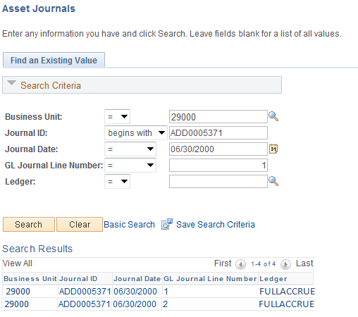

Business Unit - The Agency in which the existing Asset exists. This should default based on the User Preferences setup for the person reviewing the Asset Journals.

Journal ID, Journal Date, GL Journal Line Number – Use these fields as search criteria to find the Asset Journal(s) that will be reviewed.

Click to enter the Asset Journal page.

An AM journal ID is associated with a specific posting process, and a GL journal line is returned for each account number and chartfield combination. If a journal ID is not entered on the search page, all transactions are listed in the Search Results. The first journal ID is used to illustrate the Asset Journals page.

Asset Journals

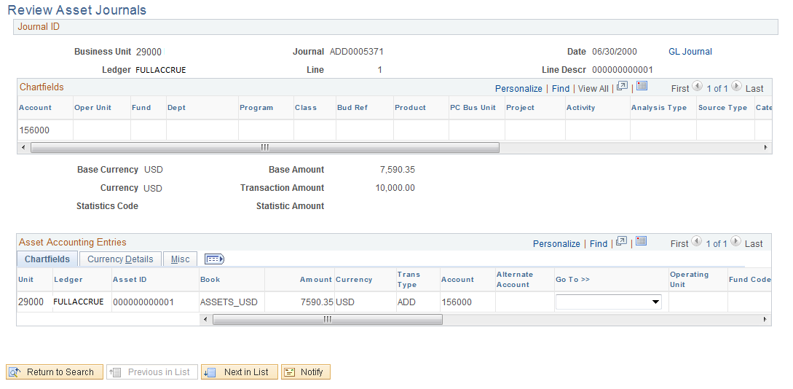

The Asset Journals page displays the posting process, the general ledger accounts to which this accounting entry has been charged, the asset ID(s) and amount(s) with which this journal line is associated, and the Asset Category and Cost Type.

Use the 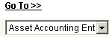 drop-down menu to select other Asset pages that will provide additional Asset details for a specific asset ID. The following pages are available:

Asset Accounting Entries – the Accounting Entries associated with this Asset’s transactions (additions, adjustments, etc.)

Asset Basic Information – the Basic Add pages illustrated in the Viewing Assets chapter

Asset Cost History – the transactional history of the Asset related to the Asset’s Cost and ChartFields

Asset Depreciation – for CAFR or Federal Assets view the history of Depreciation for the Asset

Asset Retirements – drill to the Retirement/Reinstate pages

Copy Asset – drill to the Asset Copy pages

Define Tax/Depreciation Criteria – this link provides the Asset Book page

Print an Asset – the printable view of the Asset is available

Step 7 – Review Ledger Information
Ledger Inquiry summarizes account balances based on selected criteria and can be used to review the Asset Management accounts. The Balance Sheet totals recorded in the FullAccrue ledger as of fiscal year end should agree to the Total Cost and Accumulated Depreciation totals in the Net Book Value report and the totals reported on the GAAP Capital Asset Package H, Lease Package L, and Infrastructure Package Y.

Navigation: General Ledger > Review Financial Information > Ledger > Ledger Inquiry

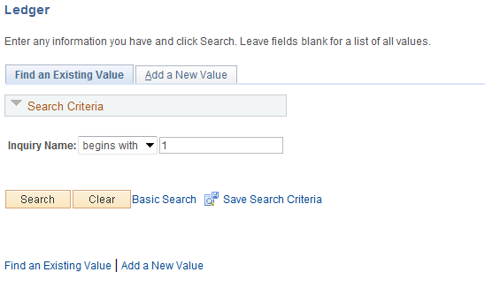

Run Control ID – populate with an existing Run Control ID or add a New Value.

Click the button.

Ledger Inquiry

Enter or select at a minimum the fields shown to establish ledger inquiry criteria for asset balance sheet account cumulative balances. The remaining fields are optional and serve to further refine your inquiry. See the COR123 Journal, Ledger, Budget Inquiry, Query and Reports Manual for additional details about Ledger Inquiry.

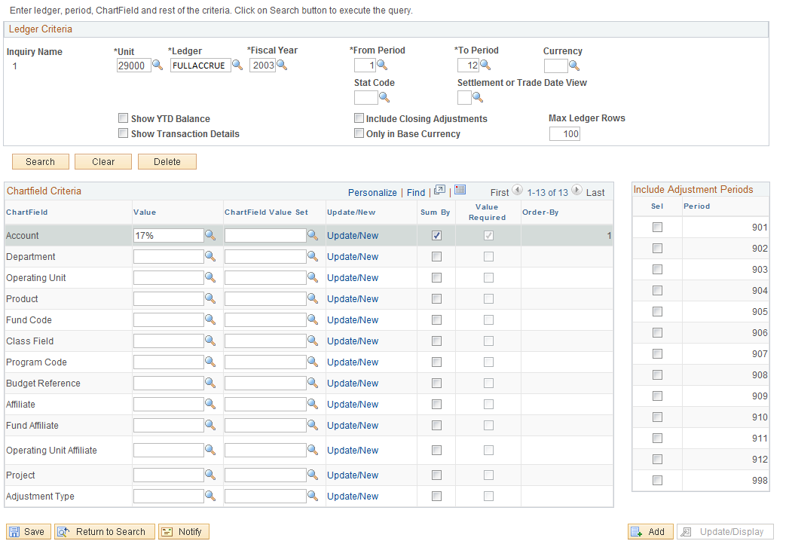

Unit – populate with the Agency Business Unit

Ledger – populate with the ‘FULLACCRUE’ ledger value
Fiscal Year/ From Period/To Period – populate with the appropriate Fiscal Year and Periods. The From Period must be populated with “1” in order to obtain cumulative balance sheet account balances.

Show YTD Balance – select to return a summary of selected data by period totals.

Include Closing Adjustments – select to include closing balances (entered by the CAFR group) along with the current period options.

Account Chartfield – populate with 17% to view the cumulative asset related balance sheet accounts.

Sum By – select to sum data by chartfield selected. Selection for at least one chartfield is required.

Click to enter the Ledger Summary page.

Ledger Summary
The cumulative asset balance sheet account balances display as of the fiscal year To Period. The Amount at the bottom of the page should be the Net Book Value of all combined assets.

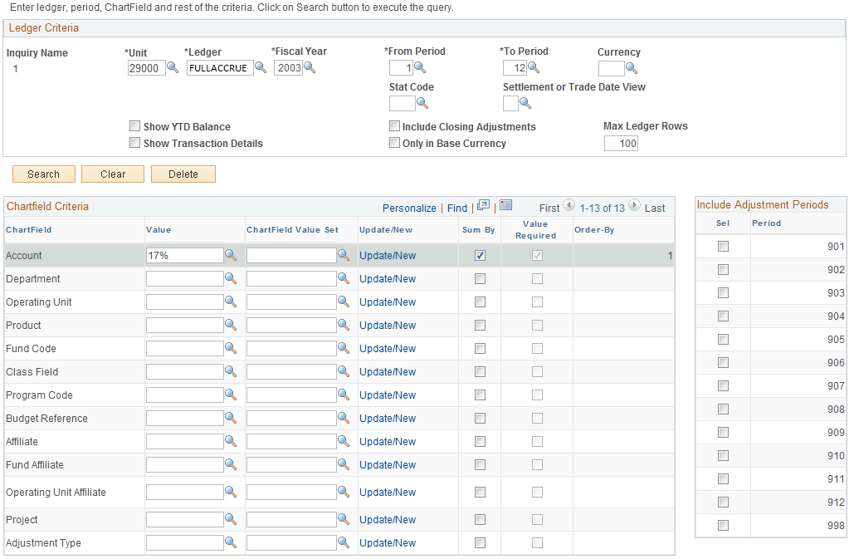
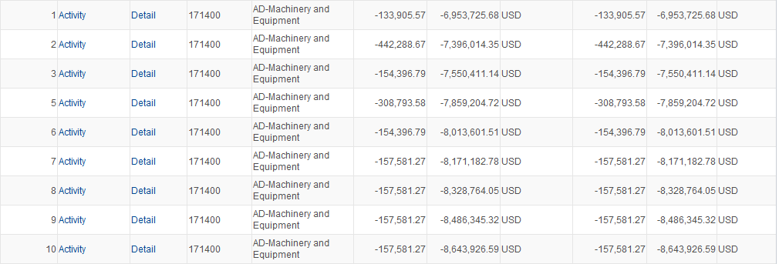

Activity – Click to view transaction details on the Ledger Inquiry – Transaction Details page..

Detail – Click the link to view ledger details on the Ledger Inquiry – Ledger Details page.

Asset Month/Year-End Checklist

 | Task | Initials | Date | Comment
1.01 | Run OCP_AM_RECV_NOT_PUSHED_TO_AM query to identify asset-related receivers not pushed to AM when receiver was created.
 | - Research reason for receipts showing pending AM status versus moved AM status.
 | - Contact appropriate personnel and ask if there is any reason the receipt should not be pushed.
1.02 | Run OCP_AM_PHY_A_RCPTS_TO_REVIEW query to identify Physical Load Lines that are not Approved.
 | - Quantity > 1 – Unitize to create additional Load Lines.
 | - Quantity < 1 – Consolidate with the other Load Lines from the receipt.
 | - Research transactions in Error or In process Status. Submit a helpdesk case if necessary.
1.03 | Run OCP_AM_PRE_AM_VCHRS_NEXT_ID query to identify vouchers in the AM Pre Interface Table with associated Asset IDs that need to be retrieved..
1.04 | Run OCP_AM_PRE_AM_NEW_ERR_INP query to identify vouchers that was pushed to AM without a receipt, or are in Error or an In Process Status.
 | - Retrieve vouchers with an Asset ID associated with voucher (cost rows are added to existing asset IDs).
 | - Research vouchers without a receipt or asset ID and retrieve vouchers only if another asset ID should be created.
 | - Research transactions in Error or In Process status. Submit a helpdesk case if necessary.
1.05 | Review Pending, Error, or In Process transactions in the Pre-AM, Financial, and Physical Interface tables. Enter the interface ID or search by Load Status.
a. Asset Management > Send/Receive Information > Preview
AP/PO Information > Find an Existing Value
b. Asset Management > Send/Receive Information > Approve
Physical Information > Review-A > Find an Existing Value
c. Asset Management > Send/Receive Information > Approve
Financial Information > Review > Find an Existing Value
2.01 | Complete processes to run Depreciation Calculation. Note: Once depreciation calculation has been run, an asset cannot be deleted.
 | - Review Open Transactions
 | - Asset Management > Depreciation > Open Transactions > Review > Find an Existing
 | - Identify Assets with Depreciation Calc Status not equal to Completed Depreciation.
 | - Run OCP_ASSET_OPEN_TRANS_ROWS query if there are more than 300 Open Transactions.
 | - Make note of beginning and ending Asset ID numbers.
 | - Run the Depreciation Calculation Process
 | - Asset Management > Depreciation > Processing > Calculate
 | - Review Depreciation Error Log – Asset Management > Depreciation > Depreciation Process Log
 | - Review Open Transactions or run the OCP_ASSET_OPEN_ TRANS_ROWS query and confirm there are no Depreciation Calculation Open Transactions.
3.01 | Load Reporting Tables to populate Asset Information used in Depreciation and Net Book Value reports.
 | - Asset Management > Financial Reports > Load Reporting Tables > Depr Reporting Table (Select Run Control ID for the remaining processes)
 | - Asset Management > Financial Reports > Load Reporting Tables > Net Book Value Table
3.02 | Run the OCP_AM_ASSET_NET_BOOK_VALUE query as of a specified date using Run Control ID used to load reporting tables.
 | - Highlight Asset ID column.
 | - In Word 2007, while on cell C3, click the Home ribbon > Conditional Formatting > New Rule > Use a formula to determine which cells to format.
 | - In the formula box, enter “+(C4-C3)>1”
 | - Click Format, Fill tab, and select a color
 | - Filter by color and research Missing Asset IDs (may be retired, deleted, etc.)
 | - Filter to Identify:
 | - Asset IDs without Tag IDs
 | - Orphan Child Assets
 | - Incorrect Asset Status (if disposals were included)
 | - Descriptions that should be revised in Basic Add
 | - Incorrect Categories for recently added Assets
 | - Blank Asset Subtypes for ITSYS Asset Category
 | - Blank Fund Type and Class Funding (and any other agency required funding) for assets entered manually
 | - In Service Assets with a Cost Type of C and lives not greater than 12 months and/or costs < $25,000
 | - Standalone Assets > or = to $25,000 without a Cost Type of “C”
 | - Incomplete or incorrect locations
 | - Update Basic Add or perform a Financial Transaction to correct incorrect or missing information
3.03 | Run OCP_AM_ASSET_ID_NOT_CAPITALIZED query to identify Asset IDs not capitalized timely and research.
3.04 | Run OCP_AM_DCS_ASSET_LISTING query.
 | - Run the report as of current date.
 | - Filter quantity and correct quantities > or < 1 using Adjustment Financial Transaction
4.01 | Contact OSF to run accounting entries and journal generation once information is complete and accurate.
5.01 | Compare General Ledger Asset Account balances as of specified date to total of CAFR assets on Net Book Value query

Financial Reports
Within the system there are both Reports and Queries. Reports are executed through a Run Control page and produce an instance of the report containing desired details. Reports can generally be printed with report headers, subtotals, and footers. Queries are executed through the Query Tool and produce “raw data” that can be viewed or exported into Excel. Queries typically do not have header, summary, or footer information.

The reports below in BOLD were modified from their delivered format for increased functionality and usefulness. When executing these reports using a Template (described later in this chapter), ALL field values available on the Template MUST BE selected. The instructions on adding and populating Report Templates are illustrated later in this chapter.

See COR416 for instructions on how to load PeopleSoft Reporting Tables.

List of Reports and Queries

PeopleSoft Report Title | Report Description | Typical Report Use | Notes
Asset Details
AMAS2100 - Asset Acquisition by ChartField | Lists asset information and includes Cost, LTD and YTD depreciation, and NBV with CF totals for specified period or date range. | Report to review asset acquisitions by CF, by dept ID | Uses report formatting features to include/exclude CF data, override title, and change amount column widths. Hard coded to sort by Dept.
AMAS2110 Asset Acquisitions by In Service Date | Lists asset information and includes Cost, LTD and YTD depreciation, and NBV with CF, and In-service Period/Year totals for specified period or date range. | Report to review asset acquisitions by in-service period/year. | Uses report formatting features to include/exclude CF data, override title, and change amount column widths.
AMAS2200 Asset List By Location | Lists information on assets by location for assets acquired during a specified period or date range. | Report to review asset by location. Has column for physical inventory, but report includes disposed assets. | Can narrow report to particular location and include/exclude CF data. Provides column for asset status.
AMAS2210 Asset List By Asset ID | Lists asset by Asset ID for specified period or date range and includes Cost, LTD and YTD depreciation, and NBV. | Report to review asset IDs acquired during a specified period or date range. | Can narrow report to particular location and include/exclude CF data. Does not exclude disposed assets.
AMDE4001 Physical Inventory List | Lists detailed information about assets within inventory. | Report is not real helpful for physical inventory. Each department must be run separately and report includes disposed assets. | Sequence is asset ID, and only three assets print on a page.
AMDE4002 Physical Inventory List | Lists summarized information about assets within inventory. | Report is not particularly helpful for physical inventory. Each department must be run separately and report includes disposed assets. | Sequence is asset ID, and each asset prints on one line.
AMAS2201 Hazardous Assets By Location | Lists assets designated as hazardous by location as of a specified date. | Report to review hazardous assets and codes. | Can narrow report to particular location. Provides column for asset status.
Cost and Depreciation
AMAS 2000 Cost Activity | Beginning Cost plus/minus additions, adjustments, transfers, recategorizations, retirements, reinstatements equal Ending Cost activity by CF, by category for specified period or date range. | Roll-forward report used to reconcile and identify asset transactions. | Uses report formatting features to include/exclude CF data, override title, and change amount column widths. Can be sorted by account, but report will use FullAccrue ledger accounts.
AMAS 2300 Asset Transfer By ChartField | Lists asset transfers transactions ordered by CF for specified period or date range. | Report to identify In and Out transfer transactions. | Uses report formatting features to include/exclude CF data, override title, and change amount column widths. Sorts by department ID so In and Out transaction may be apart.
AMAS 2400 Asset Reclassification by ChartField | Lists asset recategorizations ordered by CR for specified period or date range. | Report to identify In and Out recategorization transactions. | Uses report formatting features to include/exclude CF data, override title, and change amount column widths. Sorts by department ID so In and Out transaction may be apart.
AMNB 1000 Net Book Value by ChartField | Lists asset information and includes Cost, Period, YTD, and LTD depreciation, and NBV totals as of a specified date. Sums by department. | Crystal report summarizing cost, depreciation, and NBV by department as of specified date. | Must load DEPRCALC and NBV tables before running. Can include/exclude transfers and retirements when loading NBV. Sorts by department. Includes category but no physical information.
AMNB 1010 Net Book Value by Category | Lists asset information and includes Cost, Period, YTD, and LTD depreciation, and NBV totals as of a specified date. Sums by category. | Crystal report summarizing cost, depreciation, and NBV by category as of specified date. | Must load DEPRCALC and NBV tables before running. Can include/exclude transfers and retirements when loading NBV. Sorts by department. Includes department but no physical information.
AMNB 1030 Net Book Value by Locations | Lists asset information and includes Cost, Period, YTD, and LTD depreciation, and NBV totals as of a specified date. Sums by location. | Crystal report summarizing cost, depreciation, and NBV by location as of specified date. | Must load DEPRCALC and NBV tables before running. Can include/exclude transfers and retirements when loading NBV. Sorts by department. Includes department but no physical information.
AMGL1000 AM to GL Reconciliation by Department | Reconciles AM To GL by ChartField. Sums by Department ID. | Crystal report summarizing cost, YTD and LTD depreciation by department ID as of a specified date. | Must load DEPRCALC, NBV, and AM_GL Recon tables before running. Can include/exclude transfers and retirements when loading NBV. Sorts by department and includes category, operating unit, sub-account, and project. Class funding, cost type, and tag # are not included.
AMGL1010 AM to GL Reconciliation by Category | Reconciles AM To GL. Sums by category. | Crystal report summarizing cost, YTD and LTD depreciation by category as of a specified date. | Must load DEPRCALC, NBV, and AM_GL Recon tables before running. Can include/exclude transfers and retirements when loading NBV. Sorts by category and includes department, operating unit, sub-account, and project. Class funding, cost type, and tag # are not included.
AMDP2000 Depreciation Activity | Beginning depreciation plus/minus PDP, recategorization, depreciation, additions, transfers, and retirements equal Ending depreciation activity by CF, by category for specified period range. | Roll-forward report used to reconcile and identify depreciation transactions. | Must load DEPRCALC, NBV, and AM_GL Recon tables before running. Can include/exclude transfers and retirements when loading NBV. Sorts by department and includes category, operating unit, sub-account, and project. Cost type and class funding are not included.
AMDP2100 Net Book Value | Sorts cost activity by CF, by category or location. | Report to identify current, YTD and LTD depreciation, and NBV for assets or categories. | Must load DEPRCALC, NBV, and AM_GL Recon tables before running. Can include/exclude transfers and retirements when loading NBV. Sorts by department and includes category, operating unit, sub-account, and project. Cost type and class funding are not included.
AMDP2200 Depreciation by Period | Sorts assets by period depreciation at asset, category, department, or project levels for specified period or date range. | Delivered PDF and CSV report difficult to use to identify depreciation for CAFR and Federal assets. | Must load DEPRCALC, NBV, and AM_GL Recon tables before running. Can include/exclude transfers and retirements when loading NBV. Sorts by department and includes category, operating unit, sub-account, and project. Cost type and class funding are not included.
AMDP2300 Depreciation by Fiscal Year | Sorts assets by fiscal year depreciation at asset, category, project, or department levels by specified period range. | Delivered PDF and CSV report difficult to use to identify depreciation for CAFR and Federal assets. | Must load DEPRCALC, NBV, and AM_GL Recon tables before running. Can include/exclude transfers and retirements when loading NBV. Sorts by department and includes category, operating unit, sub-account, and project. Class funding and cost type are not included.
Retirement
AMRT 2000 Retirement by ChartField | Sorts retirement information by CF, by department for specified period or date range. Subtotals by category and CF. | Report to obtain retirement totals by category and CF. Report is not user friendly. | Hard coded to sort by department. Can select ChartField values.
AMRT 2010 Retirement by In Service Date | Lists retirement related information with totals per in service year/period. | Report to group retired assets by their in service dates. Report is not user friendly. | Can select ChartField values. Does not identify retirement date.
AMRT 2100 Retirement Activity | Lists retirement related information as of a specified date. | Report to identify retired assets, disposal code, proceeds, accumulated depreciation, and gain/loss. | Provides a history of all retirement activity. Retirement activity is reported for reinstated assets. No date range option.
Leased Assets
AMLE2000 Lease Summary Information | Lists lease summary information by asset ID as of a specified date. | Report to obtain lease obligation, interest, obligation reduction, and remaining obligation as of a specified date. | Can select to print future rows, current month information, or YTD information. Report does not report by category, nor does it include vendor to exclude interagency leases.
AMLE2100 Lease Detail Information | Lists lease detail information as of a specified month or fiscal year. | Report to obtain payment amount, interest expense, and obligation reduced for each month or each month for fiscal year. | Can select to print future rows, current month information, or YTD information. Assets ID transactions do not report together. Report does not report by category, nor does it include vendor to exclude interagency leases.
 | Lists lease detail information as of a specified date. | Report to obtain payment amount, interest expense, and obligation reduced for each month or each month for fiscal year. Report includes payment date. | Can select to print future rows, current month information, or YTD information. Assets ID transactions do not report together. Report does not report by category, nor does it include vendor to exclude interagency leases.
AMLE2300 Lease Footnote Disclosure Detail | Lists all outstanding lease commitments for five years and provides the monthly lease payment and yearly totals. | Report to obtain lease commitments for five years by asset ID for capital and operating leases. | Report does not report by category, nor does it include vendor to exclude interagency leases.
AMLE2310 Lease Footnote Disclosure Summary | Lists all outstanding lease commitments for five years and provides the monthly lease payment and yearly totals. | Report to obtain lease commitments in total for 5 years. | Report does not report by category, nor does it include vendor to exclude interagency leases.
AMLE2400 Lease Expiration | Lists all capital leases expiring in a certain number of days from a specified date, or leases expiring within specified date range. | Report to obtain lease expiration dates. | Can select as of date or date range. Does not include operating leases.
Accounting Entries
AMAE2100 Accounting Entry Detail | Listing accounting entry detail as of a specified date range or fiscal year. | Report to review entries and obtain subtotals for each ChartField string by account number. Includes transaction type and journal ID and date. | Can select an account or journal ID and choose detail or summary.
AMAE2110 Accounting Entry Detail - Cost | Lists costs and related transaction amounts per asset, with ChartField and report totals for a date range or as of a specified date. | Report to review cost accounting entries by transaction amount and obtain subtotals for each ChartField string by account number. | Can select account and choose detail or summary. Transfers and retirements can be included or excluded.
AMAE2120 Accounting Entry Detail - Depreciation | Lists depreciation and related transaction amounts per asset, with ChartFields and report totals for a date range or as of a specified date. | Report to review depreciation accounting entries by transaction amount and obtain subtotals for each ChartField string by account number. | Can select account and choose detail or summary. Transfers and retirements can be included or excluded.
AMAE2130 Accounting Entry Detail - Net Book Value | Lists cost balance, YTD and LTD depreciation and NBV amounts per asset for a date range or as of a specified date. Subtotals by category and account number. | Report to review net book value calculations for each asset and obtain subtotals for each category by account number. | Can select account and choose detail or summary. Transfers and retirements can be included or excluded.
AMAS2030 Account Activity Summary - Cost | Lists cost and related transaction amounts per account with ChartFields and report totals for a date range or as of a specified date. | Report to obtain summary account activity. | Can select account. Transfers and retirements can be included or excluded.
AMDP2030 Account Activity Summary - Depreciation | Lists depreciation and related transaction amounts per account with ChartFields and report totals for a date range or as of a specified date. | Report to obtain summary depreciation activity. | Can select account. Transfers and retirements can be included or excluded.
AMDP2130 Account Activity Summary - Net Book Value | Lists cost balance, YTD and LTD depreciation and NBV amounts per account for a date range or as of a specified date. | Report to obtain summary net book value activity. | Can select account. Transfers and retirements can be included or excluded.
Queries
OCP__AM_ASSET_NET_BOOK_VALUE | Lists current, YTD, and accumulated depreciation, and net book value amounts by asset ID. | To obtain current depreciation and net book value for each asset with current depreciation and/or net book values. | Must load DEPRCALC and NBV tables before running. Can include/exclude transfers and retirements when loading NBV. Must select retirements to obtain YTD depreciation for assets retired in FY. Prompts by user ID and run control. Sorts by BU and asset ID.
OCP_AM_ASSET_ACQ_BY_JRNL_DATE | Add and Adjust transactions posted to the ledger during the specified period are added together to report acquisition costs. | To obtain assets acquisition costs during a specified period. | Prompts by journal date. Sorts by BU, Category, Cost Type (descending), and asset ID.
OCP_AM_ASSET_TRSFR_BY_JRNL_DATE | Lists asset transfers transactions posted to the ledger during the specified period. | To review asset transfers by asset ID. | Prompts by journal date. Sorts by BU and asset ID.
OCP_AM_ASSET_RECAT_BY_JRNL_DATE | Lists asset recategorizations transactions posted to the ledger during the specified period. | To review asset recategorizations by asset ID. | Prompts by journal date. Sorts by BU and asset ID.
OCP_AM_ASSET_RET_BY_JRNL_DATE | RET and REI transactions posted to the ledger during the specified periods are added together to report asset retirements. | To obtain a listing of assets with a disposal status during a specified period. | Prompts by journal date. Sorts by BU, Category, Cost Type (descending), and asset ID.
OCP_AM_DCS_ASSETS_LISTING | List of received and in service assets excluding land, building, and land improvements. | To comply with State Inventory Rule 580:70-3-1 | Prompts by BU and is in format required by DCS. Sorts by BU and asset ID. May need crystal report for larger agencies.
OCP_AM_IT_ASSET_LISTING | List of received and in service IT assets. | To comply with OSF requirements. | Prompts by BU and is in format required by OSF. Sorts by BU, category, and asset ID. May need crystal report for larger agencies.
OCP_AM_DCS_SURPLUS_ASSETS | List of assets to be sent to Surplus. | To comply with State Surplus Rule 580:65-3-1(d) - Listing accompanies the Surplus Property Transfer Form | Prompts by BU and is in format required by DCS. Sorts by BU and asset ID. Criteria based on assets flagged with Surplus attribute and a status not equal to disposed.
OCP_AM_DCS_MISSING_ASSETS | List of missing assets during specified retirement date range. | To comply with State Inventory Rule 580:70-3-3 | Prompts by BU and retirement date range. Sorts by BU and asset ID. Criteria based on disposed assets with missing disposal codes. Latest Comment is included in query.
OCP_AM_DCS_TRADE_IN_ASSETS | List of assets traded in during specified retirement date range. | To comply with State Inventory Rule 580:70-3-2 | Prompts by BU and retirement date range. Sorts by BU and asset ID. Criteria is based on assets with trade in disposal codes and sums RET and REI journal transactions.
OCP_AM_REINSTATED_ASSETS | List of reinstated assets posted to the ledger during the specified period. | To obtain a listing of reinstated assets during a specified period. | Prompts by BU and retirement date range. Sorts by BU and asset ID. Criteria s based on REI transactions and a status not equal to disposed. Comments are included in query and only the latest comment is included if an asset has multiple comments.
OCP_AM_RCVR_NOT_PUSHED_TO_AM | List of asset-related receipts not pushed to Asset Management. | To ensure the physical information is integrated to AM before the assets are capitalized from Accounts Payable. | Prompts by BU, sorts by receipt number, and includes description, user ID, serial status, amount, and receipt date and time.
OCP_AM_PHY_A_RCPTS_TO_REVIEW | List of receipt load lines that are not approved in the AM Interface table. | To review, document, and track the AM Interface Load Lines and identify changes to be made after the asset ID is created since the Physical A Page is not editable. | Prompts by BU, sorts by interface ID and interface line number, and provides information such as quantity, amount, profile ID, PO and receipt information, and other physical information that is not available on the Load Preview Physical A search page.
OCP_AM_PRE_AM_VCHRS_NEXT_ID | List of vouchers without an Asset ID in the Pre-AM Interface table. | To identify associated receipts that have been completely interfaced to AM so voucher load lines can be interfaced to the AM Interface Table. | Prompts by BU, sorts by voucher ID and Pre-Interface ID, and provides the corresponding information for the receipt on the voucher in the AM Interface Table.
OCP_AM_VCHR_BEFORE_RECVR | List of vouchers integrated to AM with no corresponding receipt in the Interface Tables. | To prevent vouchers from creating an Asset ID before the physical information is loaded to AM. | Prompts by BU, sorts by Pre-Interface ID and Pre-Interface Line number, and identifies the PO and receipt on the vouchers.
OCP_AM_ASSET_ID_NOT_CAPITALIZE | List of Asset IDs that have not been capitalized. | To follow up on Asset IDs not capitalized, including assets ‘Consolidated’ in AM. | Prompts by BU, sorts by asset ID, and provides description, amount, and PO and receipt information.
ASSET_BY_CUSTODIAN | List of assets assigned to a custodian | To obtain a listing of assets assigned to a custodian. | Prompts by Empl ID and is sorted by Empl ID and location code. Includes only physical information.
ASSETS_BY_VOUCHER_ID | List of asset IDs capitalized from a voucher ID. | To obtain a listing of assets associated with a voucher. | Prompts by Voucher ID and includes Profile ID and Invoice information.
ASSETS_RECEIVED | Lists assets with a status of received. | To obtain a listing of assets are that are received but not in service | No prompts. Lists ‘Received’ assets by BU and asset ID order and includes physical information only.
ASSETS_TAGGABLE_UNTAGGED | Lists assets flagged as taggable but no tag number is entered. | To obtain a listing of untagged assets that should be tagged. | No prompts. Lists untagged taggable assets by BU and asset ID order and includes physical information only.
ASSET_COST_CURRENT_BALANCE | Lists asset cost and funding for a specified asset ID. | To obtain the cost and funding of a particular asset for each period and fiscal year. | Prompts by BU and asset ID. Uses Cost_Asof2_VW table.
ASSET_OPEN_TRANSACTION_ROW | List of open transaction review by asset ID for each asset transaction type. | To obtain open transaction review in query form. | Prompts by BU and sorts by asset ID.

