COR430 Grants – Grant Setup

The content of this training manual is based largely on a generic system configuration and illustrates the base-line functionality required to execute transactions in the module. Your agency may be utilizing more or less of the functionality illustrated in this manual. This manual is intended to be a framework upon which agencies can add agency-specific training content that speaks specifically to the system functionality that they have deployed and related configuration that they use for transaction processing. Agencies should not depend on these manuals for end-user training or problem resolution until they have been reviewed by the agency for appropriateness.

Authorized by: [_CORE_] Original Issue: [06//01/2010]
Maintained by: [____Grant Lead___] Current Version: [05/01/2014]
Review Date: [05/01/2015]

Table of Contents

Document History 5
Grant Setup Overview 6
Key Terms 7
Grants Business Unit 7
Grant Proposal 7
Grant Award 7
Grant Professionals 7
Sponsors 7
Subrecipients 7
Project ID 7
Institution 7
Project Manager and Team 7
Grant Contract Definition 8
Facilities and Administration (F&A) 8
Process Flows 9
Grants Module Integration 9
PeopleSoft Grants Management 10
PeopleSoft Proposal Model 11
Defining the Institution 12
Institution General Information 12
Definition Tab 12
Information Tab 13
Attributes Tab 14
Address Tab 15
Institution Contacts 16
Institution Contacts Tab 16
Institution F&A (Indirect Cost) Rates 17
F&A Rates Tab 17
Defining the Sponsor 18
Sponsor General Information 18
General Information Tab 18
Details Tab 21
Attributes Tab 22
Sponsor F&A (Indirect Cost) Rates 23
Facilities Admin Rates Tab 23
Budget Items Page 24
Budget Items Tab 24
Defining Departments 25
Department General Information 25
Department Tab 25
Address Tab 26
Attributes Tab 27
Department Contacts 28
Department Contacts Tab 28
Defining Professionals 29
Professional Data 29
Professional Data Tab 29
Job and Employment Data 31
Job Data Tab 31
Employment Tab 32
Additional Grants Setup 33
Budget Items 33
Budget Items Tab 33
Facilities Admin Bases (Indirect Cost) 34
Facilities and Administration Bases 34
Facilities Admin Rates (Indirect Cost) 35
Facilities and Administration Bases 35

Document History

Document Revision | Date | Description
1.0  2.0 | 06/01/2010  05/01/2014 | Initial Document  Upgrade Update

Grant Setup Overview
The Grants module provides functionality to support both Pre and Post Award Grant administration and management. Before creating and administering Grants, configuration of Grant Required elements is necessary. Some of those configuration items include:
- Grant Sponsors
- Institutions
- Departments
- Professionals
- Subrecipients
The Grants module must have these and other related setup elements in place before Grant processing can begin.

Key Terms
Grants Business Unit: Each agency has one, and only one Grants Management Business Unit. The Business Unit is the three (3) digit agency code, plus 00. For example, Office of State Finance is 09000.
Grant Proposal: The Proposal represents the intent and request for Grant Funding from the State Agency. State Agencies create Grant Proposals that identify resources, projects, budgets, etc. that will be integral in the utilization of the funding request.
Grant Award: Once the Proposal has been negotiated and approved by the sponsoring entity, the Award represents the final agreement between the sponsor and the state agency for receipt and expenditure of funds.
Grant Professionals: Agency personnel responsible for administration of grant proposal.
Sponsors: The Sponsor represents the grant funding source. Generally, this is the Federal Agency through which federal grant funds are received.
Subrecipients: Subrecipients are entities or individuals that receive grant funding from the primary grantee within the parameters of a grant.
Project ID: Agency program or initiative funded by grant dollars (a.k.a. set aside).
Institution: State agency applying for grant funding and managing the grant funded projects.
Project Manager and Team: Project Manager & Team – agency personnel working on grant funded project.
Grant Contract Definition: The Contract defines funding Sponsor and Draw parameters for reimbursement. Also, defines reimbursable Product, Accounting and Grant funded Project relationships.
Facilities and Administration (F&A): The term F&A equates to Indirect Cost calculation for state agencies. This includes budgeting, calculating and accounting for Indirect Costs.

Process Flows

Grants Module Integration
Diagram 1 : Grants Module Integration

PeopleSoft Grants Management
Diagram 2: Grants Chartfield Flow

PeopleSoft Proposal Model
Diagram 3 : Grants Proposal Model

Defining the Institution
The Institution in Grants represents the entity receiving grant funding. In the state deployment of Grants the Institution will generally equate to the Agency.

Institution General Information
Navigation: Grants > Institutions > General Information. > Find and Existing Value

Definition Tab

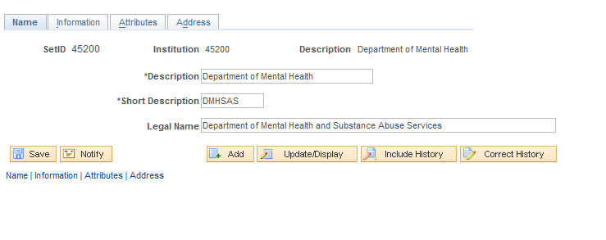
The Institution Definition page provides description information for the Institution (state agency).
Business Unit – is the Agency description.
Legal Name – is the legal entity or legal agency name.
Click the Information Tab.

Information Tab

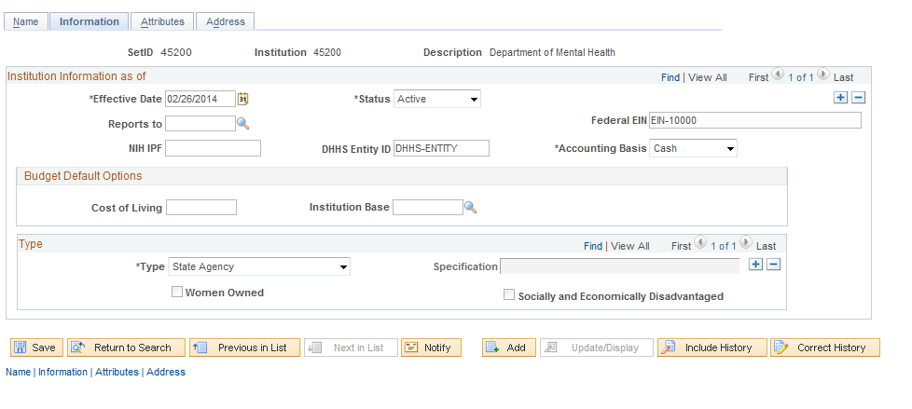

The Institution Information page holds general date elements for the Institution.
Reports to – If the institution reports to another entity, the pre-defined value can be stored here.
Federal EIN – the agency federal Employer Identification Number can be stored.
Cost of Living/Institution Base – when creating Proposal Budgets default these values into the Budget for the Proposal.
Type – For the state deployment, Institution Type will be State Agency.
Click the Tab.

Attributes Tab
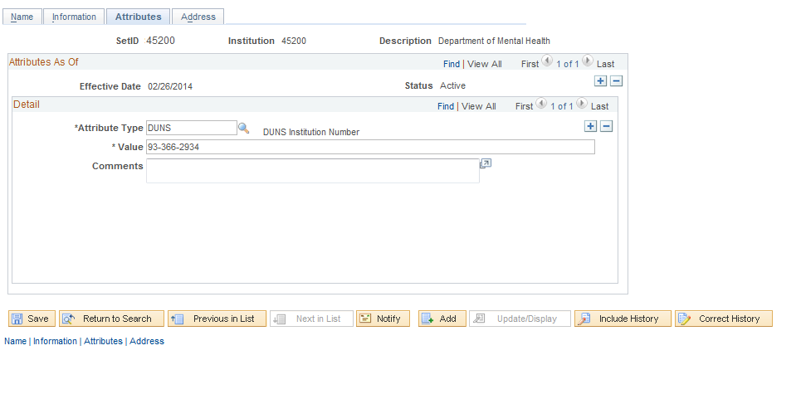
The Institution Attributes page stores grant required properties for the institution.
Attribute Type – the attribute type is a predefined property of the Institution. An Example of attribute type is the agency DUNS number.
Value – For the Attribute Type, the value displays the appropriate number or value for the attribute type.
Comments – Enter any comments specific to the Attribute Type.

NOTE: Use to insert additional Institution Attributes.

Click the Tab.

Address Tab

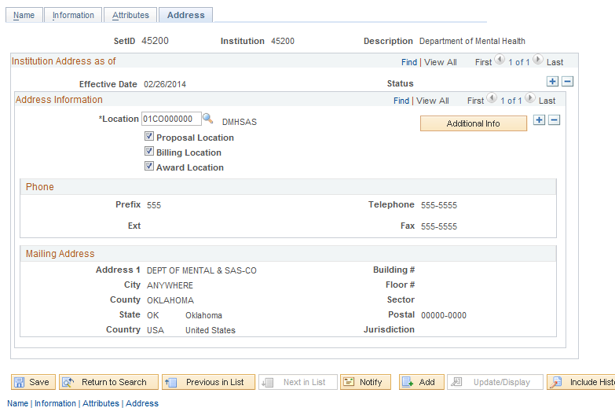
The Address Tab displays the physical address or location for the Institution. The Location must be predefined before it can be defined as the Institution location.
Proposal Location – If this checkbox is selected the Location will default into the Grant Proposal when this Institution is used on the Proposal.
Award Location - If this checkbox is selected the Location will default into the Award Profile when the Proposal is generated into an Award.

Institution Contacts
Navigation: Gants > Institutions>Contacts > Find an Existing Value

Institution Contacts Page

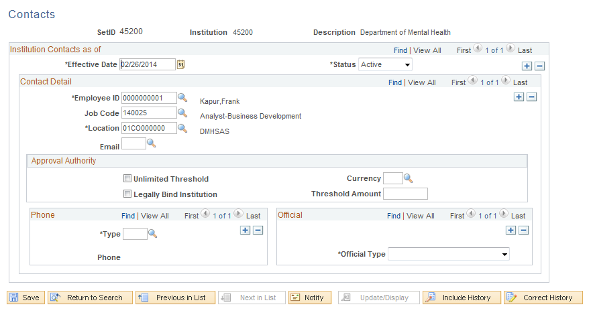
Institution Contact Tab can store multiple contacts that can be included in the Grant creation process. These values can default onto the Grant Proposal when the Institution is used.
Employee ID – Displays the individuals Employee ID
Job Code – The employees’ job code can be displayed.
Email – The contact email can be displayed.

NOTE: Use the to insert additional Institution Contacts.

Institution F&A (Indirect Cost) Rates
Navigation: Grants > Institutions > Facilities Admin Rates > Find an Existing Value

F&A Rates Tab
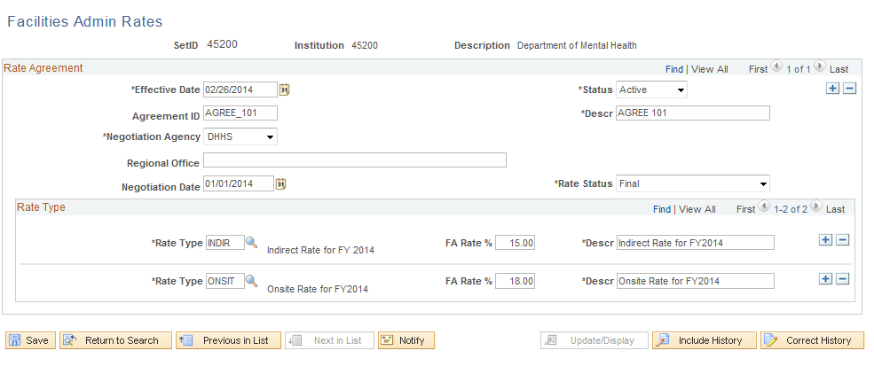
The F&A Rates Tab displays F&A or Indirect Cost properties that can default into the Grant Proposal when the Proposal Budget is being created.
Negotiation Agency – Displays the Sponsor agency negotiating the F&A Rates defined on this page.
Rate Type – For each Rate Type defined, the FA Rate percentage can be defined and can default onto the Proposal.

NOTE: Multiple Rate Types can be defined for the Institution. These Rate Types can dictate different Indirect Cost rates for each Budget ID (a.k.a. Activity ID) used in the Grant Proposal.

Defining the Sponsor
The Grant Sponsor represents the entity providing grant funding. In the state deployment of the Grants system, the Sponsors will vary by agency and each agency will have their own set of sponsors.
Sponsors in the system are built on the ‘Customer’ framework. This logic is based on the premise that funds are received by both Customers and Sponsors. Grant Sponsors are special type of Customer and therefore have properties necessary for applying and receiving funding through the Granting process.

Sponsor General Information
Navigation: Grants>Sponsors>General Information>Find an Existing Value

General Information Tab
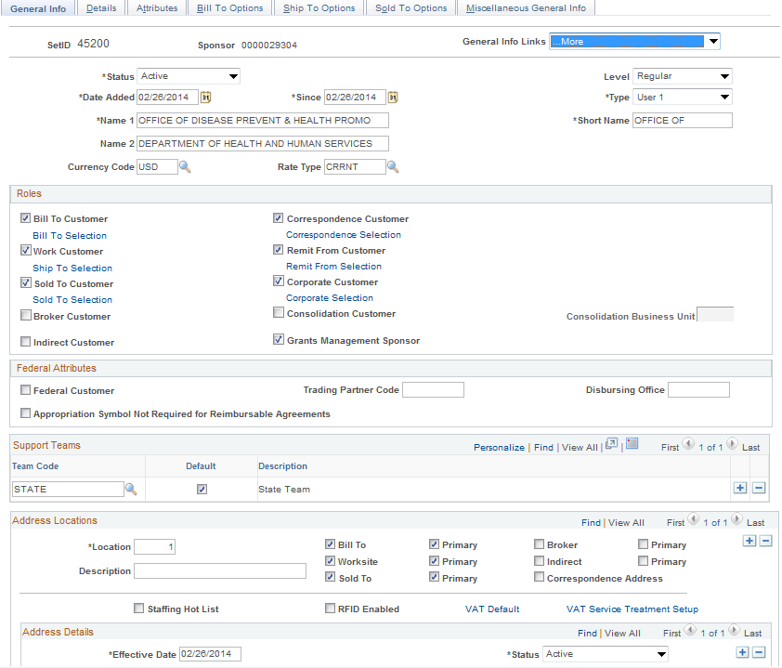
General Info Tab continued

The Tab stores date used in creating and processing the Grant Proposal and Award.
Grants Management Sponsor – The selection of this checkbox indicates that the ‘Customer’ is a Grants Customer.
General Info Tab continued
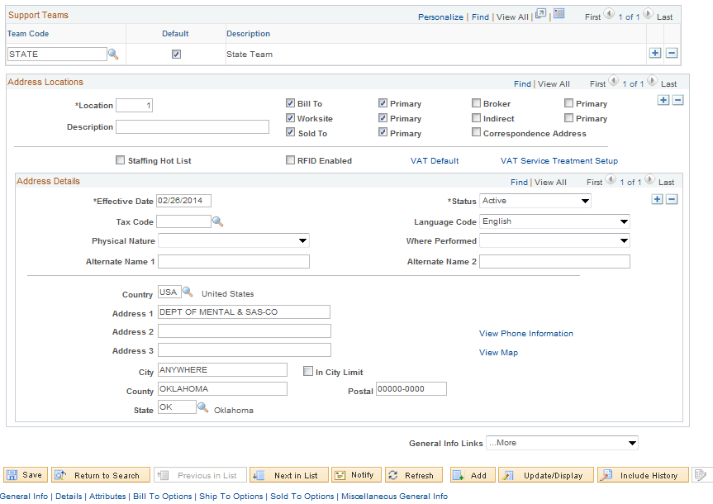
Support Teams – A required Team Code can represent those individuals participating on the Grant Proposal and Award process.
Address Details – The Sponsor Address information is displayed.
Click the Tab.

Details Tab
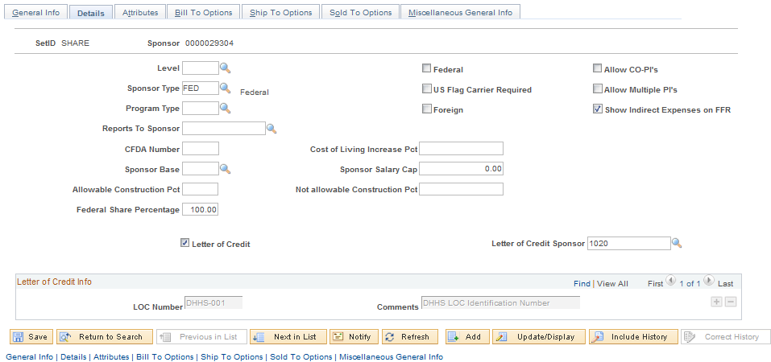
The Tab stores information used in F&A (Indirect Cost) budget calculations, Letter of Credit and Proposal Budgeting.
Federal – This checkbox indicates the Sponsor is a Federal entity.
Sponsor Base – For F&A calculations purposes, this defines the types of costs (called Budget Items) that are eligible for Sponsor indirect cost calculations.
Letter of Credit – This checkbox indicates that the Sponsor uses Letter of Credit.
Letter of Credit Sponsor – Generally this value will be the Sponsor ID itself. This indicates that the Sponsor is eligible to store a Letter of Credit Number.
LOC Number – This is the Sponsor Letter of Credit number. This number is a Sponsor level number rather than a Grant level number. On the Sponsor setup, this field is only defining valid values for the Sponsor that can be used in the Grant Proposal and Award process.

NOTE: The Letter of Credit Number is a Sponsor applicable field and value. The Letter of Credit Document ID is a Grant specific field and value. The Letter of Credit Document ID is stored on the Grant Contract (or Grant Project) and is defined after the Grant Proposal is generated into an Award.

Click the Tab.

Attributes Tab
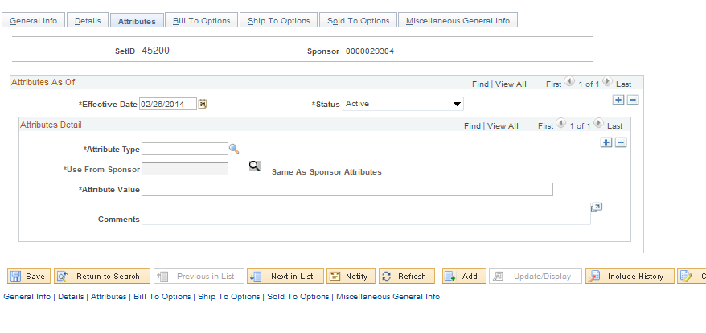
The Attributes Tab can store Sponsor specific information defined by the agency. These attributes could be codes, compliance information or grant required parameters.
Attribute Type –The attribute type is a predefined property of the Sponsor.
Attribute Value – For the Attribute Type, the value displays the appropriate number or value for the attribute type.
Comments – Enter any comments specific to the Attribute Type.

NOTE: Use the to insert additional Sponsor Attributes.

Sponsor F&A (Indirect Cost) Rates
Navigation: Grants > Sponsors > Facilities Admin Rates > Find an Existing Value

Facilities Admin Rates Page

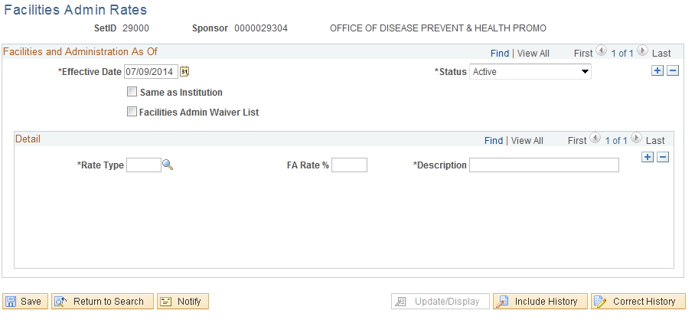
The Facilities Admin Rates Tab displays F&A or Indirect Cost properties that can default into the Grant Proposal when the Proposal Budget is being created.
Same as Institution – this checkbox will be selected if the Institution and Sponsor have the same rate. Generally in state deployment of Grants this will be the case.
Rate Type – for each Rate Type defined, the FA Rate percentage can be defined and can default onto the Proposal.

NOTE: Multiple Rate Types can be defined for the Sponsor. These Rate Types can dictate different Indirect Cost rates for each Budget ID (a.k.a. Activity ID) used in the Grant Proposal.

Click .

Budget Items Page
Navigation: Grants > Sponsors > Budget Items > Find an Existing Value

Budget Items Tab

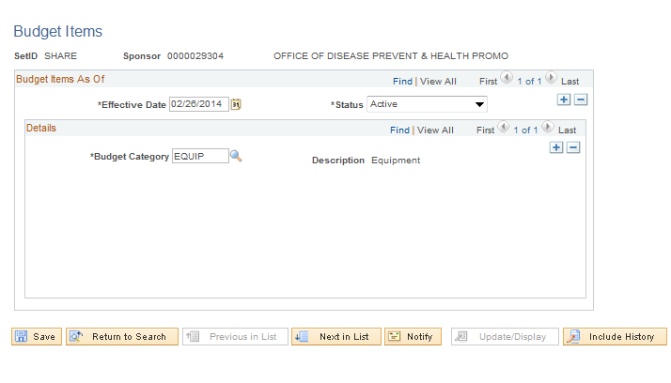
The Budget Items Page can be used to define particular Budget Items applicable to this Sponsor. These Budget Items can be used when developing a Grant Budget for this Sponsor.
Budget Item – Defines the Budget Items(s) that will be used to budget costs for this Sponsor. Generally, these will be the categories of expenditures used for agency grant processing.

NOTE: Budget Items will be defined by agency and generally match those expenditure categories defined by the sponsoring entity. For example Budget Items could be Salary, Fringe, Travel and Equipment.

Defining Departments
Departments are used in the Grant Proposal and Award process to define agency specific divisions that represent ownership of a Proposal, F&A or Indirect Cost designation and budget assignment.
When selecting a Department in the Grants module for a Proposal or Award, the available values are the same as the Department ID Chartfield. Additional properties can be assigned to each Department ID value that will be used in the Grant process. These properties can be individuals, address and attributes.

Department General Information
Navigation: Grants > Departments>General Information > Find an Existing Value

Department Tab
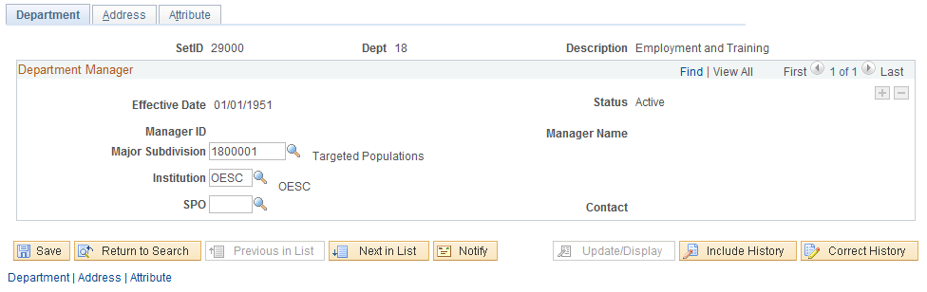
The Tab allows the agency to assign additional properties to the Department ID that will be used in the Grant Proposal creation process.
Manager ID – Assign a Department Manager to the Department.
Major Subdivision – optionally identify a subdivision of the Department. This value is required on the Grant Proposal even if the subdivision is the same as the Department.
Institution – identify the institution that will be using this Department. Generally this will be the agency.
Click the tab.

Address Tab

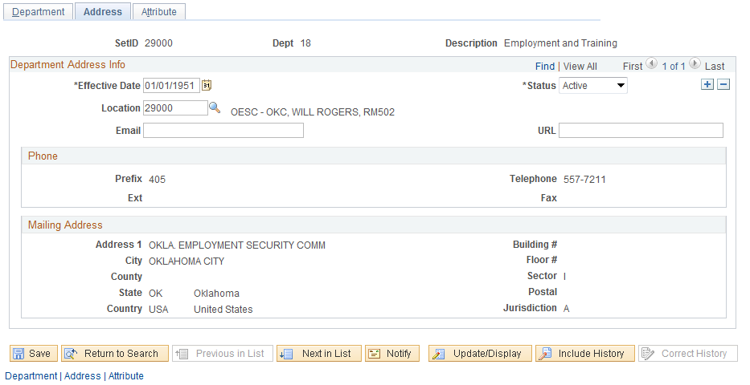
The Tab allows the agency to assign a pre-defined Location value as the address for the Department.
Location – This is a pre-defined physical location that can be linked to the Department. The Location defined for the Department will default into the Grant Proposal as the Project Location (See COREXXX – Grant Proposal and Award Management manual).
Email – Define the email address for the Department Address.
Phone/Mailing Address – These sections of the page will default from the Location value when it is selected.
Click the Tab.

Attribute Tab

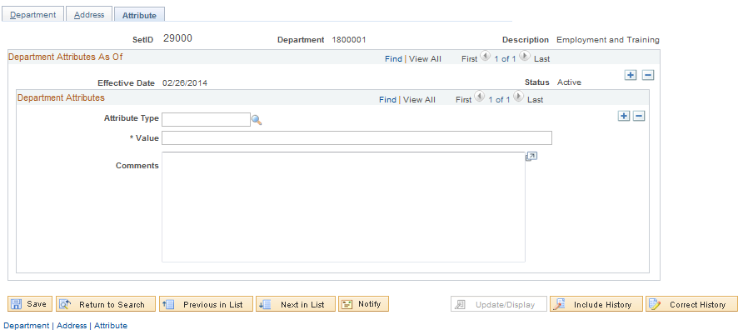
The Tab can store Department specific information defined by the agency. These attributes could be codes, compliance information or grant required parameters.
Attribute Type – The attribute type is a predefined property of the Department.
Value – For the Attribute Type, the value displays the appropriate number or value for the attribute type.
Comments – Enter any comments specific to the Attribute Type.

NOTE: Use the to insert additional Department Attributes.

Department Contacts
Navigation: Grants > Departments > Contacts > Find an Existing Value

Department Contacts Page

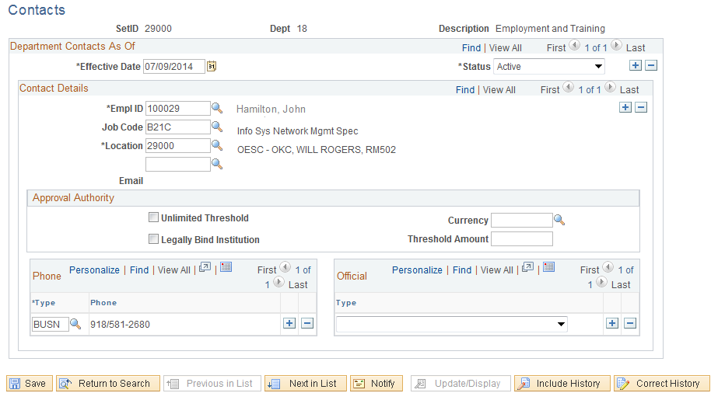

The Department Contacts Page allows the agency to assign individuals as contacts for the Department. When the Department is used in the Grant Proposal and Award process, these Contacts can be assigned as contact resources for the Department.
EmplID – This employee is defined as the Department Contact. The Employee ID can be selected from a pre-defined list of agency resources.
Job Code – This field stores the job for the Department Contact.
Location – The Location defines the physical location for the Department Contact.
Email – Defines the Contact email address for the individual.

NOTE: Use the to insert additional Department Contacts.

Defining Professionals
Professionals are agency personnel that participate in the Grant administration, support or execution roles. Professionals are assigned initially to a Grant Proposal and can be linked to a particular role on the Grant.
Professionals for Grant processing can have various properties including Job Code, Job History or other Grant related Grant information.

Professional Data
Navigation: Grants > Professionals > Professional Data > Find an Existing Value

Professional Data Page
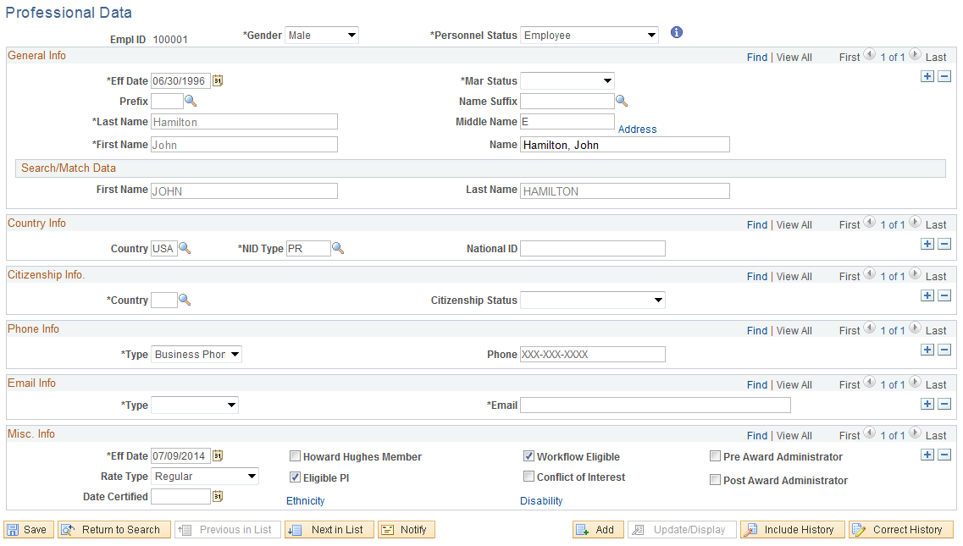
The Professional Data Page displays employment information for agency resources. This information can be used in the Grant Proposal and Award process.
Professional Data Page continued

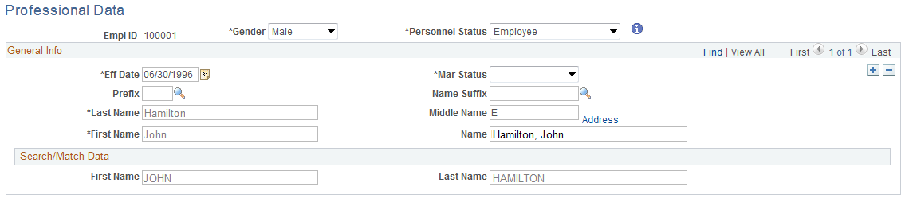
The General Information section of the page displays basic employee data.

The Phone and Email sections of the page display employee phone and email information.
Eligible PI – this checkbox indicates that the individual is eligible to be identified as a Professional on the Grant Proposal (See CORE431 – Grant Proposal and Award Management manual).

Job and Employment Data
Navigation: Grants > Professionals > Job and Employment Data > Find an Existing Value

Job Data Tab
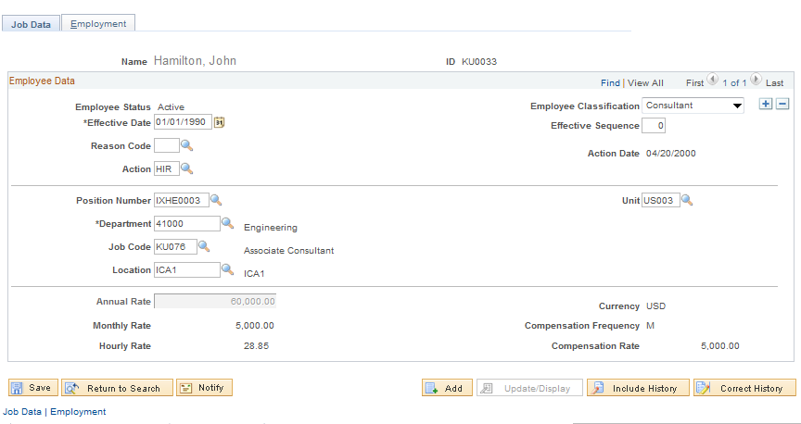
The Tab displays job specific data for the resource.
Department – Defines the Department value for the employee.
Job Code – Indicates the Job Code for the employee.
Location – Defines the Location for the employee.

NOTE: Most of the information on the Job Data page is derived from the HCM System (Human Capital Management).

Click the Tab.

Employment Tab
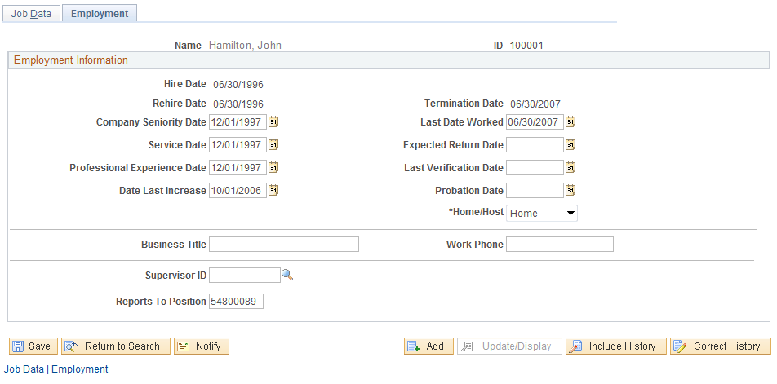
The Tab stores details employment history and additional employment details for the employee.

Additional Grants Setup
In addition to Sponsors, Professional, Departments and Institutions, the Grants system uses additional pre-defined values to create and process Grant Proposals and Awards.

Budget Items
Navigation: Setup Financials Supply Chain > Product Related > Grants > Budget Items > Find an Existing Value

Budget Items Page
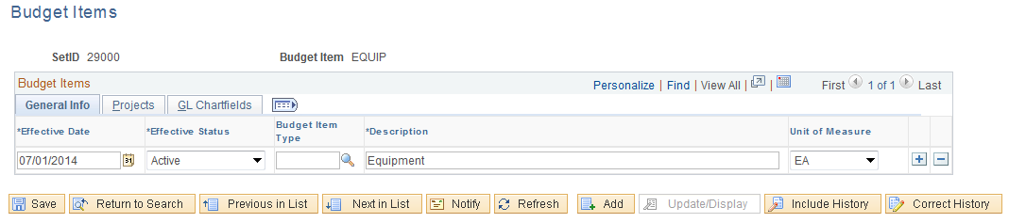
Budget Items define the categories of costs that are included in a Grant Budget. Budget Items can also default in other Chartfield values including both ‘GL Chartfields” and “Project Costing Chartfields”.
When Budget Items are selected onto the Grant Proposal, the Chartfields defined on this page will default onto the Budget Line as well.
Click the Tab.

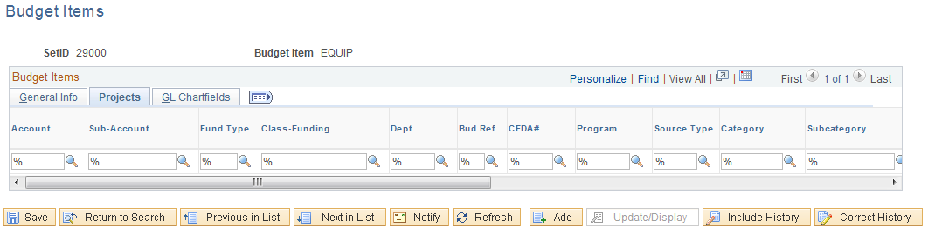
The and Tabs allow the user to define the Chartfields that will default into the Grant Budget Line when the Budget Item is selected.

Facilities Admin Bases (Indirect Cost)
Navigation: Setup Financials Supply Chain > Product Related>Grants > Facilities Admin Bases > Find an Existing Value

Facilities and Administration Bases
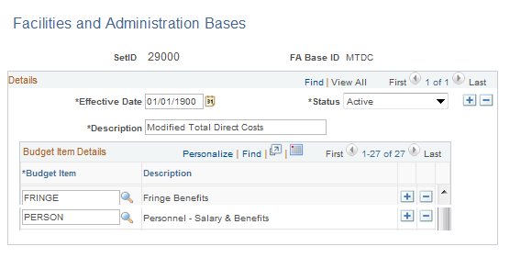
Facilities and Administration Bases store the Budget Items that the system uses to calculate the budgeted F&A (Indirect Costs) Amounts for Grant Proposal Budgets.
F&A and Pricing Setup are configured in the Grant Proposal, including indirect cost rates. Those rates are applied to the Budget Items defined for the Facilities and Administration Bases. The result of that calculation makes up Budgeted F&A or Indirect Cost amounts.

NOTE: F&A Bases are also used in the calculation of actual F&A or Indirect Cost amounts in the Post-Award process. Trees are also used in the calculation of actual Indirect Costs.

Facilities Admin Rates (Indirect Cost)
Navigation: Setup Financials Supply Chain > Product Related>Grants>Facilities Admin Rates > Find an Existing Value

Facilities and Administration Bases
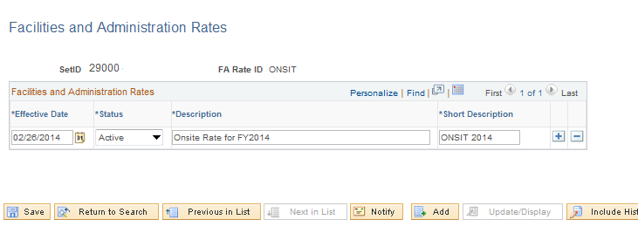

Facilities and Administration Rates are used to store the different F&A or Indirect Cost rates that are negotiated with Sponsors. Used on the Grant Proposal, F&A Rates can store multiple rates if necessary. For example, rates could be different for On-Site versus Off-Site labor.

NOTE: To use multiple F&A Rate, multiple Budget ID’s, (a.k.a. Activity ID’s) must be defined for the Grant Proposal (See CORE431 – Grant Proposal and Award Management manual).

