COR431 Grants - Grants Proposal and Pre-Award Management Manual

The content of this training manual is based largely on a generic system configuration and illustrates the base-line functionality required to execute transactions in the module. Your agency may be utilizing more or less of the functionality illustrated in this manual. This manual is intended to be a framework upon which agencies can add agency-specific training content that speaks specifically to the system functionality that they have deployed and related configuration that they use for transaction processing. Agencies should not depend on these manuals for end-user training or problem resolution until they have been reviewed by the agency for appropriateness.

Authorized by: [_CORE_] Original Issue: [06/01/2010]
Maintained by: [____Grants Lead___] Current Version: [05/01/2014]
Review Date: [05/01/2015]

Table of Contents

Document History 4
Grants Pre-Award Overview 5
Key Terms 6
Grants Business Unit 6
Grants Proposal 6
Grants Award 6
Sponsors 6
Subrecipients 6
Project ID 6
Project Manager and Team 6
Grants Contract Definition 6
Cost Share 7
Letter of Credit Number 7
Process Flows 8
Create a Grants Proposal 11
Step 1: Adding a Grants Proposal 11
Proposal Tab 12
Projects Tab 14
Budgets Tab 16
F&A Sub-Page 17
Resources Tab 18
Professional Details Sub-Page 19
Certifications Tab 20
Reports Tab 21
Attachments Tab 22
Location Tab 23
Key Words Tab 24
Step 2: Building a Grants Proposal Budget 25
Enter Budget Detail Page 27
Overall Cost Sharing Sub-Page 29
Awarding a Proposal 31
Step 1: Submit a Grants Proposal 31
Submission Page 32
Step 2: Award a Grants Proposal 33
Generate Award Page 34
Finalize the Grants Budget 35
Step 1: Finalize the Grants Budget 35
Budget Details Page 36
Copy a Proposal 37
Step 1: Copy from an Existing Proposal 37
Copy Proposal Page 38
Copy a Proposal Budget 40
Step 1: Copy from an Existing Proposal with Budget 40
Copy Budget Period Page 41

Document History

Document Revision | Date | Description
1.0  2.0 | 06/01/2010  05/01/2014 | Initial Document  Upgrade Update

Grants Pre-Award Overview

The Grants module provides functionality to support both Pre and Post Award Grants administration and management. Grants Proposal and Award features include:

- Grants Proposal creation and management
- Grants Proposal Budgeting
- Indirect Cost Budgeting and Calculation
- Automated Federal Reimbursement Calculations
- Review Grants Proposal and Award history online
- Track Expenditure Limits against Grants Budget for reimbursement checking
- Track and manage Award Close-out activities

The Grants module works in combination with the Project Costing module to track and report on Grants funded Projects and Activities.

Key Terms
Grants Business Unit: Each agency has one, and only one Grants Management Business Unit. The Business Unit is the 3 digit agency code, plus 00. For example, Office of State Finance is 09000.

Grants Proposal: The Proposal represents the intent and request for Grants Funding from the State Agency. State Agencies create Grants Proposals that identify resources, projects, budgets, etc. that will be integral in the utilization of the funding request.

Grants Award: Once the Proposal has been negotiated and approved by the sponsoring entity, the Award represents the final agreement between the sponsor and the state agency for receipt and expenditure of funds.

Sponsors: The Sponsor represents the Grants funding source. Generally, this is the Federal Agency through which federal Grants funds are received.

Subrecipients: Subrecipients are entities or individuals that receive Grants funding from the primary Grantee within the parameters of a Grants.

Project ID: Agency program or initiative funded by Grants dollars (a.k.a. set aside). Institution State agency applying for Grants funding and managing the Grants funded projects.

Project Manager and Team: Agency personnel working on Grants funded project.

Grants Contract Definition: The Contract defines funding Sponsor and Draw parameters for reimbursement. Also, defines reimbursable Product, Accounting and Grants funded Project relationships. Facilities and Administration (F&A) the term F&A equates to Indirect Cost calculation for state agencies. This includes budgeting, calculating and accounting for Indirect Costs.

Cost Share: The term Cost Share refers to the agency contributing additional cost in addition to those received from the Sponsor, to accomplish Grants program goals.

Letter of Credit Number: The Letter of Credit ID is a Sponsor specific number used to track Grants draws throughout the system. Letter of Credit Document ID The Letter of Credit Doc ID is a Grants Project specific number, input on the Grants Contract Line, used to track Grants draws throughout the system.

Process Flows

Diagram 1: Grants Module Integration

Diagram 2: Grants Chartfield Flow

Diagram 3: Grants Proposal Model

Create a Grants Proposal

The Grants Proposal represents the agencies application for Grants funding. The Grants Proposal contains a Sponsor of funding, begin and end dates, Indirect Cost rates, Budget dollars, Cost Share configuration and other Grants required information.

Step 1: Adding a Grants Proposal

Navigation: Grants > Proposals > Maintain Proposals > Add a New Value

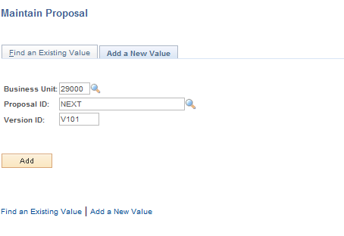

Business Unit – is the Agency in which the Grants Proposal will be created.

Proposal ID – leave this value as ‘NEXT’, as the system will sequentially assign the next available Proposal ID.

Version ID – is the Version number for this Proposal. Leave this value as the default for the first version of the Proposal.

Click to enter the Grants Proposal pages.

Proposal Tab

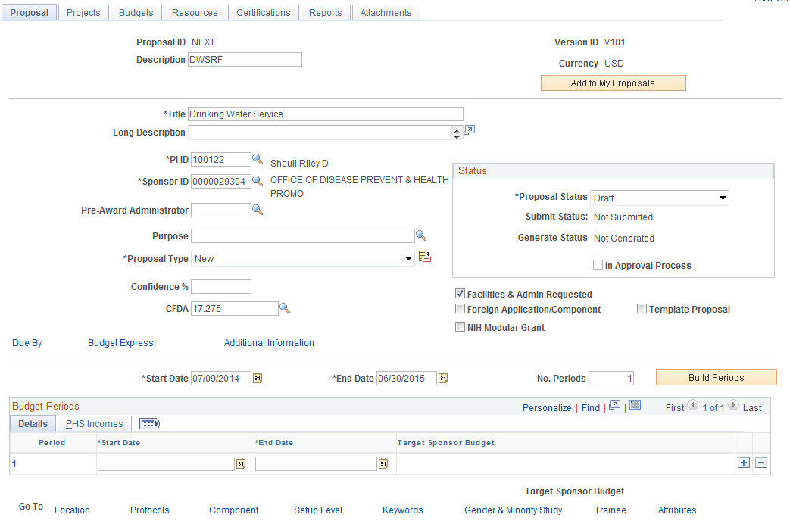

The Tab defines general information and processing options for the Grants Proposal.

NOTE: Not all fields available in Grants pages will be defined and explained in this training manual. Those fields not referenced in the manual are generally not required for transaction processing.

Description – enter a general description of the Grants Proposal.

Title – enter a Title for the Grants Proposal. This generally will be a more specific descriptive value than the Proposal Description.

PI ID – the ‘Primary Investigator’ is the agency resource identified as the lead individual for the Grants Proposal.

Sponsor ID – the Sponsor represents the entity responsible for evaluating, approving and Grantsing the funding for this Proposal.
Proposal Type – describes the kind of Grants Proposal. For a first time Grants Proposal, use the ‘New’ value.

CFDA – select from a pre-defined list of federally issued CFDA numbers.

Proposal Status – defines a particular status for the Grants Proposal. For new proposals, leave this value as ‘Draft’.

Facilities and Administration Requested – select this checkbox if using the delivered F&A or Indirect Cost rates and calculation process.

Proposal Tab continued

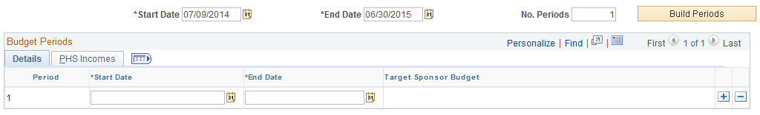

Start Date – populate with the Grants start date.

End Date – populate with the Grants end date.

NOTE: The Start and End Dates may or may not coincide with the state fiscal year.

No Periods – enter the number of Grants Periods between the Start and End Dates defined.

- Click to build the Grants periods based on the Start and End Date.

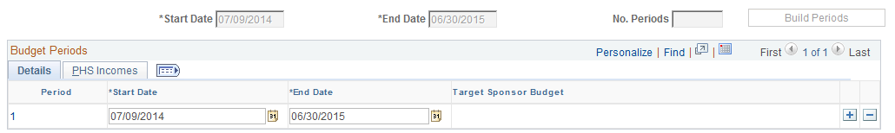

The Grants Periods will be built based on the Start and End Dates and the Number of Periods.

Click the Tab.

Projects Tab

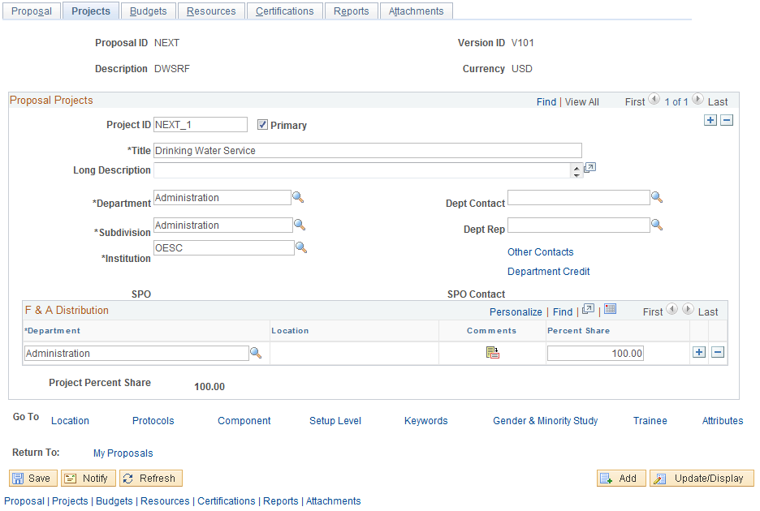

The Tab defines details for one or more Project ID’s that will be funded in this Proposal.

Project ID – Populate with the Grants Funded Project ID for this Proposal. A Grants Proposal funds one or many Projects identified by the Project ID chartfield.

NOTE: The Project ID naming convention will be specific for each agency using the Grants and Projects modules.

NOTE: Use the to insert additional Project ID’s for this Proposal.

Title – Populate a Title for each Project ID in the Proposal. The Title represents a description for the Project ID.

NOTE: See the Process Flows section of this manual for an explanation of the mapping of fields from the Proposal to the Award definition.

NOTE: If the Proposal is Awarded to a Grants Award, the Title will become the Project ID Description field shown on Project ID search pages See the Process Flows section of this manual for an explanation of the mapping of fields from the Proposal to the Award definition.

Department /Department Contact – select an agency Department ID and Department Contact (optional). The available values are the existing Department ID chartfield values.

Subdivision/Department Rep - select an agency Subdivision and Department Rep (optional). The available values are the existing Department ID chartfield values.

Institution – the Institution field will represent the agency. It is the equivalent of the Grants Business Unit.

Projects page continued

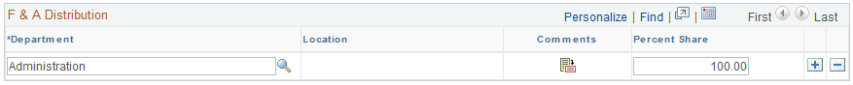

Department – when using the F&A (Indirect Cost) feature; populate the department field with the Department ID chartfield value that will be assigned to F&A budget transactions.

Percent Share – to split F&A transactions between Department ID values, populate the Percent Share for each.

NOTE: Use the to insert additional Department ID values.

Click the Tab.

Budgets Tab

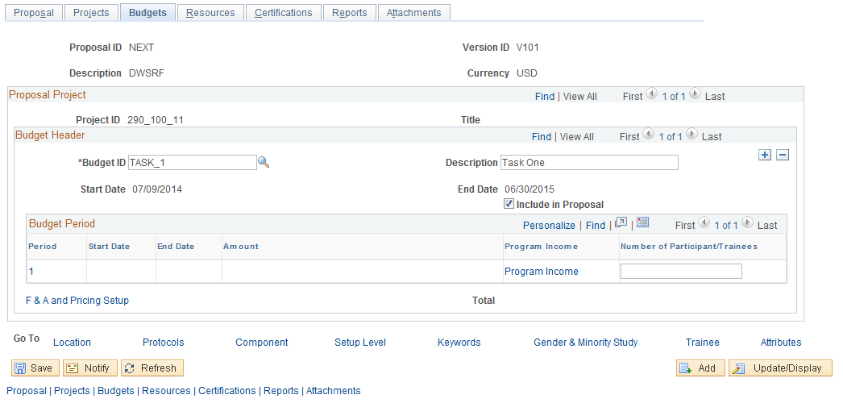

The Tab defines Budget ID’s for each Project ID in the Proposal. The budget amounts can be accessed and updated for each Budget Period in the Project for the Proposal by using the link.

Budget ID – for each Project ID in the Proposal, populate one or more Budget ID values that will be used to budget Grants amounts and track Grants costs. The Budget ID value will become the Activity ID value for the Project if the Proposal is Awarded.

NOTE: The Budget ID can be created ‘Free-Form’ or can be selected from a prompt list.

NOTE: See the Process Flows section of this manual for an explanation of the mapping of fields from the Proposal to the Award definition.

NOTE: Use the to insert additional Budget ID’s as necessary for the Project.

Description – enter a description for each Budget ID created.

Budget page continued

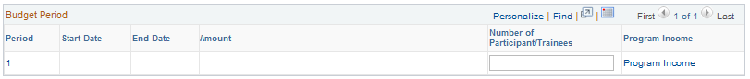

Period – use the Period link to drill to the Budget pages where the Proposal Budget can be created. The steps to create the Proposal Budget are defined later in this section. Click .

Click F & A and Pricing Setup to define the Indirect Cost Budgeting Rules. You will be asked to save your work before proceeding. Click and click . If you have not filled in Location, you will be prompted to do so, then click . Return to the Tab if you are not there.

F&A Sub-Page

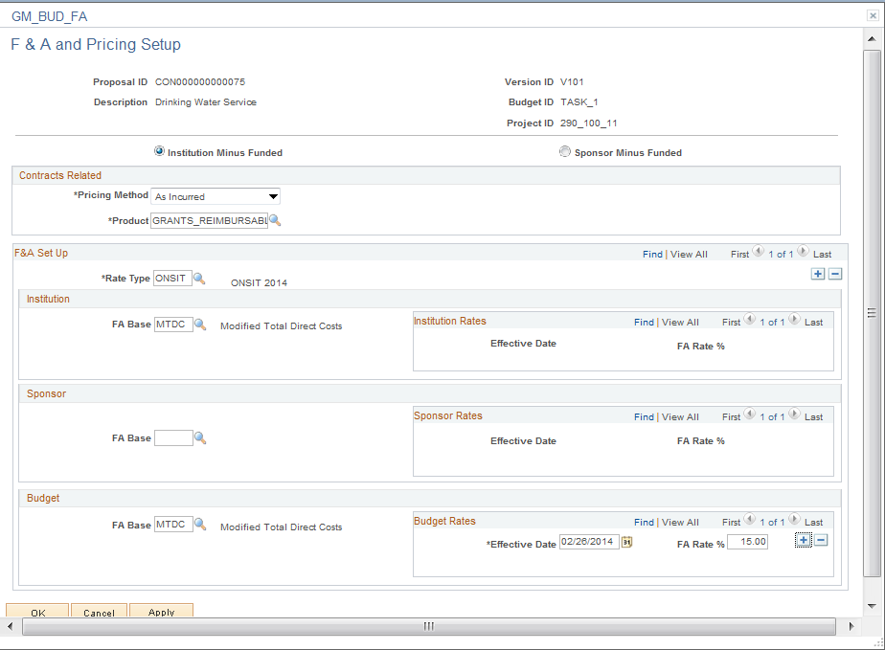

For the Project and Budget ID, define the Product for F&A calculations, the Rate Type and FA Bases. The FA Base on the Budget section of the page is used to calculate the Proposal F&A Budget.

Click to return to the Budgets page.

Click the Tab.

Resources Tab

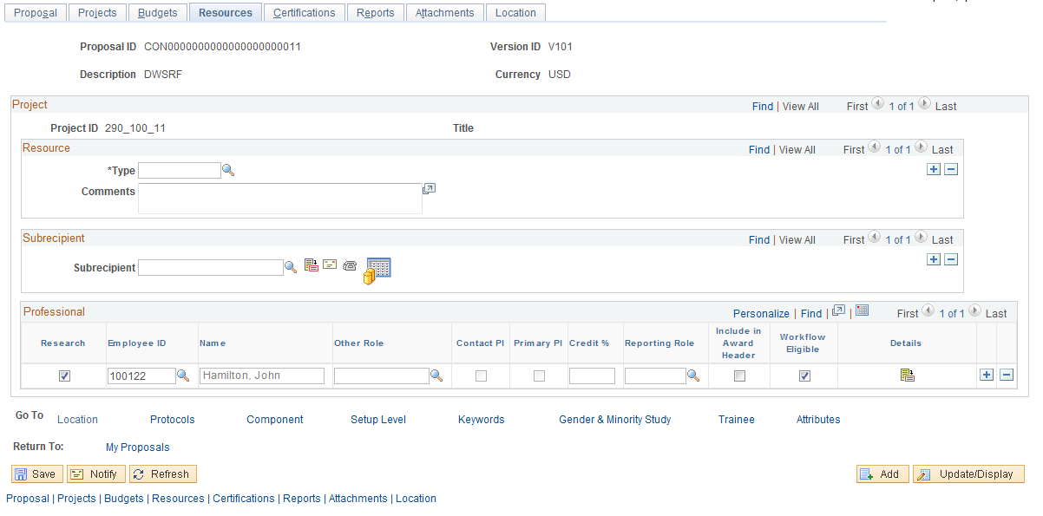

The Tab defines Resource Types for the Grants Project as well as additional Professionals (in addition to the Principal Investigator). Resource Types are generally used for higher education Grants.

Type – If defined, populate the Resource Type value for the Proposal Project.

Subrecipient – To track Sub-recipient activity for this Proposal Project, select from a pre-defined Vendor value.

NOTE: Since Subrecipients receive funding through the primary recipient (state agency) they are considered a type of vendor by the system.

Professional – populate the individuals that will work on the Grants Funded Project. By default the Principal Investigator (PI) populated on the Proposal page will default into this section of the page.

Use the icon to populate additional detail for each Professional entered in this section of the page.

Professional Details Sub-Page

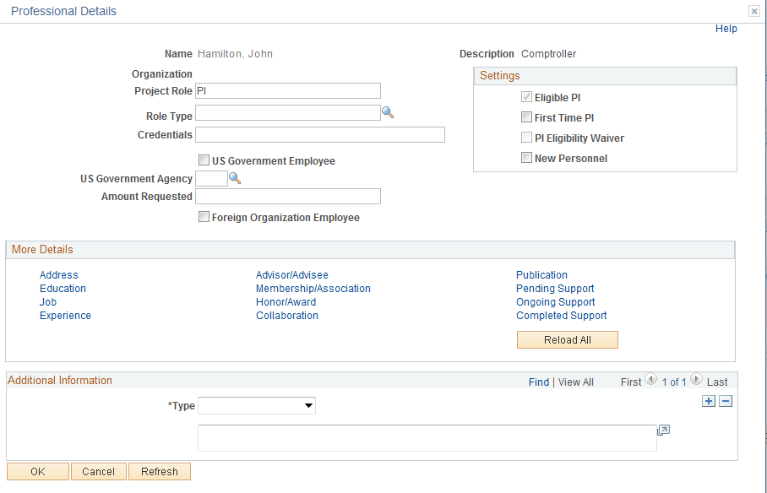

The Professional Details page allows additional information for each individual assigned to the Grants Proposal Project.

Click to return to the Resources page.

Click the Tab.

Certifications Tab
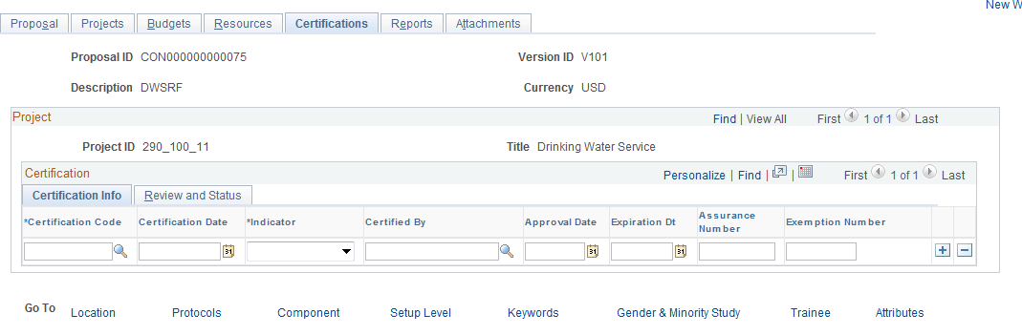

The Tab allows the user to populate certifications applicable to the Grants Project. These certifications could be for things like “Smoke Free Environment” or “Drug Free Workplace”.

Certification Code – select from the pre-defined list of Certification Codes.

Certification Date – define the date that the certification is applicable.

Indicator – indicate whether or not the certification is active.

Certified By – define by whom the certification has been approved. Select from a list of agency employees.

Approval Date – select the date on which the certification is approved.

Expiration Date - select the date on which the certification expires.

Assurance/Exemption – if applicable, define these values for the certification.

Use the Sub-Tab to define any certification review information.

Click the Tab.

Reports Tab

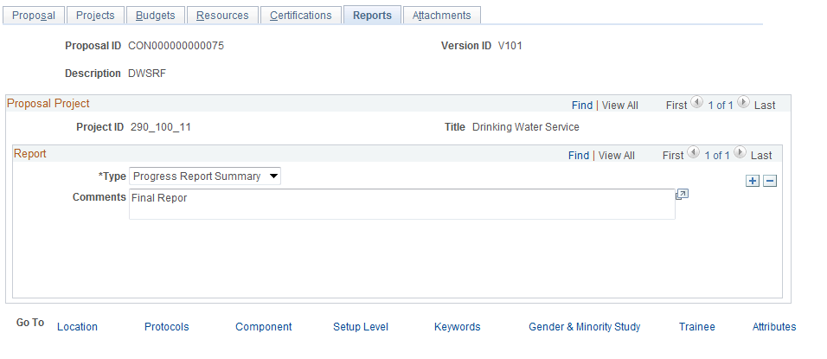

The Tab allows the user to define different report Types and store pertinent Comments for each type report.

Type – Select the appropriate report type from the available values.

Comments – Enter any comments that need to be tracked for the report type selected.

Click the Tab.

Attachments Tab

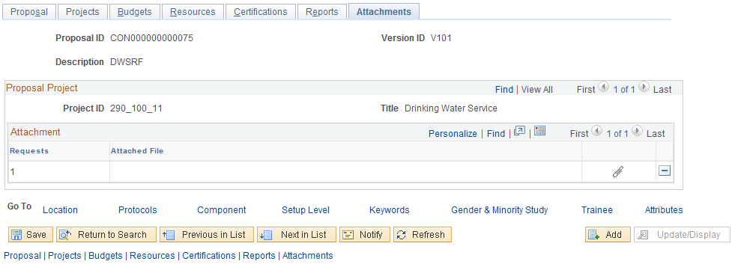

The Tab allows the user attach a document (Microsoft Word, Excel, etc.) to the Grants as supporting documentation. These could include work papers, design specifications, etc.

Use the icon to select a file that will be uploaded into the system and attached to the Grants Proposal.

Once the file is attached, use the icon to remove the file from the Proposal or the icon to view the document.

Click the Location link at the bottom of the page.

Location Tab

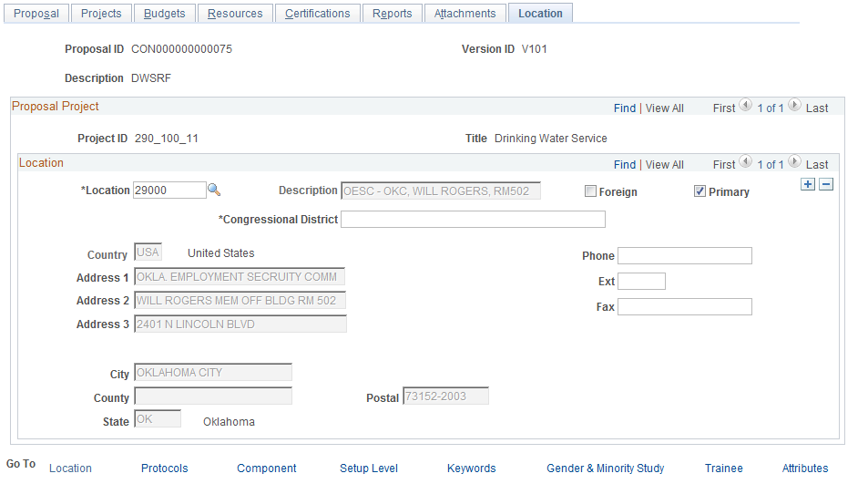

The Tab allows the user to define the physical location for each Proposal Project.

NOTE: The Location value selected here will become the Project Location when the Proposal is generated into an Award.

Location – select the physical location value from the pre-defined list. These location values should be specific locations within the agency.

Phone/Extension/Fax – these fields are available to populate with specific values for this Grants Proposal.

Click the Keywords link at the bottom of the page.

Key Words Tab

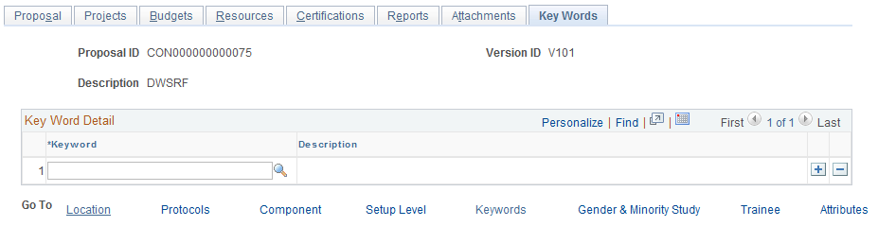

The Tab allows the user to select from pre-defined key words or categories for the Grants Proposal. Key Words will be defines specifically for each agency and could be related to things like jurisdiction, level of effort subject category, etc.

Key Word – Select from the pre-defined list of key work values defined by the agency.

Click to Save the Grants Proposal and created the Proposal ID.

Step 2: Building a Grants Proposal Budget

Navigation: Grants > Proposals > Enter Budget Detail > Find an Existing Value

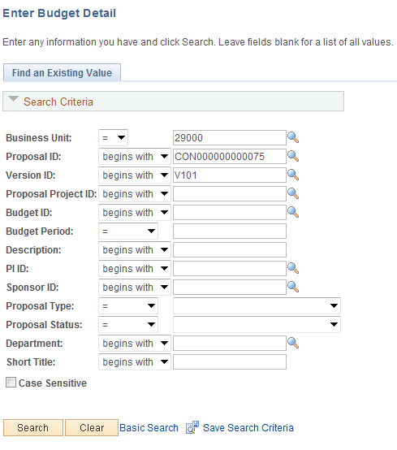

Use the Search Criteria to select the Proposal for which the Budget needs to be created.

Click to enter the Budget Detail pages.

Or
Proposal Tab

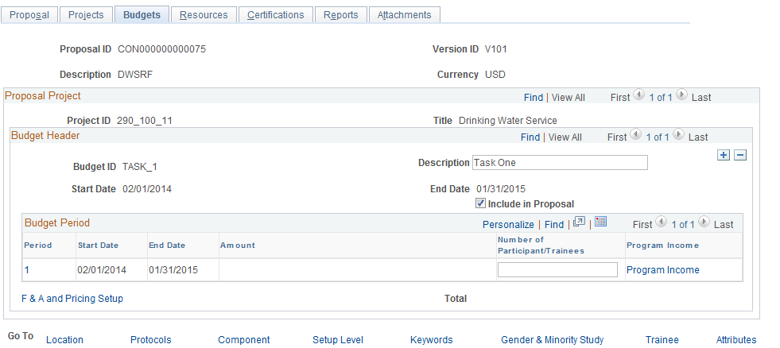

From the Maintain Proposal component, select the link for the Budget Period on the Budget page. This will direct the user to the Budget Detail pages.

NOTE: The Grants Proposal Budget is created and stored by the Grants Periods, Project ID(s) and Budget ID’s defined in the Grants Proposal.

Enter Budget Detail Page

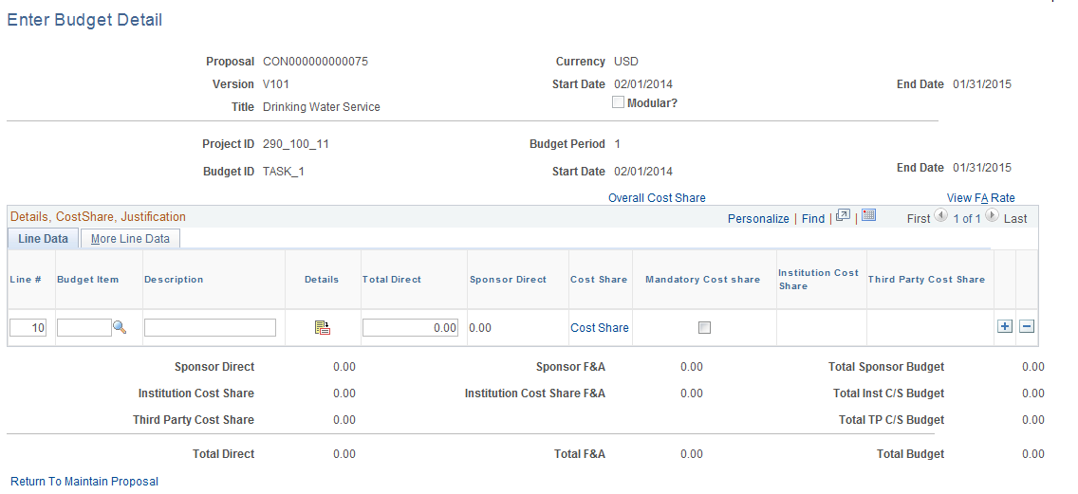

The Budget Detail page allows the user to define the Budget for the Grants Proposal. The Budget Items make up the Line Items for the Budget. Grants Cost Sharing details can be entered for the entire budget or for a particular budget line item(s). Totals are dynamically calculated at the bottom of the page for Sponsor, Institution, F&A and Cost Share amounts.

Enter Budget Details page continued

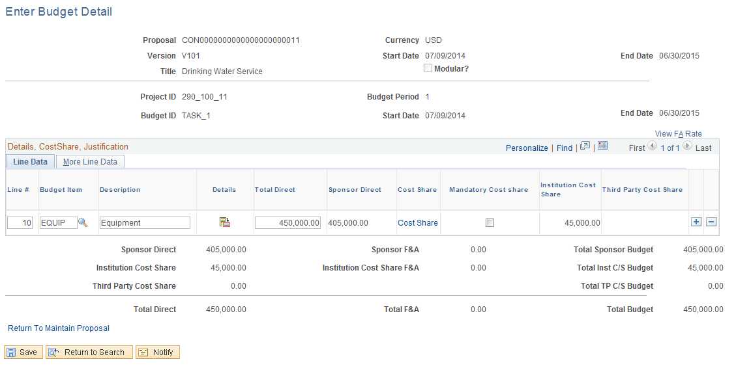

The Budget Details page allows the user to select the required, pre-defined Budget Items that make up the Grants Proposal Budget. For each Budget Item populate the Total Direct amount field.

NOTE: If Overall Cost Share is defined for the Grants Proposal, the system will allocate the correct amounts to Agency Cost Share and Sponsor Direct costs.

Line # - the system will assign the Budget Line Numbers for each Budget Line defined.

Budget Item – select the Budget Item(s) that make up this Grants Proposal Budget.

NOTE: Budget Items are defined by each agency. Depending on the requirements of each agency, Grants budget preparation process there could be One (1) or Many Budget Items.

Total Direct – for each Budget Line (Budget Item) define the amount of costs that will be budgeted.

NOTE: Use the to insert additional Budget Items.

To define Cost Sharing for the Grants Proposal, click the Overall Cost Share link.

Overall Cost Sharing Sub-Page

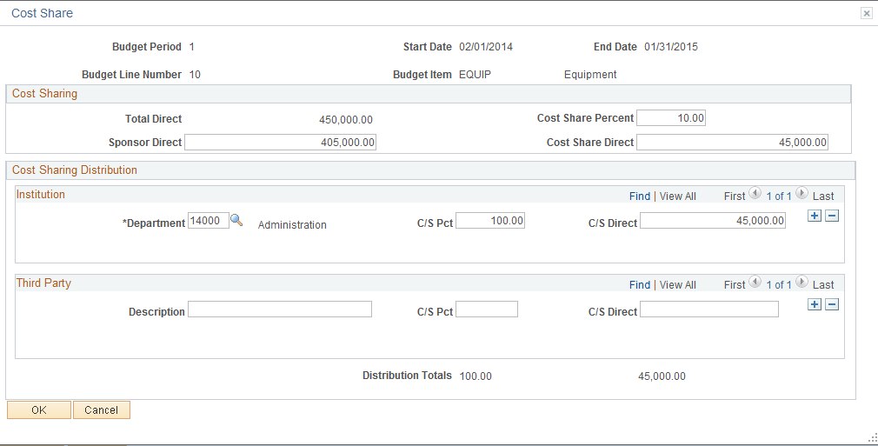

The Overall Cost Sharing page allows the user to define ‘Overall’ agency share of Grants Proposal budget amounts. The agency Cost Share can also be attributed to a Department within the Agency and/or to a Third Party entity.

Cost Share Percent – define the agency share of proposal budget dollars by percent. This percent will be applied to all Budget Lines defined on the Budget Details page.

Cost Share Direct – this field can be dynamically populated by using the Cost Share Percent field, or define the amount of agency Cost Share (monetary versus percentage).

Department – define the agency Department(s) that will bear the Cost Share. The value defined here will be assigned to the Cost Share budget lines when the budget is created in the Award process.

NOTE: Use the to insert additional Department ID’s as necessary for the Cost Sharing.

C/S Percent – for each Department define the percent of the Cost Share that will be attributed to that Department.
C/S Direct - for each Department define the amount of the Cost Share that will be attributed to that Department.

Description – to define a Third Party Cost Share, populate the Description for the Third Party.

C/S Percent – for each Third Party define the percent of the Cost Share that will be attributed to that Department.

C/S Direct - for each Third Party define the amount of the Cost Share that will be attributed to that Department.

Click to return to the Budget Details page.

Enter Budget Details page continued

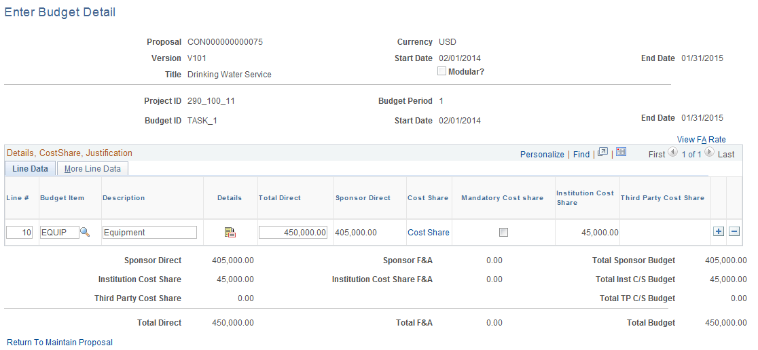

The Budget Details page displays the calculations of the Cost Share if defined. The Sponsor Direct amount reflects the Sponsor portion of the entire budget. The Institution Cost Share amount reflects the agency cost share portion of the entire budget. Total Direct amount reflects the total amount of the Proposal budget.

NOTE: Use the Cost Share link on the Budget Line to define agency Cost Share by Line. The mechanics of populating the Cost Share by line are the same as those for the Overall Cost Share configuration.

Use the View F&A Rate link to see Indirect Cost configuration for this Proposal.

To return to the Grants Proposal pages, use the Return to Maintain Proposal link.

Click to Save the Grants Proposal Budget.

Awarding a Proposal

Once the Grants Proposal has been negotiated with the Sponsor, required adjustments have been made and the Proposal is ready to become a complete Grants, the Proposal must be ‘Awarded’ in the system. This process is also called ‘Award Generation’ in the system.

Step 1: Submit a Grants Proposal

Navigation: Grants > Proposals > Submit Proposals > Find an Existing Value

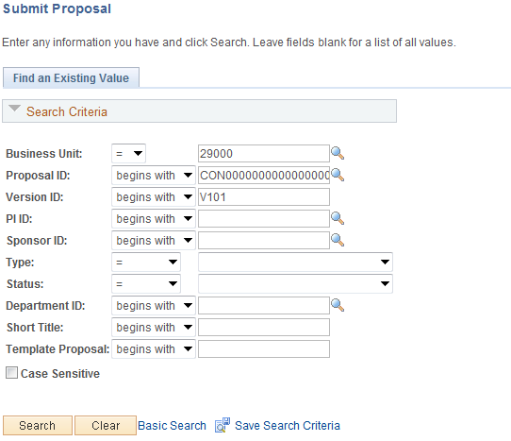

Use the Search Criteria to select the Proposal that needs to be Submitted for Award.

Click to enter the Proposal Submission pages.

Submission Page

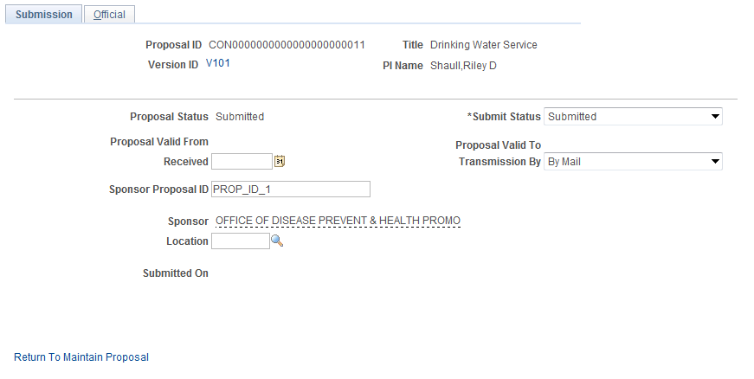

The Submission page allows the user to define parameters for submitting the Grants Proposal for Award.

NOTE: The Grants Proposal MUST be submitted before it can be Awarded.

Submit Status – the Submit Status must be set to ‘Submitted’ for the Grants Proposal to be ‘Awarded’.

Sponsor Proposal ID – the sponsor opportunity or proposal number can be stored in this field.

Transmission By – the method by which the Grants Proposal is submitted to the sponsor can be tracked.

Use the Official Tab to manage Approval Workflow for the Grants Proposal.

NOTE: Grants Proposal workflow must be configured for the agency before the Official page can be used as a workflow approval mechanism.

Click to Save the Grants Proposal in Submitted status.

Step 2: Award a Grants Proposal

Navigation: Grants > Proposals > Generate Award > Find an Existing Value

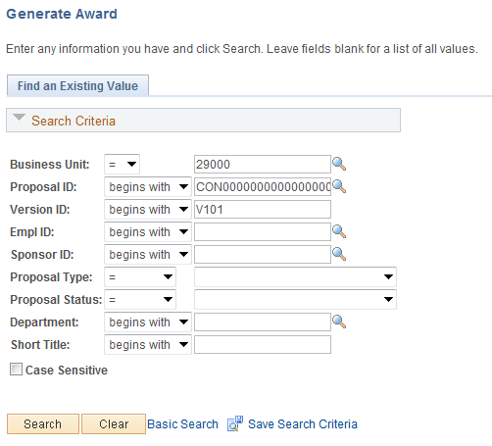

Click to retrieve the Asset based on the Search Criteria provided.

Generate Award Page

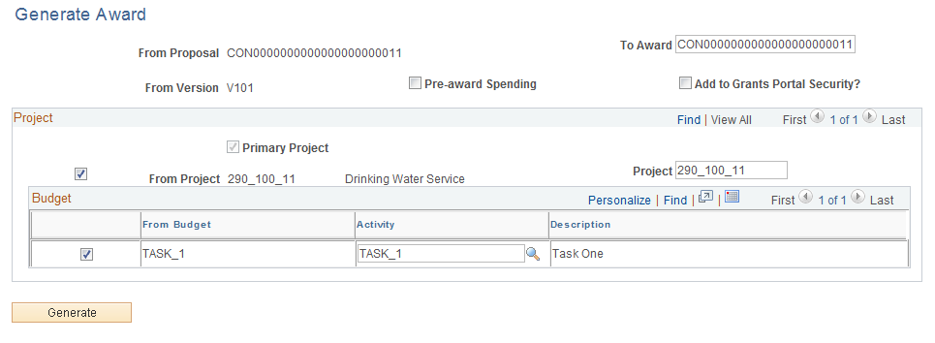

The Generate Award page allows the user to define how the Grants Proposal will be mapped to the Grants Award Profile.

From Proposal – this value is the existing Proposal ID.

To Award – once the Proposal is ‘Generated’ to an Award, this value will be the Award Profile ID as well as the Grants Contract that facilitates Grants draws from the Sponsor.

Pre-award Spending – this one-time option allows the agency to created the Project ID and Activity ID ONLY to begin Grants spending (through Requisitions, Purchase Orders and Vouchers) before the Award Profile and Grants Contract is created.

From Project – this value is the Project ID from the Grants Proposal.

Project – this value will be the Project ID when the Award is Generated.

From Budget – this value is the Budget ID from the Grants Proposal.

Activity - this value will be the Activity ID when the Award is Generated.

NOTE: The To Award, Project and Activity fields can be change on this page before the button is selected. Once the button is selected, these values CANNOT be changed.

Click to create the Award Profile including Grants Contract, Project(s) and Activities.

Finalize the Grants Budget
Once the Grants Proposal has been negotiated, approved and awarded, the Grants Budget must be finalized to update the Commitment Control ledgers and the Project Costing module.

This process includes accessing the Grants Budget defined during the Proposal creation process, reviewing and updating the Budget if necessary, and Finalizing the Budget.

Grants Budgets are retrieved by the Project ID’s defined in the Grants Proposal.

Step 1: Finalize the Grants Budget

Navigation: Grants > Awards > Project Budgets > Find an Existing Value

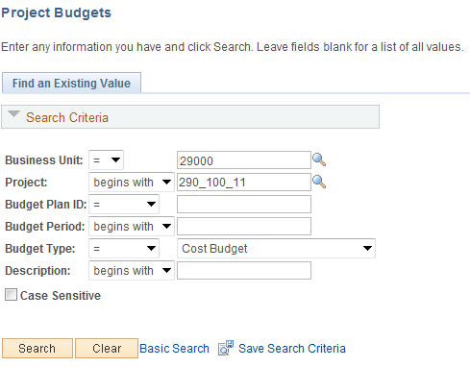

Business Unit – the agency business unit value in which the Grants Project budget is stored.

Project – the Grants Project in which the budget is defined.

Click to enter the Budget Details pages to Finalize the Budget.

Budget Details Page
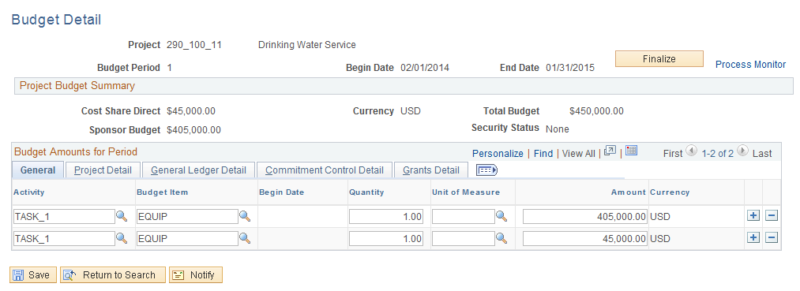

The Budget Details page allows the user to review and add additional chartfield values to the Budget Lines created in the Proposal. In addition to the chartfield values defaulted into Budget Lines from the Budget Items, an agency may choose to add additional GL chartfields to the Budget Lines for reporting purposes.

NOTE: The Grants Proposal Budget is created and stored by the Grants Periods and Project ID(s) with Budget ID values also available.

Cost Share Direct – this field displays the total amount of agency Cost Share if applicable.

Total - displays the amount of the Sponsor applicable Project Budget.

Total Budget – displays the total amount of the Grants Project Budget.

General Tab – use the chartfield fields on the General tab to define more chartfield values if necessary.

NOTE: Use the to insert additional Budget Rows as necessary to split budget costs. For example, to split a budget line between fiscal years (Budget Ref), insert an additional row and allocate the costs between the Budget Ref values as appropriate.

Click to finalize the Grants Project Budget and update the Commitment Control and Project Costing modules.

Use the Process Monitor link to view the status of the Finalization process.

NOTE: Once the Grants Project Budget has been finalized, revisions can be done thru this page as well.

Copy a Proposal

When a Grants Proposal has been saved in the system, it is available to copy from when new Proposals are being developed. This would be useful when there is a new Proposal that needs much of the same content as an existing Proposal. Rather than created the new Proposal from scratch, the existing Proposal can be used as a template to copy needed information.

This feature may be useful for Grants that are renewed each year and keep much of the same information and need only minor adjustments from year to year.

Step 1: Copy from an Existing Proposal

Navigation: Grants > Proposals > Copy Proposal > Find an Existing Value

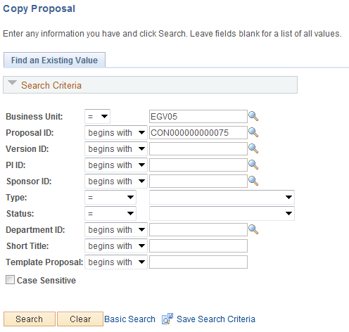

Use the Search Criteria to select the Grants Proposal that will be copied from.

Click to enter the Copy Proposal pages.

Copy Proposal Page

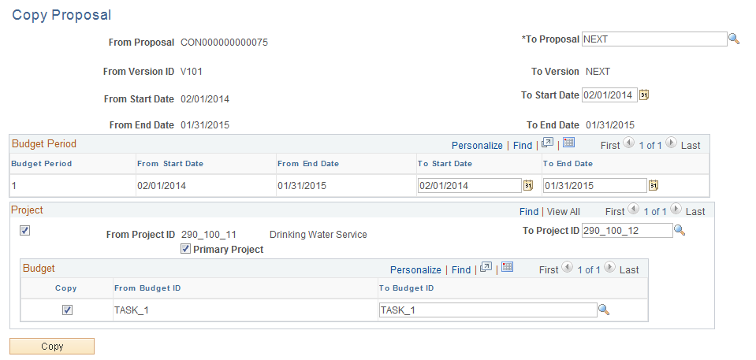

The Copy Proposal page displays information from the Proposal that will be copied from as well as details from the Proposal that will be created from the copy. The source Proposal information is labeled as “From” while the target Proposal is labeled as “To”.

From Proposal – the Grants Proposal that will be copied from.

To Version ID – this field is the version of the Proposal that will be copied from.

From Start/End Date – the Proposals start and end period dates from the source Proposal.

To Proposal – use ‘NEXT’ to allow the system to assign the next available Proposal ID, or populate the Proposal ID number.

To Version – leave this field as ‘NEXT’ to allow the system to assign the new Version ID.

To Start/End Date – for the new Proposal, populate the Grants Proposal start and end dates.

Budget Period Start/End Dates – populate the start and end dates for each Budget Period in the new Proposal.

NOTE: There can be one or many Budget Periods within the Grants Proposal.

From Project – displays the Project(s) from the source Proposal.

To Project – for the new Proposal, allow the system to assign the next Project ID by leaving this field set to ‘NEXT’. Alternatively, populate the Project ID.

NOTE: For most agencies, the Project ID will be populated by the user on this page when creating the new Proposal to comply with agency Project ID naming standards.

From Budget ID – this field displays the Budget ID from the source Proposal.

To Budget ID – this field holds the new Budget ID for the target Proposal.

Click to execute the copy function and create the new Grants Proposal.

NOTE: The Copy Proposal feature will copy information from the Proposal including Descriptions, Sponsor, Professional(s), Departments, Budget Details and any other Grants Proposal properties. If changes need to be made to the target Proposal, retrieve the new Proposal and make necessary changes.

NOTE: The new Proposal will be created in ‘Draft’ status and will need to be reviewed, saved and submitted before it can be Awarded.

Copy a Proposal Budget

A Proposal ID, any number of its child Projects, and selected Proposal Budgets and Periods can be copied from one Proposal to another without reentering data. This feature is helpful when created a Proposal that is similar to one that already exists in the system. In addition, a budget can be copied from one Budget Period to another within the same Proposal.

Step 1: Copy from an Existing Proposal with Budget

Navigation: Grants > Proposals > Copy Budget Period > Find an Existing Value

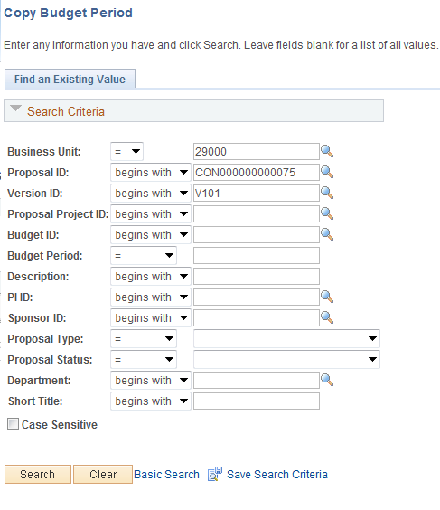

Use the Search Criteria to select the Grants Proposal that will be copied from.

Click to enter the Copy Budget Period pages.

Copy Budget Period Page

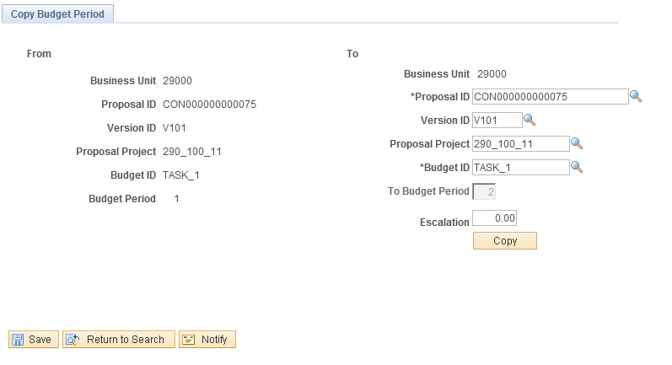

Use the Copy Budget Period page to define the ‘Target’ Proposal information that will be created through the copy feature.

Use the ‘To’ side of the page to define the Target values:
- Proposal ID – define the target Proposal ID. This could be the same proposal if copying to a new Budget Period.
- Version – define the new Proposal Version.
- Proposal Project – define the target Project ID.
- Budget ID – define the new Budget ID.
- To Budget Period – this field will be incremented by 1 to create a new Budget Period.
- Escalation – use this field to inflate all budget amounts by the specified percent when they are copied to the new budget period.

NOTE: When copying to a new Budget Period within an existing Proposal, the Budget Period must be defined before the copy feature can be executed.

Click to execute the copy process.

