COR432 Grants – Grants Post-Award Management Manual

The content of this training manual is based largely on a generic system configuration and illustrates the base-line functionality required to execute transactions in the module. Your agency may be utilizing more or less of the functionality illustrated in this manual. This manual is intended to be a framework upon which agencies can add agency-specific training content that speaks specifically to the system functionality that they have deployed and related configuration that they use for transaction processing. Agencies should not depend on these manuals for end-user training or problem resolution until they have been reviewed by the agency for appropriateness.

Authorized by: [_CORE_] Original Issue: [06/01/2010]
Maintained by: [____Grants Lead___] Current Version: [05/01/2014]
Review Date: [05/01/2015]

Table of Contents

Document History 5
Grants Post-Award Overview 6
Key Terms 7
Grants Business Unit 7
Grants Proposal 7
Grants Award 7
Grants Professionals 7
Sponsors 7
Sub-recipients 7
Project ID 7
Institution 7
Project Manager and Team 7
Grants Contract Definition 8
Facilities and Administration (F&A) 8
Cost Share 8
Process Flows 9
Award Profile 12
Step 1: View and Update an Award Profile 12
Award Tab 13
Funding Tab 15
Terms Tab 16
Milestones Tab 17
Grants Projects 18
Step 1: Project General Information 18
General Information Tab 19
Project Department Tab 21
Location Tab 22
Attachments Tab 23
Step 2: Define Project Teams 24
Team Tab 25
Team Detail Tab 27
Step 3: Set Project Status 29
Project Status Page 30
Grants Activities 31
Step 1: Activity General Information 31
General Information Tab 32
FA Rates Page 33
User Fields Tab 34
Rates Tab 35
Step 2: Set Activity Status 36
Activity Status Page 37
Funds Distribution 38
Step 1: Define Funds Distribution 38
Funds Distribution Tab 40
Target Definition Tab 41
Process Facilities and Administration 43
Process Facilities and Administration 43
Grants Contracts 46
Step 1: Complete and Activate Grants Contract 46
General Tab 49
Lines Tab 50
Accounting Distribution Page 51
Related Projects Tab 52
Transaction Limits Sub-Page 53
Assign Billing Plan Page 55
Billing Plan General Tab 57
Assign Revenue Plan Page 60
Billing Options Tab (Letter of Credit) 63
General Tab – Activate the Contract 65
Step 2: Contract Support Teams 66
Support Team by Contract Page 67
Grants Contract Processing 68
Run Contract to Billing Interface 68
Process As Incurred Billing Page 69
Process Scheduler Request Page 71
Grants Contract Amendments (Billing Limit Adjustment) 72
General Tab 73
Amendments Tab 74
Amendment Details Page 76

Document History

Document Revision | Date | Description
1.0  2.0 | 06/01/2010  05/01/2014 | Initial Document  Upgrade Update

Grants Post-Award Overview

The Grants module provides functionality to support both Pre and Post Award Grants administration and management. Grants Proposal and Award features include:

- Grants Proposal creation and management
- Grants Proposal Budgeting
- Indirect Cost Budgeting and Calculation
- Automated Federal Reimbursement Calculations
- Review Grants Proposal and Award history online
- Track Expenditure Limits against Grants Budget for reimbursement checking
- Track and manage Award Close-out activities

A Grants Proposal must be submitted and ‘Generated’ in the system before the Award Profile can be seen and reviewed. The Award Generation process is effectively the ‘Gateway’ to the Award Profile and Grants Administration features.

Post-Award activities are largely accomplished through the Project Costing, Contracts and Billing modules. Since Grants Awards budgets and expenditures are stored and tracked by Project ID and Activity ID, the Project Costing module plays a major role in Grants reporting. The Contracts and Billing modules facilitate federal draws including Letter of Credit identifiers, limits and revenue accounting entries.

Key Terms
Grants Business Unit: Each agency has one, and only one Grants Management Business Unit. The Business Unit is the 3 digit agency code, plus 00. For example, Office of State Finance is 09000.

Grants Proposal: The Proposal represents the intent and request for Grants Funding from the State Agency. State Agencies create Grants Proposals that identify resources, projects, budgets, etc. that will be integral in the utilization of the funding request.

Grants Award: Once the Proposal has been negotiated and approved by the sponsoring entity, the Award represents the final agreement between the sponsor and the state agency for receipt and expenditure of funds.

Sponsors: The Sponsor represents the Grants funding source. Generally, this is the Federal Agency through which federal Grants funds are received.

Subrecipients: Subrecipients are entities or individuals that receive Grants funding from the primary Grantee within the parameters of a Grants.

Project ID: Agency program or initiative funded by Grants dollars (a.k.a. set aside). Institution State agency applying for Grants funding and managing the Grants funded projects.

Project Manager and Team: Agency personnel working on Grants funded project.

Grants Contract Definition: The Contract defines funding Sponsor and Draw parameters for reimbursement. Also, defines reimbursable Product, Accounting and Grants funded Project relationships. Facilities and Administration (F&A) the term F&A equates to Indirect Cost calculation for state agencies. This includes budgeting, calculating and accounting for Indirect Costs.

Cost Share: The term Cost Share refers to the agency contributing additional cost in addition to those received from the Sponsor, to accomplish Grants program goals.

Letter of Credit Number: The Letter of Credit ID is a Sponsor specific number used to track Grants draws throughout the system. Letter of Credit Document ID The Letter of Credit Doc ID is a Grants Project specific number, input on the Grants Contract Line, used to track Grants draws throughout the system.

Process Flows

Diagram 1: Grants Module Integration

Diagram 2: Grants Chartfield Flow

Diagram 3: Grants Proposal Model

Award Profile

The Award Profile is created when the Grants Proposal is Awarded through the ‘Award Generation’ process. The Award Profile inherits most of the information from the Grants Proposal and populates required Grants Project information.

Step 1: View and Update an Award Profile

Navigation: Grants > Awards>Award Profile > Find an Existing Value

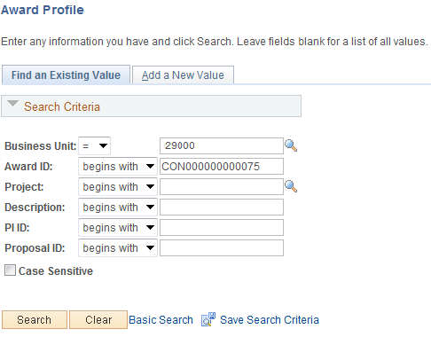

Use the Search Criteria to retrieve the Award Proposal.

Business Unit – is the Agency in which the Grants Award is stored.

Award ID – the Award ID created thru the Award Generation process.

PI ID – to retrieve Awards for a particular Professional use this field.

Proposal ID –search by all or part of the Proposal ID.

Click to enter the Award Profile pages.

Award Tab

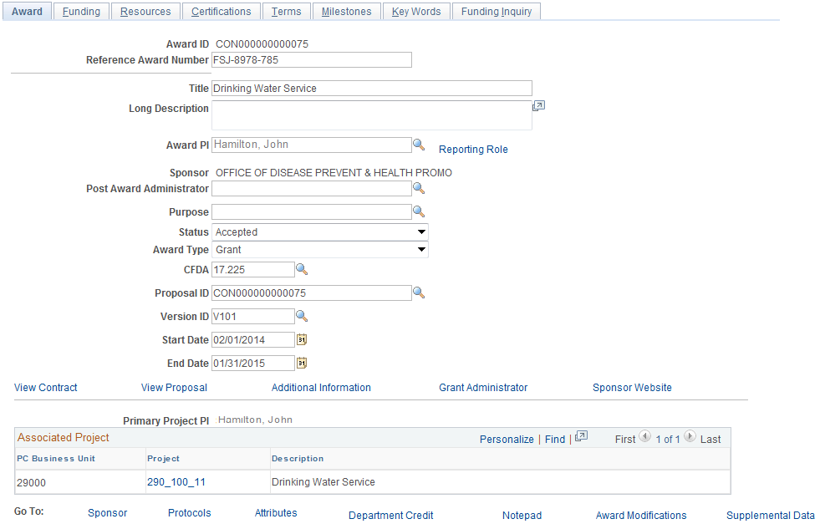

The Tab displays general information derived from the Grants Proposal. For greater explanation of Grants Proposal fields see CORE431 – Grants Proposal and Pre-Award Management manual.

Reference Award Number – use this field to hold a Grants number or ID that could be different than the Award ID. For example, if the agency allows the system to assign the Award ID the Reference Award Number could hold the Sponsor assigned Grants Number.

Status – the Grants Profile will be set to Accepted initially.

Proposal ID – this field displays the Proposal ID number.

Use the View Contract link to drill to the Grants Contract.

Use the View Proposal link to drill to the Grants Proposal.

Award page continued

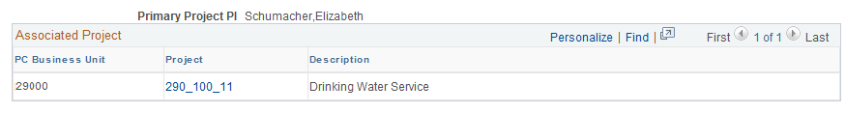

The Associated Project section of the page displays all Projects defined for the Award Profile.

NOTE: The Project ID values are defined on the Grants Proposal or through the Grants Award process. There can be one or more Project ID’s defined for the Award.

Click the Tab.

Funding Tab

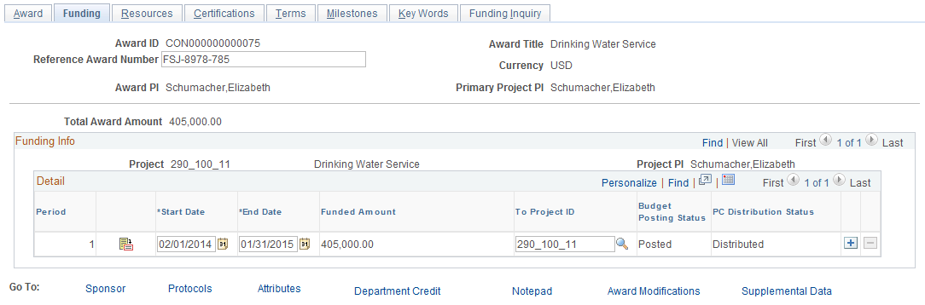

The Tab displays Budget amounts and details from the Grants Proposal.

Total Award Amount – this field displays the Sponsor share of the Award Budget.

The Funding Info section of the page displays for each Project ID the Professional, Budget Period and Funding Amount.

Click the Tab.

Terms Tab

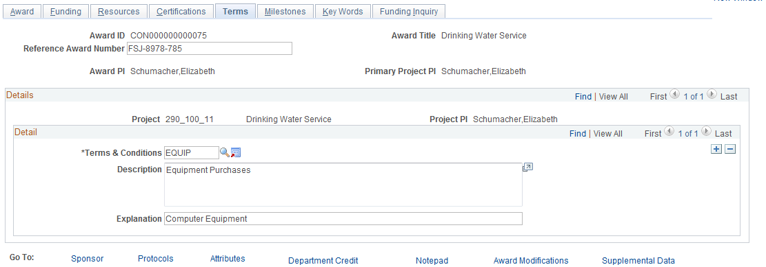

Use the Tab to store Terms and Conditions that are required by Grants parameters. These could be spending requirements, reporting requirements or any other requirements stipulated in the Grants agreements.

Click the Tab.

Milestones Tab

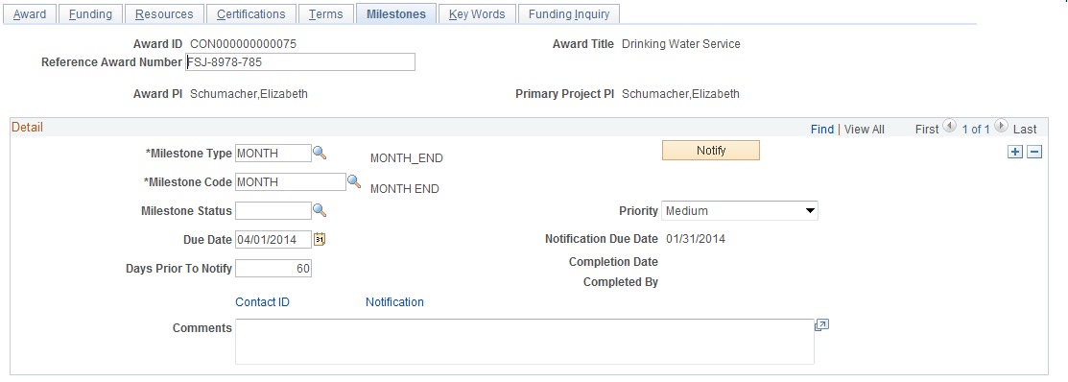

The Tab allows the agency to store Grants milestone requirements by category with Due Dates, Priority and Completion parameters.

Milestone Type – define a high-level milestone type.

Milestone Code – for each Milestone Type, define a Milestone Code as a lower-lever identifier.

Due Date – define the Milestone due date.

Priority – assign a Milestone priority.

Completed – mark the Milestone as complete when appropriate.

Comments – add additional free-form comments for the milestone.

Completion Date/Completed By – the system stores the Milestone details of when and who completed the Milestone.

Click to save the changes to the Grants Award.

NOTE: Not all tabs and fields available in Grants Award Profile pages have been defined. Refer to COR431 – Grants Proposal & Pre-Award Management manual for further explanation.

Grants Projects

When the Grants Proposal and defined Grants Projects are generated into an Award, the Project information and properties can be seen in the Grants module or the Project Costing module. The illustrations below show the Grants pages that display Grants Project information.

Step 1: Project General Information

Navigation: Grants > Awards > Project > Find an Existing Value

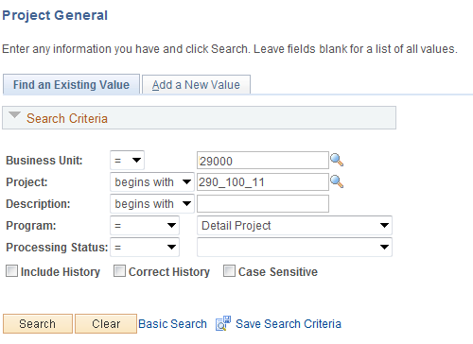

Use the Search Criteria to retrieve the Award Project.

Business Unit – is the Agency in which the Grants Award Project is stored. This is the Project Costing Business Unit value.

Project – the Project ID for the Grants Award.

Description – search by Project Description.

Click to enter the Project Award.

General Information Tab

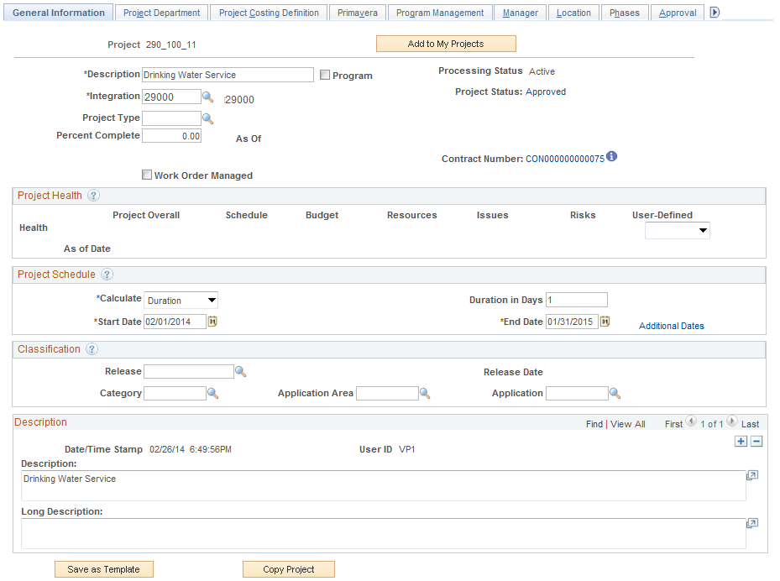

The Tab displays high-level parameters and properties for the Grants Project. Some of these properties are defaulted into the Project ID from the Grants Proposal through the Generation Award process.

Description – the Project Description is taken from the Grants Proposal Project Description value.

Integration Template – this value defines how the Project ID will integrate with other system modules. This value will generally be defaulted through the Grants Award Generation process.

Project Type – select the Project Type to categorize the Project. This value can also impact the Revenue Accounting Entries for the Grants.

Start/End Date – the Start and End Dates will be taken from the Budget Period Start and End Dates for the Grants Proposal Project.

Description – use the Description fields to store additional Comments about the Grants Project. The Description field will initially store the Project Description from the Grants Proposal.

Click the Tab.

Project Department Tab

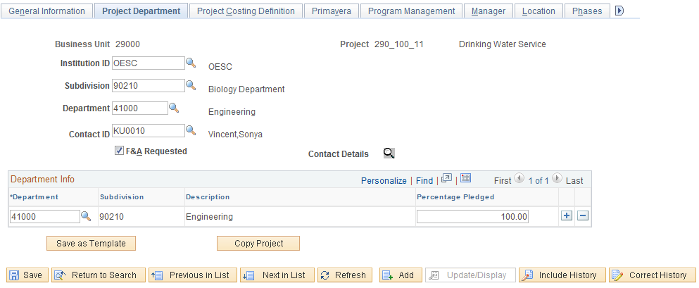

The Tab displays agency information from the Grants Proposal.

Institution – this field holds the agency institution value from the Proposal.

Subdivision – taken from the Grants Proposal.

Department - taken from the Grants Proposal.

Contact ID – this field holds the Employee ID for the Department Contact defined on the Proposal.

Click the Tab.

Location Tab

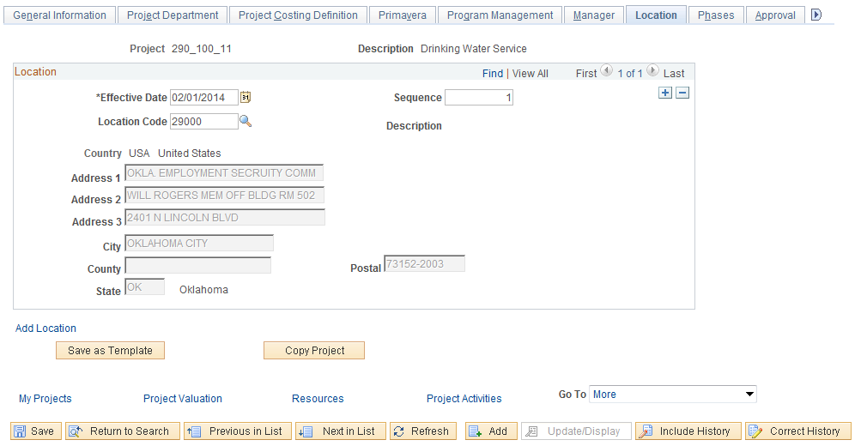

The Tab displays the Location information defined on the Grants Proposal. The Location value can be changed by inserting a new Effective Dated row by using.

Click the Tab.

Attachments Tab

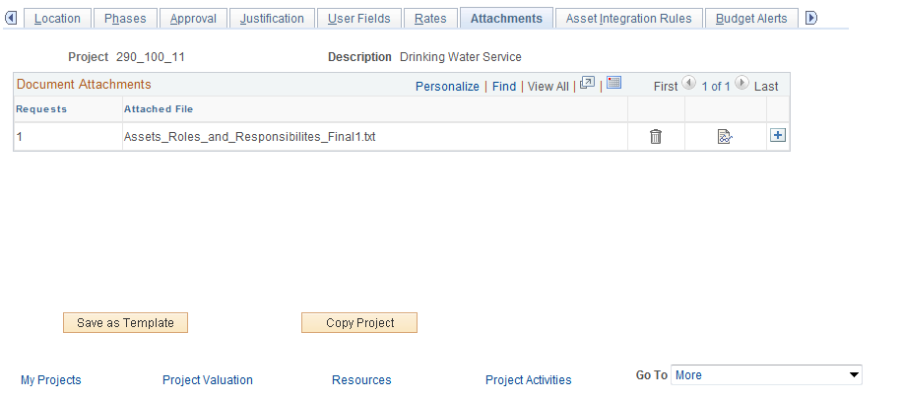

The Attachments Tab displays any file attachments that were added in the Proposal creation phase.

NOTE: Use the to insert additional file attachments.

Click to save any changes made to the Grants Award Profile.

Step 2: Define Project Teams

Navigation: Project Costing > Project Definitions > Team > Find an Existing Value

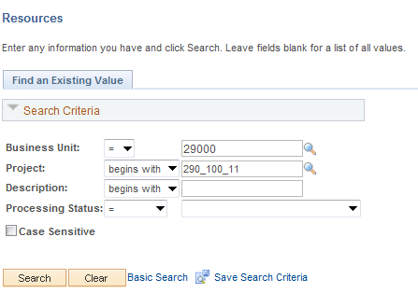

Use the Search Criteria to retrieve the Grants Project ID.

Business Unit – is the Agency in which the Grants Award Project is stored. This is the Project Costing Business Unit value.

Project – the Project ID for the Grants Award.

Description – search by Project Description.

Click to enter the Project Award.

ALTERNATIVELY,

Select the Resources link from the Project Component illustrated above.

Team Tab

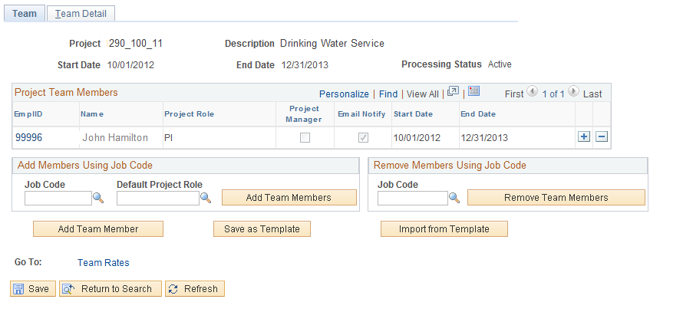

The Tab allows the user to define a support team for the Grants Project. This team could consist of project managers, program support individuals, project administration resources.

NOTE: The Grants Project Team will initially hold the Professional (PI) defined on the Grants Proposal.

Job Code – define a particular Job Code to add Team Members by Job Code.

Default Project Role – select a Project Role for all individuals selected by Job Code will inherit.

When the Job Code has been populated, use the to populate the team with individuals meeting that Job Code.

NOTE: All individuals with the Job Code selected will become members of the Project Team when using the “Add Members Using Job Code” feature.

Click to enter another Team Member.

Team Tab

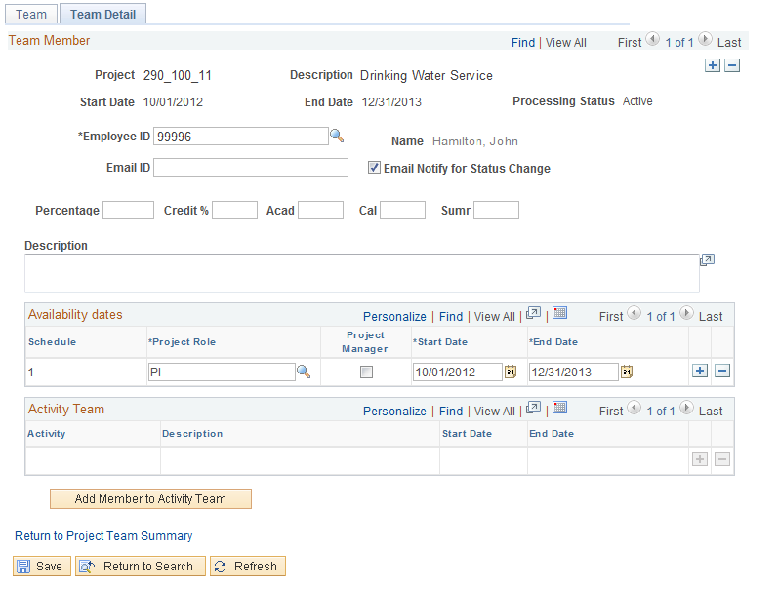

The Tab allows the user to select individuals by Employee ID to add to the Project Team.

Employee ID – select the individual to add to the Team.

Email ID – populate an email ID for the employee.

Project Role – select a pre-defined Project Role that the employee will hold on the team.

Project Manager – select this checkbox if this employee will be the Project Manager. This individual will be displayed on the Project Manager page.

Start/End Date – define the period of time that this employee will be a member of the Project Team.

Use to add Project Team members as Activity Team Members.

Click to save the Grants Project Team.

NOTE: The Team Detail Tab will hold all team members. Use the arrows to scroll thru Team Members.

Step 3: Set Project Status

Navigation: Project Costing > Projects Definitions > Status > Find an Existing Value

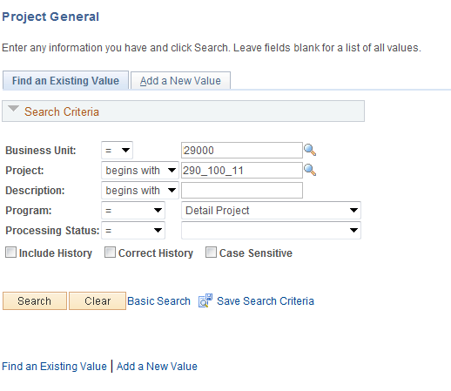

Use the Search Criteria to retrieve the Grants Project ID.

Business Unit – is the Agency in which the Grants Award Project is stored. This is the Project Costing Business Unit value.

Project – the Project ID for the Grants Award.

Description – search by Project Description.

Click to enter the Project Status pages.

ALTERNATIVELY,

Use the drop down to select the Project Status option.

Project Status Page

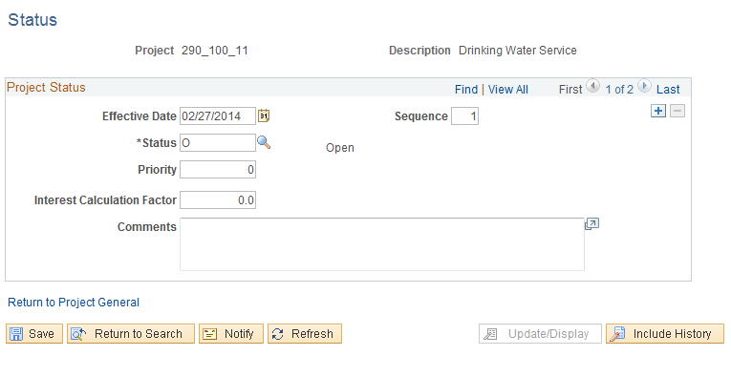

The Project Status page allows the user to define an effective dated Status for each Project.

Effective Date – define the date that the Status will be effective. Generally this will be the Grants begin date initially.

EFFSEQ – use ‘1’ if there is only one Status for an effective date.

Status – select the Project Status for the Project.

Click to Save the Project Status.

NOTE: Use to insert additional Project Status values.

Grants Activities

When the Grants Proposal with Grants Projects and Activities (a.k.a. Budget ID’s) are generated into an Award, the Activity information and properties can be seen in the Grants module or the Project Costing module. The illustrations below show the Grants pages that display Grants Activity information.

Step 1: Activity General Information

Navigation: Grants > Awards > Project Activity > General Information > Find an Existing Value

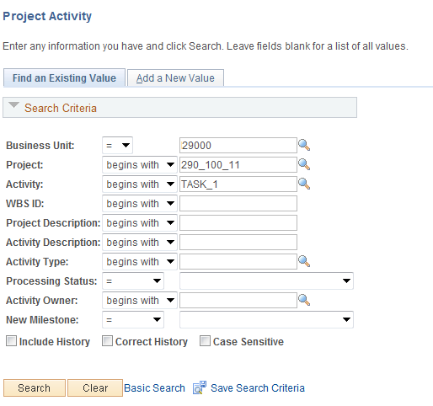

Use the Search Criteria to retrieve the Award Project.

Business Unit – is the Agency in which the Grants Award Project is stored. This is the Project Costing Business Unit value.

Project – the Project ID for the Grants Award.

Activity – search by Activity (Budget ID) for the Grants Award.

Click to enter the Project Award.

General Information Tab

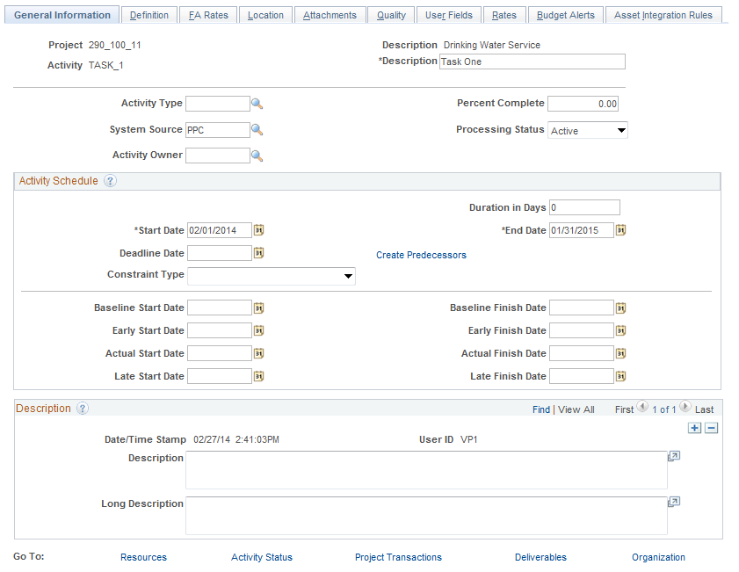

The Tab displays high-level parameters and properties for the Grants Activity. The Activity ID and Description is the Budget ID and Description from the Grants Proposal.

Activity Type – select the Activity Type to categorize the Activity. This value is not required for the Activity.

Start/End Date – the Start and End Dates will be taken from the Budget Period Start and End Dates for the Grants Proposal Project.

Long Description – use the Description fields to store additional Comments about the Grants Project.

Click the Tab.

FA Rates Page

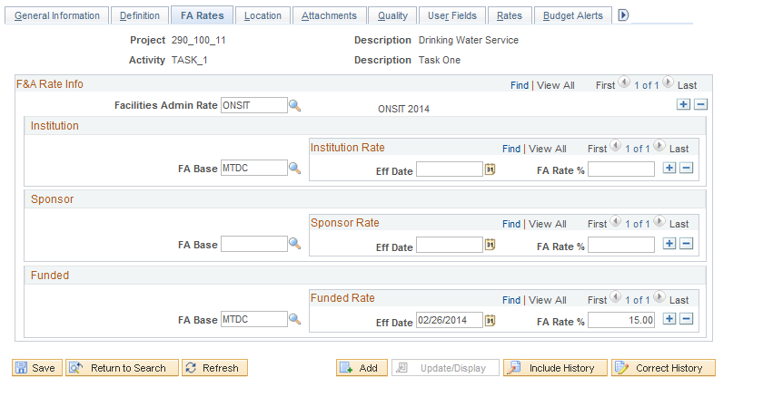

The Tab displays the F&A or Indirect Cost configuration for the Grants Award. The F&A configuration for indirect cost calculations are stored at the Activity level for each Award.

NOTE: Since the indirect cost configuration, including rates, are stored at the Activity level of details, multiple Activities are required to calculate different rates within a single Project. For example, if an agency requires both on-site and off-site indirect cost rates, an Activity(s) must be created to store the different rates.

Facility Admin Rates – the F&A Rate Type defined for the Activity.

F&A Base – the Base Type defined for the Activity. The ‘Funded’ FA Base is the value that is used to calculate indirect costs using the Process Facilities Admin batch process.

NOTE: The FA Base Type value must match the F&A Tree Node on the F&A Tree defined for the Facilities Admin Process. The F&A Tree is part of the Grants Business Unit setup.

Click the Tab.

User Fields Tab

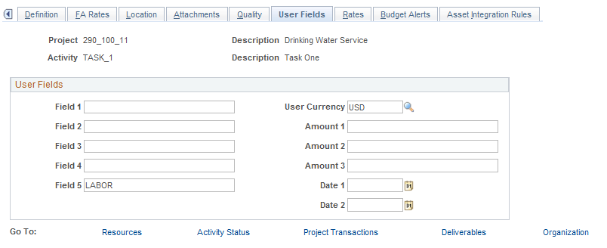

The Tab is used to designate a particular Activity as labor bearing or non-labor bearing.

Field 5 – select from the available values to designate the Activity as LABOR or NON-LABOR.

Click the Tab.

Rates Tab

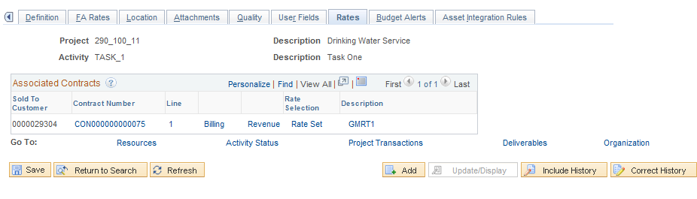

The Tab displays Contract information for the Grants Award including Contract ID, Bill/Revenue Plans and Rate Sets.

Sold To Customer – this field displays the Sponsor for the Grants.

Contract Number – this field displays the Contract Number defined for the Award. This number will also match the Award number.

Rate – displays the Rate Set defined on the Contract.

Click to save the Activity.

Step 2: Set Activity Status

Navigation: Project Costing > Activity Definition > Status > Find an Existing Value

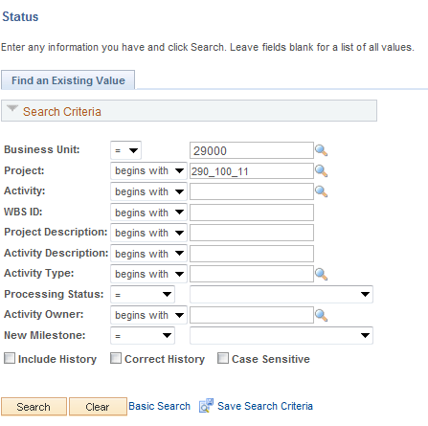

Use the Search Criteria to retrieve the Grants Project ID.

Business Unit – is the Agency in which the Grants Award Project is stored. This is the Project Costing Business Unit value.

Project – the Project ID for the Grants Award.

Activity – search by Activity ID.

Click to enter the Activity.

ALTERNATIVELY,

Use the Activity Status link from the Activity component illustrated in the previous section.

Activity Status Page

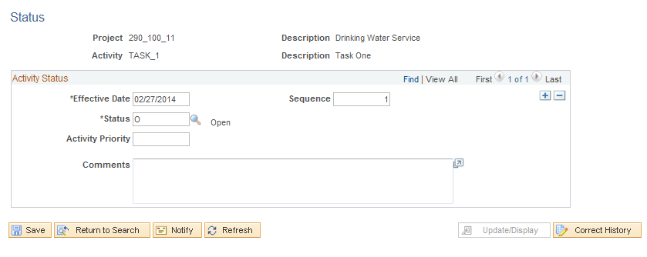

The Activity Status page allows the user to define an effective dated Status for each Activity.

Effective Date – define the date that the Status will be effective. Generally this will be the Grants begin date initially.

EFFSEQ – use ‘1’ if the is only one Status for an effective date.

Status – select the Activity Status for the Project.

Click to Save the Activity Status.

NOTE: Use to insert additional Activity Status values.

Funds Distribution

Project transactions can be split or distributed among multiple funding sources. A Funds Distribution process (PC_FND_DIST) distributes funding by applying Funds Distribution rules to incoming transactions from feeder systems, and assigning costs accordingly. These distributed transactions can be priced using the Pricing Engine (PC_PRICING) for billing purposes.

Funds Distribution is a three-step process:
- Identify Project transactions that are eligible for distribution at the Activity level.
- Define Funds Distribution rules—the percentages of the Project transaction amounts that are
passed on to each funding source.
- Run the Funds Distribution process

Step 1: Define Funds Distribution - Source

Navigation: Project Costing > Funds Distribution > Funds Distribution > Find an Existing Value

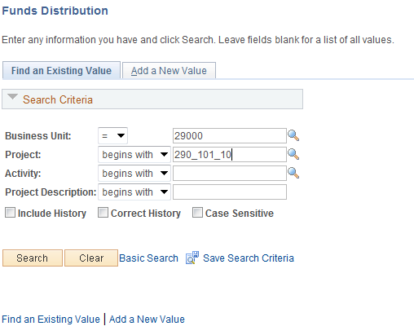

Use the Search Criteria to retrieve the Activity for Funds Distribution.

Business Unit – is the Agency in which the Project is stored.

Project – the Project ID for Funds Distribution.

Activity – select the Activity for Funds Distribution.

Click to enter the Funds Distribution pages.

Funds Distribution-Source Page

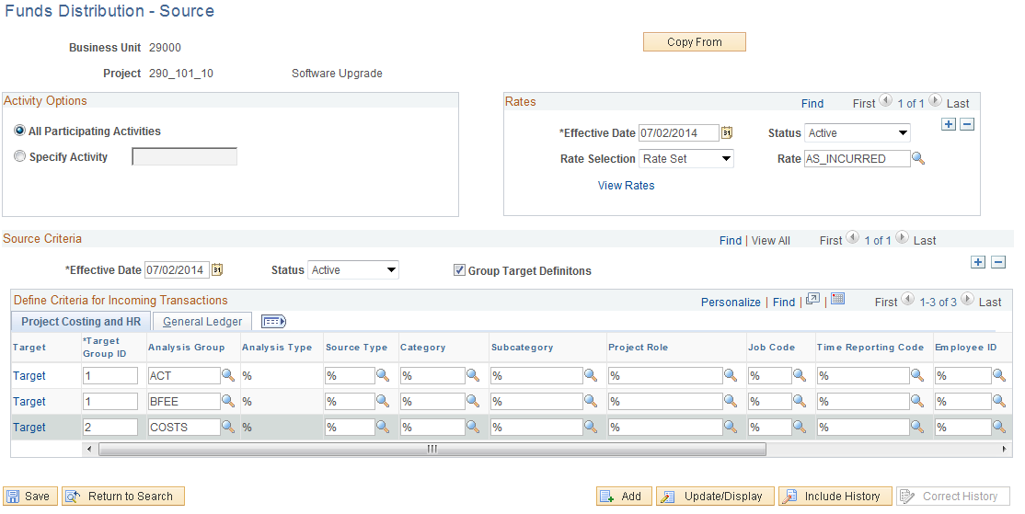

Use the Funds Distribution – Source Page to define the incoming Project transactions that are subject to Funds Distribution rules.

Click to copy funds distribution rules from another Activity in the same Business Unit.

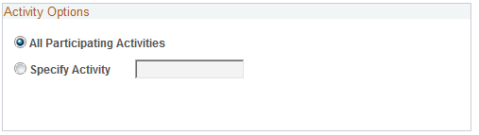

All Participating Activities – This allows all activities, for a particular project, that have the Participating feature checked on the Activity Definition page under Funds Distribution, to be grouped together. As a group, the same source rules will apply to all the activities and the group can be associated with one Target definition.

Specific Activity – Select to indicate that the source rule applies to one activity in the project. Enter the activity in the field to the right.

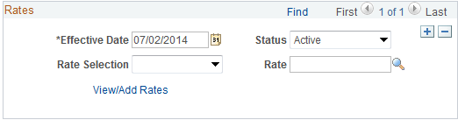

Effective Date – define when this Funds Distribution Rule is effective.

Rate Selection – allows you to select a Rate Set or a Rate Plan

Rate – Select a rate plan or a rate set, depending on the selection in the Rate Selection field.

Group Target Definitions – This value will default from the Project Costing Options page at the Business Unit level if checked. Otherwise it will default from the Project Definition page of the current project, if checked. The default can be overridden on this page.

Select it to indicate that the funding source rules can be grouped manually, each Source Analysis Group associated with its own Target rule.

Deselect to indicate that each Funding Source rule will be associated with a separate Target Definition.

Project Costing and HR Tab

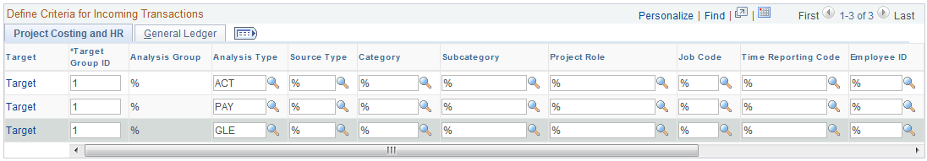

Target Group ID – Assign this ID based on which source rules will be grouped together. This takes alphanumeric combinations or sequential numbers. Basically, each line which shares the same Target Group ID shares the same source funding. This field is only visible if Group Target Definitions checkbox is selected.

Analysis Group - This field defaults to ‘%’. For a particular source rule you can only enter a value for either Analysis Group or Analysis Type. If source rule is entered by analysis group then the corresponding target definition will apply to all the analysis types within that analysis group.

Analysis Type – for incoming Project transactions, define which Analysis Types are subject to distribution. If this field is populated, Analysis Group cannot be used.

Source Type – for incoming Project transactions, define which Source Types are subject to distribution.

Category – for incoming Project transactions, define which Category values are subject to distribution.

Subcategory – for incoming Project transactions, define which Sub Category values are subject to distribution.

General Ledger Tab

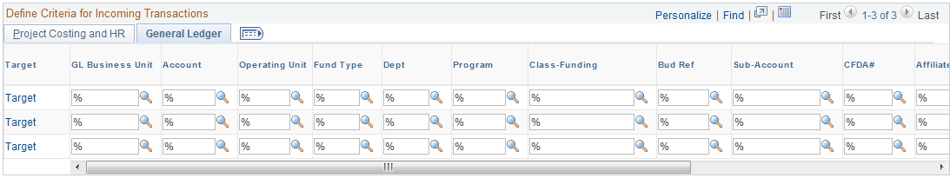

General ledger chartfields can be overridden here, but caution should be used to ensure that any changes made to chartfields are in accordance with accepted business practice.

NOTE: Use the % (wildcard) symbol to indicate all values in that field are eligible for distribution.

Click the Target link on the line to view the Target page.

Funds Distribution - Target Page

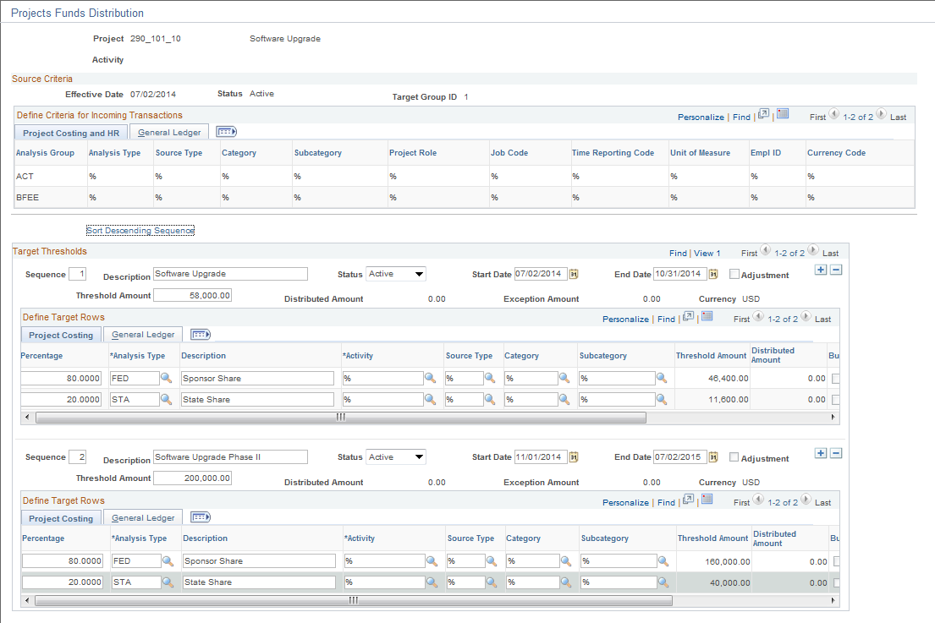

Use the Funds Distribution-Target Page to define percentages that will be used to split Project transactions between funding sources.

Sequence – Funding can be applied sequentially. Each sequence represents an approved amount of available funding to which costs can be distributed. Different rules can be set up for each sequence of funding. When one funding sequence is depleted, the costs start applying to the next sequence.

Status – this field allows you to make a particular sequence Active or Inactive within a rule. If you make a sequence Inactive, it can only be made Active if the Distributed Amount within the sequence is equal to zero.

Adjustment – Indicates the particular sequence is for adjustments. The Target Percentage Distribution field is not available for entry. This option enables you to synchronize the manual adjustments from Billing with the funds distribution rules and reports. Adjustment sequences are not processed by the Funds Distribution process. When the Threshold amount and Distributed amount in the sequence is equal to zero, the Adjustment check box can be changed.

Start/End Dates – Costs with an accounting or transaction date that fits within the date parameters can be distributed in the sequence. If the Adjustment check box is selected, these dates do not apply.

Threshold Amount - Enter an amount that represents the maximum amount of source transactions that may be distributed to funding sources according to the distribution rules defined for the sequence. If the Update Threshold Amounts field on the Installation Options - Project Costing Integration page is selected, then this field can be modified after costs have been distributed against the threshold. However, the threshold amount cannot be less than the distributed amount. If the Update Threshold Amounts field on the Installation Options - Project Costing Integration page is not selected, then this field cannot be modified after costs have been distributed against the threshold. If additional funding is received, a new sequence must be added to create additional distribution rows.

Distributed Amount – Displays the amount of costs distributed for the sequence.

Exception Amount – Displays the amount of costs distributed that have been held from additional process due to Budget checking exceptions. These are not in PROJ_RESOURCE, use Budget Exceptions page to correct.

Project Costing Tab

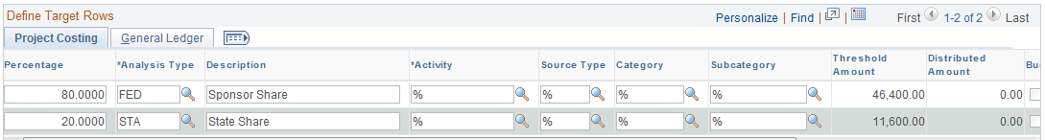

Percentage – define the percentage split for each funding source.

NOTE: For each incoming Project transaction that meets the Source Criteria, the system creates a Target row in the Project Transaction table with an amount equal to the defined percentage of the cost, and it uses the Analysis Type, Activity, Source Type, Category, and Subcategory that are defined in this row in the Define Target Rows section of the page.

NOTE: Use to insert as many rows as necessary to accomplish the desired split.

Target Analysis Type – define the Analysis Type for the target row that will be created from the distribution.

Description – this description will be populated on the Target row that is created from the distribution.

Target Activity – optionally, assign the distributed costs to a different Activity within the Project.

Target Source Type/Category/Subcategory – populate these fields to change the value on the Target row.

NOTE: If no Target Source Type, Category or Subcategory is defined, the target row will inherit these values from the Source row.

Threshold Amount – Displays the percent of the total threshold amount for the source.

Distributed Amount – Displays the total costs that are distributed to the funding source specified for the row.

Budget Check – Select to indicate the resulting distribution is to be budget checked.

Reversals – Select to indicate reversals are allowed for the row.

Balancing – Select one row in a sequence to indicate that this target row should be used by the system if rounding differences are encountered during the Funds Distribution process.

General Ledger Tab

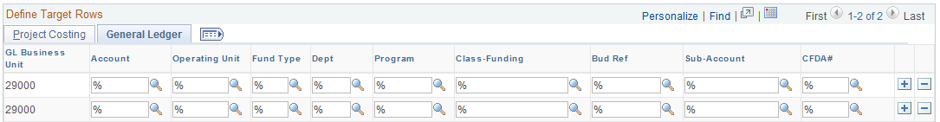

General ledger chartfields can be overridden here, but caution should be used to ensure that any changes made to chartfields are in accordance with accepted business practice.

Click to save the Funds Distribution Rule.

Process Facilities and Administration

A batch process is required to initiate the Indirect Cost (Facilities and Administration) calculations in the system.

Process Facilities and Administration

Navigation: Grants > Awards>Process Facilities Admin > Find an Existing Value

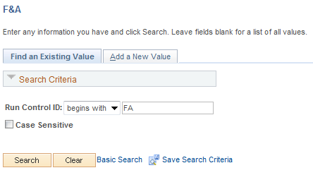

Enter and existing Run Control value or create a new value.

Click to use an existing Run Control value.

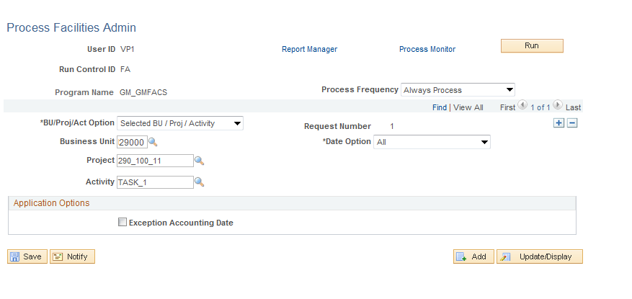

Process Frequency – set this field to ‘Always’.

BU/Proj/Act Option – define the Project Business Unit, Project or Activity on which the F&A process will be executed.
- Business Unit – populate the Project Costing Business Unit.
- Project – select to run the process on a particular Project ID.
- Activity – select the run the process on a particular Activity ID.

Date Option – use the date option to further define the Grants Project transactions that will be selected for the F&A Process.

Exception Accounting Date - select to specify an accounting date other than the current date for F&A processing.

Click to execute the F&A Process.

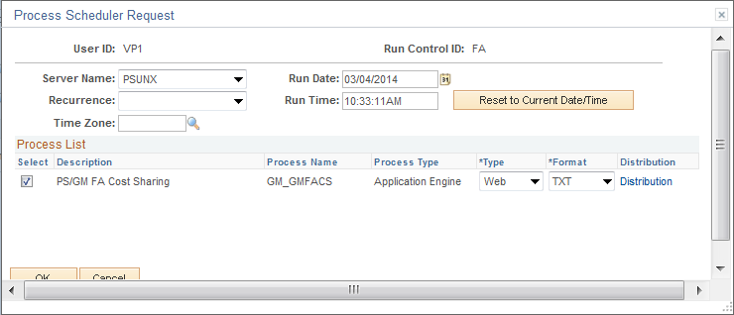

Select the checkbox next to the process that will be executed.

Click to execute the process. Navigate to the Process Monitor to view the results

Grants Contracts

When the Grants Proposal is ‘Generated’ into a Grants Award, the Grants Contract with the Sponsor (funding entity) is also automatically created in system. The Grants Contract needs to be retrieved and activated in order for Grants costs to be properly collected and Grants draws to be completed.

Step 1: Complete and Activate Grants Contract

Navigation: Customer Contracts > Created and Amend > General Information > Find an Existing Value

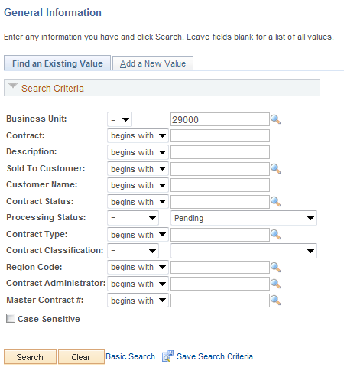

Use the Search Criteria to retrieve the Grants Project ID.

Business Unit – is the Agency in which the Grants Contract is stored. This is the Contracts Business Unit value.

Contract – the Contract ID (also Award ID) for the Grants Contract.

Sold to Customer – this field is the Grants Sponsor.
Processing Status – initially after Grants Award generation, the Contract Status will be Pending.

Click to enter the Activity.

ALTERNATIVELY,

Use the View Contract link from the Grants Award component illustrated in the previous section.

NOTE: Not all of the fields in the Contracts component are illustrated in this manual. Some fields are defaulted when the Grants Contract is created through the Grants Award Generation process and do not need to be changed. Others are not necessary for Grants Reimbursement Billing or Draws.

General Tab

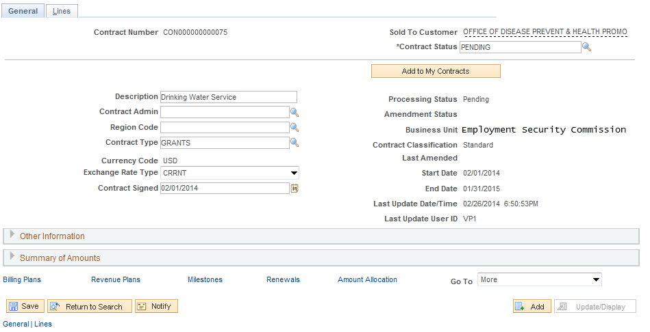

The Tab displays a number of data elements from the Grants Award and Grants Business Unit configuration.

Contract Type – ensure the Contract Type field is populated.

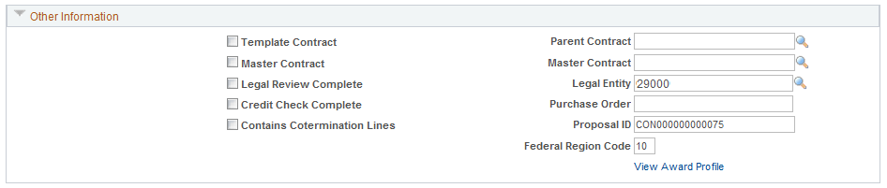

Legal Entity – in the Other Information section of the page ensure the Legal Entity is populated.

Click the Tab.

Lines Tab

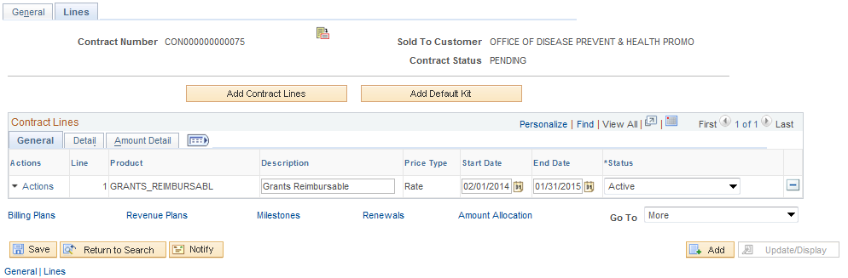

The Tab displays the contract line(s) defined in through the Grants Award process. The Product is derived from the Grants Business Unit configuration.

Start/End Dates – mapped from the Grants Proposal Period Begin and End Dates.

Price Type – defines the Contract Product as ‘Cost Reimbursable”. This allows costs collected in the Grants Project to be billed or drawn from the Grants Sponsor.

Click the Tab.

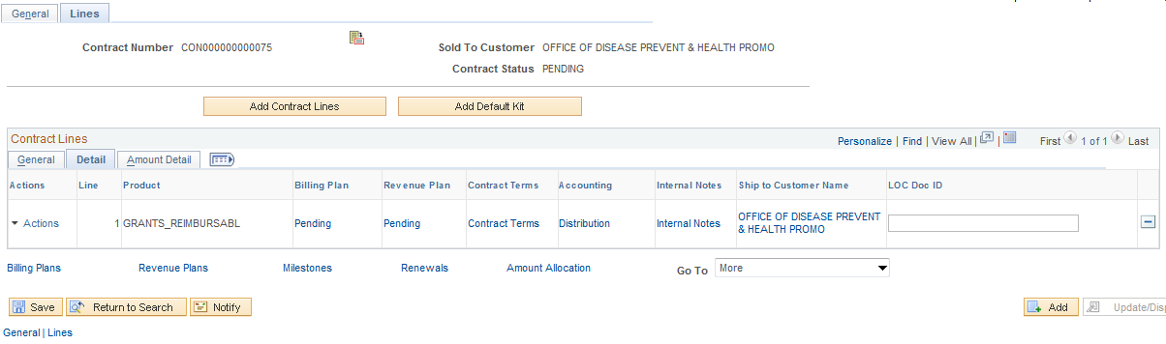

Click the Distribution link to verify the Accounting Distribution is complete.

Accounting Distribution Page

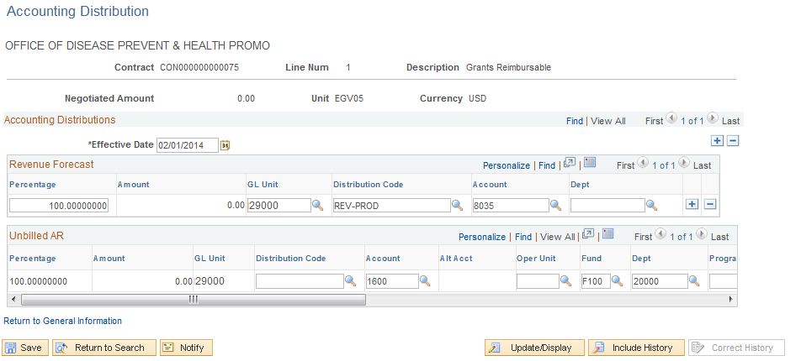

Ensure the Unbilled AR section of the page contains a value for Fund Type and Class Funding chartfields.

NOTE: Although Grants Contracts use Project Costing Accounting Rules to generate Unbilled AR Accounting Entries, chartfield edit combination rules are checked on this page and certain chartfield value are required to save the contract.

Click to save any Accounting Distribution changes.

Click the Return to General Information link.

Click the Tab.

Click the Contract Terms link.

Related Projects Tab

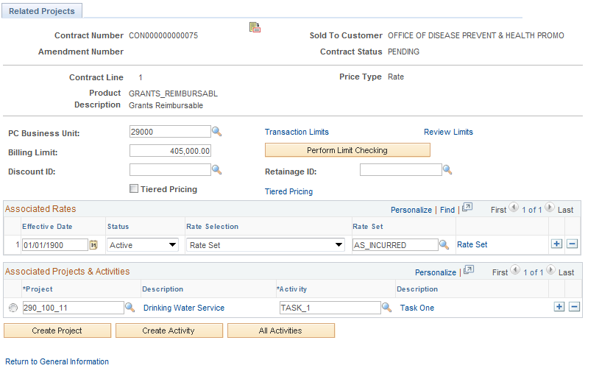

The Tab displays information from the Grants Award.

PC Business Unit – this field displays the agency business unit derived from the Grants configuration.

Billing Limit – this amount reflects the entire Grants Amount based on the Awarded Grants budget.

NOTE: Once the Contract is Activated, any changes to the Billing Limits must be done through a Contract Amendment. See Contract Amendments later in this manual.

Click the Transaction Limits link.

Transaction Limits Sub-Page

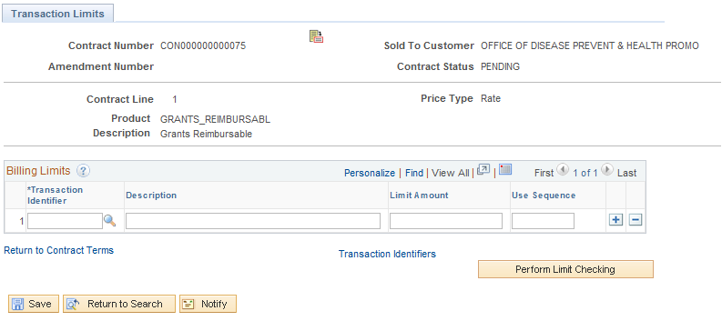

The Sub-page allows the agency to define billing limits by transaction or Project Costing chartfield.

Transaction Identifier – populate this field with a pre-defined transaction identifier that specifies which chartfields will be evaluated when testing the Limit Amount.

Limit Amount – define the limit amount that the transactions containing the chartfields in the Transaction Identifier will be subject to.

NOTE: The Transaction Limits feature is intended to be a limit checking ‘BELOW’ the overall Grants limit defined on the Grants budget. This feature will check individual transactions to determine if they are over a pre-defined limit. For example, within a Grants Contract the agency may want to limit Equipment purchases to a certain dollar amount. The chartfield values that identify Equipment purchases should be defined in a Transaction Identifier and the Limit Amount defined here.

Click the Return to Contract Terms link.

Related Projects page continued

Rate Selection – typically this value will be Rate Set. The Rate Set is configured to calculate draw amount on incurred costs in the Grants Project.

Rate Set – if not populated, select the correct Rate Set for the Grants. Typically this will be an ‘As Incurred’ rate set.

Project – this field displays the Grants Project from the Grants Award.

Activity - this field displays the Grants Activity from the Grants Award.

Click to save any Accounting Distribution changes.

Click the Return to General Information link.

Click the Billing Plans link.

Assign Billing Plan Page

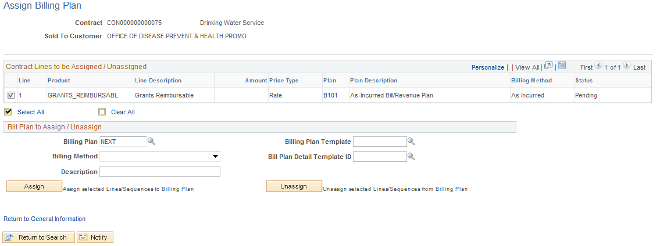

If the Billing Plan is not defined for the Grants Contract, it can be defined before the Contract has been activated.

NOTE: Agency configuration may allow the Bill Plan to be created automatically when the Contract is established through the Grants Award process. If so, these steps are not necessary.

Select – select the checkbox next to the Product.

NOTE: When creating and assigning a Bill Plan to a Contract Line, the ‘Assign’ action will not work without this checkbox selected.

Billing Method – define this field as ‘As Incurred’ for all Grants cost reimbursement agreements.

Description – populated a Bill Plan description.

Click .

Once assigned, click the Bill Plan ID link.

Billing Plan General Tab

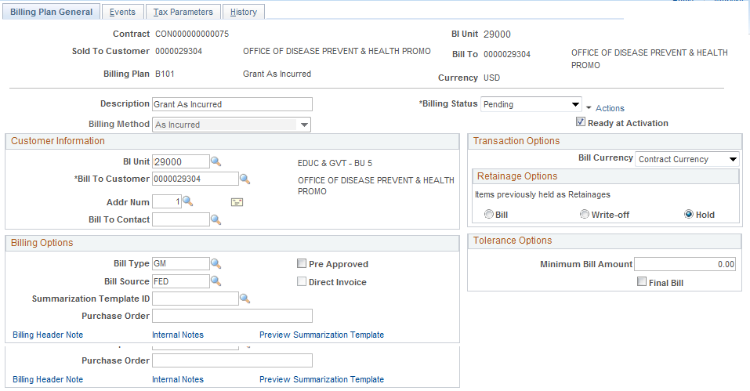

The Billing Plan General Tab displays information required to create the Grants Bill.

Bill Type – define the Bill Type for the Grants Bill.

Bill Source – define the Bill Source for the Grants Bill.

Ready at Activation – select this checkbox is to activate the Bill Plan when the Contract is Activated.

Tab continued

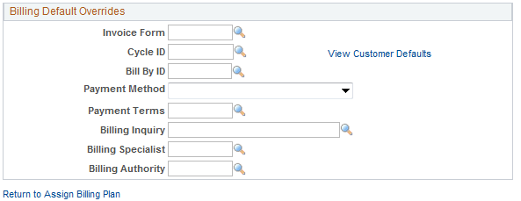

Use the Billing Default Overrides section of the page to default any different values onto the bill.

Click to save any Bill Plan changes.

Click the Return to Assign Billing Plan link.

Click the Return to General Information link.
General Tab continued

From the Tab, select the Revenue Plans link to create the Revenue Plan for the Grants Contract.

NOTE: Although a Revenue Plan is created, Grants Contracts use Project Costing Accounting Rules to generate Unbilled AR Accounting Entries and Revenue Accounting Entries.

Assign Revenue Plan Page

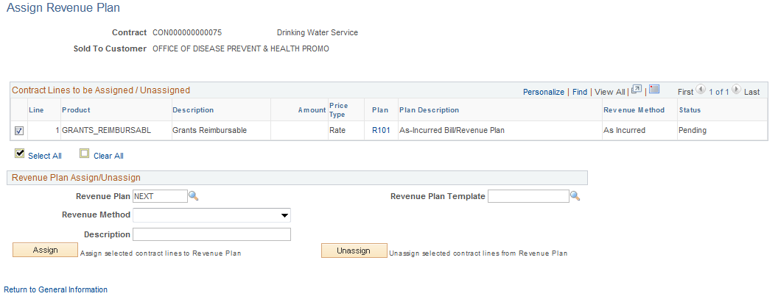

If the Revenue Plan is not defined for the Grants Contract, it can be defined before the Contract is activated.

NOTE: Agency configuration may allow the Revenue Plan to be created automatically when the Contract is established through the Grants Award process. If so, these steps are not necessary.

Select – select the checkbox next to the Product.

NOTE: When creating and assigning a Revenue Plan to a Contract Line, the ‘Assign’ action will not work without this checkbox selected.

Revenue Method – define this field as ‘As Incurred’ for all Grants cost reimbursement agreements.

Description – populated a Revenue Plan description.

Click .

Click the Return to General Information link.
Contract General Tab continued

From the Tab, select the ‘More’ drop-down field to Access Letter of Credit information for the Sponsor and Contract.

Select Billing Options value from the drop-down.

NOTE: Sponsor Letter of Credit information is created when the Sponsor is set up in the system. Letter of Credit Document ID information is created in the Contract at the Contract Line level of detail. This allows the agency to track Sponsor specific draw requirements as well as Grants or Grants Project draw requirements (tracking numbers).

Billing Options Tab (Letter of Credit)

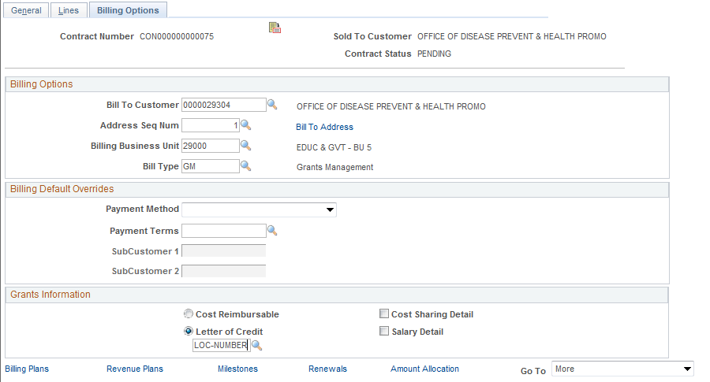

NOTE: The Billing Options page appears as an additional tab at the top of the Contract component.

The Tab displays the Letter of Credit number defined for the Sponsor. This option is available to change but can only be populated with a valid Letter of Credit number configured for the Sponsor.

From the Billing Options page select the Tab.

Lines Tab continued

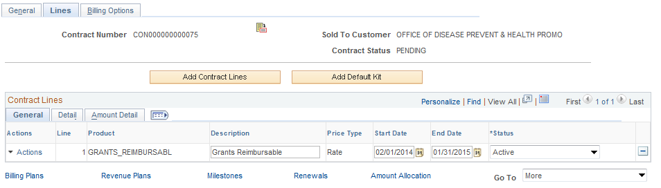

From the Contract Lines page select the Detail Tab.

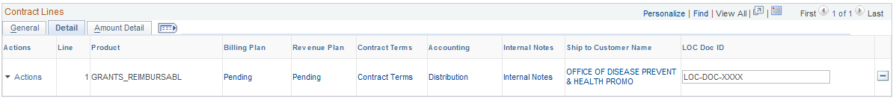

The LOC Doc ID field allows the user to define a Letter of Credit number for the Contract Line.

Click to save the Letter of Credit Doc ID.

NOTE: Since the Letter of Credit Doc ID value is stored at the Contract Line and the Grants Project and Activity are stored on the Contract line, agencies effectively have the option of creating Letter of Credit information at the Project and Activity level of detail.

Click the Tab.

General Tab – Activate the Contract

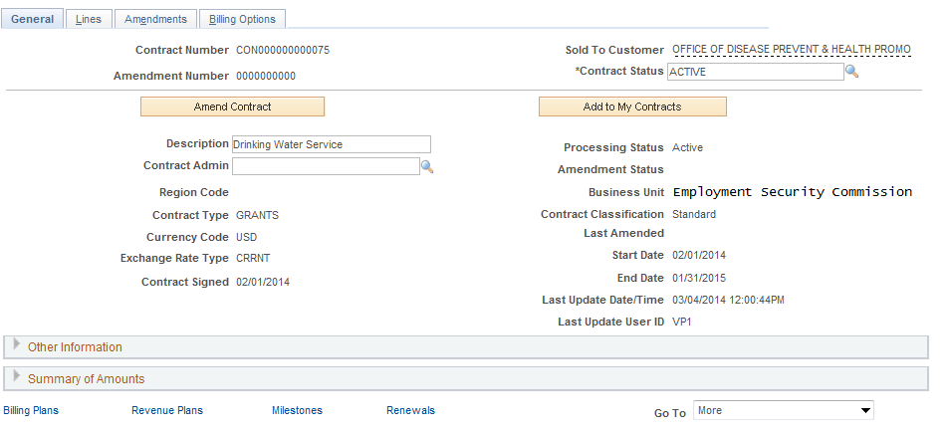

On the General Tab Change the Contract Status from ‘Pending’ to ‘Active’

NOTE: If there are any problems with the information in the Contract, the system will issue an error message before the Contract will be activated. Ensure that corrective action is taken on the Contract so it can be activated.

Click to Save the Contract.

Step 2: Contract Support Teams
Contract Support Teams allow the agency to attach a team of individuals to the Grants Contract for support purposes.

Navigation: Customer Contracts>Created and Amend>Support Teams>Find an Existing Value

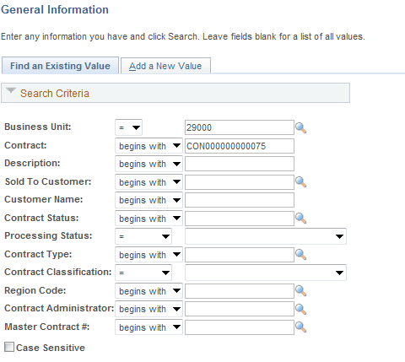

Use the Search Criteria to retrieve the Grants Project ID

Business Unit – is the Agency in which the Grants Contract is stored. This is the Contracts Business Unit value.

Contract – the Contract ID (also Award ID) for the Grants Contract.

Click to enter the Activity.

Support Team by Contract Page

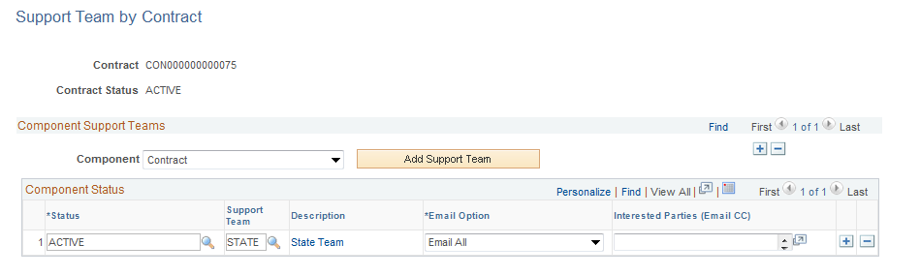

For any contract in the system, select a pre-defined Support Team from the list.

Status – identify the Status value for a contract status change that will enable workflow in the system.

Support Team – select from a pre-defined Support Team. Support Teams are configured and include individual resources.

Click to Save the Support Team.

Grants Contract Processing

Once the Grants Contract has been created through the Award Generation process, it has been updated and activated, and costs have begun to be collected, Grants Draws and related Accounting Entries can be created.

A batch process executed from Contracts is initiated to select all costs collected in a Grants Project and send those costs to the Billing Interface tables. Once in the Billing Interface Tables, those costs can be reviewed before an actual bill or draw is finalized.

When adjustments to Grants Contracts need to be made, a Contract Amendment may be necessary. For example, to increase a Billing Limit on a Grants Contract due to a budget adjustment, a Contract Amendment is necessary.

Run Contract to Billing Interface

Navigation: Customer Contracts > Schedule and Process Billing > Process As Incurred Billing > Find an Existing Value

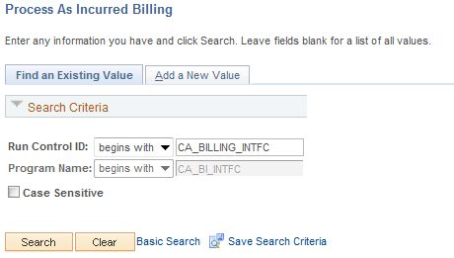

Run Control Id – Add a new Run Control value or select and Existing Value.

NOTE: The Contract must be activated and the Bill Plan in Ready status for this process to run successfully.

Click to use an existing run Control ID.

Process As Incurred Billing Page

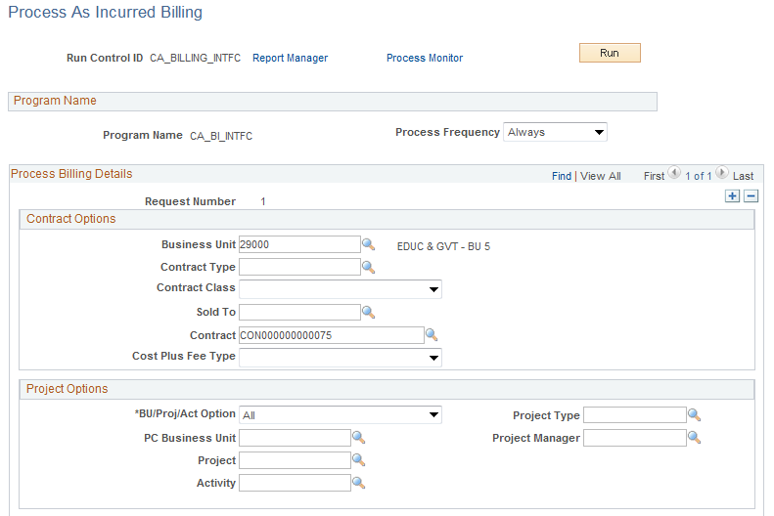

The Process As Incurred Billing page allows the user to define the Contract(s) for which billing (draws) will be created.

Use the Contract Options section of the page to define by Contract, which Contract(s) will be selected for the process.

Use the Project Options section of the page to define by Project, which Project(s) will be selected for the process.

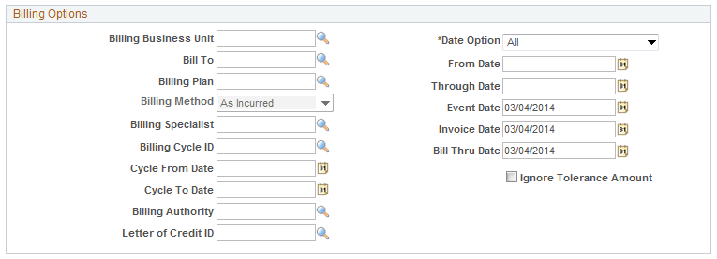

Use the Billing Options section of the page to define Billing properties which costs will be selected for the process. For example, by using the Letter of Credit value, only those Contracts with that Letter of Credit ID will be selected for processing.

Click to execute the Report.

Process Scheduler Request Page

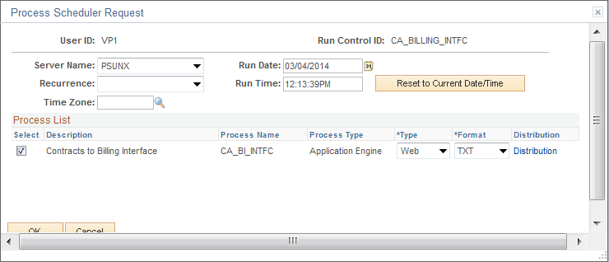

Select the checkbox next to the Contracts to Billing Interface process.

Click to execute the Report. Navigate to the Process Monitor to view the Report instance.

Grants Contract Amendments (Billing Limit Adjustment)

Navigation: Customer Contracts > Created and Amend > General Information > Find an Existing Value

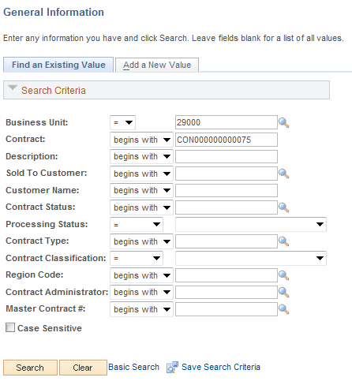

Use the Search Criteria to retrieve the Grants Project ID

Business Unit – is the Agency in which the Grants Contract is stored. This is the Contracts Business Unit value.

Contract – the Contract ID (also Award ID) for the Grants Contract.

Processing Status – a Contract Amendment will be executed on a Grants in Active status.

Click to enter the Activity.

General Tab

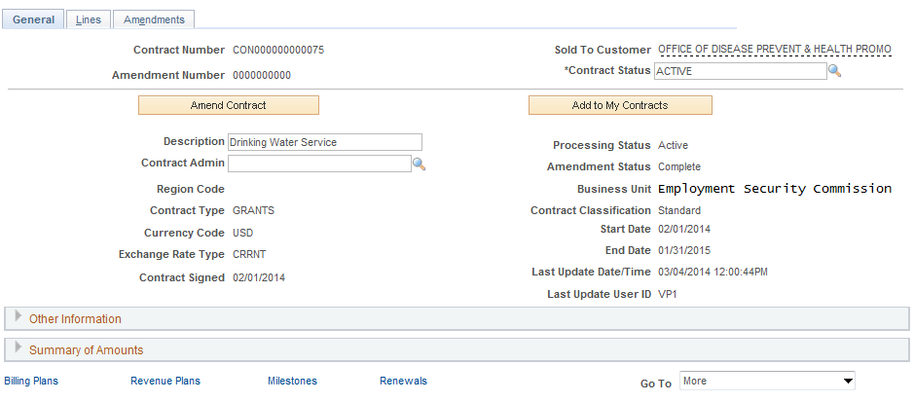

On the Tab, select to initiate the Contract Amendment.

Amendments Tab

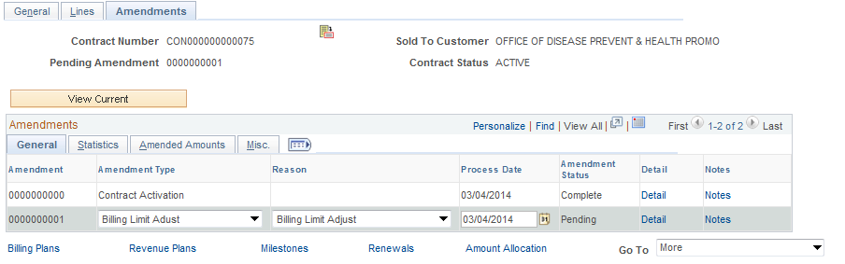

The Tab allows the user to define Amendment properties and Ready the Amendment.

Amendment Type – select the type of Amendment from a pre-defined list for categorization purposes.

Amendment Reason - select the Reason for the Amendment from a pre-defined list for categorization purposes.

NOTE: Amendments are numbered by the system sequentially starting with Amendment 0000000001.

Click to Save the Amendment.

NOTE: The Amendment Status should be Pending.

Click the Tab.

Click the Sub-Tab.

Click the Contract Terms link.

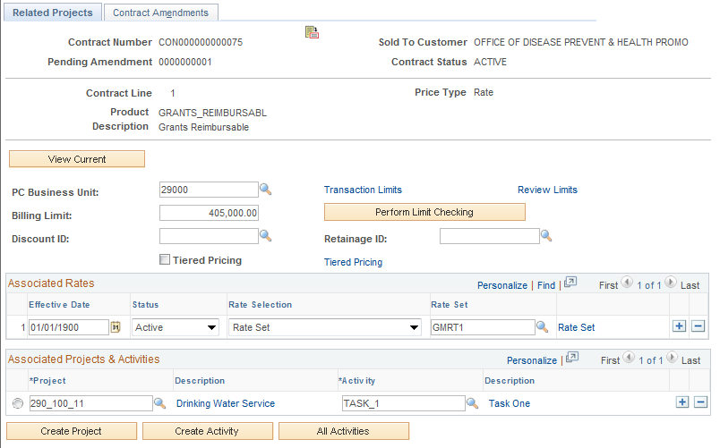

The Related Projects Tab now shows the Billing Limit as editable. Make necessary changes to the Billing Limit.

Click to Save the Bill Limit value.

Click Return to General Information link.

Click the Tab.

Click the Detail link for the Amendment.

Amendment Details Page

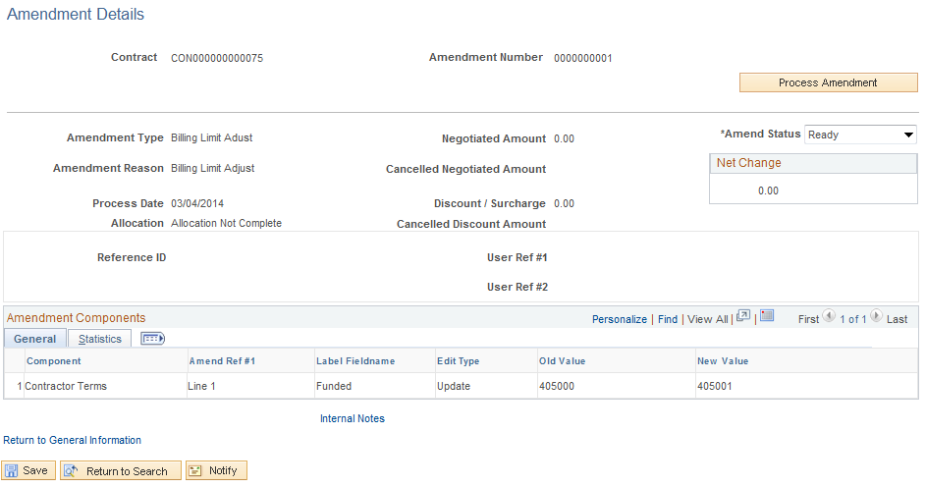

Ready the Amendment from the Amendment Details page.

Amendment Status – change to ‘Ready’ to make the amendment active.

Click to Save the Amendment Status value.

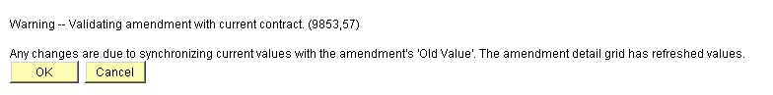

A warning message may appear for the Amendment. Click .F

Click to execute a batch process that will complete the Amendment.

