COR433 Grants – Grant Inquiry and Reporting Manual

The content of this training manual is based largely on a generic system configuration and illustrates the base-line functionality required to execute transactions in the module. Your agency may be utilizing more or less of the functionality illustrated in this manual. This manual is intended to be a framework upon which agencies can add agency-specific training content that speaks specifically to the system functionality that they have deployed and related configuration that they use for transaction processing. Agencies should not depend on these manuals for end-user training or problem resolution until they have been reviewed by the agency for appropriateness.

Authorized by: [EBS_] Original Issue: [06/01/2010]
Maintained by: [Grants Lead___] Current Version: [05/01/2014]
Review Date: [05/01/2014]

Table of Contents

Document History 4
Grant Inquiry and Reporting 5
Key Terms 6
Grants Business Unit 6
Grant Proposal 6
Grant Award 6
Grant Professionals 6
Sponsors 6
Sub-recipients 6
Project ID 6
Institution 6
Project Manager and Team 6
Grant Contract Definition 6
Facilities and Administration (F&A) 7
Letter of Credit Number 7
Letter of Credit Document ID 7
Process Flows 8
Grant Inquiry 11
Proposal Audit Logs 11
Header Tab 12
Projects Tab 13
Project Budget Inquiry 14
Budget Inquiry Page 15
Review Award Modifications 16
Award Modification Inquiry Tab 17
Award Inventory 18
Award Inventory Page 18
Project Forecast 19
Project Forecast Report Tab 20
Project Variance Report Tab 22
Proposal Inventory 24
Proposal Inventory Page 24

Document History

Document Revision | Date | Description
1.0  2.0 | 06/01/2010  05/01/2014 | Initial Document  Upgrade Update

Grant Inquiry and Reporting

The Grants module provides functionality to support both Pre and Post Award Grant administration and management. Once Grant Proposals have been created and awarded, the system provides online inquiry pages, delivered reports and custom queries.

Key Terms
Grants Business Unit: Each agency has one, and only one Grants Management Business Unit. The Business Unit is the three (3) digit agency code, plus 00. For example, Office of State Finance is 09000.

Grant Proposal: The Proposal represents the intent and request for Grant Funding from the State Agency. State Agencies create Grant Proposals that identify resources, projects, budgets, etc. that will be integral in the utilization of the funding request.

Grant Award: Once the Proposal has been negotiated and approved by the sponsoring entity, the Award represents the final agreement between the sponsor and the state agency for receipt and expenditure of funds.

Grant Professionals: Agency personnel responsible for administration of grant proposal.

Sponsors: The Sponsor represents the grant funding source. Generally, this is the Federal Agency through which federal grant funds are received.

Subrecipients: Subrecipients are entities or individuals that receive grant funding from the primary grantee within the parameters of a grant.

Project ID: Agency program or initiative funded by grant dollars (a.k.a. set aside).

Institution: State agency applying for grant funding and managing the grant funded projects.

Project Manager and Team: Project Manager & Team – agency personnel working on grant funded project.

Grant Contract Definition: The Contract defines funding Sponsor and Draw parameters for reimbursement. Also, defines reimbursable Product, Accounting and Grant funded Project relationships.

Facilities and Administration (F&A): The term F&A equates to Indirect Cost calculation for state agencies. This includes budgeting, calculating and accounting for Indirect Costs.
budgeting, calculating and accounting for Indirect Costs.

Letter of Credit Number: The Letter of Credit ID is a Sponsor specific number used to track Grant draws throughout the system.

Letter of Credit Document ID: The Letter of Credit Doc ID is a Grant Project specific number, input on the Grant Contract Line, used to track Grant draws throughout the system.

Process Flows

Diagram 1: Grants Module Integration

Diagram 2: Grants Chartfield Flow

Diagram 3: Grants Proposal Model

Grant Inquiry

Proposal Audit Logs

Navigation: Grants > Proposals > Review Proposal Audit Logs > Find an Existing Value

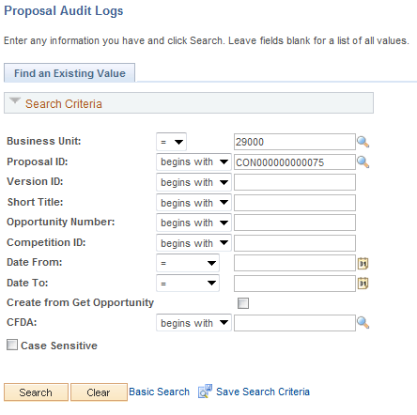

Use the Search Criteria to retrieve the Proposal.

Business Unit – Is the Agency in which the Proposal is created.

Proposal – The Grant Proposal ID.

Click to enter the Proposal Logs.

Header Tab

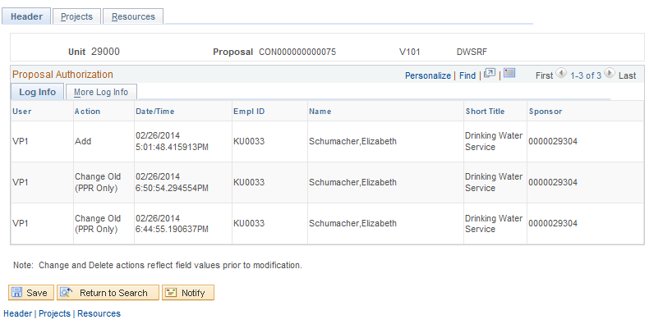

The Proposal Log Header Tab displays the history of the Grant Proposal Header. Header changes reflect global changes made to the Proposal.

User – Displays the User who made the Proposal Header change.

Action – Indicates what was done to the Proposal. Values could be Add, Delete or Change.

Date/Time – Indicates when the change was made.

Click the Tab to view history of the Grant Proposal Project.

Projects Tab

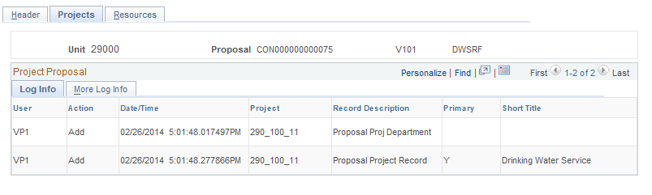

The Tab displays history of Grant Project changes.

Project – Displays the Project ID from the Proposal that was altered.

Primary – Indicates whether or not the change was made to a Primary project.

Project Budget Inquiry

Navigation: Grants > Awards > Project Budget Inquiry > Find an Existing Value

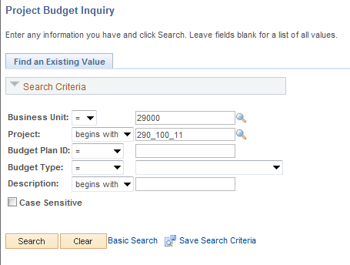

Use the Search Criteria to retrieve the Award Project.

Business Unit – the Agency in which the Grant Award Project is stored. This is the Project Costing Business Unit value.

Project – The Project ID for the Grant Award.

Click to enter the Project Award.

Budget Inquiry Page

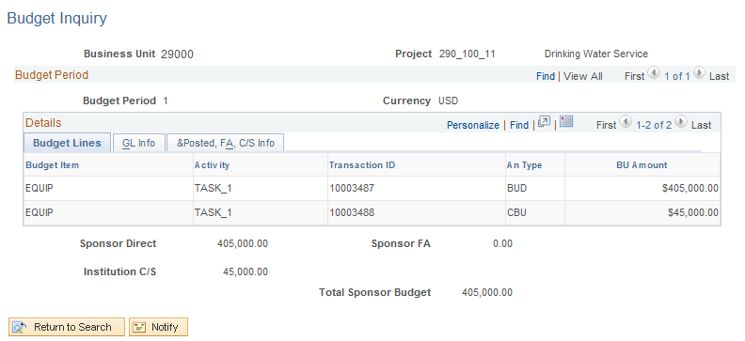

The Budget Inquiry page displays the details of the Budget for the Grant Award.

The Tab displays the details and amounts for each Budget Line.

Sponsor FA – For Grants using Cost Sharing, this field displays the Sponsor share of the Grant costs.

Review Award Modifications

Navigation: Grants > Awards > Review Award Modifications > Find an Existing Value

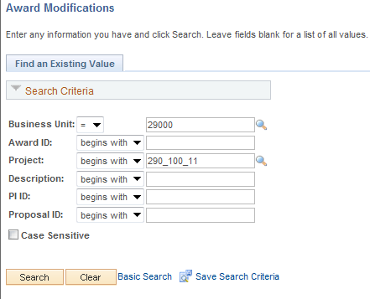

Use the Search Criteria to retrieve the Award Project.

Business Unit – The Agency in which the Grant Award is stored.

Award – Select the Award by Award number.

Project – The Project ID for the Grant Award.

Click to enter the Project Award

Award Modification Inquiry Tab

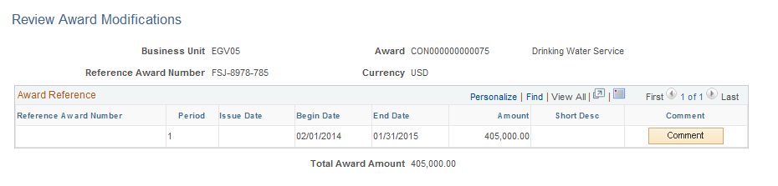

The Award Modification Inquiry page displays the history of any Award Modifications.

Use to view any stored comments with the award modification.

Award Inventory

Navigation: Grants > Interactive Reports > Award Inventory

Award Inventory Page

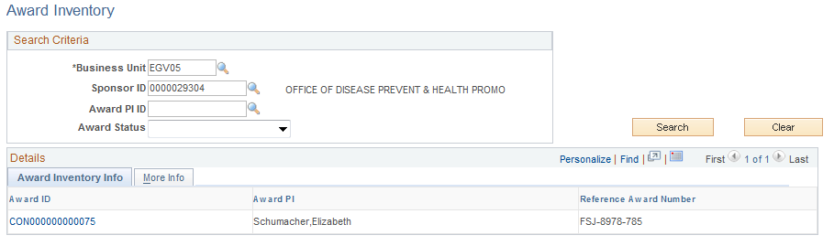

Use the Award Inventory page allows the user to search for Grant Awards using Search Criteria.

Sponsor ID – Select a Sponsor ID to retrieve all Grant Awards for a particular Sponsor ID.

Award PI ID – Populate with a Professional ID to retrieve all Awards that have a particular Professional.

Award Status – Retrieve all Grant Awards in a particular Status.

Click to select all Awards matching the Search Criteria.

Project Forecast

Navigation: Grants > Interactive Reports > Project Forecast

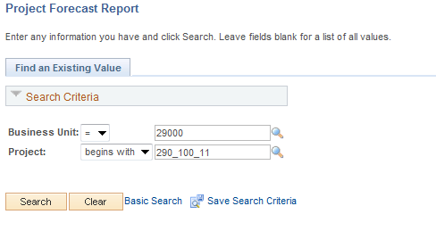

Use the Search Criteria to retrieve the Award Project.

Business Unit – The Agency in which the Grant Award is stored.

Project – The Project ID for the Grant Award.

Click to enter the Project Award

Project Forecast Report Tab

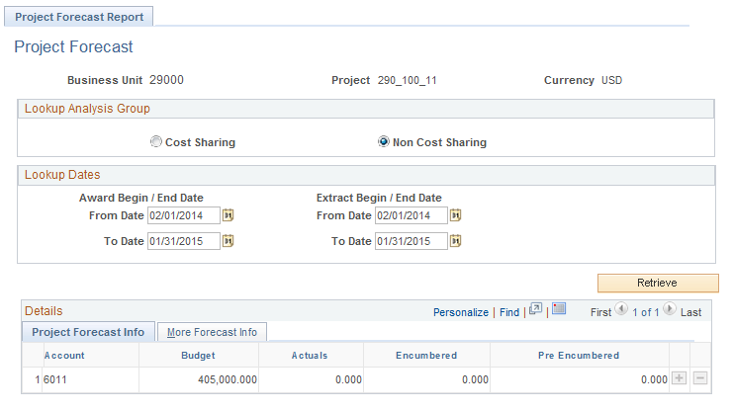

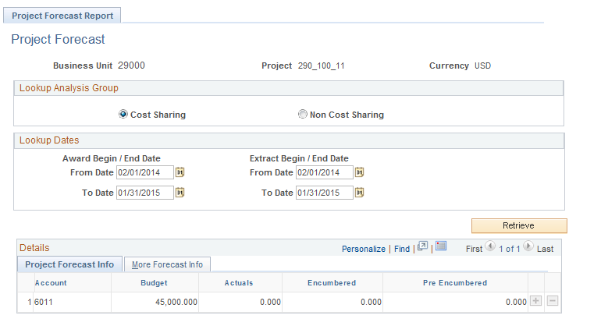

The Tab uses Lookup Dates to retrieve Budgeted and Actual Costs for a Grant Project.

Cost Sharing/Non Cost Sharing – Choose the appropriate radio button to view Cost Sharing or Non-Cost Sharing values.

NOTE: These radio buttons apply to the Grant Cost Sharing model configured in the Grant Proposal.

Award Begin/End Dates – Populate these date fields to retrieve all costs within this date range.

Extract Begin/End Dates – Use these dates to define which transactions for the Grant Project will be retrieved.

Click to select all transactions matching the Search Criteria.

The Tab displays, by Account, Budget, Actuals (expended), Encumbered and Pre-encumbered amounts for the Grant Project.

NOTE: The Grant Project amounts displayed on this page are grouped by Account value. This means that the Account value used when the Grant Budget is ‘Finalized’ must match the Account Values that are used when recording Expenditures (actual, encumbered and pre-encumbered).

Click the Tab.
Project Forecast Report page continued

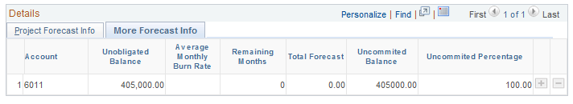

The More Forecast Info Tab displays by Account, the remaining balance and projections for future expenditures based on previous history.

Unobligated Balance – Displays Budgeted less Expended costs.

Average Monthly Burn Rate – This field is a projection of monthly expenditures base on historical expenditures.

Total Forecast – Displays the projected expenditures for the entire Grant Period based on history of expenditures.

Project Variance Report

Navigation: Grants > Interactive Reports > Project Variance

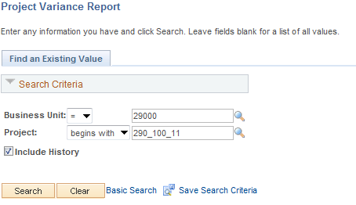

Use the Search Criteria to retrieve the Award Project.

Business Unit – Is the Agency in which the Grant Award is stored.

Click to enter the Project Award

Select the desired Project ID link.

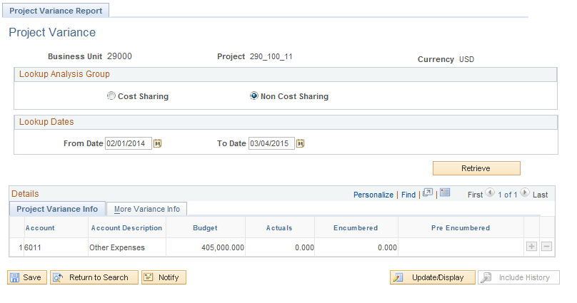

Cost Sharing/Non Cost Sharing – Choose the appropriate radio button to view Cost Sharing or Non-Cost Sharing values.

NOTE: These radio buttons apply to the Grant Cost Sharing model configured in the Grant Proposal.

From/To Dates – Define a date range from which to retrieve Grant Project transactions.

Click to select all transactions matching the Search Criteria.

NOTE: The Grant Project amounts displayed on this page are grouped by Account value. This means that the Account value used when the Grant Budget is ‘Finalized’ must match the Account Values that are used when recording Expenditures (actual, encumbered and pre-encumbered).

Click the Tab to view balance information for the Grant Project.

Proposal Inventory

Navigation: Grants > Interactive Reports > Proposal Inventory

Proposal Inventory Page

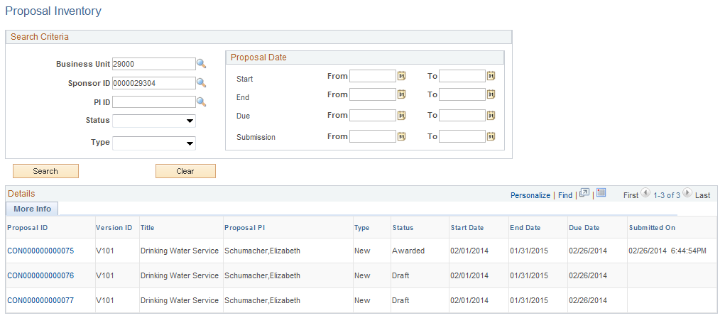

Use the Proposal Inventory page allows the user to search for Grant Proposals using Search Criteria.

Business Unit – Select an agency business unit.

Sponsor ID – Retrieve all Proposals for a Sponsor.

Proposal Status – Retrieve all Grant Proposals in a particular Status.

Click to select all Proposals matching the Search Criteria.

