COR436 Project Costing – Project Inquiry and Reporting Manual

The content of this training manual is based largely on a generic system configuration and illustrates the base-line functionality required to execute transactions in the module. Your agency may be utilizing more or less of the functionality illustrated in this manual. This manual is intended to be a framework upon which agencies can add agency-specific training content that speaks specifically to the system functionality that they have deployed and related configuration that they use for transaction processing. Agencies should not depend on these manuals for end-user training or problem resolution until they have been reviewed by the agency for appropriateness.

Authorized by: [_EBS_] Original Issue: [05/01/2014]
Maintained by: [____Project Costing Lead___]
Review Date: [05/01/2014]

Table of Contents

Document History 5
Project Inquiry and Reporting 6
Key Terms 7
Project Costing Business Unit 7
Project ID 7
Activity ID 7
Analysis Type 7
Analysis Group 7
Budget Item 8
Work Breakdown Structure 8
Project Budget 8
Project Accounting 8
Project Trees 8
Project Transaction 8
Process Flows 9
Guidelines, Concepts and Alternatives 10
Refresh Summary Tables 12
Step 1: Run Summary Table Refresh Process 12
Refresh Summary Tables Page 13
Flexible Analysis 14
Step 1: Create Flexible Analysis Template 14
Flexible Analysis Template Page 15
Step 2: Analyze Project 16
Flexible Analysis Page 17
Transaction List Page 19
Step 3: Edit Flexible Analysis Template 20
Flexible Analysis User Default Page 20
Flexible Analysis Template Page 21
Project Valuation 22
Step 1: Project Valuation Template 22
Valuation Template Tab 23
Step 2: Project Valuation 25
Project Valuation Tab 26
Activity Valuation Tab 27
Summary Pages and Reports 28
Budget Item Page 28
Budget Item Page 29
Budget vs. Actual Tab 30
Budget vs. Actual Page 31
Report Summarization Option 33
Step 1: Define Report Summarization Options 33
Report Summarization Options Page 34
Step 2: Run the Summarization Process 35
Report Options Page 36
Step 3: Running Transaction Summary Report 39
Transaction Summary Page 40
Review Costs 42
Purchase Orders by Activity Page 42
Purchase Orders by Activity Page 43
Purchase Orders Inquiry Page 44
Vouchers by Activity Page 45
Vouchers by Activity Page 46
Vouchers Accounting Entries Page 47
Summarize by Analysis Type Page 48
Summarize by Analysis Type Tab 49
Summarize by Category Page 51
Summarize by Category Tab 52

Document History

Document Revision | Date | Description
1.0  2.0 | 04/30/2010  05/01/2014 | Initial Document  Upgrade Update

Project Inquiry and Reporting

Project Costing provides delivered reports, inquiry pages and queries to analyze Project data. Transactional information for Costs, Revenue and Budget can be retrieved and reported on.

Analysis Types play a critical role in Project Reporting. Certain Analysis Types allow the user to group Project transactions together at a summary level to analyze Project profitability, budget versus actual and statistical data.

This manual describes the processes used to review and report on Project transactions.

Key Terms

Project Costing Business Unit: Each agency has one, and only one Project Costing Business Unit. The Business Unit is the 3 digit agency code, plus 00. For example, Office of State Finance is 09000.

Project ID: The Project ID represents the basic unit that serves to establish budgets and collect costs and revenue for analysis purposes. Projects serve to collect construction costs and capitalize Assets in conjunction with the Asset Management module. Project ID is also a Chartfield and as such a part of the distribution line. Project IDs are a maximum 15 characters long, and they are alpha-numeric (can be letters and/or numbers). Additionally Project IDs must be unique throughout the system; hence each ID should start with the first three digits of the Agency number. Ex: 090CORE_PHASEII

Activity ID: An Activity ID generally represents a task that makes up a Project. Project Costs and Budgets are stored in Activities.

Analysis Type: Analysis Types are used in both Grants and Project Costing to reflect the nature of transactional data as it flows thru the system. PeopleSoft delivers a set of Analysis Types that support the functionality of software particularly in Grants and Projects. This set of Analysis Types should not be altered. However, if business process requires additional Analysis Types be added (this is likely) additional “agency specific” Analysis Types can be added and used.

Each project is composed, at the most basic level, of transactions. Transaction rows in the PROJ_RESOURCE table contain the quantity, amount, chartfields and other detailed data elements associated with each transaction (PO#, Req#, Voucher#, Vendor, etc.).

Analysis types are assigned to individual transactions to identify the different types of transactions, such as estimated costs, budgeted amounts, actual costs, and billed costs. For a single transaction, the Analysis Type can change as the transaction flows thru the system. For example, a requisition begins with and Analysis Type = REQ, when the requisition is sourced into a Purchase Order another transaction is created with an analysis type = COM. Finally, when the PO is copied into a voucher for payment, a third transaction is created with the ACT analysis type. In this way, analysis types describe the nature of a transaction within Project Costing or Grants.

Analysis Group: A collection of Analysis Types used for securing Project Transactions, calculating Billable costs and Reporting.

Budget Item: An agency defined category of budgeting. These could be similar to a roll-up account like Labor, Equipment or Travel. Budget Item is used in several of PeopleSoft’s delivered inquiry pages.

Work Breakdown Structure: Organization of Activity ID’s to define the total scope of each Project. Each descending level represents an increasingly detailed definition of a project component.

Project Budget: Project Budgets are Cost or Revenue budget estimates that are distributed to Project Activities and Budget Items across time periods for budgetary or project performance measurement.

Project Accounting: The Accounting for Projects feature provides a method for translating Project transactions into accounting entries that can be sent to General Ledger. Using Accounting Rules, the system converts transactions in Project Costing to accounting lines that the Journal Generator Application Engine process (FS_JGEN) later converts into journal entries.

Project Trees: Project Trees define how Projects are related to each other. The relationships between projects determine the level of detail achieved when tracking and reporting costs. Within a Project Tree, a project can be hierarchically related to as many projects as necessary to achieve the necessary degree of cost tracking and analysis.

Project Transaction: Project Transactions represent the cost, revenue or budget amounts defined for and collected in a Project. A Project Transaction can be a Purchase Order encumbrance, a Voucher cost, a Billing amount or a Budgeted estimate. Project Transactions make up the amounts and estimates by which Project Accounting and Reporting is accomplished.

Process Flows

Diagram 1: Project Costing Module Integration

Guidelines, Concepts and Alternatives
Table 1: Available Analysis Types

Analysis Type | Description | Analysis Type | Description
ACT | Actual Cost | FRV | Fixed-Cost Revenue Amount
ASP | Express Asset Percentage Distribution | FTC | Forecast Cost to Complete
BAJ | Billing Adjustment | GLE | General Ledger Expense
BD1 | Total Cost Budget - Scenario 1 | GLR | General Ledger Revenue
BD2 | Total Cost Budget - Scenario 2 | GNT | Grant Reimbursement
BD3 | Total Cost Budget - Scenario 3 | OLT | Over Limit Amount
BD4 | Total Cost Budget - Scenario 4 | ORD | Order
BD5 | Total Cost Budget - Scenario 5 | PAY | Time and Labor Actual
BD6 | Total Cost Budget - Scenario 6 | PCA | Profile Adjustment
BD7 | Total Cost Budget - Scenario 7 | PCL | Profile Cost Summary
BD8 | Total Cost Budget - Scenario 8 | PFS | Proceeds from Sale of Asset
BIL | Billable Amount | PSD | Purchase/Sold Time Discount
BLD | Billed Amount | PSR | Proceeds from Sale Summary
BRT | Billing Retainage | PST | Purchase/Sold Time
BUD | Total Cost Budget | RAJ | Released Retainage Adjustment
CAC | Cost Sharing Actuals | RB1 | Revenue Budget 1
CBA | Cost Budget Adjustment | RB2 | Revenue Budget 2
CBU | Cost Sharing Budget | RB3 | Revenue Budget 3
CCA | Closed Commitment Adjustment | RBD | Revenue Budget
CCO | Cost Sharing Commitment | REB | Rebate
CFA | Cost Sharing Finance and Administration | REQ | Requisition
CGE | Cost Sharing General Ledger Expense | RET | Retirement Cost
CLS | Asset Cost Summary | REV | Revenue
COM | Commitment including Purchase Order & Subcontractor | RRT | Released Billing Retainage
COR | Cost of Removal of Asset | RRV | Requisition Reversal
CPY | Cost Sharing Payroll | SFA | Sponsor Finance and Administration
CRQ | Cost Sharing Requisition | SHD | Shared Discount
CRR | Cost of Removal Cost Summary | SHR | Shared Revenue
CRV | Commitment Reversal | SUT | Sales/Use Tax
CST | Costing (without PeopleSoft Contracts) | TLA | Time and Labor Estimate
DEF | Deferred Amount | TLB | Time and Labor Estimate for Billing
DSC | Billing Discount | TLC | Time and Labor Contractors
EMP | Project Costing Employee Time | TLX | Cost from Time Traveler
ESB | Engagement Plan Bill Estimate | UAJ | Prepaid Utilization Adjustment
ESC | Engagement Plan Cost Estimate | UTL | Prepaid Utilization (Billing)
FBD | Fixed Cost Billed Amount | VAR | Variance
FCC | Completion Cost | VIN | Not Recoverable Value Added Tax
FND | Fund Distribution | WTO | Write Off
FND | Fund Distribution

* Commonly used Analysis Types are displayed on BOLD in this table.

Refresh Summary Tables

Project Costing Analysis pages use Project Summary tables to display results. The Integration processes from feeder modules populate these tables, but they may also be populated on an ad hoc basis if necessary.

Step 1: Run Summary Table Refresh Process

Navigation: Project Costing > Utilities > Refresh Summary Tables > Find an Existing Value

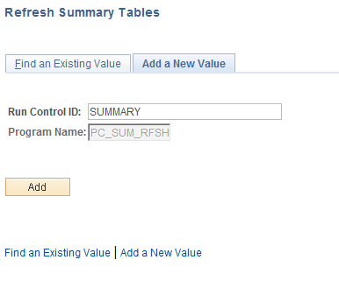

Run Control ID – create a new Run Control or select an existing value from the list. If a new Run Control is created, click , otherwise click to retrieve an existing Run Control.

Refresh Summary Tables Page

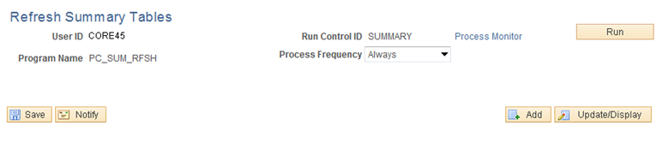

There are no parameters to populate on the Refresh Summary Tables page.

Process Frequency – set to Always.

Click to execute the Summary Table Refresh process.

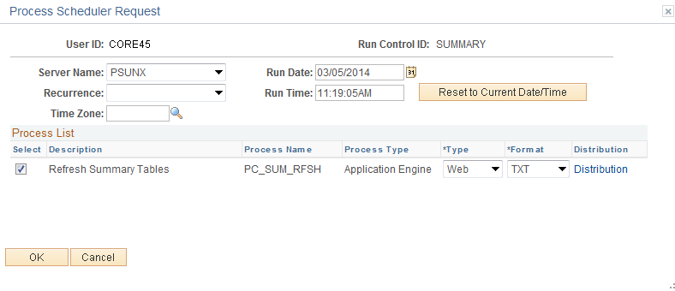

Select the checkbox next to the desired process.

Click to execute the process. Navigate to the Process Monitor to view the Report instance.

Flexible Analysis

The Flexible Analysis feature provides a view of Project costs based on the Analysis Groups that are specified in a Flexible Analysis Template (user defined by User ID). Flexible Analysis is an interactive tool that works effectively if you want to view one data item at a time, such as costs by Source Type or Category.

The user must create a Flexible Analysis Template before they can perform flexible analysis. Templates define the Analysis Types that the system uses to gather Project costs. A template can be saved as a user default to save time performing flexible analysis. Flexible Analysis Templates can be modified by the user as required.

Step 1: Create Flexible Analysis Template

Navigation: Project Costing > Flexible Analysis Template > Add a New Value

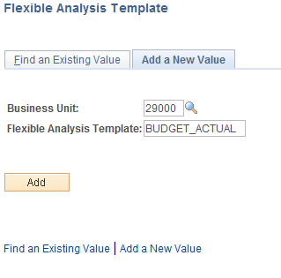

Business Unit – is the Agency in which the Projects and Analysis will be done.

Flexible Analysis Template – define the Template ID. This name could represent the desired reporting analysis that will be provided.

Click to enter the Flexible Analysis Template pages.

NOTE: The Analysis Group mapping configuration may need to be reviewed prior to building a Flexible Analysis Template. The Analysis Types and mapping in the Analysis Group determine how the Project dollars will be summarized in the Flexible Analysis. Set Up Financials/Supply Chain>Product Related>Project Costing>Transaction Options>Analysis Groups.

Flexible Analysis Template Page

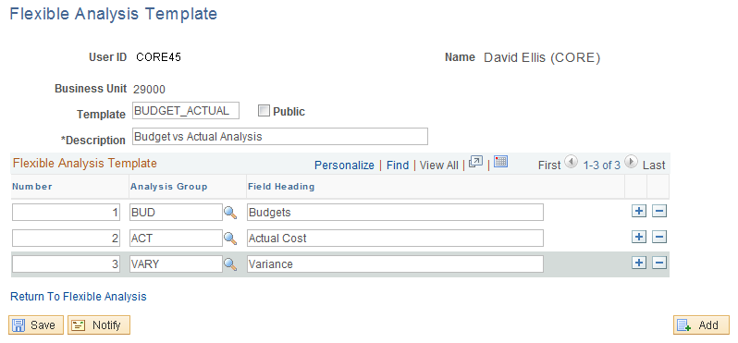

Template – the Flexible Analysis Template ID.

Description – define a Flexible Analysis Template Description.

Number – define the sequence of the column order for the Flexible Analysis columns on the analysis page.

Analysis Group – select the Analysis Groups the will be displayed on the Flexible Analysis page.

Field Heading – provide a column heading for the Flexible Analysis page.

NOTE: The Analysis Groups defined here will make up the page appearance when utilizing the Flexible Analysis feature.

Use to add additional Analysis Groups.

Click to save the Template.

Step 2: Analyze Project

Navigation: Project Costing > Interactive Reports > Flexible Analysis > Find an Existing Value

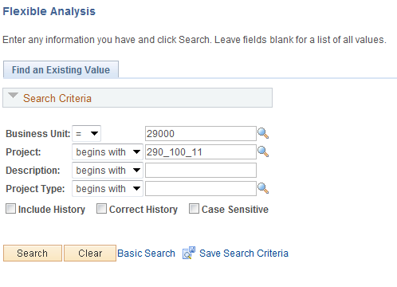

Use the Search Criteria to retrieve the Project ID to be analyzed.

Business Unit – is the Agency in which the Project is stored.

Project – the Project ID value.

Description – search by Project Description.

Click to enter the Project Flexible Analysis pages.

NOTE: In order for the Flexible Analysis pages to display Project information correctly the Project Summary tables must be populated. These should be populated when transactions are collected from feeder modules.

Flexible Analysis Page

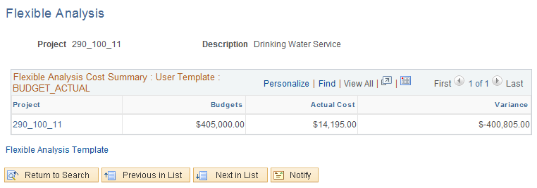

The Flexible Analysis page initially displays Project amounts at the Project level of detail. The Columns displayed on the page are derived from the Flexible Analysis Template and the amounts are grouped by the Analysis Groups defined on the Template.

Use the Flexible Analysis Template link to navigate back to the template.

Click the Project ID link to drill-down to the Activity Level of detail.

Flexible Analysis page continued

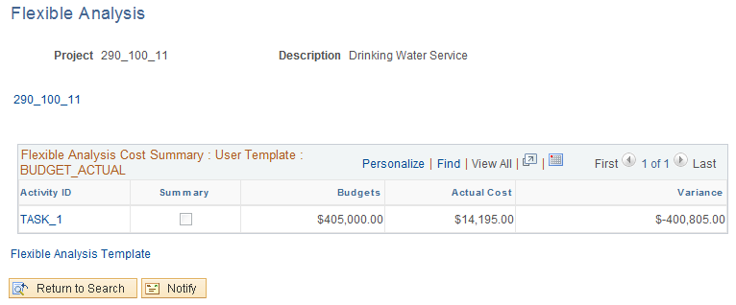

The Flexible Analysis page at the Activity level of detail shows the same columns defined from the Template, but the costs are broken out by Activity ID.

Summary – this checkbox indicates an Activity to be a “Summary Activity”. See COR434 - Project Definition Manual.

NOTE: The Project ID is displayed as a hyperlink at the top of the page to make visible the “bread crumbs” indicating to the user what level of the drill-down is being shown on the page.

Click the Activity ID link to drill-down to the Detail Activity Level of detail or to the Source Type level of detail.

NOTE: The Flexible Analysis page allows the user to continue to drill-down on Project transactions to the Source Subcategory level where the button is available.

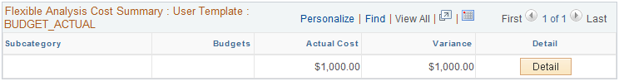

Click to drill to the actual Project Transaction.

Transaction List Page

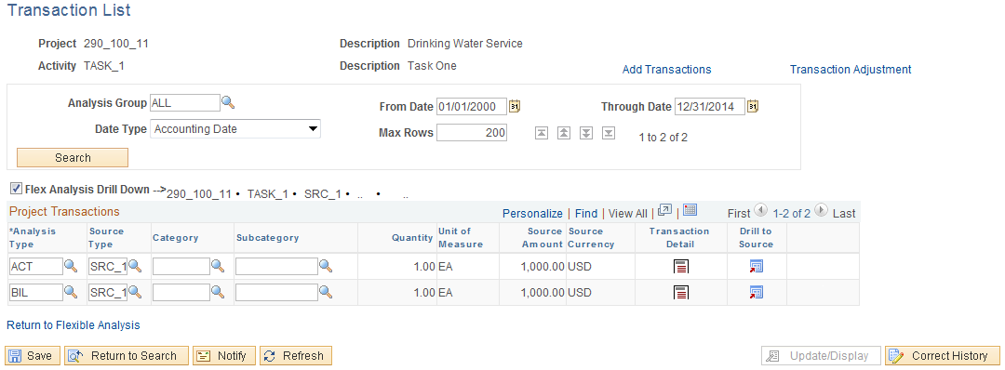

When accessed from the Flexible Analysis pages, the Transaction List page displays all of the Project transactions that made up the drill-down level of detail.

Click the Return to Flexible Analysis link to start another analysis for the Project.

Step 3: Edit Flexible Analysis Template

Navigation: Project Costing > Flexible Analysis User Default > Find an Existing Value

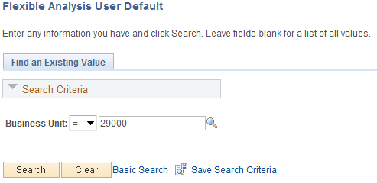

Business Unit – select the agency business unit where the Flexible Analysis Template resides.

Click to enter the Project Flexible Analysis Template pages.

Flexible Analysis User Default Page

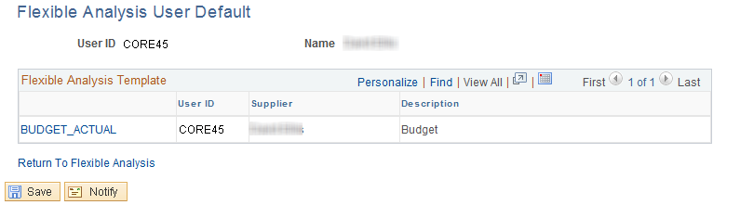

Each user has a default Flexible Analysis Template that is used in the Project Analysis pages. This default template is displayed on the Flexible Analysis User Default Page.

Click the Return to Flexible Analysis link to change the default template, view a template or create a new template.

Flexible Analysis Template Page

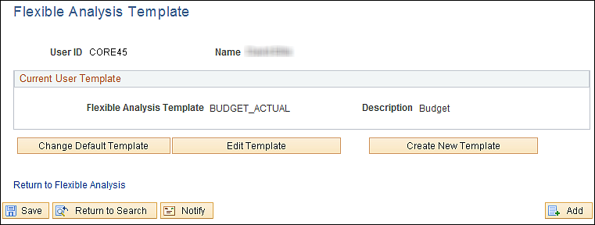

Use the Flexible Analysis Template page to change the default template, edit an existing template or add a new template.

Click to change the template that is used to summarize Project costs in the Flexible Analysis pages.

Click to change the Analysis Types, column headings or description of an existing template.

Click to create a new Flexible Analysis Template for different Project analysis.

Project Valuation

Project Valuation uses templates that contain evaluation criteria for Project and Activity summary information. To perform the evaluation, select a Project Business Unit, Project and Template that the system uses to calculate a summary view of different Project dimensions, and an activity-based view of financial data.

Users can create arithmetic equations using parenthesis to calculate statistics such as the actual percent of budget. Reporting calculation results appear below the transaction group summary rows on the Project Valuation page.

Step 1: Project Valuation Template

Navigation: Project Costing > Interactive Reports > Valuation Template > Find an Existing Value

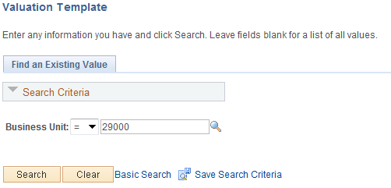

Business Unit – select the agency business unit to create a Valuation Template.

Click to enter the Project Valuation Template pages.

NOTE: The Analysis Group configuration may need to be reviewed prior to building a Valuation Template. The Analysis Types in the Analysis Group determine how the Project dollars will be summarized in the Valuation Template. Set Up Financials/Supply Chain>Product Related>Project Costing>Transaction Options>Analysis Groups.

Valuation Template Tab

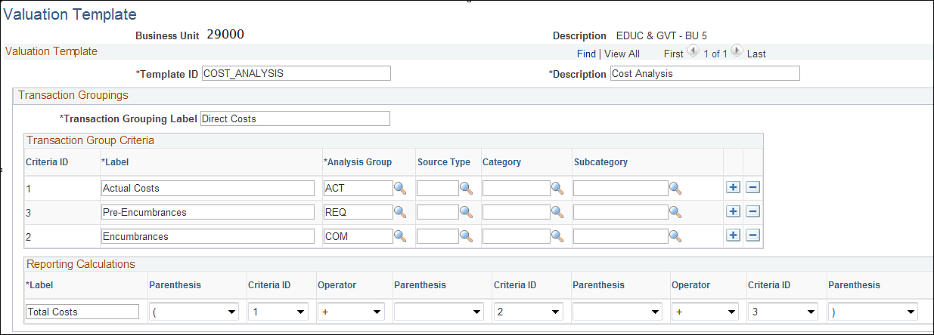
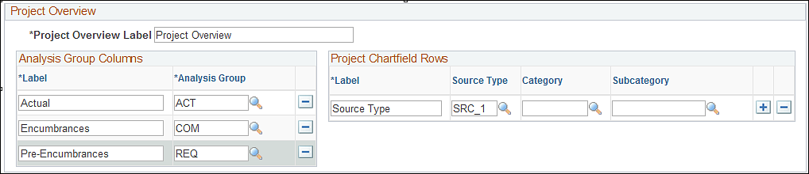

The Valuation Template Tab allows the user to create a template using Analysis Groups, Project Costing Chartfields, Labels and Arithmetic calculations to build a page that summarizes, groups and displays Project transactions.

Template ID – create a Valuation Template ID that will be selected when analyzing Project transactions.

Description – define the description of the Template.

Transaction Grouping Label – this value will be displayed on the Project Valuation page as a label for the Criteria defined below. This label will be displayed as a section of the page.

Transaction Group Criteria – create Criteria ID’s using Labels, Analysis Groups and Project Costing chartfields.

Reporting Calculations – for the Criteria ID’s defined in this template, use the Operators to add, subtract, multiply or divide the Project transactions.

Project Overview Label – this value will be displayed on the Project Valuation page as a label for the section of the page.

Analysis Group Columns – these labels and Analysis Groups will become column headings and Project summary criteria respectively on the Project Valuation page.

Project Chartfield Rows – these labels and Project Costing chartfield values make up the rows on a summary section of the Project Valuation page.

Click to save the Template.

NOTE: Use to add additional templates as needed for Project analysis.

NOTE: Creating the Valuation Template may be a trial-and-error process to achieve the desired column headings, analysis group summarization and chartfield groupings. Once the Valuation Template is complete, test the accuracy by displaying the Project Valuation page, then make necessary changes to the template.

Step 2: Project Valuation

Navigation: Project Costing > Interactive Reports > Project Valuation > Find an Existing Value

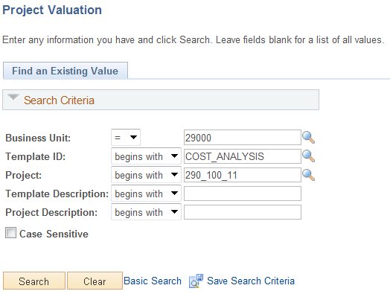

Business Unit – select the agency business unit to create a Valuation Template.

Template ID – select the Valuation Template to analyze the Project.

Project – select the Project ID to review.

Click to enter the Project Valuation page.

Project Valuation Tab

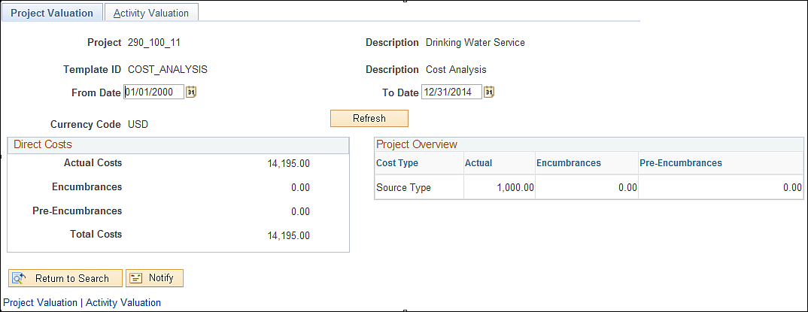

The Project Valuation Tab displays Project transactions in the summary format defined on the Valuation Template.

From/Thru Dates – define a date range from which Project Transactions will be retrieved.

Use to retrieve Project transactions based on the date range.

The bottom section of the page displays Transaction Groupings and Project Overview pieces of the Valuation Template.

Click the Activity Valuation Tab to drill-down to the Activity level of detail for the Project.

Activity Valuation Tab

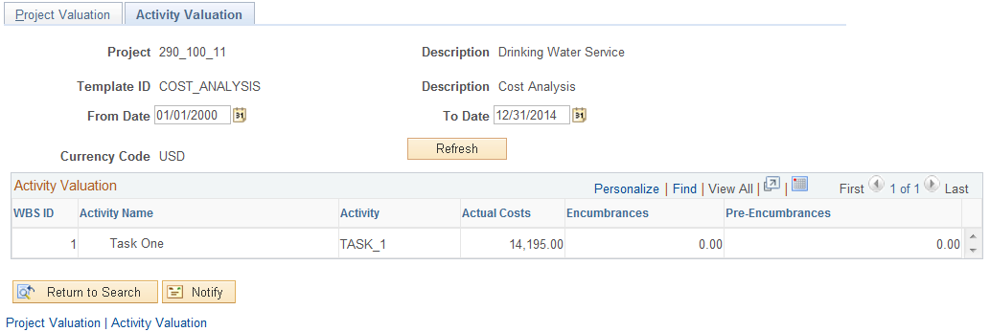

The Activity Valuation Tab displays Project transactions selected through the Valuation Template at the Activity level of detail.

NOTE: The Work Breakdown Structure for the Project Activity configuration is displayed.

Summary Pages and Reports

Project Summary pages and reports are available in Project Costing. These features allow analysis and review of Project transactions at a summary level with drill-down capability available on most pages.

Budget Item Page

Navigation: Project Costing > Interactive Reports > Budget Item > Find an Existing Value

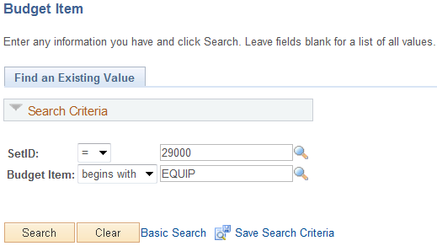

SetID – select the agency business unit value.

Budget Item – select a Budget Item to view budget versus actual comparison.

Click to enter the Budget Item pages.

Budget Item Page

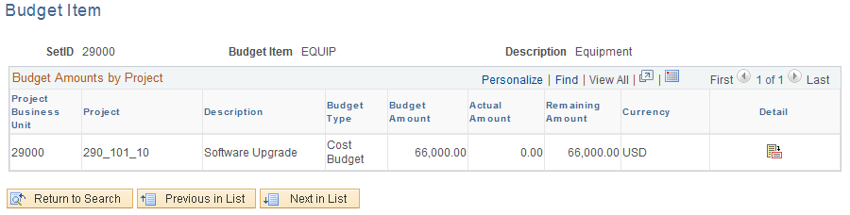

The Budget Item page displays all Projects within the Business Unit that have the Budget Item defined and budgeted.

Budget Type – this value defines the budget type as Cost or Revenue.

Remaining Amount – this field displays the budget versus actual difference.

Click the Activity Definition icon to drill-down to the Activity level of detail.

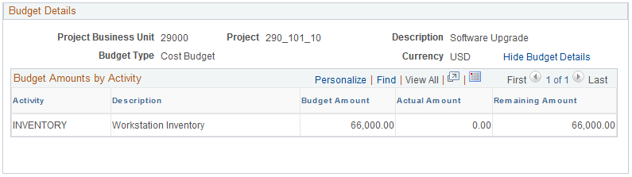

The Budget Details section of the page displays Activity level details for the Project and Budget Item.

Budget vs. Actual Tab

Navigation: Project Costing > Interactive Reports > Budget vs. Actual > Find an Existing Value

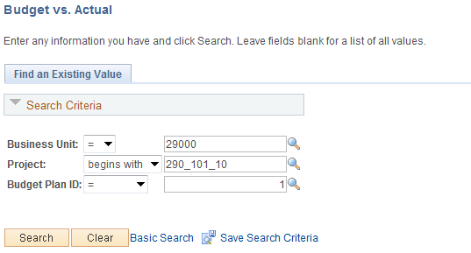

Business Unit – select the agency business unit to view Budget versus Actual comparison.

Project – select a Project ID.

Budget Plan ID – if multiple Budget Plans exist for a Project, select the desired value.

Click to enter the Budget vs. Actual pages.

Budget vs. Actual Page

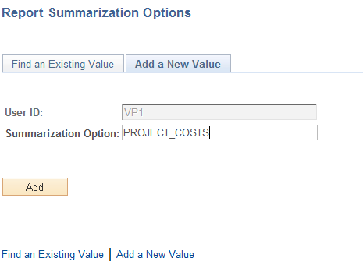

The Budget vs. Actual page displays Project Budget Plan information at the top of the page including Budget Type, budget Start Date and budget Calendar.

The Amounts section of the page displays Project Budget, Actual and Remaining Amount.

Status – the status indicator reflects the budget versus actual ‘Budget Alert’ defined for the Project (see COR434 Projects – Project Definition Manual)

The Select Activity section of the page displays Activity level of detail with drill-down capability.

Click the Activity ID link to drill-down to Activity level budget versus actual.

Budget vs. Actual page continued

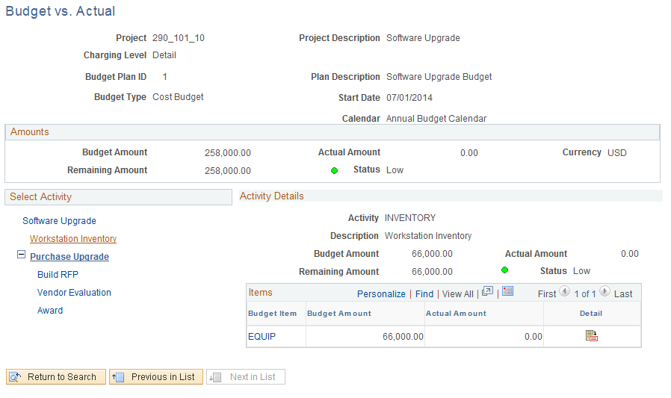

The Activity Details section of the page displays budget versus actual amounts (with remaining amounts).

Budget Item – the Budget Items defined for the Activity are visible.

Click the Activity Definition icon to drill-down to the Budget Item level of detail.

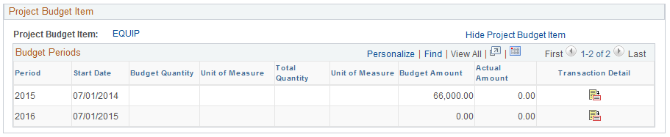

Report Summarization Option

The Report Summarization feature summarizes rows in the Project Transaction table (PROJ_RESOURCE) into a smaller Project Transaction Reporting table (PC_RPO) for enhanced performance and reporting. Creating reports by using report summarization is a three-step process:

- Create a Report Summarization group that contains the distinct fields that you want to summarize from the Project Transaction table. This “template” is defined for each User.
- Run the Report Summarization process to populate the Project Transaction Reporting table (PC_RPO).
- Create a report using the reporting table – PC_RPO.

Step 1: Define Report Summarization Options

Navigation: Project Costing>Reports > Summary>Report Summarization Options > Create a New Value

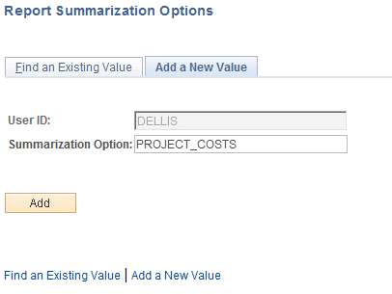

User ID – the system will default the User ID for the Summarization Options being created.

Summarization Option – create a name for this Summarization Option “template” that describes how the Project transactions are being summarized.

Click to create the Summarization Option template.

Report Summarization Options Page

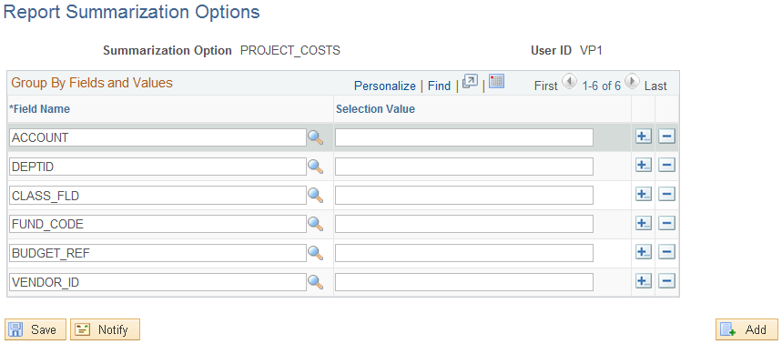

Use the Report Summarization Options page to create group by (summary) and filter criteria for the Report Summarization process. This will be used as a template for the summarization process to select and summarize data into the RPO table.

Field Name – select fields to be selected in the Report Summarization process to summarize in the Project Transaction Reporting table.

Selected Value – enter a value to restrict the Report Summarization process to summarize only rows with the specific field value. If this field is left blank, the process will select all value in the field.

Click to save the Summarization Options.

NOTE: Summarization Option “templates” are stored by User ID in the system.

NOTE: The Report Summarization process automatically summarizes Business Unit, Project ID, Activity ID and Analysis Type fields for all rows in the Project Transaction table.

Step 2: Run the Summarization Process

Navigation: Project Costing>Reports > Summary > Reporting Options > Find an Existing Value

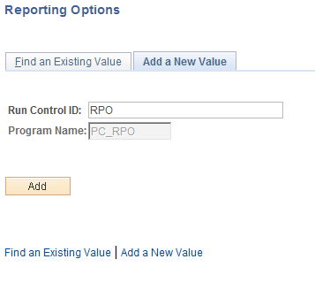

Run Control – create a new Run Control or search for an existing value.

Click to retrieve an existing Run Control.

Report Options Page

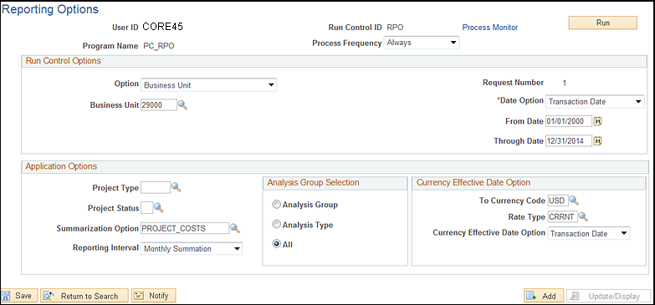

Process Frequency – set to ‘Always’.

Option – define the scope of the Summarization process for this run. The process can be executed by:
- All – summarize all Project Costing transactions for all Business Units. This value should likely not be used when running the process on an Ad-Hoc basis.
- Business Unit – summarize all Project Costing transactions for an agency Business Unit.
- Business Unit/Project – summarize all Project Costing transactions for an agency Business Unit and Project ID.
- Business Unit/Project/Activity - summarize all Project Costing transactions for an agency Business Unit Project ID and Activity ID.
- Tree Node – summarize all Project Costing transactions for a Tree Node.

Date Option – select the date that the processes uses to select Project transactions for summarization.

NOTE: The Transaction Date must be used to summarize for these reports to run correctly: Financial Summary (PCPL1000), Transaction Summary (PCPL2000) and Transaction Level Report (PCY5050.rpt).

From/Thru Date – define a date range that will be used to select Project transactions for summarization.

Project Type – define a value to have the process select only Projects with this Project Type.

Project Status – define a value to have the process select only Projects with this Project Status.

Summarization Option – select from a pre-defined Summarization Option “template”. (See Step 1 in this section.).

Reporting Interval – define how the process summarizes Project transactions by date:

- Daily – select to summarize Project transaction rows by day.
- Inception – select to summarize all Project transaction rows. The Date Option must be ‘All’.
- Monthly – select to summarize Project transaction rows by month.
- Quarterly – select to summarize Project transaction rows by quarter.
- Yearly – select to summarize Project transaction rows by year.

NOTE: The Accounting or Transaction Date assigned in the Reporting table will be the last day of the Month, Quarter or Year if those interval values are used.

Analysis Group Selection – select the radio button to summarize Project transactions for an Analysis Group, a particular Analysis Type or All.

Click to execute the Summarization process.

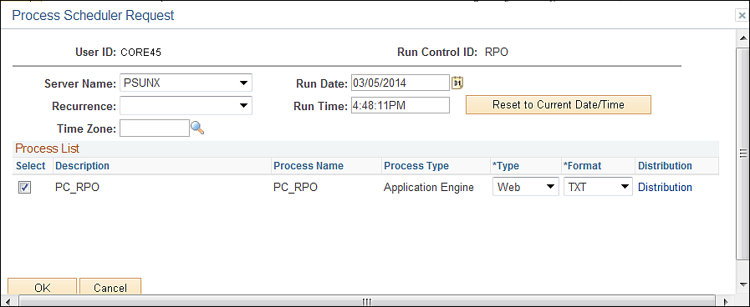

Select the checkbox next to the desired process.

Click to execute the process. Navigate to the Process Monitor link to view the Process instance.

NOTE: Once the Summarization table (PC_RPO) has been populated, the table can be queried or delivered reports can be executed against the summarized data. Delivered reports include: Financial Summary (PCPL1000), Transaction Summary (PCPL2000) and Transaction Level Report (PCY5050.rpt).

Step 3: Running Transaction Summary Report

Navigation: Project Costing > Reports>Summary > Transaction > Find an Existing Value

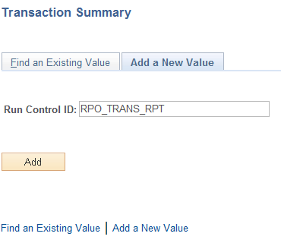

Run Control – create a new Run Control or search for an existing value.

Click to retrieve an existing Run Control.

Transaction Summary Page

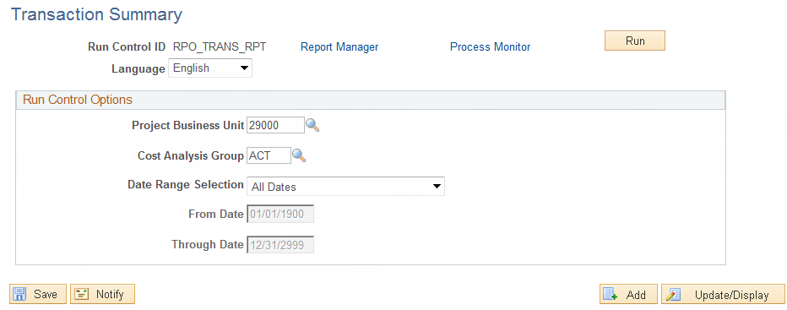

Project Business Unit – define the agency business unit.

Cost Analysis Group – define the Analysis Group that will be used to filter data from the Summarization table.

Date Range Selection – define the range of days that the report will be built upon.

Click to execute the Summarization process.

NOTE: Other delivered reports using the Report Summarization feature include:

Financial Summary (PCPL1000) – Project Costing>Reporting>Summary>Financial

Transaction Level Report (PCY5050.rpt) - Project Costing > Reporting >Summary >Transaction Level Report.

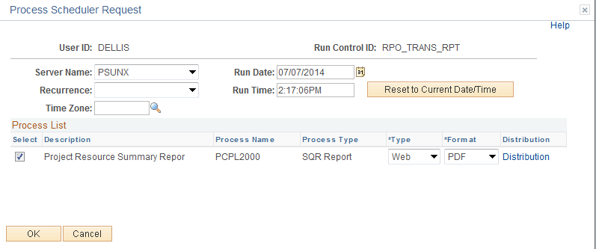

Select the checkbox next to the desired process.

Click to execute the report. Navigate to the Process Monitor link to view the Report instance.

Review Costs

Project Costing provides a number of pages designed to review Project transactional costs.

Purchase Orders by Activity Page

Navigation: Project Costing > Review Costs > Accumulated Costs > Purchase Orders by Activity > Find an Existing Value

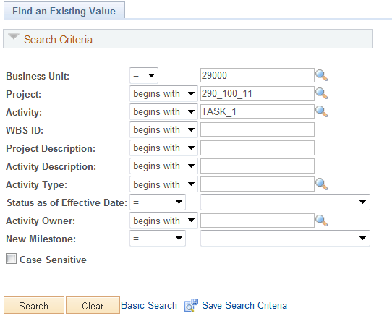

Use the Search Criteria to retrieve the Project containing PO transactions.

Business Unit – is the Agency in which the Project is stored.

Project – the Project ID containing PO transactions.

Activity – select the Project Activity to view.

Click to enter the Activity PO Review pages.

Purchase Orders by Activity Page

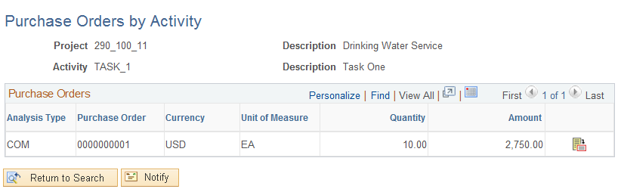

The Purchase Orders by Activity page displays all Project transactions related to a Purchase Order. These transactions could carry different Analysis Types depending on what status they are in. For example, a transaction with an Analysis Type of ‘BIL’ could have been created from a Purchase Order, paid by a Voucher, and then priced into a BIL row.

Analysis Type – the rows with ‘COM’ Analysis Type are the actual Project Encumbrance transaction.

Use the Activity Definition icon to dill to Purchase Order Inquiry pages.

Purchase Orders Inquiry Page

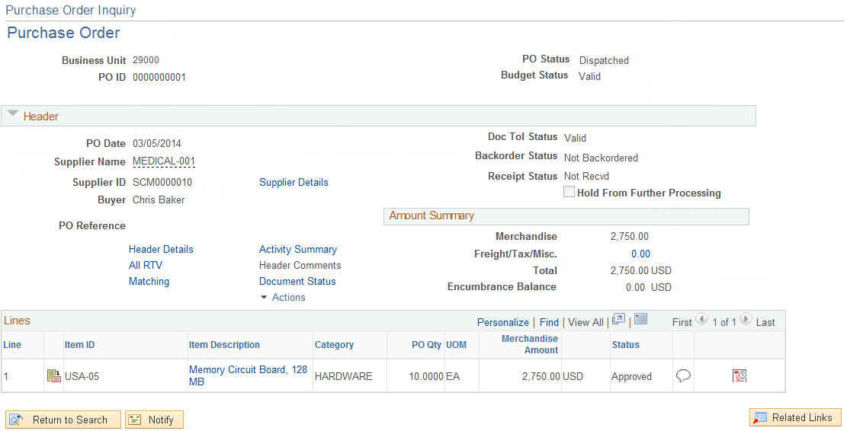

The Purchase Order Inquiry page will display Purchase Order information including the PO Line, Schedule, and Distribution pages.

NOTE: The user must have access to the Purchase Order Inquiry page for the drill-down feature to work correctly.

Vouchers by Activity Page

Navigation: Project Costing > Review Costs > Accumulated Costs > Vouchers by Activity > Find an Existing Value

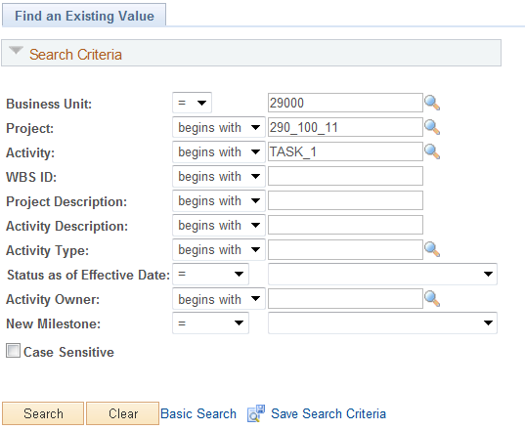

Use the Search Criteria to retrieve the Project containing Voucher transactions.

Business Unit – is the Agency in which the Project is stored.

Project – the Project ID containing Voucher transactions.

Activity – select the Project Activity to view.

Click to enter the Activity Voucher Review pages.

Vouchers by Activity Page

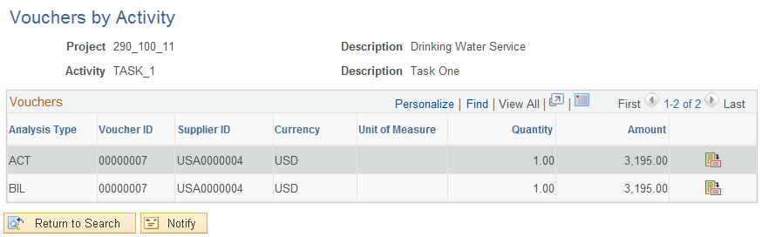

The Vouchers by Activity page displays all Project transactions related to a Payables Voucher. These transactions could carry different Analysis Types depending on what status they are in. For example, a transaction with an Analysis Type of ‘BIL’ could have been created from a Voucher that was priced into a BIL row.

Analysis Type – the rows with ‘ACT’ Analysis Type are the actual Project Expenditure (Payables) transaction.

Use the Activity Definition icon to dill to Voucher Account Entry pages.

Vouchers Accounting Entries Page

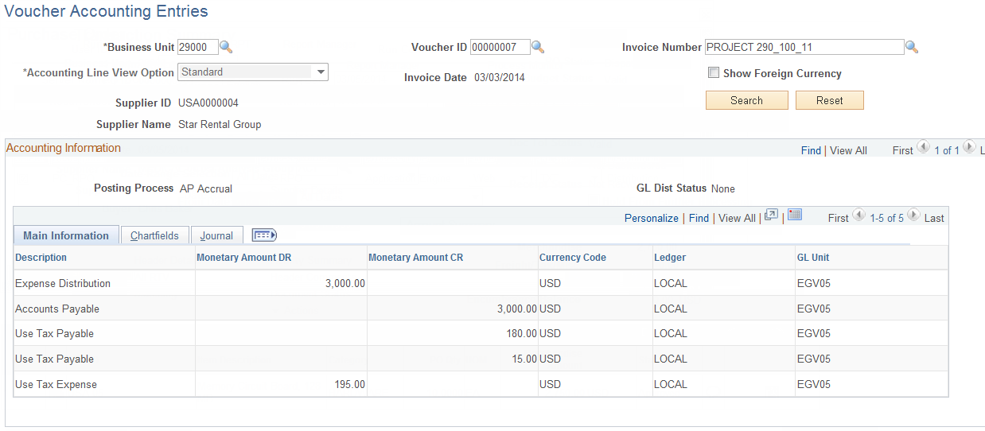

The Voucher Accounting Entries page displays payables information related to the Project transaction including Voucher Number, Invoice Number, Invoice Date, Vendor ID, Vendor Name and accounting entry details.

NOTE: The user must have access to the Voucher Accounting Entries page for the drill-down feature to work correctly.

Summarize by Analysis Type Page

Navigation: Project Costing > Review Costs > Summarize by Analysis Type > Find an Existing Value

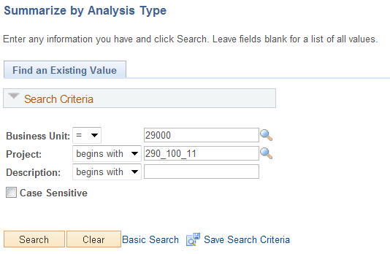

Business Unit – define the agency business unit.

Project – select the Project to analyze.

Description – search by Project Description.

Click to enter the Summary pages.

Summarize by Analysis Type Tab

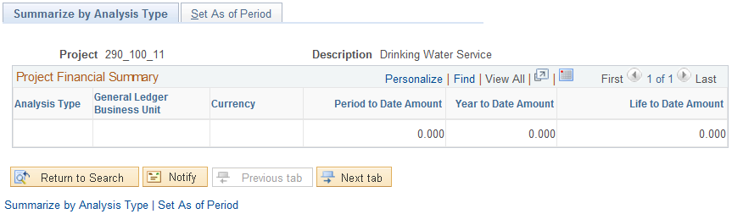

Click the Set As of Period Tab to define the Period used to retrieve Project transactions.

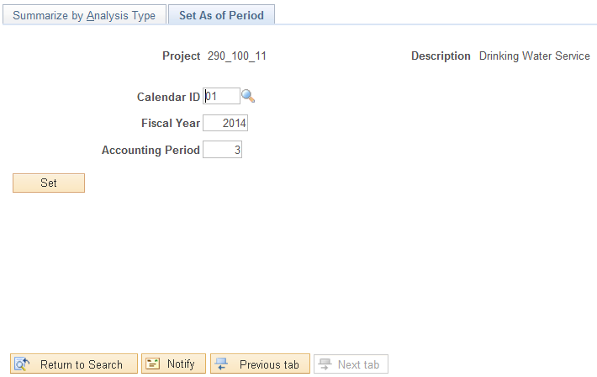

Calendar - select a Calendar that will be used to retrieve Project transactions as of a certain date.

Fiscal Year – populate the “as of” Fiscal year to retrieve Project transactions.

Accounting Period – define the “as of” Accounting Period for the Fiscal Year defined.

Click to lock the Calendar, Fiscal Year and Accounting Period.

Click the Summarize by Analysis Type Tab.

Summarize by Analysis Type Tab continued

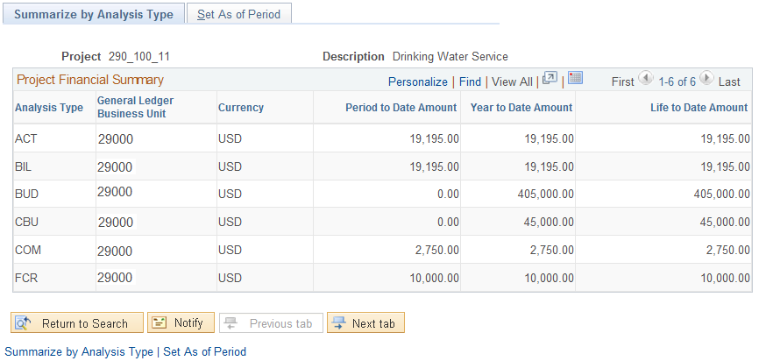

Once the “As Of Periods” are set, the Summarize by Analysis Type Tab displays Project transactions summarized by Analysis Type and Date.

Period to Date Amount – this column shows the sum of Project transactions for the Accounting Period defined.

Year to Date Amount – this column shows the sum of “Year to Date” Project transactions based on the Fiscal Year defined.

Life to Date Amount – this column shows the sum of “Life to Date” Project transactions based on the Fiscal Year defined.

Summarize by Category Page

Navigation: Project Costing > Review Costs > Summarize by Category > Find an Existing Value

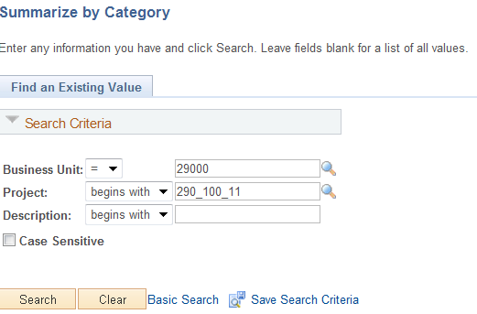

Business Unit – define the agency business unit.

Project – select the Project to analyze.

Description – search by Project Description.

Click to enter the Summary pages.

Summarize by Category Tab

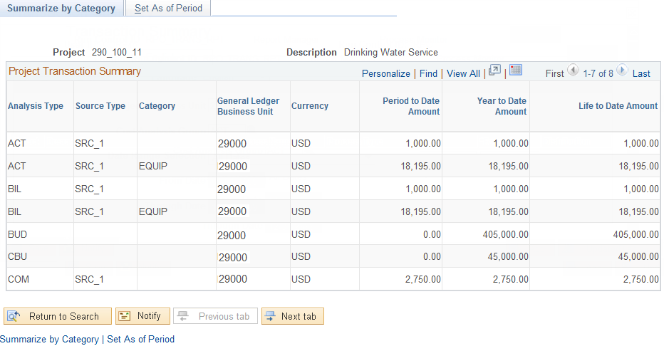

Once the “As Of Periods” are set, the Summarize by Category Tab displays Project transactions summarized by Analysis Type and Category (Project Chartfield) and Date.

Period to Date Amount – this column shows the sum of Project transactions for the Accounting Period defined.

Year to Date Amount – this column shows the sum of “Year to Date” Project transactions based on the Fiscal Year defined.

Life to Date Amount – this column shows the sum of “Life to Date” Project transactions based on the Fiscal Year defined.

NOTE: The Set As A Period Tab may need to be visited to change the “As of Dates” to retrieve the desired Project transactions.

