COR437 Contracts –

Contract Setup Manual

The content of this training manual is based largely on a generic system configuration and illustrates the base-line functionality required to execute transactions in the module. Your agency may be utilizing more or less of the functionality illustrated in this manual. This manual is intended to be a framework upon which agencies can add agency-specific training content that speaks specifically to the system functionality that they have deployed and related configuration that they use for transaction processing. Agencies should not depend on these manuals for end-user training or problem resolution until they have been reviewed by the agency for appropriateness.

Authorized by: [_EBS_] Original Issue: [04/03/2010]
Maintained by: [____Contracts Lead___]
Review Date: [05/01/2015]

Table of Contents

Document History 4
Contracts Setup 5
Key Terms 6
Contracts Business Unit 6
Customer 6
Contract Bill Plan 6
Contract Revenue Plan 6
Billing Event 6
Revenue Recognition Method 6
Product 6
Price Type 7
Project Costing Business Unit 7
Project ID 7
Activity ID 7
Prepaid 7
Process Flows 8
Guidelines, Concepts and Alternatives 9
Define Contract Support Teams 10
Define Support Teams by Contract 10
Support Team by Contract Page 12
Define Support Teams by Contract Type 13
Support Team by Contract Type Page 14
Define Amendment Types and Reasons 15
Define Amendment Types 15
Amendment Type Page 16
Define Amendment Reasons 17
Amendment Reason Page 18
Define Rate Sets 19
Creating Rate Sets 19
Rate Sets Tab 20
Target Page 21
Define Contract Templates 22
Creating Revenue/Bill Plan Templates 22
Revenue/Bill Plan Template Page 23
Creating Detail Bill Plan Templates 25
Bill Plan Detail Template Page 26
Define Contract Products 27
Step 1: Product Definition 27
Product Definition Tab 28
Contracts Options Tab 29
Step 2: Product Unit of Measure 30
Product Attributes by UOM Tab 31
Step 3: Product List Price 32
Product Price Tab 33

Document History

Document Revision | Date | Description
1.0  2.0 | 04/30/2010  05/01/2014 | Initial Document  Upgrade Update

Contracts Setup

Customer Contracts require initial setup and configuration to operate in the system.

Products are the building block of Contract Lines and define how the Contract will bill Customers and recognize Revenue.

Support Teams allow an agency to link individuals to a Contract.

Contract Amendments are classified and recorded by Amendment Types and Amendment Reasons.

Contract Templates are used to facilitate Bill and Revenue Plan creation.

Key Terms
Contracts Business Unit: Each agency has one, and only one Contracts Business Unit. The Business Unit is the three (3) digit agency code, plus 00. For example, Office of State Finance is 09000.

Customer: A customer is an external entity that is defined in a Contract to receive invoices and from which revenue is recognized.

Contract Bill Plan: The Bill Plan defines the schedule, parameters and configuration of the Customer invoice. A Contract manages the billing process through the creation of Billing plans. Billing plans are Contract specific. The Billing plan stores the schedule of billing events and the corresponding bill lines for these events. Each contract line product is tied to a billing plan.

Contract Revenue Plan: The Contract Revenue Plan defines how and when customer revenue will be recognized for accounting purposes. Define a revenue plan for Contract lines in which revenue is managed by Contracts. For each revenue plan that is defined, select a Revenue Recognition method for the Revenue Plan and define the Events that trigger revenue recognition. Revenue Plans are not defined for contract lines with a revenue method of Billing Manages Revenue.

Billing Event: A Billing Event is a “trigger” that initiates contract billing. The Event could be a date, milestone, etc. Bill Plans define Billing Events that are used to generate billing that is interfaced into the Billing Module.

Revenue Recognition Method: Revenue recognition methods define the criteria that must be met before revenue can be recognized. Specify revenue recognition methods for products on the Product Definition component. The associated revenue recognition method appears when you select a product onto the contract line.

Product: A Product is the core contractual obligation of products or services that an agency provides to the public. These could be fees, licenses or even grant related products. A Product represents the basis for the Contract Line and determines what type of Contract will be created. Products are associated with a set of attributes that include pricing structure, tax parameters, and accounting information. Once defined Products are use in the Contract creation process.

Price Type: Contract Products are classified as Rate-Based, Amount-Based, or Recurring. Rate-based products have a price type of Rate, Amount-Based products have a price type of Amount or Percent, and recurring products have a price type of Recurring. The price type that you select for a product determines the details that you define for that product and the billing and revenue recognition methods with which you can associate the product.

Project Costing Business Unit: Each agency has one, and only one Project Costing Business Unit. The Business Unit is the 3 digit agency code, plus 00. For example, Office of State Finance is 09000.

Project ID: The Project ID represents the basic unit that serves to establish budgets and collect costs and revenue for analysis purposes. Projects serve to collect construction costs and capitalize Assets in conjunction with the Asset Management module. Project ID is also a Chartfield and as such a part of the distribution line. In Contracts, Project ID is the basic unit that makes up a Rate Based contract used to collect expended costs and bill customers for those costs.

Activity ID: An Activity ID generally represents a task that makes up a Project. Project Costs and Budgets are stored in Activities. In Contracts, Activity ID is used to collect costs that are priced and billed to customers for reimbursement.

Prepaid: An amount paid in advance by a Customer in a Rate Based Contract agreement. The prepaid amounts are applied or deducted from otherwise billable costs collected in a Project until all prepaid amounts are fully “utilized”.

Process Flows

Diagram 1: Customer Contracts Module Integration

Guidelines, Concepts and Alternatives

Price Type | Description | Billing Method | Revenue Recognition Method
Amount or Percent | Used for contracts with a fixed price. Or, used for contracts that are priced as a percent of one or more contract lines. | Milestone, Percent Complete, Immediate | Milestone, Percent Complete, Apportionment, Billing Manages Revenue
Rate | Used for contracts, such as services, with a rate-based pricing structure, such as $400 per hour worked. The actual monetary amount is not known until the hours have been worked and reported | As-incurred, Value-based | As-incurred
Recurring | Used for contracts that have a recurring pricing structure where a start date and schedule are defined | Recurring | Billing Manages Revenue

Table 1: Product Price Types with Billing and Revenue Methods

Define Contract Support Teams

Use Contract Support Teams to better track individuals that are associated with a Contract. Employees must be set up as team members and associated with a function. When Support Teams are added to a contract, an indication of who is associated with the Contract and what role they play.

Contract Support Teams can be associated to an individual Contract, a Contract Type or a Contract Business Unit.

Define Support Teams by Contract

Navigation: Customer Contracts > Create and Amend > Support Teams > Find an Existing Value

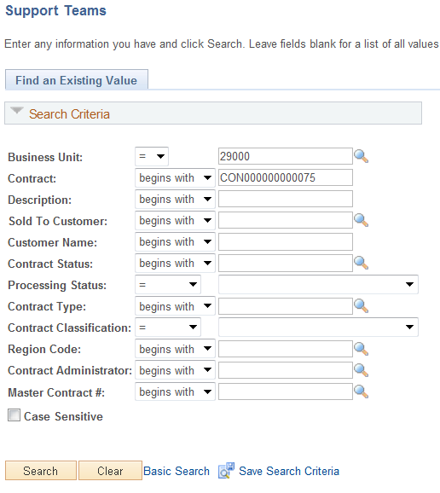

Use the Search Criteria to find the desired Contract.

Business Unit – select the agency Contracts business unit.

Contract – Populate if the Contract number is known.

Description – Search by Contract Description.

Sold to Customer – Search by the Customer ID.

Contract Status – Use this field to retrieve all Contracts in a particular Status.

Click to retrieve Contracts matching the Search Criteria.

Support Team by Contract Page

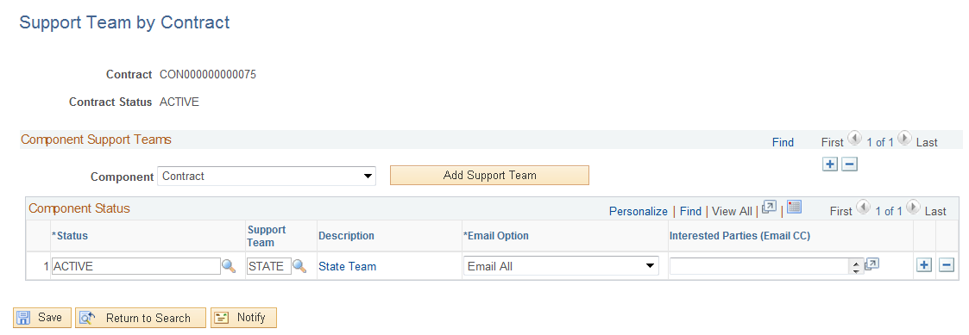

The Support Team by Contract page allows the user to select a pre-defined Support Team, configure a new Support Team and link the Team to a Contract component or feature.

Component – select the component of the Contract to which this Support Team will be linked.

Status – use the status values to define a Support Team for a particular Contract Status.

Support Team – select the pre-defined Support Team for the Contract.

Description – the description hyperlink navigates to the Support Team page where Team Members can be seen.

Click to add a new Support Team to the system.

Click to save the Contract Support Team.

Define Support Teams by Contract Type

Navigation: Setup Financial Supply Chain > Product Related > Contracts > Support Teams > Support Teams by Contract Type > Find an Existing Value

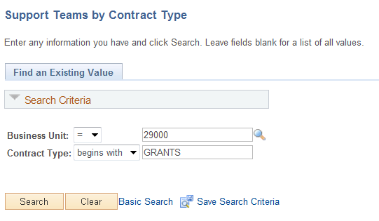

Business Unit – Select the agency Contracts business unit.

Contract Type – Populate the Contract Type that will be linked to the Support Team.

Click to retrieve Contracts matching the Search Criteria.

Support Team by Contract Type Page

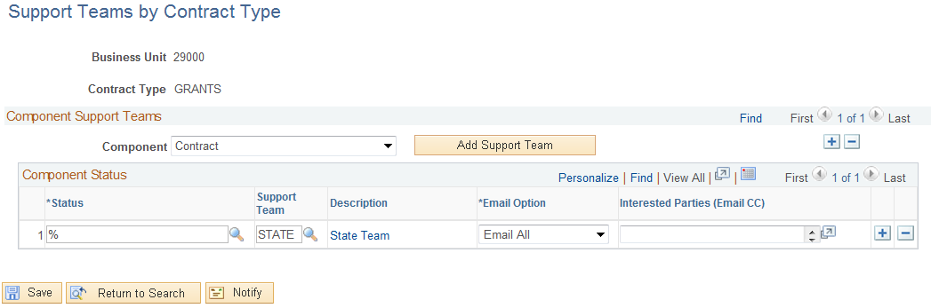

Use the Support Teams by Contract Type page to link a team to all contracts that are categorized in a particular Contract Type.

Component – Select the component of the Contract to which this Support Team will be linked.

Status – Use the status values to define a Support Team for a particular Contract Status.

Support Team – Select the pre-defined Support Team for the Contract Type.

Description – The description hyperlink navigates to the Support Team page where Team Members can be seen.

Click to add a new Support Team to the system.

Click to save the Contract Type Support Team.

Define Amendment Types and Reasons

When Contract Amendments are initiated they can be categorized by Amendment Type and Amendment Reason. Amendment Types and Reasons provide a history and classification mechanism to view Contract Amendments.

Amendment Types are high-level classifications that are assigned to an amendment. Amendment Reasons are typically lower-level detail than the Amendment Reason and provide more insight to the actual amendment process.

Define Amendment Types
Navigation: Setup Financial Supply Chain > Product Related > Contracts>Amendments > Amendment Type > Add a New Value

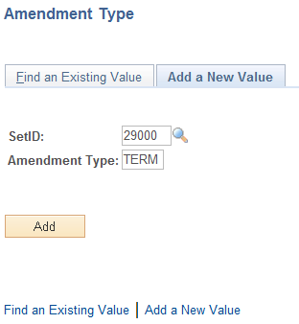

Set ID – Populate with the agency business unit number.

Amendment Type – Populate with a 4 character Amendment Type.

Click to create an Amendment Type.

Amendment Type Page

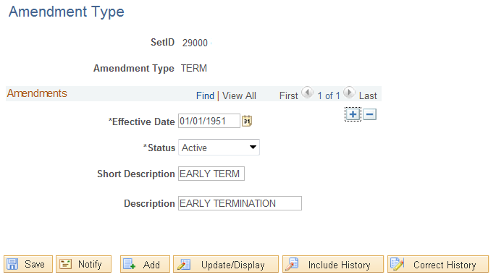

Use the Amendment Type page to define dates, status and description information.

Effective Status – The date the Amendment Type is effective.

Description – This value is visible on the Contract Amendment page when initiating an Amendment.

Click to Save the Amendment Type.

Define Amendment Reasons

Navigation: Setup Financial Supply Chain > Product Related > Contracts > Amendments > Amendment Reason > Add a New Value

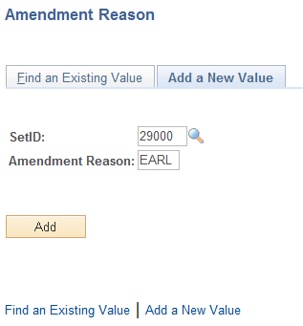

Set ID – Populate with the agency business unit number.

Amendment Reason – Populate with a 4 character Amendment Reason.

Click to create an Amendment Reason.

Amendment Reason Page

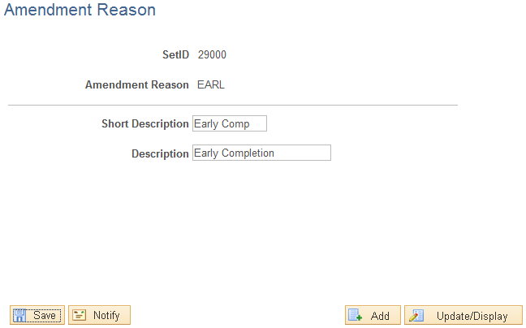

Use the Amendment Reason page to define dates, status and description information.

Short Description – Enter a short description for the Amendment Reason.

Description – This value is visible on the Contract Amendment page when initiating an Amendment.

Click to Save the Amendment Reason.

Define Rate Sets

Rate Based Contracts use Project Costing to store Project transactions for customer billing purposes. When Project transactions are collected in Project Costing and the Project and Activity is linked to a Contract, those Project transactions are “Priced” to facilitate customer billing.

The Pricing Engine is driven by Rate Sets. Rate Sets are stored on the Contract Line where the Project and Activity are defined for Rate Based Contracts. Rate Sets define how collected Project transactions are treated by the Pricing Engine. Project transactions can be marked up, marked down, billed at cost, etc.

Creating Rate Sets

Navigation: Setup Financial Supply Chain>Product Related > Contracts>Templates > Rate Sets > Add a New Value

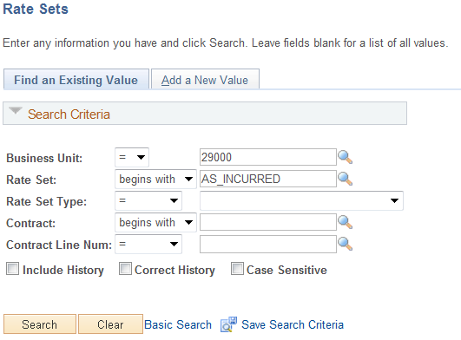

Business Unit – Rate Sets are defined for each agency business unit.

Rate Set – The Rate Set value.

Rate Set Type – Set to ‘Standard’.

Click create a Rate Set.

Rate Sets Tab

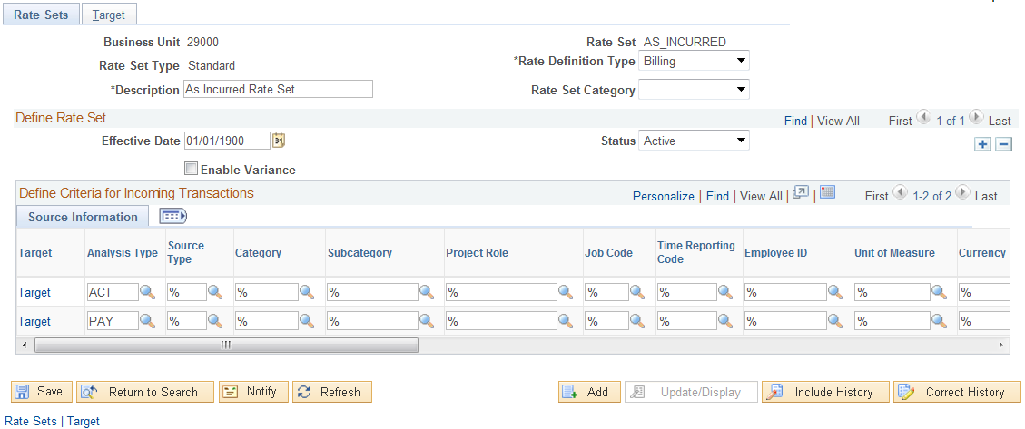

The Tab defines the chartfield values that will be matched against incoming Project transactions to create target rows.

Rate Definition Type – Define the Rate Set for ‘Billing’ Project transactions or for ‘Costing’ Project transactions. Rate Sets for Billing are used with the Contracts Module to create Rate Based Billing rows for invoicing. Rate Sets for Cost could be used to create ‘Overhead’ rows in a Project.

NOTE: This selection will restrict the Target Analysis Types available for selection on the Target page.

Description – Create a Description for the Rate Set.

Effective Date – Define the date that the Rate Set will be effective.

Analysis Type – Define the Analysis Type that the Rate Set will use to match Project transactions for Pricing.

NOTE: The Rate Set page works as a ‘Filter’ that only selects incoming Project Transactions that match exactly the values on the Rate Set page. All incoming transactions that match the field values on the Target page are subject to the Pricing Engine. The wildcard value of ‘%’ indicates that any value in that field will match the Rate Set.

Click the Tab or use the Target link.

Target Page

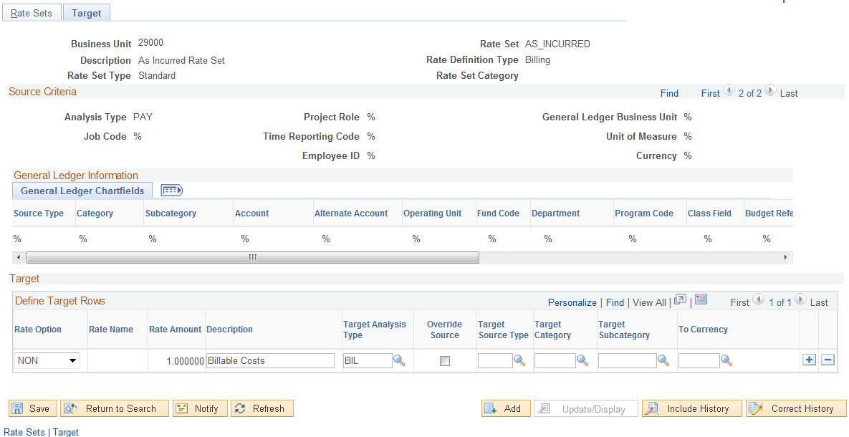

For each row on the Tab, a Target row will be created to define the type of row that will be created by the Pricing Engine.

Rate Option – Defines how the target row will be created. This could be a markup or actual cost.

Description – This target row created in Projects will hold the description defined here.

Target Analysis Type – The target row created by the Pricing Engine will have this Analysis Type.

Target Source Type – The target row created by the Pricing Engine will have this Source Type. If left blank, the target row will inherit the Source Type from the source row,

Target Category – The target row created by the Pricing Engine will have this Source Category. If left blank, the target row will inherit the Source Category from the source row

Target Subcategory – The target row created by the Pricing Engine will have this Source Subcategory. If left blank, the target row will inherit the Source Subcategory from the source row

NOTE: If a chartfield value is not defined on the Target row, the target row will inherit the chartfield value from the source Project transaction line.

Click to Save the Rate Set.

NOTE: Once the Rate Set is defined, it can be linked to a Project and Activity for Pricing on the Contract Line page.

Define Contract Templates

Contracts Templates can be used to facilitate the process of creating Bill and Revenue Plans when initially defining Contracts. Templates can be used for Revenue Plans or Bill Plans. Once a Template is defined, it can be selected when defining the Contract.

Set up Revenue and Billing plan templates to automate the creation of Revenue and Billing plans. Optionally, associate events with your Revenue and Billing plan templates depending on the Plan Method. These events will populate onto the contract line when the Revenue or Billing plan template is linked with a Contract.

Templates are optional but can be particularly useful for Amount Based Contracts that use Milestone Date Events (i.e. Monthly Billing).

Creating Revenue/Bill Plan Templates

Navigation: Setup Financial Supply Chain > Product Related > Contracts > Templates > Revenue/BIl Plan Template > Add a New Value

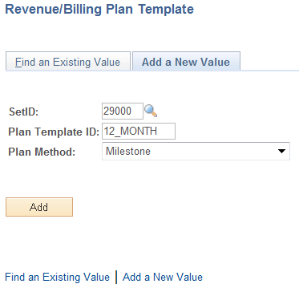

Set ID – Enter the agency Business Unit value for the SetID.

Plan Template ID – Give the Template a Plan Template ID that represents the usage of the template.

Plan Method – Select the appropriate Bill or Revenue Method for this template. This value will define which types of Bill or Revenue Plans this template can be used with.

Click create a Bill or Revenue Plan Template.

Revenue/Bill Plan Template Page

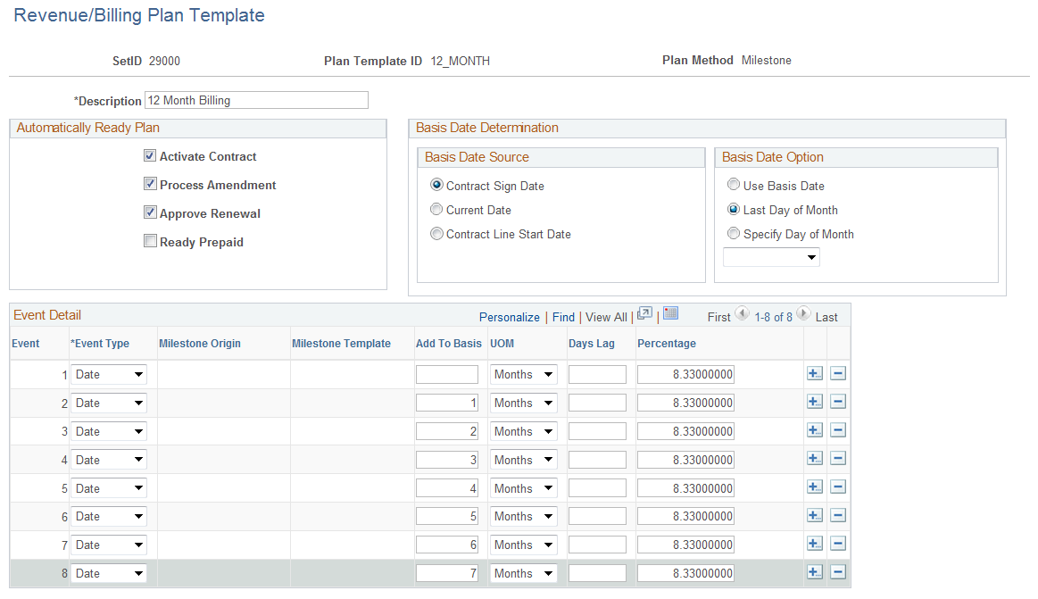

Use the Revenue/Billing Plan Template page to define default status values, dates and Event information.

Description – Populate the Template description.

Activate Contract - Select to have the system automatically set this Billing or Revenue plan to Ready upon contract activation.

Process Amendment - Select to have the system automatically set this Billing or Revenue plan to Ready upon amendment processing.

Approve Renewal - Select to have the system automatically set this Billing or Revenue plan to Ready upon renewal approval

Ready Prepaid - Select to have the system automatically set the initial billing plan to Ready when the associated prepaid status is changed to Ready.

Basis Date Source – Define the source date that the system will use to populate Event Dates.

Basis Date Option – Define the date that will be used for Event Dates. This can be the Basis Date Source defined on this page, End of Month or a Specific Date defined.
Event Type – Select the Event Type. These values will be defined based on the Plan Method.

Add to Basis – Define the increment that will be used to build Events.

Unit of Measure – Select a pre-defined unit of measure to build Events.

Percentage – Define the Bill or Revenue Percentage that each Event will hold.

NOTE: Not all fields on this page are available for each Plan Method. Based on the Plan Method certain needed fields will be visible on the page.

Click to Save the Template.

NOTE: Revenue Plan Templates can also be created based on the same information defined in a Bill Plan Template but will facilitate revenue recognition rather than invoicing. For example, Event Dates can be defined monthly to recognize revenue along those dates.

Creating Detail Bill Plan Templates

Navigation: Setup Financial Supply Chain > Product Related > Contracts > Templates > BIl Plan Detail Template > Add a New Value

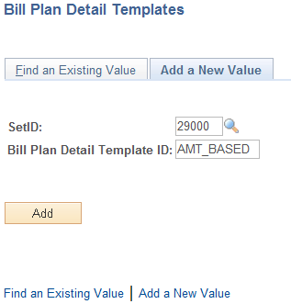

Set ID – Enter the agency Business Unit value for the SetID.

Bill Plan Detail Template ID – Give the Template a Plan Template ID that represents the usage of the template.

Click create a Bill Plan Detail Template.

Bill Plan Detail Template Page

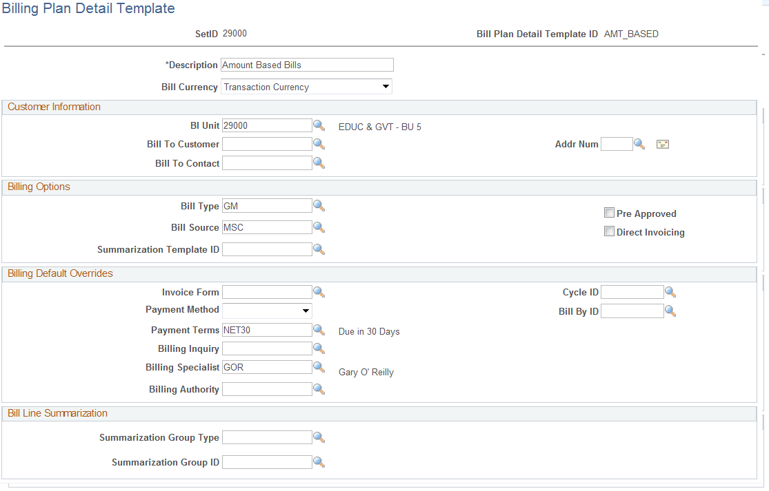

Use the BiIl Plan Detail Template page to define default values that will be copied into the Bill Plan on the Contract.

Description – This field displays the description defined for the Billing Plan.

Bill Currency – Set to ‘Transaction Currency.

Bill Unit – Define the agency business unit value.

Billing Type – Define the Bill Type for the invoices that will be created from this Bill Plan Template. Bill Type defines default values for the invoice and is required on the Bill Plan.

Bill Source - Define the Bill Source for the invoices that will be created from this Bill Plan Template. Bill Source defines default values for the invoice and is required on the Bill Plan.

Billing Default Overrides – Use this section of the page to override Billing Default values derived from the Billing Default Hierarchy.

Click to Save the Bill Template Detail Template.

Define Contract Products

Products are the key elements in a contractual relationship with a customer. Products can be defined for fixed-fee agreements (Amount Based Contracts), cost reimbursement agreements (Rate Based Contracts) or recurring fees or bills (Recurring Contracts).

In the Contracts module, a standard set of Products are defined, associated with a set of attributes that include pricing structure, tax parameters, and accounting information, and then used on Contract Lines to define the contractual obligation details.

For Contracts purposes, Products are Rate-based, Amount-based, or Recurring. Rate-based products have a Price Type of Rate, Amount-based products have a price type of Amount or Percent, and Recurring products have a price type of Recurring. The Price Type that you select for a Product determines the details that you define for that Product and the Billing and Revenue recognition methods with which you can associate the Product.

An Ad Hoc product is a product that is defined during the contract entry process. Ad Hoc products that are defined for a Contract are available for use only on the Contract from which they were created. Otherwise, an Ad Hoc product is essentially the same as a regular product.

Step 1: Product Definition

Navigation: Products > Identifying Product Details > Definition > Add a New Value

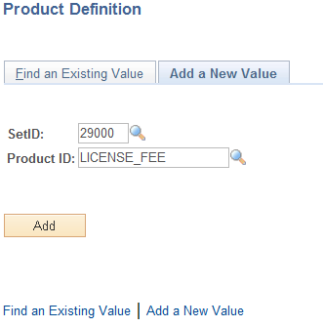

Set ID – Populate with the agency business unit number.

Product ID – Populate with a Product Identifier that represents the type of Product being added.

Click to enter a Product.

Product Definition Tab

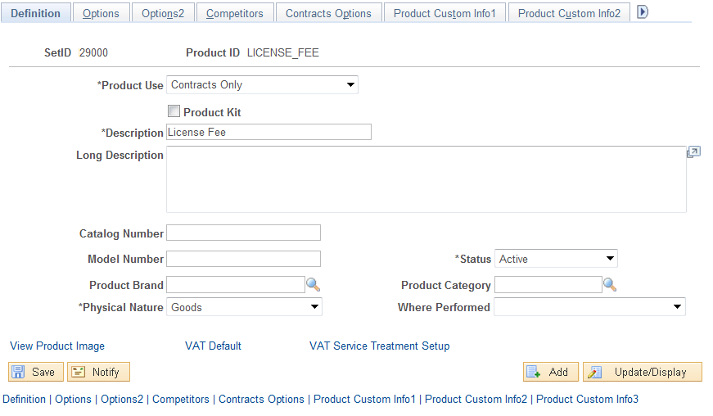

Use the Tab to describe the Product.

NOTE: Not all fields in the Product Component are required for use in Contracts. Some Product properties are used in other system modules not used by the state. Only those fields that are required are described in this section.

Product Use – Select the product use as ‘Contracts Only’. The Products need only be defined for the Contracts Module.

Description – Define a description for the Product that can be seen on the Contract.

Status – Ensure the Product is ‘Active’.

Click the Tab.

Contracts Options Tab

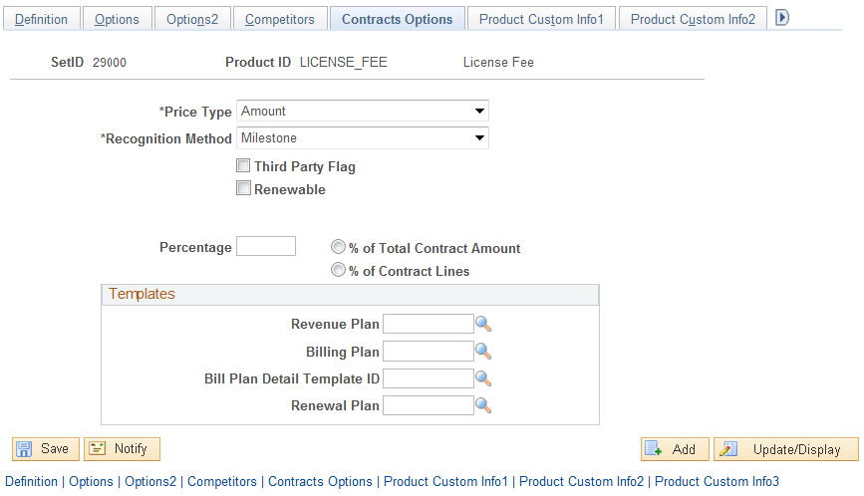

Use the Tab to define how the Product will be used in a Contract.

Price Type – select from a pre-defined list of Price Types (See COR438 Contracts – Contract Definition Manual for more explanation):

- Amount – Select for Amount Based Contracts
- Rate – Select for Rate Based Contracts using Project Costing
- Recurring – Select for Recurring type Contracts

Recognition Method – define the Revenue Recognition Method (See COR438 Contracts – Contract Definition Manual for more explanation):

- As Incurred – Recognized revenue using Accounting Rules for rate based contracts.
- Billing Manages Revenue – Select to allow the Billing Module to book revenue accounting entries.
- Milestone – Select to book revenue based on milestones like dates.

NOTE: Some Revenue Recognition Methods do not work with certain Price Types. See Guidelines, Concepts and Alternatives section in this manual.

Renewable – if the Product is to be renewable, select this checkbox and indicate whether the renewal will be ‘Automatic’ or ‘Manual’. This option is only available for Amount Based Products (See COR439 Contracts – Contract Processing & Administration Manual).

Templates – Use this section of the page to default certain Bill and Revenue Plan Templates into the Contract when this Product is selected.

Click to Save the Product.

Step 2: Product Unit of Measure

NOTE: Optionally Define Product Unit of Measure values and List Price information for the Product. For List Pricing, the Unit of Measure must be populated for the Product. Only Contracts with for Recurring Products (Price Type) use a List Price.

Navigation: Products > Identify Product Details > Attributes by UOM > Find an Existing Value

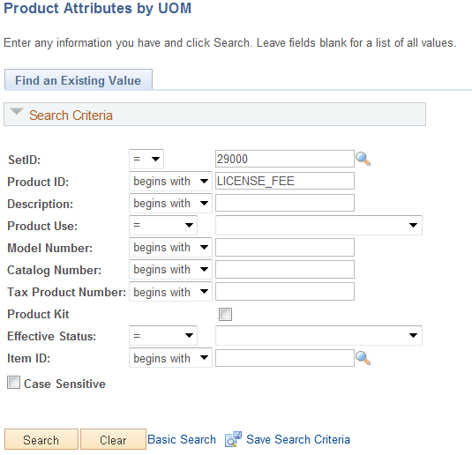

Use the Search Criteria to find the desired Product.

SetID – Select the agency value.

Product ID – The Product ID that will be assigned a Unit of Measure.

Description – Search by Product Description.

Click to retrieve Products matching the Search Criteria.

Product Attributes by UOM Tab

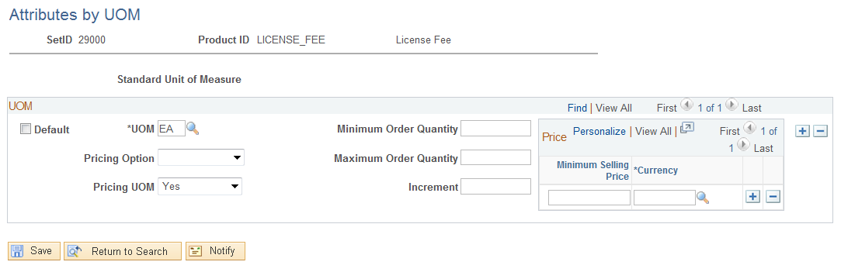

Use the Product Attribute by UOM Page to select a unit of measure value for the Contract.

UOM – Select the unit of measure from a pre-defined list.

NOTE: The Unit of Measure defined for the Product will default into the Contract Line when the Product is selected.

Click to Save the Product UOM.

Step 3: Product List Price

Navigation: Products > Identify Product Details > Assign List Price > Find an Existing Value

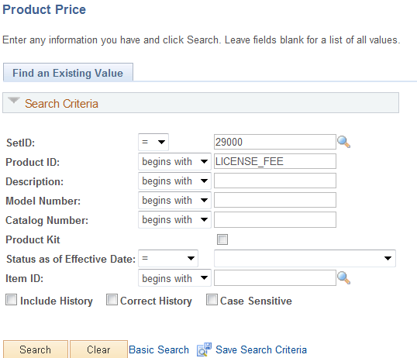

Use the Search Criteria to find the desired Product.

SetID – Select the agency value.

Product ID – The Product ID that will be assigned a List Price.

Description – Search by Product Description.

Click to retrieve Products matching the Search Criteria.

Product Price Page

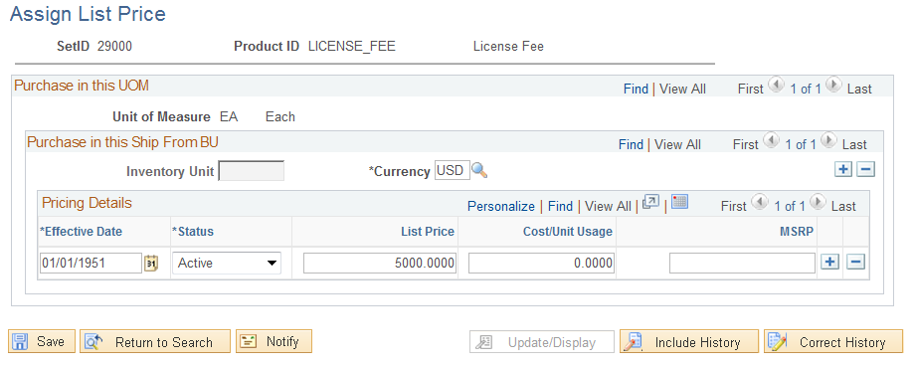

Use the Product Price Page to define List Pricing for a Product.

Currency – Populate with ‘USD’.

Effective Date – Select the date that the List Price is effective. This allows the user the opportunity to make changes to List price effective as of a certain date.

Status – Set to ‘Active’.

NOTE: When using List Pricing with a Recurring Product, the Unit of Measure on the Product must match the Unit of Measure from the Contract Line.

