COR438 Contracts –

Contract Definition Manual

The content of this training manual is based largely on a generic system configuration and illustrates the base-line functionality required to execute transactions in the module. Your agency may be utilizing more or less of the functionality illustrated in this manual. This manual is intended to be a framework upon which agencies can add agency-specific training content that speaks specifically to the system functionality that they have deployed and related configuration that they use for transaction processing. Agencies should not depend on these manuals for end-user training or problem resolution until they have been reviewed by the agency for appropriateness.

Authorized by: [_EBS_] Original Issue: [05/01/2014]
Maintained by: [____Contracts Lead___]
Review Date: [05/01/2014]

Table of Contents

Document History 5
Defining Contracts 6
Key Terms 7
Contracts Business Unit 7
Customer 7
Contract Bill Plan 7
Contract Revenue Plan 7
Billing Event 7
Revenue Recognition Method 7
Product 7
Price Type 8
Project Costing Business Unit 8
Project ID 8
Activity ID 8
Prepaid 8
Process Flows 9
Guidelines, Concepts and Alternatives 10
Create Amount Based Contracts 11
Step 1: Amount Based Contract Header and Lines 11
General Tab 12
Lines Tab 14
Add Contract Lines Page 15
Related Projects Tab 19
Accounting Distribution Page 21
Amount Allocation Page 23
Step 2: Create Bill Plan 24
Assign Billing Plan Page 24
Billing Plan General Tab 26
Events Tab 27
Step 3: Create Revenue Plan 31
Assign Revenue Plan Page 31
Revenue Plan Tab 33
Step 4: Activate the Contract 37
Create Rate Based Contracts 38
Step 1: Rate Based Contract Header and Lines 38
General Tab 39
Lines Tab 41
Add Contract Lines Page 42
Related Projects Tab 46
Accounting Distribution Page 48
Step 2: Create Bill Plan 50
Assign Billing Plan Page 50
Billing Plan General Page 52
Step 3: Create Revenue Plan 53
Assign Revenue Plan Page 53
Revenue Plan Tab 55
Step 4: Activate the Contract 56
Create Recurring Contracts 57
Step 1: Recurring Contract Header and Lines 57
General Tab 58
Lines Page 59
Add Contract Lines Page 60
Related Projects Tab 64
Accounting Distribution Page 66
Step 2: Create Bill Plan 68
Assign Billing Plan Page 68
Billing Plan General Tab 70
Recurring Detail Tab 71
Step 3: Create Revenue Plan 73
Assign Revenue Plan Page 73
Step 4: Activate the Contract 75
Create Pre-Paid Contracts 76
Step 1: Rate Based Contract Header and Lines 76
General Tab 77
Lines Tab 78
Add Contract Lines Page 79
Related Projects Tab 83
Accounting Distribution Page 85
Step 2: Establish Prepaid Amounts and Bill Plan 87
Prepaids Tab 87
Utilization Criteria Tab 89
Billing Plan General Tab 90
Audit History Tab 93
Step 3: Create Bill Plan for Rate Based Contract Line 95
Assign Billing Plan Page 95
Billing Plan General Tab 97
Step 4: Create Revenue Plan for Rate Based Contract Line 98
Assign Revenue Plan Page 98
Revenue Plan Tab 100
Step 5: Activate the Contract 102

Document History

Document Revision | Date | Description
1.0  2.0 | 04/30/2010  05/01/2014 | Initial Document  Upgrade Update

Defining Contracts

Customer Contracts are defined to establish Billing and Revenue Recognition transactions between an agency and an external Customer. Each Contract is built for one, and only one, customer. Contracts can be defined in three broad categories with various billing and revenue features available under each.

Rate Based Contracts are built on a Cost-Reimbursement model using the Project Costing module to collect costs for billing. Amount Based Contracts are built on a periodic or milestone based model and use Contract parameters for billing and revenue recognition. Recurring Contracts are built on a repeating invoice schedule such as monthly, quarterly or annually.

A Contract consists of two levels: the Contract Header and the Contract Line. The Contract Header relates one-to-many with the Contract Line. The Contract header stores agreement information relevant to all the products and services that you are licensing through the Contract. Agreement information may include customer information, terms and conditions, contract sign dates, etc. Also stored at the header level is any administrative information, such as notes and support teams that are associated with the entire contract.

The Contract Line relates many-to-one with the Contract header. Multiple lines may be added to each Contract. Contract Lines are linked to Billing and Revenue plans. Each Contract Line has its own status, which enables you to add all Products associated with a contract during contract setup and then to manage each Contract Line as appropriate to the line in accordance with the terms and conditions of the contract

A Contract Line also corresponds to an individual Product that you are licensing or offering to the public. To set up a Contract Line, you first select a Product onto a Contract Line.

Contracts use Bill Plans to define the timing, structure and presentation of the invoice. Revenue Plans are used to manage the recognition of invoice revenue. Bill Plans and Revenue Plans are a component of a Customer Contract and are generally defined and activated as part of the Contract creation process.

Key Terms
Contracts Business Unit: Each agency has one, and only one Contracts Business Unit. The Business Unit is the three (3) digit agency code, plus 00. For example, Office of State Finance is 09000.

Customer: A customer is an external entity that is defined in a Contract to receive invoices and from which revenue is recognized.

Contract Bill Plan: The Bill Plan defines the schedule, parameters and configuration of the Customer invoice. A Contract manages the billing process through the creation of Billing plans. Billing plans are Contract specific. The Billing plan stores the schedule of billing events and the corresponding bill lines for these events. Each contract line product is tied to a billing plan.

Contract Revenue Plan: The Contract Revenue Plan defines how and when customer revenue will be recognized for accounting purposes. Define a revenue plan for Contract lines in which revenue is managed by Contracts. For each revenue plan that is defined, select a Revenue Recognition method for the Revenue Plan and define the Events that trigger revenue recognition. Revenue Plans are not defined for contract lines with a revenue method of Billing Manages Revenue.

Billing Event: A Billing Event is a “trigger” that initiates contract billing. The Event could be a date, milestone, etc. Bill Plans define Billing Events that are used to generate billing that is interfaced into the Billing Module.

Revenue Recognition Method: Revenue recognition methods define the criteria that must be met before revenue can be recognized. Specify revenue recognition methods for products on the Product Definition component. The associated revenue recognition method appears when you select a product onto the contract line.

Product: A Product is the core contractual obligation of products or services that an agency provides to the public. These could be fees, licenses or even grant related products. A Product represents the basis for the Contract Line and determines what type of Contract will be created. Products are associated with a set of attributes that include pricing structure, tax parameters, and accounting information. Once defined Products are used in the Contract creation process.

Price Type: Contract Products are classified as Rate-Based, Amount-Based, or Recurring. Rate-based products have a price type of Rate, Amount-Based products have a price type of Amount or Percent, and recurring products have a price type of Recurring. The price type that you select for a product determines the details that you define for that product and the billing and revenue recognition methods with which you can associate the product.

Project Costing Business Unit: Each agency has one, and only one Project Costing Business Unit. The Business Unit is the 3 digit agency code, plus 00. For example, Office of State Finance is 09000.

Project ID: The Project ID represents the basic unit that serves to establish budgets and collect costs and revenue for analysis purposes. Projects serve to collect construction costs and capitalize Assets in conjunction with the Asset Management module. Project ID is also a Chartfield and as such a part of the distribution line. In Contracts, Project ID is the basic unit that makes up a Rate Based contract used to collect expended costs and bill customers for those costs.

Activity ID: An Activity ID generally represents a task that makes up a Project. Project Costs and Budgets are stored in Activities. In Contracts, Activity ID is used to collect costs that are priced and billed to customers for reimbursement.

Prepaid: An amount paid in advance by a Customer in a Rate Based Contract agreement. The prepaid amounts are applied or deducted from otherwise billable costs collected in a Project until all prepaid amounts are fully “utilized”.

Process Flows

Diagram 1: Customer Contracts Module Integration

Guidelines, Concepts and Alternatives

Price Type | Description | Billing Method | Revenue Recognition Method
Amount or Percent | Used for contracts that have a fixed price. Or, Used for contracts that are priced as a percent of one or more contract lines. | Milestone, Percent Complete, Immediate | Milestone, Percent Complete, Apportionment, Billing Manages Revenue
Rate | Used for contracts, such as services, that have a rate-based pricing structure, such as $400 per hour worked. The actual monetary amount is not known until the hours have been worked and reported | As-incurred, Value-based | As-incurred
Recurring | Used for contracts that have a recurring pricing structure where a start date and schedule are defined | Recurring | Billing Manages Revenue

Table 1: Product Prince Types with Billing and Revenue Methods

Create Amount Based Contracts

Amount Based Contracts use dollar amounts defined in the Contract as the basis for customer billing. Invoiced amounts can be spread across the life of the contract as desired and all related revenue entries are derived from the Contract Line Distribution pages.

Customer Contracts are created by agency for a single customer. Contracts are created in ‘Pending’ status initially, then moved to ‘Active’ status for contract billing and revenue purposes, and finally to ‘Closed’ status at the completion of the contract terms.

Customer Contracts will contain Bill Plans to manage the invoice process and Revenue Plans to manage the revenue recognition process. Amount based Contracts use parameters in the contract definition to define amounts for billing and revenue, while Rate Based Contracts use Project Costing stored amounts to define billing and revenue.

Step 1: Amount Based Contract Header and Lines

Navigation: Customer Contracts > Create and Amend > General Information > Add a New Value

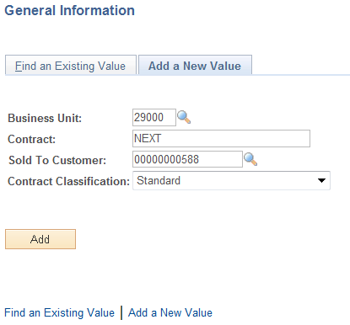

Business Unit – Select the agency Contracts business unit.

Contract – Leave as ‘NEXT’ to allow the system to assign the Contract ID. Alternatively, key the Contract ID value.

Sold To Customer – Select from the list of pre-defined Customers. Customers are unique to the agency business unit.

Contract Classification – Set to ‘Standard’

Click to enter the Customer Contract pages.

General Tab

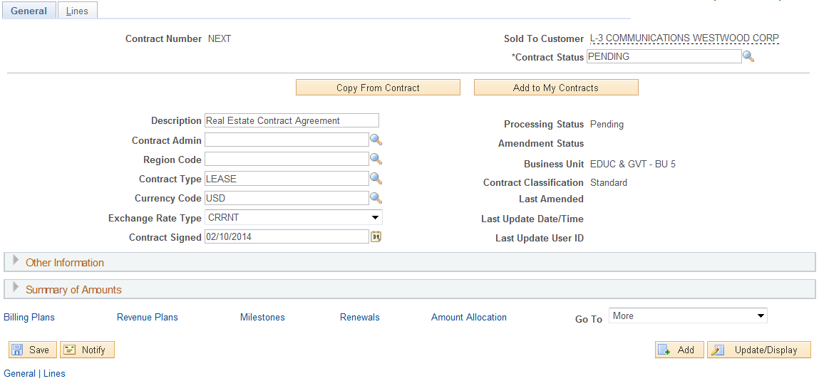

When initially creating a Contract, the General and Lines tabs only will be visible. Use the General Tab to define Contract header information. Some fields will be populated with default values. Others will need to be populated by the user.

Contract Status – Initially the Contract Status should be set to ‘Pending’. The Contract Status will change to ‘Active’ when defined correctly and all system edits have been passed.

Description – Define a description for this Contract.

Contract Type – Select a Contract Type from the pre-defined values. The Contract Type categorizes the Contract.

Expand the Other Information section of the page.

General Tab continued.

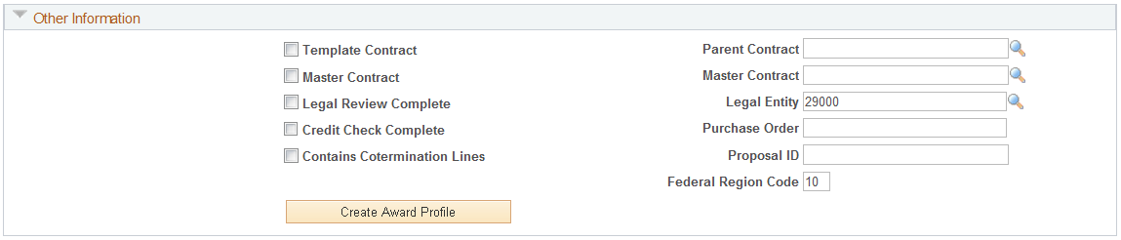

Template Contract – select this checkbox to use this Contract as a template that can be copied from later.

Ensure the Legal Entity is populated with the agency number.

Expand the Summary of Amounts section of the page.

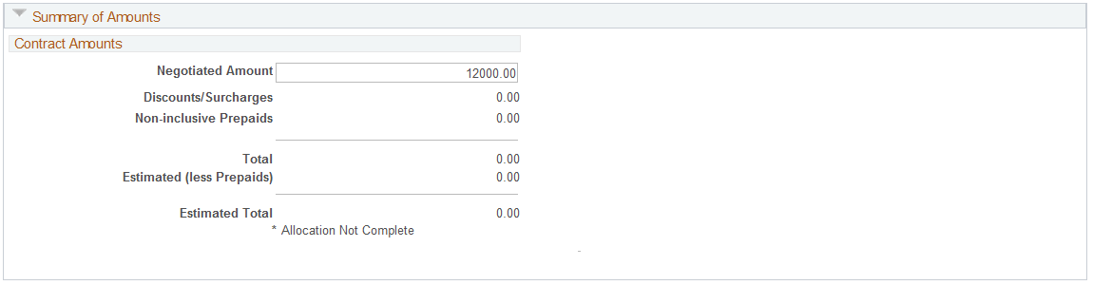

The Summary of Amounts section of the page is required for Amount Based Contracts. This section of the page defined the overall amount of billing and revenue for the Contract.

Negotiated Amount – define the overall amount of the Contract.

NOTE: The “Allocation not Complete” flag is visible indicating that the Amount has not yet been allocated to any Contract Lines. This will be done in subsequent steps in this section of the manual.

Click the Lines Tab.

Lines Tab

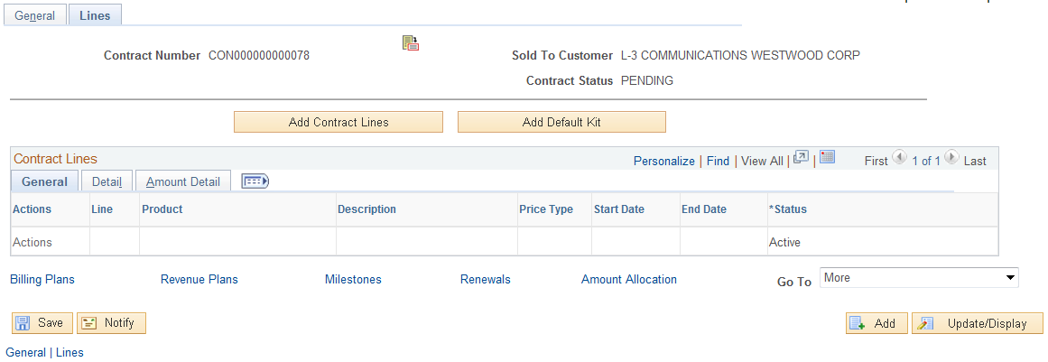

The Tab initially displays with no Contract Line or Product information. By selecting a Product onto the Contract Line, the Line will be created.

NOTE: At this point in the Contract Creation steps, the fields for the Contract Line are inactive. By selecting Product, these fields will become Active.

Click to initiate the Contract Line.

NOTE: Before creating a Contract Line, a working knowledge of the agency Product values that are available is necessary. Products have different properties that directly impact the billing and revenue cycle of the Contract and should be understood prior to creating Contract Lines.

Add Contract Lines Page

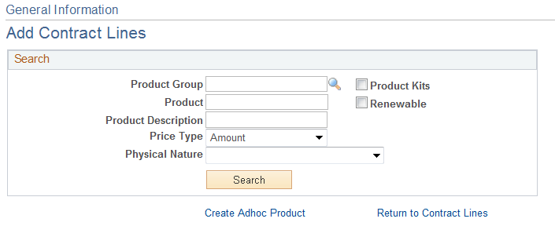

The Add Contract Lines page allows the user to search for pre-defined Products using the Search Products criteria. (Refer to COR437-Contracts – Contract Setup Manual on how to setup a Product.)

Product Group – If the desired Product is part of a Product Group, search by this value.

Product – If the Product ID is known, use that value as search criteria.

Description – Search by Product Description.

Price Type – For an Amount based Contract, the Price Type will be ‘Amount’.

Click to retrieve Products matching the search criteria provided.

Add Contract Lines page continued.

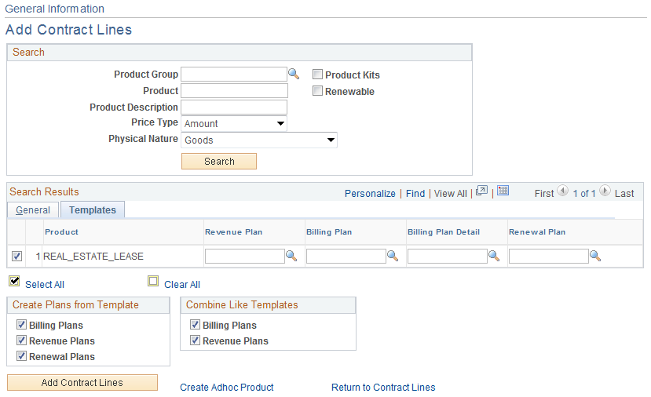

From the list of Products that match the search criteria, select the Product to copy onto the Contract Line.

Price Type – the Product Price Type defines what type of Contract billing and revenue will be created.

Unit of Measure – the default UOM from the Product definition.

Create Plans from Template – select the check boxes to enable the system to create a Billing Plan, Revenue Plan or Renewal Plan when adding the contract line to the contract.

Combine Like Templates - select to combine multiple Contract lines with the same Billing plan template into one Billing plan.

NOTE: These options are only active if Templates are defined on the Templates Tab.

Click the Tab.

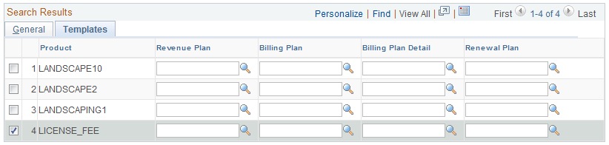

Define a Template for the Revenue Plan, Bill Plan, Bill Plan Detail or Renewal for this Contract Line.

NOTE: Templates are optional and can be defined for the Contract Line at this point or when the Bill and Revenue Plans are added to the Contract Line.

Use the Create Adhoc Product link to define a Product that can be used only for this Contract Line.

Click to add a Product to the Contract Line.

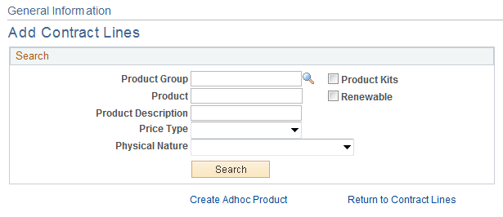

The Add Contract Lines page indicates that a Line has been added to the Contract.

Click the Return to Contract Lines link.

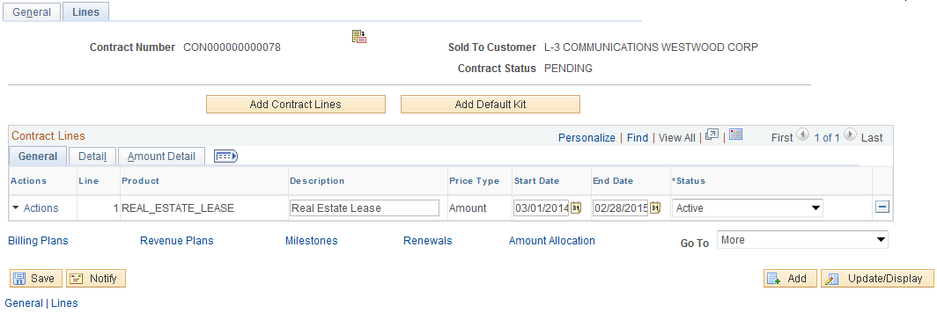

For an Amount Based Contract, define the Start and End Dates for the agreement.

Start Date – Define the Contract start date.

End Date - Define the Contract start date.

Click to save the Contract and assign the Contract ID.

Click the Sub-Tab.

Click the Contract Terms link.

Related Projects Tab

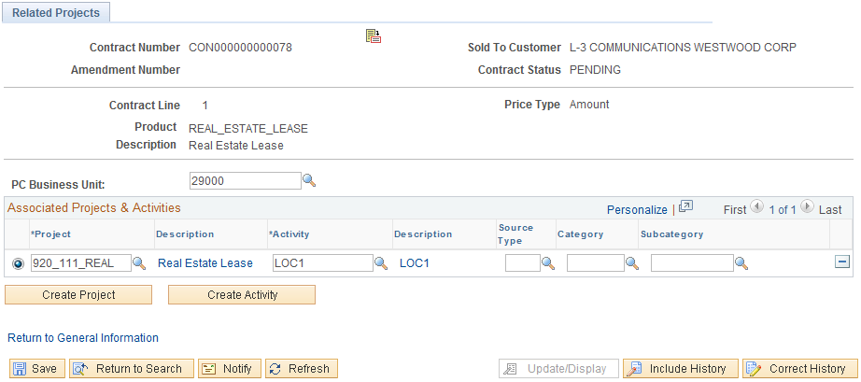

For an Amount Based Contract, the Tab can be used to associate the Contract (Contract Line) with a Project and Activity.

NOTE: A Project and Activity could be associated with an Amount Based Contract to capture costs incurred against a Project and compare to revenue generated from the contract for profitability analysis.

PC Business Unit – Select the agency Project Costing Business Unit. This value should be equal to the Contracts Business Unit.

Project – Select a Project to associate with this Contract Line. Optionally use to create a new Project ID.

Activity – Select an Activity for the Project defined. Optionally use to create a new Project ID.

NOTE: These steps are optional as Amount Based Contracts do not need to be associated with a Project and Activity.

Click to save the Contract.

Click the Return to General Information link.

Click the Deferred Revenue Tab.

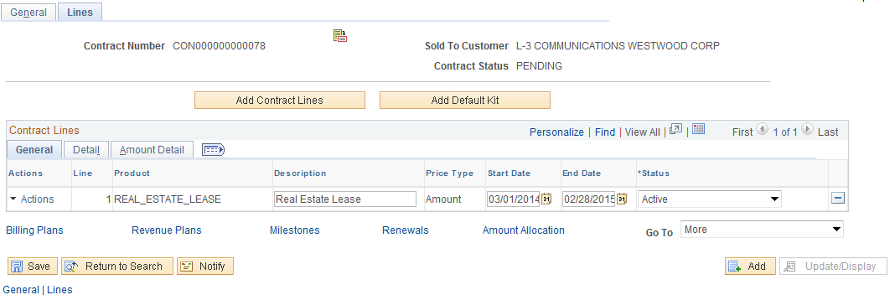

To enable Deferred Revenue Accounting Entries for this Contract Line, select the Deferred Revenue checkbox.

Click to save the Deferred Revenue checkbox.

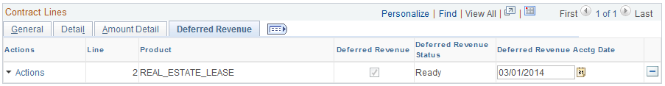

Deferred Revenue Accounting Date – define the accounting date for deferred revenue entries. The Deferred Revenue process does not process any contract line until the deferred revenue accounting date is populated.

NOTE: Deferred Revenue accounting entries are optional for Amount Based Contracts. These accounting entries are generally created before contract billing occurs.

Click to save the Deferred Revenue Accounting Date.

Click the Sub-Tab.

Click the Distribution link.

Accounting Distribution Page

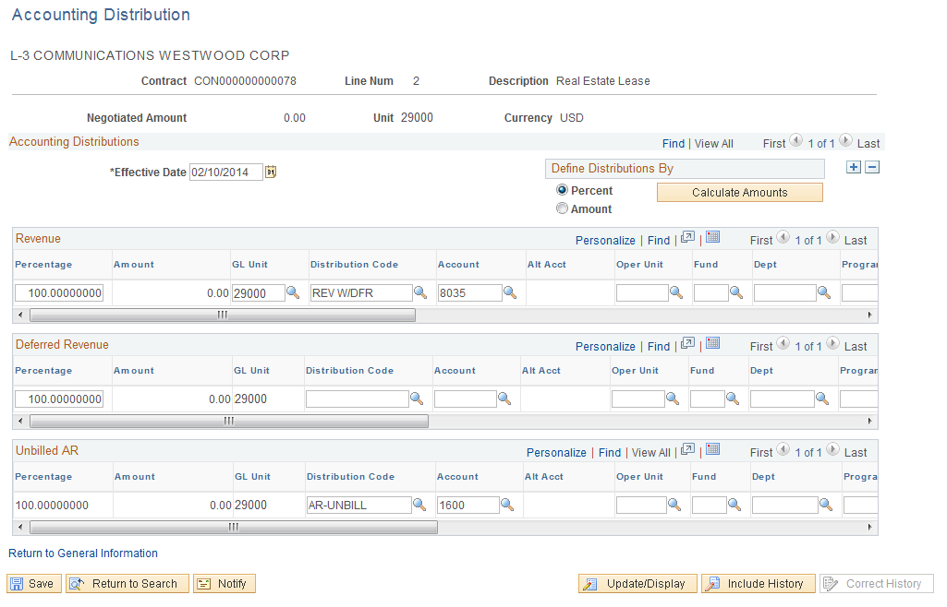

The Accounting Distribution page is used to establish Revenue and Unbilled Accounts Receivable accounting entries for an Amount Based Contract.

NOTE: When updating this page during the Contract creation process, the user may need to enter “Correction Mode” to update the value on the page. Use if necessary.

Effective Date – Set the Effective Date earlier enough to capture all contract revenue events. This is generally the contract begin date.

Percentage – To assign all of the revenue accounting entries to one distribution line, leave this value at 100.00 Percent.

GL Unit – This value should be set to the agency business unit value.

Distribution Code – Select from pre-defined Distribution Codes for the Revenue line and the Unbilled AR Line. Based on agency configuration, Distribution Codes can populate some or all of the chartfields on this page.

Chartfields – Populate the remaining chartfield values based on agency revenue accounting entry requirements.

NOTE: Combination Edit rules are in effect on this page. It will be necessary to understand the agency accounting requirements related to chartfield usage to populate this page.

NOTE: If deferred revenue is enabled for the Contract Line that distribution line will also need to be populated on this page.

Click to save the Contract Accounting Distribution.

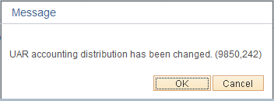

When altering accounting distribution information, the user may receive this warning message. If no billing or revenue recognition has taken place for the Contract, no “reconciliation issues” will exist.

Click the Return to General Information link.

Click the Amount Allocation link.

Amount Allocation Page

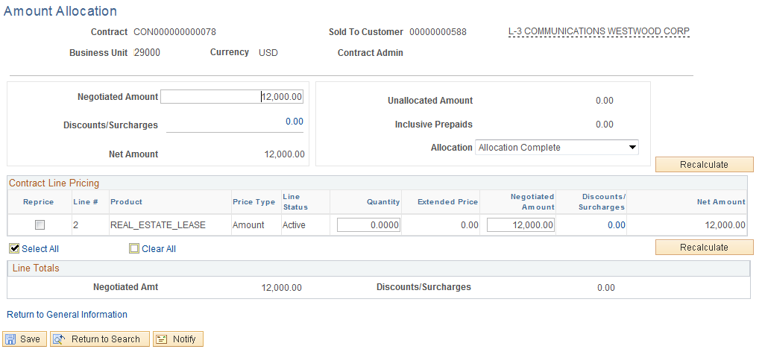

The Amount Allocation page is used to allocate the Contract Amount (defined on the General tab in a previous step) to the Contract Line(s).

Negotiated Amount – This amount should default from the Negotiated Amount populated on the General Tab.

In the Contract Line Pricing section of the page, populate the Negotiated Amount for the Contract Line(s).

Click to ensure the Negotiated Amount from the Contract Header is fully allocated to the Contract Line(s).

Allocation – The Allocation flag should be set to ‘Complete’ when the Contract Amount is fully allocated to the Contract Line(s).

NOTE: Use as necessary to check that the Contract Amount is fully allocated.

Click to save the Amount Allocation.

Click the Return to General Information link.

Click the Bill Plan link.

Step 2: Create Bill Plan

Assign Billing Plan Page

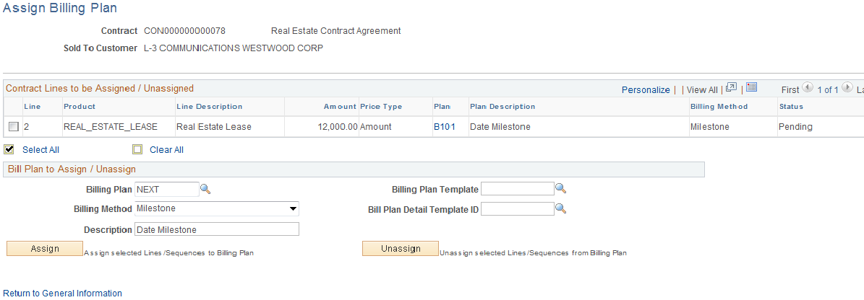

The Assign Billing Plan page allows the user to define a Bill Plan for each Contract Line.

Select the checkbox next to the Contract Line that will have a Bill Plan assigned to it.

Billing Plan – Leave this value as ‘NEXT’ to allow the system to create a Bill Plan ID.

Billing Method – For an Amount Based Contract the Billing Method can be:

- Immediate – To issue bills immediately.
- Milestone – Billing based on a milestone like date.
- Percent Complete – Billing based on Project Percent Complete.

Description – Enter a description for the Bill Plan.

Billing Plan Template – Optionally, select a pre-defined Billing Template to default Activation status and Bill Plan Events into the Billing Plan.

Detail Template – Optionally, select a Billing Detail Template to default billing options and default values into the Billing Plan.

NOTE: Bill Plan Templates are optional when creating a Bill Plan.

Click to assign the Bill Plan to the Contract Line.

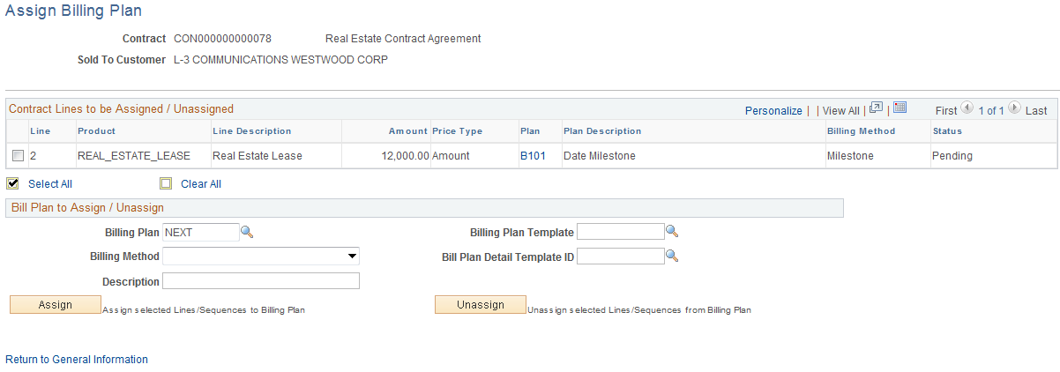

Once the Billing Plan is assigned to the Contract Line, the Bill Plan ID, Billing Method and Status is visible.

Click the Bill Plan ID link – B101.

Billing Plan General Tab

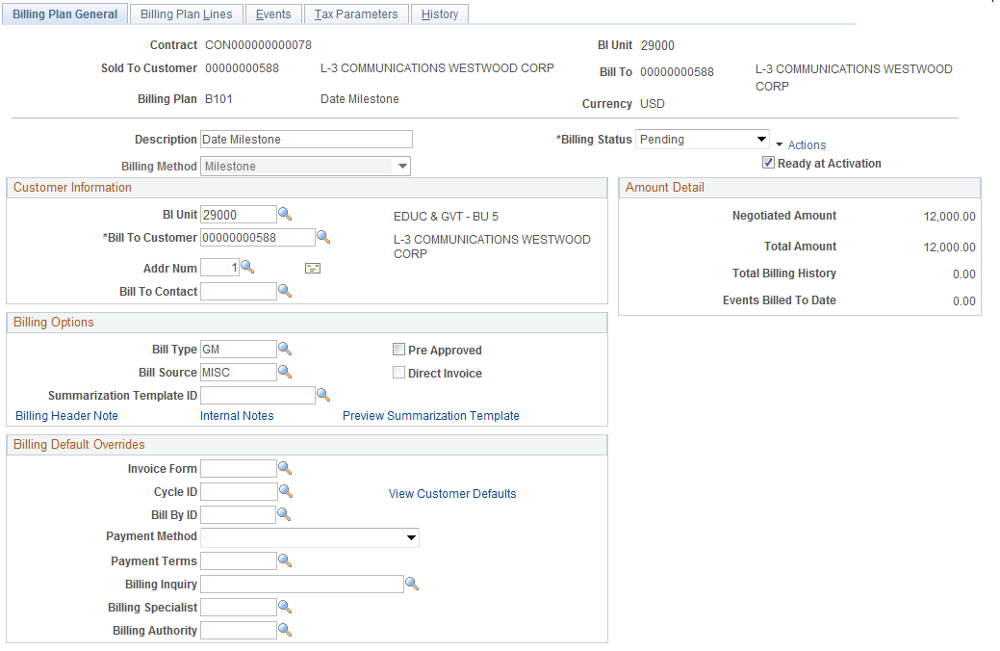

The Billing Plan General Tab allows the user to define Status, Billing Options and Bill Defaults.

Description – This field displays the description defined for the Billing Plan.

Billing Status – At this point the Bill Plan should be in ‘Pending’ status.

Ready at Activation – This checkbox indicates whether the Bill Plan will be set to ‘Ready’ status when the Contract is Activated. The Bill Plan must be set to ‘Ready’ for bills to be created.

Customer Information – This section of the page displays the agency Billing Business Unit, Customer under contract, and Address.

Billing Type – Define the Bill Type for the invoices that will be created from this Bill Plan. Bill Type defines default values for the invoice and is required on the Bill Plan.

Bill Source - Define the Bill Source for the invoices that will be created from this Bill Plan. Bill Source defines default values for the invoice and is required on the Bill Plan.

Billing Default Overrides – Use this section of the page to override Billing Default values derived from the Billing Default Hierarchy.

Click the Events Tab.

Events Tab

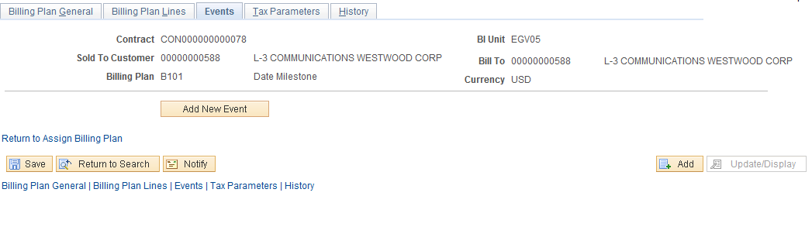

Use the Tab to define Billing Events that will be used to define the timing of the billing schedule.

Click to create Bill Events for the Plan.

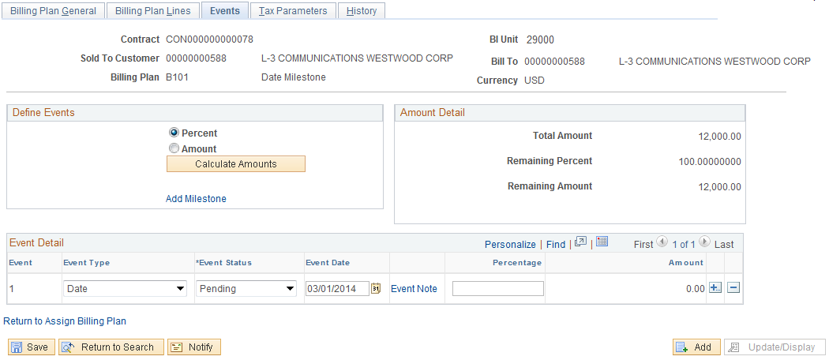

The Bill Events can be defined by Percent or Amount. The Total Amount of the Contract Line should be allocated to the Event Lines.

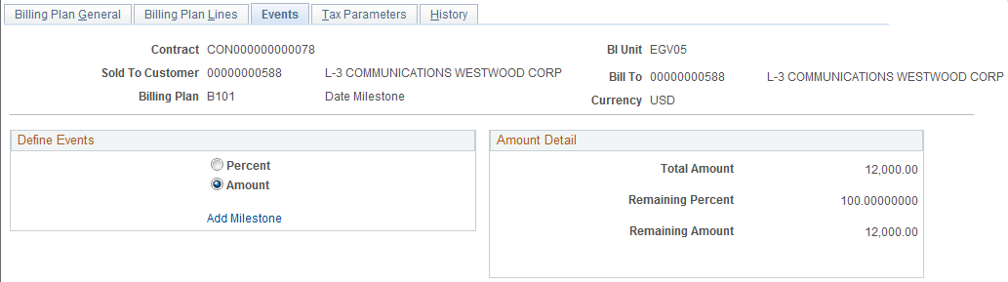

Define Events – Select to define Bill Plan Events by Percent or Amount.

Amount Detail – This section of the page defines the Total Amount of the Contract plus the Remaining Amount and Percent to be allocated to the Event Lines.

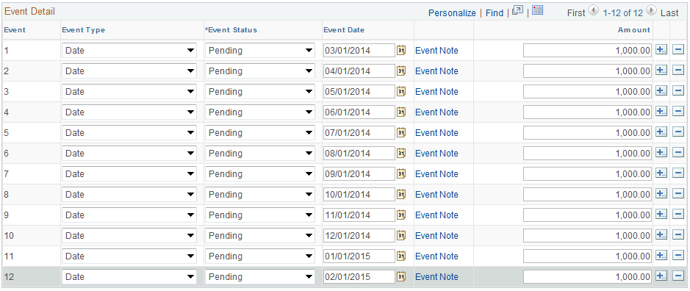

Event Type – Define the Event Type as ‘Milestone’ or ‘Date’.

Event Status – The Event Lines initially are set to ‘Pending’ status. In order for an Event Line to create a bill, the Status must be ‘Ready’.
Event Date – For Event Type of ‘Date’, set the Event Date for each Line. The Event Date will be used by the system to determine when the bill will be created.

Amount or Percent – Depending on the Define Event selection, populate this field with the Amount or Percent of the Event Line. This will be the bill amount.

NOTE: Use to insert additional Event Lines as required.

Click the Event Note link to add a Note to the bill.

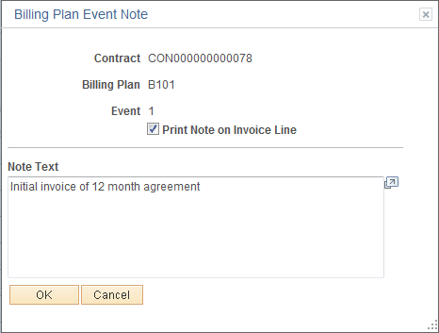

Print Note on Invoice Line – Select this checkbox to print the note on the invoice.

Note Text – Populate with note content.

Click to save the Note and return to the Events page.

Click to save the Events Page.
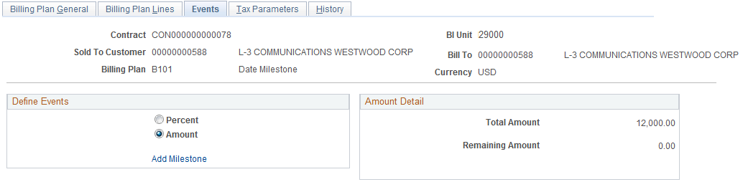

Ensure the Remaining Amount and Percent fields reflect zero.

NOTE: For all Bill Plan Events, the Status must be set to ‘Ready’ for the Event to be processed and create a bill.

Click Return to Assign Billing Plan link.

Click the Return to General Information link.

Click the Revenue Plans link.

Step 3: Create Revenue Plan

Assign Revenue Plan Page

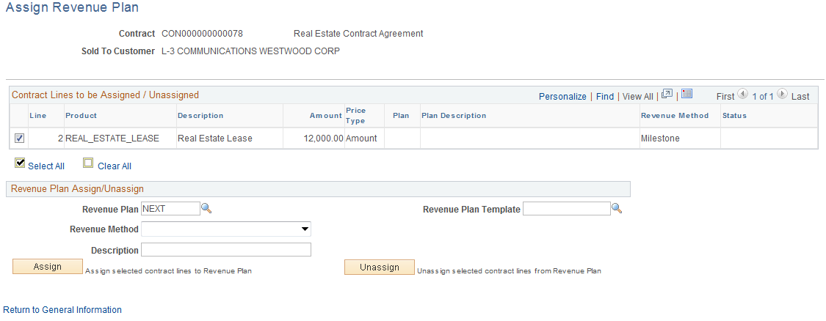

The Assign Revenue Plan page allows the user to define a Revenue Plan for each Contract Line.

Select the checkbox next to the Contract Line that will have a Revenue Plan assigned to it.

Revenue Plan – Leave this value as ‘NEXT’ to allow the system to create a Revenue Plan ID.

Revenue Method – For an Amount Based Contract the Billing Method can be:

- Immediate – To issue bills immediately.
- Milestone – Revenue recognition based on a milestone like date.
- Percent Complete – Revenue recognition based on Project Percent Complete.

Description – Enter a description for the Revenue Plan.

Revenue Plan Template – Optionally, select a pre-defined Revenue Template to default Activation status and Revenue Plan Events into the Revenue Plan.

Click to assign the Revenue Plan to the Contract Line.

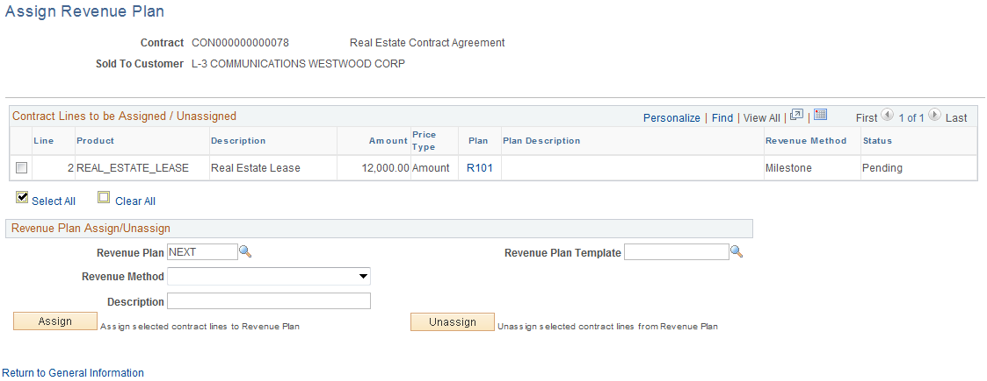

Once the Revenue Plan is assigned to the Contract Line, the Revenue Plan ID, Revenue Method and Status is visible.

Click the Revenue Plan ID link R101.

Revenue Plan Tab

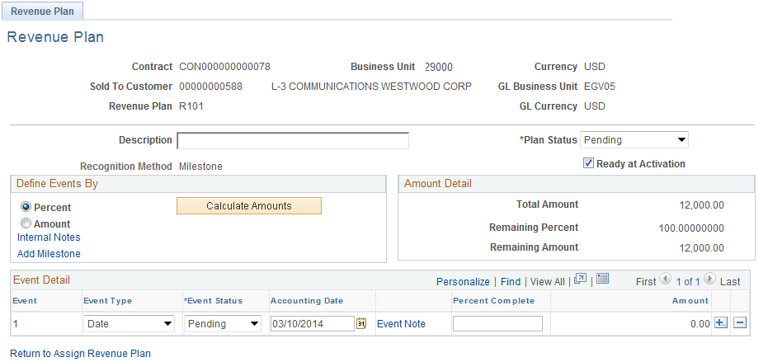

The Tab defines the Status, Amounts and Events that will determine revenue recognition.

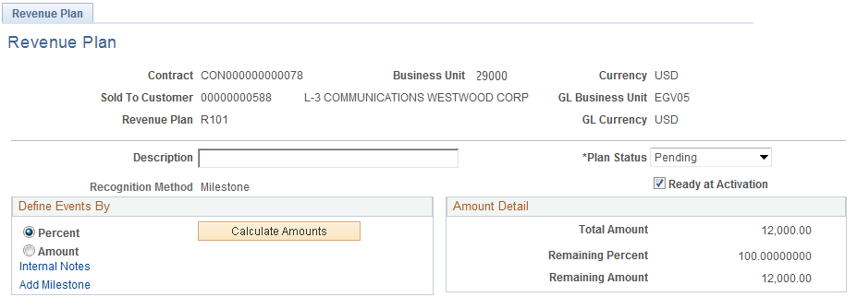

Define Event By – Use this section of the page do determine how the Contract Amount will be allocated to the Revenue Event Lines – by Percent or Amount.

Plan Status – At this point the Revenue Plan Status should be set to ‘Pending’.

NOTE: The Remaining Amount field will be equal to the Total Amount until the Event lines are populated.

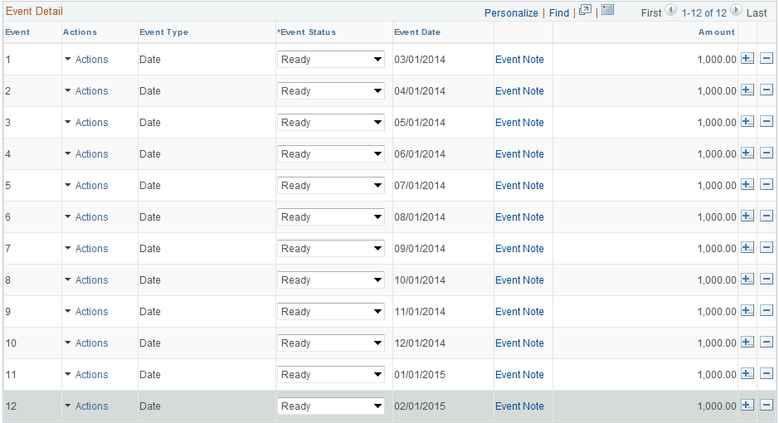

Event Type – Define the Event Type as ‘Milestone’ or ‘Date’.

Event Status – The Event Lines initially are set to ‘Pending’ status. In order for an Event Line to create a revenue accounting entry, the Status must be ‘Ready’.

Accounting Date – For Event Type of ‘Date’, set the Accounting Date for each Line. The Accounting Date will be used by the system to determine when the revenue accounting entries will be created.

Amount or Percent – Depending on the Define Event selection, populate this field with the Amount or Percent of the Event Line. This will be the revenue amount.

Use the Event Note link to add a note to the Event Line.

NOTE: Use to insert additional Event Lines as required.

Click to save the Revenue Plan Page.

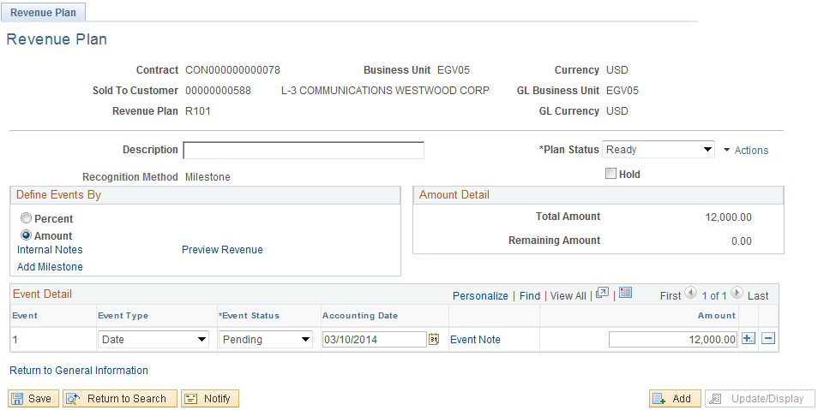

Ensure the Remaining Amount field reflects zero.

NOTE: For all Revenue Plan Events, the Status must be set to ‘Ready’ for the Event to be processed and create an accounting entry.

Click Return to Assign Revenue Plan link.

Click the Return to General Information link.

Click the Tab.

Step 4: Activate the Contract

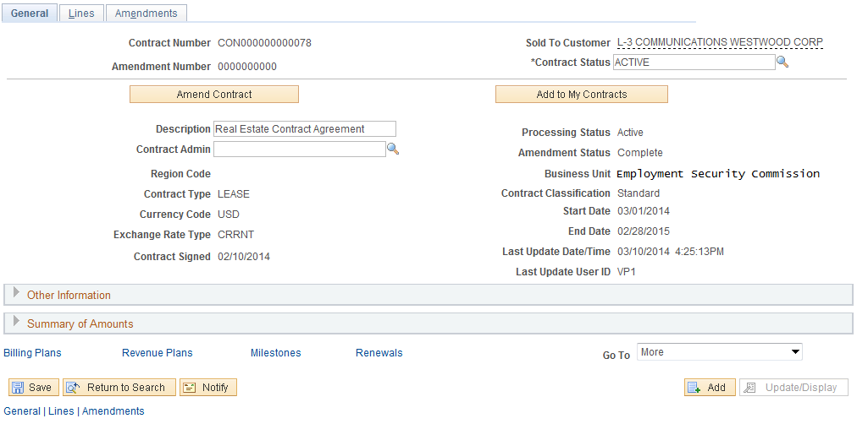

Use the General Tab to Activate the Contract.

Contract Status – Set the Contract Status to ‘Active’.

Click to save the Contract in Active Status.

NOTE: The Bill and Revenue plans will also be set to ‘Ready.’ If configured to ready at Contract activation.

NOTE: Once activated, the Contract is ready for Billing and Revenue Recognition.

Create Rate Based Contracts

Rate Based Contracts use dollar amounts captured in Project Costing as the basis for customer billing. These amounts can be billed and revenue recognized on an ad hoc basis.

Customer Contracts are created by agency for a single customer. Contracts are created in ‘Pending’ status initially, then moved to ‘Active’ status for contract billing and revenue purposes, and finally to ‘Closed’ status at the completion of the contract terms.

Customer Contracts will contain Bill Plans to manage the invoice process and Revenue Plans to manage the revenue recognition process. Amount Based Contracts use parameters in the contract definition to define amounts for billing and revenue, while Rate Based Contracts use Project Costing stored amounts to define billing and revenue.

Step 1: Rate Based Contract Header and Lines

Navigation: Customer Contracts > Create and Amend > General Information > Add a New Value

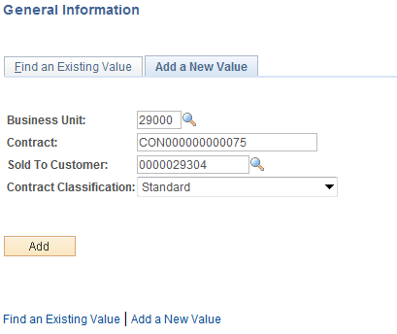

Business Unit – Select the agency Contracts business unit.

Contract – Leave as ‘NEXT’ to allow the system to assign the Contract ID. Alternatively, key the Contract ID value.

Sold To Customer – Select from the list of pre-defined Customers. Customers are unique to the agency business unit.

Contract Classification – Set to ‘Standard’.

Click to enter the Customer Contract pages.

General Tab

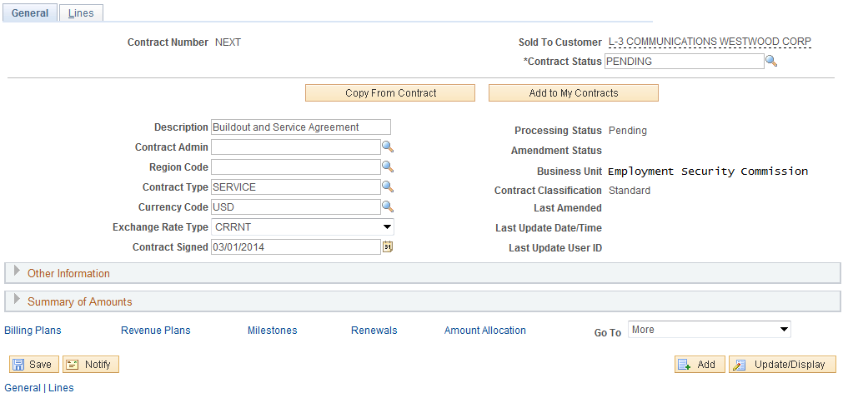

When initially creating a Contract, the and Tabs only will be visible. Use the Tab to define Contract header information. Some fields will be populated with default values. Others will need to be populated by the user.

Contract Status – Initially the Contract Status should be set to ‘Pending’. The Contract Status will change to ‘Active’ when defined correctly and all system edits have been passed.

Description – Define a description for this Contract.

Contract Type – Select a Contract Type from the pre-defined values. The Contract Type categorizes the Contract.

Expand the Other Information section of the page.

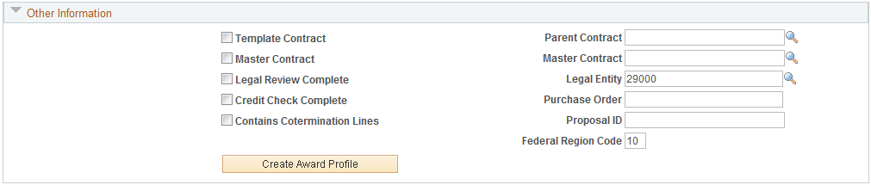

Template Contract – Select this checkbox to use this Contract as a template that can be copied from later.

Ensure the Legal Entity is populated with the agency number.

Click the Tab.

Lines Tab

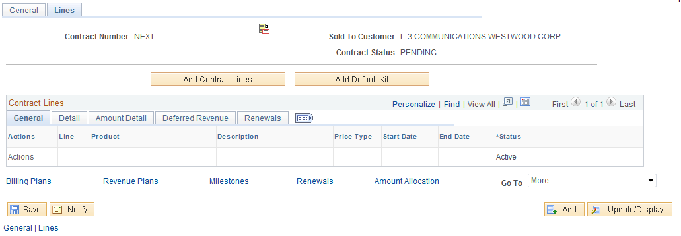

The Lines page initially displays with no Contract Line or Product information. By selecting a Product onto the Contract Line, the Line will be created.

NOTE: At this point in the Contract Creation steps, the fields for the Contract Line are inactive. By selecting Product, these fields will become Active.

Click to initiate the Contract Line.

NOTE: Before creating a Contract Line, a working knowledge of the agency Product values that are available is necessary. Products have different properties that directly impact the billing and revenue cycle of the Contract and should be understood prior to creating Contract Lines.

Add Contract Lines Page

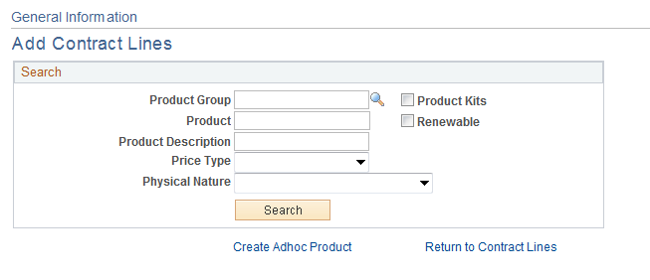

The Add Contract Lines page allows the user to search for pre-defined Products using the Search Products criteria.

Product Group – If the desired Product is part of a Product Group, search by this value.

Product – If the Product ID is known, use that value as search criteria.

Description – Search by Product Description.

Price Type – For Rate based Contract, the Price Type will be ‘Rate’.

Click to retrieve Products matching the search criteria provided.

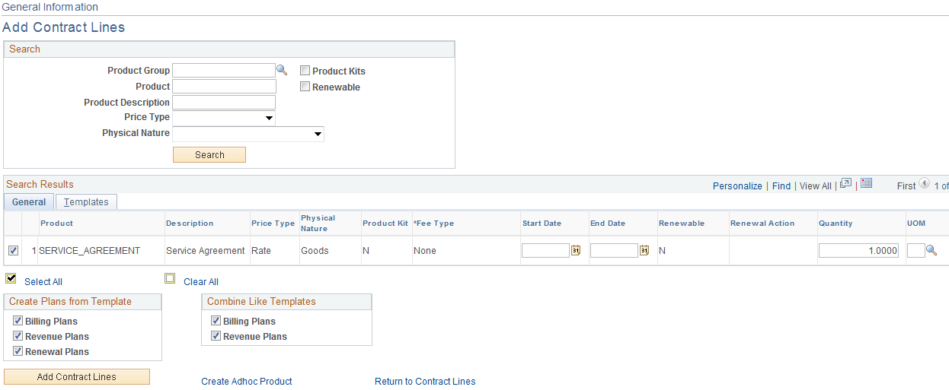

From the list of Products that match the search criteria, select the Product to copy onto the Contract Line.

Price Type – The Product Price Type defines what type of Contract billing and revenue will be created.

Unit of Measure – The default UOM from the Product definition.

Create Plans from Template – Select the check boxes to enable the system to create a Billing Plan, Revenue Plan or Renewal Plan when adding the contract line to the contract.

Combine Like Templates - Select to combine multiple Contract lines with the same Billing plan template into one Billing plan.

NOTE: These options are only active if Templates are defined on the Templates Tab.

Click the Tab.

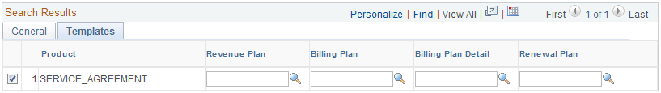

Define a Template for the Revenue Plan, Bill Plan, Bill Plan Detail or Renewal for this Contract Line.

NOTE: Templates are optional and can be defined for the Contract Line at this point or when the Bill and Revenue Plans are added to the Contract Line.

Use the Create Adhoc Product link to define a Product that can be used only for this Contract Line.

Click to add a Product to the Contract Line.

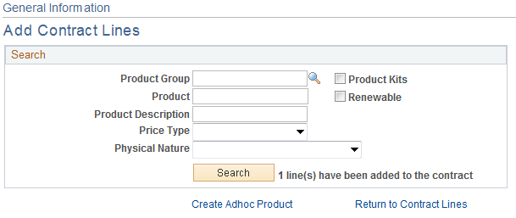

The Add Contract Lines page indicates that a Line has been added to the Contract.

Click the Return to Contract Lines link.

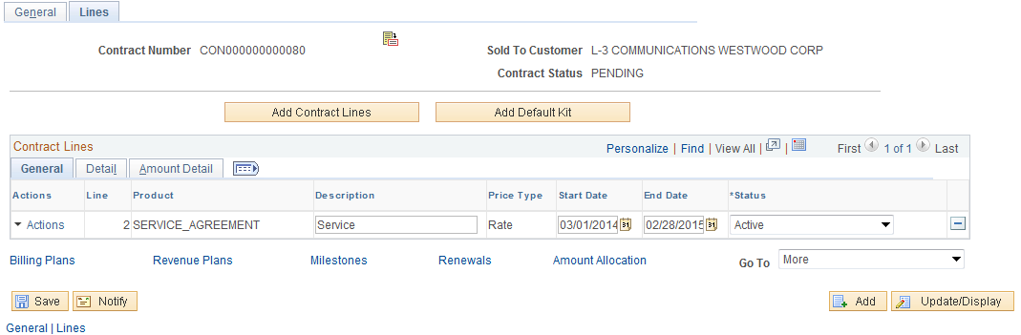

For a Rate Based Contract, optionally define the Start and End Dates for the agreement.

Start Date – Define the Contract start date.

End Date - Define the Contract start date.

Click to save the Contract and assign the Contract ID.

Click the Tab.

Click the Contract Terms link.

Related Projects Tab

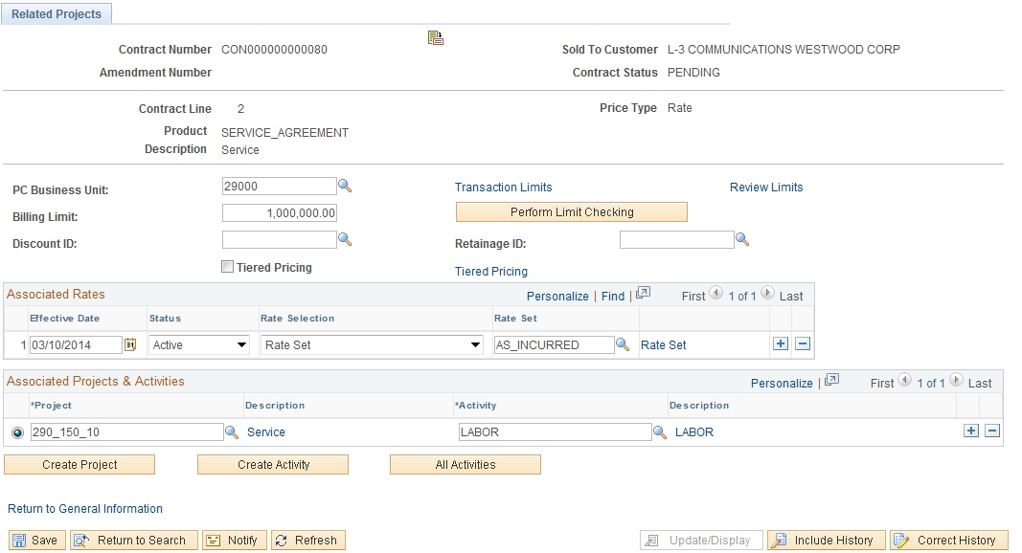

For a Rate Based Contract, use the Related Projects page to associate the Contract (Contract Line) with a Project and Activity.

NOTE: A Project and Activity is required on each line for a Rate Based Product (rate based contract line).

PC Business Unit – Select the agency Project Costing Business Unit. This value should be equal to the Contracts Business Unit.

Billing Limit – To set a ceiling on the amount that can be billed from this contract, define that amount in this field.

Use the Transaction Limits link to define billing limits by Project Costing chartfield combination.

NOTE: Transaction Identifiers must be configured for Transaction Limits to be used on the Contract Line. (See COR434 Projects – Project Definition Manual)

Associate Rates – Use this section of the page to define the Rate Set or Rate Plan that will be used to Price Project Transactions (See COR435 Projects – Project Costs and Revenue Manual).

Project – Select a Project to associate with this Contract Line. Optionally use to create a new Project ID (See COR434 Projects – Project Definition Manual).

Activity – Select an Activity for the Project defined. Optionally use to create a new Project ID. (See the COR434 Projects – Project Definition Manual).

NOTE: When creating a Project and Activity from the Contract Line, additional steps for Project Status, Project Team, Project Budgeting, etc. can be completed after the Contract is complete and activated.

Click to save the Contract.

Click the Return to General Information link.

Click the Tab.

Click the Distribution link.

Accounting Distribution Page

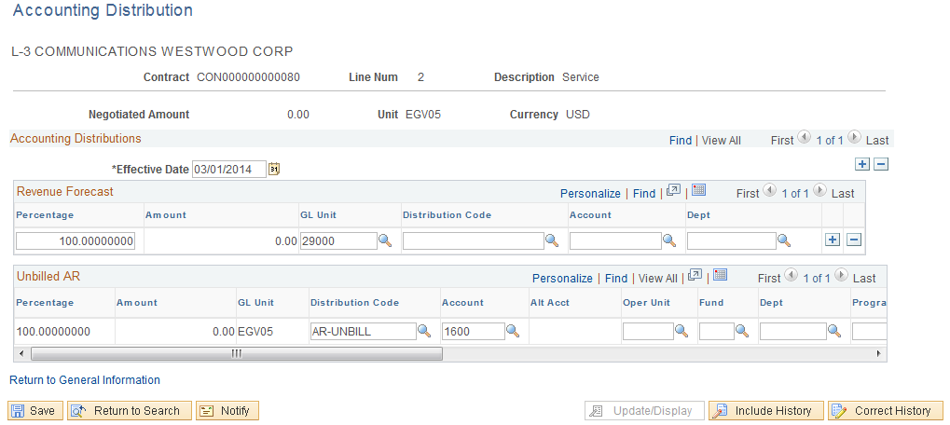

The Accounting Distribution page is used to establish Revenue Forecast (optional) and Unbilled Accounts Receivable accounting entries.

NOTE: This page, while required, does not control Accounting Entries for a Rate Based contract. Those entries are controlled by the Accounting Rules defined for the Project. (See the COR435 Projects – Project Costs and Revenue Manual).

NOTE: When updating this page during the Contract creation process, the user may need to enter “Correction Mode” to update the value on the page. Use , if necessary.

Effective Date – This is generally the contract begin date.

GL Unit – This value should be set to the agency business unit value.

Distribution Code – Select from pre-defined Distribution Codes for the Unbilled AR Line. Based on agency configuration, Distribution Codes can populate some or all of the chartfields on this page.

Chartfields – Populate the remaining chartfield values based on agency Unbilled AR accounting entry requirements.

NOTE: Combination Edit rules are in effect on this page. It will be necessary to understand the agency accounting requirements related to chartfield usage to populate this page.

Click to save the Contract Accounting Distribution.

When altering accounting distribution information, the user may receive this warning message. If no billing or revenue recognition has taken place for the Contract, no “reconciliation issues” will exist.

Click the Return to General Information link.

Click the Bill Plan hyperlink.

Step 2: Create Bill Plan

Assign Billing Plan Page

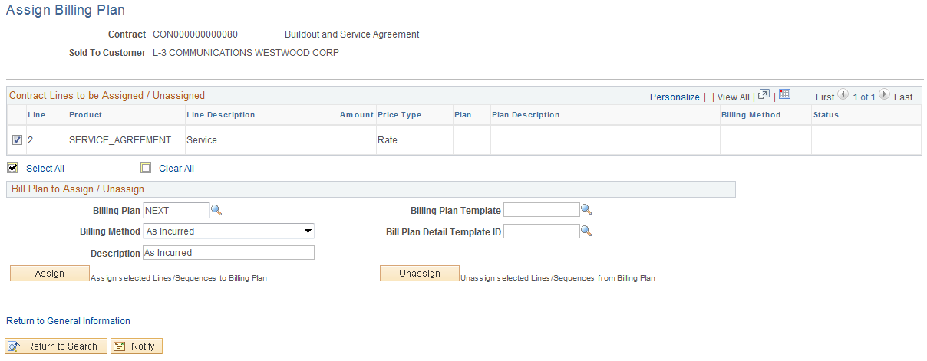

The Assign Billing Plan page allows the user to define a Bill Plan for each Contract Line.

Select the checkbox next to the Contract Line that will have a Bill Plan assigned to it.

Billing Plan – Leave this value as ‘NEXT’ to allow the system to create a Bill Plan ID.

Billing Method – For a Rate Based Contract the Billing Method will be ‘As Incurred’.

NOTE: Rate Based Contract Lines, use As Incurred Bill Method to create a bill plan that will create invoicing on an ad hoc basis when Project incurred costs are ready to be billed.

Description – Enter a description for the Bill Plan.

Billing Plan Template – Optionally, select a pre-defined Billing Template to default Activation status and Bill Plan Events into the Billing Plan.

Detail Template – Optionally, select a Billing Detail Template to default billing options and default values into the Billing Plan.

NOTE: Bill Plan Templates are optional when creating a Bill Plan.

Click to assign the Bill Plan to the Contract Line.

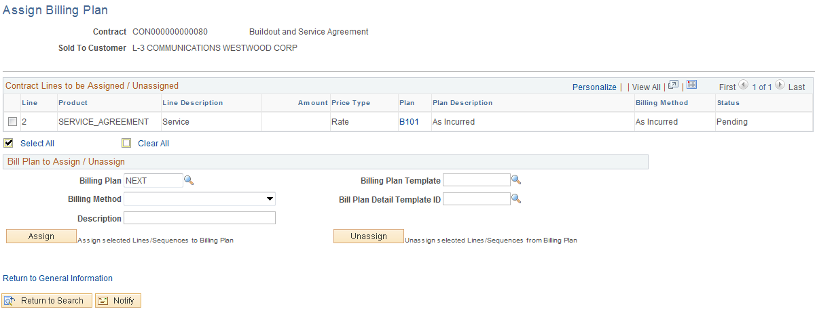

Once the Billing Plan is assigned to the Contract Line, the Bill Plan ID, Billing Method and Status is visible.

Click the Bill Plan ID link B101.

Billing Plan General Page

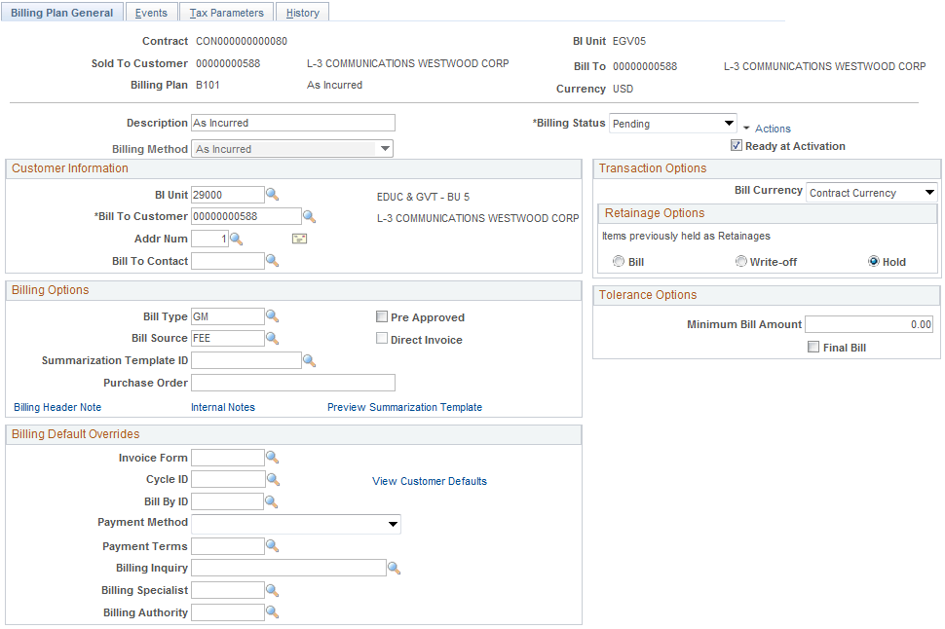

The Billing Plan General Page allows the user to define Status, Billing Options and Bill Defaults.

Description – This field displays the description defined for the Billing Plan.

Billing Status – At this point the Bill Plan should be in ‘Pending’ status.

Ready at Activation – This checkbox indicates whether the Bill Plan will be set to ‘Ready’ status when the Contract is Activated. The Bill Plan must be set to ‘Ready’ for bills to be created.

Customer Information – This section of the page displays the agency Billing Business Unit, Customer under contract, and Address.

Billing Type – Define the Bill Type for the invoices that will be created from this Bill Plan. Bill Type defines default values for the invoice and is required on the Bill Plan.

Bill Source - Define the Bill Source for the invoices that will be created from this Bill Plan. Bill Source defines default values for the invoice and is required on the Bill Plan.

Purchase Order - If this Contract Line is associated with a Customer purchase order, enter the purchase order reference information.

Billing Default Overrides – Use this section of the page to override Billing Default values derived from the Billing Default Hierarchy.

Click to save the Bill Plan General Page.

Click Return to Assign Billing Plan link.

Click the Return to General Information link.

Click the Revenue Plans link.

Step 3: Create Revenue Plan

Assign Revenue Plan Page

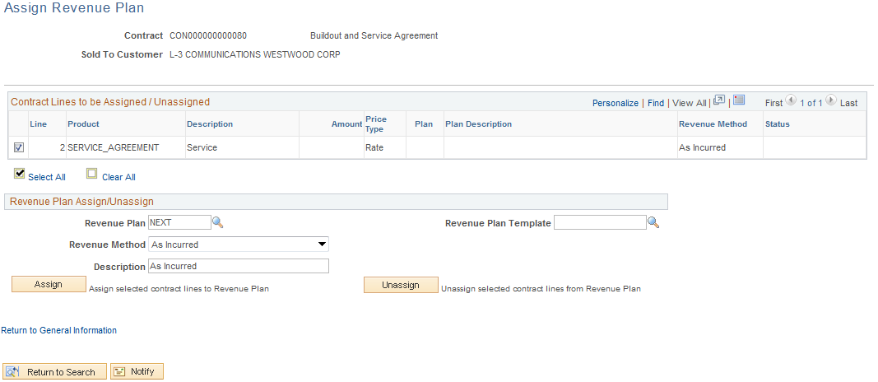

The Assign Revenue Plan page allows the user to define a Revenue Plan for each Contract Line.

Select the checkbox next to the Contract Line that will have a Revenue Plan assigned to it.

Revenue Plan – Leave this value as ‘NEXT’ to allow the system to create a Revenue Plan ID.

Revenue Method – For an Amount Based Contract the Billing Method will be ‘As Incurred’.

NOTE: Rate Based Contract Lines use As Incurred Revenue Method to create a revenue plan that will create accounting entries on an ad hoc basis when revenue needs to be recognized.

Description – Enter a description for the Revenue Plan.

Revenue Plan Template – Optionally, select a pre-defined Revenue Template to default Activation status and Revenue Plan Events into the Revenue Plan.

Click to assign the Revenue Plan to the Contract Line.

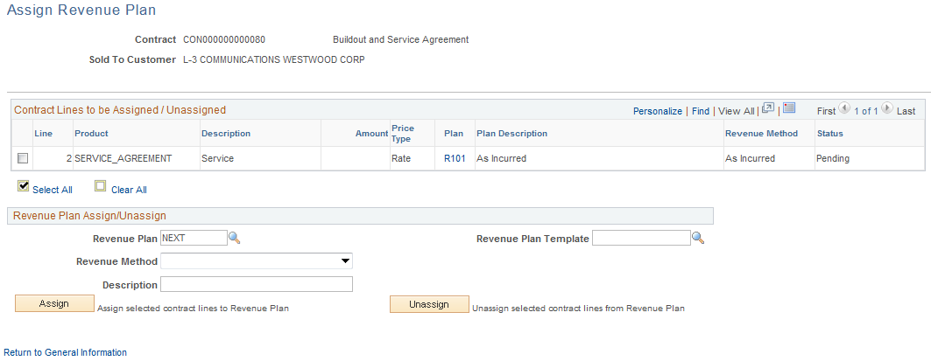

Once the Revenue Plan is assigned to the Contract Line, the Revenue Plan ID, Revenue Method and Status is visible.

Click the Revenue Plan ID link R101.

NOTE: Rate Based Contract Lines use Project Costing Accounting Rules to create Revenue accounting entries. These rules are established as part of the Project Costing configuration.

Revenue Plan Tab

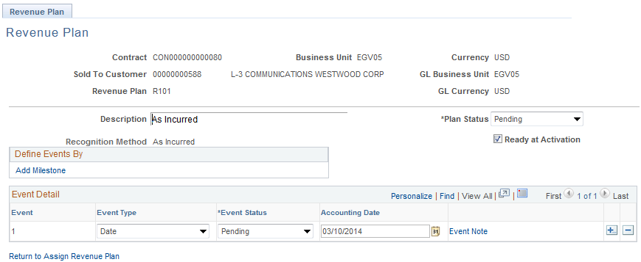

Since this is an As Incurred revenue plan, no Revenue Events are defined for revenue recognition. Revenue will be recognized on an ad hoc basis when batch processes are executed.

Click to save the Revenue Plan Page.

Click Return to Assign Revenue Plan link.

Click the Return to General Information link.

Click the General Tab.

Step 4: Activate the Contract

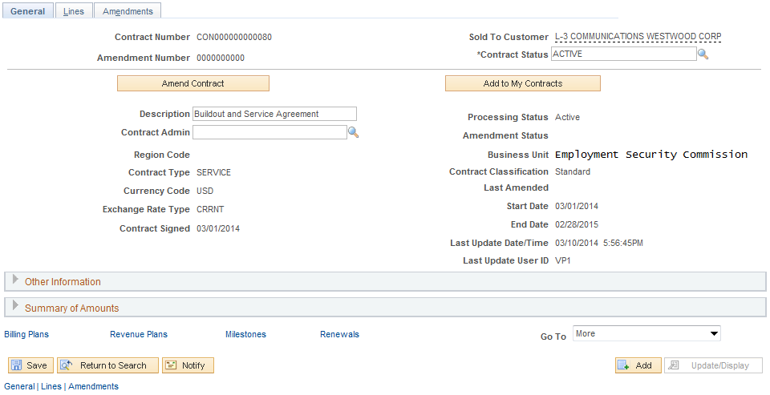

Use the General page to Activate the Contract.

Contract Status – Set the Contract Status to ‘Active’.

Click to save the Contract in Active Status.

NOTE: The Bill and Revenue plans will also be set to ‘Ready.’ If configured to ready at Contract activation.

NOTE: Once activated, the Contract is ready for Billing and Revenue Recognition.

Create Recurring Contracts

Recurring Contracts use a pre-defined schedule and contract defined amounts to build a recurring billing schedule. Recurring Contracts use the Billing Module, rather than Contracts to create revenue accounting entries.

A Recurring contract line is a product or service that requires recurring bills. With a revenue recognition method of Billing Manages Revenue, for a recurring contract line, the contract line is not associated with a revenue plan.

When setting up billing for recurring contract lines, you must select the Recurring billing method. There are no billing plan lines or Events associated with a Recurring billing plan. Define the start date and schedule, and each time the plan is eligible for billing, the system generates the appropriate invoice lines and sends them to Billing along with the accounting distribution.

Customer Contracts are created by agency for a single customer. Contracts are created in ‘Pending’ status initially, then moved to ‘Active’ status for contract billing and revenue purposes, and finally to ‘Closed’ status at the completion of the contract terms.

Step 1: Recurring Contract Header and Lines

Navigation: Customer Contracts > Create and Amend > General Information > Add a New Value

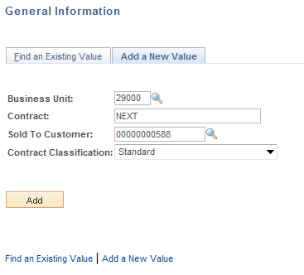

Business Unit –Select the agency Contracts business unit.

Contract – Leave as ‘NEXT’ to allow the system to assign the Contract ID. Alternatively, key the Contract ID value.

Sold To Customer – Select from the list of pre-defined Customers. Customers are unique to the agency business unit.

Contract Classification – Set to ‘Standard’

Click to enter the Customer Contract pages.

General Tab

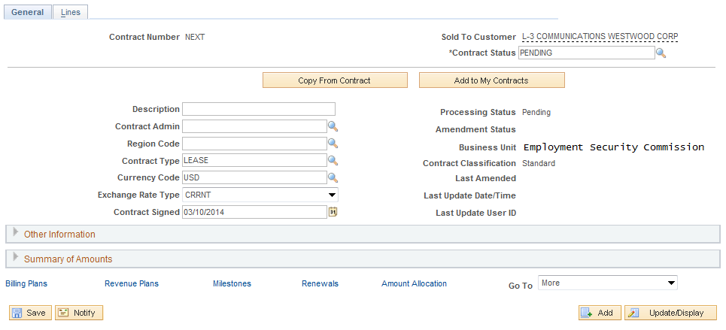

When initially creating a Contract, the General and Lines tabs only will be visible. Use the Tab to define Contract header information. Some fields will be populated with default values. Others will need to be populated by the user.

Contract Status – Initially the Contract Status should be set to ‘Pending’. The Contract Status will change to ‘Active’ when defined correctly and all system edits have been passed.

Description – Define a description for this Contract.

Contract Type – Select a Contract Type from the pre-defined values. The Contract Type categorizes the Contract.

Expand the Other Information section of the page.

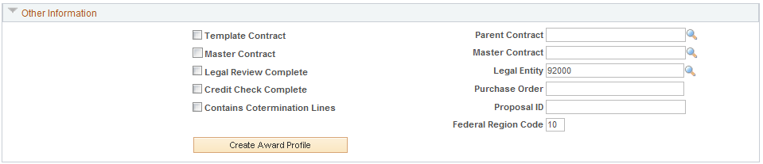

Template Contract – Select this checkbox to use this Contract as a template that can be copied from later.

Ensure the Legal Entity is populated with the agency number.

Click the Tab.

Lines Page

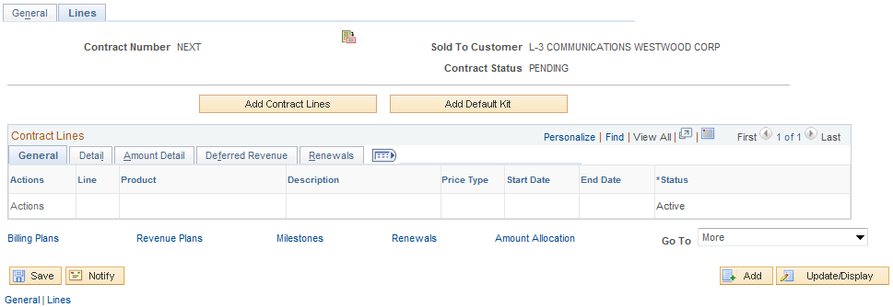

The Lines Tab initially displays with no Contract Line or Product information. By selecting a Product onto the Contract Line, the Line will be created.

NOTE: At this point in the Contract Creation steps, the fields for the Contract Line are inactive. By selecting Product, these fields will become Active.

Click to initiate the Contract Line.

NOTE: Before creating a Contract Line, a working knowledge of the agency Product values that are available is necessary. Products have different properties that directly impact the billing and revenue cycle of the Contract and should be understood prior to creating Contract Lines.

Add Contract Lines Page

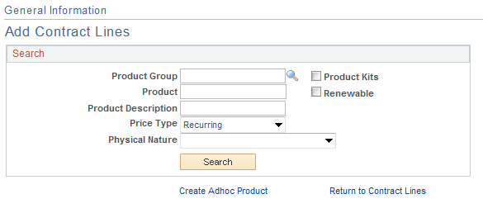

The Add Contract Lines page allows the user to search for pre-defined Products using the Search Products criteria.

Product Group – If the desired Product is part of a Product Group, search by this value.

Product – If the Product ID is known, use that value as search criteria.

Description – Search by Product Description.

Price Type – For a Recurring Contracts, the Price Type will be ‘Recurring’.

Click to retrieve Products matching the search criteria provided.

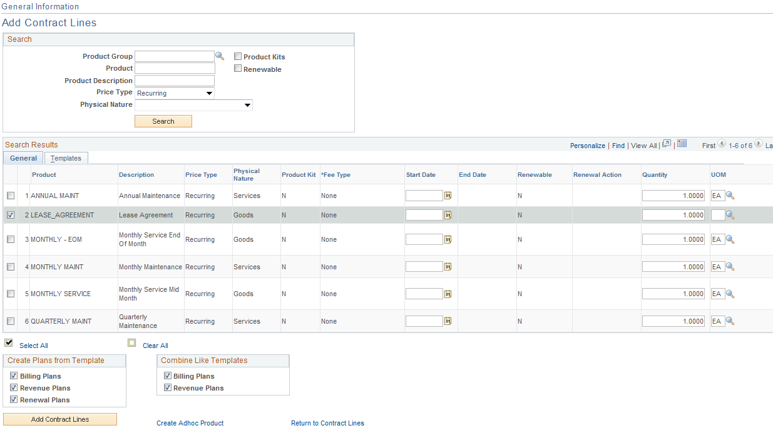

From the list of Products that match the search criteria, select the Product to copy onto the Contract Line.

Price Type – The Product Price Type defines what type of Contract billing and revenue will be created.

Unit of Measure – The default UOM from the Product definition.

Create Plans from Template – Select the check boxes to enable the system to create a Billing Plan, Revenue Plan or Renewal Plan when adding the contract line to the contract.

Combine Like Templates - Select to combine multiple Contract lines with the same Billing plan template into one Billing plan.

NOTE: These options are only active if Templates are defined on the Templates Tab.

Click the Tab.

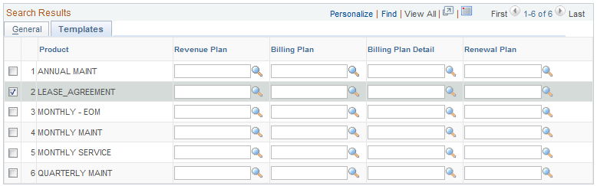

Define a Template for the Revenue Plan, Bill Plan, Bill Plan Detail or Renewal for this Contract Line.

NOTE: Templates are optional and can be defined for the Contract Line at this point or when the Bill and Revenue Plans are added to the Contract Line.

Use the Create Adhoc Product link to define a Product that can be used only for this Contract Line.

Click to add a Product to the Contract Line.

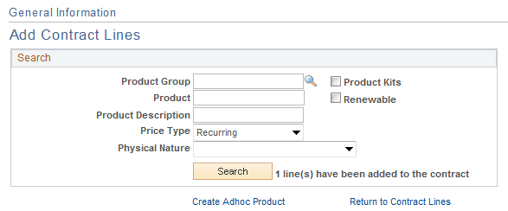

The Add Contract Lines page indicates that a Line has been added to the Contract.

Click the Return to Contract Lines page link.

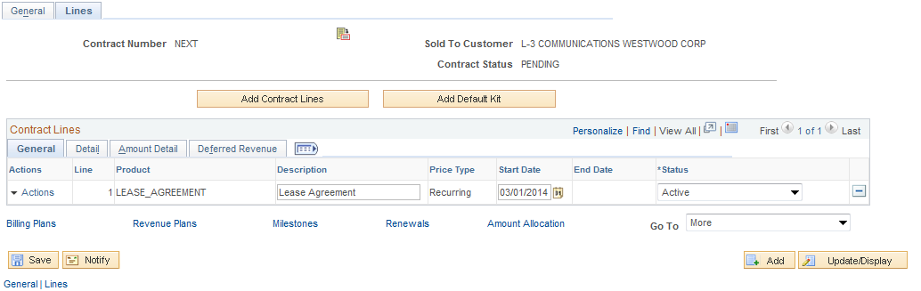

For a Recurring Based Contract, define only the Start Date for the agreement.

NOTE: The Start Date is used by the system to big the billing cycle for Recurring Contracts. This date only is required because the Billing Schedule will define the End Date of the Contract.

Start Date – Define the Contract start date (and the billing begin date.

Click to save the Contract and assign the Contract ID.

Click the Tab.

Click the Contract Terms link.

Related Projects Tab

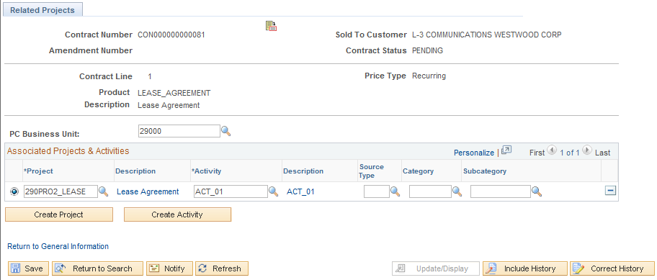

For a Recurring Contract, the Related Projects page can be used to associate the Contract (Contract Line) with a Project and Activity.

NOTE: A Project and Activity could be associated with a Recurring Contract to capture costs incurred against a Project and compare to revenue generated from the contract for profitability analysis.

PC Business Unit – Select the agency Project Costing Business Unit. This value should be equal to the Contracts Business Unit.

Project – Select a Project to associate with this Contract Line. Optionally use to create a new Project ID.

Activity – Select an Activity for the Project defined. Optionally use to create a new Project ID.

NOTE: These steps are optional as Recurring Contracts do not need to be associated with a Project and Activity.

Click to save the Contract.

Click the Return to General Information link.

Click the Tab.

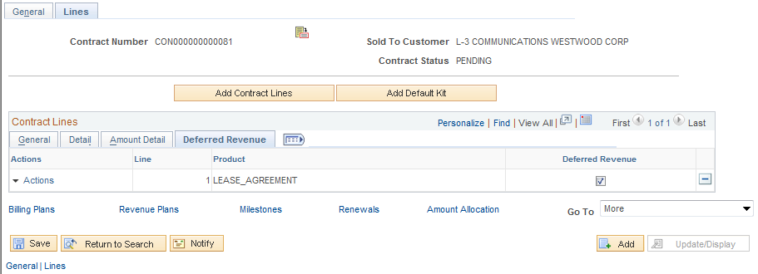

To enable Deferred Revenue Accounting Entries for this Contract Line, select the Deferred Revenue checkbox.

Click to save the Deferred Revenue checkbox.

NOTE: Deferred Revenue accounting entries are optional for Recurring Contracts. These accounting entries are generally created before contract billing occurs.

Click to save the Deferred Revenue Accounting Date.

Click the Tab.

Click the Distribution link.

Accounting Distribution Page

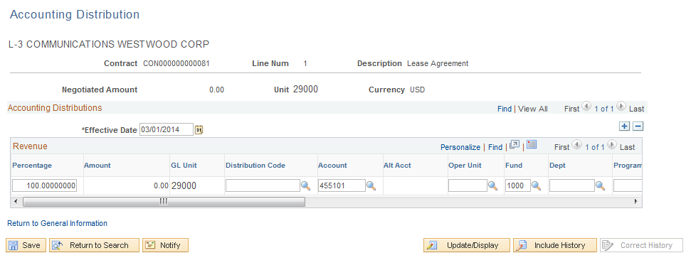

The Accounting Distribution page is used to establish Revenue (and Deferred Revenue if applicable) accounting entries for a Recurring Contract.

NOTE: When updating this page during the Contract creation process, the user may need to enter “Correction Mode” to update the value on the page. Use if necessary.

Effective Date – Set the Effective Date earlier enough to capture all contract revenue events. This is generally the contract begin date.

Percentage – To assign all of the revenue accounting entries to one distribution line, leave this value at 100.00 Percent.

GL Unit – This value should be set to the agency business unit value.

Distribution Code – select from pre-defined Distribution Codes for the Revenue line (and the Deferred Revenue Line if applicable). Based on agency configuration, Distribution Codes can populate some or all of the chartfields on this page.

Chartfields – Populate the remaining chartfield values based on agency revenue accounting entry requirements.

NOTE: Combination Edit rules are in effect on this page. It will be necessary to understand the agency accounting requirements related to chartfield usage to populate this page.

NOTE: If Deferred Revenue is selected on the Contract Line, the distribution chartfields for deferred revenue will be available for population on this page.

Click to save the Contract Accounting Distribution.

Click the Return to General Information link.

Click the Billing Plans link.

Step 2: Create Bill Plan

Assign Billing Plan Page

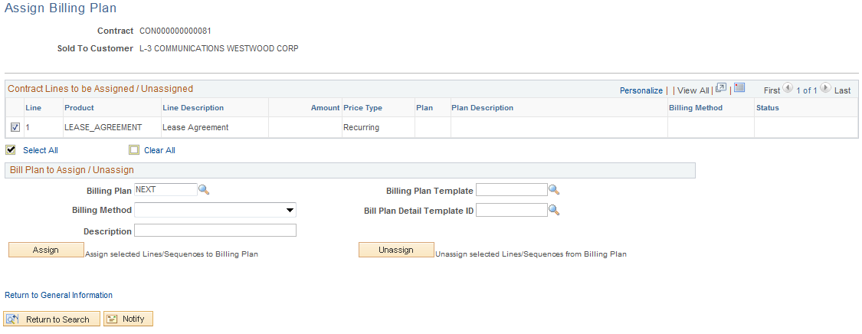

The Assign Billing Plan page allows the user to define a Bill Plan for each Contract Line.

Select the checkbox next to the Contract Line that will have a Bill Plan assigned to it.

Billing Plan – Leave this value as ‘NEXT’ to allow the system to create a Bill Plan ID.

Billing Method – For a Recurring Contract the Billing Method will be ‘Recurring’.

Description – Enter a description for the Bill Plan.

Billing Plan Template – Optionally, select a pre-defined Billing Template to default Activation status and Bill Plan Events into the Billing Plan.

Detail Template – Optionally, select a Billing Detail Template to default billing options and default values into the Billing Plan.

NOTE: Bill Plan Templates are optional when creating a Bill Plan.

Click to assign the Bill Plan to the Contract Line.
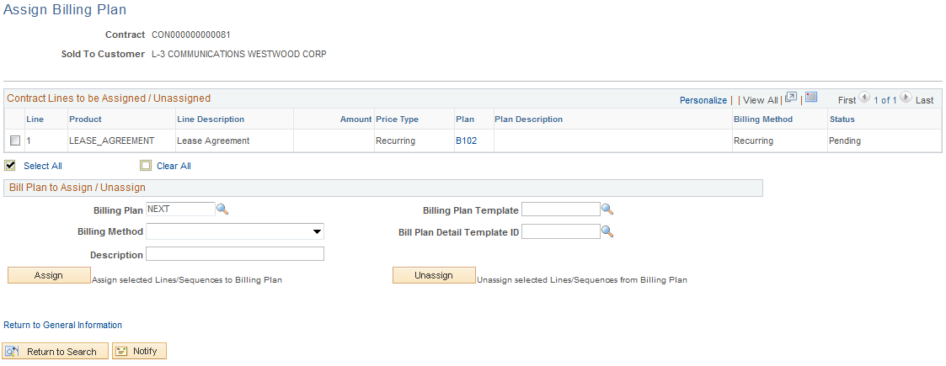

Once the Billing Plan is assigned to the Contract Line, the Bill Plan ID, Billing Method and Status is visible.

Click the Bill Plan ID link B101.

Billing Plan General Tab

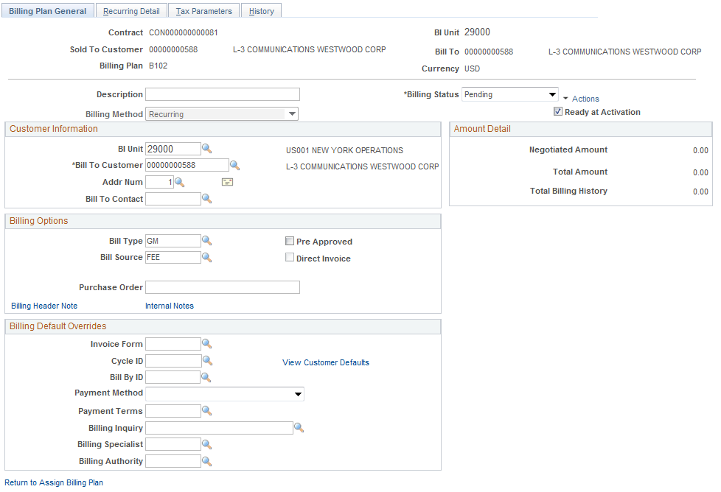

The Billing Plan General Tab allows the user to define Status, Billing Options and Bill Defaults.

Description – This field displays the description defined for the Billing Plan.

Billing Status – At this point the Bill Plan should be in ‘Pending’ status.

Ready at Activation – This checkbox indicates whether the Bill Plan will be set to ‘Ready’ status when the Contract is Activated. The Bill Plan must be set to ‘Ready’ for bills to be created.

Customer Information – This section of the page displays the agency Billing Business Unit, Customer under contract, and Address.

Billing Type – Define the Bill Type for the invoices that will be created from this Bill Plan. Bill Type defines default values for the invoice and is required on the Bill Plan.

Bill Source - Define the Bill Source for the invoices that will be created from this Bill Plan. Bill Source defines default values for the invoice and is required on the Bill Plan

Billing Default Overrides – Use this section of the page to override Billing Default values derived from the Billing Default Hierarchy.

Click the Recurring Detail Tab.

Recurring Detail Tab

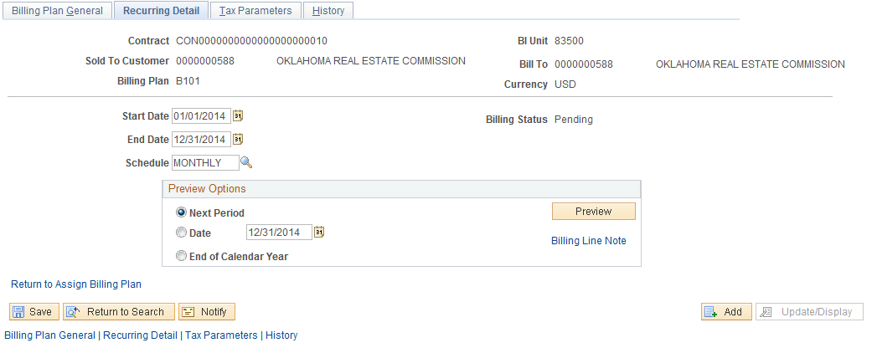

Use the Recurring Detail Tab to define and preview the recurring billing schedule for this Contract Line.

Start Date – This value is defaulted from the Contract Begin Date defined on the contract line earlier in the Contract setup.

End Date – Populate the end date for the recurring billing schedule.

Schedule – Select from a list of pre-defined billing schedules. These schedules could be weekly, monthly, annually, etc.

In the Preview Options section of the page, define the options that will be used to veiw the recurring billing schedule:

- Next Period – Select this value to see only the next period of the billing schedule.
- Date – Define the date through which the recurring schedule will be previewed.
- End of Calendar Year – Select to view the recurring schedule thru the end of the year.

Click to view the recurring schedule based on the options defined.

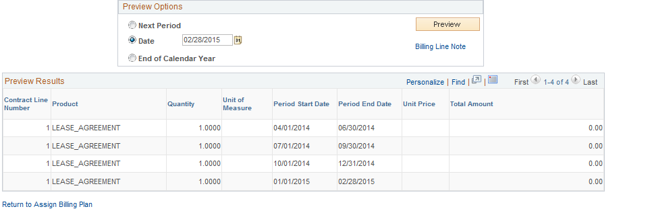

Click to save the Recurring Detail Page.

Click Return to Assign Billing Plan link.

Click the Return to General Information link.

Click the Revenue Plans link.

Step 3: Create Revenue Plan

Assign Revenue Plan Page

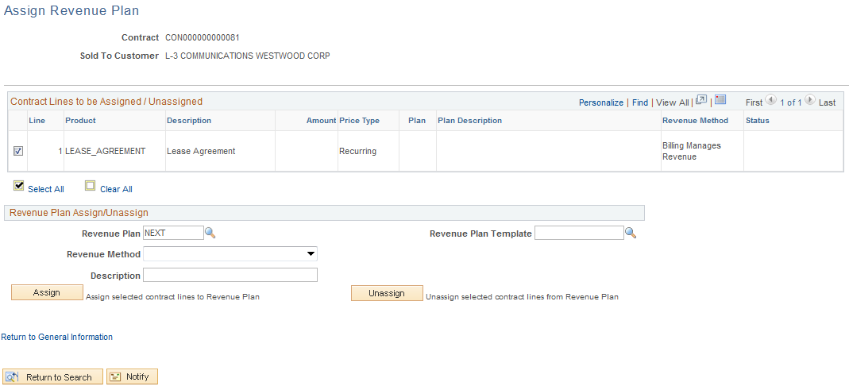

The Assign Revenue Plan page allows the user to define a Revenue Plan for each Contract Line.

NOTE: Since Billing Manages the revenue in a Recurring Contract, the Revenue Plan is assigned in the Contract but does not control revenue billing accounting entries.

Select the checkbox next to the Contract Line that will have a Revenue Plan assigned to it.

Revenue Plan – Leave this value as ‘NEXT’ to allow the system to create a Revenue Plan ID.

Revenue Method – For a Recurring Contract the Billing Method will be ‘Billing Manages Revenue’.

Description – Enter a description for the Revenue Plan.

Click to assign the Revenue Plan to the Contract Line.

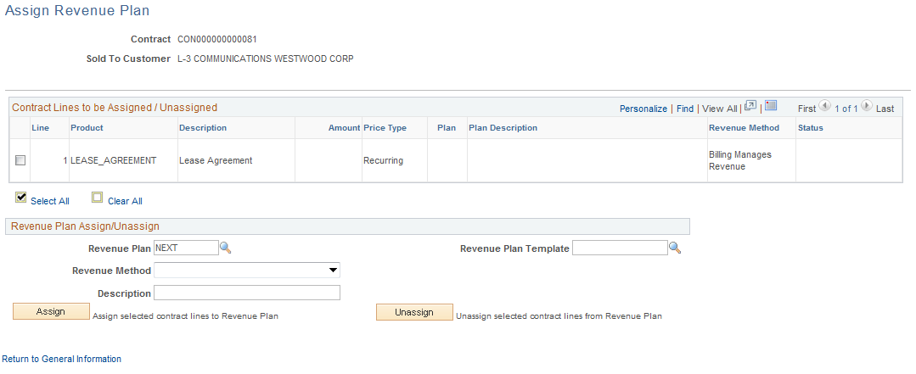

Since Billing Manages Revenue, there is not Revenue Plan ID as is the case with Amount Based or Rate Based Contracts.

Click Return to General Information link.

Click the General Tab.

Step 4: Activate the Contract

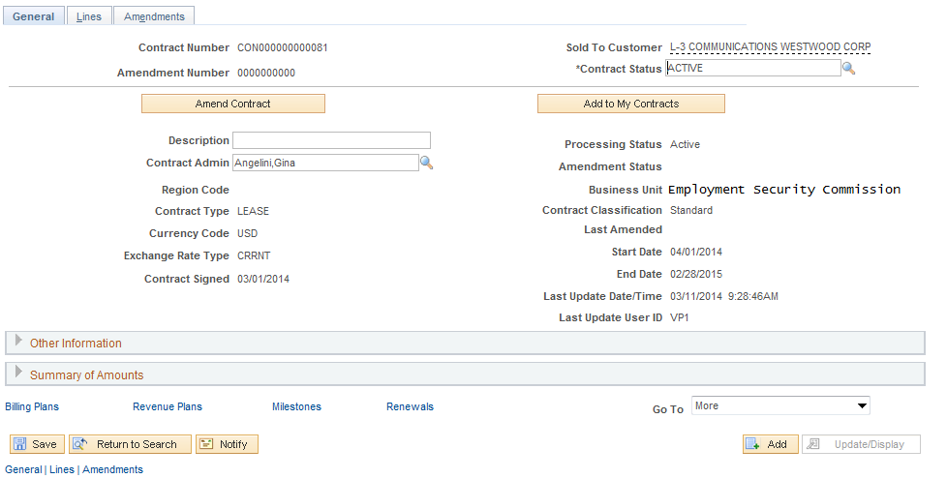

Use the Tab to Activate the Contract.

Contract Status – Set the Contract Status to ‘Active’.

Click to save the Contract in Active Status.

NOTE: The Bill and Revenue plans will also be set to ‘Ready’ if configured to ready at Contract activation.

NOTE: Once activated, the Contract is ready for Billing and Revenue Recognition.

Create Prepaid Contracts

Prepaid Contracts are used in combination with Rate Based Products that integrate with Project Costing as described in previous sections of this manual. Customers can prepay for Rate based goods and services. The prepaid amount may be applied to one or more Rate based Contract lines. The amount may be used against all or a portion of the billing activity for the applicable Contract lines.

Matching prepaid amounts to Rate Based Contract Lines is called Utilization. As reimbursable Project Costs are accumulated in a Project and Activity, the billable amounts are applied to the prepaid amount and it is ‘utilized’ until all prepaid amounts are liquidated. Once the prepaid amount is liquidated, the reimbursable Project costs are sent to the Billing Module for invoice creation.

Prepaid ‘utilization’ criteria are related only to Rate-based contract lines. Rate-based contract lines are linked to a different billing plan than that of the prepaid. The billing plan linked to the prepaid is used for the initial billing of the prepaid amount. The billing plan linked to the Rate-based line is used for the perpetual billing activity that occurs with the utilization of the prepaid

Step 1: Rate Based Contract Header and Lines

Navigation: Customer Contracts > Create and Amend > General Information > Add a New Value

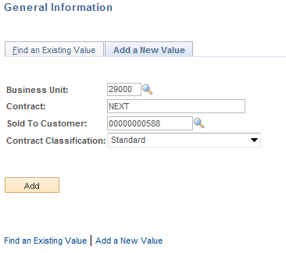

Business Unit – Select the agency Contracts business unit.

Contract – Leave as ‘NEXT’ to allow the system to assign the Contract ID. Alternatively, key the Contract ID value.

Sold To Customer – Select from the list of pre-defined Customers. Customers are unique to the agency business unit.

Contract Classification – Set to ‘Standard’

Click to enter the Customer Contract pages.

General Tab

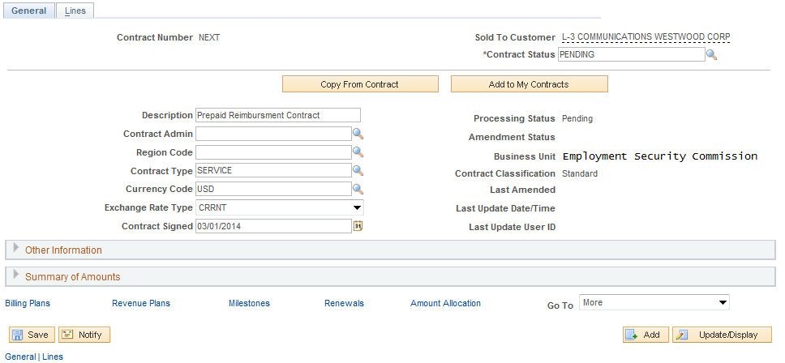

When initially creating a Contract, the and tabs only will be visible. Use the General tab to define Contract header information. Some fields will be populated with default values. Others will need to be populated by the user.

Contract Status – Initially the Contract Status should be set to ‘Pending’. The Contract Status will change to ‘Active’ when defined correctly and all system edits have been passed.

Description – Define a description for this Contract.

Contract Type – Select a Contract Type from the pre-defined values. The Contract Type categorizes the Contract.

Expand the Other Information section of the page.

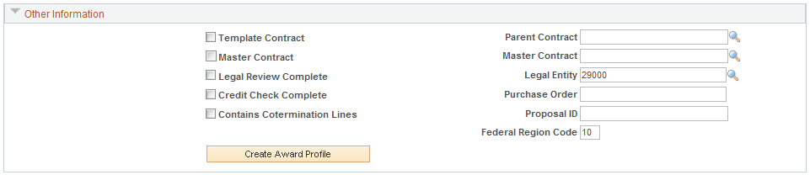

Template Contract – Select this checkbox to use this Contract as a template that can be copied from later.

Ensure the Legal Entity is populated with the agency number.

Click the Tab.

Lines Tab

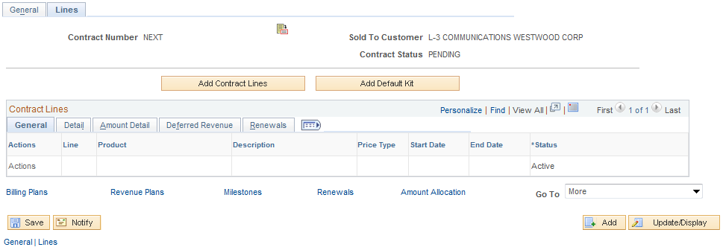

The Tab initially displays with no Contract Line or Product information. By selecting a Product onto the Contract Line, the Line will be created.

NOTE: At this point in the Contract Creation steps, the fields for the Contract Line are inactive. By selecting Product, these fields will become Active.

Click to initiate the Contract Line.

NOTE: Before creating a Contract Line, a working knowledge of the agency Product values that are available is necessary. Products have different properties that directly impact the billing and revenue cycle of the Contract and should be understood prior to creating Contract Lines.

NOTE: The Rate Based Product must be selected onto the Contract Line before the Prepaid amount can be established.

Add Contract Lines Page

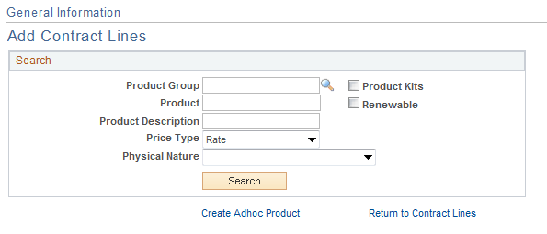

The Add Contract Lines page allows the user to search for pre-defined Products using the Search Products criteria.

Product Group – If the desired Product is part of a Product Group, search by this value.

Product – If the Product ID is known, use that value as search criteria.

Description – Search by Product Description.

Price Type – For Rate based Contract, the Price Type will be ‘Rate’.

Click to retrieve Products matching the search criteria provided.

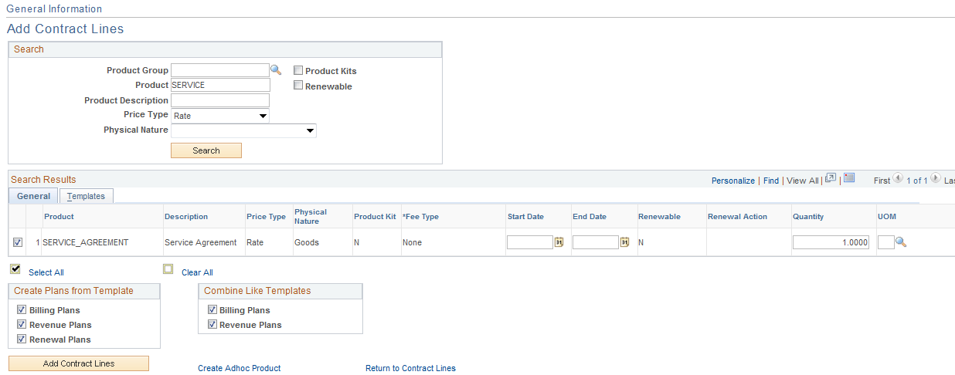

From the list of Products that match the search criteria, select the Product to copy onto the Contract Line.

Price Type – The Product Price Type defines what type of Contract billing and revenue will be created.

Unit of Measure – The default UOM from the Product definition.

Create Plans from Template – Select the check box to enable the system to create a Billing Plan, Revenue Plan or Renewal Plan when adding the contract line to the contract.

Combine Like Templates - Select to combine multiple Contract lines with the same Billing plan template into one Billing plan.

NOTE: These options are only active if Templates are defined on the Templates Tab.

Click the Tab.

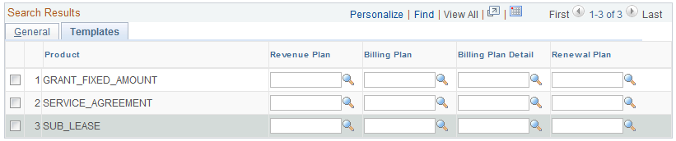

Define a Template for the Revenue Plan, Bill Plan, Bill Plan Detail or Renewal for this Contract Line.

NOTE: Templates are optional and can be defined for the Contract Line at this point or when the Bill and Revenue Plans are added to the Contract Line.

Use the Create Adhoc Product link to define a Product that can be used only for this Contract Line.

Click to add a Product to the Contract Line.

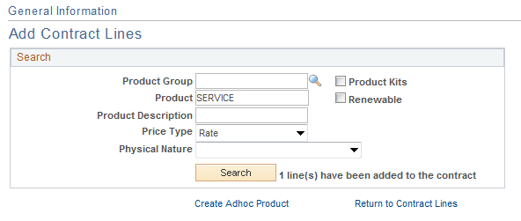

The Add Contract Lines page indicates that a Line has been added to the Contract.

Click the Return to Contract Lines link.

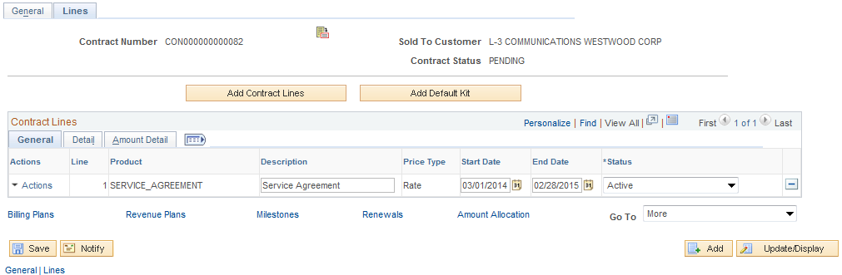

For a Rate Based Contract, optionally define the Start and End Dates for the agreement.

Start Date – Define the Contract start date.

End Date - Define the Contract start date.

Click to save the Contract and assign the Contract ID.

NOTE: The Line information defined relates to the Rate Based Product that will facilitate billing of Project Cost the same as with a Non-Prepaid Contract.

Click the Tab.

Click the Contract Terms link.

Related Projects Tab

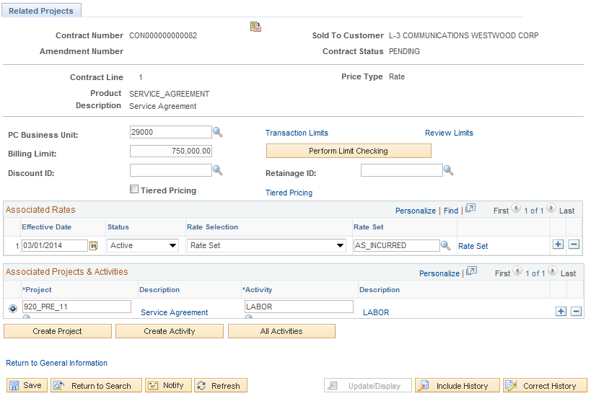

For a Rate Based Contract, use the Tab to associate the Contract (Contract Line) with a Project and Activity.

NOTE: A Project and Activity is required on each line for a Rate Based Product (rate based contract line).

PC Business Unit – select the agency Project Costing Business Unit. This value should be equal to the Contracts Business Unit.

Billing Limit – to set a ceiling on the amount that can be billed from this contract, define that amount in this field.

Use the Transaction Limits link to define billing limits by Project Costing chartfield combination.

NOTE: Transaction Identifiers must be configured for Transaction Limits to be used on the Contract Line. (See COR434 Projects – Project Definition manual).

Associate Rates – Use this section of the page to define the Rate Set or Rate Plan that will be used to Price Project Transactions (See COR435 Projects – Project Costs and Revenue Manual).

Project – Select a Project to associate with this Contract Line. Optionally use to create a new Project ID (See COR434 Projects – Project Definition Manual).

Activity – Select an Activity for the Project defined. Optionally use to create a new Project ID. (See COR434 Projects – Project Definition Manual).

NOTE: When creating a Project and Activity from the Contract Line, additional steps for Project Status, Project Team, Project Budgeting, etc. can be completed after the Contract is complete and activated.

Click to save the Contract.

NOTE: Cost collected in the Project and Activity defined on this page will be subject to Prepaid Utilization rules defined on the Prepaid Bill Plan for this Contract Line (created in subsequent steps in this section of the manual).

Click the Return to General Information link.

Click the Tab.

Click the Distribution link.

Accounting Distribution Page

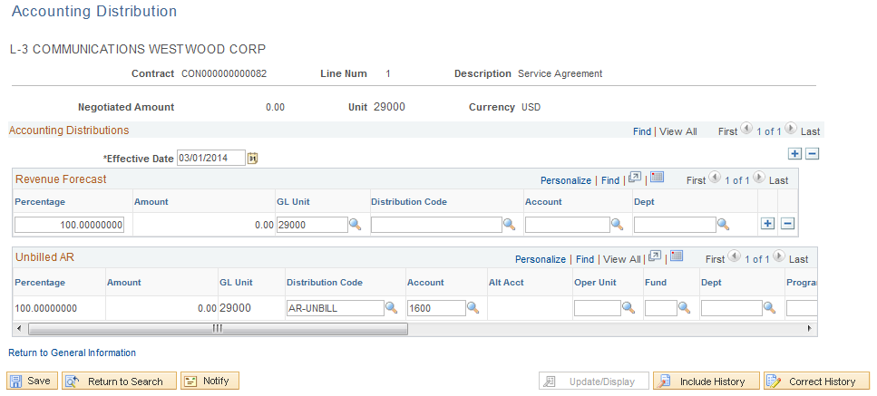

The Accounting Distribution page is used to establish Revenue Forecast (optional) and Unbilled Accounts Receivable accounting entries.

NOTE: This page, while required, does not control Accounting Entries for a Rate Based contract. Those entries are controlled by the Accounting Rules defined for the Project. (See COR435 Projects – Project Costs and Revenue Manual).

NOTE: When updating this page during the Contract creation process, the user may need to enter “Correction Mode” to update the value on the page. Use if necessary.

Effective Date – This is generally the contract begin date.

GL Unit – This value should be set to the agency business unit value.

Distribution Code – Select from pre-defined Distribution Codes for the Unbilled AR Line. Based on agency configuration, Distribution Codes can populate some or all of the chartfields on this page.

Chartfields – Populate the remaining chartfield values based on agency Unbilled AR accounting entry requirements.

NOTE: Combination Edit rules are in effect on this page. It will be necessary to understand the agency accounting requirements related to chartfield usage to populate this page.

Click to save the Contract Accounting Distribution.

When altering accounting distribution information, the user may receive this warning message. If no billing or revenue recognition has taken place for the Contract, no “reconciliation issues” will exist.

Click the Return to General Information link.

Click the drop-down list at the bottom of the page.

Select the Prepaid option.

Step 2: Establish Prepaid Amounts and Bill Plan

Prepaids Tab

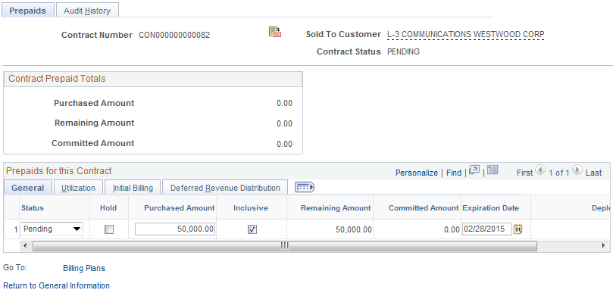

The Tab allows the user to define the amount that will be prepaid by the customer for the Contract. The rules for how to apply or ‘utilize’ the prepaid amount against billable Project Costs are also defined.

Status – When initially defining the Prepaid amounts and rules, this value will be ‘Pending’.

Hold – Select to place the prepaid amount on hold. If on hold, no utilization of the prepaid will be done against the prepaid amount.

Purchased Amount – Define the amount of the customer prepayment.

Expiration Date – Generally defined as the contract end date. This date does not restrict processing.

Remaining Amount – Displays the Purchase amount (prepaid) less any utilized amounts or bills that have been processed in the Billing module (invoice is Finalized). This amount represents what’s left to utilize from the original prepaid amount.

Committed Amount – Displays the amount that has been utilized against the Prepaid but has NOT yet been processed in the Billing module (invoice is not Finalized).

Click the Tab.

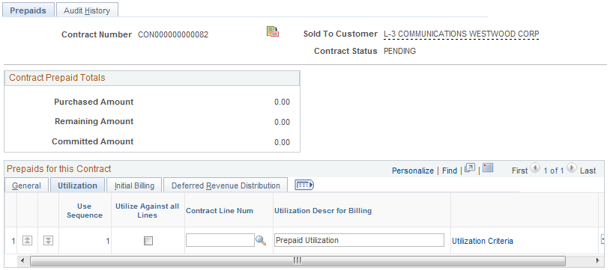

The Tab associates a prepaid amount with a Contract Line(s).

Use Sequence - If multiple prepaid amounts are associated with the same billable activity, the system uses this value to determine which prepaid amount is depleted first

Use for All Lines in Contract – Select is the prepaid amount defined should apply to all Contract Lines in the Contract.

Contract Line Number – Select the Contract Line number that the prepaid will be associated or applied to.

Select the Utilization Criteria link.

Utilization Criteria Tab

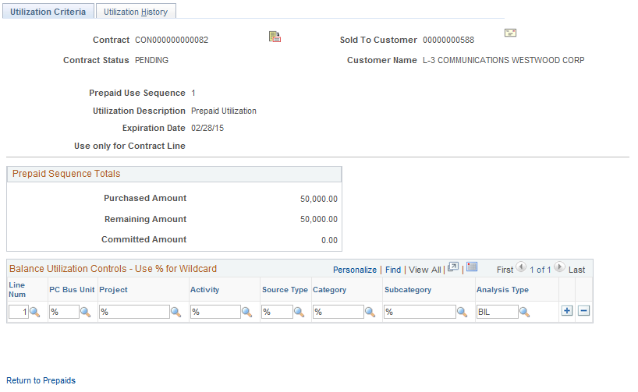

Use the Tab to define certain Projects, Activities or transactions that will be applied to the prepaid amount for Utilization.

Balance Utilization Controls – Use % for Wildcard - use the fields in this section of the page to select a specific set of Project transactions to which the prepaid amount can be applied.

Analysis Type – This field will remain as ‘BIL’ indicating that all Project transactions with that Analysis Type will be used for prepaid utilization. Only billable Project transactions are applied to prepaids for utilization.

NOTE: The wildcard symbol % indicates that Project transactions with any value in that field will be used for prepaid utilization.

NOTE: If the Utilization Criteria page is not populated, the prepaid amount will be matched against all billable Project costs for the Project and Activity defined on the Rate Based Contract Line.

Click the Return to Prepaids link.

Click the Tab.

Click Billing Plans link.

Assign Billing Plan Page

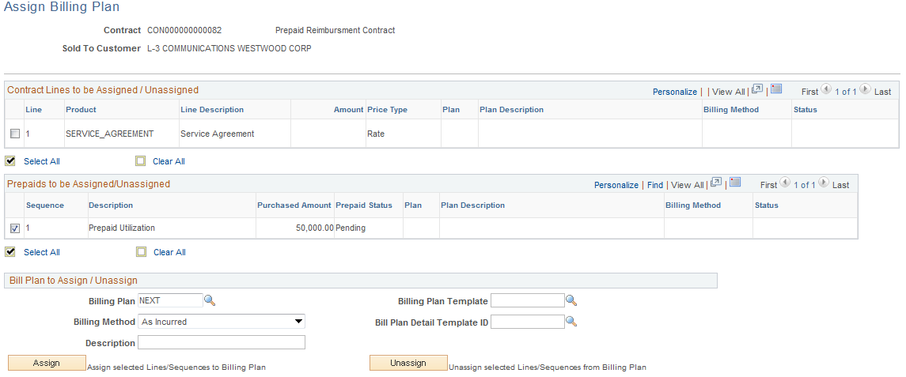

The Assign Billing Plan page allows the user to define a Bill Plan for each Prepaid Contract Line.

Select the checkbox next to the Prepaid Contract Line that will have a Bill Plan assigned to it.

Billing Plan – Leave this value as ‘NEXT’ to allow the system to create a Bill Plan ID.

Billing Method – For a Recurring Contract the Billing Method will be ‘Recurring’.

Description – Enter a description for the Bill Plan.

Billing Plan Template – Optionally, select a pre-defined Billing Template to default Activation status and Bill Plan Events into the Billing Plan.

Detail Template – Optionally, select a Billing Detail Template to default billing options and default values into the Billing Plan.

NOTE: Bill Plan Templates are optional when creating a Bill Plan.

Click to assign the Bill Plan to the Contract Line.

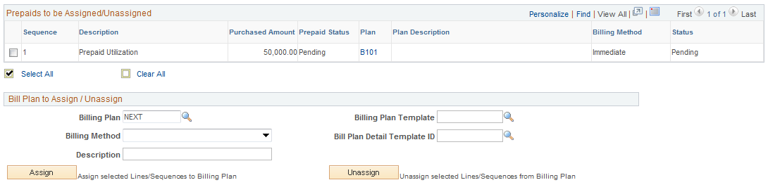

Once the Billing Plan is assigned to the Contract Line, the Bill Plan ID, Billing Method and Status is visible.

Click the Bill Plan ID link B101.

Billing Plan General Tab

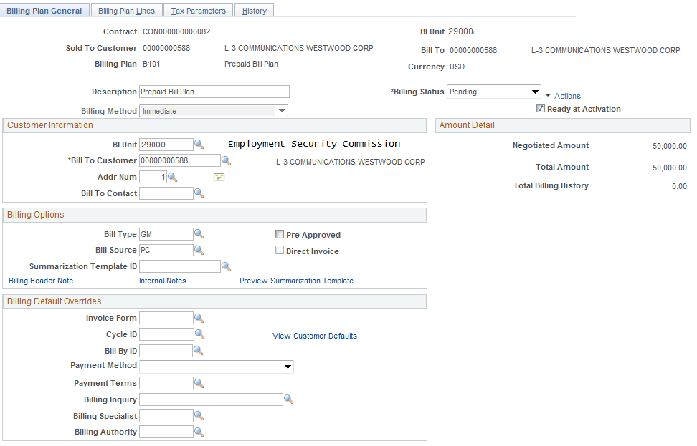

The Billing Plan General Tab allows the user to define Status, Billing Options and Bill Defaults for the prepaid bill plan.

NOTE: This step will create the Bill Plan for the prepaid amount ONLY. The Bill Plan for the Rate Based Contract Line will be defined in subsequent steps.

Description – This field displays the description defined for the Prepaid Billing Plan.

Billing Method – The billing method is generally ‘Immediate’ to send an initial prepaid invoice to the customer immediately.

Ready at Activation – This checkbox indicates whether the Bill Plan will be set to ‘Ready’ status when the Contract is Activated. The Bill Plan must be set to ‘Ready’ for bills to be created.

Customer Information – This section of the page displays the agency Billing Business Unit, Customer under contract, and Address. This is derived from the Contract header information.

Billing Type – Define the Bill Type for the invoices that will be created from this Bill Plan. Bill Type defines default values for the invoice and is required on the Bill Plan.

Bill Source - Define the Bill Source for the invoices that will be created from this Bill Plan. Bill Source defines default values for the invoice and is required on the Bill Plan.

Use the Billing Header Note link to define a note for the invoice header.

Billing Default Overrides – Use this section of the page to override Billing Default values derived from the Billing Default Hierarchy.

Negotiated Amount – This field does not display the prepaid amount for the prepaid billing plan. This amount is defined as the Purchase Amount in the prepaid pages.

Click to save the Bill Plan General Page for the Prepaid Bill Plan.

Click Return to Assign Billing Plan to return to Assign Billing Plan page.

Click Return to Prepaid Balances to return to Prepaids.

Prepaids Tab continued

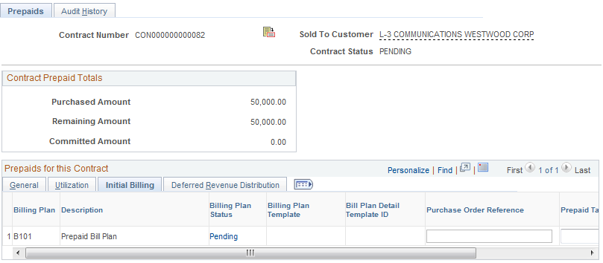

Once the Prepaid Bill Plan has been defined, use the Initial Billing Tab to access the Prepaid Bill Plan and add additional information.

Bill Plan – This is the Bill Plan ID that was created for the Prepaid amount.

Description – Use the Billing Plan Status link to access the Prepaid Bill Plan.

Billing Plan Status – Defined the current Bill Plan status for the prepaid. This value will be changed in subsequent steps.

Purchase Order Reference - If this prepaid amount is associated with a Customer purchase order, enter the purchase order reference information.

Prepaid Tax Timing – Set to ‘Tax on Utilization’.

NOTE Currently taxing of utilization bills is not applicable to state processing.

Click the Tab.

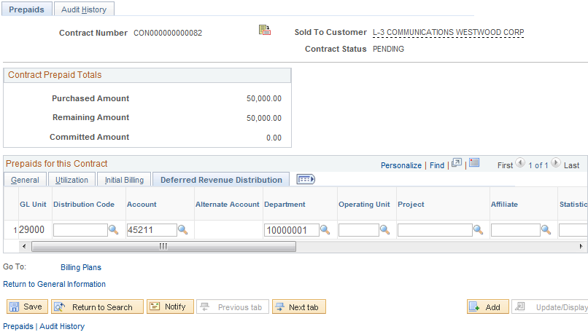

Use the Deferred Revenue Distribution Tab to define the deferred revenue accounting treatment for the prepaid accounting entry. Since the Rate Based Contract Line does not define deferred revenue for rate based billing, that configuration for the prepaid bill is done here.

Distribution Code – Select the Deferred Revenue Distribution code to populated the chartfields required.

Chartfields – Populate the remaining chartfield values based on agency Revenue accounting entry requirements.

NOTE The prepaid deferred revenue accounting entries are booked as specified on this page regardless of whether the Deferred Revenue checkbox is selected on the Rate Based Contract Line.

Audit History Tab

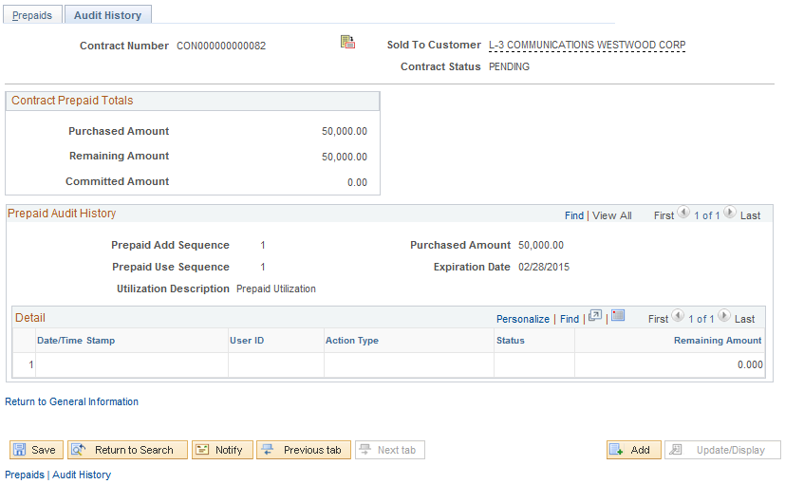

Use the Tab to review a history of all billing utilization activity.

NOTE: Utilization Bills (bills applied against prepaid amounts) must be Finalized in Billing to be seen on this page. Once the utilization bill is Finalized, Project Costing is updated and the results are visible on this page.

Click to save the Prepaid Amounts.

Click the Tab.

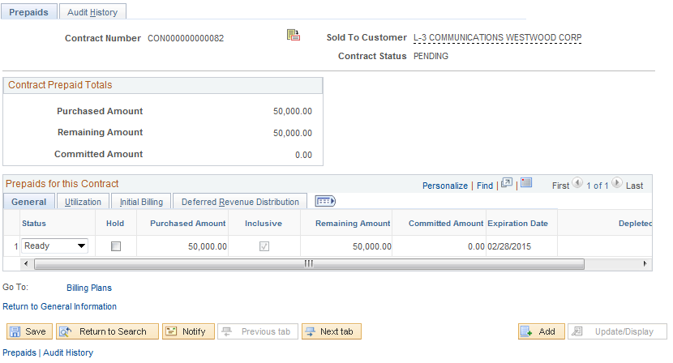

Change the Status of the prepaid to ‘Ready’.

NOTE The Prepaid status must be set to Ready for the utilization process to occur.

Return to Contract General Information:

Click on Return to General Information link.

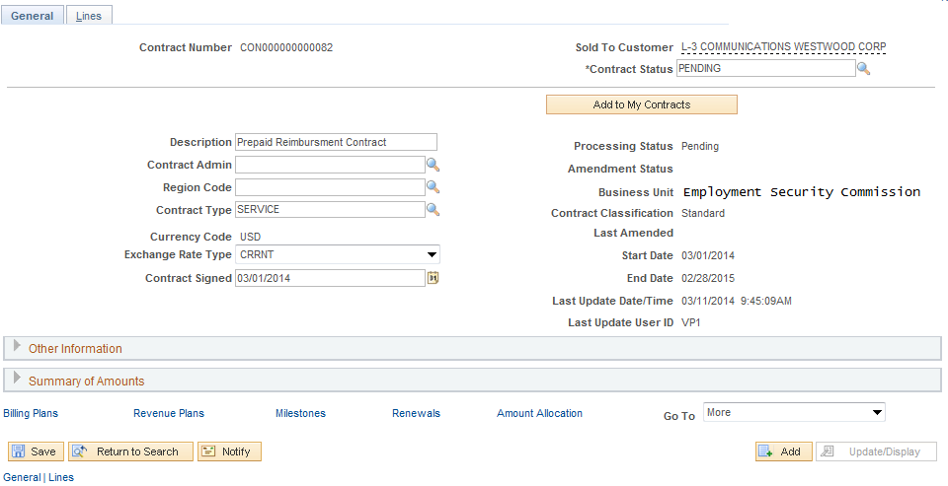

Click the Billing Plans link.

Step 3: Create Bill Plan for Rate Based Contract Line

Assign Billing Plan Page

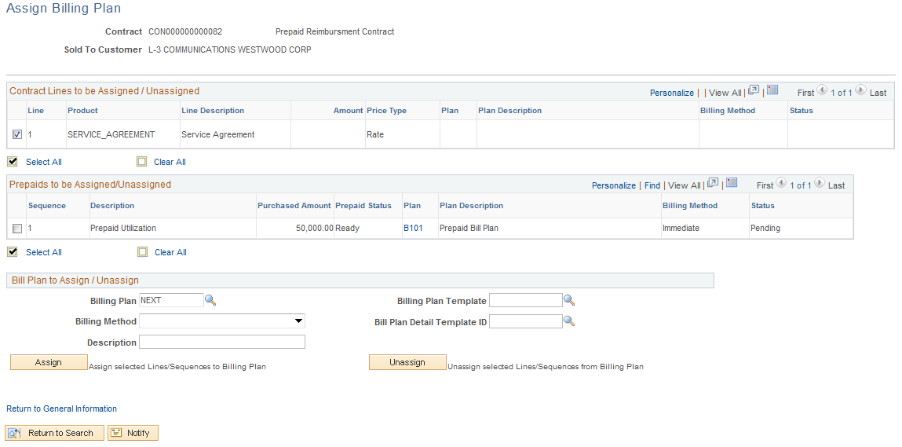

The Assign Billing Plan page allows the user to define a Bill Plan for each Contract Line.

NOTE The Bill Plan created in this step is the Bill Plan for the Rate Based Contract Line NOT the Bill Plan for the Prepaid amount. That Bill Plan is illustrated in previous steps.

Select the checkbox next to the Contract Line that will have a Bill Plan assigned to it.

Billing Plan – Leave this value as ‘NEXT’ to allow the system to create a Bill Plan ID.

Billing Method – For a Rate Based Contract the Billing Method will be ‘As Incurred’.

NOTE Rate Based Contract Lines use As Incurred Bill Method to create a bill plan that will create invoicing on an ad hoc basis when Project incurred costs are ready to be billed.

Description – Enter a description for the Bill Plan.

Billing Plan Template – Optionally, select a pre-defined Billing Template to default Activation status and Bill Plan Events into the Billing Plan.

Detail Template – Optionally, select a Billing Detail Template to default billing options and default values into the Billing Plan.

NOTE Bill Plan Templates are optional when creating a Bill Plan.

Click to assign the Bill Plan to the Contract Line.

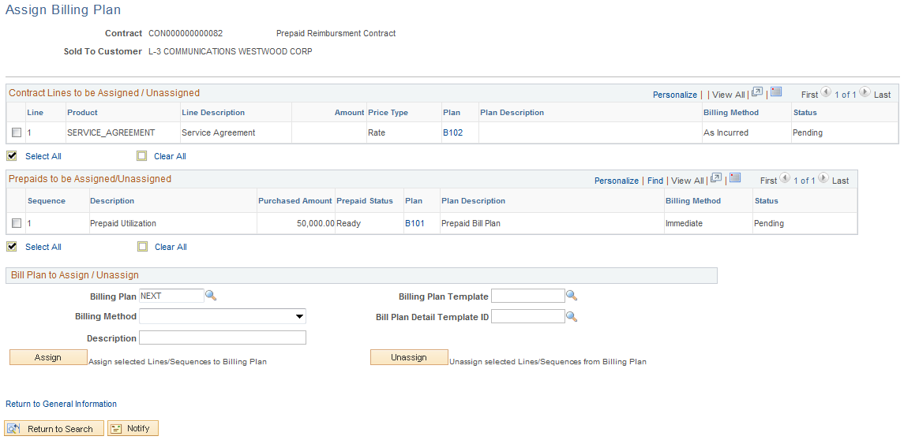

Once the Billing Plan is assigned to the Contract Line, the Bill Plan ID, Billing Method and Status is visible.

Click the Bill Plan ID link B102.

NOTE The Bill Plan ID is this case is set to B102. That value is used if the Prepaid Bill Plan is created before the Rate Based Contract Line Bill Plan.

Billing Plan General Tab

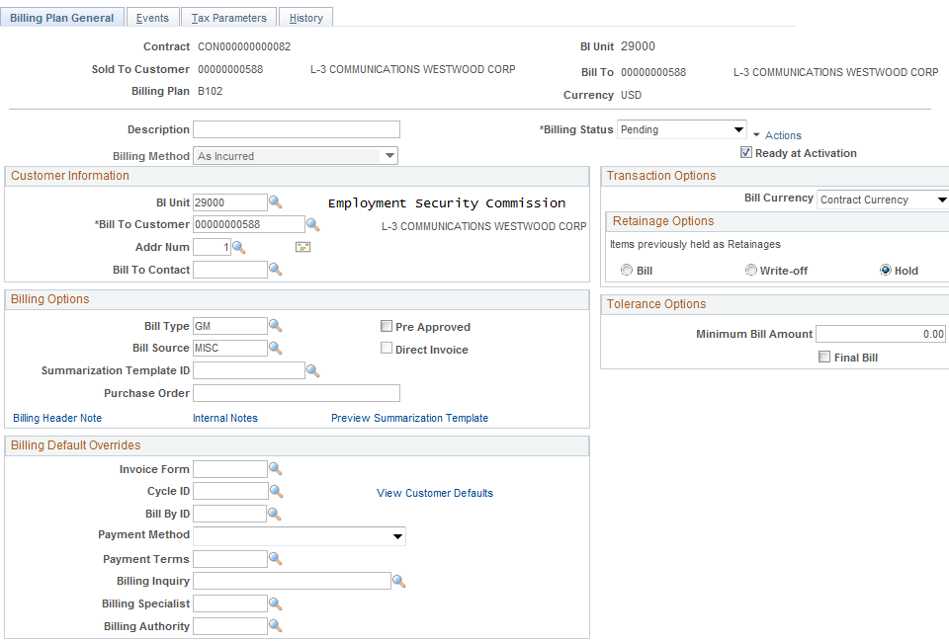

The Billing Plan General Tab allows the user to define Status, Billing Options and Bill Defaults.

Description – This field displays the description defined for the Billing Plan.

Billing Status – At this point the Bill Plan should be in ‘Pending’ status.

Ready at Activation – This checkbox indicates whether the Bill Plan will be set to ‘Ready’ status when the Contract is Activated. The Bill Plan must be set to ‘Ready’ for bills to be created.

Customer Information – This section of the page displays the agency Billing Business Unit, Customer under contract, and Address.

Billing Type – Define the Bill Type for the invoices that will be created from this Bill Plan. Bill Type defines default values for the invoice and is required on the Bill Plan.

Bill Source - Define the Bill Source for the invoices that will be created from this Bill Plan. Bill Source defines default values for the invoice and is required on the Bill Plan.

Purchase Order - If this Contract Line is associated with a Customer purchase order, enter the purchase order reference information.

Billing Default Overrides – Use this section of the page to override Billing Default values derived from the Billing Default Hierarchy.

Click to save the Bill Plan General Page.

Click Return to Assign Billing Plan link.

Click the Return to General Information link.

Click the Revenue Plans link.

Step 4: Create Revenue Plan for Rate Based Contract Line

Assign Revenue Plan Page

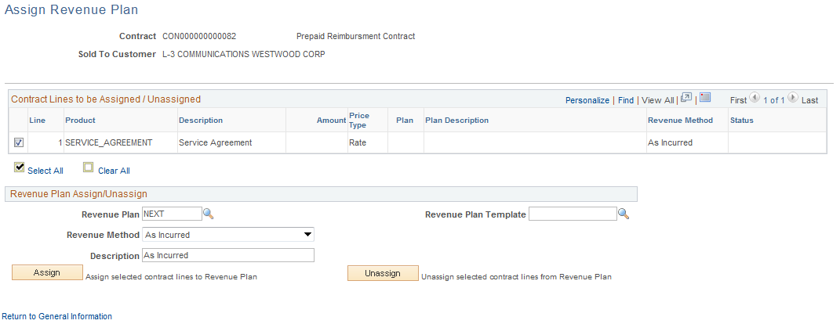

The Assign Revenue Plan page allows the user to define a Revenue Plan for each Contract Line.

Select the checkbox next to the Contract Line that will have a Revenue Plan assigned to it.

Revenue Plan – Leave this value as ‘NEXT’ to allow the system to create a Revenue Plan ID.

Revenue Method – For an Amount Based Contract the Billing Method will be ‘As Incurred’

NOTE Rate Based Contract Lines use As Incurred Revenue Method to create a revenue plan that will create accounting entries on an ad hoc basis when revenue needs to be recognized.

Description – Enter a description for the Revenue Plan.

Revenue Plan Template – Optionally, select a pre-defined Revenue Template to default Activation status and Revenue Plan Events into the Revenue Plan.

Click to assign the Revenue Plan to the Contract Line.

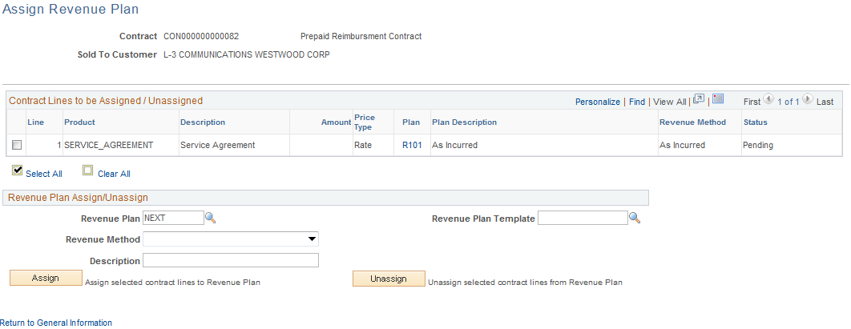

Once the Revenue Plan is assigned to the Contract Line, the Revenue Plan ID, Revenue Method and Status is visible.

Click the Revenue Plan ID link R101.

NOTE Rate Based Contract Lines use Project Costing Accounting Rules to create Revenue accounting entries. These rules are established as part of the Project Costing configuration.

Revenue Plan Tab

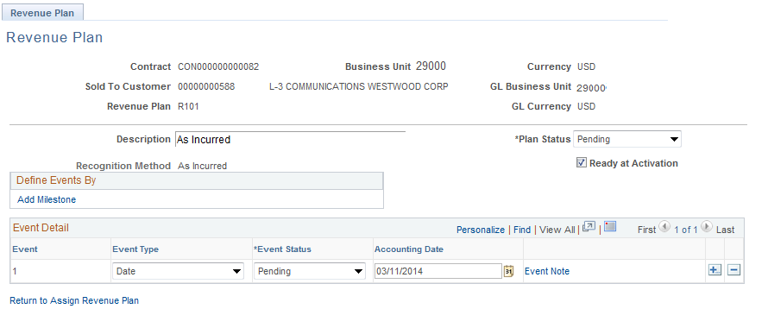

Since this is an As Incurred revenue plan, no Revenue Events are defined for revenue recognition. Revenue will be recognized on an ad hoc basis when batch processes are executed using the Project Costing Accounting Rules.

Click to save the Revenue Plan Page.

Click Return to Assign Revenue Plan link.

Click the Return to General Information link.

Click the Amount Allocation link.

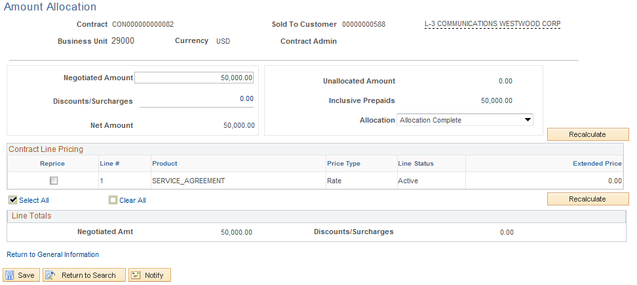

The Amount Allocation for a Prepaid Contract is used to allocate the prepaid amount to the Contract.

Negotiated Amount – Populate with the Prepaid Amount for the Contract.

Click to allocate the Negotiated Amount of the prepaid to the Contract.

Allocation – The Allocation flag should be set to ‘Complete’.

Unallocated Amount – When the prepaid is fully allocated to the Contract, this field should display 0.00.

Click to save the Contract Allocation.

Click the Return to General Information link.

Click the General Tab.

Step 5: Activate the Contract

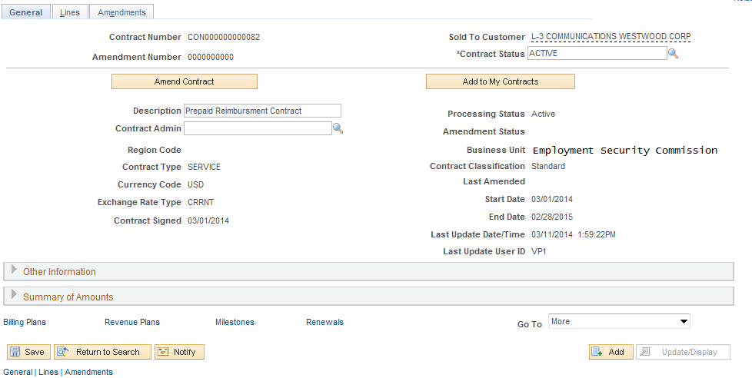

Use the General Tab to Activate the Contract.

Contract Status – Set the Contract Status to ‘Active’.

Click to save the Contract in Active Status.

NOTE The Bill and Revenue plans will also be set to ‘Ready.’ If configured to ready at Contract activation.

NOTE The Bill Plan for the Prepaid amount should already be set to ‘Ready’. If not, navigate to the Prepaid pages to Ready that Bill Plan.

NOTE Once activated, the Contract is ready for Billing and Revenue Recognition.

