COR439 Contracts – Contract Processing & Administration Manual

The content of this training manual is based largely on a generic system configuration and illustrates the base-line functionality required to execute transactions in the module. Your agency may be utilizing more or less of the functionality illustrated in this manual. This manual is intended to be a framework upon which agencies can add agency-specific training content that speaks specifically to the system functionality that they have deployed and related configuration that they use for transaction processing. Agencies should not depend on these manuals for end-user training or problem resolution until they have been reviewed by the agency for appropriateness.

Authorized by: [_CORE_] Original Issue: [04/30/2010]
Maintained by: [____Contract Lead___] Current Version: [04/30/2010]
Review Date: [12/30/2010]

Table of Contents

Document History 5
Contract Processing 6
Key Terms 7
Contracts Business Unit 7
Customer 7
Contract Bill Plan 7
Contract Revenue Plan 7
Billing Event 7
Revenue Recognition Method 7
Product 7
Price Type 8
Project Costing Business Unit 8
Project ID 8
Activity ID 8
Prepaid 8
Process Flows 9
Guidelines, Concepts and Alternatives 10
Contract Billing 11
Amount Based Contract Billing 11
Process Other Billing Methods Page 12
Rate Based Contract Billing 14
Process As Incurred Billing Page 15
Recurring Contract Billing 18
Process Recurring Billing Page 19
Contract Revenue 21
Fixed Fee Revenue 21
Process Fixed Fee Revenue Page 22
As Incurred Revenue 24
Process Project Accounting Page 25
Deferred Revenue 27
Process Deferred Revenue Page 28
Contract Amendments 30
Step 1: Contract Amendment 30
General Tab 32
Amendments Tab 33
Amendment Details Page 34
Step 2: Process Contract Amendment 35
Process Amendments Page 36
Contract Renewals 37
Step 1: Create a Contract with Renewable Product 37
General Tab 39
Add Contract Lines Page 40
Step 2: Create a Renewal Plan 43
Define Renewal Plan Page 44
Step 3: Create a Renewal Cycle 45
Define Renewal Cycle Page 45
Step 4: Assign Contracts to Renewals 46
Assign Cycles Page 46
Step 5: Process Renewals in Batch 48
Process Renewals Page 49
Step 5: Process Renewals Ad Hoc 51
Review Renewals Page 51
Step 6: Verify the Contract Renewal 52
Adjust Revenue and Billing 53
Adjust Fixed Fee Revenue 53
Revenue Redistribution Page 54
New Chartfield Assignment Page 55

Document History

Document Revision | Date | Description
1.0 | 04/30/2010 | Initial Document

Contract Processing

Once Contract setup and configuration is complete and Contracts have been defined and activated a series of batch processes are used to Bill Customers, Recognize Revenue, Amend Contracts and Renew Contracts.

Some of the batch processes required to process Contracts data are scheduled to run at pre-defined intervals while others are available to run on an ad hoc basis.

Key Terms

Contracts Business Unit
Each agency has one, and only one Contracts Business Unit. The Business Unit is the three (3) digit
agency code, plus 00. For example, Office of State Finance is 09000.

Customer
A customer is an external entity that is defined in a Contract. to receive invoices and from which revenue is recognized.

Contract Bill Plan
The Bill Plan defines the schedule, parameters and configuration of the Customer invoice. A Contract manages the billing process through the creation of Billing plans. Billing plans are Contract specific. The Billing plan stores the schedule of billing events and the corresponding bill lines for these events. Each contract line product is tied to a billing plan.

Contract Revenue Plan
The Contract Revenue Plan defines how and when customer revenue will be recognized for accounting purposes. Define a revenue plan for Contract lines in which revenue is managed by Contracts. For each revenue plan that is defined, select a Revenue Recognition method for the Revenue Plan and define the Events that trigger revenue recognition. Revenue Plans are not defined for contract lines with a revenue method of Billing Manages Revenue

Billing Event
A Billing Event is a “trigger” that initiates contract billing. The Event could be a date, milestone, etc. Bill Plans define Billing Events that are used to generate billing that is interfaced into the Billing Module.

Revenue Recognition Method
Revenue recognition methods define the criteria that must be met before revenue can be recognized. Specify revenue recognition methods for products on the Product Definition component. The associated revenue recognition method appears when you select a product onto the contract line.

Product
A Product is the core contractual obligation of products or services that an agency provides to the public. These could be fees, licenses or even grant related products. A Product represents the basis for the Contract Line and determines what type of Contract will be created. Products are associated with a set of attributes that include pricing structure, tax parameters, and accounting information. Once defined Products are use in the Contract creation process.

Price Type
Contract Products are classified as Rate-Based, Amount-Based, or Recurring. Rate-based products have a price type of Rate, Amount-Based products have a price type of Amount or Percent, and recurring products have a price type of Recurring. The price type that you select for a product determines the details that you define for that product and the billing and revenue recognition methods with which you can associate the product

Project Costing Business Unit
Each agency has one, and only one Project Costing Business Unit. The Business Unit is the 3 digit
agency code, plus 00. For example, Office of State Finance is 09000.

Project ID
The Project ID represents the basic unit that serves to establish budgets and collect costs and revenue for analysis purposes. Projects serve to collect construction costs and capitalize Assets in conjunction with the Asset Management module. Project ID is also a Chartfield and as such a part of the distribution line. In Contracts, Project ID is the basic unit that makes up a Rate Based contract used to collect expended costs and bill customers for those costs.

Activity ID
An Activity ID generally represents a task that makes up a Project. Project Costs and Budgets are stored in Activities. In Contracts, Activity ID is used to collect costs that are priced and billed to customers for reimbursement.

Prepaid
An amount paid in advance by a Customer in a Rate Based Contract agreement. The prepaid amounts are applied or deducted from otherwise billable costs collected in a Project until all prepaid amounts are fully “utilized”.

Process Flows

Diagram 1: Customer Contracts Module Integration

Guidelines, Concepts and Alternatives

Price Type | Description | Billing Method | Revenue Recognition Method
Amount or Percent | Used for contracts with a fixed price. Or, Used for contracts that are priced as a percent of one or more contract lines. | Milestone, Percent Complete, Immediate | Milestone, Percent Complete, Apportionment, Billing Manages Revenue
Rate | Used for contracts, such as services, with a rate-based pricing structure, such as $400 per hour worked. The actual monetary amount is not known until the hours have been worked and reported | As-incurred, Value-based | As-incurred
Recurring | Used for contracts that have a recurring pricing structure where a start date and schedule are defined | Recurring | Billing Manages Revenue

Table 1: Product Price Types with Billing and Revenue Methods

Contract Billing

When Contract Bill Plans are created, set to Ready status and the Contract to which the Bill Plan is linked is Activated, Customer bills can be released to the Billing Module.

There are different batch processes that release Contract billing for Amount Based Contracts, Rate Based Contracts and Recurring Contracts. While each type of Contract uses a different page from which the process will be executed, each Contract executes the Contracts to Billing Interface (CA_BI_INTFC)

Amount Based Contract Billing

Navigation: Customer Contracts > Schedule and Process Billing > Process Other Billing Methods > Find an Existing Value

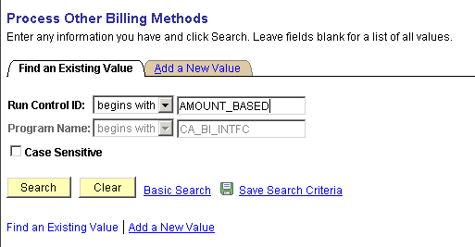

Select an existing Run Control ID or add a new value.

Click to use an existing Run Control value.

Process Other Billing Methods Page

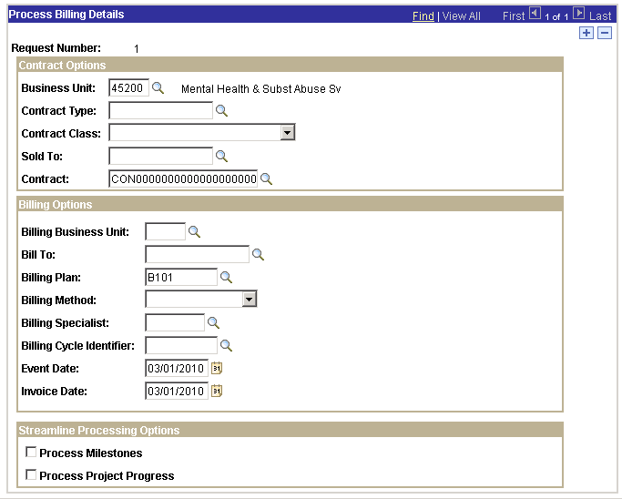

Use the Process Other Billing Methods page to define parameters for Contract Billing.

Process Frequency – set to ‘Always’

Use the Contract Options section of the page to select particular Contracts from which billing will be released:

- Business Unit – select the agency business unit in which the Contract information resides.
- Contract Type – populate to select all Contracts with a particular Contract Type.
- Sold To – to release billing for all Contracts to a particular Customer, populate this value.
- Contracts ID – to release billing for a particular Contract ID, populate the Contract ID.

Use the Billing Options section of the page to further define the Contract Options defined.

- Billing Business Unit – populate to define a particular Billing business unit.
- Billing Plan – to bill for only a particular Bill Plan, populate the Bill Plan ID from Contract defined in the previous section.
- Billing Method – release bills for a particular Bill Method.
- Event Date – for Amount Based Contracts with Milestone Event Dates, this value determines which bills from the Bill Plan will be released.

NOTE: For Amount Based Contracts with Event Dates, the Event Date field is critical in determining which bill from the Bill Plan is released. This date MUST be equal to or greater than the Event Date on the Bill Plan for the bill to be released to the Billing Module.

Invoice Date – define the Invoice Date for the released bill.

NOTE: Use to insert additional rows as necessary to select additional Contracts.

Click to execute the Contracts to Billing Interface.

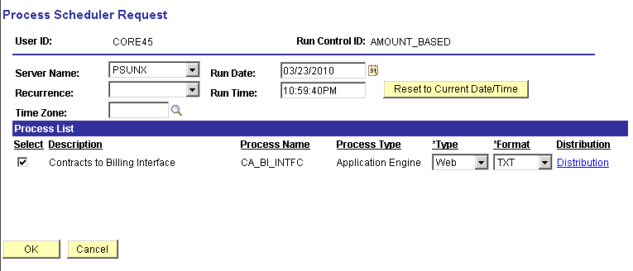

Select the checkbox next to the desired process.

Click to execute the process. Navigate to the Process Monitor to view the Process status.

NOTE: The bill(s) released from the Contracts to Billing Interface process will be inserted into the Billing Interface Tables in the Billing Module.

Rate Based Contract Billing

Navigation: Customer Contracts > Schedule and Process Billing > Process As Incurred Billing > Find an Existing Value

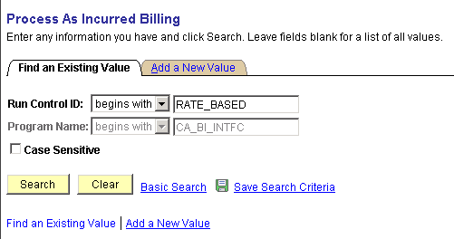

Select an existing Run Control ID or add a new value.

Click to use an existing Run Control value.

Process As Incurred Billing Page

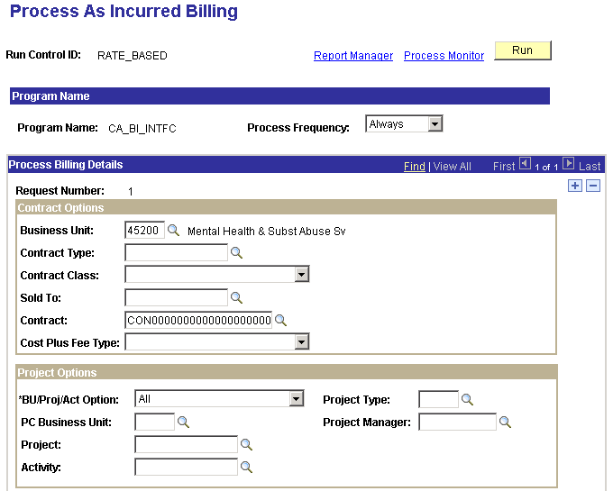

Use the Process As Incurred Billing page to define parameters for Contract Billing.

Process Frequency – set to ‘Always’.

Use the Contract Options section of the page to select particular Contracts from which billing will be released:

- Business Unit – select the agency business unit in which the Contract information resides.
- Contract Type – populate to select all Contracts with a particular Contract Type.
- Sold To – to release billing for all Contracts to a particular Customer, populate this value.
- Contracts ID – to release billing for a particular Contract ID, populate the Contract ID.

Use the Projects Option section of the page to define which Projects or Activities BU/Proj/Act Option – define a Project Business Unit, Project or Activity that will be used as selection criteria for billing.

- PC Business Unit – populate to release billing for an agency Projects business unit.
- Project - populate to release billing for a particular Project ID.
- Activity - populate to release billing for an Activity.
- Project Type - populate to release billing for all Projects with a particular Project Type.

NOTE: The Projects section of the page can be useful to bill only a particular Project or Activity or a Rate Based Contract Line.

Use the Billing Options section of the page to further define the Contract Options defined.

- Billing Business Unit – populate to define a particular Billing business unit.
- Billing Plan – to bill for only a particular Bill Plan, populate the Bill Plan ID from Contract defined in the previous section.
- Letter of Credit ID – for Grant billing, the Letter of Credit can be used for a selection criteria.
- Invoice Date – define the Invoice Date for the released bill.

NOTE: For Rate Based (As Incurred) billing, the Project transactions that have been Priced into Billing rows will be selected and released to the Billing module.

NOTE: Use to insert additional rows as necessary to select additional Contracts.

Click to execute the Contracts to Billing Interface.

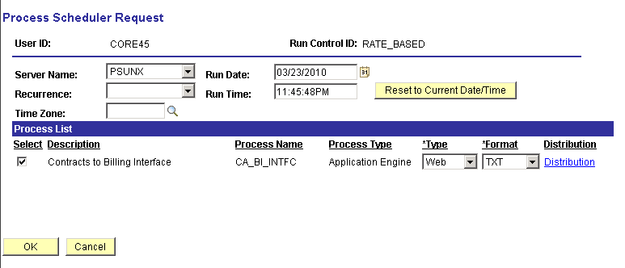

Select the checkbox next to the desired process.

Click to execute the process. Navigate to the Process Monitor link to view the Process status.

NOTE: The bill(s) released from the Contracts tot Billing Interface process will be inserted into the Billing Interface Tables in the Billing Module.

Recurring Contract Billing

Navigation: Customer Contracts > Schedule and Process Billing > Process Recurring Billing > Find an Existing Value

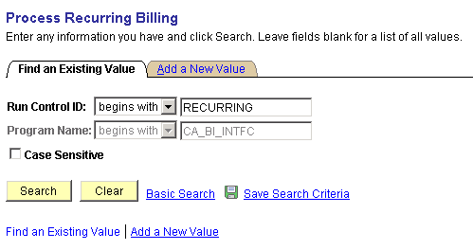

Select an existing Run Control ID or add a new value.

Click to use an existing Run Control value.

Process Recurring Billing Page

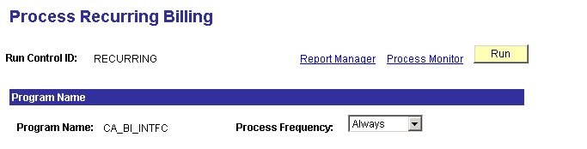
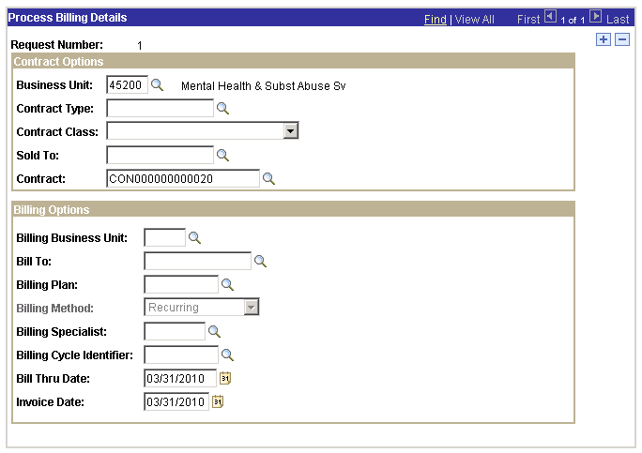

Use the Process Recurring Billing page to define parameters for Contract Billing.

Process Frequency – set to ‘Always’.

Use the Contract Options section of the page to select particular Contracts from which billing will be released:

- Business Unit – select the agency business unit in which the Contract information resides.
- Contract Type – populate to select all Contracts with a particular Contract Type.
- Sold To – to release billing for all Contracts to a particular Customer, populate this value.
- Contracts ID – to release billing for a particular Contract ID, populate the Contract ID.

Use the Billing Options section of the page to further define the Contract Options defined.

- Billing Business Unit – populate to define a particular Billing business unit.
- Billing Plan – to bill for only a particular Bill Plan, populate the Bill Plan ID from Contract defined in the previous section.
- Bill Thru Date – release recurring bills thru a particular date.

NOTE: For Recurring Contract Bill Plans this date is critical in releasing the proper bills from the Bill Plan.

Invoice Date – define the Invoice Date for the released bill.

NOTE: Use to insert additional rows as necessary to select additional Contracts.

Click to execute the Contracts to Billing Interface.

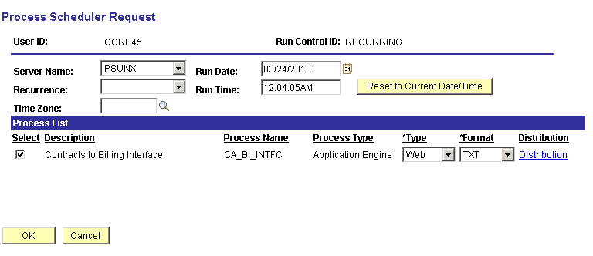

Select the checkbox next to the desired process.

Click to execute the process. Navigate to the Process Monitor link to view the Process status.

NOTE: The bill(s) released from the Contract to Billing Interface process will be inserted into the Billing Interface Tables in the Billing Module.

Contract Revenue

Accounting Entries are created in the Contracts module for interface to the General Ledger through Journal Generation. Accounting Entries can be for Revenue, Deferred Revenue or Unbilled Accounts Receivable based on the type of Contract and revenue distribution that is defined.

Revenue Accounting Entries are create by batch process with each type of Contract (Product and Contract Line) having a separate page from which the process is executed.

Fixed Fee Revenue

Navigation: Customer Contracts > Schedule and Process Revenue > Process Fixed Fee Revenue > Find an Existing Value

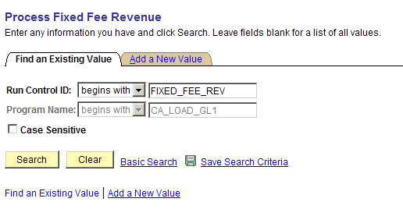

Find and Existing Run Control ID or Add a New Value

Click to use an existing Run Control ID.

Process Fixed Fee Revenue Page

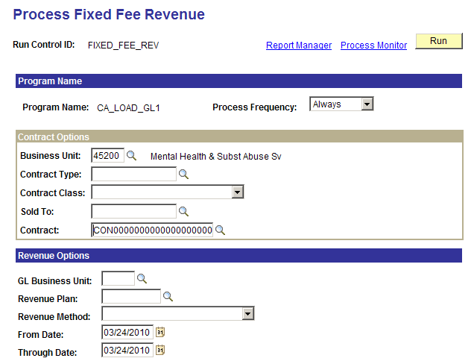
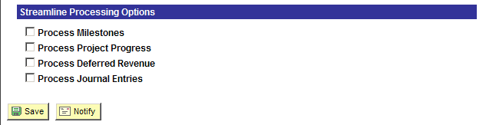

Use the Process Fixed Fee Revenue page to select the Contract(s) for which Revenue Accounting Entries will be created.

Use the Contract Options section of the page to define the Contract(s) that will be selected for revenue accounting entry creation.

- Business Unit – select the agency business unit in which the Contract information resides.
- Contract Type – populate to select all Contracts with a particular Contract Type.
- Sold To – to release billing for all Contracts to a particular Customer, populate this value.
- Contract ID – to release billing for a particular Contract ID, populate the Contract ID

Use the Revenue Options section of the page to further define which revenue accounting entries will be created.

- General Ledger Business Unit – select to create accounting entries for a single GL Business Unit.
- Revenue Plan – populate to create accounting entries for a particular Revenue Plan.
- Revenue Method – select to create accounting entries by Revenue Method.

NOTE: Only Fixed Fee Revenue Methods will be available on this page.

From/Through Date – for Revenue Plans using Event Dates, populate the From and Through dates that will select the desired Revenue Event.

Use the Streamline Processing Options section of the page to initiate other batch processes with the Revenue Accounting Entry process is executed.

Click to execute the Contracts Revenue process.

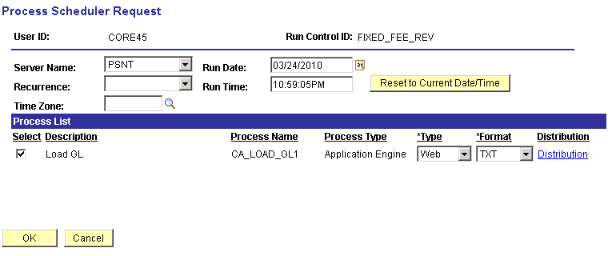

Select the checkbox next to the desired process.

Click to execute the process. Navigate to the Process Monitor to view the Process status.

NOTE: The Accounting Entries created from the Load GL process will be inserted into the CA_ACCTG_LINE table.

As Incurred Revenue

Navigation: Customer Contracts > Schedule and Process Revenue > Process As Incurred Revenue > Find an Existing Value

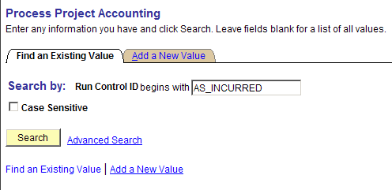

Find and Existing Run Control ID or Add a New Value.

Click to use an existing Run Control ID.

Process Project Accounting Page

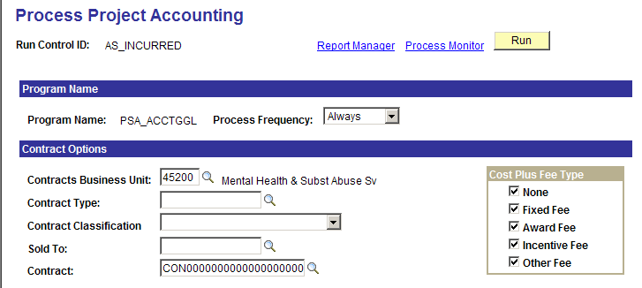
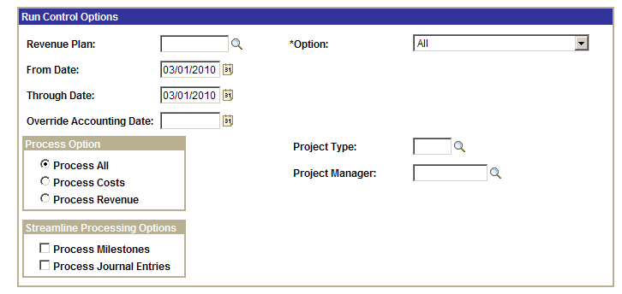

Use the Process Project Accounting page to select the Contract(s) for which Revenue Accounting Entries will be created.

Use the Contract Options section of the page to define the Contract(s) that will be selected for revenue accounting entry creation.

- Contracts Business Unit – select the agency business unit in which the Contract information resides.
- Contract Type – populate to select all Contracts with a particular Contract Type.
- Sold To – to release billing for all Contracts to a particular Customer, populate this value.
- Contract ID – to release billing for a particular Contract ID, populate the Contract ID

Use the Run Control Options section of the page to further define which revenue accounting entries will be created.

- Revenue Plan – populate to create accounting entries for a particular Revenue Plan.
- Override Accounting Date – populate to create a new Accounting Date for accounting entries.

Use the Option drop-down to define which Projects or Activities

- All – select to run accounting entries for all business units.
- Business Unit – populate to release billing for an agency Projects business unit.
- Project - populate to release billing for a particular Project ID.
- Activity - populate to release billing for an Activity.
- Project Type - populate to release billing for all Projects with a particular Project Type.

Use the Streamline Processing Options section of the page to initiate other batch processes with the Revenue Accounting Entry process is executed.

Click to execute the Contracts Revenue process.

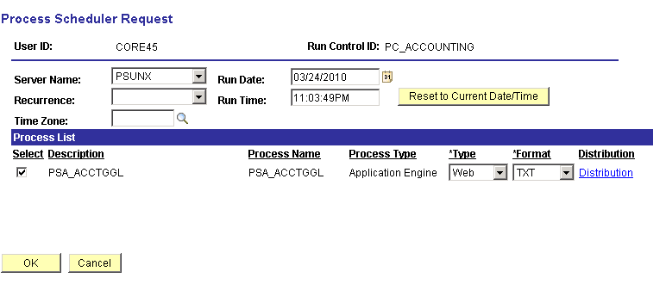

Select the checkbox next to the desired process.

Click to execute the process. Navigate to the Process Monitor link to view the Process status.

NOTE: The Accounting Entries created from the PSA_ACCTGGL process will be inserted into the CA_ACCTG_LN_PC table.

Deferred Revenue

Navigation: Customer Contracts > Schedule and Process Revenue > Process Deferred Revenue > Find an Existing Value

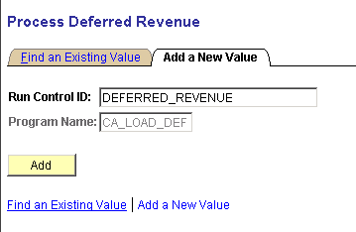

Find and Existing Run Control ID or Add a New Value.

Click to use an existing Run Control ID.

Process Deferred Revenue Page

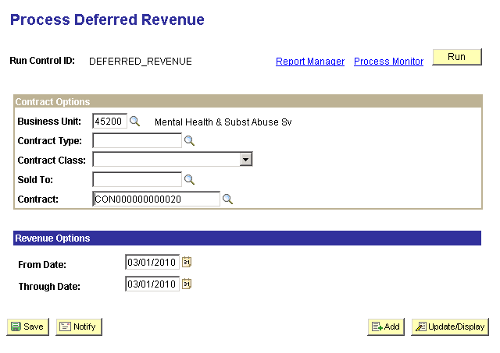

Use the Contract Options section of the page to define the Contract(s) that will be selected for revenue accounting entry creation.

- Contracts Business Unit – select the agency business unit in which the Contract information resides.
- Contract Type – populate to select all Contracts with a particular Contract Type.
- Sold To – to release billing for all Contracts to a particular Customer, populate this value.
- Contracts ID – to release billing for a particular Contract ID, populate the Contract ID.

From/Though Date – the time frame defined in these fields is matched against the Accounting Date of the deferred revenue defined on the Contract

NOTE: Any active, un-booked, deferred revenue with an Accounting Date within this range will be picked up by the process.

Click to execute the Contracts Revenue process.

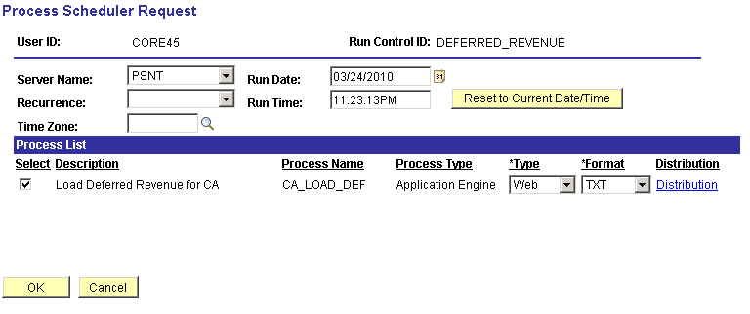

Select the checkbox next to the desired process.

Click to execute the process. Navigate to the Process Monitor link to view the Process status.

NOTE: The Accounting Entries created from the CA_LOAD_DEF process will be inserted into the CA_ACCTG_LINE table.

Contract Amendments

A Contract Amendment is required to make changes to an Active Contract that impact the core data elements of the Contract. Contract Amendments are initiated from the Contract component that is used to initially create and save the Contract.

When the Amend Contract button is selected on a Contract, the user is transferred to the Amendments page. If a pending amendment exists, the changes are added to it. If there is no existing pending amendment, the system creates a new amendment. On the Amendments page define the high-level details of the amendment, including the amendment type and amendment reason.

Amendments can be done to change Contract Amounts for an Amount Based Contract, Project and Activity values for a Rate Based Contract, change Contract Line amounts and properties, cancel a Contract Line, etc.

Amendments are assigned an amendment number that is visible from the Contract pages. To complete the Amendment, set the status to ‘Ready’ and process the Amendment through the Contract Component or a batch process.

Step 1: Contract Amendment

Navigation: Customer Contracts > Create and Amend > General Information > Find an Existing Value

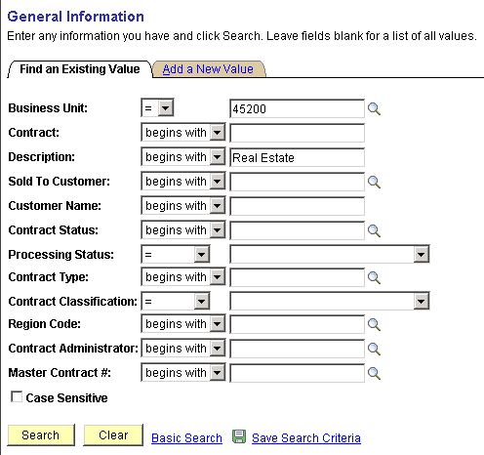

Use the Search Criteria to find the Contract to Amend.

Business Unit – populate with the agency business unit number.

Contract – search by Contract ID.

Description – search by the Contract description.

Processing Status – search by Contract Status of Active, Pending or Closed.

Click to use enter the Contract component.

General Tab

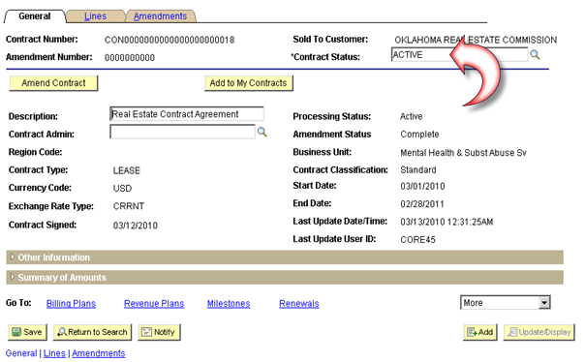

With the Contract in ‘Active’ status the General page displays the button.

Click to initiate the Contract Amendment.

Amendments Tab

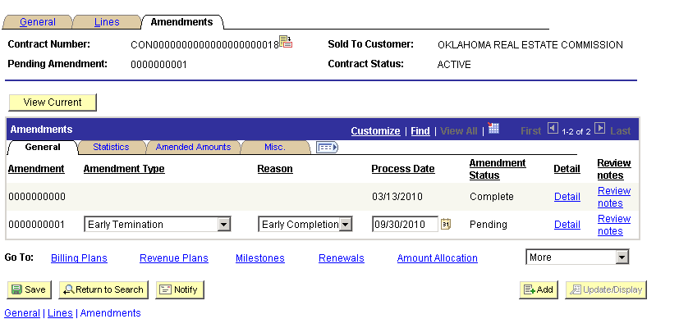

The Amendments Tab allows the user to categorize the Amendment by Amendment Type and Reason.

Amendment – the system assigned amendment number.

Amendment Type – select a high-level classification for the amendment for historical purposes.

Amendment Reason – choose a pre-defined reason for the amendment.

NOTE: Generally the Amendment Type and Reason are a parent-child relationship. This allows the amendment to have a high-level and a low-level classification.

Process Date – define the date that the amendment is to be processed or active.

NOTE: By defining the Process Date, the user has the ability to create an Amendment and post-date when it will impact the Contract.

Amendment Status – the status should be ‘Pending’ when initiating the amendment.

Click to save the Amendment.

Make necessary change to the Contract and Contract Lines and click the Amendments Tab again.

Click the Detail link button to complete the Amendment.

Amendment Details Page

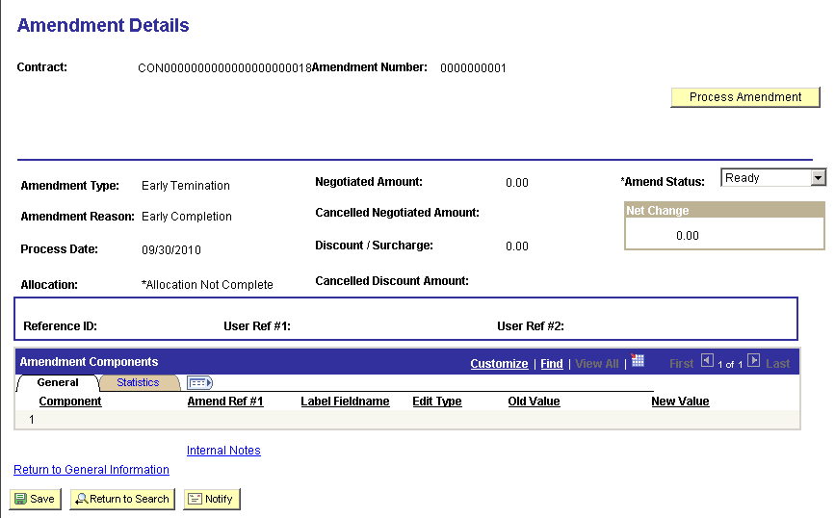

When the Contract and Contract Line amendment (changes) have been made, return to the Amendment Details page to complete the Amendment.

Amendment Status – set the status to ‘Ready’.

To process a single Contract amendment click to initiate the Amendment Processing batch process.

Step 2: Process Contract Amendment

Navigation: Customer Contracts > Create and Amend > Process Amendments > Find an Existing Value

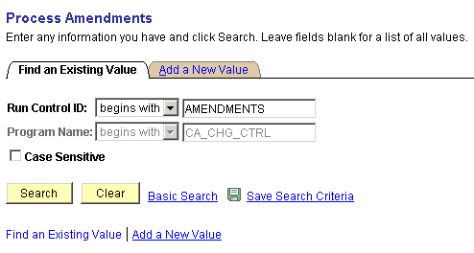

Find and Existing Run Control ID or Add a New Value.

Click to use an existing Run Control ID.

Process Amendments Page

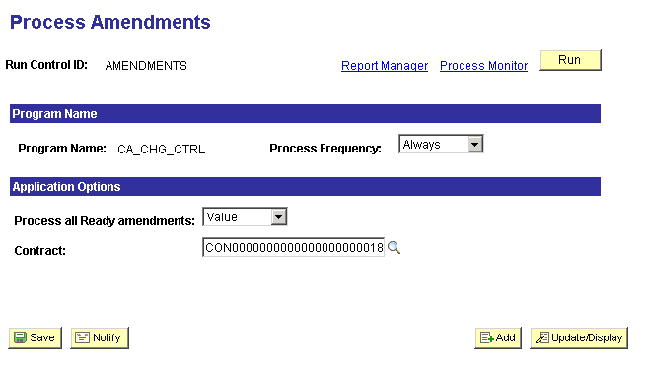

Process all Ready Amendments – select ‘All’ to process all active amendments or a specific ‘Value’.

Contract – select a particular Contract ID that has been amended.

Click to execute the Contracts Amendments process.

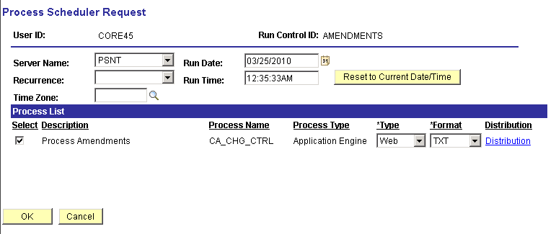

Select the checkbox next to the desired process.

Click to execute the process. Navigate to the Process Monitor link to view the Process status.

NOTE: Verify that the Contract Amendment has been processed to completion by navigating back to the Contract and checking the Amendment Status.

Contract Renewals

The Contracts Module provides the ability to renew Contract Lines outside of amendment processing. A Renewable Contract Line is defined for a Fixed Fee (Amount Based) Product. An example could be a maintenance contract, where the agreement is for a fixed period of time and the customer is allowed to extend the agreement once the initial contract period has expired.

When defining an Amount Based Product, identify the Product as renewable, select the renewal action (manual versus automated renewal), and optionally select a default Renewal Plan Template. When selecting a Renewable Product for a Contract Line, define a start and end date for the contract line, and identify a future Renewal Plan. If you select a Renewal Plan Template for a Product, the system creates a Renewal Plan when the Contract is saved.

Products must be flagged as Renewable and renewal processing defined as Automatic or Manual.

Renewal Plans and Renewal Cycles are the main components of the renewal feature. A renewal plan contains one or more renewal cycles. Each cycle represents a period of time. The user defines the Product and amount corresponding to this period of time. When the user assigns renewable contract lines to a renewal cycle and approves the cycle, the system generates a new contract line.

Step 1: Create a Contract with Renewable Product

Navigation: Customer Contracts > Create and Amend > General Information > Add a New Value

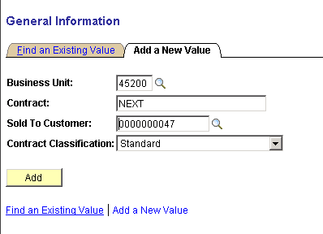

Business Unit – select the agency Contracts business unit.

Contract – leave ‘NEXT’ in the Contract field to allow the system to assign the Contract ID. Alternatively, key the Contract ID value.

Sold To Customer – select from the list of pre-defined Customers. Customers are unique to the agency business unit.

Contract Classification – set to ‘Standard’.

Click to enter the Customer Contract pages.

General Tab

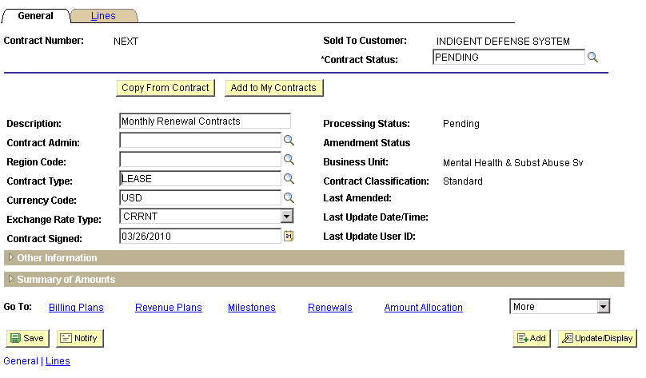

NOTE: Not all required fields in the Contract component are illustrated in this section. Only those fields required and specific to Renewal Contracts are listed.

When initially creating a Contract, only the General and Lines tabs will be visible. Use the General tab to define Contract header information. Some fields will be populated with default values. Others will need to be populated by the user.

Click the Lines Tab.

Click to initiate the Contract Line.

Add Contract Lines Page

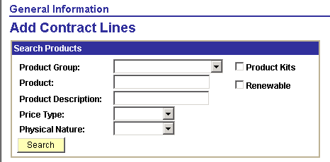

The Add Contract Lines page allows the user to search for pre-defined Products using the Search Products criteria.

Click to retrieve Products matching the search criteria provided.

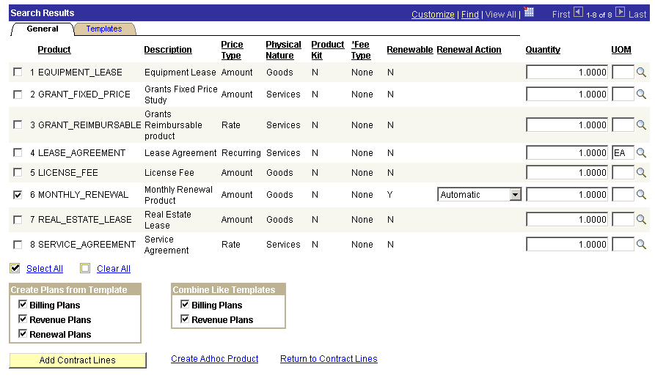

From the list of Products that match the search criteria, select the Product to copy onto the Contract Line.

Renewal – this column indicates whether the Product is defined as ‘Renewable’.

Renewal Action – this field indicates whether the Product is defined for ‘Automatic’ or ‘Manual’ renewal.

NOTE: The Renewal Action can be changed on this page from the default value defined on the Product. Manual Renewals require the user to confirm the customer before the finalizing the renewal.

Click to add a Product to the Contract Line.

Click the Return to Contract Lines link.
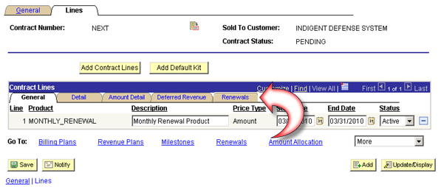

The Renewable Contract Line displays the ‘Renewal Tab’.

Click the Renewal Tab.

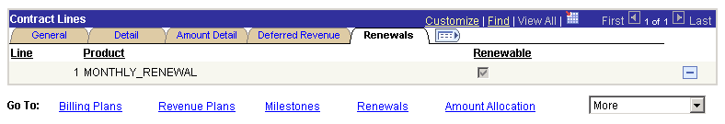

The Renewal Tab displays the Renewal checkbox indicating a renewable Product is being used.

NOTE: The Contract should be completed with a Bill Plan, Revenue Plan, Amount Allocation (if applicable), Distribution and Activation before the Renewal subsequent renewal steps are initiated.

Step 2: Create a Renewal Plan

Navigation: Customer Contracts > Define Renewals > Plan > Add a New Value

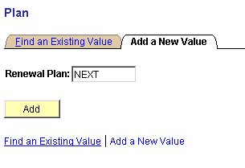

Renewal Plan – leave the value as ‘NEXT’ for the system to assign the next available Plan number or key the Plan ID.

Click to enter the Renewal Plan pages

Define Renewal Plan Page

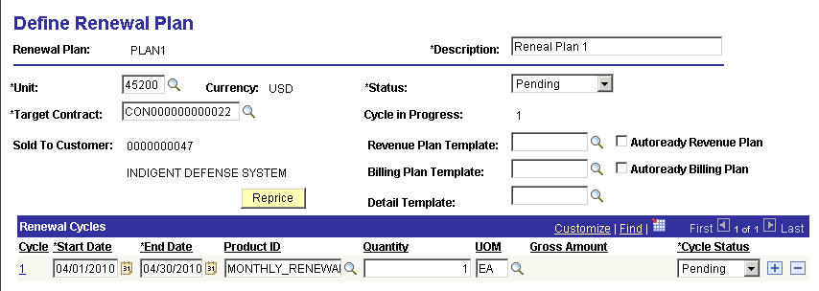

Unit – select the agency business unit.

Target Contract – select to link the plan to the Contract.

Start/End Dates – define the Plan start date and end dates.

Product ID – select from the list of pre-defined Product ID’s.

Unit of Measure – select from the UOM defined for the Product.

Click to save the Renewal Plan.

NOTE: The Renewal Cycle is also seen on this page in the Cycle hyperlink – 1.

Click the Renal Cycle link 1.

Step 3: Create a Renewal Cycle

Navigation: Customer Contracts > Define Renewals > Cycles > Add a New Value

Define Renewal Cycle Page

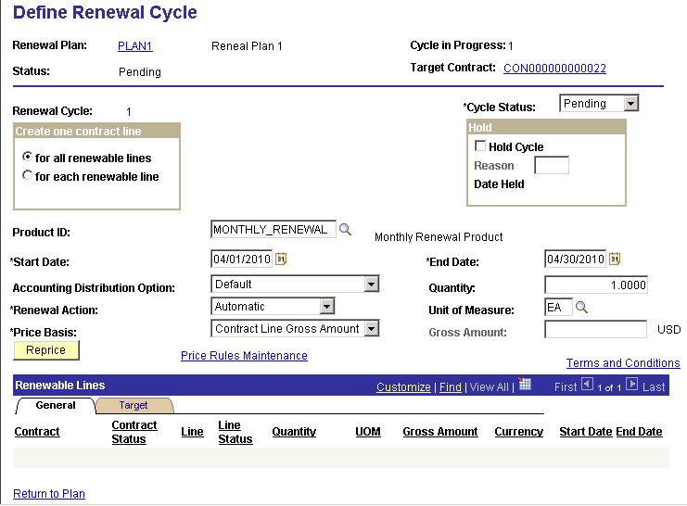

The Define Renewal Cycle page displays information inherited from the Renewal Plan.

Cycle Status – set to ‘Ready’ to process the Renewal.

For all renewable lines – select for the renewals process to generate one new contract line for one or multiple renewable contract lines that are linked to the same renewal cycle

For each renewable line - select for the renewals process to generate a new contract line for each renewable contract line that is linked to the renewal cycle.

Click to save the Renewal Cycle.

Step 4: Assign Contracts to Renewals

Navigation: Customer Contracts > Define Renewals > Assign Cycles > Add a New Value

Assign Cycles Page

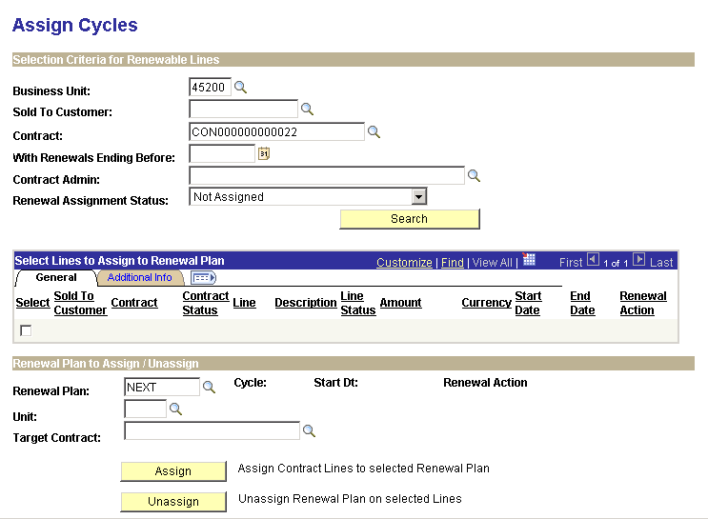

Use the Assign Cycles page to link Contract Lines to Renewal Cycles.

Business Unit – select the agency business unit value.

Contract – select the Contract to which the Renewal Cycle will be assigned.

Click to retrieve Contract Lines.

Assign Cycles page continued

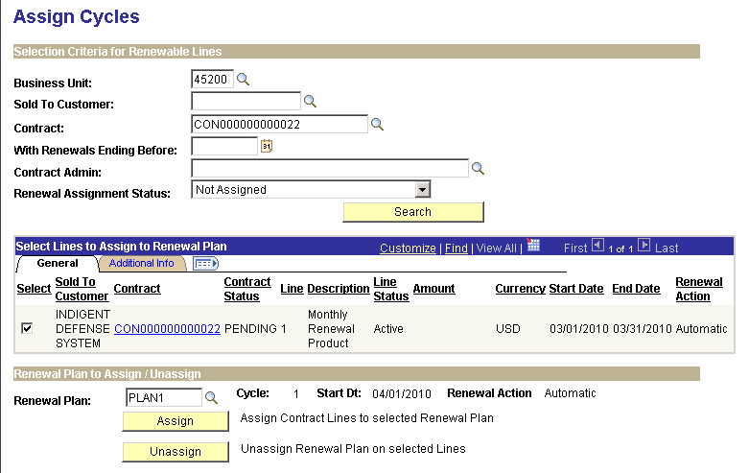

The Assign Cycles page displays all Contract Lines meeting the Selection Criteria.

Select – select the Contract Line that will be assigned to the Renewal Cycle.

Renewal Plan – if the Plan has been defined select the Plan ID. Leave as ‘NEXT’ to allow the system to create a new Plan.

Click to assign the Contract Line.

Step 5: Process Renewals in Batch

Navigation: Customer Contracts > Schedule and Process Renewals > Process Renewal > Add a New Value

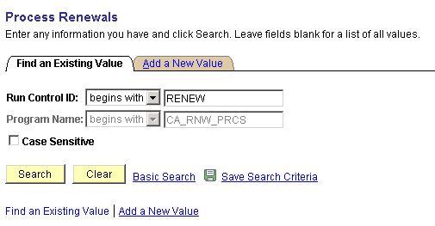

Use and Existing Run Control ID or Add a New Value.

Click to use an existing Run Control ID.

NOTE: The Renewal Cycle must be set to Ready to be successfully processed.

Process Renewals Page

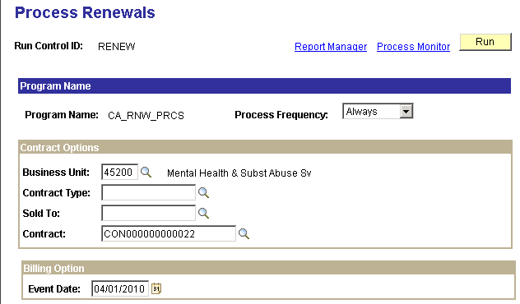
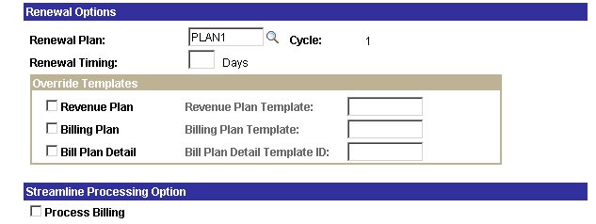

Business Unit – populate with the agency business unit value.

Contract – select the Contract that will be renewed.

Renewal Plan – to narrow the selection to a particular Renewal Plan, select the value here.

Use the Override Templates section of the page to use Template for the Bill and Revenue Plans that will be created on the Renewal Contract Line.

Click to execute the Contracts Renewal process.

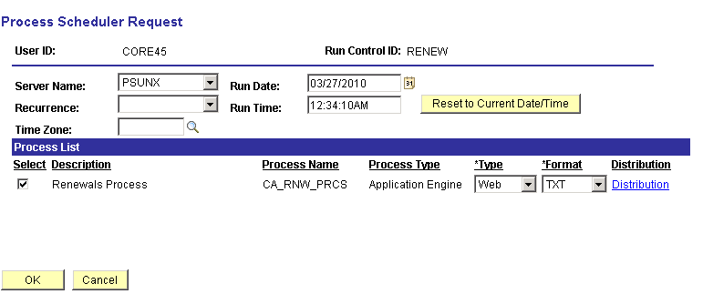

Select the checkbox next to the desired process.

Click to execute the process. Navigate to the Process Monitor link to view the Process status.

Step 5: Process Renewals Ad Hoc

Navigation: Customer Contracts > Define Renewals > Review Renewals

Review Renewals Page

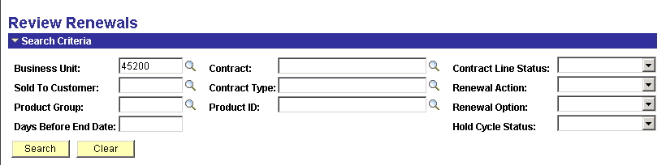

Use the Search Criteria to find the Contract(s) that will be Renewed.

Click to use to find the renewable lines.

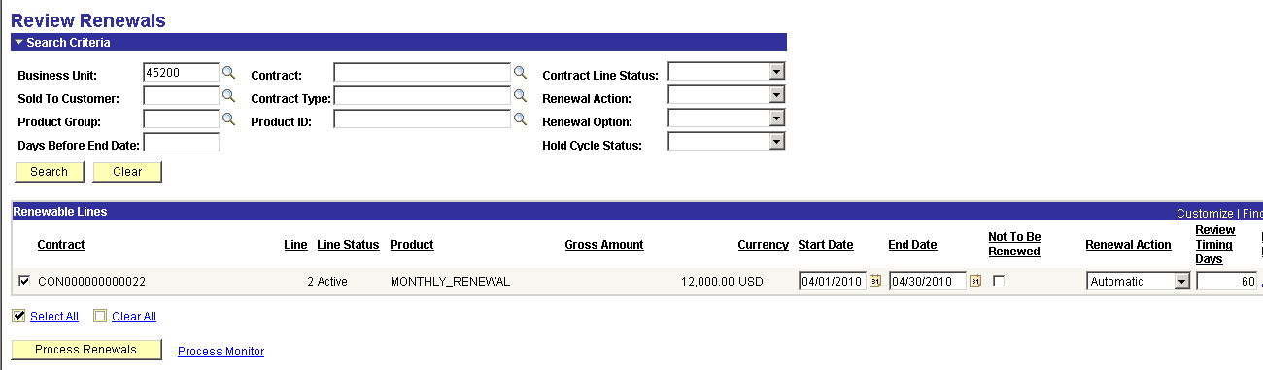

Select the Contract Line that will be renewed.

Click to execute the renewal.

Step 6: Verify the Contract Renewal

Navigation: Customer Contracts > Create and Amend > General Information > Find an Existing Value

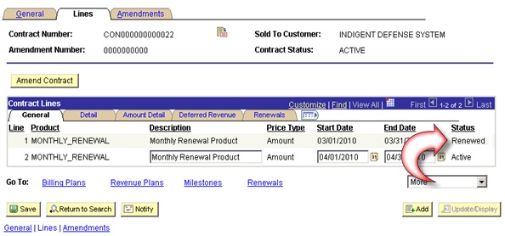

The Contract Line page should reflect the new renewed Contract Line.

Status – the renewed (original) Contract Line should have a ‘Renewed’ status. The renewal (new) Contract Line should show a status of ‘Active’.

NOTE: If Templates were not used to create Bill and Revenue Plans, they must be created for the new Contract Line.

Adjust Revenue and Billing

When Revenue Accounting Entries have been made and Billing has been released, the resulting transactions can be adjusted. Revenue Entries can be adjusted for chartfield changes while Billing can be adjusted for Amounts.

Adjust Fixed Fee Revenue

Navigation: Customer Contracts > Adjust Revenue and Billing > Redistribute Fixed Fee > Find an Existing Value

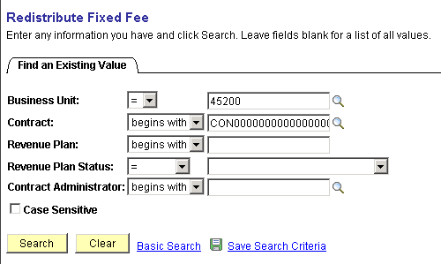

Business Unit – select the agency Contracts business unit.

Contract – select the Contract that will be adjusted.

Click to enter the Redistribute pages.

NOTE: Accounting Entries for Contract Revenue must have been created for them to be redistributed.

Revenue Redistribution Page

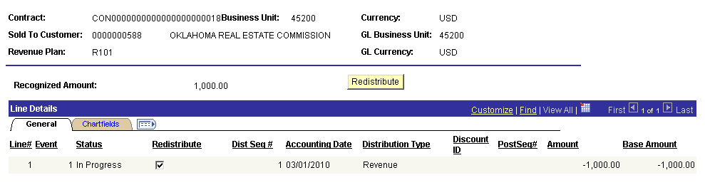

Redistribute – select the redistribution checkbox for the Line on which revenue accounting will be changed.

Click to initiate the revenue redistribution process.

New Chartfield Assignment Page

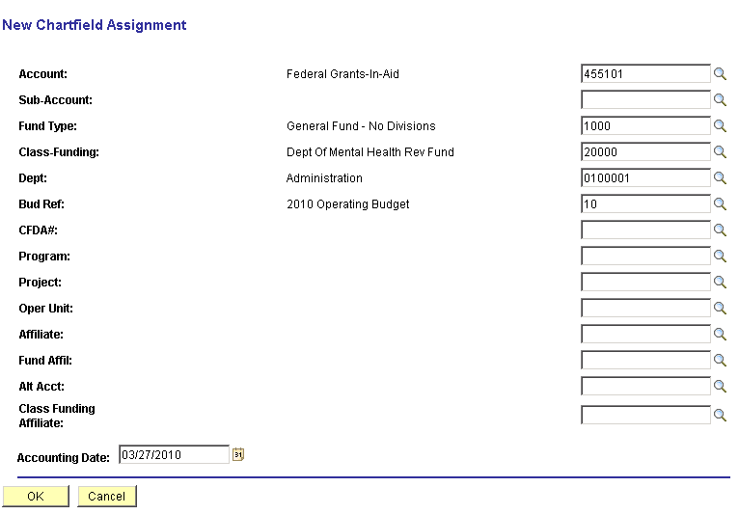

Use the New Chartfield Assignment page to make changes to the revenue accounting entry.

Chartfields – change the desired chartfield values.

Accounting Date – select the accounting date for the redistribution accounting entry that will be created.

Click to initiate the Revenue Accounting Entry redistribution.

Revenue Redistribution page continued

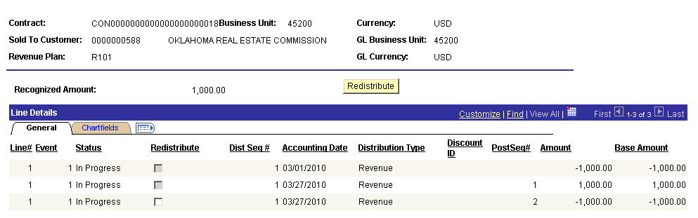

The Revenue Redistribution page should show the adjusting entries.

