COR440 Contracts –Revenue & Billing Review Manual

The content of this training manual is based largely on a generic system configuration and illustrates the base-line functionality required to execute transactions in the module. Your agency may be utilizing more or less of the functionality illustrated in this manual. This manual is intended to be a framework upon which agencies can add agency-specific training content that speaks specifically to the system functionality that they have deployed and related configuration that they use for transaction processing. Agencies should not depend on these manuals for end-user training or problem resolution until they have been reviewed by the agency for appropriateness.

Authorized by: [_CORE_] Original Issue: [04/30/2010]
Maintained by: [____Contracts Lead___] Current Version: [04/30/2010]
Review Date: [12/30/2010]

Table of Contents

Document History 5
Contract Processing 6
Key Terms 7
Contracts Business Unit 7
Customer 7
Contract Bill Plan 7
Contract Revenue Plan 7
Billing Event 7
Revenue Recognition Method 7
Product 7
Price Type 8
Project Costing Business Unit 8
Project ID 8
Activity ID 8
Prepaid 8
Process Flows 9
Guidelines, Concepts and Alternatives 10
Revenue Review and Inquiry 11
Review Revenue Plans 11
Review Revenue - Plans Page 11
Revenue Plan Tab 13
Review Plan - Event Page 15
Fixed Fee Revenue History Page 16
As Incurred Revenue Plans 18
Review Revenue – As Incurred Page 18
New Chartfield Assignment Page 20
Fixed Fee Journals 22
Fixed Fee Journal Accounting Lines Page 23
As Incurred Journals 24
As Incurred Journal Accounting Lines Page 25
Billing Review and Inquiry 26
Review Bill Plans 26
Review Billing - Plans Page 26
Billing Plan General Tab 28
Review Billing - Events Page 30
History Tab 32
Review As Incurred Billing 34
Review Billing – As Incurred Page 34
Billing Plan General Tab 36
History Tab 37
Adjust Revenue and Billing 38
Reverse Contract 38
Contract Reversal Tab 39
Redistribute Fixed Fee 40
Redistribute Fixed Fee Page 41
New Chartfield Assignment Page 42
Redistribute As Incurred 43
Redistribute As Incurred Page 44
New Chartfield Assignment Page 45
Review and Manage Limits 47
Review Limits Page 47
Review Contracts 49
Review Contract Summary 49
Contract Summary Page 50

Document History

Document Revision | Date | Description
1.0 | 04/30/2010 | Initial Document

Contract Processing

Once Contract setup and configuration is complete and Contracts have been defined and activated a series of batch processes are used to Bill Customers, Recognize Revenue, Amend Contracts and Renew Contracts.

Some of the batch processes required to process Contracts data are scheduled to run at pre-defined intervals while others are available to run on an ad hoc basis.

Key Terms

Contracts Business Unit
Each agency has one, and only one Contracts Business Unit. The Business Unit is the three (3) digit
agency code, plus 00. For example, Office of State Finance is 09000.

Customer
A customer is an external entity that is defined in a Contract. to receive invoices and from which revenue is recognized.

Contract Bill Plan
The Bill Plan defines the schedule, parameters and configuration of the Customer invoice. A Contract manages the billing process through the creation of billing plans. Billing plans are Contract specific. The Billing plan stores the schedule of billing events and the corresponding bill lines for these events. Each contract line product is tied to a billing plan.

Contract Revenue Plan
The Contract Revenue Plan defines how and when customer revenue will be recognized for accounting purposes. Define a revenue plan for Contract lines in which revenue is managed by Contracts. For each revenue plan that is defined, select a Revenue Recognition method for the Revenue Plan and define the Events that trigger revenue recognition. Revenue Plans are not defined for contract lines with a revenue method of Billing Manages Revenue

Billing Event
A Billing Event is a “trigger” that initiates contract billing. The Event could be a date, milestone, etc. Bill Plans define Billing Events that are used to generate billing that is interfaced into the Billing Module.

Revenue Recognition Method
Revenue recognition methods define the criteria that must be met before revenue can be recognized. Specify revenue recognition methods for products on the Product Definition component. The associated revenue recognition method appears when you select a product onto the contract line.

Product
A Product is the core contractual obligation of products or services that an agency provides to the public. These could be fees, licenses or even grant related products. A Product represents the basis for the Contract Line and determines what type of Contract will be created. Products are associated with a set of attributes that include pricing structure, tax parameters, and accounting information. Once defined Products are use in the Contract creation process.

Price Type
Contract Products are classified as Rate-Based, Amount-Based, or Recurring. Rate-based products have a price type of Rate, Amount-Based products have a price type of Amount or Percent, and recurring products have a price type of Recurring. The price type that you select for a product determines the details that you define for that product and the billing and revenue recognition methods with which you can associate the product.

Project Costing Business Unit
Each agency has one, and only one Project Costing Business Unit. The Business Unit is the three (3) digit agency code, plus 00. For example, Office of State Finance is 09000.

Project ID
The Project ID represents the basic unit that serves to establish budgets and collect costs and revenue for analysis purposes. Projects serve to collect construction costs and capitalize Assets in conjunction with the Asset Management module. Project ID is also a Chartfield and as such a part of the distribution line. In Contracts, Project ID is the basic unit that makes up a Rate Based contract used to collect expended costs and bill customers for those costs.

Activity ID
An Activity ID generally represents a task that makes up a Project. Project Costs and Budgets are stored in Activities. In Contracts, Activity ID is used to collect costs that are priced and billed to customers for reimbursement.

Prepaid
An amount paid in advance by a Customer in a Rate Based Contract agreement. The prepaid amounts are applied or deducted from otherwise billable costs collected in a Project until all prepaid amounts are fully “utilized”.

Process Flows

Diagram 1: Contracts Module Integration

Guidelines, Concepts and Alternatives

Price Type | Description | Billing Method | Revenue Recognition Method
Amount or Percent | Used for contracts with a fixed price. Or, Used for contracts that are priced as a percent of one or more contract lines. | Milestone, Percent Complete, Immediate | Milestone, Percent Complete, Apportionment, Billing Manages Revenue
Rate | Used for contracts, such as services, with a rate-based pricing structure, such as $400 per hour worked. The actual monetary amount is not known until the hours have been worked and reported | As-incurred, Value-based | As-incurred
Recurring | Used for contracts that have a recurring pricing structure where a start date and schedule are defined | Recurring | Billing Manages Revenue

Table 1: Product Prince Types with Billing and Revenue Methods

Revenue Review and Inquiry

Once Revenue Accounting Entries have been booked, they can the reviewed and adjusted as needed. Revenue Plans can be managed individually or collectively in the Review Revenue pages. Revenue Events can also be reviewed and managed to assist the user in administrating revenue recognition events.

Review Revenue Plans

Navigation: Customer Contracts > Review Revenue > Plans

Review Revenue - Plans Page

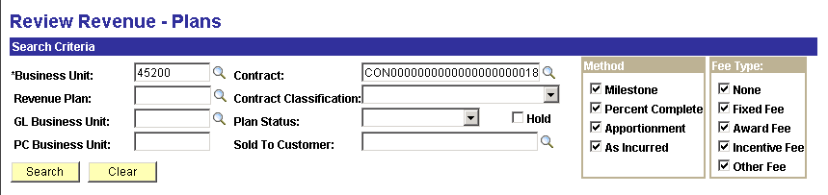

Use the Review Revenue – Plans page to retrieve Revenue Plans for review and changes.

Search Criteria – use the search criteria fields to select the desired Revenue Plan(s).

Method – use the Revenue Recognition method to further define the search criteria.

Click to retrieve Revenue Plans that match the search criteria.

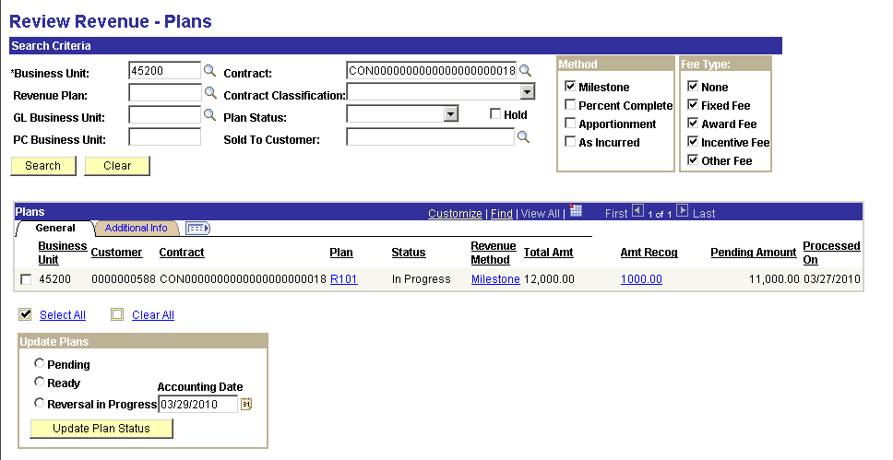

The Revenue Plan(s) that match the search criteria will be visible.

Select the checkbox next to the Contract Revenue Plan to update that Plan.

Click the Plan link R101 to view Revenue Plan Events can make changes.

Revenue Plan Tab

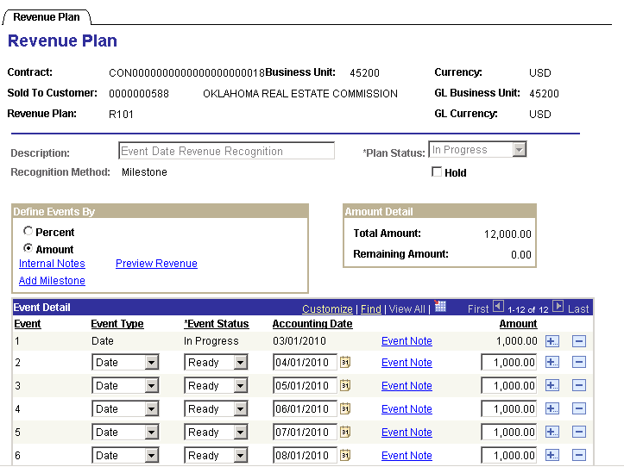

Make changes to the Revenue Plan Events or place the Plan on Hold.

Click the Return to Plans link to further Review the Revenue Plan.

Click the Revenue Method Milestone link to update the Status of multiple Revenue Events at once.

NOTE: The Review Plan Events page can also be accessed by navigating to Customer Contracts>Review Revenue>Events.

Review Plan - Event Page

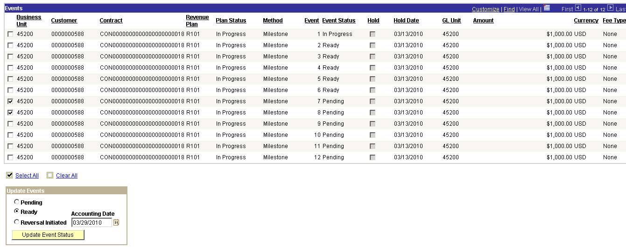

Select the Revenue Plan Events to take action on.

Use the Update Events section of the page to change the Status of a Plan Event or Initiate a Reversal of revenue.

Accounting Date – when reversing Revenue, determine the Accounting Date that the reversal will be booked with.

Click to initiate the selection Action on the Revenue Plan Events.

Return to the Review Revenue – Plans page.

Review Revenue – Plans page

Total Amount - displays the total amount for the revenue plan associated with this row.

Click the Amount Recognized link 1000.00 to view the Accounting Entries for the revenue that has been recognized.
Fixed Fee Revenue History Page

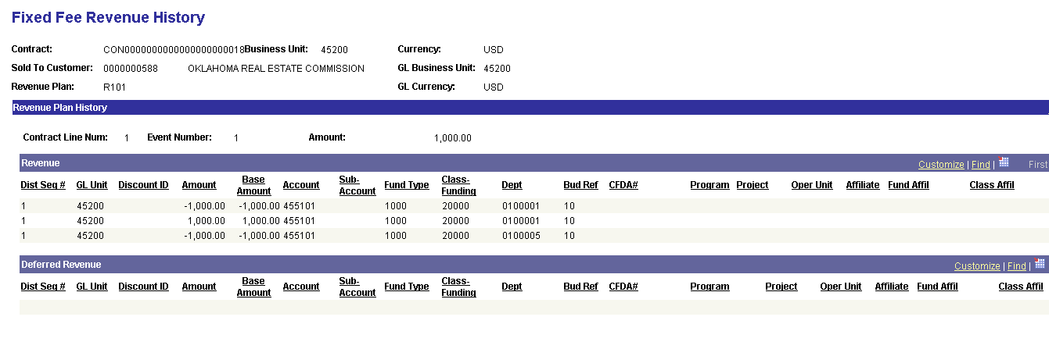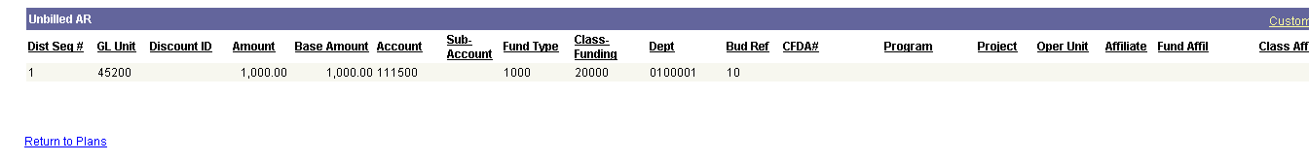

View the Accounting Entries related to the Revenue Plan.

The Revenue section of the page shows the revenue amounts recognized for the Plan.

The Deferred Revenue section of the page will be populated if deferred revenue is recognized for the Plan, those entries will be visible here.

The Unbilled AR section of the page shows unbilled accounts receivable entries.

Click the Return to Plans link.

Processed On – reflects the last day that revenue was recognized for this plan.

Use the Update Plans section of the page to take a particular action on the Revenue Plan:

- Pending – select to change the status of a Plan or Plans from Ready to Pending.
- Ready – select to change the status of a Plan or Plans from Pending to Ready.
- Reversal in Progress – select to reverse the accounting entries for a revenue plan.
- Accounting Date - enter a date for the system to use as the accounting date for the reversing entries.

Click to initiate the selected action on the Plan.

As Incurred Revenue Plans

Navigation: Customer Contracts > Review Revenue > As Incurred

Review Revenue – As Incurred Page

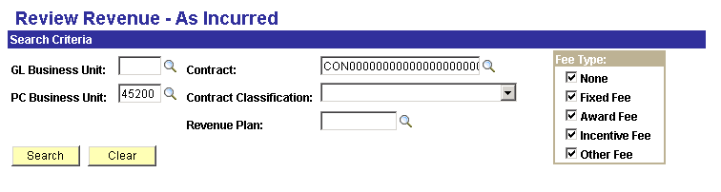

Use the Review Revenue – As Incurred page to retrieve Contracts with As Incurred Revenue Plans.

Search Criteria – use the search criteria fields to select the desired Revenue Plan(s).

Click to retrieve Revenue Plans that match the search criteria.

NOTE: As Incurred Revenue must have been created thru the As Incurred Revenue process (PSA_ACCTGGL) before this page will display revenue information.

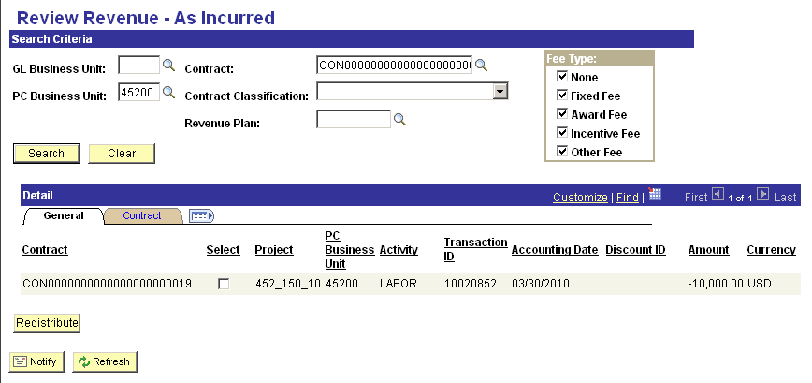

When revenue has been created in Contracts for As Incurred Revenue Plans, those results will be displayed.

Select – click this checkbox to ‘Redistribute’ the revenue that has already been recognized (booked).

Project – this field displays the Project in which the As Incurred Revenue has been booked.

Activity - this field displays the Activity in which the As Incurred Revenue has been booked.

Accounting Date – displays the accounting date for the revenue. This date will determines into which period the revenue will be booked.

Amount – displays the amount of revenue that was recognized for this row.

NOTE: There could be multiple rows of revenue recognized for the Project depending on how the BIL rows were created in the Project Costing module.

Click the Select checkbox to redistribute previously booked revenue.

Click to display the revenue redistribution page.

New Chartfield Assignment Page

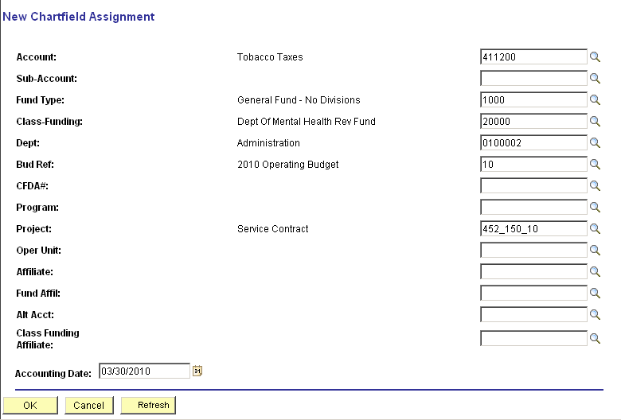

The New Chartfield Assignment page allows the user to change the chartfields values for revenue that has previously been created.

Chartfields – make any desired changes to the chartfield values that were used to originally create the revenue accounting entry.

Accounting Date – populate the accounting date with the date that the redistribution accounting entry will date place.

Click to create the redistribution rows.

NOTE: The system will automatically create the reversing entries required to reverse the revenue accounting entry. No batch process is required.

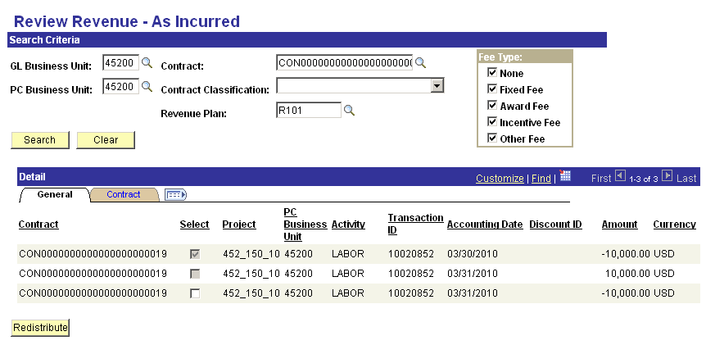

The Review Revenue – As Incurred page now shows the redistribution accounting entry rows.

NOTE: Two (2) rows are created in the redistribution: one to clear the original accounting entry distribution, the other to book the new revenue distribution.

NOTE: There redistribution accounting entry rows have now been created in the Projects/Contracts Accounting Entry Table – CA_ACCTG_LN_PC and are eligible for Journal Generation to General Ledger.

Fixed Fee Journals

Navigation: Customer Contracts > Review Revenue > Fixed Fee Jrnl Acctg Lines

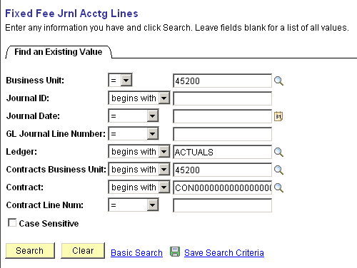

Use the Search fields to find the desired Fixed Fee Journals.

Business Unit – select the agency business unit number. This is the General Ledger business unit value.

Ledger – define the ledger that the Journals are posted to. This field is required.

Contracts Business Unit – select the agency business unit number.

Contract – select the Contract ID from which Journals will be retrieved.

Click to retrieve Revenue Journals.

Fixed Fee Journal Accounting Lines Page

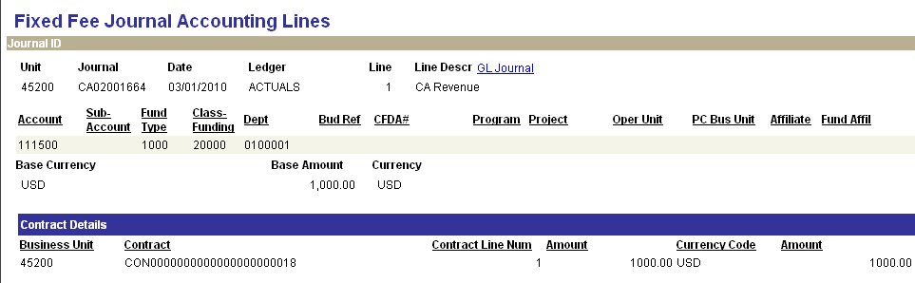

The Fixed Fee Journals Accounting Lines page displays General Ledger details for the revenue accounting entries that have been created in the Contracts module and interfaced to General Ledger.

Unit – displays the General Ledger business unit value.

Journal – displays the Journal ID from General Ledger.

Date – reflects the Journal Date from the Journal.

Line – displays the Journal Line from the Journal.

Base Amount – the amount reflects debit or credit for the Journal Line (Credit is negative).

The Contract Details section of the page displays Contract specific information related to the Journal that has been created.

NOTE: Journal Lines are displayed individually on this page. Navigate back to the search list to view different journal lines for a single Journal ID.

As Incurred Journals

Navigation: Customer Contracts > Review Revenue > As Incurred Jrnl Acctg Lines

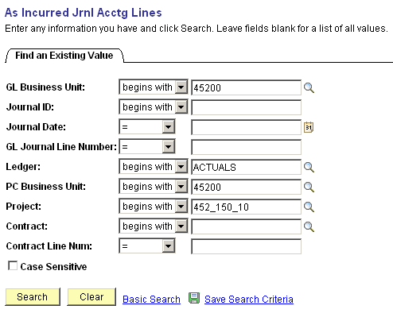

Use the Search fields to find the desired As Incurred Journals.

Business Unit – select the agency business unit number. This is the General Ledger business unit value.

Ledger – define the ledger that the Journals are posted to. This field is required.

PC Business Unit – select the agency business unit value.

Project – to retrieve Journals by Project populate this field.

Contract – select the Contract ID from which Journals will be retrieved.

Click to retrieve Revenue Journals.

As Incurred Journal Accounting Lines Page

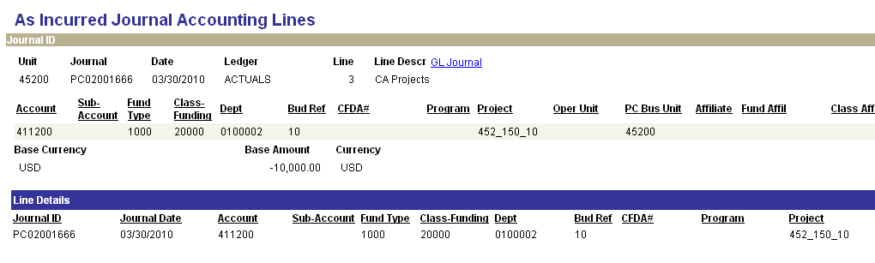

The Fixed Fee Journals Accounting Lines page displays General Ledger details for the revenue accounting entries that have been created in the Contracts module and interfaced to General Ledger.

Unit – displays the General Ledger business unit value.

Journal – displays the Journal ID from General Ledger.

Date – reflects the Journal Date from the Journal.

Line – displays the Journal Line from the Journal.

Base Amount – the amount reflects debit or credit for the Journal Line (Credit is negative).

The Line Details section of the page displays Journal Line details for the Journal ID.

NOTE: Journal Lines are displayed individually on this page. Navigate back to the search list to view different journal lines for a single Journal ID.

Billing Review and Inquiry

Once Contract Bill Plans have been created, they can be managed individually or collectively in the Review Billing pages. Changes to Status, recognized Revenue and previously processed Billing can all be made. History of revenue Accounting Entries and Invoicing can also be viewed through the review pages.

Review Bill Plans

Navigation: Customer Contracts > Review Billing > Plans

Review Billing - Plans Page

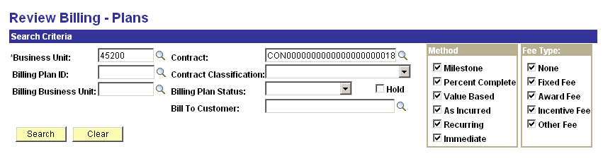

Use the Review Billing – Plans page to retrieve Billing Plans for review and changes.

Search Criteria – use the search criteria fields to select the desired Billing Plan(s).

Method – use the Billing Method to further define the search criteria.

Click to retrieve Billing Plans that match the search criteria.
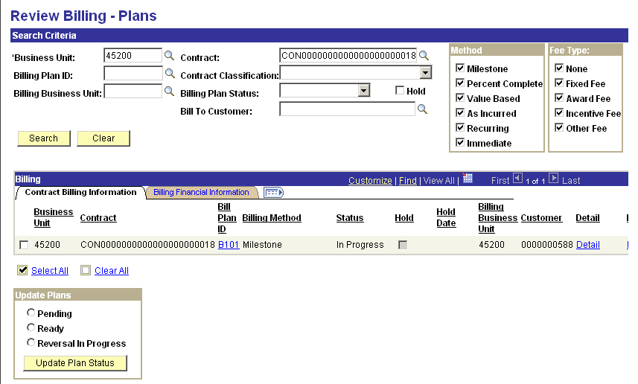

The Billing Plan(s) that match the search criteria will be visible.

Select the checkbox next to the Contract Billing Plan to update that Plan.

Click the Billing Financial Information Tab.

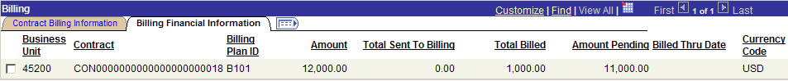

Cumulative billing information for this Bill Plan is visible.

On the Contract Billing Information Tab, click the Plan link B101 to view the detail Billing Plan.

Billing Plan General Tab

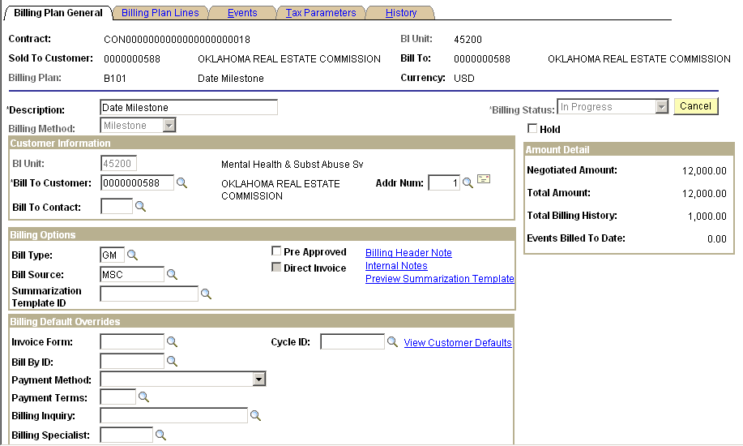

Changes to the Billing Plan can be made.

Click the Return to Billing Plan Management link.

NOTE: The Bill Plan Status may prevent certain change from being made to the Bill Plan.

Click the Detail link to view Bill Plan Event information.

Review Billing - Events Page

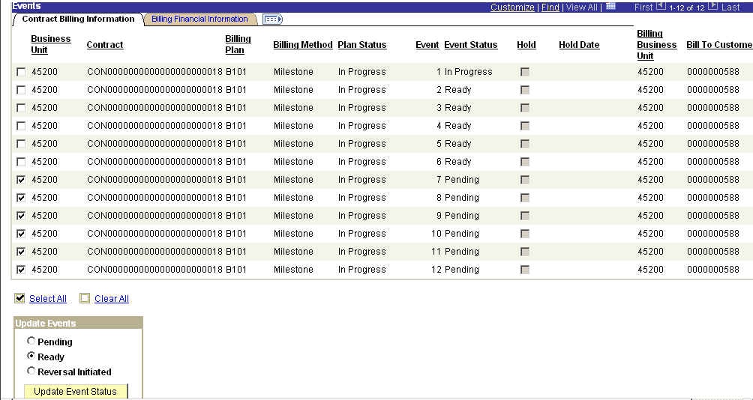

Select the Bill Plan Events to take Action on.

Use the Update Events section of the page to change the Status of a Plan Event or Initiate a Reversal of billing.

Click to initiate the selection Action on the Billing Plan Events.

Click the Return to Billing Plan Management link.
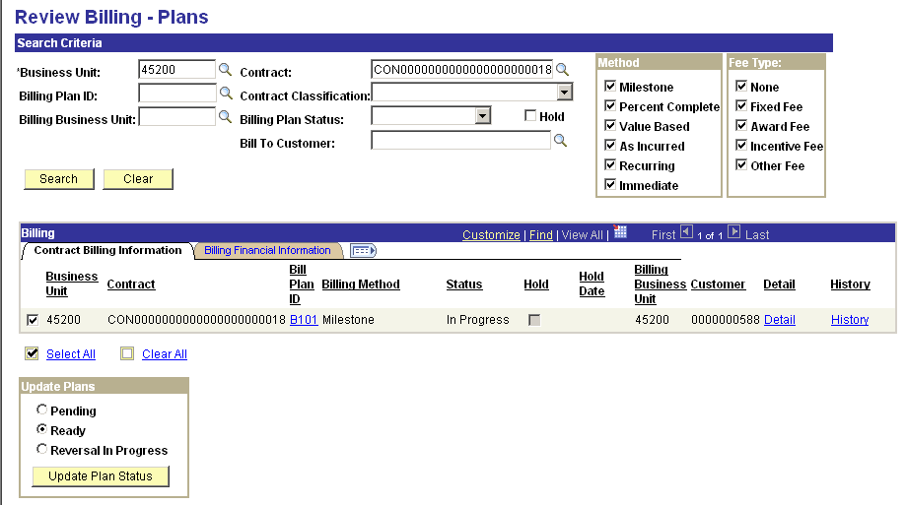

Click the History link to view a billing history for this Bill Plan.

History Tab

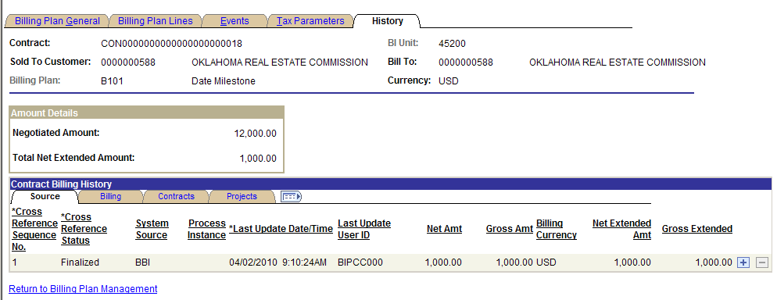

The billing History Tab displays information about the bills that have been created from this Bill Plan.

Net Amount – displays the amount of the bill.

Click the Billing Tab.

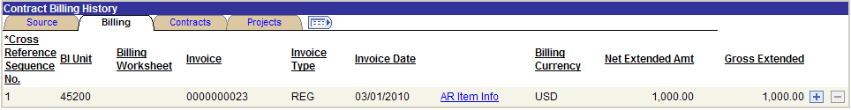

The Billing Tab displays details about each invoice including Invoice Number, Invoice Type and Invoice Date.

Click the Return to Billing Plan Management link.

Use the Update Plans section of the page to take a particular action on the Revenue Plan:

- Pending – select to change the status of a Plan or Plans from Ready to Pending.
- Ready – select to change the status of a Plan or Plans from Pending to Ready.
- Reversal in Progress – select to reverse all or a portion of the billing that has been billed for the selected billing plan.

Click to initiate the selected action on the Plan.

Review As Incurred Billing

Navigation: Customer Contracts > Review Billing > As Incurred

Review Billing – As Incurred Page

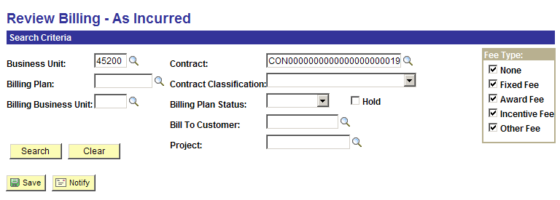

Use the Review Billing – As Incurred page to retrieve As Incurred (Rate Based) Billing Plans for review and changes.

Search Criteria – use the search criteria fields to select the desired Billing Plan(s).

Click to retrieve Billing Plans that match the search criteria.
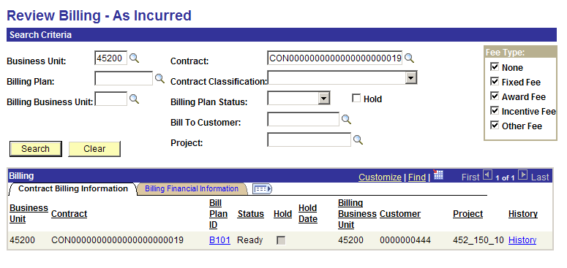

The Billing Plan(s) that match the search criteria will be visible.

Status – Bill Plan Status is visible.

Project – the Project ID that the Contract Line is linked to will be visible.

Click the Billing Financial Information Tab.

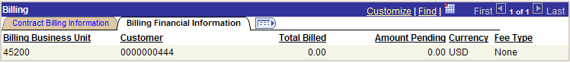

Cumulative Billing information for this Plan is visible.

On the Contract Billing Information Tab, click the Plan hyperlink B101 to view the detail Billing Plan.

Billing Plan General Tab

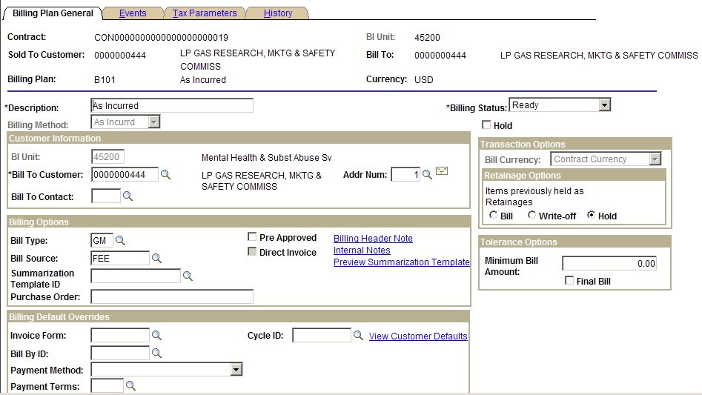

Changes to the Billing Plan can be made.

Click the Return to Search – As Incurred link.

NOTE: The Bill Plan Status may prevent certain change from being made to the Bill Plan.

Review Billing – As Incurred page continued

Click the History link to view a billing history for this Bill Plan.

History Tab

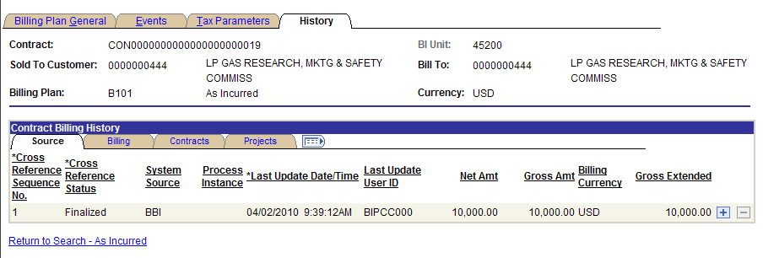

The Billing History Tab displays information about the bills that have been created from this Bill Plan.

Last Updated Date/Time – this value reflects the last time the Bill Plan was updated with billing information.

NOTE: The Bill History page for As Incurred bills is update through a batch process and therefore does not always reflect “Real Time’ billing activity.

Net Amount – displays the amount of the bill.

Click the Billing Tab.

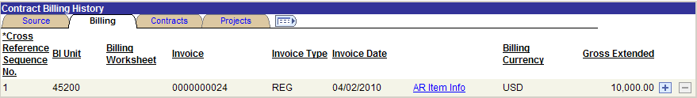

The Billing Tab displays details about each invoice including Invoice Number, Invoice Type and Invoice Date.

Click the Return to Search – As Incurred link to return to the Review Billing – As Incurred page.

Adjust Revenue and Billing

Recognized Revenue and processed Billing can be adjusted from the Contracts module.

When revenue is reversed, the system creates additional accounting entries to back out the original recognized revenue. The system can reverse revenue previously recognized for an entire Contract, a single Revenue Plan, or a single Revenue Plan Event. When reversing the Event or Plan, the system reverses the original entry—debiting revenue and crediting either unbilled AR or deferred revenue.

Billing activity can be reversed from the Contracts module by issuing Credit bills (invoices).

Revenue Accounting Entries can also be “Redistributed” to change the chartfield values that we’re used on the accounting entry. This could be useful when revenue entries were booked with the wrong chartfield values and need to be corrected.

Reverse Contract

Navigation: Customer Contracts > Adjust Revenue and Billing > Reverse Contract > Find an Existing Value

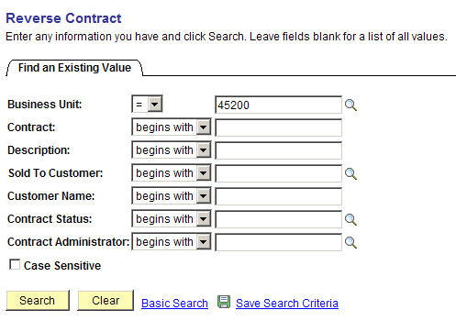

Use the Search fields to retrieve the Contract that will be reversed.

Business Unit – enter the agency business unit value.

Contract – populate with the Contract ID.

Sold to Customer – select from a list of valid Customers.

Click to retrieve the desired Contract for reversal.

Contract Reversal Tab

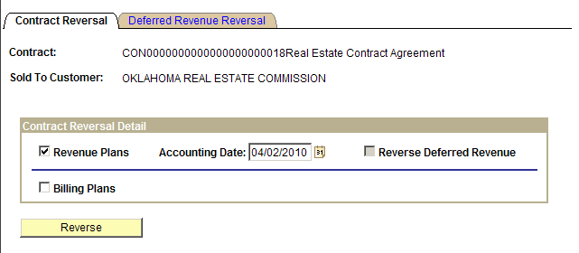

The Contract Reversal Tab allows the user to reverse all revenue accounting entries for an Amount Based Contract.

Revenue Plans – select to reverse all Accounting Entries for Amount Based Contract Lines in this Contract.

Accounting Date – select the accounting date for the reversal Accounting Entries.

Reverse Deferred Revenue – if deferred revenue is enabled for the Contract, select this checkbox to reverse those accounting entries.

Billing Plans - select this check box to reverse billing for all Billing Plans associated with this Contract. The system generates bills with credit amounts only for billing plans with a method of Percent Complete, Milestone, and Immediate.

When reversing deferred revenue, click the Deferred Revenue Reversal Tab to define parameters for that accounting entry including Accounting Date. Execute the deferred revenue reversal using the .

Click .

NOTE: Amount-based revenue previously recognized for a revenue plan event can be reversed only when the status is In Progress or Completed. Revenue for an entire revenue plan can be reversed only if the revenue plan status is In Progress or Completed.

Redistribute Fixed Fee

Navigation: Customer Contracts > Adjust Revenue and Billing > Redistribute Fixed Fee > Find an Existing Value

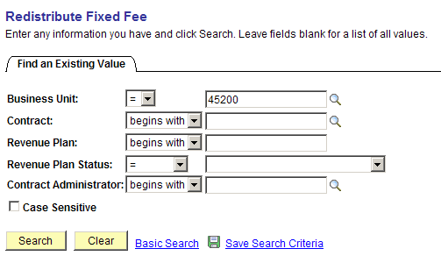

Use the Search fields to retrieve the Contract that will be redistributed.

Business Unit – enter the agency business unit value.

Contract – populate with the Contract ID.

Revenue Plan – to redistribute a particular Revenue Plan, populate this field with the Plan ID.

Click to retrieve the desired Contract.

Redistribute Fixed Fee Page

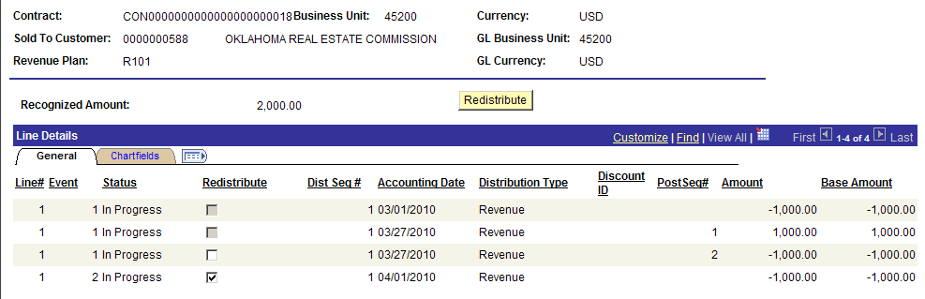

Revenue Accounting Entries that have been recognized can be redistributed to alter the chartfield value on the entry.

Recognized Amount – this value represents the amount of recognized revenue to date on this Revenue Plan.

Redistribute – select to identify which accounting entry line that will be Redistributed.

Accounting Date – this value is the accounting date on the accounting entry line.

Post Sequence # - indicates that the accounting entry line has been redistributed previously.

Click the Chartfields Tab to view the chartfield distribution for the accounting entry lines.

Click to enter the redistribution pages to change chartfield values.

New Chartfield Assignment Page

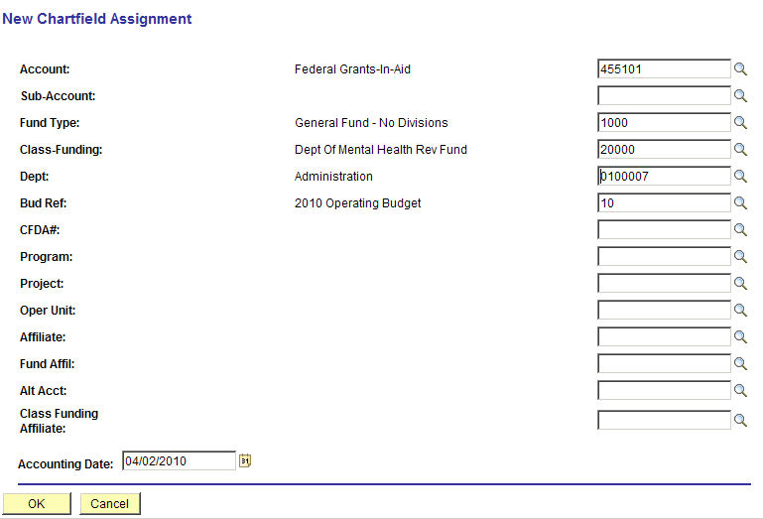

The New Chartfield Assignment page allows the user to change the chartfields values for revenue that has previously been created.

Chartfields – make any desired changes to the chartfield values that were used to originally create the revenue accounting entry.

Accounting Date – populate the accounting date with the date that the redistribution accounting entry will date place.

Click to create the redistribution rows.

NOTE: The system will automatically create the reversing entries required to reverse the revenue accounting entry. No batch process is required.

Redistribute As Incurred

Navigation: Customer Contracts > Adjust Revenue and Billing > Redistribute As Incurred > Find an Existing Value

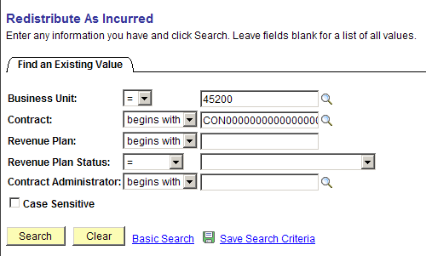

Use the Search fields to retrieve the Contract that will be redistributed.

Business Unit – enter the agency business unit value.

Contract – populate with the Contract ID.

Revenue Plan – to redistribute a particular Revenue Plan, populate this field with the Plan ID.

Click to retrieve the desired Contract.

Redistribute As Incurred Page

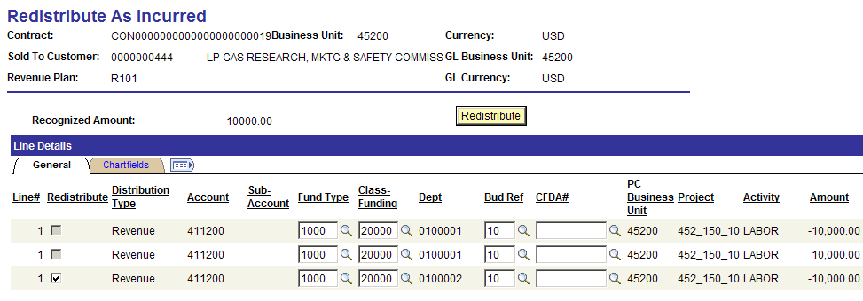

The Redistribute As Incurred page displays existing revenue accounting entries for an As Incurred Contract.

The General Tab displays current accounting entry chartfields.

Click to enter the redistribution pages to change chartfield values.

New Chartfield Assignment Page

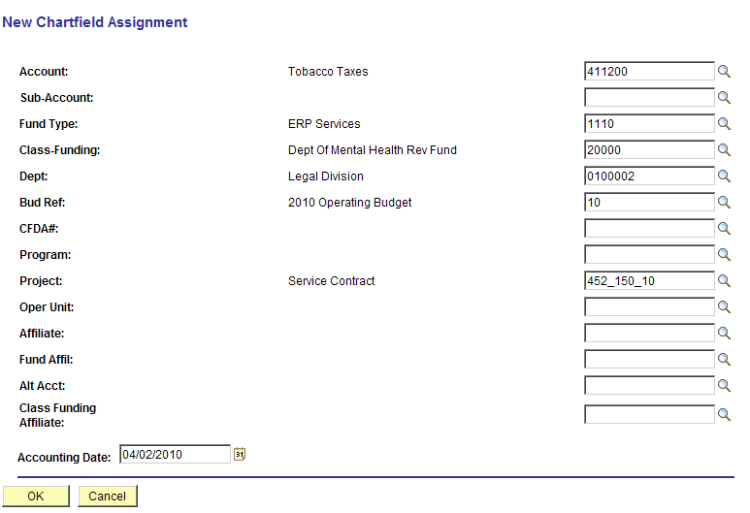

The New Chartfield Assignment page allows the user to change the chartfields values for revenue that has previously been created.

Chartfields – make any desired changes to the chartfield values that were used to originally create the revenue accounting entry.

Accounting Date – populate the accounting date with the date that the redistribution accounting entry will date place.

Click to create the redistribution rows.

NOTE: The system will automatically create the reversing entries required to reverse the revenue accounting entry. No batch process is required.

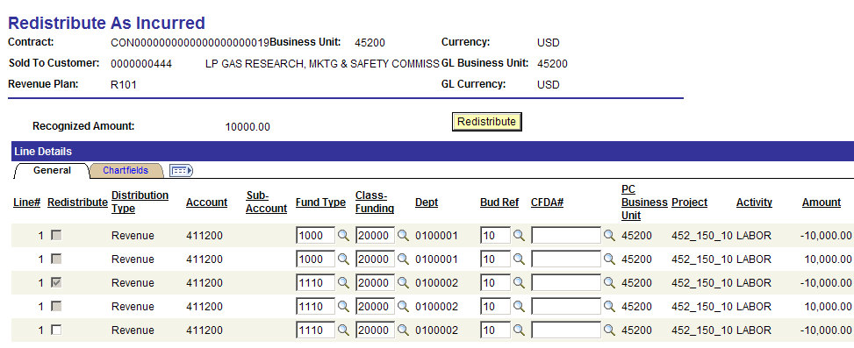

The Redistribute As Incurred page now shows the new accounting entries that reflect the redistribution.

Review and Manage Limits

Throughout the duration of a Contract, Contract Line limits must be managed, including the amount of the limits that have been used to date, the amounts remaining, and any amounts that have been exceeded. Review and Manage Limits is an inquiry page that provides both a summarized and detail view of this information, with filtering capabilities, that enables management of Contract Line Limits.

Navigation: Customer Contracts > Adjust Revenue and Billing > Review and Manage Limits

Review Limits Page

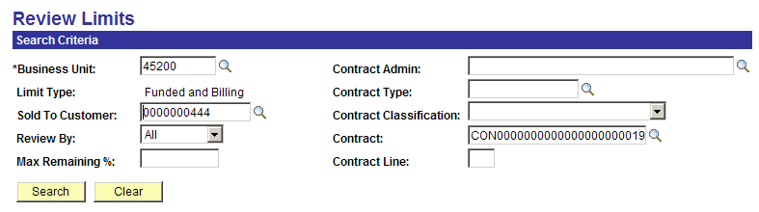

Use the Review Limits page to retrieve Limit information for a Rate Based Contract Line.

Search Criteria – use the search criteria fields to select the desired Contract Line.

Sold To Customer – define the Customer for the Contract that will be limit checked.

Review By – select a value that will be used to display Limit Amounts:

- All - select this option to view all limit amounts including any remaining amounts and amounts that have exceeded the limits for contract lines.
- Excess - select this option to view only those amounts that have exceeded the limit amount for contract lines.
- Remaining - select this option to see the remaining available limit amounts for contract lines.

Max Remaining – if the ‘Remaining’ option was selected for the Review By field, enter a maximum remaining amount percentage to restrict the results to only those contract lines with that limit amount percentage or less remaining.

NOTE: Values in Business Unit, Limit Type, Sold To Customer, and Review By fields are required for search capability on this page.

Click to retrieve Limit amounts for Contract Lines matching the search criteria.
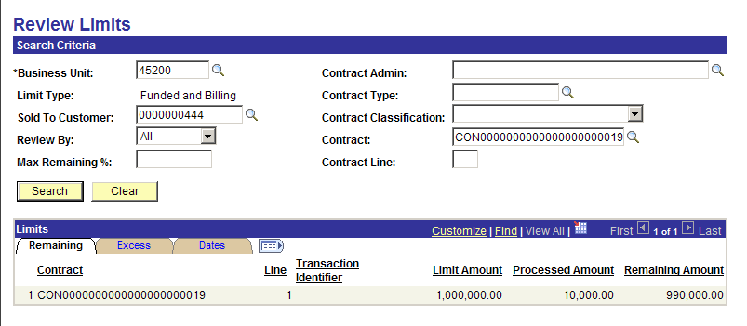

The Remaining Tab displays Limit and balance information.

Limit Amount – this value is the Contract Line limit amount.

Processed Amount – this value reflects the amount of contract billing that has taken place against the Limit.

Remaining Amount – this value is the amount of Limit left after current billing.

Click the Excess Tab.

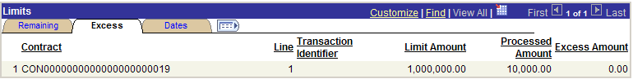

Excess Amount – this field displays any amount in excess of the Limit defined on the Contract Line.

Click the Dates Tab.

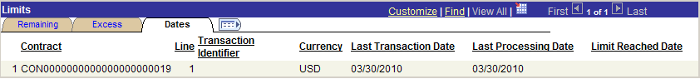

Last Transaction Date – this date reflects the last billing transaction date for the Contract Line.

Limit Reached Date – if the Line Limit Amount has been reached, the date that the limit was exceeded will be visible.

Review Contracts

The Contract Summary feature provides Contract-related information, including current status, associated Amendments, Related Projects and Contract Amounts (including total amount invoiced, total cash collected, total revenue recognized, and total forecasted revenue). The feature also provides hyperlinks to the Contract, Bill Plan, Revenue Plan or any Amendments.

Review Contract Summary

Navigation: Customer Contracts > Review Contract Summary

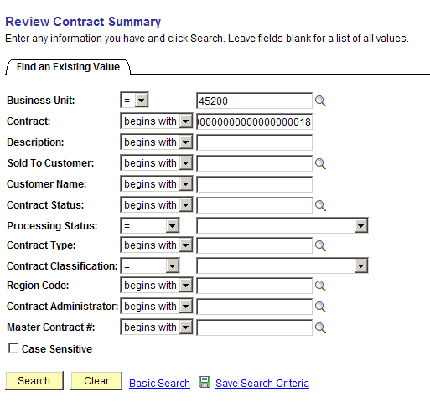

Use the Search fields to retrieve the Contract that will be reviewed.

Business Unit – enter the agency business unit value.

Contract – populate with the Contract ID.

Description – to search by Contract Description populate this field.

Contract Status – to retrieve Contracts by Contract Status, populate this field.

Click to retrieve the desired Contract.

Contract Summary Page

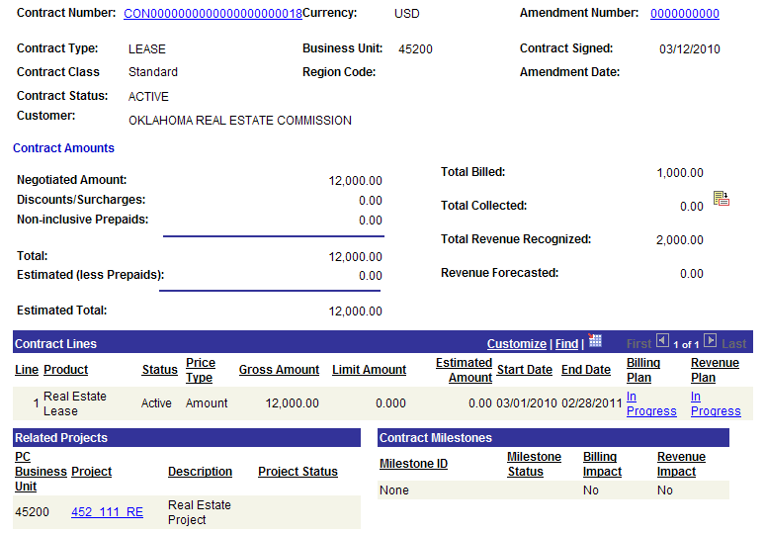

The Contract Summary page provides existing contract-related information, such as where the contract is in its lifecycle, associated Amendments, and Contract Amounts (including total amount invoiced, total cash collected, total revenue recognized, and total forecasted revenue).

Contract Number – use this hyperlink to navigate directly to the Contract entry pages.

The Contract Amounts section of the page displays total negotiated contract amount (for Amount Based Contracts), billed amounts, collected amounts and revenue recognized.

The Contract Lines section of the page displays each Contract Line with status, amounts and hyperlinks to Bill and Revenue Plans.

The Related Projects section of the page shows any Projects that are linked to Contract Lines.

