COR441 Budgeting by Operating Unit

Authorized by: [_CORE_] Original Issue: [06/01/2010]
Maintained by: [____Project Costing Lead___] Current Version: [06/01/2010]
Review Date: [12/30/2010]

Table of Contents

Document History 5
Commitment Control 6
Key Terms 7
Detail Ledger 7
Budget Definition 7
Expense 7
Encumbrance 7
Pre-Encumbrance 7
PeopleSoft Trees 7
Effective Dating 7
Process Flows 8
Commitment Control Overview 10
Commitment Accounting 10
Underlying Data Structure of Commitment Control 11
Budget Definition 12
Control Budget Options Page 13
Ruleset Charfield Page 14
Keys and Translations Page 15
Control Chartfield Page 16
Budget Offsets Page 17
Excluded Account Types 18
Budget Journal Entry 19
Overview 19
Step 1: Enter the Budget Journal Header 20
Step 2: Enter the Budget Journal Lines 22
Step 3: Post the Budget Journal 24
Step 4: Processing Budget Journal Errors 25
Budget Journal Errors Page 25
Budget Journal Exceptions and Corrections 26
Budget Journal Exceptions Page 27
Budget Journal Line Exceptions Page 28
Budget Journal Correction 28
Copy a Budget Journal Entry 29
Overview 29
Step 1: Open a Source Journal 29
Source Journal Header Page 30
Source Journal Lines Page 31
Step 2: Process Budget Journal Copy 32
Step 3: Edit and Post New Budget Journal 33
Delete a Budget Journal Entry 34
Overview 34
Step 1: Select the Budget Journal 34
Step 2: Process Delete Budget Journal 35

Document History

Document Revision | Date | Description
1.0 | 06/01/2010 | Initial Document

Commitment Control
Commitment Control is an optional feature that enables control of expenditures actively against predefined, authorized budgets. In particular, Commitment Control enables the business unit to:

- Create and maintain control budgets.
- Check actual transactions (such as actual expenditures and revenues) against control budgets.
- Check imminent future financial obligations (pre-encumbrances and encumbrances) against control budgets.
When a control budget is setup, it is associated with a particular General Ledger business unit and the kinds of transactions that are to check against the control budget.

Once the budget is established, the transactions are checked against the budget. Passing or failing of the transactions will depend on the degree of budgetary control set up for the budget and/or the remaining available budget amount.

Key Terms

Detail Ledger
A ledger is used to store accounting transaction details for a business unit.

Budget Definition
A ledger group is a set of detail ledgers. A Commitment Control Expense ledger group typically contains a budget, pre-encumbrance, encumbrance, and expense detail ledgers.

Expense
An amount actually expended. Vouchers and general ledger journal entries are typical sources for expenses.

Encumbrance
Amount in which there is a legal obligation to spend in the future. A purchase order is a typical encumbrance transaction.

Pre-Encumbrance
Amount expected to be spent, but are under no legal obligation to spend. A requisition is a typical pre-encumbrance transaction.

PeopleSoft Trees
A graphical hierarchy that displays the relationship between accounting units, e.g., account chartfield and determines roll-up hierarchies.

Effective Dating
Information stored in critical tables is keyed by effective date. The effective date is the date in which the information will take effect.

Process Flows

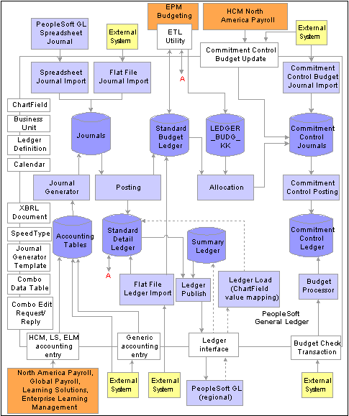

Diagram 1: Commitment Control Module Integration

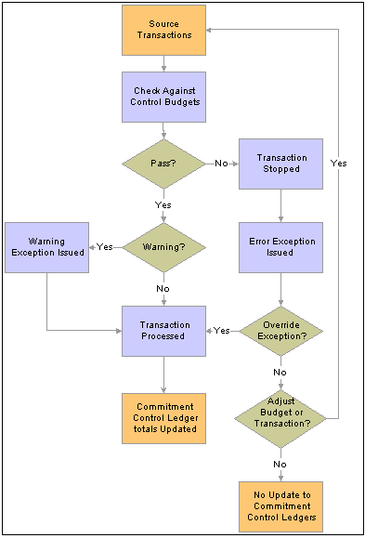

Diagram 2: Commitment Control Budget Checking Process

Commitment Control Overview
PeopleSoft Commitment Control enables tracking of expenditures and obligations against a predefined, authorized budget. Commitment Control is configured to:
- Create and maintain tracking budgets.
- Track actual expenditures against the budget.
- Track imminent future financial obligations (pre-encumbrances and encumbrances) against the budget.

Once budgets are established, all of these transactions are recorded against the budget.

http://webdev.oklaosf.state.ok.us:7071/fsbooks/eng/psbooks/fscc/htm/ - topofpage

Commitment Accounting
Commitment Accounting is an integral part of budgetary control. By establishing and tracking commitments to spend funds—and by tracking these against budgets—an organization can maintain a snapshot of future spending.

Three (3) expenditure commitment amount types are included in Commitment Accounting:
- Expense
- Encumbrance
- Pre-Encumbrance

The following procedure from the procurement life cycle is a typical example of budget checking from commitment through actual transaction:
- When a requisition is generated, Commitment Control records it against the appropriate budget and posts it as a Pre-encumbrance in the Commitment Control ledger.
- When a requisition becomes a purchase order, Commitment Control liquidates the Pre-encumbrance and posts the purchase order amount as an Encumbrance.
- When the purchased goods or services are delivered and the Purchase order becomes a Voucher, Commitment Control liquidates the Encumbrance and posts an Expense.

http://webdev.oklaosf.state.ok.us:7071/fsbooks/eng/psbooks/fscc/htm/ - topofpage

Underlying Data Structure of Commitment Control
Commitment Control uses Ledger and Ledger Group structure to store summarized transactions in the Commitment Control Ledger data table (LEDGER_KK).

An expenditure Commitment Control ledger group consists of a budget ledger, pre-encumbrance ledger, encumbrance ledger, and expenditure ledger; that is, a ledger for budget amounts and ledgers for each transaction amount type that will process against the budget:

Commitment Control  Ledger Group | Budget Ledger | Pre-encumbrance Ledger | Encumbrance  Ledger | Expenditure  Ledger
OPUNIT | OPUNIT_BUD | OPUNIT_PRE | OPUNIT_ENC | OPUNIT_EXP

The way budget data is actually stored in the Commitment Control Ledger Data table looks something like this:

Ledger | Fiscal Year | Acct Period | Account | Operating Unit | Budget Period | Posted Total Amt
OPUNIT_BUD | 2010 | 11 | 510000 | 00011 | 2010 | $100,000
OPUNIT_PRE | 2010 | 11 | 510000 | 00011 | 2010 | $3,000
OPUNIT_ENC | 2010 | 12 | 510000 | 00011 | 2010 | $50,000
OPUNIT_EXP | 2010 | 12 | 510000 | 00011 | 2010 | $25,000

Each time a budget-checked transaction updates the Commitment Control Ledger Data table, it updates the Posted Total Amount by Fiscal Year and Acct Period. Note that the remaining available budget balance is not a stored amount, but is calculated each time the budget checking process is initiated.

In the example above, the OPUNIT available budget is $22,000 ($100,000 - $3,000 - $50,000 - $25,000)

Budget Definition

Navigation: Commitment Control > Define Control Budgets > Budget Definitions

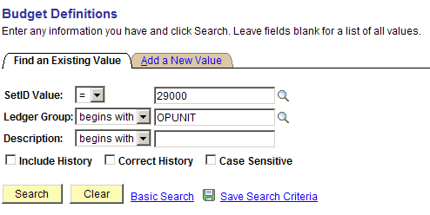

Setid Value – Select or enter the agency business unit

Ledger Group – Select or enter OPUNIT ledger group

Click to enter the budget definition pages.

Control Budget Options Page

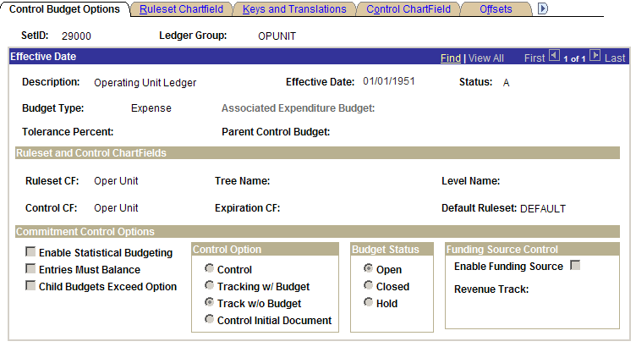

This is a Display only page. Values on this page cannot be changed without additional security.

Ruleset and Control ChartFields – The budget definition is defined by a single control ChartField, in this case, Operating Unit. This is the ChartField that the budget processor considers when determining if a given transaction line is subject to the rules associated with the budget definition.

Control Option - ‘Track without Budget’ is selected when transactions are tracked even if there is no budget setup. If a budget row does exist, warnings will be logged when transactions exceed the budgeted amount. If no budget row exists, no warning is issued. No warnings are issued for commitment control detail tracking ledger groups with the control option track without budget.

Budget Status – Is set to ‘Open’. This means the budget can accept transactions.

Ruleset Charfield Page
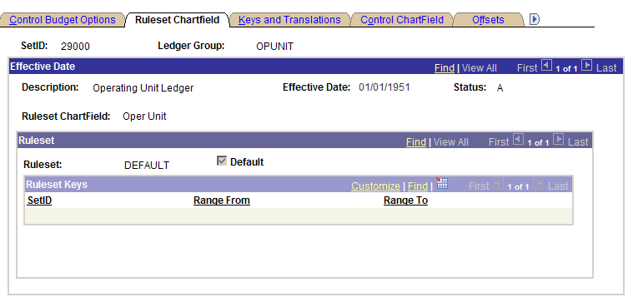

This is a Display only page. Values on this page cannot be changed without additional security.

The Ruleset is set at ‘DEFAULT’. No rules have been defined for this budget definition.

Keys and Translations Page

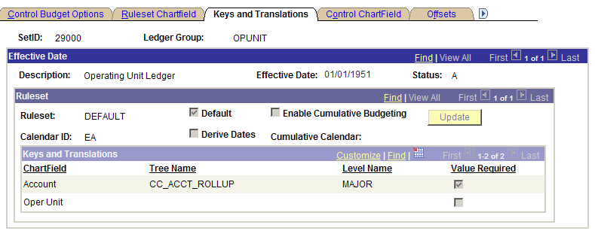

This is a Display only page. Values on this page cannot be changed without additional security.

Ruleset – The Calendar ID is set to ‘EA’. This is the primary budget period calendar to specify the budget periods valid for the Ruleset. If a calendar ID is not specified for the Ruleset, the entire budget is viewed as a single period.

Keys and Translations – Defines the key chartfields and translation trees for the budget definition.

Account – An account value is a required chartfield on all transactions for successful budget checking.

In this case, PeopleSoft uses Trees to translate detail chartfield values to a value level.

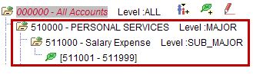

Example:
The account chartfield detail value ‘511110’ entered on the source transaction will record at the MAJOR level value of ‘510000’ on the commitment control ledgers.

Operating Unit is a key chartfield. The Operating Unit will record at the detail value on the commitment control ledgers. This is not a required chartfield. The budget processor ignores transactions that do not have an Operating Unit value.

Control Chartfield Page

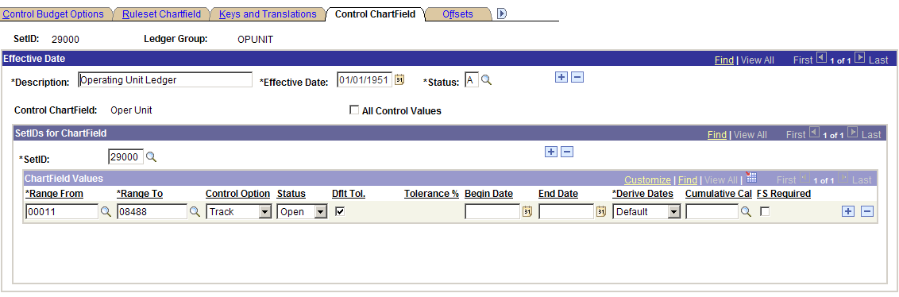

The fields on this page are active. Values on this page can be changed by the user.

All Control Values - Selecting this option enables all ChartField values for the control ChartField at or above the tree level entered on the Keys and Translations page for budgeting.
Since a tree level was not selected on the Keys and Translations page for the ‘Operating Unit’ chartfield, this option was left blank.

Setid – Business unit for the agency

Chartfield Values
Range From / Range To - Enter a range of chartfield values that share the same control option for budget checking. To enter one value, repeat it in both fields.

Control Option - Defaults as the control option value from the Control Budget Options page. Individual or a range of chartfield values may be controlled here. Available Control Options are:

Control – This option is used to strictly control transactions against budgeted amounts. Error exceptions are logged when transactions exceed the budgeted amount. No additional processing can be executed for the transaction.

Tracking with Budget - Tracks transaction amounts against a budget, but does not issue error exceptions unless there is no corresponding budget row. A transaction will pass if a budget row exists, even for a zero amount, but will issue a warning when transactions exceed the budgeted amount.

Track without Budget (aka Track) - Tracks transactions even if there is no budget set up. No warning is issued for the track without budget control option with commitment control detail tracking ledger groups.

NOTE: This value may be changed. User needs a thorough understanding of Control Options before changes are made.

Status - Default value selected from the Control Budget Options page. The status should have a value of Open. This means the budget can still accept transactions.

NOTE: Do not change the status.

Dflt Tol. (default tolerance), Begin Date, End Date, Derive Dates, Cumulative Cal (cumulative calendar), FS Required (Funding Source Required) are not applicable to this budget definition configuration.

Budget Offsets Page

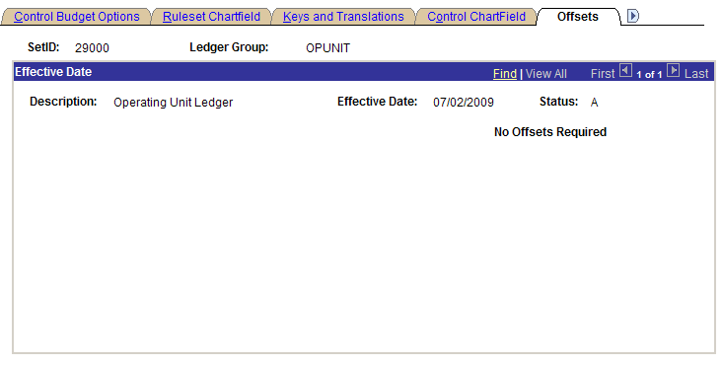

This is a Display only page. No offsets were defined for this budget definition.

Excluded Account Types

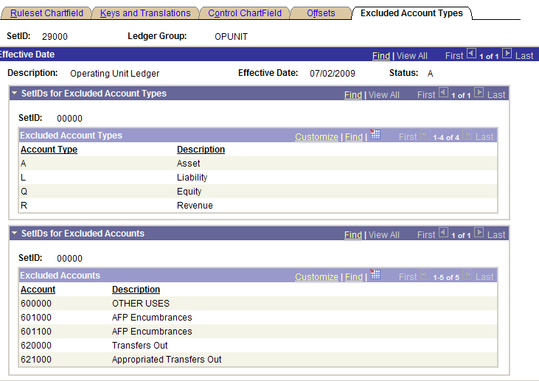

This is a Display only page. Values cannot be change without additional security.

Excluded Account Types - Excludes all Asset, Liability, Equity and Revenue accounts from the budget checking process.

Excluded Accounts - Excludes individual expense accounts from the budget checking process.

Budget Journal Entry

Overview

Budget journals may be entered manually to establish or change the budgeted amount for a control budget. Budget journals post to budget ledgers. The way budget journal entries are processed depends on the rules set up for the budget definition.

Successful budget journal entry and posting follows the major steps below:

- Enter budget journal header information on the Budget Header page.
- Enter budget journal lines on the Budget Lines page.
- Edit and post the budget journal.
- If entries fail edits, check the applicable errors page, correct the errors, and process the journal again.

Step 1: Enter the Budget Journal Header

Navigation: Commitment Control > Budget Journals > Enter Budget Journals

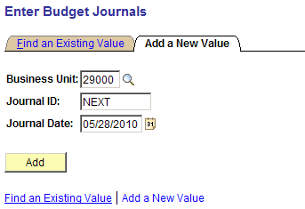

Business Unit – select the agency’s General Ledger business unit

Journal ID – leave as ‘NEXT’ to allow the system to assign the Journal ID. Alternatively, key the Journal ID value. Journal IDs are unique by business unit.

Journal Date – defaults to the system date or date may be entered.

Click to enter the Budget Journal Entry pages.

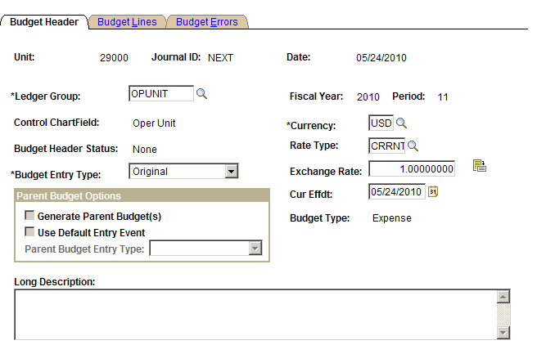

Ledger Group - Select value ‘OPUNIT’ from the lookup. Ledger groups PRJ_CH_KK and PROJECT_KK may also be listed in the lookup search results.

NOTE: Budgets for PRJ_CH_KK and PROJECT_KK ledger groups are entered through the Grants and Project Costing modules. Do not enter budgets for Grants or Projects here.

Budget Entry Type - Original indicates an original budget journal entry. This is used to record adopted or approved budgets. Adjustment is an change to an original budget. The selection has no processing functionality. However, budget entry types enable the proper segregation of budget amounts for reporting.

Currency – Leave as default value USD.

Rate Type – This is used for foreign current translation. Leave value as CRRNT.

Exchange Rate – This is used for foreign current translation. Leave value as 1.0.

Current Effdt - This is used for foreign current translation. This date will default as the journal date.

Long Description – Enter a description of the entry.

Click Budget Lines Tab.

Step 2: Enter the Budget Journal Lines

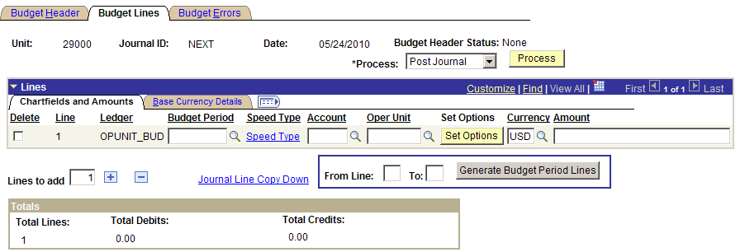

The following elements may be manipulated to enter journal lines:

Click to add additional journal lines to the scroll, enter the number of lines to add in the “Lines to add” field and click the Insert Journal Lines button.

All fields from the previous line are copied to the new line or lines. The fields that are copied can be limited by clicking the Journal Line Copy Down link to access the Journal Entry Copy Down Option page. Select the desired fields for copying.

Click to delete specific lines from the journal, select the Delete check box for the lines and click the Delete Selected Journal Lines button.

The Refresh button updates the journal Totals and other data elements on the screen.

The Save button will save the budget entry and assign a Journal ID. The entry is still eligible for editing.

This button is not applicable for the budget configuration. Generate Budget Period Lines is used for budget definitions that use Cumulative Budgeting, i.e., crosses over Budget Periods. This button creates future Budget Period rows.

Chartfields and Amounts

Budget Period – The budget period is based on the State Fiscal Year which begins July 1 and ends June 30. Populate this field with the appropriate budget period.

Account – Enter an Expense account at the appropriate level. Refer to the budget definition Keys and Translations on page 13 of this manual. For example, enter account ‘510000’ to budget for all payroll and professional consulting expenses, i.e., transaction detail accounts that begin with ‘51xxxx’.
Oper Unit – Enter the appropriate Operating Unit chartfield.

Amount – Enter the budget dollar amount.

Speed Type – Not applicable for this budget journal entry

Set Options – Not applicable for this budget journal entry

Base Currency Details

Not applicable for this budget journal entry

Step 3: Post the Budget Journal

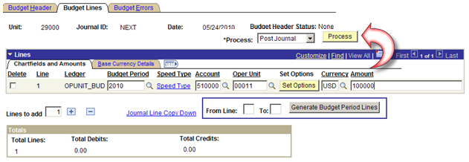

Post the budget journals by selecting Post Journal in the Process field and click .

NOTE: A message will appear, “Are you sure you want to post this journal?”. Respond with ‘Yes’.

Commitment Control posting performs a series of edits. If the entries pass the edits, the process posts the entries to the budget ledger.

If the posting process is successful, the Budget Header Status is set to Posted.

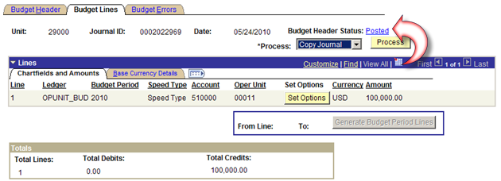

Step 4: Processing Budget Journal Errors

If the budget journal entry posting process is not successful, the Budget Header Status is set to Error.

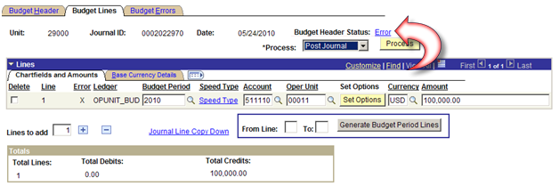

Click the Budget Errors Tab.

Budget Journal Errors Page

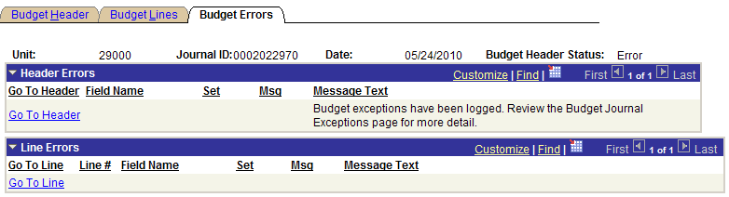

Click the Go To Header link in the Header Errors scroll area to open the Budget Header page. Budget header journal errors may be corrected.

Click the Go To Line link in the Line Errors scroll area to open the Budget Lines page and correct errors.

Budget Journal Exceptions and Corrections

If the budget journal entry fails edits or receives warnings, use the budget journal exceptions pages to view the exceptions and derive more detailed information about the budget journals, journal lines and the associated exceptions.

Navigation: Commitment Control→Review Budget Check Exceptions→General Ledger→Budget Journal

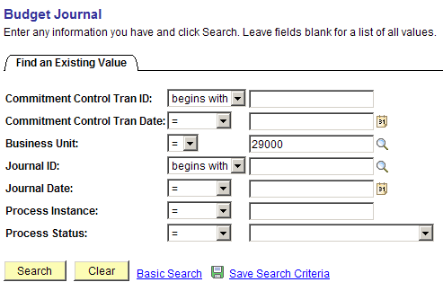

Enter additional criteria or click to return budget journals with in Error status.

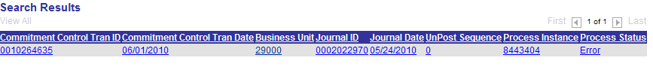

Click a link in the Search Results to open the Budget Journal Exception pages.

Budget Journal Exceptions Page

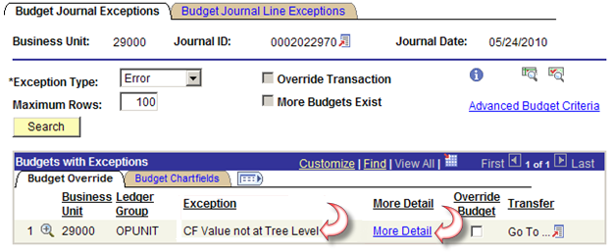

Review the Exception message in the Budget with Exceptions section.

For additional information, click the More Detail link.

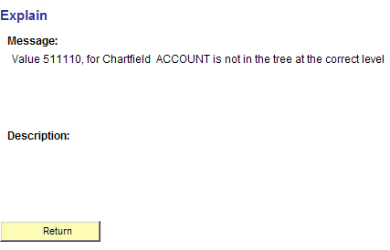

Click to return to the previous page.

Click the Budget Journal Line Exceptions Tab.

Budget Journal Line Exceptions Page

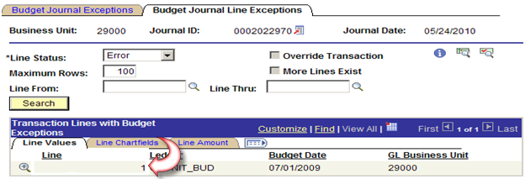

This page displays exceptions associated with a particular journal line.

Click the icon located next to the journal ID to access the original budget journal.

Budget Journal Correction

Make corrections as needed to either the Budget Header or Budget Lines page.

Post the budget journal by running the Post Journal process. Refer to Step 3: Post the Budget Journal for additional help.

Repeat Step 3: Post the Budget Journal and Step 4: Processing Budget Journal Errors as required until all budget journals are successfully posted.

Copy a Budget Journal Entry

Overview

Open an existing budget journal using the Budget Journal Entry page to copy it to a new budget journal entry. This includes posted, unposted, edited and edit required budget journals. Journals having an error status can also be copied.

When the copy process finishes successfully, the Budget Journal Entry page is refreshed and is loaded with the newly copied journal and unique journal id.

Most of the data for the new journal comes from the source journal. For example, those lines having a budget period, the budget date is populated with values from the original journal but for lines without budget period, the budget date takes the value from the new journal date.
With the exception of these changes, an exact copy of the source journal is created.

Step 1: Open a Source Journal

Navigation: Commitment Control→Budget Journals→Enter Budget Journals→Find an Existing Value

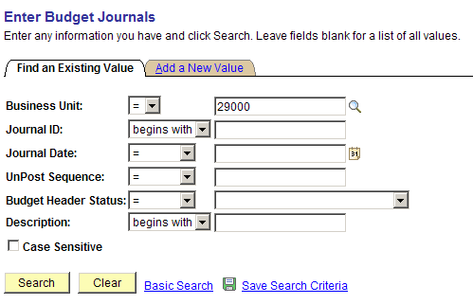

Enter additional criteria as needed and click to locate and open a source journal.

Source Journal Header Page

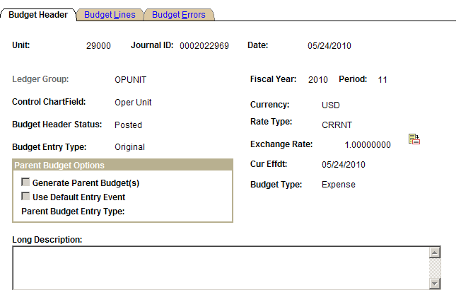

Click the Budget Lines Tab.

Source Journal Lines Page

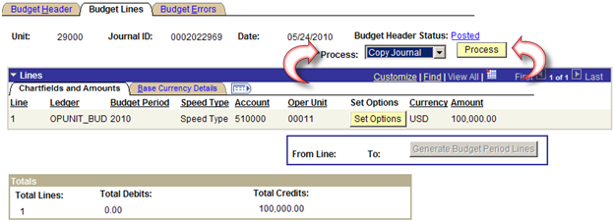

Open the Budget Journal Copy page by selecting Copy Journal in the Process field and click .

Step 2: Process Budget Journal Copy

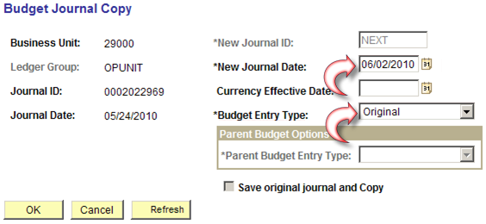

New Journal ID – the system automatically assigns the next available value.

New Journal Date - enter the date for the new journal. The system uses Business Unit, New Journal ID and New Journal Date to check for the creation of duplicate journal, and prevents duplicates by issuing an error message. Copied budget journal lines with a existing budget period are populated with values from the original journal.

Currency Effective Date – the system uses the new journal date when it copies the journal.

Budget Entry Type - select the budget entry type for the copied journal, which can be either Original or Adjustment. The value defaults from the budget entry type of the source journal, but can be changed for the newly copied journal here.

Click to initiate the Budget Journal Copy process.

The new budget journal will automatically open and appear in the view.

Step 3: Edit and Post New Budget Journal

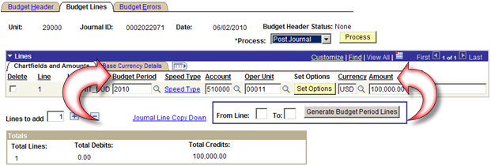

Edit, add or delete budget lines as required.

Post the budget journal by running the Post Journal process.

Refer to Step 2: Enter Budget Journal Lines or Step 3: Post the Budget Journal for additional help if needed.

Delete a Budget Journal Entry

Overview

There may be various reasons why a budget journal entry may need to be deleted, such as, a duplication or an entry created in error.

As long as the Budget Header Status is not Posted or Unposted, a budget journal entry may be deleted.

Commitment Control budgets are not affected by deleting a budget journal entry.

Step 1: Select the Budget Journal

Navigation: Commitment Control > Budget Journals > Enter Budget Journals > Find an Existing Value

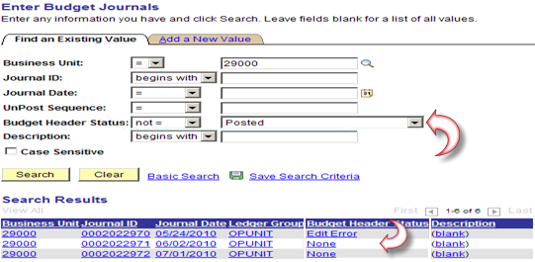

The criteria was added to help identify budget journals eligible for deletion. Click .

All the above budget journals returned in the Search Results are eligible to be deleted based on the Budget Header Status.

Click the selected budget journal link to access the Budget Journal Entry pages.

Click the Budget Lines Tab.

Step 2: Process Delete Budget Journal

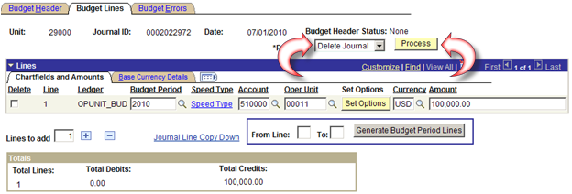

Change the Process from Post Journal to Delete Journal.

Click to run the Delete Journal process.

The following dialogue box will appear

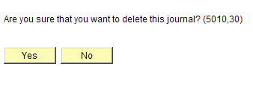

Click .

Return to the Search page to verify the budget journal is deleted.

