Purchase Order Change Orders

Adding New Purchase Order Line(s)
Navigation: Purchasing > Purchase Orders > Add/Update PO
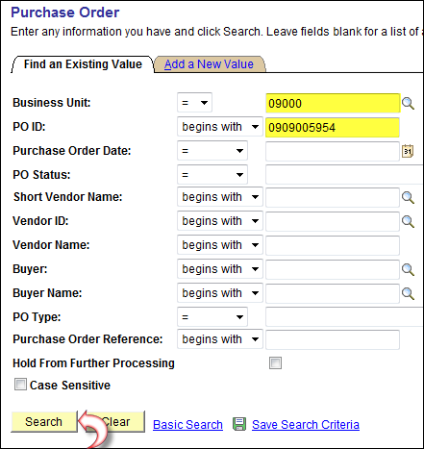
From Find an Existing Value Tab, enter Business Unit and PO ID number to be changed.
Click .
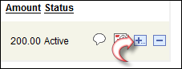
On the Maintain PO screen, at the far right of the last PO line, click .
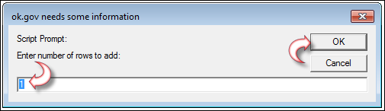
Enter the number of rows to be added. Click .
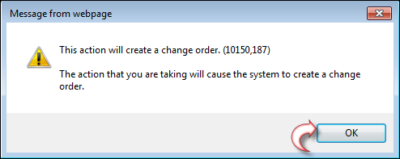
Click .
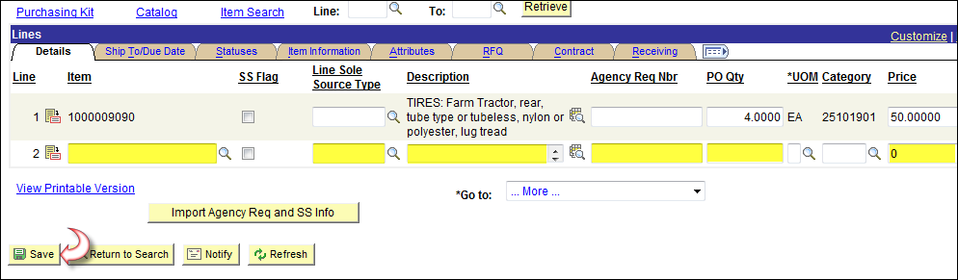
Enter all criteria for the new line, schedule and distribution, same as creating a new PO.
Click
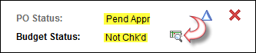
Notice the PO Status is Pend Appr and the Budget Status is now Not Chk’d.
Click to budget check the requisition.
The PO now needs to be Approved.
Navigation: Purchasing > Purchase Orders > Approve Amounts
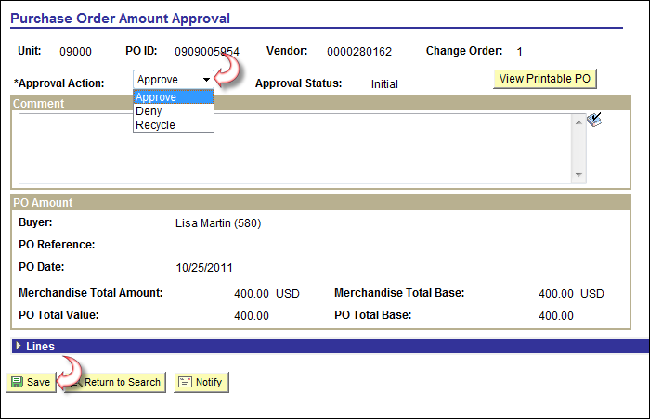
Click and select Approve.
Click
PO now needs to be dispatched.
Navigation: Purchasing > Purchase Orders > Approve Amounts
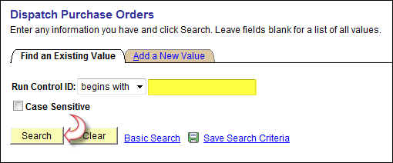
Enter a Run Control ID. Click .
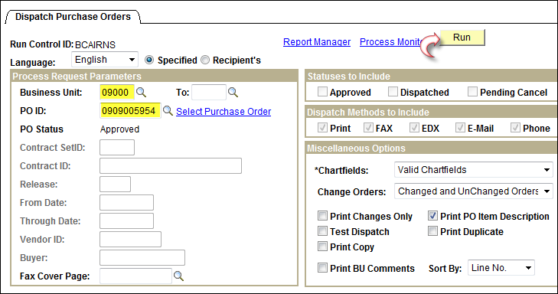
Enter you Business Unit and PO ID numbers. Click .
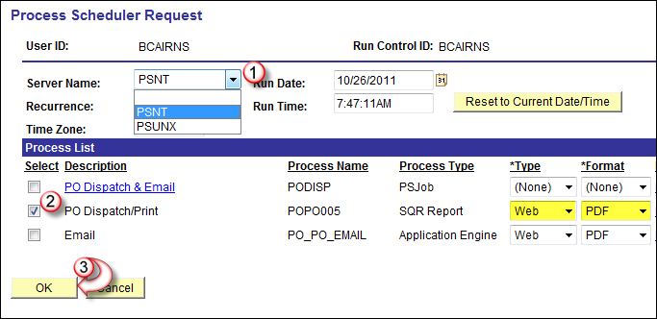
In the Server Name Field, click and select PSNT.
Check PO Dispatch/Print, making sure it has Type as Web and Format as PDF.
Click .
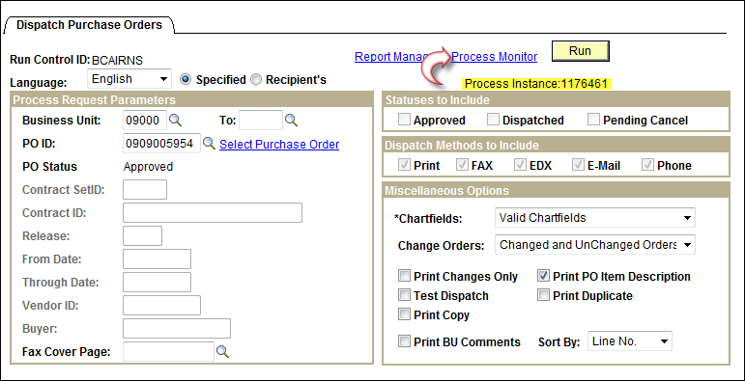
Make note of the Process Instance number and click Process Monitor link.
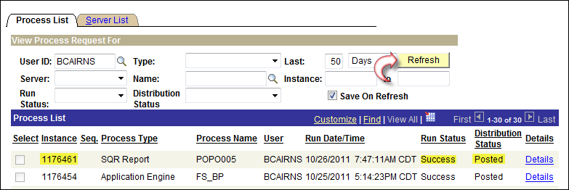
From the Process List Tab, click repeatedly, until your instance number has Run Status of Success and Distribution Status as Posted.

Adding New Purchase Order Schedule Line(s)
Navigation: Purchasing>Purchase Order > Add/Update POs
From Find an Existing Value Tab, enter Business Unit and PO ID number to be changed.
Click .
To add new schedule(s) to an existing line, for lines that are distributed by Quantity, you must increase the line quantity to accommodate the new schedule. (For those distributed by Amount you must increase the amount).
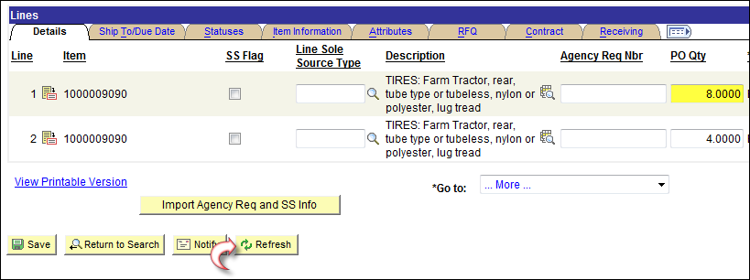
Enter the new quantity and click .
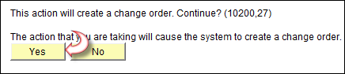
Click .
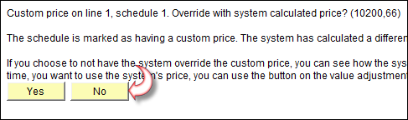
This is just a warning. You have to decide if you want to use the price you originally entered or the System calculated price. Normally you will click to use your price.
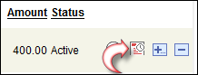
From the far right of the line you want to add a schedule to, click .
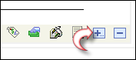
From the far right of the last schedule line, click .
Enter the number of new schedule line(s) to be added.
Click .
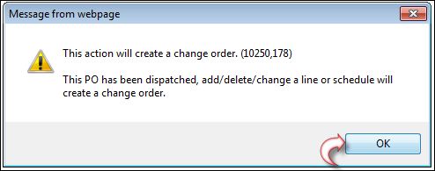
Click .
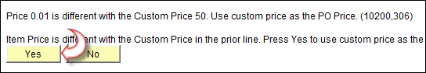
Click to use your price.
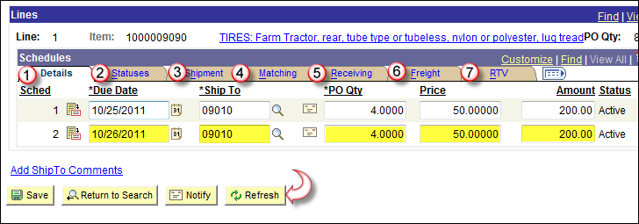
Enter all criteria on all Tabs for new schedule line(s). Click .
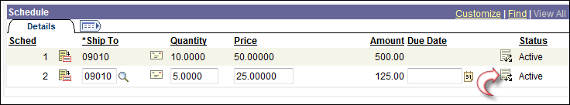
From the far right of the schedule you want to change, Click .
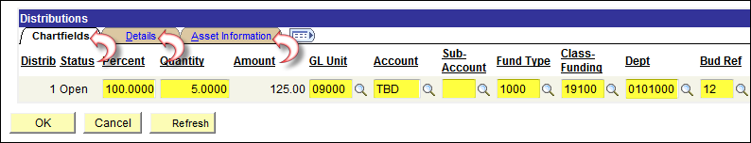
Verify all fields on each of the Tabs on the distribution line to be sure the data is accurate.
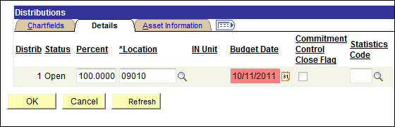
Pay close attention to the Details Tab, this is where you will find the budget date that defaults in form the header page.
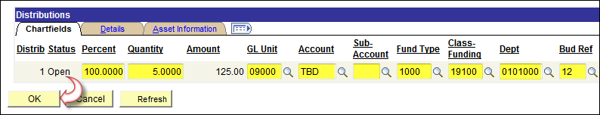
Once you are satisfied with the criteria, click .
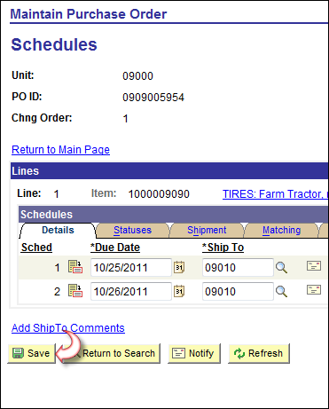
Click
You will need to Re-Budget Check, Approve and Dispatch the PO. See pages four (4) thru seven (7) of this document.

Adding New Purchase Order Distribution Line(s)
Navigation: Purchasing > Purchase Orders > Add/Update POs
From Find an Existing Value Tab, enter Business Unit and PO ID number to be changed.
Click .
From the far right of the line you want to add a distribution line to, click
In order to add distribution lines to an existing schedule, you must first adjust the line and schedule to accomadate the change.
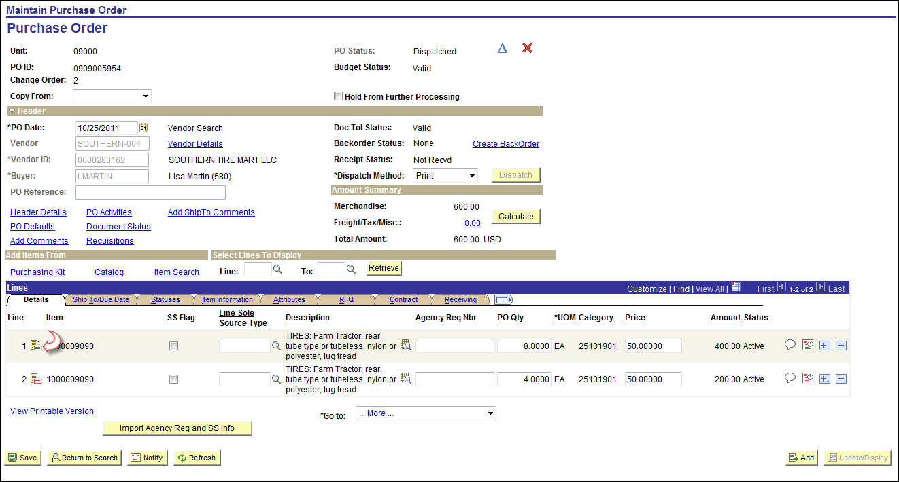
From the Maintain Purchase Order screen, click on the line you want to change.
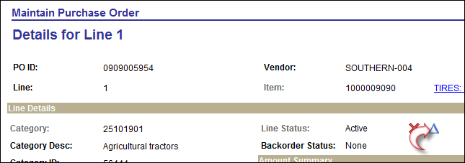
On the Details for Line number screen, click .
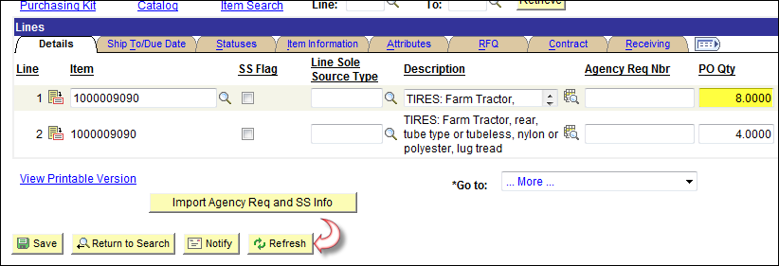
Increase PO Qty to new quantity and click .
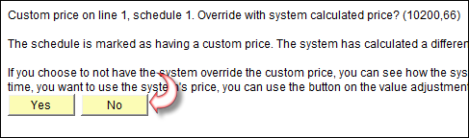
Click to use your own price.
From the far right of the line you want to add a distribution line(s) to, click .
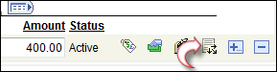
From the far right of the schedule you want to a distribution line(s) to, Click .
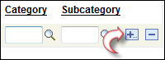
From the far right of the last distribution line, click .
Enter the number of new distribution line(s) to be added. Click .
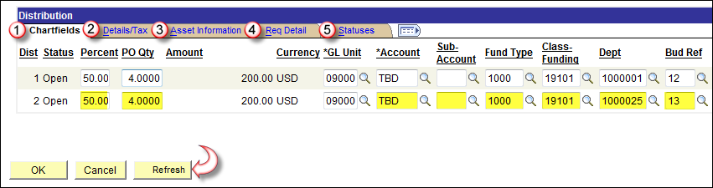
Enter all criteria on all Tabs for new distribution line(s).
Click .
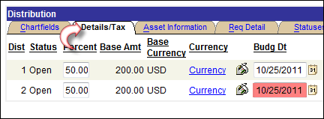
Pay close attention to the Details Tab, this is where you will find the budget date that defaults in form the header page.
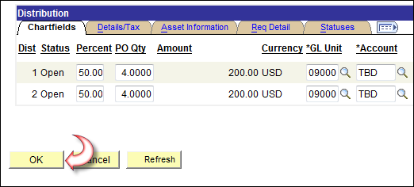
Once you are satisfied with the criteria, click .
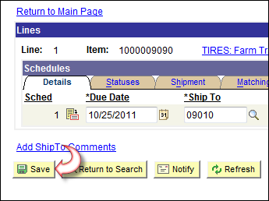
Click
You will need to Re-Budget Check, Approve and Dispatch the PO. See pages 4 thru 7 of this document.

Changes to the PO Header
Navigation: Purchasing > Purchase Orders > Add/Update POs
From Find an Existing Value Tab, enter Business Unit and PO ID number to be changed.
Click .
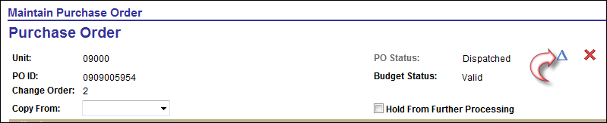
From the Maintain Purchase Order screen, click .
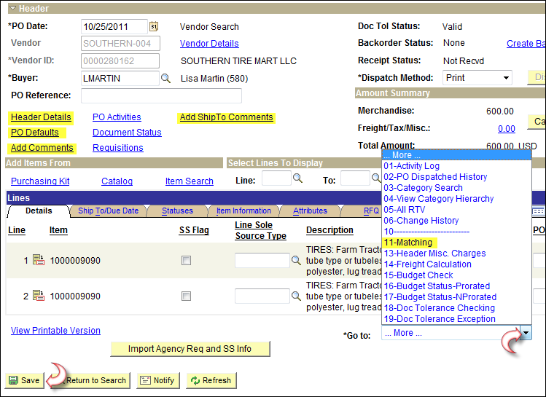
Click any of the highlighted links or select from the Go to field for more options.
Depending on the change(s) made, you may need to Approve, Budget Check and Dispatch the PO once you are finished. See pages four (4) thru seven (7) of this document.

