How to Cancel PO’s/Requisitions and RFQ’s

Canceling Requisition(s) sourced to PO(s)
To cancel a Requisition(s) that have been sourced to a PO(s), the PO(s) must be in a valid budget status and must be canceled first.
Navigation: Purchasing > Purchase Orders > Add/Update Pos

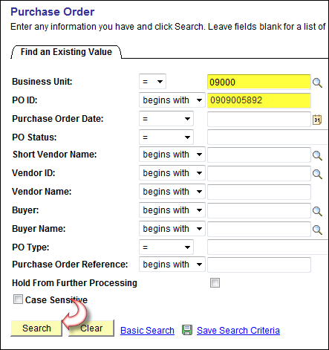

From Find an Existing Value Tab, enter Business Unit and PO ID number.
Click .


On the Maintain Purchase Order screen, verify the Budget Status is Valid, and click .
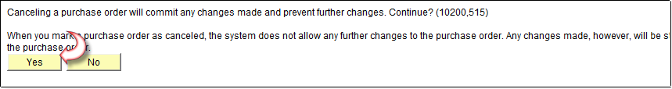

Click .

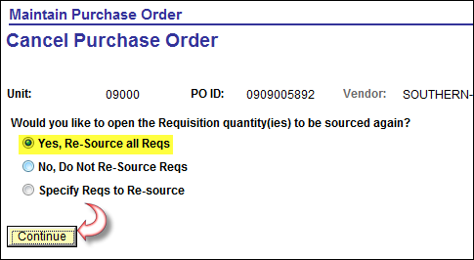

Select Yes, Re-Source all Reqs, (you can also select Specify Reqs to Re-source if there are more than one requisition on the PO).

Click .

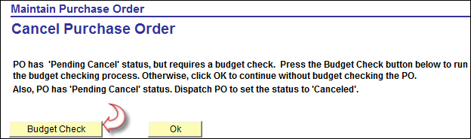

Click .
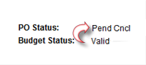
PO Status is now Pend Cncl, (Pending Cancel). PO must be dispatched to complete the cancelation process.

Canceling the Requisition

Navigation: Purchasing>Requisitions>Add/Update Requisitions

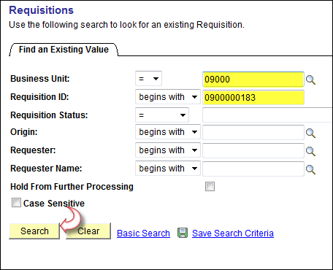

From Find an Existing Value Tab, enter Business Unit and Requisition ID number.

Click .
The requisition must be in a valid budget status before proceeding.

From the Maintain Requisitions screen, verify the Budget Status is Valid. Click .

NOTE: If No - Do Not Re-source Reqs was selected when the PO was canceled OR if the PO was canceled thru the PO reconciliation workbench, the Requisition cannot be canceled, it will have to be closed thru the Requisition reconciliation workbench.

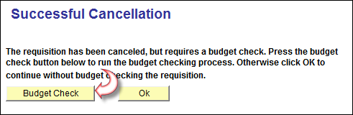

Click .

Canceling RFQ(s) from Requisition(s) sourced to PO(s)
Once a Requisition has been used to create a RFQ and that RFQ has been used to create a PO(s), neither the Requisition nor the RFQ can be Canceled. They both have to be Closed. Prior to closing, the PO(s) must be in a valid budget status and must be canceled first.

NOTE: To cancel PO(s) see steps on page 2 through 4 of this document.

Canceling the RFQ

Once the RFQ has been used to create a PO the RFQ cannot be canceled. The RFQ must be closed.

Navigation: Purchasing>Request for Quotes>Add/Update RFQs

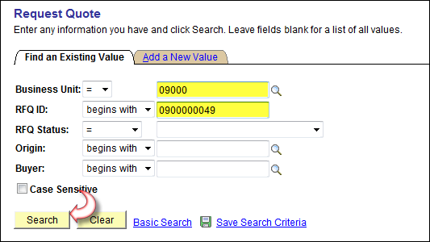

From Find an Existing Value Tab, enter Business Unit and RFQ ID number.

Click .
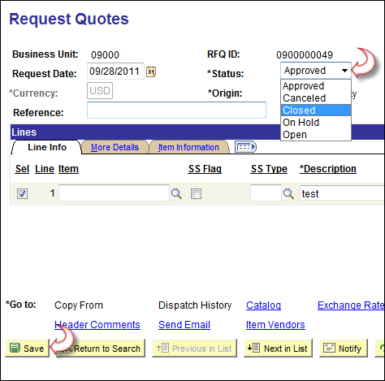

Click in the *Status field and select Closed.

Click

The Requisition can now be Closed thru the Reconciliation workbench.

Messages
If the previous steps are not followed, you will receive the following messages.

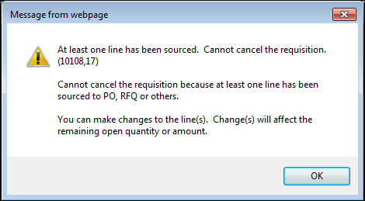

Receiving this messages means that the No – Do Not Re-Source all Reqs option was selected at the time the PO was canceled. The Requisition must be Closed through the Requisition Reconcillation workbench.

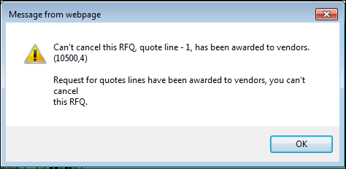

Receiving this messages means that the Request for Quote was used to create a PO. The RFQ must be Closed by selecting the *Status field drop down arrow on the Add / Update RFQ screen and selecting Closed.

NOTE: In the event your PO was canceled with the Yes – Re-Source all Reqs or Specify Reqs to Re-Source option(s) selected, you will have to source the Requisition to a new PO, Final that PO from the Requisition, Cancel the PO selecting No – Do Not Re-Source Reqs option, and finally Close the Requisition thru the Requisition Reconciliation workbench.

