Negative Number Assigned to an Unsigned Field
This message is sometimes received when a user is trying to pull up a Purchase Order or Requisition that was processed against a Statewide Contract. This message is received when the contract release QTY/Amount goes negative.
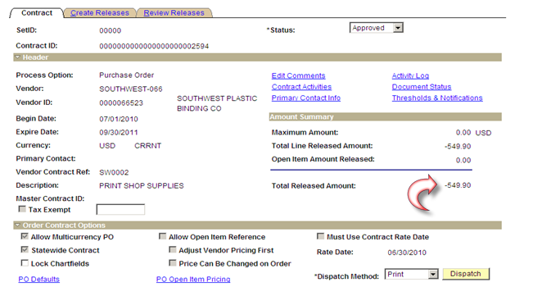
The contract release QTY/Amount goes negative when a Requisition is created with a Statewide Contract and the CALC Price is changed from a Y to N. This is done so the Requisition will be the price on the PO when sourced/copied.
NOTE: To avoid this issue, the user must leave CACL Price turned to (Y) for the Statewide Requisitions and change the PO price when sourced/copied.
