SpeedType Instructions

SpeedTypes
SpeedTypes can be used in General Ledger and Accounts Receivable modules. For purposes of this document, the following screen prints were taken from Accounts Receivable.
Users often have common transactions in which they must enter the same combination of ChartField values repeatedly. By creating shortcut keys called SpeedTypes for these frequently used combinations of ChartFields, users can increase deposit entry efficiency and reduce errors.
Assume that a user regularly post deposits to a specific ChartField string. Each time the user creates a deposit entry for this type of transaction, they enter the same business unit, account, sub-account, fund type, class-funding, dept, CFDA#, and Program Code. Using a SpeedType key that the user defines, they can type in one alphanumeric code that automatically enters most of these ChartField values.

Step 1 – Set Up SpeedTypes

SpeedType Set Up Page
Navigation: Set Up Financials/Supply Chain > Common Definitions > Design ChartFields > Define Values > Speed Types

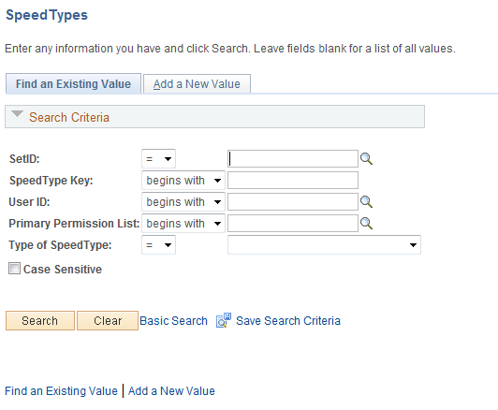
SETID – Enter Business Unit number.
SpeedType Key – Assign a meaningful name to the SpeedType based on the accounting distribution defined in the SpeedType, (be descriptive to help determine the type of SpeedType you are using).
User ID – Enter User ID.
In the example below, SetID field the business unit ‘58000’ was entered. Also, the SpeedType Key field ‘Clearing01’ was entered. Enter PeopleSoft Financial User ID. The page should look like this:

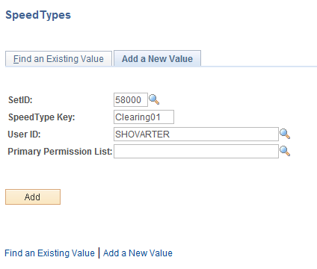

Click . The SpeedType page will appear.

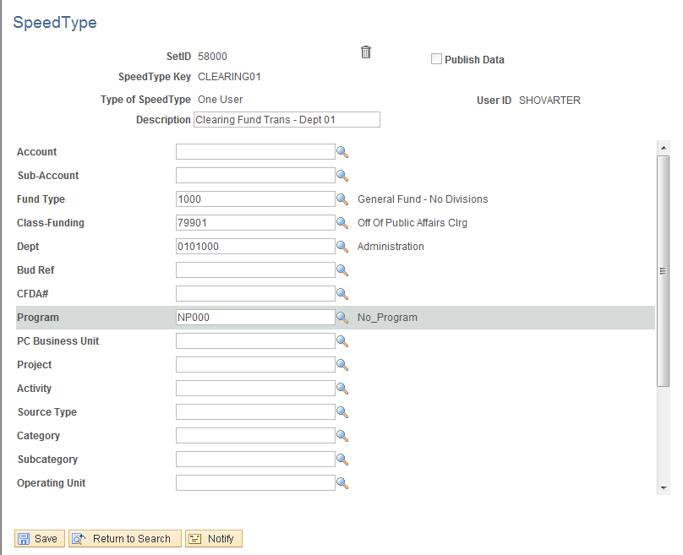
Enter the desired chartfield values to be assigned to the SpeedType. The number of chartfields entered can vary based on the user’s preference. Once the chart fields have been entered, click . This completes the set up of SpeedTypes.

Step 2 – Use the SpeedType in the Deposit Entry

Deposit Lines Page
Navigation: Accounts Receivable > Payments > Online Payments > Regular Deposits > Add a New Value Tab

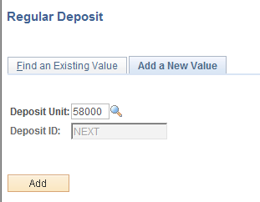
Click to view the Regular Deposit pages.
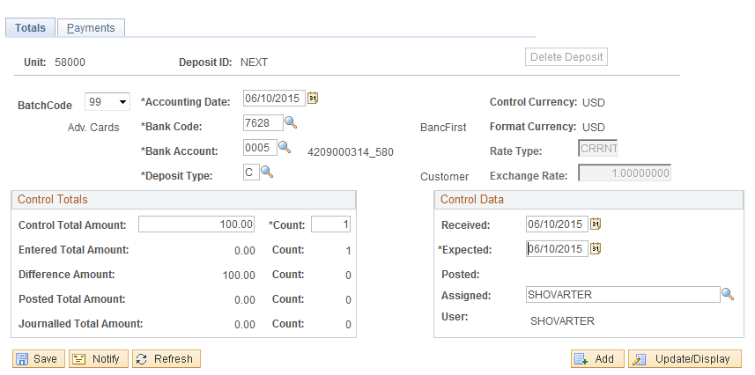
On the Totals Tab - enter necessary fields to complete a deposit.
Click Payments Tab.

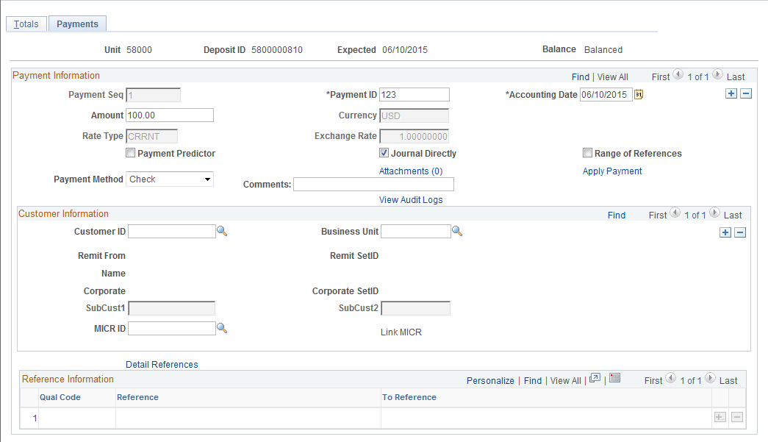
Enter Payment ID field
Enter Amount field
Check Journal Directly box.
Click .
Click Apply Payment link.

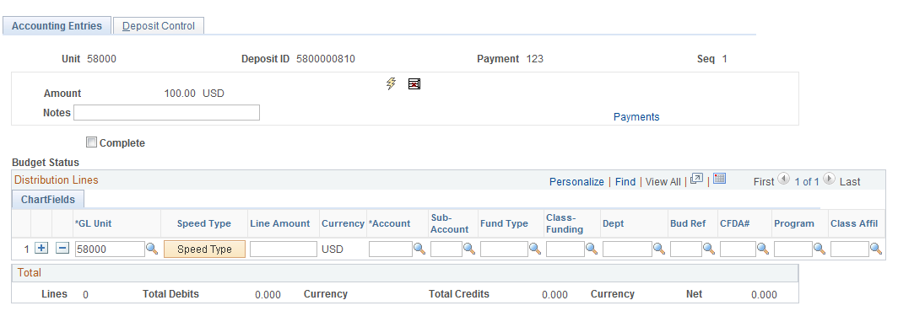
On the Accounting Entries Tab – Distribution Lines ChartFields click .
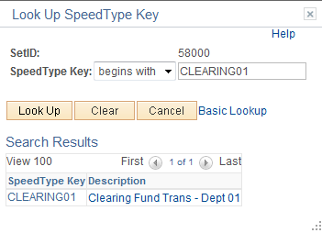
On the SpeedType Search Results page, click CLEARNING01 link.
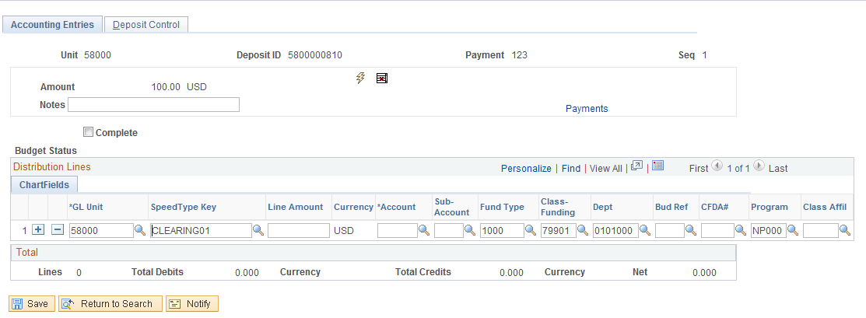
On the Accounting Entries – Distribution Lines ChartFields page the Fund Type, Class-Funding, Dept, and Program Code fields have been populated. Enter the Account and any other fields that are required. The entry is ready for normal Deposit Entry processing.

NOTE: See the Deposit Entry section of COR121 Deposit/Transfer Entry Manual if you need a refresher on other aspects of the deposit entry.

CORE Manual Website link: http://www.ok.gov/cio/Customer_Portal/Business_Application_Services_Essentials/Financials/

